Business Requirements Document (BRD)

Kiro SDLC Agents — KSA-12: Release v1.0.1 — Checksum management, CI/CD fixes, sync tooling

Document Information
Field | Value
Jira Ticket | KSA-12
Title | Release v1.0.1 — Checksum management, CI/CD fixes, sync tooling
Author | BA Agent
Version | 1.0
Date | 2026-05-10
Status | Draft

Revision History
Version | Date | Author | Changes
1.0 | 2026-05-10 | BA Agent | Initiate document — auto-generated from Jira ticket KSA-12

1. Introduction

1.1 Scope
This release (v1.0.1) delivers three major capabilities to the Kiro SDLC Agents VS Code extension:
- Checksum Management System — SHA-256 integrity tracking for all injected files, enabling safe updates with user-modification detection
- CI/CD Pipeline Fixes — Corrected GitHub Actions workflow placement and configuration for proper triggering
- Sync Tooling — PowerShell script to synchronize templates, agents, and indexer scripts from the MCPOrchestration source repository

1.2 Out of Scope
- New agent prompts or steering content (only synced existing content)
- VS Code Marketplace publishing process changes (existing workflow reused)
- Extension UI redesign
- Multi-workspace support
- Rollback mechanism for failed updates (handled by user via git)

1.3 Preliminary Requirements
- Node.js 20+ runtime for CI/CD
- VS Code extension development environment (vsce, ovsx CLI)
- Access to MCPOrchestration source repository (for sync tooling)
- Git repository with committed content (gen-checksums reads from git HEAD)

2. Business Requirements

2.1 High Level Process Map
The release addresses three independent but related concerns:
- File Integrity — When the extension injects files into a workspace, users may customize them. On extension update, the system must detect modifications and offer safe update options.
- CI Reliability — GitHub Actions workflows must trigger correctly on push/PR to build, test, and publish the extension.
- Source Synchronization — Development workflow requires syncing shared resources from the MCPOrchestration monorepo into the extension package.

2.2 List of User Stories / Use Cases
# | Story / Use Case | Priority | Source Ticket
1 | As a developer using the extension, I want the system to detect when I’ve modified injected files so that my customizations aren’t silently overwritten on update | MUST HAVE | KSA-12
2 | As a developer using the extension, I want to see which files are outdated/modified/current so I can decide what to update | MUST HAVE | KSA-12
3 | As a developer using the extension, I want safe update options (Skip Modified, Backup & Overwrite, Overwrite All) when new versions are available | MUST HAVE | KSA-12
4 | As a CI pipeline, I want workflows to trigger correctly when code changes in the kiro-sdlc-agents subdirectory | MUST HAVE | KSA-12
5 | As a CI pipeline, I want checksums auto-generated from git committed content before VSIX packaging | MUST HAVE | KSA-12
6 | As an extension maintainer, I want to sync shared resources from MCPOrchestration with a single command | SHOULD HAVE | KSA-12
7 | As an extension maintainer, I want dry-run mode to preview sync changes before applying | SHOULD HAVE | KSA-12

2.3 Details of User Stories

Business Flow
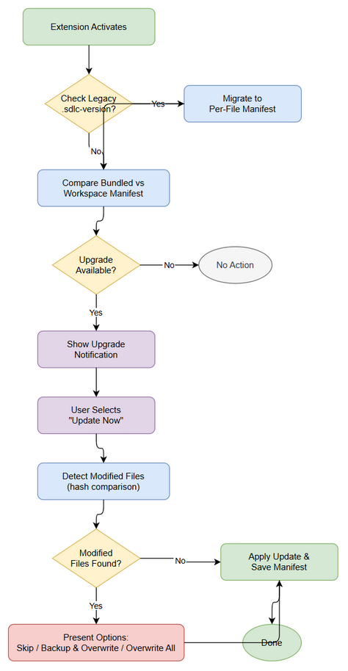
Business Flow
Update Detection Flow:
Step 1: Extension activates in VS Code workspace
Step 2: Extension checks for legacy .kiro/.sdlc-version file and migrates to per-file manifest if found
Step 3: Extension compares bundled manifest (resources/.sdlc-checksums.json) with workspace manifest (.kiro/.sdlc-manifest.json)
Step 4: If any bundled file has newer version than workspace → show upgrade notification
Step 5: User clicks “Update Now” → extension runs safe update
Step 6: For each outdated file, compute current file hash and compare with recorded hash
Step 7: If hash differs from recorded → file was user-modified → present options (Skip/Backup & Overwrite/Overwrite All)
Step 8: Apply user’s choice, update workspace manifest with new versions and hashes

STORY 1: Detect User-Modified Files
As a developer using the extension, I want the system to detect when I’ve modified injected files so that my customizations aren’t silently overwritten on update.
Requirement Details:
- Extension stores a per-file workspace manifest at .kiro/.sdlc-manifest.json tracking version, SHA-256 hash, and injection timestamp for each file
- Bundled manifest at resources/.sdlc-checksums.json contains the expected hash for each file at the current extension version
- On activation, extension compares workspace file hash against the recorded hash in workspace manifest
- If current file hash ≠ recorded hash → file state = “modified” (user changed it)
- If workspace version < bundled version → file state = “outdated”
- If file doesn’t exist on disk → file state = “missing”
- If hash matches and version matches → file state = “current”
Data Fields:
Field | Type | Required | Description | Example
relativePath | string | Yes | Path relative to workspace root | .kiro/agents/ba-agent.md
hash | string | Yes | SHA-256 hex digest of file content | 4b35262c5de6...
version | string | Yes | Semver version when file was injected | 1.0.5
injectedAt | string | Yes | ISO 8601 timestamp | 2026-05-10T04:22:47.128Z
state | enum | Yes | Computed file status | current\|outdated\|modified\|missing
Acceptance Criteria:
- Given a file injected at v1.0.0 that user has NOT modified, when extension checks status, then state = “current”
- Given a file injected at v1.0.0 that user HAS modified (different hash), when extension checks status, then state = “modified”
- Given a file injected at v1.0.0 when bundled version is v1.0.5, when extension checks status, then state = “outdated”
- Given a file tracked in manifest but deleted from disk, when extension checks status, then state = “missing”
- Legacy .kiro/.sdlc-version file is automatically migrated to per-file manifest on first activation

STORY 2: File Status Report
As a developer using the extension, I want to see which files are outdated/modified/current so I can decide what to update.
Requirement Details:
- Status command (kiroSdlc.status) shows per-file status with ✅/❌ indicators
- “Show File Versions” action displays detailed version report in output channel
- Report includes: file path, workspace version, bundled version, state
Acceptance Criteria:
- Given workspace with mixed file states, when user runs status command, then all files are listed with correct state indicators
- Given user clicks “Show File Versions”, then output channel shows detailed report with version comparison
- Given user clicks “Inject Missing”, then selective injection command is triggered

STORY 3: Safe Update Options
As a developer using the extension, I want safe update options when new versions are available.
Requirement Details:
- When upgrade is available, show notification: “🆕 SDLC Agents update available → v{version}”
- Options: “Update Now”, “Show Details”, “Later”
- “Update Now” triggers safe update that:
  - Identifies modified files
  - Presents per-file options: Skip Modified, Backup & Overwrite, Overwrite All
  - Updates workspace manifest after successful injection
- After update, workspace manifest records new version and hash for each updated file
Acceptance Criteria:
- Given bundled version > workspace version, when extension activates, then upgrade notification appears
- Given user selects “Update Now” with modified files, then user is prompted with safe options before overwriting
- Given user selects “Skip Modified”, then modified files are left unchanged and only outdated/missing files are updated
- Given user selects “Backup & Overwrite”, then original file is backed up before overwriting
- After successful update, workspace manifest reflects new versions and hashes

STORY 4: CI Workflow Triggers Correctly
As a CI pipeline, I want workflows to trigger correctly when code changes in the kiro-sdlc-agents subdirectory.
Requirement Details:
- .github/workflows/ci.yml placed at repository root (not inside kiro-sdlc-agents/)
- Workflow uses paths filter: kiro-sdlc-agents/**
- Workflow uses working-directory: kiro-sdlc-agents for all run steps
- CI steps: checkout → setup-node → npm ci → copy-resources → gen-checksums → compile → package VSIX
- Publish workflow triggers on tag push (v*) or manual dispatch
Acceptance Criteria:
- Given push to main with changes in kiro-sdlc-agents/, when CI triggers, then build completes successfully
- Given push to main with changes ONLY outside kiro-sdlc-agents/, then CI does NOT trigger
- Given tag v1.0.1 pushed, then publish workflow triggers and publishes to both VS Code Marketplace and Open VSX
- Given manual dispatch with target “vscode-only”, then only VS Code Marketplace publish runs

STORY 5: CI Auto-generate Checksums
As a CI pipeline, I want checksums auto-generated from git committed content before VSIX packaging.
Requirement Details:
- Script scripts/gen-checksums.js generates resources/.sdlc-checksums.json
- Script reads file content from git show HEAD:{path} (not filesystem) to ensure reproducibility
- Script scans paths: .kiro/agents/, .kiro/hooks/, .kiro/steering/, documents/templates/, .analysis/code-intelligence/index-config.json
- Output manifest includes: version (from package.json), generatedAt timestamp, per-file hash entries
- npm run gen-checksums added to vscode:prepublish script so it runs automatically before packaging
Acceptance Criteria:
- Given clean git checkout, when npm run gen-checksums runs, then .sdlc-checksums.json is generated with correct hashes
- Given uncommitted local changes, when script runs, then hashes reflect git HEAD content (not local modifications)
- Given new file added to tracked paths and committed, when script runs, then new file appears in manifest
- Manifest version matches package.json version

STORY 6: Sync Tooling
As an extension maintainer, I want to sync shared resources from MCPOrchestration with a single command.
Requirement Details:
- PowerShell script scripts/sync-from-source.ps1 copies files from MCPOrchestration to FEC_CR_Builder
- Sync mappings:
  - documents/templates → documents/templates
  - .kiro → .kiro
  - .analysis/code-intelligence/scripts → .analysis/code-intelligence/scripts
- Only copies NEW or CHANGED files (MD5 hash comparison)
- Skips: settings/, node_modules/, __pycache__/, out/, dist/, .git/
- Skips files: mcp.json, mcp.json,bk
Acceptance Criteria:
- Given new file in MCPOrchestration source, when sync runs, then file is copied to destination
- Given changed file in source (different MD5), when sync runs, then file is overwritten in destination
- Given unchanged file (same MD5), when sync runs, then file is skipped
- Given file in settings/ directory, when sync runs, then file is skipped
- Summary shows count of new, changed, and skipped files

STORY 7: Dry-Run Mode for Sync
As an extension maintainer, I want dry-run mode to preview sync changes before applying.
Requirement Details:
- -DryRun switch parameter shows what would be copied without actually copying
- Output clearly indicates “(DRY RUN — no files were copied)”
- Same detection logic (new/changed) runs in dry-run mode
Acceptance Criteria:
- Given -DryRun flag, when sync runs, then no files are modified on disk
- Given -DryRun flag with new files detected, then output shows “NEW: {path}” for each
- Given -DryRun flag with changed files detected, then output shows “CHANGED: {path}” for each

3. Dependencies
Dependency | Type | Related Ticket | Description
Node.js 20+ | Infrastructure | N/A | Required for CI build and gen-checksums script
VS Code Extension API | System | N/A | Extension host for checksum management
Git CLI | System | N/A | gen-checksums.js uses git ls-tree and git show
MCPOrchestration repo | External | N/A | Source repository for sync tooling
GitHub Actions | Infrastructure | N/A | CI/CD platform for build and publish
VSCE_PAT secret | Infrastructure | N/A | VS Code Marketplace publish token
OVSX_TOKEN secret | Infrastructure | N/A | Open VSX Registry publish token

4. Stakeholders
Role | Name / Team | Responsibility | Source
Reporter / Developer | Duc Nguyen | Implementation, release management | Jira reporter
Extension Users | Development teams | Use extension, provide feedback | End users

5. Risks and Assumptions

5.1 Risks
Risk | Impact | Likelihood | Mitigation
Hash collision (SHA-256) | Low | Negligible | SHA-256 collision probability is astronomically low
Git not available in CI | High | Low | CI uses actions/checkout which includes git
User deletes workspace manifest | Medium | Low | Extension recreates manifest on next activation
MCPOrchestration repo unavailable | Medium | Low | Sync is manual, not blocking CI
Large number of tracked files slows activation | Medium | Medium | Manifest is JSON, reads are fast; currently ~50 files

5.2 Assumptions
- Users have git installed in their development environment
- VS Code workspace has a single root folder (multi-root not supported)
- Extension has filesystem read/write access to workspace
- CI environment has clean git checkout (no uncommitted changes)
- MCPOrchestration source paths remain stable

6. Non-Functional Requirements
Category | Requirement | Details
Performance | Activation check < 500ms | Hash computation for ~50 files should complete within 500ms
Performance | Gen-checksums < 5s | Script should complete within 5 seconds for current file count
Reliability | Manifest corruption recovery | If manifest is corrupted (invalid JSON), treat as missing and rebuild
Security | Tamper-proof bundled manifest | Bundled manifest inside VSIX cannot be modified by users
Compatibility | VS Code 1.85+ | Minimum VS Code version for extension API compatibility
Maintainability | Single source of truth | gen-checksums.js reads from git HEAD, ensuring reproducibility

7. Related Tickets
Ticket Key | Summary | Status | Type | Relationship
KSA-12 | Release v1.0.1 — Checksum management, CI/CD fixes, sync tooling | In Progress | Task | Main ticket

8. Appendix

Glossary
Term | Definition
Bundled Manifest | resources/.sdlc-checksums.json — shipped inside the VSIX, contains expected hashes
Workspace Manifest | .kiro/.sdlc-manifest.json — stored in user’s workspace, tracks injected file versions
Injection | Process of copying agent/steering/template files from extension into workspace
Safe Update | Update process that detects user modifications before overwriting
VSIX | VS Code Extension package format

Use Case Diagram
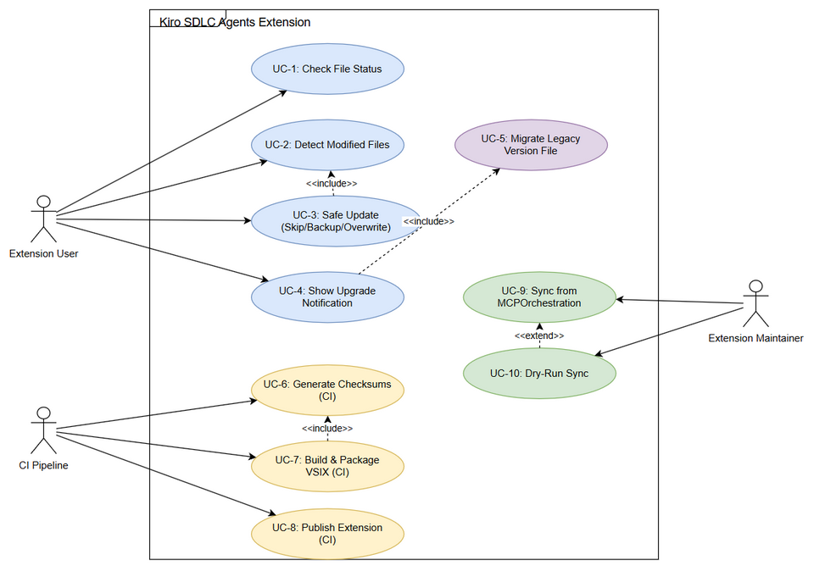
Use Case Diagram

Diagram Index
# | Diagram | Image | Source (editable)
1 | Business Flow | business-flow.png | business-flow.drawio
2 | Use Case Diagram | use-case.png | use-case.drawio

