Functional Specification Document (FSD)

Kiro SDLC Agents — KSA-12: Release v1.0.1 — Checksum management, CI/CD fixes, sync tooling

Document Information
Field | Value
Jira Ticket | KSA-12
Title | Release v1.0.1 — Checksum management, CI/CD fixes, sync tooling
Author | BA Agent + TA Agent
Version | 1.0
Date | 2026-05-10
Status | Draft
Related BRD | BRD-v1-KSA-12.docx

Revision History
Version | Date | Author | Changes
1.0 | 2026-05-10 | BA Agent | Initiate document from BRD
1.1 | 2026-05-10 | TA Agent | Technical enrichment — API contracts, pseudocode

1. Introduction

1.1 Purpose
This FSD specifies the functional behavior of three subsystems introduced in Kiro SDLC Agents v1.0.1: 1. Checksum Management — per-file integrity tracking with safe update UX 2. CI/CD Workflows — GitHub Actions configuration for build and publish 3. Sync Tooling — cross-repository file synchronization script

1.2 Scope
Covers all user-facing and system-facing behaviors for the features described in BRD KSA-12. Includes use cases, data flows, processing logic, and error handling.

1.3 Definitions & Acronyms
Term | Definition
Bundled Manifest | resources/.sdlc-checksums.json — shipped inside VSIX, contains expected SHA-256 hashes
Workspace Manifest | .kiro/.sdlc-manifest.json — per-workspace file tracking injected versions
VSIX | VS Code Extension package format (.vsix)
Injection | Copying agent/steering/template files from extension resources into workspace
Safe Update | Update process that detects user modifications before overwriting

1.4 References
Document | Location
BRD | BRD-v1-KSA-12.docx
Source: checksum.ts | kiro-sdlc-agents/src/checksum.ts
Source: injector.ts | kiro-sdlc-agents/src/injector.ts
Source: gen-checksums.js | kiro-sdlc-agents/scripts/gen-checksums.js
Source: sync-from-source.ps1 | scripts/sync-from-source.ps1

2. System Overview

2.1 System Context Diagram
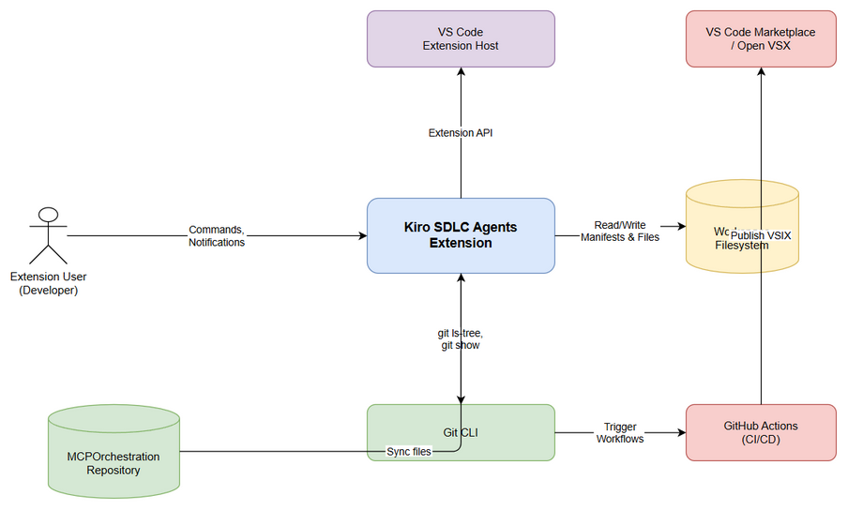
System Context
The extension operates within VS Code, interacting with: - Workspace filesystem — reads/writes manifest files and injected resources - Extension resources — bundled manifest and resource files inside VSIX - Git CLI — used by gen-checksums.js to read committed content - GitHub Actions — CI/CD platform executing build and publish workflows - MCPOrchestration repo — source for sync tooling

2.2 Component Overview
Component | Location | Responsibility
checksum.ts | src/checksum.ts | Hash computation, manifest I/O, file status detection
injector.ts | src/injector.ts | File injection, safe update logic, backup
extension.ts | src/extension.ts | VS Code command registration, UX orchestration
gen-checksums.js | scripts/gen-checksums.js | CI-time manifest generation from git
sync-from-source.ps1 | scripts/sync-from-source.ps1 | Cross-repo file sync
ci.yml | .github/workflows/ci.yml | CI build pipeline
publish.yml | .github/workflows/publish.yml | Publish pipeline

3. Functional Requirements

3.1 Feature: Checksum Management System
Source: BRD Stories 1, 2, 3

3.1.1 Description
The checksum management system provides per-file integrity tracking for all resources injected by the extension into a workspace. It enables detection of user modifications and safe update workflows.

3.1.2 Use Cases

Use Case ID: UC-01 Name: Detect File Modification Status Actor: Extension (automatic on activation) Preconditions: Workspace has been previously injected (workspace manifest exists) Postconditions: File statuses computed and available for display/update logic
Main Flow:
Step | Actor | System | Description
1 |  | Extension | Load bundled manifest from resources/.sdlc-checksums.json
2 |  | Extension | Load workspace manifest from .kiro/.sdlc-manifest.json
3 |  | Extension | For each file in bundled manifest, compute current SHA-256 hash
4 |  | Extension | Compare: workspace version vs bundled version, current hash vs recorded hash
5 |  | Extension | Assign state: current / outdated / modified / missing
Alternative Flows:
ID | Condition | Steps
AF-01 | Workspace manifest doesn’t exist | Treat all files as “missing” state
AF-02 | Legacy .sdlc-version file exists | Migrate to per-file manifest first (UC-02), then proceed
AF-03 | Bundled manifest doesn’t exist | Return empty status list (extension packaging error)
Exception Flows:
ID | Condition | Steps
EF-01 | Workspace manifest is corrupted JSON | Delete corrupted file, treat as missing
EF-02 | File read permission denied | Skip file, mark as “missing” with warning

Use Case ID: UC-02 Name: Migrate Legacy Version File Actor: Extension (automatic on activation) Preconditions: .kiro/.sdlc-version exists in workspace Postconditions: Per-file manifest created, legacy file deleted
Main Flow:
Step | Actor | System | Description
1 |  | Extension | Read version from .kiro/.sdlc-version JSON
2 |  | Extension | Load bundled manifest to get file list
3 |  | Extension | For each bundled file that exists on disk, compute hash
4 |  | Extension | Create workspace manifest with legacy version for all existing files
5 |  | Extension | Save workspace manifest
6 |  | Extension | Delete .kiro/.sdlc-version
Exception Flows:
ID | Condition | Steps
EF-01 | Legacy file is invalid JSON | Use default version “1.0.0”, continue migration

Use Case ID: UC-03 Name: Safe Update with Modification Detection Actor: Extension User Preconditions: Upgrade available (bundled version > workspace version for at least one file) Postconditions: Files updated according to user choice, manifest reflects new state
Main Flow:
Step | Actor | System | Description
1 | User |  | Clicks “Update Now” from upgrade notification
2 |  | Extension | Detect modified files (hash comparison)
3 |  | Extension | Categorize: outdated (version mismatch), modified (hash mismatch)
4 |  | Extension | If no modified files → force update all outdated files
5 |  | Extension | If modified files exist → show modal with file details and options
6 | User |  | Selects: “Overwrite All” / “Skip Modified” / “Backup & Overwrite” / “Cancel”
7 |  | Extension | Execute chosen strategy
8 |  | Extension | Rebuild workspace manifest with new versions/hashes
Alternative Flows:
ID | Condition | Steps
AF-01 | User selects “Skip Modified” | Update only outdated files, leave modified files unchanged
AF-02 | User selects “Backup & Overwrite” | Copy modified files to .kiro/.sdlc-backup/{timestamp}/, then overwrite all
AF-03 | User selects “Cancel” | No changes made

Use Case ID: UC-04 Name: Show Upgrade Notification Actor: Extension (automatic on activation) Preconditions: Extension activated, workspace has injected files Postconditions: User informed of available upgrade
Main Flow:
Step | Actor | System | Description
1 |  | Extension | Check isUpgradeAvailable() — any bundled file newer than workspace
2 |  | Extension | If upgrade available → show info message with version
3 | User |  | Selects “Update Now” / “Show Details” / “Later”
4a |  | Extension | “Update Now” → execute UC-03
4b |  | Extension | “Show Details” → show version report in output channel
4c |  | Extension | “Later” → dismiss notification

Use Case ID: UC-05 Name: Check Component Status Actor: Extension User Preconditions: Workspace open Postconditions: Status displayed to user
Main Flow:
Step | Actor | System | Description
1 | User |  | Clicks status bar item or runs kiroSdlc.status command
2 |  | Extension | Check existence of each component’s target path
3 |  | Extension | Show info message with ✅/❌ per component
4 | User |  | Selects “Show File Versions” / “Inject Missing” / “Close”
5a |  | Extension | “Show File Versions” → show detailed report in output channel
5b |  | Extension | “Inject Missing” → trigger selective injection

3.1.3 Business Rules
Rule ID | Rule | Source
BR-01 | File state is “modified” when current hash ≠ recorded hash AND version matches | BRD Story 1
BR-02 | File state is “outdated” when workspace version < bundled version | BRD Story 1
BR-03 | File state is “missing” when file doesn’t exist on disk | BRD Story 1
BR-04 | File state is “current” when hash matches AND version matches | BRD Story 1
BR-05 | Legacy migration assigns the legacy version to ALL existing files | BRD Story 1 AC-5
BR-06 | Backup directory uses ISO timestamp: .kiro/.sdlc-backup/{timestamp}/ | BRD Story 3
BR-07 | gen-checksums reads from git HEAD, not filesystem | BRD Story 5
BR-08 | Sync only copies NEW or CHANGED files (MD5 comparison) | BRD Story 6
BR-09 | Sync skips directories: settings, node_modules, pycache, out, dist, .git | BRD Story 6
BR-10 | Sync skips files: mcp.json, mcp.json,bk | BRD Story 6

3.1.4 Data Specifications
Bundled Manifest (ChecksumManifest):
Field | Type | Required | Validation | Description
version | string | Yes | Semver format | Extension version
generatedAt | string | Yes | ISO 8601 | Generation timestamp
files | Record<string, FileChecksum> | Yes | Non-empty | Per-file entries
files[].hash | string | Yes | 64-char hex | SHA-256 hash
files[].version | string | Yes | Semver | File version
files[].injectedAt | string | Yes | ISO 8601 | Injection timestamp
Workspace Manifest (WorkspaceManifest):
Field | Type | Required | Validation | Description
lastUpdated | string | Yes | ISO 8601 | Last manifest update
files | Record<string, WorkspaceFileEntry> | Yes | — | Per-file entries
files[].version | string | Yes | Semver | Injected version
files[].hash | string | Yes | 64-char hex | Hash at injection time
files[].injectedAt | string | Yes | ISO 8601 | When file was injected
File Status (computed):
Field | Type | Description
relativePath | string | Path relative to workspace root
workspaceVersion | string | Version from workspace manifest
bundledVersion | string | Version from bundled manifest
state | “current” | “outdated” | “modified” | “missing” | Computed state

3.2 Feature: CI/CD Workflows
Source: BRD Stories 4, 5

3.2.1 Description
GitHub Actions workflows for continuous integration (build verification) and continuous deployment (publish to marketplaces).

3.2.2 Use Cases

Use Case ID: UC-06 Name: CI Build on Push/PR Actor: CI Pipeline (GitHub Actions) Preconditions: Push to main or PR targeting main with changes in kiro-sdlc-agents/ Postconditions: Build verified, VSIX package created
Main Flow:
Step | Actor | System | Description
1 | Developer |  | Pushes code to main or opens PR
2 |  | GitHub Actions | Trigger CI workflow (paths filter matches)
3 |  | CI | Checkout repository
4 |  | CI | Setup Node.js 20
5 |  | CI | npm ci (install dependencies)
6 |  | CI | npm run copy-resources (copy from workspace root)
7 |  | CI | npm run gen-checksums (generate manifest)
8 |  | CI | npm run compile (TypeScript compilation)
9 |  | CI | npx vsce package --no-dependencies (create VSIX)
10 |  | CI | Verify VSIX file exists
Alternative Flows:
ID | Condition | Steps
AF-01 | Changes only outside kiro-sdlc-agents/ | Workflow does NOT trigger (paths filter)
Exception Flows:
ID | Condition | Steps
EF-01 | npm ci fails | Build fails, PR blocked
EF-02 | TypeScript compilation error | Build fails, PR blocked
EF-03 | gen-checksums fails (git error) | Build fails

Use Case ID: UC-07 Name: Publish Extension on Tag Actor: CI Pipeline (GitHub Actions) Preconditions: Tag matching v* pushed OR manual workflow dispatch Postconditions: Extension published to VS Code Marketplace and/or Open VSX
Main Flow:
Step | Actor | System | Description
1 | Maintainer |  | Pushes tag v1.0.1
2 |  | GitHub Actions | Trigger publish workflow
3 |  | CI | Build job: checkout → install → copy-resources → gen-checksums → compile → package
4 |  | CI | Upload VSIX as artifact
5 |  | CI | publish-vscode job: download artifact → npx vsce publish with VSCE_PAT
6 |  | CI | publish-openvsx job: download artifact → npx ovsx publish with OVSX_TOKEN
Alternative Flows:
ID | Condition | Steps
AF-01 | Manual dispatch target=“vscode-only” | Only publish-vscode job runs
AF-02 | Manual dispatch target=“openvsx-only” | Only publish-openvsx job runs

Use Case ID: UC-08 Name: Generate Checksums Manifest Actor: CI Pipeline or Developer (manual) Preconditions: Git repository with committed files in tracked paths Postconditions: resources/.sdlc-checksums.json generated
Main Flow:
Step | Actor | System | Description
1 |  | Script | Read version from package.json
2 |  | Script | Run git ls-tree -r --name-only HEAD for tracked paths
3 |  | Script | For each file: git show HEAD:{path} → compute SHA-256
4 |  | Script | Build manifest JSON with version, timestamp, file entries
5 |  | Script | Write to resources/.sdlc-checksums.json
Tracked Paths: - .kiro/agents/ - .kiro/hooks/ - .kiro/steering/ - documents/templates/ - .analysis/code-intelligence/index-config.json

3.3 Feature: Sync Tooling
Source: BRD Stories 6, 7

3.3.1 Description
PowerShell script that synchronizes shared resources from the MCPOrchestration source repository into the FEC_CR_Builder extension repository.

3.3.2 Use Cases

Use Case ID: UC-09 Name: Sync Files from Source Repository Actor: Extension Maintainer Preconditions: MCPOrchestration repo exists at configured path, PowerShell available Postconditions: New/changed files copied to destination
Main Flow:
Step | Actor | System | Description
1 | Maintainer |  | Runs sync-from-source.ps1
2 |  | Script | For each mapping (3 mappings defined)
3 |  | Script | Recursively enumerate source files
4 |  | Script | Skip excluded directories and files
5 |  | Script | For each file: check if exists in destination
6a |  | Script | If not exists → copy (NEW)
6b |  | Script | If exists → compare MD5 hashes
7 |  | Script | If MD5 differs → overwrite (CHANGED)
8 |  | Script | If MD5 same → skip
9 |  | Script | Print summary: new count, changed count, skipped count
Alternative Flows:
ID | Condition | Steps
AF-01 | -DryRun flag | Show what would be copied without actually copying
AF-02 | Source directory doesn’t exist | Print “SKIP: Source not found” and continue to next mapping
Sync Mappings:
Source (MCPOrchestration) | Destination (FEC_CR_Builder)
documents/templates | documents/templates
.kiro | .kiro
.analysis/code-intelligence/scripts | .analysis/code-intelligence/scripts

3.3.3 Business Rules
Rule ID | Rule | Source
BR-08 | Only copy if file is NEW (doesn’t exist) or CHANGED (different MD5) | BRD Story 6
BR-09 | Skip directories: settings, node_modules, pycache, out, dist, .git | BRD Story 6
BR-10 | Skip files: mcp.json, mcp.json,bk | BRD Story 6
BR-11 | DryRun mode shows actions without executing | BRD Story 7

4. Data Model

4.1 Logical Entities

Entity: ChecksumManifest (Bundled)
Attribute | Type | Required | Business Rule | Description
version | string | Yes | — | Extension semver version
generatedAt | ISO 8601 string | Yes | — | When manifest was generated
files | map | Yes | — | Keyed by relative path

Entity: FileChecksum (Bundled entry)
Attribute | Type | Required | Business Rule | Description
hash | string (64 hex chars) | Yes | BR-07 | SHA-256 of git committed content
version | string | Yes | — | Version at generation time
injectedAt | ISO 8601 string | Yes | — | Timestamp

Entity: WorkspaceManifest
Attribute | Type | Required | Business Rule | Description
lastUpdated | ISO 8601 string | Yes | — | Last save timestamp
files | map | Yes | — | Keyed by relative path

Entity: WorkspaceFileEntry
Attribute | Type | Required | Business Rule | Description
version | string | Yes | BR-02 | Version when file was injected
hash | string (64 hex chars) | Yes | BR-01 | SHA-256 at injection time
injectedAt | ISO 8601 string | Yes | — | When file was injected
Relationships:
From Entity | To Entity | Cardinality | Description
ChecksumManifest | FileChecksum | 1:N | One manifest has many file entries
WorkspaceManifest | WorkspaceFileEntry | 1:N | One manifest has many file entries

5. Integration Specifications

5.1 External System: Git CLI
Attribute | Value
Purpose | Read committed file content for reproducible hash generation
Direction | Outbound (script reads from git)
Data Format | Binary (file content via git show)
Frequency | On-demand (during gen-checksums execution)
Commands Used:
Command | Purpose | Output
git ls-tree -r --name-only HEAD -- {paths} | List tracked files | Newline-separated file paths
git show HEAD:{path} | Read committed file content | Raw file bytes

5.2 External System: VS Code Extension API
Attribute | Value
Purpose | UI notifications, commands, output channels, status bar
Direction | Bidirectional
Data Format | TypeScript API calls
Frequency | Real-time (on user interaction)

5.3 External System: GitHub Actions
Attribute | Value
Purpose | Automated build, test, and publish
Direction | Triggered by git events
Data Format | YAML workflow definitions
Frequency | On push/PR/tag/manual dispatch

6. Processing Logic

6.1 Hash Computation
Trigger: Called during status check, update, or manifest generation Input: File path (absolute) Output: 64-character hex string (SHA-256)
Pseudocode:
function computeFileHash(filePath):
content = readFileSync(filePath) // raw bytes
return sha256(content).toHex()

6.2 File Status Determination
Trigger: Extension activation or status command Input: Workspace root, extension path Output: Array of FileStatus objects
Pseudocode:
function getFileStatuses(workspaceRoot, extensionPath):
bundled = loadBundledManifest(extensionPath)
if bundled is null: return []
wsManifest = loadWorkspaceManifest(workspaceRoot)
statuses = []
for each (relativePath, entry) in bundled.files:
fullPath = join(workspaceRoot, relativePath)
wsEntry = wsManifest?.files[relativePath]
wsVersion = wsEntry?.version ?? "0.0.0"
if not exists(fullPath):
state = "missing"
else if wsVersion != entry.version:
state = "outdated"
else if computeFileHash(fullPath) != entry.hash:
state = "modified"
else:
state = "current"
statuses.push({ relativePath, wsVersion, bundledVersion: entry.version, state })
return statuses

6.3 Safe Update Strategy Selection
Trigger: User clicks “Update Now” Input: Workspace root, extension path Output: Updated files list
Pseudocode:
function safeUpdate(root, extensionPath):
migrateLegacyVersion(root, extensionPath)
modified = detectModifiedFiles(root, extensionPath)
if modified is empty:
showMessage("All files match. No update needed.")
return []
statuses = getFileStatuses(root, extensionPath)
outdated = statuses.filter(s => s.state == "outdated")
userModified = statuses.filter(s => s.state == "modified")
if outdated.length > 0 AND userModified.length == 0:
return forceUpdate(root, extensionPath)
action = promptUser(outdated, userModified)
switch action:
"overwrite": return forceUpdate(root, extensionPath)
"skip": return updateSkipModified(root, extensionPath, modified)
"backup": return updateWithBackup(root, extensionPath, modified)
"cancel": return []

6.4 Sync File Detection
Trigger: Maintainer runs sync script Input: Source path, destination path Output: File copied or skipped
Pseudocode:
function syncFile(srcFile, dstFile, dryRun):
if not exists(dstFile):
if not dryRun: copy(srcFile, dstFile)
print "NEW: {relativePath}"
return "new"
srcHash = md5(srcFile)
dstHash = md5(dstFile)
if srcHash != dstHash:
if not dryRun: copy(srcFile, dstFile, force=true)
print "CHANGED: {relativePath}"
return "changed"
return "skipped"

7. Security Requirements

7.1 Data Sensitivity
Data Type | Classification | Business Requirement
File hashes (SHA-256) | Internal | Integrity verification only, not secret
VSCE_PAT | Restricted | GitHub secret, never exposed in logs
OVSX_TOKEN | Restricted | GitHub secret, never exposed in logs
Workspace manifest | Internal | User’s local file, no sensitive data

7.2 Security Controls
Control | Implementation | Rationale
Tamper-proof bundled manifest | Stored inside VSIX package | Users cannot modify expected hashes
Git-based hash generation | Reads from git HEAD, not filesystem | Prevents uncommitted content from entering manifest
Secret masking in CI | GitHub Actions secrets mechanism | Tokens never appear in logs

8. Non-Functional Requirements
Category | Business Requirement | Acceptance Criteria
Performance | Extension activation < 500ms overhead | Hash computation for 50 files completes within 500ms
Performance | gen-checksums < 5s | Script completes within 5 seconds
Reliability | Manifest corruption recovery | Invalid JSON → treated as missing, rebuilt on next inject
Compatibility | VS Code 1.85+ | Extension uses stable API only
Maintainability | Single source of truth for hashes | gen-checksums reads git HEAD exclusively

9. Error Handling

9.1 Error Scenarios
Scenario | Severity | User Message | Expected Behavior
Bundled manifest missing | Warning | (silent) | Extension functions without checksum features
Workspace manifest corrupted | Warning | (silent) | Delete and rebuild on next injection
File read permission denied | Warning | “Failed to inject {id}: {error}” | Skip file, continue with others
Source not found (injection) | Warning | “Source not found: {path}” | Skip component, continue
Git not available (gen-checksums) | Critical | Script exits with error | CI build fails
Source repo not found (sync) | Info | “SKIP: Source not found — {path}” | Skip mapping, continue

10. State Diagram
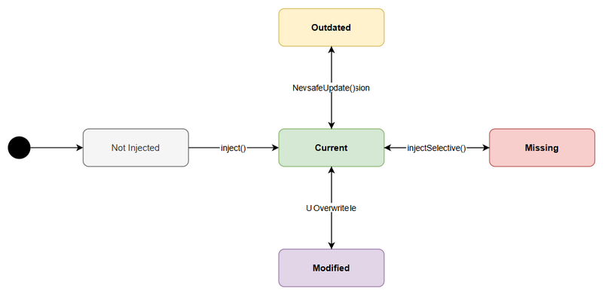
State Diagram — File Lifecycle
File States: - Not Injected → Initial state before extension injects files - Current → File matches bundled version and hash - Outdated → Bundled version is newer than workspace version - Modified → User changed file content (hash mismatch) - Missing → File tracked in manifest but deleted from disk
Transitions: - Not Injected → Current: inject() - Current → Outdated: Extension updates (new bundled version) - Current → Modified: User edits file - Current → Missing: User deletes file - Outdated → Current: safeUpdate() applied - Modified → Current: User selects “Overwrite” during update - Missing → Current: injectSelective() or safeUpdate()

11. Sequence Diagrams

11.1 Activation & Upgrade Check
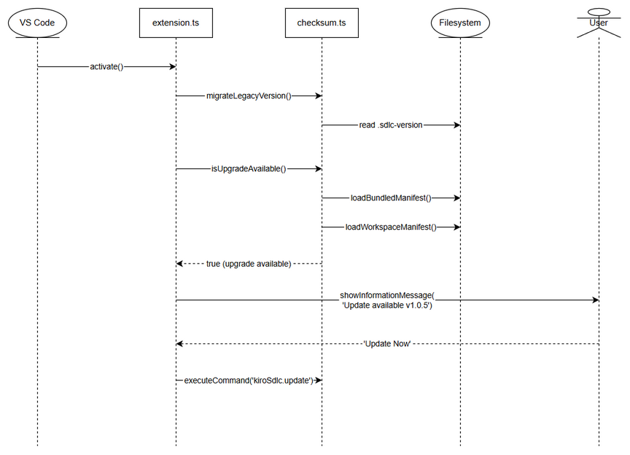
Sequence — Activation

11.2 Safe Update Flow
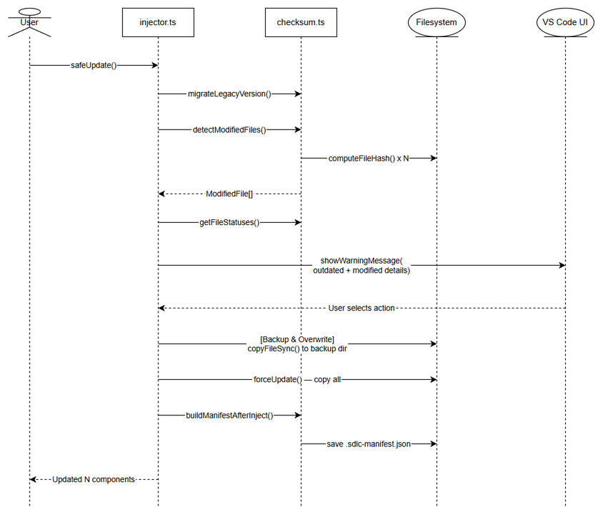
Sequence — Safe Update

12. Appendix

Diagram Index
# | Diagram | Image | Source (editable)
1 | System Context | system-context.png | system-context.drawio
2 | State — File Lifecycle | state-file-lifecycle.png | state-file-lifecycle.drawio
3 | Sequence — Activation | sequence-activation.png | sequence-activation.drawio
4 | Sequence — Safe Update | sequence-safe-update.png | sequence-safe-update.drawio

