Technical Design Document (TDD)

Kiro SDLC Agents — KSA-12: Release v1.0.1 — Checksum management, CI/CD fixes, sync tooling

Document Information
Field | Value
Jira Ticket | KSA-12
Title | Release v1.0.1 — Checksum management, CI/CD fixes, sync tooling
Author | SA Agent
Version | 1.0
Date | 2026-05-10
Status | Draft
Related BRD | BRD-v1-KSA-12.docx
Related FSD | FSD-v1-KSA-12.docx

Revision History
Version | Date | Author | Changes
1.0 | 2026-05-10 | SA Agent | Initiate document from BRD and FSD

1. Introduction

1.1 Purpose
This TDD specifies the technical implementation of three subsystems for Kiro SDLC Agents v1.0.1: 1. Checksum Management — TypeScript module for SHA-256 integrity tracking 2. CI/CD Workflows — GitHub Actions YAML configurations 3. Sync Tooling — PowerShell script for cross-repository synchronization

1.2 Scope
- src/checksum.ts — hash computation, manifest I/O, file status detection
- src/injector.ts — safe update logic with backup/skip/overwrite strategies
- src/extension.ts — VS Code command registration and UX orchestration
- scripts/gen-checksums.js — CI-time manifest generation
- scripts/sync-from-source.ps1 — cross-repo file sync
- .github/workflows/ci.yml — CI build pipeline
- .github/workflows/publish.yml — publish pipeline

1.3 Technology Stack
Layer | Technology | Version
Language | TypeScript | 5.x
Runtime | Node.js | 20+
Platform | VS Code Extension API | 1.85+
Build Tool | npm + tsc | —
CI/CD | GitHub Actions | v4 actions
Scripting | PowerShell | 5.1+
Hashing | Node.js crypto (SHA-256) | Built-in

1.4 Design Principles
- Single Responsibility — Each module handles one concern (checksum.ts = hashing, injector.ts = file operations)
- Immutable Bundled Manifest — Shipped inside VSIX, cannot be tampered with
- Git as Source of Truth — gen-checksums reads from git HEAD, not filesystem
- Graceful Degradation — Missing/corrupted manifests don’t crash the extension
- Idempotent Operations — Running inject/update multiple times produces same result

1.5 Constraints
- Extension must work offline (no network calls for checksum operations)
- Maximum 500ms overhead on extension activation for ~50 tracked files
- gen-checksums.js must use Node.js stdlib only (no external dependencies)
- sync-from-source.ps1 must use PowerShell built-in cmdlets only

1.6 References
Document | Location
BRD | BRD-v1-KSA-12.docx
FSD | FSD-v1-KSA-12.docx

2. System Architecture

2.1 Architecture Overview
The system follows a layered architecture within the VS Code extension:
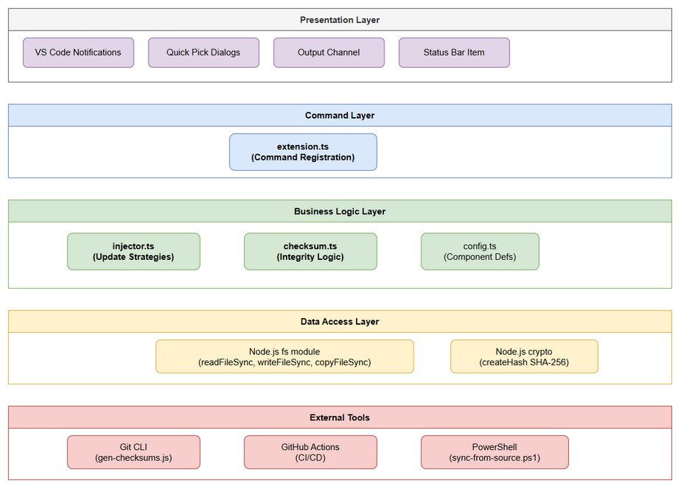
Architecture Diagram
Layers: 1. Presentation Layer — VS Code UI (notifications, quick picks, output channels, status bar) 2. Command Layer — extension.ts registers commands and orchestrates workflows 3. Business Logic Layer — injector.ts (update strategies), checksum.ts (integrity logic) 4. Data Access Layer — Direct filesystem I/O via Node.js fs module 5. External Tools — Git CLI (for gen-checksums), PowerShell (for sync)

2.2 Component Diagram
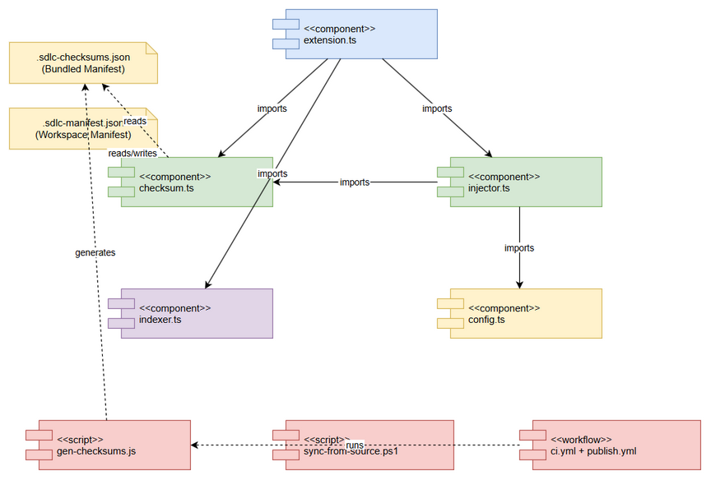
Component Diagram
Component | Responsibility | Technology
extension.ts | Command registration, UX orchestration, status bar | VS Code API
checksum.ts | Hash computation, manifest load/save, status detection | Node.js crypto
injector.ts | File injection, safe update, backup, filtered copy | Node.js fs
config.ts | Component definitions, paths, labels | TypeScript constants
indexer.ts | Code intelligence indexer execution | Child process
gen-checksums.js | CI manifest generation from git | Node.js + git CLI
sync-from-source.ps1 | Cross-repo file sync | PowerShell

2.3 Deployment Architecture
The extension is packaged as a VSIX and distributed via: - VS Code Marketplace (vsce publish) - Open VSX Registry (ovsx publish)
Runtime deployment: - Extension runs inside VS Code Extension Host process - No separate server or container needed - All data stored in workspace filesystem

2.4 Communication Patterns
From | To | Protocol | Pattern | Description
extension.ts | checksum.ts | Function call | Sync | Direct module import
extension.ts | injector.ts | Function call | Async | Async for UI interactions
gen-checksums.js | Git CLI | Child process | Sync | execSync for git commands
sync-from-source.ps1 | Filesystem | PowerShell cmdlets | Sync | Get-FileHash, Copy-Item
GitHub Actions | npm scripts | Shell | Sync | Sequential CI steps

3. Module Design
Note: This extension has no REST APIs. This section covers the internal module interfaces.

3.1 Module: checksum.ts
Exports:
Function | Signature | Description
computeFileHash | (filePath: string) => string | SHA-256 hex digest of file
loadBundledManifest | (extensionPath: string) => ChecksumManifest \| null | Load from resources/
loadWorkspaceManifest | (workspaceRoot: string) => WorkspaceManifest \| null | Load from .kiro/
saveWorkspaceManifest | (workspaceRoot: string, manifest: WorkspaceManifest) => void | Save to .kiro/
recordFileInjected | (manifest, relativePath, version, hash) => void | Record injection
getFileStatuses | (workspaceRoot, extensionPath) => FileStatus[] | Compute all statuses
detectModifiedFiles | (workspaceRoot, extensionPath) => ModifiedFile[] | Find hash mismatches
isUpgradeAvailable | (workspaceRoot, extensionPath) => boolean | Any file newer?
migrateLegacyVersion | (workspaceRoot, extensionPath) => void | Migrate .sdlc-version
buildManifestAfterInject | (workspaceRoot, extensionPath) => void | Rebuild manifest
Interfaces:
interface ChecksumManifest {
version: string;
generatedAt: string;
files: Record<string, FileChecksum>;
}
interface FileChecksum {
hash: string; // SHA-256 hex (64 chars)
version: string; // semver
injectedAt: string; // ISO 8601
}
interface WorkspaceManifest {
lastUpdated: string;
files: Record<string, WorkspaceFileEntry>;
}
interface WorkspaceFileEntry {
version: string;
hash: string;
injectedAt: string;
}
interface FileStatus {
relativePath: string;
workspaceVersion: string;
bundledVersion: string;
state: "current" | "outdated" | "modified" | "missing";
}
interface ModifiedFile {
relativePath: string;
expectedHash: string;
actualHash: string;
injectedVersion: string;
}

3.2 Module: injector.ts
Exports:
Function | Signature | Description
injectAll | (root, extensionPath) => Promise<string[]> | Inject all components
injectSelective | (root, extensionPath) => Promise<string[]> | User picks components
safeUpdate | (root, extensionPath) => Promise<string[]> | Update with safety
checkStatus | (workspaceRoot) => Record<string, boolean> | Component existence
getVersionReport | (root, extensionPath) => string | Detailed version report
Update Strategies:
Strategy | Function | Behavior
Force Update | forceUpdate() | Overwrite all files, rebuild manifest
Skip Modified | updateSkipModified() | Skip files in ModifiedFile set
Backup & Overwrite | updateWithBackup() | Copy to .kiro/.sdlc-backup/{timestamp}/, then force

3.3 Module: gen-checksums.js
Algorithm: 1. Read package.json → extract version 2. git ls-tree -r --name-only HEAD -- {RESOURCE_PATHS} → file list 3. For each file: git show HEAD:{path} → SHA-256 4. Write JSON manifest to resources/.sdlc-checksums.json
Tracked Paths (RESOURCE_PATHS): - .kiro/agents/ - .kiro/hooks/ - .kiro/steering/ - documents/templates/ - .analysis/code-intelligence/index-config.json

3.4 Module: sync-from-source.ps1
Parameters: - -DryRun (switch) — preview mode
Configuration (hardcoded): - SOURCE_ROOT: C:\projects\kotlin\MCPOrchestration - DEST_ROOT: C:\projects\kiro\FEC_CR_Builder - MAPPINGS: 3 source→dest pairs - SKIP_DIRS: settings, node_modules, pycache, out, dist, .git - SKIP_FILES: mcp.json, mcp.json,bk
Algorithm:
for each mapping:
enumerate source files recursively
for each file:
if path matches skip pattern → skip
if not exists in dest → copy (NEW)
else if MD5(src) != MD5(dest) → overwrite (CHANGED)
else → skip (unchanged)
print summary

4. Data Storage Design

4.1 File Locations
File | Location | Created By | Read By
Bundled Manifest | {extensionPath}/resources/.sdlc-checksums.json | gen-checksums.js (CI) | checksum.ts
Workspace Manifest | {workspaceRoot}/.kiro/.sdlc-manifest.json | injector.ts | checksum.ts
Legacy Version | {workspaceRoot}/.kiro/.sdlc-version | (deprecated) | checksum.ts (migration)
Backup Files | {workspaceRoot}/.kiro/.sdlc-backup/{timestamp}/ | injector.ts | User (manual recovery)

4.2 JSON Schemas
Bundled Manifest Schema:
{
"version": "1.0.5",
"generatedAt": "2026-05-10T04:22:47.128Z",
"files": {
".kiro/agents/ba-agent.md": {
"hash": "4b35262c5de6e127b6b4dd6f1ff2d42fec3b6c819d341b9f1207580fea22d3e4",
"version": "1.0.5",
"injectedAt": "2026-05-10T04:22:47.128Z"
}
}
}
Workspace Manifest Schema:
{
"lastUpdated": "2026-05-10T04:30:00.000Z",
"files": {
".kiro/agents/ba-agent.md": {
"version": "1.0.5",
"hash": "4b35262c5de6e127b6b4dd6f1ff2d42fec3b6c819d341b9f1207580fea22d3e4",
"injectedAt": "2026-05-10T04:30:00.000Z"
}
}
}

5. CI/CD Pipeline Design

5.1 CI Workflow (ci.yml)
Trigger: Push to main OR PR targeting main, with paths: kiro-sdlc-agents/**
Steps:
jobs:
build:
runs-on: ubuntu-latest
defaults:
run:
working-directory: kiro-sdlc-agents
steps:
- actions/checkout@v4
- actions/setup-node@v4 (node 20)
- npm ci
- npm run copy-resources
- npm run gen-checksums
- npm run compile
- npx vsce package --no-dependencies
- verify *.vsix exists

5.2 Publish Workflow (publish.yml)
Trigger: Tag v* OR manual dispatch (target: both/vscode-only/openvsx-only)
Jobs: 1. build — same as CI + upload VSIX artifact 2. publish-vscode — download artifact → npx vsce publish --packagePath *.vsix -p $VSCE_PAT 3. publish-openvsx — download artifact → npx ovsx publish *.vsix -p $OVSX_TOKEN
Conditional execution: - publish-vscode: runs if tag push OR target=both OR target=vscode-only - publish-openvsx: runs if tag push OR target=both OR target=openvsx-only

5.3 Key Design Decisions
Decision | Rationale
Workflows at repo root | GitHub requires .github/workflows/ at repo root
working-directory directive | Extension code is in subdirectory
paths filter | Avoid triggering on non-extension changes
--no-dependencies flag | Extension has no runtime npm dependencies
Separate build + publish jobs | Build once, publish to multiple targets
Artifact upload between jobs | Ensures same VSIX is published everywhere

6. Security Design

6.1 Secrets Management
Secret | Storage | Usage | Rotation
VSCE_PAT | GitHub Secrets | VS Code Marketplace publish | Per PAT expiry
OVSX_TOKEN | GitHub Secrets | Open VSX publish | Per token expiry

6.2 Integrity Guarantees
Guarantee | Mechanism
Bundled manifest tamper-proof | Stored inside VSIX (signed package)
Hash reproducibility | gen-checksums reads git HEAD, not filesystem
No secret exposure | GitHub Actions masks secrets in logs

6.3 Input Validation
Input | Validation | Location
Manifest JSON | try/catch on JSON.parse, return null on failure | checksum.ts
File paths | path.join (prevents traversal), existsSync check | checksum.ts, injector.ts
Git output | trim + split, filter empty lines | gen-checksums.js

7. Error Handling Design

7.1 Error Recovery Matrix
Error | Component | Recovery | User Impact
Bundled manifest missing | checksum.ts | Return null/empty | Checksum features disabled
Workspace manifest corrupted | checksum.ts | Return null, rebuild on next inject | Temporary loss of modification detection
File read permission denied | checksum.ts | Skip file, continue | File shows as “missing”
Injection source not found | injector.ts | Show warning, skip component | Component not injected
Injection copy fails | injector.ts | Show error, continue with others | Partial injection
Git not available | gen-checksums.js | Script exits with error | CI build fails (expected)
Source repo not found | sync-from-source.ps1 | Print “SKIP”, continue | Mapping skipped

7.2 Logging Strategy
Event | Level | Output
Manifest loaded | (silent) | —
Upgrade available | Info | VS Code notification
Migration completed | (silent) | —
Injection success | Info | VS Code notification
Injection failure | Error | VS Code error message
gen-checksums success | Console | stdout (CI logs)
gen-checksums skip file | Warn | console.warn
Sync new/changed | Console | colored stdout

8. Performance Considerations

8.1 Activation Performance
Operation | Expected Time | Optimization
Load bundled manifest (JSON parse) | < 5ms | Single file read
Load workspace manifest (JSON parse) | < 5ms | Single file read
Compute hashes for 50 files | < 400ms | Synchronous, sequential
Total activation overhead | < 500ms | No async I/O needed

8.2 gen-checksums Performance
Operation | Expected Time | Notes
git ls-tree | < 100ms | Single git command
git show × 50 files | < 3s | Sequential, could parallelize
JSON write | < 10ms | Single file
Total | < 5s | Acceptable for CI

9. Implementation Checklist

Files to Create/Modify
# | File | Action | Description
1 | src/checksum.ts | CREATE | Checksum management module
2 | src/injector.ts | MODIFY | Add safe update logic, backup strategy
3 | src/extension.ts | MODIFY | Add update command, upgrade check on activation
4 | src/config.ts | MODIFY | Add component definitions if needed
5 | scripts/gen-checksums.js | CREATE | CI manifest generation script
6 | scripts/sync-from-source.ps1 | CREATE | Cross-repo sync script (repo root)
7 | .github/workflows/ci.yml | CREATE | CI workflow at repo root
8 | .github/workflows/publish.yml | CREATE | Publish workflow at repo root
9 | package.json | MODIFY | Add gen-checksums to prepublish, bump version
10 | resources/.sdlc-checksums.json | GENERATED | Output of gen-checksums

Implementation Order
- src/checksum.ts — core hashing and manifest logic (no dependencies)
- src/injector.ts — update strategies using checksum module
- src/extension.ts — wire up commands and activation check
- scripts/gen-checksums.js — CI script
- package.json — add scripts, bump version
- .github/workflows/ — CI and publish workflows
- scripts/sync-from-source.ps1 — sync tooling (independent)
- Test: run gen-checksums locally, verify manifest
- Test: install extension, verify activation check works

10. Appendix

Diagram Index
# | Diagram | Image | Source (editable)
1 | Architecture Overview | architecture.png | architecture.drawio
2 | Component Diagram | component.png | component.drawio

