Functional Specification Document (FSD)

Kiro SDLC Agents — KSA-13: Release v1.0.3 — SM agent project-level workflow + jira.conf management

Document Information
Field | Value
Jira Ticket | KSA-13
Title | Release v1.0.3 — SM agent project-level workflow + jira.conf management
Author | BA Agent + TA Agent
Version | 1.0
Date | 2026-05-10
Status | Draft
Related BRD | BRD-v1-KSA-13.docx

Revision History
Version | Date | Author | Changes
1.0 | 2026-05-10 | BA Agent | Initial FSD — business sections
1.0 | 2026-05-10 | TA Agent | Technical enrichment — API contracts, integration specs

1. Introduction

1.1 Purpose
This FSD specifies the functional behavior of the SM agent’s new project-level workflow and jira.conf management features introduced in Release v1.0.3. It provides sufficient detail for the SA agent to create a Technical Design Document (TDD) and for the DEV agent to implement the changes.

1.2 Scope
- Input parsing logic to distinguish ticket-level vs project-level commands
- jira.conf file management (create, read, update with user confirmation)
- Project-level ticket querying and status display
- SM agent prompt updates across 4 locations

1.3 References
Document | Location
BRD | documents/KSA-13/BRD.md
SM Agent Prompt (source) | kiro-sdlc-agents/resources/.kiro/agents/scrum-master-agent.md
Sync Script | scripts/sync-from-source.ps1

2. System Context

2.1 System Context Diagram
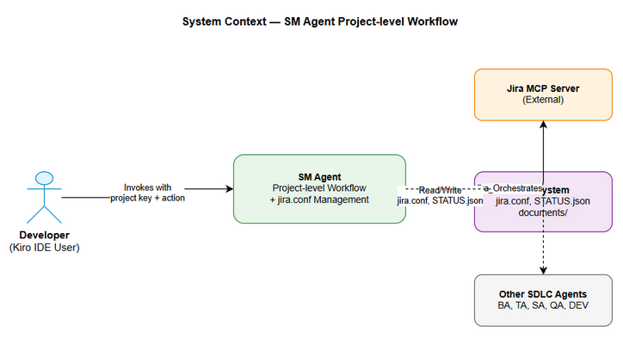
System Context

2.2 Actors
Actor | Type | Description
Developer | Human | Invokes SM agent via Kiro IDE
SM Agent | System | Orchestrates SDLC pipeline, manages project context
Jira MCP Server | External System | Provides Jira ticket data via MCP protocol
File System | System | Stores jira.conf, STATUS.json, documents

2.3 System Boundaries
The SM agent operates within the Kiro IDE extension context. It communicates with: - Jira MCP Server (read tickets, transitions) - Local file system (jira.conf, documents/, STATUS.json) - Other SDLC agents (BA, TA, SA, QA, DEV, DevOps)

3. Functional Requirements

3.1 Use Case: UC-01 — Parse Input (Ticket vs Project Level)
Field | Value
ID | UC-01
Name | Parse Input
Actor | Developer
Precondition | SM agent is invoked with text input
Postcondition | Input classified as ticket-level or project-level

Main Flow
Step | Actor | Action
1 | Developer | Provides input text to SM agent
2 | SM Agent | Applies regex ^([A-Z][A-Z0-9_]+)-(\d+)(.*)$ to input
3 | SM Agent | If matches → classify as ticket-level, extract ticket key + action
4 | SM Agent | If no match → apply regex ^([A-Z][A-Z0-9_]+)\s+(.+)$
5 | SM Agent | If matches → classify as project-level, extract project key + action
6 | SM Agent | Route to appropriate handler

Alternative Flow
Step | Condition | Action
4a | Input matches neither pattern | Report error: “Input không hợp lệ. Vui lòng cung cấp ticket key (VD: KSA-13) hoặc project key + action (VD: KSA workflow)”

Exception Flow
Step | Condition | Action
2a | Input is empty or null | Report: “Vui lòng cung cấp ticket key hoặc project key”

Business Rules
ID | Rule | Description
BR-01 | Ticket pattern | [A-Z][A-Z0-9_]+-\d+ (e.g., KSA-13, COLLEX-64)
BR-02 | Project pattern | [A-Z][A-Z0-9_]+ followed by whitespace + action keyword
BR-03 | Action keywords | workflow, quy trình, status, tạo tài liệu đầy đủ
BR-04 | Case sensitivity | Project key must be uppercase

3.2 Use Case: UC-02 — Manage jira.conf
Field | Value
ID | UC-02
Name | Manage jira.conf
Actor | SM Agent (triggered by project-level input)
Precondition | Input classified as project-level
Postcondition | jira.conf exists with correct project prefix

Main Flow
Step | Actor | Action
1 | SM Agent | Check if jira.conf exists at workspace root
2 | SM Agent | If exists → read file, extract JIRA_PROJECT_PREFIX value
3 | SM Agent | Compare extracted prefix with input project key
4 | SM Agent | If match → proceed to UC-03 (Query Project)
5 | SM Agent | If no match → execute Alternative Flow (conflict resolution)

Alternative Flow — File Does Not Exist
Step | Condition | Action
1a | jira.conf not found | Create jira.conf with comment header + JIRA_PROJECT_PREFIX={input_key}
1b |  | Proceed to UC-03

Alternative Flow — Project Key Conflict
Step | Condition | Action
5a | Keys differ | Display warning: “⚠️ jira.conf hiện tại có JIRA_PROJECT_PREFIX={old_key}. Bạn muốn đổi sang {new_key}?”
5b |  | Present options: 1) Switch, 2) Keep current
5c | User selects 1 | Update jira.conf with new key, proceed to UC-03
5d | User selects 2 | Cancel current command, report cancellation

Business Rules
ID | Rule | Description
BR-05 | File location | {workspace_root}/jira.conf
BR-06 | File format | Comment lines start with #, config line: KEY=VALUE
BR-07 | Single value | Only JIRA_PROJECT_PREFIX allowed, no other keys
BR-08 | No sensitive data | Must not contain URLs, tokens, passwords
BR-09 | Prefix validation | Value must match [A-Z][A-Z0-9_]+

Data Specification
jira.conf file format:
# Jira Configuration
# Used by SM agent to identify project scope
JIRA_PROJECT_PREFIX={PROJECT_KEY}

3.3 Use Case: UC-03 — Query Project Tickets
Field | Value
ID | UC-03
Name | Query Project Tickets
Actor | SM Agent
Precondition | jira.conf valid, project key confirmed
Postcondition | Project overview displayed to user

Main Flow
Step | Actor | Action
1 | SM Agent | Construct JQL: project = "{KEY}" ORDER BY key ASC
2 | SM Agent | Call Jira MCP: jira_search(jql, limit=50)
3 | SM Agent | For each ticket, check documents/{TICKET}/STATUS.json
4 | SM Agent | If STATUS.json missing, scan for existing files (BRD.md, FSD.md, TDD.md)
5 | SM Agent | Build overview table with columns: Ticket, Summary, Jira Status, Docs Status
6 | SM Agent | Display table to user
7 | SM Agent | If action = workflow → propose next actions with numbered options
8 | SM Agent | If action = status → display table only, no proposals

Alternative Flow — Jira Unavailable
Step | Condition | Action
2a | Jira MCP returns error | Report: “⚠️ Không thể kết nối Jira. Hiển thị status từ local files.”
2b |  | Scan documents/ directory for all {KEY}-* folders
2c |  | Display local-only status (no Jira status column)

Business Rules
ID | Rule | Description
BR-10 | Query limit | Maximum 50 tickets per query
BR-11 | Sort order | Tickets sorted by key ASC
BR-12 | Docs status logic | Complete = BRD+FSD+TDD exist; Partial = some exist; No docs = none exist
BR-13 | Status display | Use emoji indicators: ✅ Complete, 🔄 Partial, ❌ No docs

3.3.5 API Contract — Jira Search
Request:
Tool: jira_search
Parameters:
jql: "project = \"{KEY}\" ORDER BY key ASC"
limit: 50
fields: "summary,status,issuetype,labels,priority"
Response (expected structure):
{
"issues": [
{
"key": "KSA-1",
"fields": {
"summary": "Epic: Kiro SDLC Agents Extension",
"status": { "name": "In Progress" },
"issuetype": { "name": "Epic" },
"labels": ["release"],
"priority": { "name": "High" }
}
}
],
"total": 14,
"maxResults": 50
}

3.4 Use Case: UC-04 — Display Project Overview
Field | Value
ID | UC-04
Name | Display Project Overview
Actor | SM Agent
Precondition | Ticket data retrieved (from Jira or local)
Postcondition | User sees formatted overview and options

Main Flow
Step | Actor | Action
1 | SM Agent | Format overview header: “📊 Project {KEY} — Tổng quan”
2 | SM Agent | Render table with ticket data
3 | SM Agent | Calculate summary: total tickets, with docs, without docs
4 | SM Agent | Display summary section
5 | SM Agent | If action = workflow → display action options
6 | Developer | Selects an option (1, 2, or 3)
7 | SM Agent | Execute selected action

UI Specification — Overview Output
📊 Project {KEY} — Tổng quan
| Ticket | Summary | Jira Status | Docs Status |
|--------|---------|-------------|-------------|
| KSA-1 | Epic... | In Progress | ✅ Complete |
| KSA-2 | Core... | To Do | ❌ No docs |
📋 Tóm tắt:
- Tổng: {N} tickets
- Có tài liệu: {M} tickets
- Chưa có tài liệu: {N-M} tickets
Bạn muốn làm gì?
1. Tạo tài liệu cho ticket cụ thể (chọn ticket)
2. Tạo tài liệu đầy đủ cho tất cả tickets (batch)
3. Chỉ xem status

3.5 Use Case: UC-05 — SM Prompt Synchronization
Field | Value
ID | UC-05
Name | SM Prompt Synchronization
Actor | Developer (manual trigger)
Precondition | SM prompt source file updated
Postcondition | All 4 locations have identical SM prompt

Main Flow
Step | Actor | Action
1 | Developer | Updates SM prompt in source location
2 | Developer | Runs scripts/sync-from-source.ps1
3 | Script | Reads source SM prompt
4 | Script | Copies to 3 other locations (agents, prompts, bundled resources)
5 | Script | Reports sync status

4 SM Prompt Locations
# | Location | Purpose
1 | .kiro/agents/sm-agent.md | Active agent in workspace (source of truth)
2 | .kiro/agents/prompts/sm-agent.md | Prompt library (synced)
3 | kiro-sdlc-agents/resources/.kiro/agents/sm-agent.md | Bundled in VSIX
4 | kiro-sdlc-agents/resources/.kiro/agents/prompts/sm-agent.md | Bundled prompt library

4. State Diagram

4.1 jira.conf State Machine
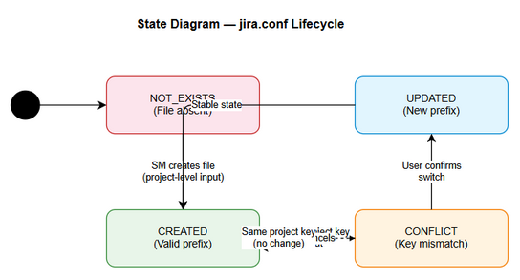
State Diagram
State | Description | Transitions
NOT_EXISTS | jira.conf file does not exist | → CREATED (on project-level input)
CREATED | File exists with valid prefix | → CONFLICT (on different project input)
CONFLICT | Input key differs from file key | → UPDATED (user confirms) / → CREATED (user cancels)
UPDATED | File updated with new prefix | → CREATED (stable state)

5. Integration Requirements

5.1 Jira MCP Server Integration
Aspect | Specification
Protocol | MCP (Model Context Protocol)
Tool | jira_search
Authentication | Handled by MCP server configuration (external to SM agent)
Rate Limiting | N/A (single query per invocation)
Error Handling | Graceful fallback to local file scan

5.2 File System Integration
Operation | Path | Format
Read/Write jira.conf | {workspace_root}/jira.conf | Plain text (KEY=VALUE)
Read STATUS.json | documents/{TICKET}/STATUS.json | JSON
Scan documents | documents/{TICKET}/ | Directory listing

6. Non-Functional Requirements
Category | Requirement | Target
Performance | Project query + display | < 5 seconds for ≤50 tickets
Reliability | Jira unavailable fallback | Local file scan within 2 seconds
Usability | Vietnamese language | All user-facing messages in Vietnamese
Compatibility | Existing commands | Ticket-level commands unchanged
Security | No secrets in jira.conf | Only project prefix stored

7. Error Handling
Error Code | Condition | User Message | Recovery
ERR-01 | Invalid input format | “Input không hợp lệ…” | Show usage examples
ERR-02 | Jira MCP unavailable | “⚠️ Không thể kết nối Jira…” | Fallback to local scan
ERR-03 | jira.conf parse error | “⚠️ jira.conf format không hợp lệ…” | Offer to recreate
ERR-04 | No tickets found | “Project {KEY} không có tickets nào” | Verify project key
ERR-05 | File write permission | “Không thể ghi jira.conf…” | Report error, suggest manual fix

8. Open Issues
# | Issue | Status | Owner
1 | Should SM support multiple project prefixes in jira.conf? | Deferred to v1.1 | PO
2 | Should jira.conf be in .gitignore by default? | To discuss | Dev team

9. Appendix

9.1 Sequence Diagram — Project-level Workflow
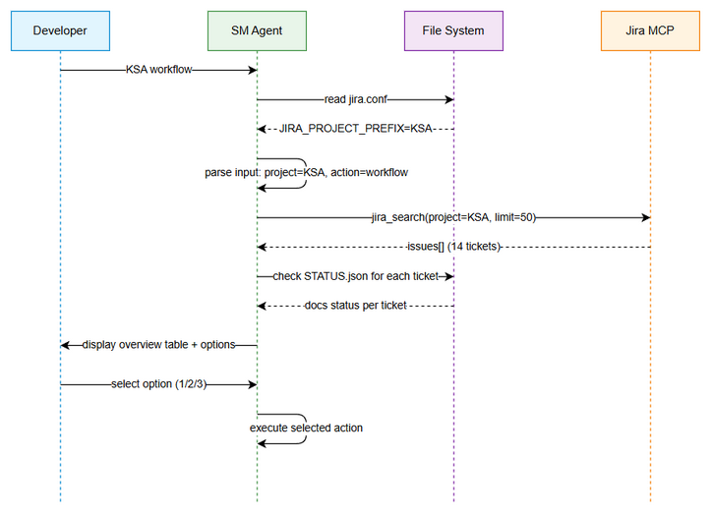
Sequence Diagram

9.2 Diagram Index
# | Diagram | Image | Source (editable)
1 | System Context | system-context.png | system-context.drawio
2 | Sequence — Project Workflow | sequence-project-workflow.png | sequence-project-workflow.drawio
3 | State — jira.conf | state-jira-conf.png | state-jira-conf.drawio

