Functional Specification Document (FSD)

Kiro SDLC Agents Extension — KSA-14: Release v1.0.5 — Fix inject overwrite bug + per-file version tracking

Document Information
Field | Value
Jira Ticket | KSA-14
Title | Release v1.0.5 — Fix inject overwrite bug + per-file version tracking
Author | BA Agent + TA Agent
Version | 1.0
Date | 2026-05-10
Status | Draft
Related BRD | BRD-v1-KSA-14.docx

Revision History
Version | Date | Author | Changes
1.0 | 2026-05-10 | BA Agent | Initiate document from BRD KSA-14
1.0 | 2026-05-10 | TA Agent | Enriched with API contracts, technical details

1. Introduction

1.1 Purpose
This FSD specifies the functional behavior of the Kiro SDLC Agents VS Code extension for releases v1.0.4 and v1.0.5. It details the fix for the inject overwrite bug and the new per-file version tracking system.

1.2 Scope
- Fix detectModifiedFiles to remove version-gating logic
- Implement per-file workspace manifest (.kiro/.sdlc-manifest.json)
- Implement safeUpdate with smart overwrite logic
- Implement getVersionReport for per-file status display
- Implement migrateLegacyVersion for backward compatibility

1.3 Definitions & Acronyms
Term | Definition
Workspace Manifest | .kiro/.sdlc-manifest.json — JSON file tracking per-file version/hash
Bundled Manifest | resources/.sdlc-checksums.json — expected file hashes shipped with extension
Inject | Copy bundled resource files into user’s workspace
Safe Update | Update that auto-overwrites outdated files, prompts for user-modified files
Hash | SHA-256 digest of file content

1.4 References
Document | Location
BRD | BRD-v1-KSA-14.docx
VS Code Extension API | https://code.visualstudio.com/api

2. System Overview

2.1 System Context Diagram
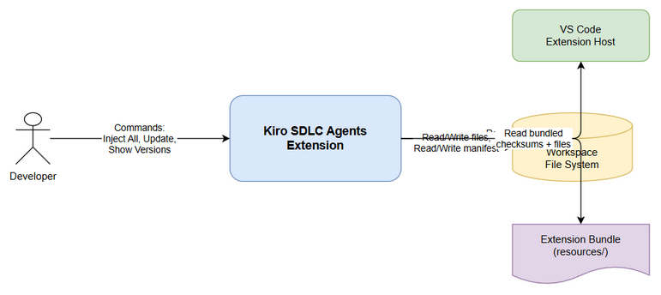
System Context
The extension operates within VS Code, interacting with: - User — triggers commands via Command Palette - Workspace File System — reads/writes agent files and manifest - Extension Bundle — contains bundled resources and checksums manifest

2.2 System Architecture
The extension consists of three core modules: 1. extension.ts — VS Code command registration and UI interaction 2. checksum.ts — Per-file version tracking, hash computation, manifest management 3. injector.ts — File injection logic, safe update, version report generation

3. Functional Requirements

3.1 Feature: Fix Inject Overwrite Bug (v1.0.4)
Source: BRD Story 1, Story 2

3.1.1 Description
Remove version-gating logic from detectModifiedFiles() that previously skipped all file entries when the workspace version didn’t match the bundled version. The function must now compare file hashes directly regardless of version.

3.1.2 Use Case
Use Case ID: UC-01 Actor: Developer Preconditions: Extension v1.0.4+ installed; workspace has files from older version Postconditions: All bundled files are present in workspace at current version
Main Flow:
Step | Actor | System | Description
1 | Runs “Inject All” |  | Developer triggers command from palette
2 |  | Copies all bundled files | System overwrites all workspace files unconditionally
3 |  | Calls buildManifestAfterInject() | Records version + hash for each file
4 |  | Shows success notification | “✅ Injected N components”
Alternative Flows:
ID | Condition | Steps
AF-01 | User cancels confirmation dialog | No files are modified; operation aborted
Exception Flows:
ID | Condition | Steps
EF-01 | File system permission denied | Show error message; skip that file; continue with others
EF-02 | Bundled manifest missing | Show error “Extension package corrupted”; abort

3.1.3 Business Rules
Rule ID | Rule | Source
BR-01 | “Inject All” MUST overwrite all files without version comparison | BRD Story 1
BR-02 | detectModifiedFiles MUST NOT skip entries based on version mismatch | BRD Story 2
BR-03 | After any inject/update, manifest MUST be updated | BRD Story 1, 2

3.2 Feature: Safe Update with Smart Overwrite
Source: BRD Story 2

3.2.1 Description
safeUpdate() provides an intelligent update mechanism that distinguishes between outdated files (version mismatch) and user-modified files (content changed by user). It auto-overwrites when safe and prompts when user customizations are at risk.

3.2.2 Use Case
Use Case ID: UC-02 Actor: Developer Preconditions: Extension has newer bundled files than workspace Postconditions: Workspace files updated; user modifications handled per user choice
Main Flow:
Step | Actor | System | Description
1 | Runs “Update Agents” |  | Developer triggers update command
2 |  | Calls migrateLegacyVersion() | Ensures manifest format is current
3 |  | Calls detectModifiedFiles() | Finds files with hash mismatch
4 |  | Calls getFileStatuses() | Classifies: outdated vs modified
5 |  | Checks if only outdated | Decision point
6a |  | Auto-overwrites all | If no user-modified files exist
6b |  | Shows prompt | If user-modified files exist
7 | Selects action |  | “Overwrite All” / “Skip Modified” / “Backup & Overwrite”
8 |  | Executes chosen action | Updates files accordingly
9 |  | Calls buildManifestAfterInject() | Records new state
Alternative Flows:
ID | Condition | Steps
AF-02 | No files need update | Show “All files match bundled version. No update needed.”
AF-03 | User selects “Skip Modified” | Only overwrite outdated files; leave modified untouched
AF-04 | User selects “Backup & Overwrite” | Create backup copies in .kiro/.sdlc-backup/{timestamp}/, then overwrite all
Exception Flows:
ID | Condition | Steps
EF-03 | User cancels prompt | No files modified; operation aborted

3.2.3 Business Rules
Rule ID | Rule | Source
BR-04 | If only outdated files exist, auto-overwrite without prompt | BRD Story 2
BR-05 | “Overwrite All (recommended)” must be the default/first option | BRD Story 2
BR-06 | “Skip Modified” must leave user-modified files untouched | BRD Story 2
BR-07 | “Backup & Overwrite” must create backup in .kiro/.sdlc-backup/{timestamp}/ before overwriting | BRD Story 2

3.2.4 Data Specifications
File Classification States:
State | Condition | Description
current | wsVersion == bundledVersion AND hash matches | File is up-to-date
outdated | wsVersion != bundledVersion | File needs update (version mismatch)
modified | wsVersion == bundledVersion AND hash differs | User modified the file
missing | File doesn’t exist in workspace | File needs injection

3.3 Feature: Per-File Version Tracking
Source: BRD Story 3

3.3.1 Description
Replace single .kiro/.sdlc-version with per-file .kiro/.sdlc-manifest.json. Each file entry records its own version, SHA-256 hash, and injection timestamp.

3.3.2 Use Case
Use Case ID: UC-03 Actor: Developer Preconditions: Extension installed; workspace has injected files Postconditions: Version report displayed in Output Channel
Main Flow:
Step | Actor | System | Description
1 | Runs “Show File Versions” |  | Developer triggers status command
2 |  | Calls migrateLegacyVersion() | Ensures manifest format is current
3 |  | Calls getFileStatuses() | Compares workspace vs bundled
4 |  | Calls getVersionReport() | Generates formatted report
5 |  | Opens Output Channel | Displays report to user

3.3.3 Business Rules
Rule ID | Rule | Source
BR-08 | Report MUST show [v{old} → v{new}] for outdated files | BRD Story 3
BR-09 | Report MUST group files by state | BRD Story 3
BR-10 | Report header MUST show extension version and file count summary | BRD Story 3

3.3.4 Data Specifications
WorkspaceManifest Schema:
{
"lastUpdated": "2026-05-10T10:00:00.000Z",
"files": {
".kiro/agents/sm-agent.md": {
"version": "1.0.5",
"hash": "a1b2c3d4...",
"injectedAt": "2026-05-10T10:00:00.000Z"
}
}
}
ChecksumManifest (Bundled) Schema:
{
"version": "1.0.5",
"generatedAt": "2026-05-10T09:00:00.000Z",
"files": {
".kiro/agents/sm-agent.md": {
"hash": "a1b2c3d4...",
"version": "1.0.5",
"injectedAt": "2026-05-10T09:00:00.000Z"
}
}
}

3.3.5 Version Report Output Format
Extension version: 1.0.5
Files: 12 current, 3 outdated, 1 modified, 0 missing
⬆️ Outdated (need update):
.kiro/agents/sm-agent.md [v1.0.3 → v1.0.5]
.kiro/agents/ba-agent.md [v1.0.3 → v1.0.5]
.kiro/steering/drawio.md [v1.0.4 → v1.0.5]
✏️ Modified by user (same version, different content):
.kiro/agents/dev-agent.md [v1.0.5]

3.4 Feature: Legacy Migration
Source: BRD Story 4

3.4.1 Description
Auto-migrate from legacy .kiro/.sdlc-version (single version JSON) to new per-file .kiro/.sdlc-manifest.json on first extension activation after upgrade.

3.4.2 Use Case
Use Case ID: UC-04 Actor: System (automatic on activation) Preconditions: Legacy .kiro/.sdlc-version file exists Postconditions: New manifest created; legacy file deleted
Main Flow:
Step | Actor | System | Description
1 |  | Extension activates | VS Code starts extension
2 |  | Checks for legacy file | fs.existsSync(".kiro/.sdlc-version")
3 |  | Reads legacy version | Parse JSON, extract version field
4 |  | Scans workspace files | Find all files listed in bundled manifest
5 |  | Creates new manifest | Each existing file gets legacy version + current hash
6 |  | Saves new manifest | Write .kiro/.sdlc-manifest.json
7 |  | Deletes legacy file | fs.unlinkSync(".kiro/.sdlc-version")
Alternative Flows:
ID | Condition | Steps
AF-05 | No legacy file exists | No-op; function returns immediately
Exception Flows:
ID | Condition | Steps
EF-04 | Legacy file is malformed JSON | Default to version “1.0.0”; continue migration
EF-05 | Cannot write new manifest | Log error; do NOT delete legacy file

3.4.3 Business Rules
Rule ID | Rule | Source
BR-11 | Migration MUST write new manifest BEFORE deleting legacy file | BRD Risk mitigation
BR-12 | Malformed legacy file defaults to version “1.0.0” | BRD Story 4 AC-4
BR-13 | Migration is idempotent — if manifest already exists, skip | Implicit

4. Data Model

4.1 Logical Entities

Entity: WorkspaceManifest
Attribute | Type | Required | Business Rule | Description
lastUpdated | ISO DateTime | Yes | BR-03 | When manifest was last modified
files | Map<string, FileEntry> | Yes |  | Per-file tracking entries

Entity: WorkspaceFileEntry
Attribute | Type | Required | Business Rule | Description
version | SemVer string | Yes | BR-08 | Version when file was injected
hash | SHA-256 hex string | Yes | BR-02 | Hash of file content at injection time
injectedAt | ISO DateTime | Yes |  | Timestamp of injection

Entity: ChecksumManifest (Bundled)
Attribute | Type | Required | Description
version | SemVer string | Yes | Extension version
generatedAt | ISO DateTime | Yes | When manifest was generated
files | Map<string, FileChecksum> | Yes | Expected file hashes

Entity: FileStatus (Runtime)
Attribute | Type | Required | Description
relativePath | string | Yes | File path relative to workspace root
workspaceVersion | SemVer string | Yes | Version in workspace manifest
bundledVersion | SemVer string | Yes | Version in bundled manifest
state | enum | Yes | current / outdated / modified / missing
Relationships:
From Entity | To Entity | Cardinality | Description
WorkspaceManifest | WorkspaceFileEntry | 1:N | Manifest contains many file entries
ChecksumManifest | FileChecksum | 1:N | Bundled manifest contains expected hashes

5. Integration Specifications

5.1 VS Code Extension API
Attribute | Value
Purpose | Register commands, show notifications, open output channels
Direction | Outbound (extension → VS Code)
Data Format | TypeScript API calls
Frequency | On-demand (user triggers)

5.2 Node.js File System
Attribute | Value
Purpose | Read/write workspace files and manifests
Direction | Bidirectional
Data Format | UTF-8 text, JSON
Frequency | On every inject/update/status operation

5.3 Node.js Crypto
Attribute | Value
Purpose | Compute SHA-256 hashes for file integrity
Direction | Inbound (crypto → extension)
Data Format | Binary → hex string
Frequency | Once per file per operation

6. Processing Logic

6.1 detectModifiedFiles (v1.0.4 Fix)
Trigger: Called by safeUpdate() during “Update Agents” Input: workspaceRoot, extensionPath Output: Array of ModifiedFile objects
Processing Steps:
Step | Description | Error Handling
1 | Load bundled manifest | Return empty array if missing
2 | For each file in bundled manifest | Continue loop on error
3 | Check if file exists in workspace | Skip if missing
4 | Compute SHA-256 hash of workspace file | Skip on read error
5 | Compare hash with bundled hash | —
6 | If different → add to modified list | —
Key Change (v1.0.4): Step 2 no longer checks workspace version against bundled version. Previously, a version mismatch caused ALL entries to be skipped.

6.2 safeUpdate Decision Logic
Trigger: User runs “Update Agents” command Input: workspaceRoot, extensionPath Output: List of updated component IDs
Pseudocode:
function safeUpdate(root, extensionPath):
migrateLegacyVersion(root, extensionPath)
modified = detectModifiedFiles(root, extensionPath)
if modified.length == 0:
show "No update needed"
return []
statuses = getFileStatuses(root, extensionPath)
outdated = statuses.filter(s => s.state == "outdated")
userModified = statuses.filter(s => s.state == "modified")
if outdated.length > 0 AND userModified.length == 0:
return forceUpdate(root, extensionPath) // Auto-overwrite
action = promptUpdateWithDetails(outdated, userModified)
switch action:
"overwrite": return forceUpdate(root, extensionPath)
"skip": return updateSkipModified(root, extensionPath, modified)
"backup": return updateWithBackup(root, extensionPath, modified)
"cancel": return []

6.3 buildManifestAfterInject
Trigger: After any successful inject or update Input: workspaceRoot, extensionPath Output: Updated .kiro/.sdlc-manifest.json
Processing Steps:
Step | Description | Error Handling
1 | Load bundled manifest | Return if missing
2 | Create empty WorkspaceManifest | —
3 | For each file in bundled manifest | —
4 | Check if file exists in workspace | Skip if missing
5 | Record: version from bundled, hash computed from file, current timestamp | —
6 | Save manifest to .kiro/.sdlc-manifest.json | Log error on write failure

7. Security Requirements

7.1 Authentication & Authorization
Not applicable — extension operates locally within user’s VS Code instance. No network calls, no authentication required.

7.2 Data Sensitivity
Data Type | Classification | Business Requirement
File hashes | Internal | Used only for integrity comparison; not sensitive
File content | User-controlled | Extension reads but does not transmit file content
Manifest JSON | Internal | Local tracking only; no PII

8. Non-Functional Requirements
Category | Business Requirement | Acceptance Criteria
Performance | Hash computation must not block UI | < 100ms per file; files are < 50KB
Reliability | Migration must not lose data | Write new manifest before deleting legacy
Compatibility | Works with VS Code 1.85+ | Tested on minimum supported version
Usability | Version report is scannable | Grouped by state, shows version arrows

9. Error Handling (User-Facing)

9.1 Error Scenarios
Scenario | Severity | User Message | Expected Behavior
Bundled manifest missing | Critical | “Extension package may be corrupted” | Abort operation
File permission denied | Warning | “Could not update {file}: permission denied” | Skip file, continue
Legacy file malformed | Info | (silent) | Default to version “1.0.0”, continue migration
No workspace open | Warning | “No workspace folder open” | Abort with message

10. Testing Considerations

10.1 Test Scenarios
ID | Scenario | Input | Expected Output | Priority
TC-01 | Inject All overwrites older files | Workspace with v1.0.3 files | All files at v1.0.5 | High
TC-02 | Inject All overwrites modified files | Workspace with user-edited files | All files overwritten | High
TC-03 | Safe Update auto-overwrites outdated only | 3 outdated, 0 modified | All 3 updated, no prompt | High
TC-04 | Safe Update prompts for modified | 2 outdated, 1 modified | Prompt shown | High
TC-05 | Skip Modified leaves modified untouched | User selects “Skip Modified” | Modified file unchanged | High
TC-06 | Backup creates .bak files | User selects “Backup & Overwrite” | .bak files created | Medium
TC-07 | Version report shows outdated | 3 outdated files | Report shows [vOld → vNew] | Medium
TC-08 | Legacy migration creates manifest | .sdlc-version exists | .sdlc-manifest.json created | High
TC-09 | Legacy migration deletes old file | After successful migration | .sdlc-version deleted | High
TC-10 | Malformed legacy defaults to 1.0.0 | Invalid JSON in .sdlc-version | Version “1.0.0” used | Medium

11. Appendix

State Diagram — File Lifecycle
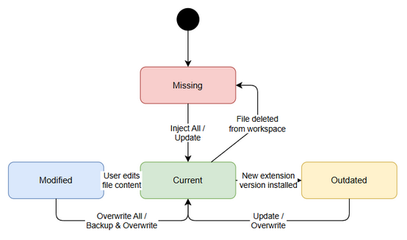
State Diagram

Sequence Diagram — Safe Update Flow
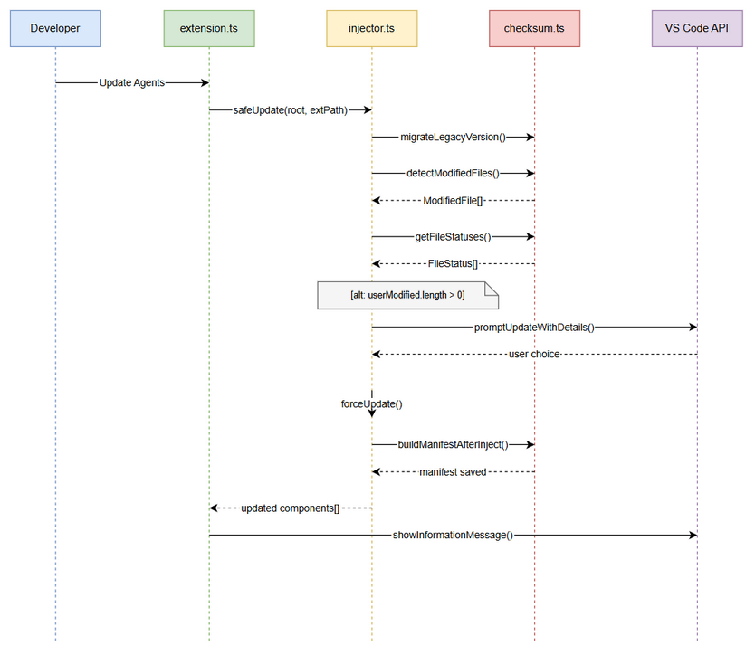
Sequence Diagram

Diagram Index
# | Diagram | Image | Source (editable)
1 | System Context | system-context.png | system-context.drawio
2 | Sequence — Safe Update | sequence-safe-update.png | sequence-safe-update.drawio
3 | State — File Lifecycle | state-file-lifecycle.png | state-file-lifecycle.drawio

