Technical Design Document (TDD)

Kiro SDLC Agents Extension — KSA-14: Release v1.0.5 — Fix inject overwrite bug + per-file version tracking

Document Information
Field | Value
Jira Ticket | KSA-14
Title | Release v1.0.5 — Fix inject overwrite bug + per-file version tracking
Author | SA Agent
Version | 1.0
Date | 2026-05-10
Status | Draft
Related BRD | BRD-v1-KSA-14.docx
Related FSD | FSD-v1-KSA-14.docx

Author Tracking
Role | Name - Position | Responsibility
Author | SA Agent – Solution Architect | Create document
Peer Reviewer | BA Agent – Business Analyst | Review document

Revision History
Version | Date | Author | Changes
1.0 | 2026-05-10 | SA Agent | Initiate document — auto-generated from BRD and FSD KSA-14

1. Introduction

1.1 Purpose
This TDD specifies the technical implementation for fixing the inject overwrite bug (v1.0.4) and introducing per-file version tracking (v1.0.5) in the Kiro SDLC Agents VS Code extension. It covers architecture decisions, module design, data structures, and implementation patterns.

1.2 Scope
- Fix detectModifiedFiles() version-gating logic in checksum.ts
- Implement per-file workspace manifest (.kiro/.sdlc-manifest.json)
- Implement safeUpdate() with smart overwrite decision logic in injector.ts
- Implement getVersionReport() for per-file status display
- Implement migrateLegacyVersion() for backward compatibility
- Update extension.ts command registration for renamed “Show File Versions” command

1.3 Technology Stack
Layer | Technology | Version
Language | TypeScript | 5.x
Runtime | Node.js | 18+
Platform | VS Code Extension API | 1.85+
Build Tool | npm + tsc | —
Packaging | vsce | latest
Hashing | Node.js crypto (SHA-256) | built-in

1.4 Design Principles
- Single Responsibility: Each module handles one concern (config, checksum, injection, extension lifecycle)
- Fail-Safe Migration: Write new data before deleting old data
- Idempotent Operations: Running inject/update multiple times produces same result
- Progressive Enhancement: Legacy format auto-migrates without user intervention

1.5 Constraints
- Extension runs in VS Code’s Node.js sandbox — no native modules
- Single workspace folder only (multi-root not supported)
- File system operations must be synchronous for manifest consistency
- No network calls — all operations are local

1.6 References
Document | Location
BRD | BRD-v1-KSA-14.docx
FSD | FSD-v1-KSA-14.docx
VS Code Extension API | https://code.visualstudio.com/api

2. System Architecture

2.1 Architecture Overview
The extension follows a layered architecture within the VS Code extension host process. It consists of four TypeScript modules with clear separation of concerns:
- Extension Layer (extension.ts): Command registration, UI interaction, lifecycle management
- Injection Layer (injector.ts): File copy logic, update strategies, version reporting
- Checksum Layer (checksum.ts): Hash computation, manifest management, file status classification
- Configuration Layer (config.ts): Component definitions, paths, constants
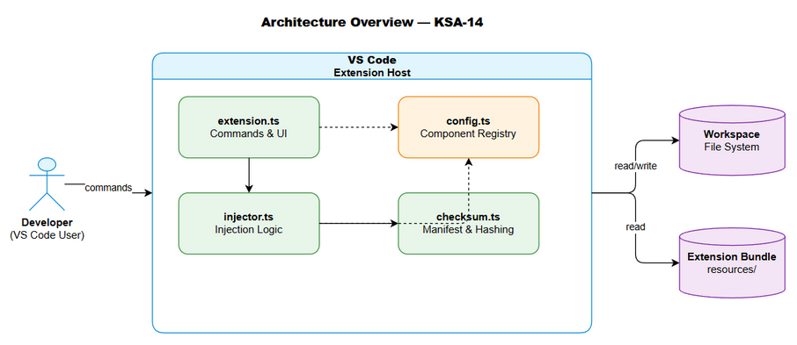
Architecture Diagram

2.2 Component Diagram
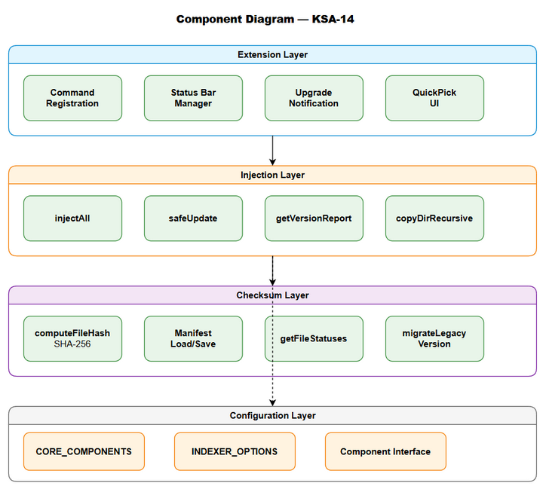
Component Diagram
Component | Responsibility | Technology
extension.ts | VS Code command registration, status bar, upgrade notification | VS Code API
injector.ts | File injection, safe update, version report generation | Node.js fs
checksum.ts | SHA-256 hashing, manifest CRUD, file status classification | Node.js crypto
config.ts | Component definitions, source/target path mapping | TypeScript constants

2.3 Data Flow Architecture
The extension operates on two manifest files:
- Bundled Manifest (resources/.sdlc-checksums.json) — read-only, shipped with extension
- Workspace Manifest (.kiro/.sdlc-manifest.json) — read-write, per-workspace tracking
Data flows: - injectAll → copies files → buildManifestAfterInject → writes workspace manifest - safeUpdate → detectModifiedFiles → classifies → prompts → updates → rebuilds manifest - getVersionReport → reads both manifests → compares → generates text report

2.4 Communication Patterns
From | To | Protocol | Pattern | Description
extension.ts | injector.ts | Function call | Sync | Command handlers invoke injection functions
injector.ts | checksum.ts | Function call | Sync | Injection logic uses checksum for manifest ops
extension.ts | VS Code API | TypeScript API | Async | UI notifications, quick picks, output channels
checksum.ts | File System | Node.js fs | Sync | Read/write manifest JSON, compute file hashes

3. Module Design

3.1 Module: checksum.ts — Per-File Version Tracking
Implements: UC-03, UC-04, BR-02, BR-03, BR-08, BR-11, BR-12, BR-13

3.1.1 Interface Definitions
export interface ChecksumManifest {
version: string; // Extension version (e.g., "1.0.5")
generatedAt: string; // ISO timestamp
files: Record<string, FileChecksum>;
}
export interface FileChecksum {
hash: string; // SHA-256 hex digest
version: string; // Version when file was added/updated
injectedAt: string; // ISO timestamp
}
export interface WorkspaceManifest {
lastUpdated: string; // ISO timestamp
files: Record<string, WorkspaceFileEntry>;
}
export interface WorkspaceFileEntry {
version: string; // Version when file was injected
hash: string; // SHA-256 at injection time
injectedAt: string; // ISO timestamp
}
export interface FileStatus {
relativePath: string;
workspaceVersion: string;
bundledVersion: string;
state: "current" | "outdated" | "modified" | "missing";
}
export interface ModifiedFile {
relativePath: string;
expectedHash: string;
actualHash: string;
injectedVersion: string;
}

3.1.2 Key Functions
Function | Input | Output | Description
computeFileHash(filePath) | File path | SHA-256 hex string | Reads file, computes hash
loadBundledManifest(extensionPath) | Extension path | ChecksumManifest or null | Loads bundled checksums
loadWorkspaceManifest(root) | Workspace root | WorkspaceManifest or null | Loads workspace manifest
saveWorkspaceManifest(root, manifest) | Root + manifest | void | Writes manifest to disk
getFileStatuses(root, extensionPath) | Root + ext path | FileStatus[] | Classifies all files
detectModifiedFiles(root, extensionPath) | Root + ext path | ModifiedFile[] | Finds hash mismatches
isUpgradeAvailable(root, extensionPath) | Root + ext path | boolean | Any file needs update?
migrateLegacyVersion(root, extensionPath) | Root + ext path | void | Migrates .sdlc-version
buildManifestAfterInject(root, extensionPath) | Root + ext path | void | Rebuilds manifest post-inject

3.1.3 File Status Classification Logic
For each file in bundled manifest:
IF file missing in workspace → state = "missing"
ELSE IF workspace version != bundled version → state = "outdated"
ELSE IF current hash != bundled hash → state = "modified"
ELSE → state = "current"

3.1.4 v1.0.4 Bug Fix — detectModifiedFiles
Before (buggy):
// OLD: Version-gating caused ALL entries to be skipped
if (wsManifest.version !== bundled.version) { return []; }
After (fixed):
// NEW: Compare hashes directly, no version gating
for (const [relativePath, entry] of Object.entries(bundled.files)) {
const fullPath = path.join(workspaceRoot, relativePath);
if (!fs.existsSync(fullPath)) { continue; }
const currentHash = computeFileHash(fullPath);
if (currentHash !== entry.hash) {
modified.push({ relativePath, expectedHash: entry.hash, actualHash: currentHash, injectedVersion: entry.version });
}
}

3.1.5 Migration Logic (migrateLegacyVersion)
1. Check .kiro/.sdlc-version exists → if not, return (no-op)
2. Load bundled manifest
3. Parse legacy JSON → extract version (default "1.0.0" on parse error)
4. For each file in bundled manifest:
- If file exists in workspace → record with legacy version + current hash
5. Save new .kiro/.sdlc-manifest.json
6. Delete .kiro/.sdlc-version
Critical safety: Step 5 (write new) MUST complete before Step 6 (delete old).

3.2 Module: injector.ts — Injection & Update Logic
Implements: UC-01, UC-02, BR-01, BR-04, BR-05, BR-06, BR-07

3.2.1 Public Functions
Function | Description | Returns
injectAll(root, extensionPath) | Overwrites ALL files unconditionally | string[] (injected IDs)
injectSelective(root, extensionPath) | User picks components via QuickPick | string[] (injected IDs)
safeUpdate(root, extensionPath) | Smart update with modified-file handling | string[] (updated IDs)
checkStatus(workspaceRoot) | Checks which components exist | Record<string, boolean>
getVersionReport(root, extensionPath) | Generates per-file version report | string (formatted text)

3.2.2 safeUpdate Decision Tree
safeUpdate(root, extensionPath):
1. migrateLegacyVersion(root, extensionPath)
2. modified = detectModifiedFiles(root, extensionPath)
3. IF modified.length == 0 → show "No update needed", return []
4. statuses = getFileStatuses(root, extensionPath)
5. outdated = statuses.filter(state == "outdated")
6. userModified = statuses.filter(state == "modified")
7. IF outdated.length > 0 AND userModified.length == 0:
→ forceUpdate() (auto-overwrite, no prompt)
8. ELSE → promptUpdateWithDetails(outdated, userModified)
→ "Overwrite All" → forceUpdate()
→ "Skip Modified" → updateSkipModified()
→ "Backup & Overwrite" → updateWithBackup()
→ "Cancel" → return []

3.2.3 Update Strategies
Strategy | Function | Behavior
Force Update | forceUpdate() | Copies all bundled files, rebuilds manifest
Skip Modified | updateSkipModified() | Copies all EXCEPT user-modified files
Backup & Overwrite | updateWithBackup() | Backs up modified to .kiro/.sdlc-backup/{timestamp}/, then force updates

3.2.4 Version Report Format
Extension version: 1.0.5
Files: 12 current, 3 outdated, 1 modified, 0 missing
⬆️ Outdated (need update):
.kiro/agents/sm-agent.md [v1.0.3 → v1.0.5]
.kiro/agents/ba-agent.md [v1.0.3 → v1.0.5]
✏️ Modified by user (same version, different content):
.kiro/agents/dev-agent.md [v1.0.5]

3.3 Module: config.ts — Component Definitions
Implements: Component registry for injection

3.3.1 Component Interface
export interface Component {
id: string; // Unique identifier
label: string; // Display name in QuickPick
description: string; // Description in QuickPick
sourcePath: string; // Relative to extension resources/
targetPath: string; // Relative to workspace root
filter?: string[]; // Optional: only copy these items
}

3.3.2 Component Registry
ID | Source Path | Target Path | Description
agents | .kiro/agents | .kiro/agents | Agent prompt files
steering | .kiro/steering | .kiro/steering | Steering rules
hooks | .kiro/hooks | .kiro/hooks | Auto-trigger hooks
templates | documents/templates | documents/templates | Document templates
indexer-config | .analysis/code-intelligence | .analysis/code-intelligence | Indexer config (filtered)
indexer-python | scripts/python | scripts/python | Python indexer
indexer-java | scripts/java | scripts/java | Java indexer
indexer-powershell | scripts/powershell | scripts/powershell | PowerShell indexer
indexer-bash | scripts/bash | scripts/bash | Bash indexer
indexer-nodejs | scripts/nodejs | scripts/nodejs | Node.js indexer

3.4 Module: extension.ts — VS Code Integration
Implements: Command registration, lifecycle, UI

3.4.1 Registered Commands
Command ID | Label | Handler | Description
kiroSdlc.injectAll | Inject All | handleInjectAll | Full injection with confirmation
kiroSdlc.injectSelective | Inject Selective | handleInjectSelective | Pick components to inject
kiroSdlc.update | Update Agents | handleUpdate | Smart update (safeUpdate)
kiroSdlc.status | Show File Versions | handleStatus | Status + version report
kiroSdlc.runIndex | Run Indexer | handleRunIndex | Execute code intelligence indexer

3.4.2 Activation Flow
activate(context):
1. Create status bar item (right-aligned)
2. Register all 5 commands
3. Update status bar (check/warning icon)
4. checkForUpgrade(context):
a. Get workspace root
b. migrateLegacyVersion()
c. isUpgradeAvailable() → if false, return
d. Show notification: "Update available → v{X}"
- "Update Now" → execute kiroSdlc.update
- "Show Details" → open Output Channel with version report
- "Later" → dismiss

3.4.3 Status Bar Behavior
Condition | Icon | Tooltip
All components present | $(check) SDLC Agents | “All SDLC components active”
Some missing | $(warning) SDLC Agents | “Some components missing — click to check”
No workspace | $(circle-slash) SDLC | “No workspace open”

4. Data Design

4.1 File System Layout
workspace/
├── .kiro/
│ ├── .sdlc-manifest.json ← NEW: per-file version tracking
│ ├── .sdlc-version ← LEGACY: deleted after migration
│ ├── .sdlc-backup/ ← Created by "Backup & Overwrite"
│ │ └── {timestamp}/
│ │ └── {backed-up-files}
│ ├── agents/ ← Injected agent prompts
│ ├── steering/ ← Injected steering rules
│ └── hooks/ ← Injected hooks
├── .analysis/
│ └── code-intelligence/ ← Injected indexer
└── documents/
└── templates/ ← Injected document templates

4.2 Workspace Manifest Schema
File: .kiro/.sdlc-manifest.json
{
"lastUpdated": "2026-05-10T10:00:00.000Z",
"files": {
".kiro/agents/sm-agent.md": {
"version": "1.0.5",
"hash": "a1b2c3d4e5f6...",
"injectedAt": "2026-05-10T10:00:00.000Z"
},
".kiro/steering/drawio.md": {
"version": "1.0.5",
"hash": "f6e5d4c3b2a1...",
"injectedAt": "2026-05-10T10:00:00.000Z"
}
}
}

4.3 Bundled Manifest Schema
File: resources/.sdlc-checksums.json
{
"version": "1.0.5",
"generatedAt": "2026-05-10T09:00:00.000Z",
"files": {
".kiro/agents/sm-agent.md": {
"hash": "a1b2c3d4e5f6...",
"version": "1.0.5",
"injectedAt": "2026-05-10T09:00:00.000Z"
}
}
}

4.4 Legacy Version Schema (to be migrated)
File: .kiro/.sdlc-version
{
"version": "1.0.3"
}

5. Error Handling Design

5.1 Error Categories
Category | Severity | Recovery Strategy
Bundled manifest missing | Critical | Abort operation, show error message
File permission denied | Warning | Skip file, continue with others, report skipped
Legacy file malformed | Info | Default to version “1.0.0”, continue migration
No workspace open | Warning | Show error message, abort
Hash computation failure | Warning | Skip file, log error

5.2 Error Handling Patterns
// Pattern 1: Graceful degradation (file operations)
try {
fs.copyFileSync(src, dest);
} catch (err) {
vscode.window.showErrorMessage(`Failed to inject ${component.id}: ${err}`);
return false;
}
// Pattern 2: Safe defaults (manifest loading)
try {
return JSON.parse(fs.readFileSync(manifestFile, "utf-8"));
} catch {
return null; // Caller handles null case
}
// Pattern 3: Atomic migration (write-before-delete)
saveWorkspaceManifest(workspaceRoot, wsManifest); // Step 1: Write new
fs.unlinkSync(legacyFile); // Step 2: Delete old

5.3 User-Facing Error Messages
Scenario | Message | Action
Extension package corrupted | “Extension package may be corrupted — bundled manifest missing” | Abort
Permission denied | “Could not update {file}: permission denied” | Skip + continue
No workspace | “No workspace folder open” | Abort

6. Security Design

6.1 Threat Model
Threat | Risk | Mitigation
Malicious bundled manifest | Low (extension is local) | Manifest is part of signed VSIX package
Hash collision | Negligible | SHA-256 has no known practical collisions
Path traversal in manifest | Low | All paths are relative, resolved against workspace root
Backup directory exposure | Low | .sdlc-backup is in .kiro/ (typically gitignored)

6.2 Data Protection
- No PII is stored in manifests (only file paths and hashes)
- No network calls — all operations are local
- File content is never transmitted or logged
- SHA-256 hashes are one-way — cannot reconstruct file content

7. Performance Design

7.1 Performance Targets
Operation | Target | Rationale
Hash computation per file | < 10ms | Agent files are < 50KB
Full manifest rebuild | < 500ms | ~50 files × 10ms
Status check | < 200ms | Read 2 JSON files + compare
Migration | < 1s | One-time operation

7.2 Optimization Decisions
Decision | Rationale
Synchronous file I/O | Manifest consistency > parallelism; files are small
No caching of hashes | Operations are infrequent (user-triggered); always fresh
Limit report to 15 outdated + 10 modified | Prevent UI overflow in notification

8. Testing Strategy

8.1 Unit Test Coverage
Module | Key Test Scenarios
checksum.ts | Hash computation, manifest load/save, file classification, migration
injector.ts | Inject all, safe update decision tree, skip modified, backup
config.ts | Component registry completeness

8.2 Integration Test Scenarios
ID | Scenario | Setup | Expected
IT-01 | Full inject on empty workspace | No .kiro/ directory | All files injected, manifest created
IT-02 | Safe update with outdated files | Workspace at v1.0.3, bundle at v1.0.5 | Auto-overwrite, manifest updated
IT-03 | Safe update with modified files | User edited agent file | Prompt shown with 3 options
IT-04 | Legacy migration | .sdlc-version exists | Manifest created, legacy deleted
IT-05 | Upgrade notification | isUpgradeAvailable = true | Notification shown

8.3 Edge Cases
Case | Expected Behavior
Empty bundled manifest | All operations return early (no files to process)
Workspace manifest corrupted JSON | loadWorkspaceManifest returns null → treated as fresh workspace
File deleted between status check and update | Skip missing file, continue
Concurrent VS Code windows | Each workspace has independent manifest

9. Implementation Checklist

9.1 Files to Modify
# | File | Changes | Priority
1 | src/checksum.ts | Remove version-gating in detectModifiedFiles; add per-file manifest interfaces and functions | P0
2 | src/injector.ts | Implement safeUpdate, getVersionReport, updateSkipModified, updateWithBackup | P0
3 | src/extension.ts | Rename “Show Status” → “Show File Versions”; add upgrade notification flow | P1
4 | src/config.ts | No changes needed (already correct) | —
5 | package.json | Bump version to 1.0.5; update command labels | P1
6 | resources/.sdlc-checksums.json | Regenerate with v1.0.5 hashes | P1

9.2 Implementation Order
- v1.0.4 — Fix detectModifiedFiles (remove version-gating logic)
- v1.0.5 — Add per-file manifest interfaces to checksum.ts
- v1.0.5 — Implement migrateLegacyVersion, getFileStatuses, buildManifestAfterInject
- v1.0.5 — Implement safeUpdate with all strategies in injector.ts
- v1.0.5 — Implement getVersionReport in injector.ts
- v1.0.5 — Update extension.ts for new command names and upgrade flow
- v1.0.5 — Regenerate bundled checksums, bump version, package VSIX

9.3 Acceptance Verification
# | Criterion | How to Verify
1 | npm run compile succeeds | Zero TypeScript errors
2 | vsce package produces valid VSIX | File exists, installable
3 | Inject All overwrites all files | Manual test on workspace with old files
4 | Safe Update auto-overwrites outdated | Test with only outdated files
5 | Safe Update prompts for modified | Test with user-edited file
6 | Legacy migration works | Test with .sdlc-version present
7 | Version report shows correct states | Compare report with actual file states

10. Deployment Considerations

10.1 Release Process
Step | Action | Tool
1 | Fix bug, commit | git
2 | Tag v1.0.4 | git tag v1.0.4
3 | Implement per-file tracking | git
4 | Regenerate checksums | node scripts/generate-checksums.js
5 | Bump package.json to 1.0.5 | manual
6 | Tag v1.0.5 | git tag v1.0.5
7 | Package VSIX | vsce package
8 | Push tags | git push --tags

10.2 Rollback Strategy
If v1.0.5 has issues: 1. Users can reinstall v1.0.4 VSIX 2. .sdlc-manifest.json is ignored by v1.0.4 (no harm) 3. If migration already deleted .sdlc-version, v1.0.4 treats workspace as fresh (safe)

10.3 Backward Compatibility
Scenario | Behavior
v1.0.5 on workspace with .sdlc-version | Auto-migrates to manifest
v1.0.5 on workspace with no version file | Creates manifest on first inject
v1.0.4 on workspace with .sdlc-manifest.json | Ignores manifest (doesn’t know about it)

11. Appendix

Glossary
Term | Definition
Workspace Manifest | .kiro/.sdlc-manifest.json — per-file version/hash tracking
Bundled Manifest | resources/.sdlc-checksums.json — expected hashes shipped with extension
Inject | Copy bundled resource files into user’s workspace
Safe Update | Update that auto-overwrites outdated files, prompts for user-modified files
Hash | SHA-256 digest of file content (hex-encoded)
Version-gating | The v1.0.3 bug where version mismatch caused all entries to be skipped

Diagram Index
# | Diagram | Image | Source (editable)
1 | Architecture Overview | architecture.png | architecture.drawio
2 | Component Diagram | component.png | component.drawio
3 | Class Diagram | class-diagram.png | class-diagram.drawio

