Business Requirements Document (BRD)

MCP Code Intelligence — KSA-140: Refactor Steering Files để Tối Ưu Token Usage

Document Information
Field | Value
Jira Ticket | KSA-140
Title | Refactor Steering Files để Tối Ưu Token Usage
Author | BA Agent
Version | 1.0
Date | 2026-05-23
Status | Draft

Author Tracking
Role | Name - Position | Responsibility
Author | BA Agent – Business Analyst | Create document
Peer Reviewer | Duc Nguyen Minh – Technical Lead | Review document

Revision History
Version | Date | Author | Changes
1.0 | 2026-05-23 | BA Agent | Initiate document — auto-generated from Jira ticket KSA-140

Sign-Off
Name | Signature and date
 | ☐ I agree and confirm all criteria on this BRD as expected requirements
 | ☐ I agree and confirm all criteria on this BRD as expected requirements

1. Introduction

1.1 Scope
This change request refactors the .kiro/steering/ and .kiro/agents/ files to optimize token consumption when agents are invoked. Currently, steering files are loaded into agent context on every invocation, consuming significant tokens even when the content is irrelevant to the current task. The refactoring restructures these files using conditional inclusion (inclusion: manual), file splitting, deduplication, and content compression to minimize token waste.
Key areas: - Consolidate overlapping steering rules across multiple files - Add inclusion: manual frontmatter to context-heavy files that are only needed in specific scenarios - Split large agent prompt files into modular sections - Remove redundant/duplicate content between steering files and agent prompts - Establish a token budget framework for steering file management

1.2 Out of Scope
- Changing agent behavior or capabilities (only restructuring how instructions are delivered)
- Modifying the Kiro platform’s steering file loading mechanism
- Creating new agents or removing existing agents
- Changing the SDLC pipeline workflow logic

1.3 Preliminary Requirement
- Understanding of current token consumption per agent invocation (baseline measurement)
- Knowledge of which steering files are loaded by default vs. manually included
- Kiro platform support for inclusion: manual frontmatter in steering files

2. Business Requirements

2.1 High Level Process Map
The refactoring follows a systematic approach: audit current steering files → measure token usage → identify optimization opportunities → restructure files → validate token savings → document new conventions.
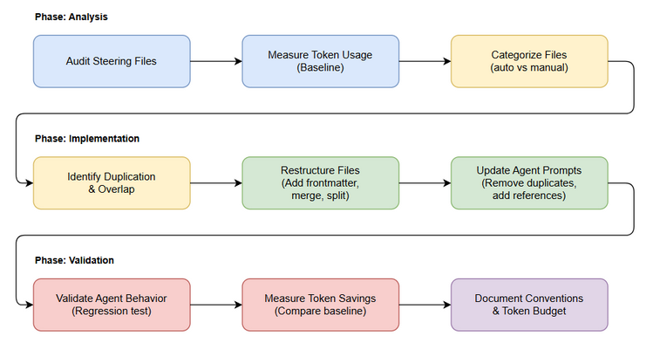
Business Flow
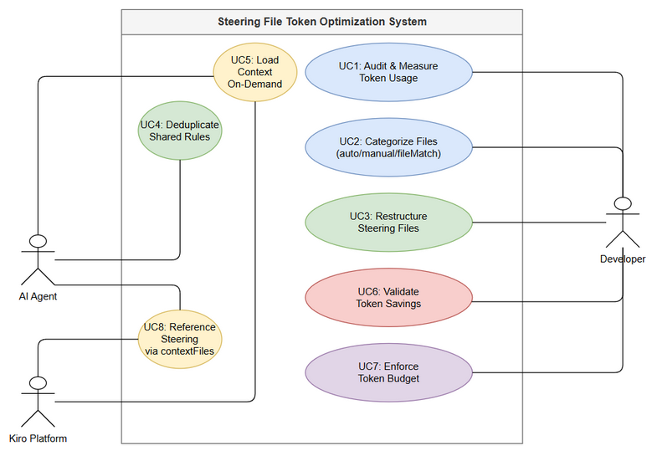
Use Case Diagram

2.2 List of User Stories / Use Cases
# | Story / Use Case | Priority | Source Ticket
1 | As an AI agent, I want only relevant steering content loaded into my context so that I have more token budget for actual work | MUST HAVE | KSA-140
2 | As a developer, I want steering files organized by concern with clear inclusion rules so that I can maintain them efficiently | MUST HAVE | KSA-140
3 | As the SM agent, I want large reference sections (workflow details, quality gates) available on-demand rather than always-loaded so that my base context is smaller | MUST HAVE | KSA-140
4 | As any agent, I want shared rules (code standards, file writing) deduplicated into single-source files so that updates propagate consistently | SHOULD HAVE | KSA-140
5 | As a developer, I want a token budget guideline for steering files so that new additions don’t regress token usage | SHOULD HAVE | KSA-140
6 | As the system, I want agent prompts to reference steering files via inclusion rather than duplicating content so that maintenance is simplified | SHOULD HAVE | KSA-140

2.3 Details of User Stories

Business Flow
Step 1: Audit all files in .kiro/steering/ and .kiro/agents/prompts/ — measure character count and token estimate per file
Step 2: Categorize each file by usage frequency: always-needed (default inclusion) vs. scenario-specific (manual inclusion)
Step 3: Identify content duplication between steering files and agent prompt files
Step 4: Restructure files: - Add inclusion: manual to scenario-specific files - Merge overlapping files into consolidated versions - Extract shared rules into reusable steering files - Compress verbose instructions into concise directives
Step 5: Update agent .md files to reference restructured steering files
Step 6: Validate: invoke each agent and verify correct behavior with reduced token load
Step 7: Document conventions for future steering file additions
Note: The refactoring must NOT change agent behavior — only reduce token consumption while maintaining identical functionality.

STORY 1: Conditional Loading of Steering Content
As an AI agent, I want only relevant steering content loaded into my context so that I have more token budget for actual work
Requirement Details:
- Steering files that are only needed in specific scenarios MUST have inclusion: manual frontmatter
- Files with inclusion: manual are NOT loaded by default — only when explicitly referenced via contextFiles in agent invocation
- Files without inclusion frontmatter (or with inclusion: auto) are loaded for every agent invocation
- The categorization must be based on actual usage patterns across the SDLC pipeline
Current State (Before):
File | Chars | Est. Tokens | Loaded | Actually Needed
orchestration.md | ~8,000 | ~2,000 | Always | Only when debugging orchestration
drawio.md | ~12,000 | ~3,000 | Always | Only when creating diagrams
indexing-guide.md | ~6,000 | ~1,500 | Always | Only when indexing code
jira-workflow.md | ~4,000 | ~1,000 | Always | Only when transitioning tickets
code-standards.md | ~3,000 | ~750 | Always | Only for DEV/SA agents
concise-responses.md | ~500 | ~125 | Always | Always (keep default)
sm-default-agent.md | ~800 | ~200 | Always | Always (keep default)
Target State (After):
File | Inclusion | Loaded When
orchestration.md | manual | Debugging orchestration issues
drawio.md | manual | Agent needs to create diagrams
indexing-guide.md | manual | Code indexing requested
jira-workflow.md | manual | Jira transitions needed
code-standards.md | manual | DEV/SA writing code
concise-responses.md | auto (default) | Always
sm-default-agent.md | auto (default) | Always
file-writing.md | auto (default) | Always
Acceptance Criteria:
- Files marked inclusion: manual are NOT loaded into agent context by default
- Agent behavior remains identical when manual files are explicitly included
- Base token consumption per agent invocation reduced by ≥40%
- No regression in agent capabilities (all SDLC phases still work correctly)

STORY 2: Organized File Structure with Clear Conventions
As a developer, I want steering files organized by concern with clear inclusion rules so that I can maintain them efficiently
Requirement Details:
- Each steering file MUST have a frontmatter block with inclusion and description fields
- File naming convention: {concern}.md (e.g., drawio.md, code-standards.md)
- Files should be single-concern — one file should not mix unrelated rules
- A README or manifest file should document all steering files and their inclusion rules
Data Fields (Frontmatter):
Field | Type | Required | Description | Example
inclusion | String | Yes | Loading strategy: auto or manual | manual
description | String | Yes | When/why this file should be included | Draw.io diagram creation rules. Activate when agent needs to create .drawio files.
Acceptance Criteria:
- All steering files have consistent frontmatter with inclusion and description
- File naming follows {concern}.md convention
- No file mixes unrelated concerns (single responsibility)
- .kiro/.sdlc-manifest.json or equivalent documents all files and their roles

STORY 3: SM Agent Context Optimization
As the SM agent, I want large reference sections (workflow details, quality gates) available on-demand rather than always-loaded so that my base context is smaller
Requirement Details:
- The SM agent prompt (sm-agent.md) is the largest agent file (~15,000+ tokens)
- Sections that are only needed during specific phases should be extractable:
  - Detailed quality gate checklists → only needed during verification
  - Jira transition rules → only needed when transitioning
  - Feedback loop logic → only needed during Phase 3.5
  - Document attachment rules → only needed after phase completion
- Core SM logic (phase detection, status management, user interaction) stays in main prompt
- Phase-specific details are loaded via contextFiles when that phase is active
Acceptance Criteria:
- SM base prompt reduced by ≥30% in token count
- Phase-specific content available via contextFiles when needed
- SM still correctly identifies current phase and proposes next steps
- No loss of quality gate enforcement

STORY 4: Deduplication of Shared Rules
As any agent, I want shared rules (code standards, file writing) deduplicated into single-source files so that updates propagate consistently
Requirement Details:
- Identify rules that appear in multiple agent prompts (e.g., “use fs_write not echo”, “Vietnamese communication”)
- Extract shared rules into dedicated steering files
- Agent prompts reference shared files instead of duplicating content
- When a shared rule changes, all agents automatically get the update
Acceptance Criteria:
- No rule appears in more than one file (single source of truth)
- Shared rules are in .kiro/steering/ (not duplicated in agent prompts)
- Updating a shared rule in one place affects all agents that use it

STORY 5: Token Budget Guidelines
As a developer, I want a token budget guideline for steering files so that new additions don’t regress token usage
Requirement Details:
- Establish maximum token budgets per category:
  - Always-loaded steering files: total ≤ 2,000 tokens
  - Agent base prompt: ≤ 8,000 tokens (excluding contextFiles)
  - Manual steering files: no hard limit (loaded on-demand)
- Document the budget in a steering file or README
- Provide a script or command to measure current token usage
Acceptance Criteria:
- Token budget documented and accessible to developers
- Current state meets the defined budgets after refactoring
- Measurement tool/script available to check compliance

STORY 6: Reference-Based Agent Prompts
As the system, I want agent prompts to reference steering files via inclusion rather than duplicating content so that maintenance is simplified
Requirement Details:
- Agent prompt files (.kiro/agents/prompts/*.md) should contain only agent-specific logic
- Common patterns (diagram creation, file writing, Jira interaction) should be in steering files
- Agent JSON config (.kiro/agents/*.json) specifies which steering files to include
- Kiro platform’s contextFiles mechanism is used for dynamic inclusion
Acceptance Criteria:
- Agent prompts contain only role-specific instructions
- Common patterns live in steering files (single source)
- Agent behavior unchanged after restructuring

3. Dependencies
Dependency | Type | Related Ticket | Description
Kiro Platform | System | N/A | Must support inclusion: manual frontmatter and contextFiles in agent invocation
Existing Steering Files | System | N/A | All current .kiro/steering/*.md files are input to this refactoring
Agent Prompt Files | System | N/A | All .kiro/agents/prompts/*.md files may be restructured
SDLC Pipeline | System | N/A | Pipeline must continue working after refactoring (regression test)

4. Stakeholders
Role | Name / Team | Responsibility | Source
Reporter | Duc Nguyen Minh | Feature owner, requirements validation | Jira reporter
Technical Lead | Duc Nguyen Minh | Architecture review, token measurement | Jira reporter
AI Agents | SM, BA, SA, QA, DEV, DevOps, TA, UI | Affected by steering changes | System users

5. Risks and Assumptions

5.1 Risks
Risk | Impact | Likelihood | Mitigation
Agent behavior regression after removing always-loaded content | High | Medium | Thorough testing of each agent after refactoring; rollback plan
Manual inclusion forgotten during agent invocation → missing context | Medium | Medium | Document which files each phase needs; SM orchestration handles inclusion
Over-optimization removes content that’s needed more often than expected | Medium | Low | Start conservative — only mark clearly scenario-specific files as manual
Token measurement inaccuracy (char-to-token ratio varies) | Low | Medium | Use actual tokenizer for measurement, not estimates
Kiro platform changes steering loading behavior in future updates | Medium | Low | Document assumptions about platform behavior; test after updates

5.2 Assumptions
- Kiro platform correctly respects inclusion: manual frontmatter (files are not loaded unless explicitly referenced)
- Token savings from reduced context directly translate to more available budget for agent work
- Agent prompts can reference steering files via contextFiles without additional platform changes
- The current steering file structure has significant redundancy (estimated 30-50% duplicate/unnecessary content)
- All agents are invoked through the SM pipeline (SM controls contextFiles for sub-agents)

6. Non-Functional Requirements
Category | Requirement | Details
Performance | ≥40% reduction in base token consumption | Measured as total tokens loaded before agent starts working
Performance | No increase in agent invocation latency | File loading should not be slower with manual inclusion
Maintainability | Single source of truth for all rules | No duplicated content across files
Maintainability | Clear documentation of file purposes | Every file has frontmatter explaining when to include
Reliability | Zero regression in agent capabilities | All SDLC phases produce identical quality output
Scalability | Token budget framework prevents future bloat | New steering additions must fit within budget

7. Related Tickets
Ticket Key | Summary | Status | Type | Relationship
KSA-140 | Refactor Steering Files để Tối Ưu Token Usage | Done | Task | Main ticket
KSA-139 | 2-Level Agent Tool Cache Registry | To Do | Task | Related — both optimize token usage

8. Appendix

Glossary
Term | Definition
Steering File | Markdown file in .kiro/steering/ that provides rules/guidelines loaded into agent context
Token | Unit of text processing in LLM context — roughly 4 characters per token
Inclusion Mode | Whether a steering file is loaded automatically (auto) or on-demand (manual)
Context Budget | Maximum number of tokens available for agent instructions before actual work begins
Frontmatter | YAML metadata block at the top of a markdown file (between --- delimiters)
contextFiles | Kiro mechanism to explicitly include additional files in agent context during invocation

Reference Documents
Document | Link / Location
Agent Token-Optimized Workflows | documents/agent-token-optimized-workflows.md
Current Steering Files | .kiro/steering/*.md
Agent Prompts | .kiro/agents/prompts/*.md
SM Agent Configuration | .kiro/agents/sm-agent.json

Current Steering File Inventory
# | File | Est. Tokens | Current Inclusion | Recommended
1 | agent-self-learning.md | ~500 | auto | manual
2 | backend-structure.md | ~800 | auto | manual
3 | code-intelligence.md | ~1,000 | auto | manual
4 | code-standards.md | ~750 | auto | manual
5 | concise-responses.md | ~125 | auto | auto (keep)
6 | drawio.md | ~3,000 | auto | manual
7 | file-writing.md | ~300 | auto | auto (keep)
8 | frontend-structure.md | ~600 | auto | manual
9 | indexing-guide.md | ~1,500 | auto | manual
10 | jira-rules.md | ~400 | auto | manual
11 | jira-workflow.md | ~1,000 | auto | manual
12 | kotlin-code-standards.md | ~800 | auto | manual
13 | manual-web-test.md | ~500 | auto | manual
14 | no-workaround-rule.md | ~200 | auto | auto (keep)
15 | orchestration.md | ~2,000 | manual | manual (keep)
16 | release-versioning.md | ~400 | auto | manual
17 | sm-default-agent.md | ~200 | auto | auto (keep)
18 | ui-relative-paths.md | ~300 | auto | manual
Estimated savings: ~11,000 tokens moved from always-loaded to on-demand = ~40-50% reduction in base context.

Diagram Index
# | Diagram | Image | Source (editable)
1 | Business Flow | business-flow.png | business-flow.drawio
2 | Use Case Diagram | use-case.png | use-case.drawio

