Software Test Plan (STP)

MCP Code Intelligence — KSA-142: Feature Parity Sync — Đồng bộ 3 MCP Implementations

Document Information
Field | Value
Jira Ticket | KSA-142
Title | Feature Parity Sync — Đồng bộ 3 MCP Implementations (Python, Node.js, Kotlin)
Author | QA Agent
Version | 1.0
Date | 2025-07-25
Status | Draft
Related BRD | BRD-v1-KSA-142.docx
Related FSD | FSD-v1-KSA-142.docx
Related TDD | TDD-v1-KSA-142.docx

Author Tracking
Role | Name - Position | Responsibility
Author | QA Agent – QA Engineer | Create document
Peer Reviewer | SA Agent – Solution Architect | Review technical feasibility

Revision History
Version | Date | Author | Changes
1.0 | 2025-07-25 | QA Agent | Initiate document — auto-generated from BRD, FSD, and TDD

Sign-Off
Name | Signature and date
 | ☐ I agree and confirm the test plan in this STP
 | ☐ I agree and confirm the test plan in this STP

1. Introduction

1.1 Purpose
This test plan defines the testing strategy, scope, schedule, and resources for validating the Feature Parity Sync (KSA-142). The goal is to ensure that all 7 features are correctly ported across the 3 MCP Code Intelligence implementations (Python, Node.js, Kotlin) with identical behavior — achieving 100% feature parity.

1.2 Test Objectives
- Verify all 12 use cases (UC-01 to UC-12) from FSD are implemented correctly in target implementations
- Validate all 45 business rules (BR-01 to BR-45) are enforced
- Ensure non-functional requirements (performance, storage, reliability) are met
- CRITICAL: Verify cross-implementation parity — same input produces same output across Python/Node.js/Kotlin
- Validate schema V3 migrations are reversible and preserve existing data
- Confirm error handling matches FSD Section 9 specifications

1.3 References
Document | Location
BRD | BRD-v1-KSA-142.docx
FSD | FSD-v1-KSA-142.docx
TDD | TDD-v1-KSA-142.docx
Node.js Reference Tests | memory/tests/core-memory.test.ts, conversation.test.ts

2. Test Strategy

2.1 Test Levels
Level | Scope | Automation | Tools
UT | Unit tests per class (CoreMemoryManager, ConversationRepo, etc.) | Automated | pytest (Python), kotest (Kotlin), Jest (Node.js)
IT | Integration tests (tool dispatcher → feature manager → DB) | Automated | pytest + SQLite (Python), kotest + SQLite (Kotlin), Jest + better-sqlite3 (Node.js)
Parity | Cross-implementation parity — same input → same output | Automated | Custom parity test runner (JSON comparison)
SIT | Manual exploratory / edge cases / visual verification | Manual | Browser (Viewer UI), CLI
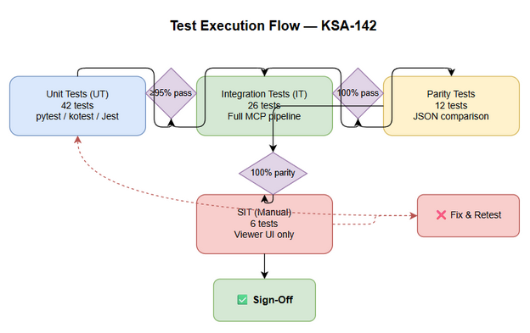
Test Execution Flow

2.2 Test Types
Type | Description | Applicable
Functional Testing | Verify features work per FSD use cases (UC-01 to UC-12) | Yes
Parity Testing | Verify identical behavior across 3 implementations | Yes — CRITICAL
Regression Testing | Ensure existing features are not broken by schema migration | Yes
Performance Testing | Verify response times (< 5ms auto-recall, < 50ms search, < 1ms cache) | Yes
Security Testing | Verify localhost-only binding for Viewer UI | Yes
Integration Testing | Verify tool dispatcher → manager → DB pipeline | Yes

2.3 Test Approach
Risk-based prioritization: 1. CRITICAL — Parity tests (TC-25, TC-26): If implementations diverge, the entire feature is broken 2. HIGH — Core Memory, Conversation, Cache (F1, F2, F4): Most actively used by agents 3. MEDIUM — Structured Map, File Watcher, Nested Detection (F3, F5, F7) 4. LOW — Viewer UI (F6): Visual, less critical for agent functionality
Automation strategy: - UT + IT: 100% automated (each implementation has its own test suite) - Parity: Automated JSON comparison across implementations - SIT: Manual for Viewer UI visual verification only

2.4 Entry Criteria
Level | Entry Criteria
UT | Code compiles, schema V3 migration applied, test data fixtures ready
IT | Unit tests pass (≥ 95%), SQLite DB initialized with V3 schema
Parity | All 3 implementations pass their own UT + IT suites
SIT | Parity tests pass, server starts without errors, Viewer UI enabled

2.5 Exit Criteria
Level | Exit Criteria
UT | 100% test cases executed, ≥ 95% pass rate, 0 Critical defects
IT | 100% integration scenarios pass, DB operations verified
Parity | 100% parity tests pass — identical JSON output across all implementations
SIT | All manual scenarios executed, 0 Critical defects, ≤ 2 Major defects

3. Test Scope

3.1 Features In Scope
# | Feature / Story | Priority | FSD Reference | Target Implementations | Test Type
1 | Core Memory (Pin/Unpin/Auto-Recall) | HIGH | UC-01, UC-02, BR-01 to BR-06 | Python, Kotlin (port from Node.js) | UT + IT + Parity
2 | Conversation History (Save/Get/Search) | HIGH | UC-03, UC-04, BR-07 to BR-12 | Python, Kotlin (port from Node.js) | UT + IT + Parity
3 | Structured Map & Entity Index | MEDIUM | UC-05, UC-06, BR-13 to BR-18 | Python, Kotlin (port from Node.js) | UT + IT + Parity
4 | Cache Layer for Orchestration | HIGH | UC-07, UC-08, BR-19 to BR-26 | Node.js (verify existing) | UT + IT
5 | File Watcher (Auto-Reindex) | MEDIUM | UC-09, BR-27 to BR-32 | Node.js (verify existing) | UT + IT
6 | Viewer UI (Web Dashboard) | LOW | UC-10, BR-33 to BR-38 | Node.js, Kotlin | SIT (manual)
7 | Nested Detection | MEDIUM | UC-11, UC-12, BR-39 to BR-45 | Kotlin | UT + IT
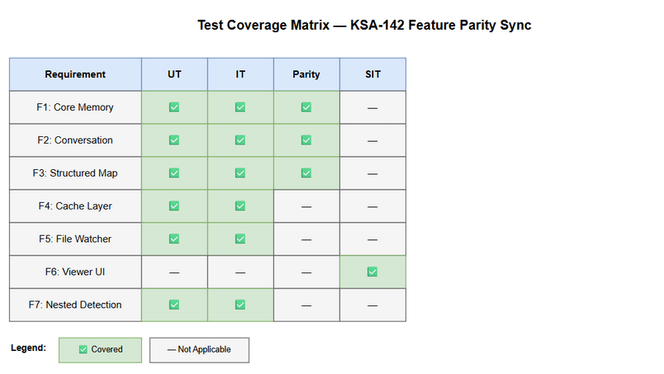
Test Coverage

3.2 Features Out of Scope
# | Feature | Reason
1 | New features not in any implementation | BRD explicitly excludes (only porting)
2 | MCP protocol changes | Out of scope per BRD 1.2
3 | UI/UX redesign of Viewer | Only port existing Python UI
4 | Performance optimization beyond parity | Only verify NFR targets are met
5 | Python File Watcher (already exists) | Only verify Node.js port
6 | Python/Kotlin Cache Layer (already exists) | Only verify Node.js port

4. Test Environment

4.1 Environment Requirements
Environment | Runtime | Database | Purpose
Python | Python 3.11+, CPython | SQLite 3.35+ (stdlib) | UT + IT + Parity for F1/F2/F3
Node.js | Node 20+, TypeScript 5.x | better-sqlite3 | UT + IT for F4/F5/F6 + Parity reference
Kotlin | JVM 21, Kotlin 2.x | sqlite-jdbc | UT + IT + Parity for F1/F2/F3/F7
Viewer UI | Any modern browser | N/A | SIT manual testing

4.2 Browser / Device Requirements (Viewer UI only)
Browser | Version | OS | Required
Chrome | 120+ | Windows/Mac/Linux | Yes
Firefox | 120+ | Windows/Mac/Linux | Optional

4.3 Test Data Requirements
Data Type | Description | Source | Preparation
Knowledge entries | 10+ entries with varying content lengths | DB seed script | SQL INSERT statements
Pinned entries | 3-5 entries within 2000-token budget | Test fixture | Created during test setup
Conversation sessions | 3 sessions with 5-20 turns each | Test fixture | Created during test setup
Entity-rich content | Content with PascalCase identifiers | Test fixture | Predefined strings
Cache entries | 100+ entries for LRU testing | Test fixture | Programmatic generation
Source files | 10+ .ts/.py/.kt files for watcher | Temp directory | Created in test setup

4.4 External Dependencies
System | Dependency | Mock/Stub Available
SQLite 3.35+ | FTS5 extension for search | Built-in (no mock needed)
File System | OS file events for watcher | chokidar (Node.js), watchdog (Python)
Child MCP Server | For nested detection testing | Mock MCP server (stdio transport)
HTTP Server | For Viewer UI | Localhost binding

5. Test Schedule
Phase | Start Date | End Date | Duration | Milestone
Test Planning | Day 1 | Day 2 | 2 days | STP + STC approved
Test Data Preparation | Day 2 | Day 3 | 1 day | Fixtures and seed scripts ready
UT Execution (all implementations) | Day 3 | Day 6 | 4 days | All unit tests pass
IT Execution (all implementations) | Day 5 | Day 8 | 4 days | Integration verified
Parity Testing | Day 7 | Day 9 | 3 days | Cross-impl parity confirmed
SIT Execution (Viewer UI) | Day 9 | Day 10 | 2 days | Manual verification complete
Defect Fix & Retest | Day 8 | Day 11 | 4 days | All Critical/Major fixed
Sign-off | Day 12 | Day 12 | 1 day | Test completion report

6. Resources & Responsibilities
Role | Name | Responsibility
Test Lead | QA Agent | Test planning, coordination, parity test design
QA Engineer (Python) | QA Agent | Python test execution, defect reporting
QA Engineer (Kotlin) | QA Agent | Kotlin test execution, defect reporting
QA Engineer (Node.js) | QA Agent | Node.js test execution, defect reporting
Developer | Dev Team | Bug fixing, unit test coverage
SA | SA Agent | Architecture review, parity criteria definition

7. Risk & Mitigation
# | Risk | Impact | Likelihood | Mitigation
1 | Schema V3 migration breaks existing data | High | Medium | Test migration on copy of production DB first
2 | Parity divergence due to language differences | High | Medium | Use JSON comparison with tolerance for ordering
3 | File watcher flaky tests (timing-dependent) | Medium | High | Use generous timeouts, retry logic in tests
4 | SQLite version mismatch (FTS5 not available) | High | Low | Check SQLite version in test setup, skip if < 3.35
5 | Token counting approximation differs | Medium | Medium | Standardize on chars / 4 across all implementations
6 | Child MCP server mock instability | Medium | Medium | Use deterministic mock with fixed responses
7 | Large scope delays testing | Medium | High | Prioritize F1/F2/F4 (HIGH), defer F6 (LOW)

8. Defect Management

8.1 Severity Levels
Severity | Definition | Example
Critical | Parity broken — implementations produce different results | mem_pin returns different JSON in Python vs Node.js
Major | Feature not working in one implementation | Conversation search returns 0 results in Kotlin
Minor | Edge case handling differs slightly | Error message wording differs
Trivial | Cosmetic, logging differences | Log format differs between implementations

8.2 Priority Levels
Priority | Definition | SLA (Fix Time)
P1 | Parity-breaking defect | 4 hours
P2 | Feature broken in one implementation | 1 business day
P3 | Edge case or minor behavior difference | 3 business days
P4 | Cosmetic or logging issue | Next release

8.3 Defect Lifecycle
New → Open → In Progress → Fixed → Ready for Retest → Verified → Closed
→ Reopened → In Progress

9. Test Metrics & Reporting

9.1 Metrics
Metric | Formula | Target
Test Execution Rate | Executed / Total × 100% | 100%
Pass Rate | Passed / Executed × 100% | ≥ 95%
Parity Pass Rate | Parity tests passed / Total parity tests × 100% | 100%
Defect Density | Defects / Test Cases | ≤ 0.1
Critical Defect Count | Count of Critical severity | 0
Cross-Impl Coverage | Features tested in all target impls / Total features × 100% | 100%

9.2 Test Cases Summary
Level | Count | Automated | Manual
UT | 42 | 42 | 0
IT | 26 | 26 | 0
Parity | 12 | 12 | 0
SIT | 6 | 0 | 6
Total | 86 | 80 (93%) | 6 (7%)

9.3 Reporting Schedule
Report | Frequency | Audience
Daily Test Status | Daily during execution | Project team
Parity Report | After each parity run | Dev team + SA
Test Completion Report | End of testing | All stakeholders

10. Appendix

Glossary
Term | Definition
Parity Test | Test that verifies identical behavior across implementations
SIT | System Integration Testing (manual)
UT | Unit Testing
IT | Integration Testing
LRU | Least Recently Used (cache eviction)
FTS5 | Full-Text Search version 5 (SQLite extension)
SSE | Server-Sent Events

Assumptions
- Node.js implementation is the reference (gold standard) for F1/F2/F3 parity
- Python implementation is the reference for F4/F5/F6 parity
- All implementations use SQLite with identical schema (V3)
- Token counting uses chars / 4 approximation uniformly
- Tests run on developer machines (no CI/CD pipeline required for initial validation)

