Deployment Guide (DPG)

Kiro SDLC Agents Extension — KSA-2: Extension Core — Commands & Activation

Document Information
Field | Value
Jira Ticket | KSA-2
Title | Extension Core — Commands & Activation
Author | DevOps Agent
Version | 1.0
Date | 2025-01-20
Status | Draft
Related TDD | TDD-v1.0-KSA-2.docx

Revision History
Version | Date | Author | Changes
1.0 | 2025-01-20 | DevOps Agent | Initiate document — auto-generated from TDD and project context

Sign-Off
Name | Role | Signature and date
 | Dev Lead | ☐ Approved for deployment
 | QA Lead | ☐ Testing completed
 | Ops Lead | ☐ Infrastructure ready

1. Overview

1.1 Feature Summary
The Extension Core — Commands & Activation component is the entry point of the Kiro SDLC Agents VS Code extension. It provides:
- Startup activation (extension loads immediately when VS Code/Kiro IDE starts)
- Five Command Palette commands for injecting SDLC agents, running code indexer, updating agents, and checking status
- A status bar indicator showing SDLC component health (present/missing/no workspace)
- Confirmation dialogs before destructive operations (inject all, update)
This is a client-side VS Code extension — no server deployment, no database, no containers. Deployment means publishing the .vsix package to VS Code Marketplace and/or Open VSX Registry.

1.2 Deployment Scope
Item | Type | Description
kiro-sdlc-agents extension | New | VS Code extension packaged as .vsix
GitHub Actions CI | New | Build + compile verification on push/PR
GitHub Actions Publish | New | Automated publish to Marketplace on tag push
VS Code Marketplace listing | New | Public extension listing
Open VSX Registry listing | New | Kiro IDE / open-source marketplace listing

1.3 Target Environments
Environment | Distribution Channel | Deploy Order | Approval Required
DEV | Local .vsix install | 1st | No
BETA | Pre-release flag on Marketplace | 2nd | Dev Lead
PROD (Marketplace) | VS Code Marketplace | 3rd | Dev Lead + QA Sign-off
PROD (Open VSX) | Open VSX Registry | 3rd | Dev Lead + QA Sign-off

2. Prerequisites

2.1 Infrastructure
Requirement | Status | Notes
GitHub repository | Ready | Source code hosted on GitHub
GitHub Actions enabled | Ready | CI/CD workflows in .github/workflows/
VS Code Marketplace publisher account | Pending | Publisher ID: your-publisher-id (must be registered)
Open VSX namespace | Pending | Namespace must be claimed on open-vsx.org

2.2 Software Dependencies
Dependency | Version | Status
Node.js | 20.x LTS | Required for build
TypeScript | ^5.4.0 | devDependency
@vscode/vsce | ^2.24.0 | Packaging & publishing tool
VS Code Engine | ^1.85.0 | Minimum compatible version

2.3 Access Requirements
Access | Type | Who Needs It
GitHub repository write | SSH key / PAT | Dev team
VS Code Marketplace PAT | Personal Access Token | CI/CD (secret: VSCE_PAT)
Open VSX Token | API Token | CI/CD (secret: OVSX_TOKEN)
GitHub Actions secrets | Repository settings | Repository admin

2.4 Backup Requirements
- ☐ Previous .vsix artifact saved (download from GitHub Actions artifacts)
- ☐ Git tag for previous release exists (enables rollback via git checkout)
- ☐ Marketplace allows unpublishing/reverting to previous version

3. Pre-Deployment Checklist
# | Item | Responsible | Status
1 | Code merged to main branch | Developer | ☐
2 | All TypeScript compilation passes (npm run compile) | Developer | ☐
3 | CI workflow passes (GitHub Actions) | Automated | ☐
4 | VSIX package builds successfully (npm run package) | Developer | ☐
5 | Manual testing in VS Code (5 commands work) | QA | ☐
6 | Status bar displays correctly (3 states) | QA | ☐
7 | Confirmation dialogs appear for inject/update | QA | ☐
8 | Extension activates on startup without errors | QA | ☐
9 | package.json version bumped to target version | Developer | ☐
10 | publisher field updated from your-publisher-id | Developer | ☐
11 | CHANGELOG.md updated with release notes | Developer | ☐
12 | GitHub secrets configured (VSCE_PAT, OVSX_TOKEN) | DevOps | ☐
13 | README.md has accurate installation instructions | Developer | ☐
14 | Icon file exists at resources/icon.png (128x128) | Developer | ☐

4. Database Migration
Not Applicable. This is a client-side VS Code extension with no database. The extension operates entirely within the user’s local file system.

5. Application Deployment

5.1 Deployment Flow
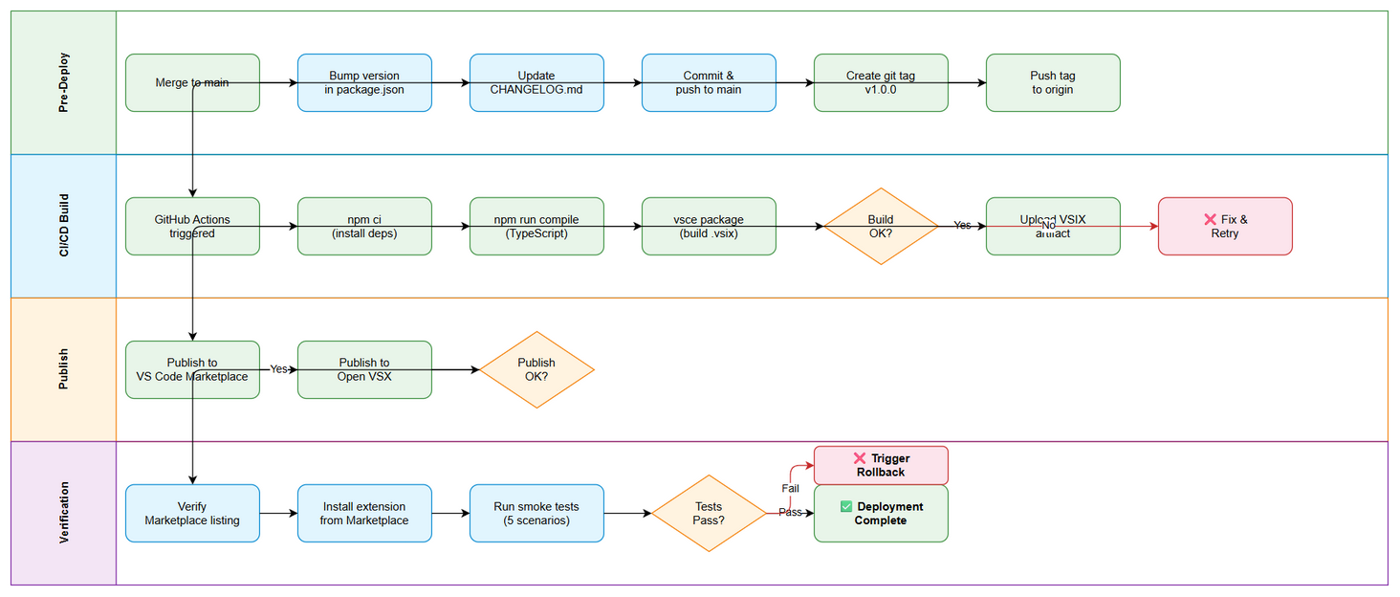
Deployment Flow

5.2 Method A: Automated Publish via GitHub Actions (Recommended)
Step | Action | Command | Verification
1 | Ensure all changes merged to main | git log --oneline -5 | Latest commit is the release commit
2 | Update version in package.json | Edit "version": "1.0.0" | npm pkg get version returns correct version
3 | Commit version bump | git commit -am "chore: bump version to 1.0.0" | Commit in log
4 | Create and push git tag | git tag v1.0.0 && git push origin v1.0.0 | Tag visible on GitHub
5 | GitHub Actions triggers publish.yml | Automatic on tag push | Check Actions tab for green build
6 | Verify VSIX artifact uploaded | GitHub Actions → Artifacts | kiro-sdlc-agents-1.0.0.vsix present
7 | Verify Marketplace publish | VS Code Marketplace website | Extension visible and installable
8 | Verify Open VSX publish | open-vsx.org | Extension visible and installable

5.3 Method B: Manual Publish (Fallback)
# Step 1: Install dependencies
npm ci
# Step 2: Compile TypeScript
npm run compile
# Step 3: Package VSIX
npx vsce package --no-dependencies
# Step 4: Verify VSIX created
ls -la kiro-sdlc-agents-1.0.0.vsix
# Step 5: Publish to VS Code Marketplace
npx vsce publish --packagePath kiro-sdlc-agents-1.0.0.vsix -p <VSCE_PAT>
# Step 6: Publish to Open VSX
npx ovsx publish kiro-sdlc-agents-1.0.0.vsix -p <OVSX_TOKEN>

5.4 Method C: Local VSIX Distribution (DEV/Testing)
# Install locally for testing
code --install-extension kiro-sdlc-agents-1.0.0.vsix
# Verify installation
code --list-extensions | grep kiro-sdlc-agents
# Uninstall if needed
code --uninstall-extension your-publisher-id.kiro-sdlc-agents

6. Configuration Changes

6.1 GitHub Repository Secrets (Required for CI/CD)
Secret Name | Description | Where to Get
VSCE_PAT | VS Code Marketplace Personal Access Token | https://dev.azure.com → User Settings → PAT → Marketplace (Manage) scope
OVSX_TOKEN | Open VSX Registry API Token | https://open-vsx.org → User Settings → Access Tokens

6.2 Extension Settings (User-Facing)
Setting | Type | Default | Description
kiroSdlc.autoIndex | boolean | true | Auto-run code indexer after injection
kiroSdlc.preferredIndexer | enum | "auto" | Preferred indexer: auto, python, java, nodejs, powershell, bash

6.3 package.json Changes Before Publish
Field | Current Value | Required Value
publisher | your-publisher-id | Actual registered publisher ID
repository.url | https://github.com/YOUR_USERNAME/kiro-sdlc-agents | Actual GitHub URL
version | 1.0.0 | Target release version

7. Post-Deployment Verification

7.1 Health Checks
Check | Method | Expected Result | Timeout
Extension activates | Open VS Code with extension installed | No errors in Extension Host output | 5s
Commands registered | Open Command Palette, type “Kiro SDLC” | All 5 commands visible | 2s
Status bar visible | Look at bottom-right status bar | Icon + “SDLC Agents” text visible | 2s
Marketplace listing | Visit marketplace URL | Extension page loads with correct metadata | 30s
Open VSX listing | Visit open-vsx.org | Extension page loads with correct metadata | 30s

7.2 Smoke Tests
# | Scenario | Steps | Expected Result
1 | Extension activates on startup | Install extension → Restart VS Code | Status bar shows, no errors in Developer Tools console
2 | Inject All command works | Ctrl+Shift+P → “Kiro SDLC: Inject All” → Yes | Confirmation dialog → files injected → success message
3 | Status command works | Ctrl+Shift+P → “Kiro SDLC: Show Status” | Status report shows ✅/❌ for each component
4 | Confirmation dialog blocks | Ctrl+Shift+P → “Kiro SDLC: Inject All” → Cancel | No files modified
5 | No workspace error | Open VS Code without folder → run any command | Error message: “No workspace folder open”

7.3 Log Verification
Log Entry | Level | Expected | Location
Extension activated | DEBUG | Within 100ms of VS Code start | Extension Host Output
Command registered | DEBUG | During activation | Extension Host Output
Indexer output | INFO | When “Run Code Indexer” executed | Output Channel: “Kiro Code Indexer”

7.4 Monitoring Dashboard
- ☐ VS Code Marketplace analytics shows installs increasing
- ☐ No crash reports in Marketplace publisher dashboard
- ☐ GitHub Issues — no critical bug reports within 24h of release
- ☐ Open VSX download count visible

8. Rollback Plan

8.1 Rollback Flow
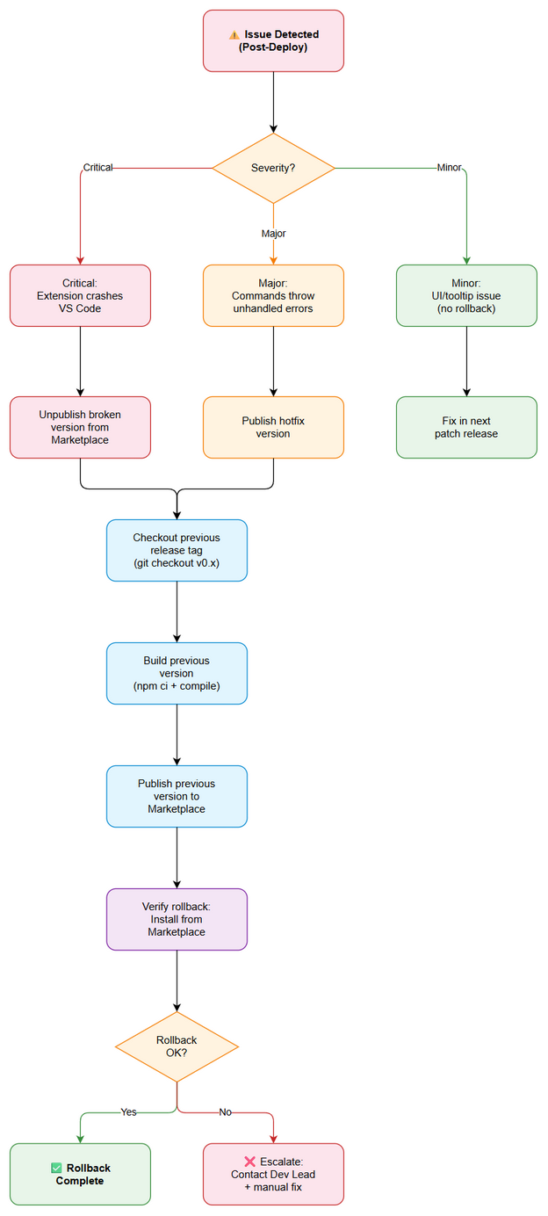
Rollback Flow

8.2 Rollback Decision Criteria
Condition | Action
Extension crashes VS Code on startup | Immediate rollback — unpublish version
Commands throw unhandled errors | Immediate rollback — publish previous version
Extension fails to activate (silent) | Hotfix — patch and publish new version
Minor UI issue (tooltip text wrong) | No rollback — fix in next patch
Marketplace listing metadata wrong | No rollback — update listing metadata

8.3 Rollback Steps
Step | Action | Command | Verification
1 | Unpublish broken version | npx vsce unpublish your-publisher-id.kiro-sdlc-agents | Marketplace shows extension removed
2 | Checkout previous release tag | git checkout v0.9.0 (previous tag) | Source matches previous release
3 | Build previous version | npm ci && npm run compile && npx vsce package | VSIX created
4 | Publish previous version | npx vsce publish --packagePath *.vsix -p <PAT> | Previous version live on Marketplace
5 | Verify rollback | Install from Marketplace | Previous behavior restored
Alternative: Version-specific unpublish (keep extension, remove bad version):
# Unpublish specific version only
npx vsce unpublish your-publisher-id.kiro-sdlc-agents --version 1.0.0

8.4 Rollback Time Estimate
Action | Estimated Time
Decision to rollback | 5 minutes
Unpublish from Marketplace | 2 minutes
Build previous version | 3 minutes
Publish previous version | 5 minutes
Verification | 5 minutes
Total | ~20 minutes

9. Environment-Specific Notes

9.1 DEV (Local Testing)
- Install directly from .vsix file: code --install-extension kiro-sdlc-agents-1.0.0.vsix
- Use VS Code’s “Run Extension” (F5) for debugging during development
- Extension Host output visible in Debug Console
- No approval required

9.2 BETA (Pre-release)
- Publish with --pre-release flag: npx vsce publish --pre-release
- Only users who opt-in to pre-release versions will receive it
- Monitor feedback via GitHub Issues
- Requires Dev Lead approval

9.3 PROD (VS Code Marketplace)
- Deployment Window: Any time (Marketplace publishes are instant, users update asynchronously)
- Approval Required From: Dev Lead + QA Lead
- Communication Plan: Update CHANGELOG.md, create GitHub Release with notes
- Propagation Time: ~5-10 minutes for Marketplace CDN, users get update on next VS Code restart
- Rollback: Unpublish via vsce unpublish or publish patched version

9.4 PROD (Open VSX Registry)
- Published simultaneously with VS Code Marketplace via GitHub Actions
- Serves Kiro IDE and other open-source VS Code forks
- Same approval requirements as Marketplace
- Rollback: npx ovsx unpublish or publish patched version

10. Appendix

Contacts
Role | Name | Contact
Dev Lead | TBD | TBD
QA Lead | TBD | TBD
DevOps | DevOps Agent | Automated
Publisher Admin | TBD | TBD

Related Tickets
Ticket | Summary | Relationship
KSA-2 | Extension Core — Commands & Activation | Main ticket
KSA-1 | Kiro SDLC Agents — VS Code/Kiro Extension | Parent epic
KSA-11 | Publish to Marketplace | Related (distribution)

CI/CD Pipeline Reference
Workflow | Trigger | Purpose
.github/workflows/ci.yml | Push to main, PR to main | Build verification (compile + package)
.github/workflows/publish.yml | Tag push v*, manual dispatch | Publish to Marketplace + Open VSX

