Business Requirements Document (BRD)

Kiro SDLC Agents — KSA-26: [Indexer] Port Pattern Detection Logic from Scripts to MCP Indexer

Document Information
Field | Value
Jira Ticket | KSA-26
Title | [Indexer] Port pattern detection logic from scripts to MCP indexer
Author | BA Agent
Version | 1.0
Date | 2026-05-16
Status | Draft

Author Tracking
Role | Name - Position | Responsibility
Author | BA Agent – Business Analyst | Create document
Peer Reviewer | SA Agent – Solution Architect | Review document

Revision History
Version | Date | Author | Changes
1.0 | 2026-05-16 | BA Agent | Initiate document — auto-generated from Jira ticket KSA-26 and linked tickets (KSA-24, KSA-25, KSA-27, KSA-28)

Sign-Off
Name | Signature and date
 | ☐ I agree and confirm all criteria on this BRD as expected requirements
 | ☐ I agree and confirm all criteria on this BRD as expected requirements

1. Introduction

1.1 Scope
This change request covers porting the existing pattern detection logic from the Code Intelligence scripts (scripts/python/patterns.py and scripts/nodejs/src/full-indexer.ts) into the MCP (Model Context Protocol) indexer servers. The goal is to enable AI agents to query coding patterns in real-time via MCP tools instead of relying on static markdown analysis files.
In scope: - Port 6 pattern detection functions: DI Style, Error Handling, Naming Conventions, Logging Framework, Testing Framework, and Module Purpose inference - Implement full pattern detection for Tier 1 languages (Node.js/TypeScript, Python, Kotlin/Java) - Implement basic pattern detection (DI + Naming only) for Tier 2 languages (Bash, PowerShell, CMD) - Store detected patterns in the modules table (schema defined by KSA-25) - Execute pattern detection after every full and incremental index run - Maintain accuracy equivalent to the existing scripts - Ensure indexing performance degradation does not exceed 10%

1.2 Out of Scope
- Modifying the existing scripts themselves (they remain for CI/CD batch use cases)
- Adding new pattern types beyond the 6 currently detected
- Implementing the code_kb_export MCP tool (covered by KSA-27)
- Enriching the code_modules tool response (covered by KSA-28)
- Schema migration implementation (covered by KSA-25)
- Ollama/AI-based semantic pattern detection (covered by KSA-22)

1.3 Preliminary Requirement
Prerequisite | Description | Related Ticket
Schema migration | The modules table must have pattern metadata columns (di_style, error_handling, naming_convention, logging_framework, testing_framework, purpose) | KSA-25
MCP Server scaffold | MCP servers must be operational with SQLite database and file scanner | KSA-17, KSA-18, KSA-19
File parser | Multi-language regex extraction must be functional to provide class/function/import data | KSA-19

2. Business Requirements

2.1 High Level Process Map
The pattern detection system operates as a post-processing step within the MCP indexer pipeline. After files are scanned and parsed, the pattern detector analyzes aggregated class, function, and import data per module to identify coding patterns.
flowchart TB
A[File Scanner] --> B[File Parser]
B --> C[Aggregate per Module]
C --> D[Pattern Detector]
D --> E[Store in modules table]
E --> F[Available via code_modules tool]
subgraph "Existing Pipeline"
A
B
end
subgraph "New: KSA-26"
C
D
E
end
subgraph "Downstream: KSA-28"
F
end
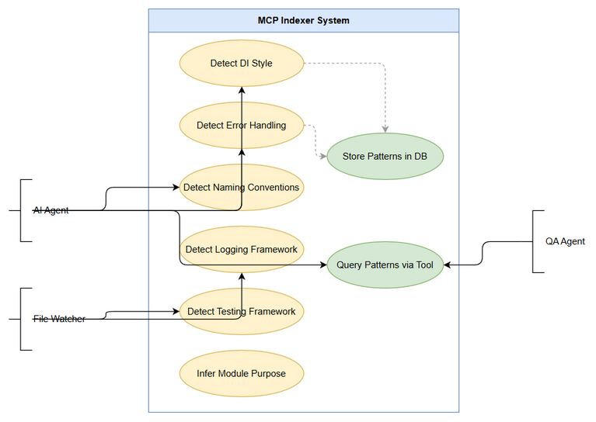 Edit in draw.io
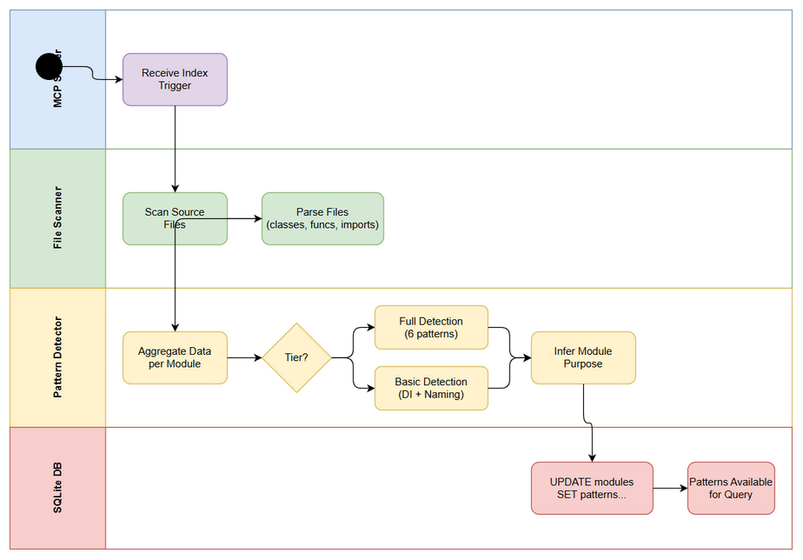 Edit in draw.io
sequenceDiagram
participant Agent as AI Agent
participant MCP as MCP Server
participant Indexer as Indexer Pipeline
participant PD as Pattern Detector
participant DB as SQLite DB
Agent->>MCP: Trigger full/incremental index
MCP->>Indexer: Start indexing
Indexer->>Indexer: Scan files
Indexer->>Indexer: Parse files (classes, functions, imports)
Indexer->>PD: Aggregate data per module
PD->>PD: Detect DI Style
PD->>PD: Detect Error Handling
PD->>PD: Detect Naming
PD->>PD: Detect Logging
PD->>PD: Detect Testing
PD->>PD: Infer Purpose
PD->>DB: UPDATE modules SET patterns...
DB-->>MCP: Patterns stored
MCP-->>Agent: Index complete (with patterns)
Agent->>MCP: code_modules query
MCP->>DB: SELECT * FROM modules
DB-->>MCP: Module data + patterns
MCP-->>Agent: Module info with patterns

2.2 List of User Stories / Use Cases
# | Story / Use Case | Priority | Source Ticket
1 | As an AI agent, I want the MCP indexer to detect DI style patterns so that I can understand dependency injection approaches without reading static files | MUST HAVE | KSA-26
2 | As an AI agent, I want the MCP indexer to detect error handling patterns so that I can generate code consistent with the project’s error handling approach | MUST HAVE | KSA-26
3 | As an AI agent, I want the MCP indexer to detect naming conventions so that I can follow established naming patterns when generating code | MUST HAVE | KSA-26
4 | As an AI agent, I want the MCP indexer to detect logging frameworks so that I can use the correct logging library in generated code | MUST HAVE | KSA-26
5 | As an AI agent, I want the MCP indexer to detect testing frameworks so that I can generate tests using the project’s testing tools | MUST HAVE | KSA-26
6 | As an AI agent, I want the MCP indexer to infer module purpose so that I understand the architectural role of each module | SHOULD HAVE | KSA-26
7 | As a developer, I want pattern detection to run automatically after indexing so that patterns are always up-to-date | MUST HAVE | KSA-26
8 | As a developer, I want pattern detection to not degrade indexing performance by more than 10% so that the development experience remains fast | MUST HAVE | KSA-26

2.3 Details of User Stories

Business Flow
Step 1: MCP server receives an index trigger (full or incremental) from an AI agent or file watcher.
Step 2: The file scanner identifies source files across all discovered modules.
Step 3: The file parser extracts classes, functions, imports, and annotations from each source file using language-specific regex patterns.
Step 4: Parse results are aggregated per module — all classes, functions, and imports belonging to a module are collected.
Step 5: The Pattern Detector runs 6 detection functions on the aggregated data for each module: - detectDiStyle() — analyzes annotations and constructor patterns - detectErrorHandling() — analyzes class names and imports for error patterns - detectNaming() — analyzes class name suffixes - detectLogging() — analyzes import statements for logging libraries - detectTesting() — analyzes import statements for test frameworks - inferModulePurpose() — analyzes module name, class names, and package names
Step 6: Detected patterns are written to the modules table in SQLite.
Step 7: Patterns become queryable via the code_modules MCP tool (KSA-28).
Note: For Tier 2 languages (Bash, PowerShell, CMD), only DI Style and Naming detection are performed due to limited annotation/import parsing capabilities.

STORY 1: Detect DI Style Patterns
As an AI agent, I want the MCP indexer to detect DI style patterns so that I can understand dependency injection approaches without reading static files.
Requirement Details:
- The pattern detector must identify the dependency injection style used in each module by analyzing class annotations, function annotations, and import statements.
- Detection logic must recognize:
  - @Inject and @Autowired annotations → “field injection”
  - Constructor functions with parameters (named constructor or __init__) → “constructor injection”
  - No DI indicators found → “none”
- The detection must work across all Tier 1 languages (TypeScript/Node.js, Python, Kotlin/Java).
- For Tier 2 languages (Bash, PowerShell, CMD), basic detection via string matching on annotations is sufficient.
Data Fields:
Field | Type | Required | Description | Example
di_style | TEXT | Yes | Detected DI pattern | “field injection”, “constructor injection”, “none”
Acceptance Criteria:
- Given a module with @Inject or @Autowired annotations in class/function metadata, the detector returns “field injection”
- Given a module with constructor functions that have parameters, the detector returns “constructor injection”
- Given a module with no DI indicators, the detector returns “none”
- Detection accuracy matches the output of scripts/python/patterns.py::_detect_di() for the same input data
Validation Rules:
- di_style must be one of: “field injection”, “constructor injection”, “none”
- If both field injection and constructor injection indicators are found, “field injection” takes precedence (matching existing script behavior)

STORY 2: Detect Error Handling Patterns
As an AI agent, I want the MCP indexer to detect error handling patterns so that I can generate code consistent with the project’s error handling approach.
Requirement Details:
- The pattern detector must identify the error handling approach by analyzing class names and import statements.
- Detection logic must recognize:
  - Result or Either types in imports/class names → “Result type”
  - ExceptionHandler or ControllerAdvice in imports/class names → “exception handler”
  - Exception, Error, try, catch keywords → “try-catch”
  - No error handling indicators → “unknown”
- Priority order: Result type > exception handler > try-catch > unknown
Data Fields:
Field | Type | Required | Description | Example
error_handling | TEXT | Yes | Detected error handling approach | “Result type”, “exception handler”, “try-catch”, “unknown”
Acceptance Criteria:
- Given a module importing Result or Either types, the detector returns “Result type”
- Given a module with @ExceptionHandler or @ControllerAdvice, the detector returns “exception handler”
- Given a module with standard try-catch patterns, the detector returns “try-catch”
- Given a module with no error handling indicators, the detector returns “unknown”
- Detection accuracy matches scripts/python/patterns.py::_detect_error_handling()
Validation Rules:
- error_handling must be one of: “Result type”, “exception handler”, “try-catch”, “unknown”

STORY 3: Detect Naming Conventions
As an AI agent, I want the MCP indexer to detect naming conventions so that I can follow established naming patterns when generating code.
Requirement Details:
- The pattern detector must identify naming conventions by analyzing class name suffixes.
- Detection logic must check for standard suffixes: Controller, Service, Repository
- Output format: comma-separated list of found patterns (e.g., "Controller, Service, *Repository")
- If no standard suffixes are found → “unknown”
Data Fields:
Field | Type | Required | Description | Example
naming_convention | TEXT | Yes | Detected naming patterns | "Controller, Service, *Repository“,”unknown"
Acceptance Criteria:
- Given a module with classes ending in “Controller”, the detector includes "*Controller" in the result
- Given a module with classes ending in “Service”, the detector includes "*Service" in the result
- Given a module with classes ending in “Repository”, the detector includes "*Repository" in the result
- Multiple suffixes are comma-separated in the output
- Given a module with no standard suffixes, the detector returns “unknown”
- Detection accuracy matches scripts/python/patterns.py::_detect_naming()
Validation Rules:
- Output is either “unknown” or a comma-separated list of *Suffix patterns
- Only the 3 standard suffixes are checked (Controller, Service, Repository)

STORY 4: Detect Logging Framework
As an AI agent, I want the MCP indexer to detect logging frameworks so that I can use the correct logging library in generated code.
Requirement Details:
- The pattern detector must identify the logging framework by analyzing import statements.
- Detection logic must recognize:
  - slf4j or SLF4J → “SLF4J”
  - log4j or Log4j → “Log4j”
  - logging (Python stdlib) → “logging”
  - console → “console.log”
  - No logging indicators → “unknown”
Data Fields:
Field | Type | Required | Description | Example
logging_framework | TEXT | Yes | Detected logging framework | “SLF4J”, “Log4j”, “logging”, “console.log”, “unknown”
Acceptance Criteria:
- Given a module importing org.slf4j.*, the detector returns “SLF4J”
- Given a module importing log4j, the detector returns “Log4j”
- Given a Python module importing logging, the detector returns “logging”
- Given a Node.js module using console, the detector returns “console.log”
- Given a module with no logging imports, the detector returns “unknown”
- Detection accuracy matches scripts/python/patterns.py::_detect_logging()
Validation Rules:
- logging_framework must be one of: “SLF4J”, “Log4j”, “logging”, “console.log”, “unknown”

STORY 5: Detect Testing Framework
As an AI agent, I want the MCP indexer to detect testing frameworks so that I can generate tests using the project’s testing tools.
Requirement Details:
- The pattern detector must identify the testing framework by analyzing import statements.
- Detection logic must recognize:
  - junit or org.junit → “JUnit”
  - jest or @jest → “Jest”
  - pytest or unittest → “pytest”
  - vitest → “vitest”
  - kotest → “kotest”
  - No testing indicators → “unknown”
Data Fields:
Field | Type | Required | Description | Example
testing_framework | TEXT | Yes | Detected testing framework | “JUnit”, “Jest”, “pytest”, “vitest”, “kotest”, “unknown”
Acceptance Criteria:
- Given a module importing org.junit.*, the detector returns “JUnit”
- Given a module importing from jest or @jest/*, the detector returns “Jest”
- Given a module importing pytest or unittest, the detector returns “pytest”
- Given a module importing from vitest, the detector returns “vitest”
- Given a module importing from kotest, the detector returns “kotest”
- Given a module with no test imports, the detector returns “unknown”
- Detection accuracy matches scripts/python/patterns.py::_detect_testing()
Validation Rules:
- testing_framework must be one of: “JUnit”, “Jest”, “pytest”, “vitest”, “kotest”, “unknown”

STORY 6: Infer Module Purpose
As an AI agent, I want the MCP indexer to infer module purpose so that I understand the architectural role of each module.
Requirement Details:
- The pattern detector must infer the purpose of each module by analyzing the module name, class names, and package names.
- Purpose inference keywords and mappings:
  - api, controller → “API layer”
  - service, business → “Business logic”
  - repository, dao, data → “Data access”
  - config, configuration → “Configuration”
  - common, shared → “Shared utilities”
  - test, spec → “Testing”
  - web, ui → “Web/UI layer”
  - model, domain → “Domain model”
  - No match → “Application module”
- All name matching is case-insensitive.
Data Fields:
Field | Type | Required | Description | Example
purpose | TEXT | Yes | Inferred module purpose | “API layer”, “Business logic”, “Data access”, etc.
Acceptance Criteria:
- Given a module named “user-controller” with Controller classes, the detector returns “API layer”
- Given a module named “order-service”, the detector returns “Business logic”
- Given a module named “data-repository”, the detector returns “Data access”
- Given a module with no matching keywords, the detector returns “Application module”
- Detection accuracy matches scripts/python/patterns.py::infer_module_purpose()
Validation Rules:
- purpose must be one of the defined purpose strings
- First keyword match wins (priority order as listed above)

STORY 7: Automatic Pattern Detection After Indexing
As a developer, I want pattern detection to run automatically after indexing so that patterns are always up-to-date.
Requirement Details:
- Pattern detection must execute automatically as a post-processing step after both full index and incremental index operations.
- For full index: detect patterns for ALL modules.
- For incremental index: detect patterns only for modules whose files were modified (re-aggregate and re-detect).
- Pattern results must be persisted to the modules table immediately after detection.
- If pattern detection fails for a module, log the error and continue with remaining modules (no full-pipeline failure).
Acceptance Criteria:
- After a full index completes, all modules in the modules table have non-null pattern columns
- After an incremental index modifies files in module X, module X’s patterns are re-detected and updated
- Modules not affected by an incremental index retain their existing pattern values
- Pattern detection errors are logged but do not cause the indexing pipeline to fail
- Pattern detection runs in all 6 MCP server variants

STORY 8: Performance Constraint
As a developer, I want pattern detection to not degrade indexing performance by more than 10% so that the development experience remains fast.
Requirement Details:
- The total time added by pattern detection must not exceed 10% of the base indexing time (scan + parse).
- Pattern detection operates on already-parsed data (classes, functions, imports) — it does NOT re-read source files.
- All detection functions are pure string matching / suffix checking — no complex regex or AST operations.
- Performance must be measured and reported in the index result summary.
Acceptance Criteria:
- Given a project with 1000 source files, pattern detection adds less than 10% to total indexing time
- Pattern detection does not perform any file I/O — it operates solely on in-memory parsed data
- The index result includes patternDetectionMs field showing elapsed time for pattern detection
- Performance is validated by comparing indexing time with and without pattern detection enabled
Validation Rules:
- patternDetectionMs / totalIndexMs < 0.10 (10% threshold)

3. Dependencies
Dependency | Type | Related Ticket | Description
Schema migration | System | KSA-25 | modules table must have pattern metadata columns before patterns can be stored
MCP Server scaffold | System | KSA-17 | MCP server must be operational with stdio transport
SQLite + FTS5 | System | KSA-18 | Database must be initialized with proper schema
File Scanner + Parser | System | KSA-19 | Multi-language regex extraction must provide class/function/import data
Incremental indexer | System | KSA-21 | Incremental index must support re-detection for modified modules
code_modules tool | Downstream | KSA-28 | Consumes pattern data stored by this ticket
code_kb_export tool | Downstream | KSA-27 | Consumes pattern data for KB payload generation

4. Stakeholders
Role | Name / Team | Responsibility | Source
Reporter | Duc Nguyen Minh | Define requirements, validate accuracy | KSA-26 reporter
SA Agent | Solution Architect | Design pattern detection architecture for 6 variants | User context
DEV Agent | Developer | Implement pattern detection in all 6 MCP server variants | User context
QA Agent | Quality Assurance | Verify accuracy vs. existing scripts output | User context

5. Risks and Assumptions

5.1 Risks
Risk | Impact | Likelihood | Mitigation
Parser output format differs between MCP variants | High | Medium | Define a common interface/contract for parsed data (ClassInfo, FunctionInfo, imports array)
Performance degradation exceeds 10% on large projects | Medium | Low | Pattern detection is pure string matching on in-memory data; benchmark early
Tier 2 languages have insufficient parse data for pattern detection | Medium | Medium | Accept basic detection only (DI + naming) for Tier 2; document limitation
Schema migration (KSA-25) delayed | High | Low | KSA-26 cannot store results without schema; coordinate delivery order
Inconsistent detection results across 6 variants | High | Medium | Use identical detection logic/algorithm; QA validates cross-variant consistency

5.2 Assumptions
- The existing pattern detection logic in scripts/python/patterns.py and scripts/nodejs/src/full-indexer.ts is the authoritative reference for expected behavior.
- The file parser (KSA-19) provides ClassInfo[], FunctionInfo[], and string[] (imports) per file, which can be aggregated per module.
- All 6 MCP server variants share the same SQLite schema (defined by KSA-25).
- Pattern detection is deterministic — same input always produces same output.
- “Accuracy equivalent to scripts” means identical output for the same parsed input data.

6. Non-Functional Requirements
Category | Requirement | Details
Performance | Pattern detection overhead < 10% | Must not add more than 10% to total indexing time
Performance | No file I/O during detection | Operates on in-memory parsed data only
Compatibility | All 6 MCP variants | Node.js, Python, Kotlin (Tier 1 full), Bash, PowerShell, CMD (Tier 2 basic)
Reliability | Fault tolerance | Detection failure for one module must not crash the pipeline
Maintainability | Single-responsibility modules | Pattern detection logic in dedicated file (e.g., patterns.ts, patterns.py)
Accuracy | Equivalent to scripts | Same input → same output as existing scripts
Backward Compatibility | Existing DB readable | Modules without patterns (null/default values) must not break queries

7. Related Tickets
Ticket Key | Summary | Status | Type | Relationship
KSA-26 | [Indexer] Port pattern detection logic from scripts to MCP indexer | To Do | Task | Main ticket
KSA-24 | [Epic] Merge Code Intelligence: Scripts Pattern Detection + MCP Real-time Query | To Do | Epic | Parent epic
KSA-25 | [DB] Extend modules table schema for pattern metadata | To Do | Task | Blocked by (schema dependency)
KSA-27 | [Tool] Add code_kb_export MCP tool for KB payload generation | To Do | Task | Depends on KSA-26
KSA-28 | [Tool] Enrich code_modules response with pattern metadata | To Do | Task | Depends on KSA-26
KSA-16 | [MCP Server] Local Code Intelligence — Standalone MCP Server | To Do | Epic | Parent system
KSA-17 | MCP Server Scaffold — TypeScript + @modelcontextprotocol/sdk | In Progress | Task | Prerequisite
KSA-18 | SQLite Schema + FTS5 Setup — Database lifecycle and migrations | In Progress | Task | Prerequisite
KSA-19 | File Scanner + Signature Extractor — Multi-language regex extraction | In Progress | Task | Prerequisite
KSA-21 | Background Indexing + File Watcher — Non-blocking incremental updates | To Do | Task | Related (incremental detection)

8. Appendix

Pattern Detection Logic Reference
The following table summarizes the detection logic that must be ported from scripts to MCP indexer:
Pattern | Input Data | Detection Logic | Possible Values
DI Style | annotations, imports, function names | Check for @Inject/@Autowired → field injection; Check for constructor with params → constructor injection | “field injection”, “constructor injection”, “none”
Error Handling | class names, imports | Check for Result/Either → Result type; Check for ExceptionHandler/ControllerAdvice → exception handler; Check for Exception/Error → try-catch | “Result type”, “exception handler”, “try-catch”, “unknown”
Naming | class names | Check suffixes: Controller, Service, Repository | "Controller, Service, *Repository" or “unknown”
Logging | imports | Check for slf4j, log4j, logging, console | “SLF4J”, “Log4j”, “logging”, “console.log”, “unknown”
Testing | imports | Check for junit, jest, pytest, vitest, kotest | “JUnit”, “Jest”, “pytest”, “vitest”, “kotest”, “unknown”
Purpose | module name, class names, package names | Keyword matching (case-insensitive) against purpose map | “API layer”, “Business logic”, “Data access”, etc.

Tier Classification
Tier | Languages | Pattern Support | Rationale
Tier 1 | Node.js/TypeScript, Python, Kotlin/Java | Full (all 6 patterns) | Rich annotation/import parsing available
Tier 2 | Bash, PowerShell, CMD | Basic (DI + Naming only) | Limited parsing capabilities; no annotation system

Source Code References
File | Functions | Purpose
scripts/python/patterns.py | detect_patterns(), infer_module_purpose(), _detect_di(), _detect_error_handling(), _detect_naming(), _detect_logging(), _detect_testing() | Python reference implementation
scripts/nodejs/src/full-indexer.ts | detectDiStyle(), detectErrorHandling(), detectNaming(), detectLogging(), detectTesting(), detectPatterns(), inferModulePurpose() | TypeScript reference implementation

Glossary
Term | Definition
MCP | Model Context Protocol — standard for AI agent tool communication
DI | Dependency Injection — design pattern for managing object dependencies
FTS5 | Full-Text Search 5 — SQLite extension for text search
Tier 1 | Languages with full pattern detection support (Node.js, Python, Kotlin)
Tier 2 | Languages with basic pattern detection support (Bash, PowerShell, CMD)
Pattern Detection | Process of identifying coding patterns from parsed source code metadata

Reference Documents
Document | Link / Location
Python patterns implementation | .analysis/code-intelligence/scripts/python/patterns.py
TypeScript indexer implementation | .analysis/code-intelligence/scripts/nodejs/src/full-indexer.ts
KSA-25 Schema definition | Jira ticket KSA-25
Epic overview | Jira ticket KSA-24

