Technical Design Document (TDD)

Kiro SDLC Agents — KSA-26: [Indexer] Port Pattern Detection Logic from Scripts to MCP Indexer

Document Information
Field | Value
Jira Ticket | KSA-26
Title | [Indexer] Port pattern detection logic from scripts to MCP indexer
Author | SA Agent
Version | 1.0
Date | 2025-01-20
Status | Draft
Related BRD | BRD-v1.0-KSA-26.docx
Related FSD | N/A (BRD serves as functional spec for this infrastructure ticket)

Author Tracking
Role | Name - Position | Responsibility
Author | SA Agent – Solution Architect | Create document
Peer Reviewer | DEV Agent – Developer | Review document

Revision History
Version | Date | Author | Changes
1.0 | 2025-01-20 | SA Agent | Initiate document — auto-generated from BRD and source code analysis

Sign-Off
Name | Signature and date
 | ☐ I agree and confirm the technical design in this TDD
 | ☐ I agree and confirm the technical design in this TDD

1. Introduction

1.1 Purpose
This TDD specifies the technical design for porting the existing pattern detection logic from the Code Intelligence scripts (scripts/python/patterns.py and scripts/nodejs/src/full-indexer.ts) into the 6 MCP indexer server variants. The goal is to enable real-time pattern detection during indexing, storing results in the modules table for downstream consumption by code_modules and code_kb_export tools.

1.2 Scope
- New pattern-detector module in each of the 6 MCP server variants
- Integration into the existing IndexingEngine pipeline (post-scan, post-parse)
- Schema extension for pattern metadata columns in modules table (depends on KSA-25)
- Performance validation (< 10% overhead)

1.3 Technology Stack
Layer | Technology | Version
Node.js MCP | TypeScript + better-sqlite3 | Node 20+
Python MCP | Python + sqlite3 (stdlib) | Python 3.11+
Kotlin MCP | Kotlin + JDBC SQLite | Kotlin 1.9+ / JDK 17+
Bash MCP | Bash + sqlite3 CLI | Bash 4+
PowerShell MCP | PowerShell + sqlite3 CLI | PowerShell 5.1+ / 7+
CMD MCP | Batch + sqlite3.exe | Windows CMD
Database | SQLite + FTS5 | 3.40+
MCP Protocol | @modelcontextprotocol/sdk | 1.x

1.4 Design Principles
- Zero external dependencies — Pattern detection uses only stdlib string operations
- Single Responsibility — Each pattern detector function does one thing
- Deterministic — Same input always produces same output
- Fault-tolerant — Detection failure for one module does not crash the pipeline
- Performance-first — Pure string matching, no file I/O, no regex beyond simple contains/endsWith

1.5 Constraints
- Pattern detection must NOT re-read source files — operates on in-memory parsed data only
- Must produce identical output to existing scripts for the same input
- Tier 2 languages (Bash, PowerShell, CMD) only support DI Style + Naming detection
- Depends on KSA-25 schema migration being applied first
- Maximum 200 lines per file, 20 lines per function (code standards)

1.6 References
Document | Location
BRD | documents/KSA-26/BRD.md
Python reference implementation | .analysis/code-intelligence/scripts/python/patterns.py
TypeScript reference implementation | .analysis/code-intelligence/scripts/nodejs/src/full-indexer.ts
KSA-25 Schema migration | Jira ticket KSA-25

2. System Architecture

2.1 Architecture Overview
The pattern detection system is a post-processing step within each MCP indexer’s pipeline. It receives aggregated parse data (classes, functions, imports) per module and produces pattern metadata that is stored in the modules table.
graph TB
subgraph "MCP Server (any variant)"
A[File Scanner] --> B[Signature Extractor]
B --> C[IndexingEngine]
C --> D[updateModules]
D --> E[PatternDetector]
E --> F[SQLite modules table]
end
subgraph "Downstream Tools"
F --> G[code_modules tool]
F --> H[code_kb_export tool]
end
subgraph "Input Data (per module)"
I[ClassInfo array] --> E
J[FunctionInfo array] --> E
K[imports array] --> E
end
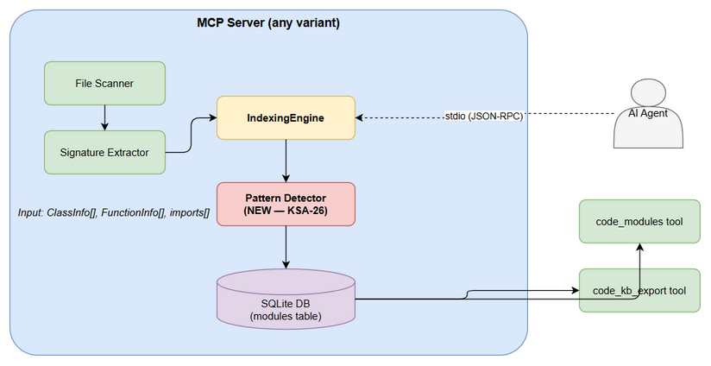 Edit in draw.io

2.2 Component Diagram
graph LR
subgraph "scanner/"
FS[file-scanner] --> SE[signature-extractor]
SE --> PD[pattern-detector]
end
subgraph "indexer/"
IE[IndexingEngine]
end
subgraph "db/"
DM[DatabaseManager]
SC[Schema/Migrations]
end
IE --> FS
IE --> PD
IE --> DM
DM --> SC
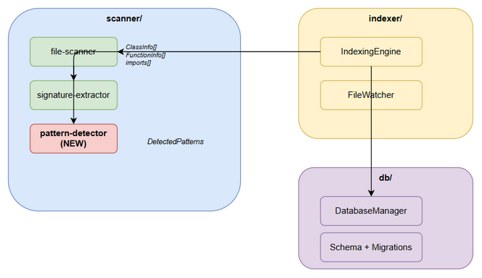 Edit in draw.io
Component | Responsibility | Technology
PatternDetector | Detect 6 coding patterns from parsed data | Pure string matching
IndexingEngine | Orchestrate scan → parse → detect → store | Language-specific
DatabaseManager | SQLite lifecycle, migrations, queries | better-sqlite3 / sqlite3
FileScanner | Traverse workspace, detect languages | fs / pathlib / find
SignatureExtractor | Extract classes, functions, imports via regex | Language-specific regex

2.3 Deployment Architecture
Each MCP server variant is a standalone process communicating via stdio with the AI agent. Pattern detection is embedded within the server process — no separate service or network call.
graph TB
subgraph "Developer Machine"
Agent[AI Agent / IDE] -->|stdio| MCP[MCP Server Process]
MCP --> DB[(SQLite .code-intel/index.db)]
MCP --> WS[Workspace Files]
end
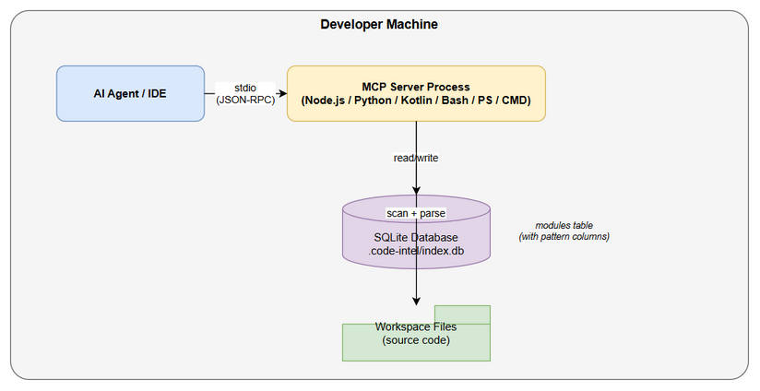 Edit in draw.io

2.4 Communication Patterns
From | To | Protocol | Pattern | Description
AI Agent | MCP Server | stdio (JSON-RPC) | Sync | Tool invocation triggers indexing
IndexingEngine | PatternDetector | In-process function call | Sync | Direct function invocation
PatternDetector | SQLite | JDBC/better-sqlite3 | Sync | UPDATE modules SET patterns

3. API Design
Pattern detection is an internal pipeline step — it does not expose new MCP tools. However, it modifies the data returned by existing tools (code_modules, code_index_status).

3.1 Modified Tool Response: code_modules
Implements: Story 1-6 (pattern data in module response)
The code_modules MCP tool response will be enriched (by KSA-28) with pattern fields. This section documents the data contract that pattern detection must fulfill.
Enhanced Module Record (after KSA-25 + KSA-26):
{
"name": "core",
"root_path": "src/main/kotlin/com/example/core",
"language": "kotlin",
"file_count": 42,
"symbol_count": 156,
"di_style": "constructor injection",
"error_handling": "Result type",
"naming_convention": "*Controller, *Service, *Repository",
"logging_framework": "SLF4J",
"testing_framework": "JUnit",
"purpose": "Business logic"
}

3.2 Modified Tool Response: code_index_status
Implements: Story 7-8 (automatic detection + performance tracking)
The index status response will include pattern detection timing:
{
"status": "complete",
"totalFiles": 1000,
"totalModules": 8,
"elapsedMs": 5200,
"patternDetectionMs": 45,
"patternsDetected": true
}

3.3 Internal API Contract: PatternDetector Input
All 6 variants must accept the same logical input structure:
// TypeScript representation (canonical)
interface PatternInput {
moduleName: string;
classes: ClassInfo[]; // from signature extractor
functions: FunctionInfo[]; // from signature extractor
imports: string[]; // from file parser
packages: string[]; // unique package names in module
}
interface ClassInfo {
name: string;
visibility: string;
annotations: string[];
}
interface FunctionInfo {
name: string;
visibility: string;
parameters: { name: string; type: string }[];
annotations: string[];
}

3.4 Internal API Contract: PatternDetector Output
interface DetectedPatterns {
diStyle: string; // "field injection" | "constructor injection" | "none"
errorHandling: string; // "Result type" | "exception handler" | "try-catch" | "unknown"
naming: string; // "*Controller, *Service, *Repository" | "unknown"
logging: string; // "SLF4J" | "Log4j" | "logging" | "console.log" | "unknown"
testing: string; // "JUnit" | "Jest" | "pytest" | "vitest" | "kotest" | "unknown"
purpose: string; // "API layer" | "Business logic" | ... | "Application module"
}

4. Database Design

4.1 Schema Overview
The modules table is extended with 6 pattern metadata columns (KSA-25 provides the migration, KSA-26 populates the data).
erDiagram
files {
INTEGER id PK
TEXT path
TEXT relative_path
TEXT language
TEXT module FK
TEXT content_hash
INTEGER size_bytes
INTEGER line_count
TEXT last_indexed
}
symbols {
INTEGER id PK
INTEGER file_id FK
TEXT name
TEXT kind
TEXT signature
INTEGER start_line
INTEGER end_line
TEXT parent_symbol
TEXT visibility
TEXT doc_comment
}
modules {
INTEGER id PK
TEXT name UK
TEXT root_path
TEXT language
TEXT description
INTEGER file_count
INTEGER symbol_count
TEXT di_style
TEXT error_handling
TEXT naming_convention
TEXT logging_framework
TEXT testing_framework
TEXT purpose
}
files ||--o{ symbols : "has"
modules ||--o{ files : "contains"
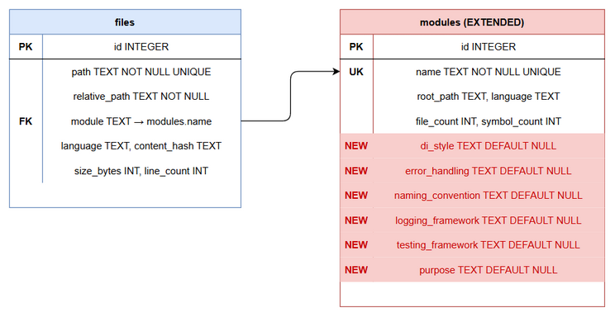 Edit in draw.io

4.2 DDL Scripts

Migration: Add pattern columns to modules table
Note: This DDL is defined by KSA-25. Shown here for reference — KSA-26 does NOT execute this migration.
-- KSA-25 Migration V2: Add pattern metadata columns
ALTER TABLE modules ADD COLUMN di_style TEXT DEFAULT NULL;
ALTER TABLE modules ADD COLUMN error_handling TEXT DEFAULT NULL;
ALTER TABLE modules ADD COLUMN naming_convention TEXT DEFAULT NULL;
ALTER TABLE modules ADD COLUMN logging_framework TEXT DEFAULT NULL;
ALTER TABLE modules ADD COLUMN testing_framework TEXT DEFAULT NULL;
ALTER TABLE modules ADD COLUMN purpose TEXT DEFAULT NULL;

KSA-26 SQL: Update patterns for a module
-- Pattern update query (executed per module after detection)
UPDATE modules
SET di_style = ?,
error_handling = ?,
naming_convention = ?,
logging_framework = ?,
testing_framework = ?,
purpose = ?
WHERE name = ?;

KSA-26 SQL: Aggregate data for pattern detection
-- Get all symbols for a specific module (used to build ClassInfo/FunctionInfo arrays)
SELECT s.name, s.kind, s.signature, s.visibility, s.doc_comment
FROM symbols s
JOIN files f ON s.file_id = f.id
WHERE f.module = ?;
-- Get all imports for a module (extracted from file content during indexing)
-- Note: imports are not currently stored in DB — they must be collected during indexing
-- and passed in-memory to the pattern detector.

4.3 Migration Plan
Order | Script | Description | Estimated Time | Rollback
1 | KSA-25 migration | Add 6 columns to modules | < 1ms (ALTER TABLE) | DROP COLUMN (SQLite 3.35+)

4.4 Query Patterns
Operation | Query Pattern | Expected Performance
Update module patterns | UPDATE modules SET ... WHERE name = ? | < 1ms per module
Get symbols per module | SELECT ... FROM symbols JOIN files WHERE module = ? | < 10ms for 500 symbols
Full pattern detection (all modules) | N updates in transaction | < 50ms for 10 modules

4.5 Data Volume Estimates
Metric | Typical | Large Project
Modules per project | 3-8 | 15-30
Files per module | 10-50 | 100-500
Symbols per module | 50-200 | 500-2000
Pattern detection time per module | < 5ms | < 10ms

5. Class / Module Design

5.1 Package Structure — All Variants
Each MCP server variant adds a single new file in the scanner directory (or equivalent):
mcp-code-intelligence-nodejs/src/scanner/
├── file-scanner.ts # Existing
├── signature-extractor.ts # Existing
└── pattern-detector.ts # NEW (KSA-26)
mcp-code-intelligence-python/src/mcp_code_intel/
├── scanner.py # Existing
├── extractor.py # Existing
└── patterns.py # NEW (KSA-26)
mcp-code-intelligence-kotlin/src/main/kotlin/com/codeintel/scanner/
├── FileScanner.kt # Existing
├── SignatureExtractor.kt # Existing
└── PatternDetector.kt # NEW (KSA-26)
mcp-code-intelligence-bash/lib/
├── scan.sh # Existing
├── extract.sh # Existing
└── patterns.sh # NEW (KSA-26)
mcp-code-intelligence-powershell/
├── code-intel-scan.ps1 # Existing
├── code-intel-extract.ps1 # Existing
└── code-intel-patterns.ps1 # NEW (KSA-26)
mcp-code-intelligence-cmd/
├── code-intel-scan.cmd # Existing
├── code-intel-extract.cmd # Existing
└── code-intel-patterns.cmd # NEW (KSA-26)

5.2 Class Diagram
classDiagram
class PatternDetector {
+detectPatterns(classes, functions, imports) DetectedPatterns
+inferModulePurpose(name, classes, packages) string
-detectDiStyle(classes, functions, imports) string
-detectErrorHandling(classes, imports) string
-detectNaming(classes) string
-detectLogging(imports) string
-detectTesting(imports) string
}
class DetectedPatterns {
+diStyle: string
+errorHandling: string
+naming: string
+logging: string
+testing: string
}
class IndexingEngine {
+runFullIndex() void
+indexSingleFile(path) void
-updateModules() void
-detectAndStorePatterns() void
}
class ClassInfo {
+name: string
+visibility: string
+annotations: string[]
}
class FunctionInfo {
+name: string
+visibility: string
+parameters: ParameterInfo[]
+annotations: string[]
}
IndexingEngine --> PatternDetector : uses
PatternDetector --> DetectedPatterns : produces
PatternDetector ..> ClassInfo : reads
PatternDetector ..> FunctionInfo : reads
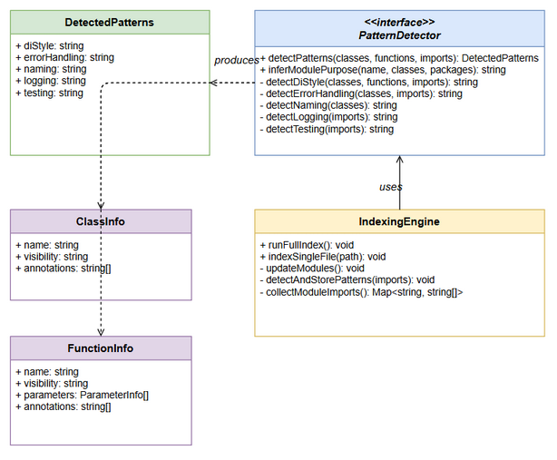 Edit in draw.io

5.3 Key Interfaces — TypeScript (Node.js)
// pattern-detector.ts — New file
/** Input: aggregated parse data for one module. */
export interface ModuleParseData {
moduleName: string;
classes: ClassInfo[];
functions: FunctionInfo[];
imports: string[];
packages: string[];
}
/** Output: detected patterns for one module. */
export interface DetectedPatterns {
diStyle: string;
errorHandling: string;
naming: string;
logging: string;
testing: string;
}
/** Detect all coding patterns from aggregated module data. */
export function detectPatterns(
classes: ClassInfo[],
functions: FunctionInfo[],
imports: string[]
): DetectedPatterns;
/** Infer module purpose from name, classes, and packages. */
export function inferModulePurpose(
moduleName: string,
classes: ClassInfo[],
packages: string[]
): string;

5.4 Key Interfaces — Python
# patterns.py — New file
from typing import TypedDict
class DetectedPatterns(TypedDict):
di_style: str
error_handling: str
naming: str
logging: str
testing: str
def detect_patterns(
classes: list[dict], functions: list[dict], imports: list[str]
) -> DetectedPatterns:
"""Detect coding patterns from aggregated parse results."""
...
def infer_module_purpose(
name: str, classes: list[dict], packages: list[str]
) -> str:
"""Infer a module's purpose from its contents."""
...

5.5 Key Interfaces — Kotlin
// PatternDetector.kt — New file
package com.codeintel.scanner
data class DetectedPatterns(
val diStyle: String,
val errorHandling: String,
val naming: String,
val logging: String,
val testing: String
)
object PatternDetector {
fun detectPatterns(
classes: List<SymbolInfo>,
functions: List<SymbolInfo>,
imports: List<String>
): DetectedPatterns
fun inferModulePurpose(
moduleName: String,
classes: List<SymbolInfo>,
packages: List<String>
): String
}

5.6 Detection Algorithm — Pseudocode

5.6.1 detectDiStyle
FUNCTION detectDiStyle(classes, functions, imports):
allText = JOIN(imports) + JOIN(class.annotations for each class) + JOIN(function.annotations for each function)
IF "@Inject" IN allText OR "@Autowired" IN allText:
RETURN "field injection"
FOR EACH function IN functions:
IF function.name == "constructor" OR function.name == "__init__":
IF function.parameters.length > 0:
RETURN "constructor injection"
RETURN "none"
Priority: field injection > constructor injection > none

5.6.2 detectErrorHandling
FUNCTION detectErrorHandling(classes, imports):
allText = JOIN(imports) + JOIN(class.name for each class)
IF "Result" IN allText OR "Either" IN allText:
RETURN "Result type"
IF "ExceptionHandler" IN allText OR "ControllerAdvice" IN allText:
RETURN "exception handler"
IF "Exception" IN allText OR "Error" IN allText:
RETURN "try-catch"
RETURN "unknown"
Priority: Result type > exception handler > try-catch > unknown

5.6.3 detectNaming
FUNCTION detectNaming(classes):
suffixes = ["Controller", "Service", "Repository"]
found = []
FOR EACH suffix IN suffixes:
IF ANY class.name ENDS_WITH suffix:
found.APPEND("*" + suffix)
IF found IS EMPTY:
RETURN "unknown"
RETURN JOIN(found, ", ")

5.6.4 detectLogging
FUNCTION detectLogging(imports):
allImports = JOIN(imports)
IF "slf4j" IN allImports OR "SLF4J" IN allImports:
RETURN "SLF4J"
IF "log4j" IN allImports OR "Log4j" IN allImports:
RETURN "Log4j"
IF "logging" IN allImports:
RETURN "logging"
IF "console" IN allImports:
RETURN "console.log"
RETURN "unknown"
Priority: SLF4J > Log4j > logging > console.log > unknown

5.6.5 detectTesting
FUNCTION detectTesting(imports):
allImports = JOIN(imports)
IF "junit" IN allImports OR "org.junit" IN allImports:
RETURN "JUnit"
IF "pytest" IN allImports OR "unittest" IN allImports:
RETURN "pytest"
IF "jest" IN allImports OR "@jest" IN allImports:
RETURN "Jest"
IF "kotest" IN allImports:
RETURN "kotest"
IF "vitest" IN allImports:
RETURN "vitest"
RETURN "unknown"
Priority: JUnit > pytest > Jest > kotest > vitest > unknown

5.6.6 inferModulePurpose
FUNCTION inferModulePurpose(moduleName, classes, packages):
allNames = LOWERCASE(JOIN([moduleName] + class.names + packages))
purposes = [
("api", "API layer"), ("controller", "API layer"),
("service", "Business logic"), ("business", "Business logic"),
("repository", "Data access"), ("dao", "Data access"), ("data", "Data access"),
("config", "Configuration"), ("configuration", "Configuration"),
("common", "Shared utilities"), ("shared", "Shared utilities"),
("test", "Testing"), ("spec", "Testing"),
("web", "Web/UI layer"), ("ui", "Web/UI layer"),
("model", "Domain model"), ("domain", "Domain model"),
]
FOR EACH (keyword, purpose) IN purposes:
IF keyword IN allNames:
RETURN purpose
RETURN "Application module"
Priority: First match wins (order matters).

5.7 Design Patterns
Pattern | Where Used | Rationale
Pure Functions | All detection functions | No side effects, deterministic, easy to test
Strategy (implicit) | Per-pattern detection | Each pattern has its own detection strategy
Facade | detectPatterns() | Single entry point aggregates all 5 detections
Module Pattern | File-level encapsulation | Private helpers, public API surface

5.8 Error Handling
Pattern detection is fault-tolerant. Errors are logged but never propagate to crash the pipeline.
Error Scenario | Handling | Fallback Value
Empty classes array | Return defaults | “none”/“unknown” per field
Empty imports array | Skip import-based detection | “unknown” for logging/testing
Null/undefined input | Guard clause, return defaults | All fields “unknown”
SQL UPDATE fails | Log error, continue next module | Module retains NULL patterns
Exception in detection | try-catch wrapper, log, continue | “unknown” for failed field

6. Integration Design

6.1 Integration Point: IndexingEngine → PatternDetector
Pattern detection integrates into the existing updateModules() method of each IndexingEngine. The integration is a post-processing step that runs after modules are rebuilt.
sequenceDiagram
participant IE as IndexingEngine
participant FS as FileScanner
participant SE as SignatureExtractor
participant PD as PatternDetector
participant DB as SQLite
IE->>FS: scanWorkspace()
FS-->>IE: ScannedFile[]
loop For each file
IE->>SE: extractSymbols(content, language)
SE-->>IE: ExtractedSymbol[]
Note over IE: Collect imports per module (in-memory)
end
IE->>DB: INSERT/UPDATE files + symbols
IE->>DB: DELETE + INSERT modules (rebuild)
Note over IE: Pattern Detection Phase
loop For each module
IE->>DB: SELECT symbols WHERE module = ?
DB-->>IE: ClassInfo[], FunctionInfo[]
IE->>PD: detectPatterns(classes, functions, imports)
PD-->>IE: DetectedPatterns
IE->>PD: inferModulePurpose(name, classes, packages)
PD-->>IE: purpose string
IE->>DB: UPDATE modules SET patterns WHERE name = ?
end
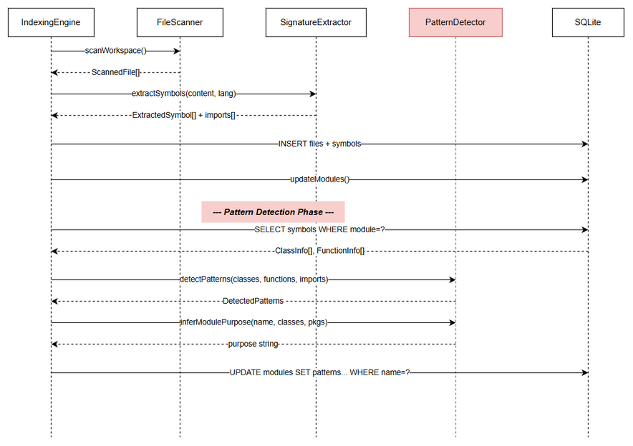 Edit in draw.io

6.2 Integration Point: Incremental Index
For incremental indexing, pattern detection runs only for modules whose files were modified:
sequenceDiagram
participant FW as FileWatcher
participant IE as IndexingEngine
participant PD as PatternDetector
participant DB as SQLite
FW->>IE: fileChanged(path)
IE->>IE: indexSingleFile(path)
IE->>IE: detectModule(path) → moduleName
Note over IE: Re-detect patterns for affected module only
IE->>DB: SELECT symbols WHERE module = moduleName
DB-->>IE: ClassInfo[], FunctionInfo[]
IE->>PD: detectPatterns(classes, functions, imports)
PD-->>IE: DetectedPatterns
IE->>DB: UPDATE modules SET patterns WHERE name = moduleName

6.3 Data Flow: Import Collection
Critical Design Decision: Imports are NOT stored in the database (they are transient parse data). For pattern detection, imports must be collected during the indexing phase and passed in-memory.
Full Index Flow: 1. During indexFiles(), collect imports per module in a Map<string, string[]> 2. After updateModules(), iterate the map and call detectPatterns() with collected imports
Incremental Index Flow: 1. When a file changes, re-parse it to get fresh imports 2. Query DB for all other files in the same module to get their symbols 3. Combine fresh imports with existing module data for re-detection
Alternative (simpler but less accurate for incremental): - Store imports in a new file_imports table or as JSON in the files table - This avoids re-parsing during incremental detection - Recommendation: Use in-memory collection for full index; for incremental, re-parse the changed file only and combine with cached module patterns

6.4 Tier 2 Language Limitations
For Bash, PowerShell, and CMD variants: - The signature extractor produces limited data (no annotations, no import statements) - Pattern detection is restricted to: - DI Style: Check for @Inject/@Autowired in symbol signatures (unlikely in scripts, will usually return “none”) - Naming: Check class/function name suffixes (Controller, Service, Repository) - All other patterns default to “unknown”

7. Security Design

7.1 Security Considerations
Pattern detection operates entirely locally with no network access:
Aspect | Design
Data Access | Read-only access to in-memory parsed data
Storage | SQLite file on local disk (same as existing)
Network | None — no external calls
Input Validation | Null checks on input arrays
Injection Risk | Parameterized SQL queries (no string interpolation)

7.2 Input Validation
Input | Validation | Sanitization
classes[] | Null/empty check | None needed (read-only)
functions[] | Null/empty check | None needed
imports[] | Null/empty check | None needed
moduleName | Non-empty string check | SQL parameterized

7.3 SQL Injection Prevention
All SQL operations use parameterized queries:
// ✅ CORRECT — Parameterized
db.prepare('UPDATE modules SET di_style = ? WHERE name = ?').run(patterns.diStyle, moduleName);
// ❌ NEVER — String interpolation
db.exec(`UPDATE modules SET di_style = '${patterns.diStyle}' WHERE name = '${moduleName}'`);
Exception: Bash and CMD variants use sqlite3 CLI which requires string escaping. These must escape single quotes in values:
# Bash: escape single quotes
escaped_value="${value//\'/\'\'}"
sqlite3 "$DB_PATH" "UPDATE modules SET di_style='$escaped_value' WHERE name='$module';"

8. Performance & Scalability

8.1 Performance Budget
Metric | Target | Rationale
Pattern detection overhead | < 10% of total index time | BRD requirement (Story 8)
Per-module detection time | < 5ms | Pure string matching on small data
Total detection (10 modules) | < 50ms | Well within 10% budget
Memory overhead | < 1MB | Only string arrays in memory

8.2 Performance Characteristics
Pattern detection is O(n) where n = total symbols + imports in a module:
Operation | Complexity | Typical Data Size
detectDiStyle | O(annotations + imports + functions) | ~100-500 strings
detectErrorHandling | O(imports + classes) | ~50-200 strings
detectNaming | O(classes × 3 suffixes) | ~20-100 classes
detectLogging | O(imports) | ~20-100 imports
detectTesting | O(imports) | ~20-100 imports
inferModulePurpose | O(classes + packages) | ~50-200 strings

8.3 Benchmarking Strategy
Each variant must report patternDetectionMs in the index result:
// Measure pattern detection time
const patternStart = Date.now();
for (const module of modules) {
detectAndStorePatterns(module);
}
const patternDetectionMs = Date.now() - patternStart;
// Validate < 10% constraint
const overhead = patternDetectionMs / totalIndexMs;
if (overhead > 0.10) {
console.error(`[indexer] WARNING: Pattern detection overhead ${(overhead * 100).toFixed(1)}% exceeds 10% budget`);
}

8.4 Optimization Techniques
- No file I/O — All detection operates on in-memory data
- String.includes() — Fastest substring check (no regex)
- Early return — Stop checking once a pattern is found (priority order)
- Batch SQL — Single transaction for all module updates
- Lazy aggregation — Collect imports during indexing, don’t re-read files

9. Monitoring & Observability

9.1 Logging
Log Event | Level | Fields | Destination
Pattern detection started | INFO | moduleCount | stderr
Pattern detected for module | DEBUG | moduleName, patterns | stderr
Pattern detection failed | ERROR | moduleName, error | stderr
Pattern detection complete | INFO | elapsedMs, moduleCount | stderr
Performance warning (>10%) | WARN | overhead%, elapsedMs | stderr

9.2 Metrics (in index result)
Metric | Type | Description
patternDetectionMs | Gauge | Time spent on pattern detection
patternsDetected | Boolean | Whether patterns were successfully detected
modulesWithPatterns | Counter | Number of modules with non-null patterns

9.3 Health Checks
Pattern detection health is implicit in the index status: - If patternDetectionMs is present → detection ran - If all modules have non-null pattern columns → detection succeeded - If patternDetectionMs / totalIndexMs > 0.10 → performance degradation alert

10. Deployment Considerations

10.1 Prerequisites
Prerequisite | How to Verify
KSA-25 schema migration applied | SELECT di_style FROM modules LIMIT 1 does not error
SQLite 3.35+ (for ALTER TABLE ADD COLUMN) | sqlite3 --version
Existing indexer functional | code_index_status returns valid response

10.2 Rollback Strategy
Pattern detection is additive — it only writes to new columns that default to NULL. Rollback: 1. Remove pattern detection code from updateModules() 2. Pattern columns remain in schema but stay NULL 3. Downstream tools (KSA-28) handle NULL gracefully

10.3 Feature Flag (Optional)
// config.ts — Optional flag to disable pattern detection
const PATTERNS_ENABLED = envBool('CODE_INTEL_PATTERNS', true);
// indexing-engine.ts
if (config.patternsEnabled) {
detectAndStorePatterns(modules);
}

10.4 Deployment Order
- KSA-25 — Schema migration (adds columns) — MUST deploy first
- KSA-26 — Pattern detection (populates columns) — This ticket
- KSA-28 — Enrich code_modules response — After KSA-26
- KSA-27 — KB export with patterns — After KSA-26

11. Implementation Guide — Per Variant

11.1 Node.js/TypeScript Implementation
File: mcp-code-intelligence-nodejs/src/scanner/pattern-detector.ts
/**
* Pattern Detector — Identifies DI style, error handling, naming, logging, testing patterns.
* Ported from: .analysis/code-intelligence/scripts/nodejs/src/full-indexer.ts
*/
import type { ExtractedSymbol } from './signature-extractor.js';
export interface DetectedPatterns {
diStyle: string;
errorHandling: string;
naming: string;
logging: string;
testing: string;
}
/** Detect all coding patterns from aggregated module data. */
export function detectPatterns(
classes: ExtractedSymbol[],
functions: ExtractedSymbol[],
imports: string[]
): DetectedPatterns {
return {
diStyle: detectDiStyle(classes, functions, imports),
errorHandling: detectErrorHandling(classes, imports),
naming: detectNaming(classes),
logging: detectLogging(imports),
testing: detectTesting(imports),
};
}
/** Infer module purpose from name, classes, and packages. */
export function inferModulePurpose(
moduleName: string,
classes: ExtractedSymbol[],
packages: string[]
): string {
const allNames = [moduleName, ...classes.map(c => c.name), ...packages]
.join(' ').toLowerCase();
const purposes: [string, string][] = [
['api', 'API layer'], ['controller', 'API layer'],
['service', 'Business logic'], ['business', 'Business logic'],
['repository', 'Data access'], ['dao', 'Data access'],
['data', 'Data access'],
['config', 'Configuration'], ['configuration', 'Configuration'],
['common', 'Shared utilities'], ['shared', 'Shared utilities'],
['test', 'Testing'], ['spec', 'Testing'],
['web', 'Web/UI layer'], ['ui', 'Web/UI layer'],
['model', 'Domain model'], ['domain', 'Domain model'],
];
for (const [keyword, purpose] of purposes) {
if (allNames.includes(keyword)) return purpose;
}
return 'Application module';
}
Integration in indexing-engine.ts:
import { detectPatterns, inferModulePurpose } from '../scanner/pattern-detector.js';
// Add to updateModules() method — after INSERT INTO modules
private detectAndStorePatterns(moduleImports: Map<string, string[]>): void {
const startMs = Date.now();
const modules = this.db.prepare('SELECT name FROM modules').all() as { name: string }[];
const updateStmt = this.db.prepare(`
UPDATE modules SET di_style = ?, error_handling = ?, naming_convention = ?,
logging_framework = ?, testing_framework = ?, purpose = ? WHERE name = ?
`);
const transaction = this.db.transaction(() => {
for (const { name } of modules) {
try {
const symbols = this.db.prepare(
'SELECT name, kind, signature, visibility FROM symbols WHERE file_id IN (SELECT id FROM files WHERE module = ?)'
).all(name) as ExtractedSymbol[];
const classes = symbols.filter(s => s.kind === 'class' || s.kind === 'interface');
const functions = symbols.filter(s => s.kind === 'function' || s.kind === 'method');
const imports = moduleImports.get(name) ?? [];
const patterns = detectPatterns(classes, functions, imports);
const purpose = inferModulePurpose(name, classes, []);
updateStmt.run(
patterns.diStyle, patterns.errorHandling, patterns.naming,
patterns.logging, patterns.testing, purpose, name
);
} catch (err) {
console.error(`[indexer] Pattern detection failed for ${name}:`, err);
}
}
});
transaction();
console.error(`[indexer] Pattern detection: ${Date.now() - startMs}ms`);
}

11.2 Python Implementation
File: mcp-code-intelligence-python/src/mcp_code_intel/patterns.py
"""Pattern detection — identifies DI style, error handling, naming, logging, testing."""
from typing import TypedDict
class DetectedPatterns(TypedDict):
"""Detected coding patterns for a module."""
di_style: str
error_handling: str
naming: str
logging: str
testing: str
def detect_patterns(
classes: list[dict], functions: list[dict], imports: list[str]
) -> DetectedPatterns:
"""Detect coding patterns from aggregated parse results."""
return {
"di_style": _detect_di(classes, functions, imports),
"error_handling": _detect_error_handling(classes, imports),
"naming": _detect_naming(classes),
"logging": _detect_logging(imports),
"testing": _detect_testing(imports),
}
def infer_module_purpose(
name: str, classes: list[dict], packages: list[str]
) -> str:
"""Infer a module's purpose from its contents."""
all_names = " ".join([name] + [c["name"] for c in classes] + packages).lower()
purposes = [
("api", "API layer"), ("controller", "API layer"),
("service", "Business logic"), ("business", "Business logic"),
("repository", "Data access"), ("dao", "Data access"),
("data", "Data access"),
("config", "Configuration"), ("configuration", "Configuration"),
("common", "Shared utilities"), ("shared", "Shared utilities"),
("test", "Testing"), ("spec", "Testing"),
("web", "Web/UI layer"), ("ui", "Web/UI layer"),
("model", "Domain model"), ("domain", "Domain model"),
]
for keyword, purpose in purposes:
if keyword in all_names:
return purpose
return "Application module"
def _detect_di(classes, functions, imports):
"""Detect dependency injection style."""
all_text = " ".join(imports)
if "@Inject" in all_text or "@Autowired" in all_text:
return "field injection"
if any(f["name"] in ("constructor", "__init__") for f in functions):
return "constructor injection"
return "none"
def _detect_error_handling(classes, imports):
"""Detect error handling approach."""
names_text = " ".join(imports + [c["name"] for c in classes])
if "Result" in names_text or "Either" in names_text:
return "Result type"
if "ExceptionHandler" in names_text or "ControllerAdvice" in names_text:
return "exception handler"
if "Exception" in names_text or "Error" in names_text:
return "try-catch"
return "unknown"
def _detect_naming(classes):
"""Detect naming conventions from class suffixes."""
suffixes = ["Controller", "Service", "Repository"]
found = [f"*{s}" for s in suffixes if any(c["name"].endswith(s) for c in classes)]
return ", ".join(found) if found else "unknown"
def _detect_logging(imports):
"""Detect logging framework from imports."""
imp_text = " ".join(imports)
if "slf4j" in imp_text or "SLF4J" in imp_text:
return "SLF4J"
if "log4j" in imp_text or "Log4j" in imp_text:
return "Log4j"
if "logging" in imp_text:
return "logging"
return "unknown"
def _detect_testing(imports):
"""Detect testing framework from imports."""
imp_text = " ".join(imports)
if "junit" in imp_text or "org.junit" in imp_text:
return "JUnit"
if "pytest" in imp_text or "unittest" in imp_text:
return "pytest"
if "jest" in imp_text:
return "Jest"
if "kotest" in imp_text:
return "kotest"
if "vitest" in imp_text:
return "vitest"
return "unknown"

11.3 Kotlin Implementation
File: mcp-code-intelligence-kotlin/src/main/kotlin/com/codeintel/scanner/PatternDetector.kt
/** Pattern detection — identifies DI style, error handling, naming, logging, testing. */
package com.codeintel.scanner
data class DetectedPatterns(
val diStyle: String,
val errorHandling: String,
val naming: String,
val logging: String,
val testing: String
)
/** Detect all coding patterns from aggregated module data. */
fun detectPatterns(
classes: List<SymbolInfo>,
functions: List<SymbolInfo>,
imports: List<String>
): DetectedPatterns = DetectedPatterns(
diStyle = detectDiStyle(classes, functions, imports),
errorHandling = detectErrorHandling(classes, imports),
naming = detectNaming(classes),
logging = detectLogging(imports),
testing = detectTesting(imports)
)
/** Infer module purpose from name, classes, and packages. */
fun inferModulePurpose(
moduleName: String,
classes: List<SymbolInfo>,
packages: List<String>
): String {
val allNames = (listOf(moduleName) + classes.map { it.name } + packages)
.joinToString(" ").lowercase()
val purposes = listOf(
"api" to "API layer", "controller" to "API layer",
"service" to "Business logic", "business" to "Business logic",
"repository" to "Data access", "dao" to "Data access",
"data" to "Data access",
"config" to "Configuration", "configuration" to "Configuration",
"common" to "Shared utilities", "shared" to "Shared utilities",
"test" to "Testing", "spec" to "Testing",
"web" to "Web/UI layer", "ui" to "Web/UI layer",
"model" to "Domain model", "domain" to "Domain model",
)
for ((keyword, purpose) in purposes) {
if (keyword in allNames) return purpose
}
return "Application module"
}
private fun detectDiStyle(
classes: List<SymbolInfo>, functions: List<SymbolInfo>, imports: List<String>
): String {
val allText = imports.joinToString(" ")
if ("@Inject" in allText || "@Autowired" in allText) return "field injection"
if (functions.any { it.name in listOf("constructor", "__init__") }) {
return "constructor injection"
}
return "none"
}
private fun detectErrorHandling(classes: List<SymbolInfo>, imports: List<String>): String {
val allText = (imports + classes.map { it.name }).joinToString(" ")
if ("Result" in allText || "Either" in allText) return "Result type"
if ("ExceptionHandler" in allText || "ControllerAdvice" in allText) return "exception handler"
if ("Exception" in allText || "Error" in allText) return "try-catch"
return "unknown"
}
private fun detectNaming(classes: List<SymbolInfo>): String {
val suffixes = listOf("Controller", "Service", "Repository")
val found = suffixes.filter { suffix -> classes.any { it.name.endsWith(suffix) } }
.map { "*$it" }
return if (found.isEmpty()) "unknown" else found.joinToString(", ")
}
private fun detectLogging(imports: List<String>): String {
val allImports = imports.joinToString(" ")
if ("slf4j" in allImports || "SLF4J" in allImports) return "SLF4J"
if ("log4j" in allImports || "Log4j" in allImports) return "Log4j"
if ("logging" in allImports) return "logging"
return "unknown"
}
private fun detectTesting(imports: List<String>): String {
val allImports = imports.joinToString(" ")
if ("junit" in allImports || "org.junit" in allImports) return "JUnit"
if ("pytest" in allImports || "unittest" in allImports) return "pytest"
if ("jest" in allImports) return "Jest"
if ("kotest" in allImports) return "kotest"
if ("vitest" in allImports) return "vitest"
return "unknown"
}

11.4 Bash Implementation (Tier 2 — Basic)
File: mcp-code-intelligence-bash/lib/patterns.sh
#!/usr/bin/env bash
# Pattern detection — basic DI + naming detection for Bash variant (Tier 2).
detect_patterns_for_module() {
# Detect patterns for a module and update DB.
local module="$1" db_path="$2"
local di_style naming purpose
di_style=$(detect_di_style "$module" "$db_path")
naming=$(detect_naming "$module" "$db_path")
purpose=$(infer_purpose "$module" "$db_path")
local sql="UPDATE modules SET di_style='$di_style', naming_convention='$naming', purpose='$purpose', error_handling='unknown', logging_framework='unknown', testing_framework='unknown' WHERE name='$module';"
run_exec "$db_path" "$sql"
}
detect_di_style() {
# Check for DI annotations in symbol signatures.
local module="$1" db_path="$2"
local sigs
sigs=$(run_query "$db_path" "SELECT signature FROM symbols WHERE file_id IN (SELECT id FROM files WHERE module='$module');")
if echo "$sigs" | grep -qi "@Inject\|@Autowired"; then
echo "field injection"
elif echo "$sigs" | grep -qi "constructor\|__init__"; then
echo "constructor injection"
else
echo "none"
fi
}
detect_naming() {
# Check class name suffixes.
local module="$1" db_path="$2"
local names found=""
names=$(run_query "$db_path" "SELECT name FROM symbols WHERE kind='class' AND file_id IN (SELECT id FROM files WHERE module='$module');")
echo "$names" | grep -q "Controller$" && found="${found}*Controller, "
echo "$names" | grep -q "Service$" && found="${found}*Service, "
echo "$names" | grep -q "Repository$" && found="${found}*Repository, "
[ -z "$found" ] && echo "unknown" && return
echo "${found%, }"
}
infer_purpose() {
# Infer module purpose from name and class names.
local module="$1" db_path="$2"
local all_names
all_names=$(run_query "$db_path" "SELECT name FROM symbols WHERE kind='class' AND file_id IN (SELECT id FROM files WHERE module='$module');")
all_names="$module $all_names"
all_names=$(echo "$all_names" | tr '[:upper:]' '[:lower:]')
echo "$all_names" | grep -q "api\|controller" && echo "API layer" && return
echo "$all_names" | grep -q "service\|business" && echo "Business logic" && return
echo "$all_names" | grep -q "repository\|dao\|data" && echo "Data access" && return
echo "$all_names" | grep -q "config" && echo "Configuration" && return
echo "$all_names" | grep -q "common\|shared" && echo "Shared utilities" && return
echo "$all_names" | grep -q "test\|spec" && echo "Testing" && return
echo "$all_names" | grep -q "web\|ui" && echo "Web/UI layer" && return
echo "$all_names" | grep -q "model\|domain" && echo "Domain model" && return
echo "Application module"
}
run_pattern_detection() {
# Run pattern detection for all modules.
local db_path="$1"
local modules
modules=$(run_query "$db_path" "SELECT name FROM modules;")
while IFS= read -r module; do
[ -z "$module" ] && continue
detect_patterns_for_module "$module" "$db_path"
done <<< "$modules"
}

11.5 PowerShell Implementation (Tier 2 — Basic)
File: mcp-code-intelligence-powershell/code-intel-patterns.ps1
<# .SYNOPSIS Pattern detection — basic DI + naming for PowerShell variant (Tier 2). #>
function Invoke-PatternDetection {
<# Run pattern detection for all modules. #>
param([string]$DbPath, [string]$SqlitePath)
$modules = Invoke-SqlQuery -DbPath $DbPath -SqlitePath $SqlitePath -Sql "SELECT name FROM modules;"
foreach ($module in $modules) {
if (-not $module) { continue }
$moduleName = $module.Trim()
if (-not $moduleName) { continue }
try {
Invoke-ModulePatternDetection -Module $moduleName -DbPath $DbPath -SqlitePath $SqlitePath
} catch {
Write-Host "[patterns] ERROR: $moduleName — $_" -ForegroundColor Red
}
}
}
function Invoke-ModulePatternDetection {
<# Detect patterns for a single module. #>
param([string]$Module, [string]$DbPath, [string]$SqlitePath)
$diStyle = Get-DiStyle -Module $Module -DbPath $DbPath -SqlitePath $SqlitePath
$naming = Get-NamingConvention -Module $Module -DbPath $DbPath -SqlitePath $SqlitePath
$purpose = Get-ModulePurpose -Module $Module -DbPath $DbPath -SqlitePath $SqlitePath
$escapedModule = $Module.Replace("'", "''")
$sql = "UPDATE modules SET di_style='$diStyle', naming_convention='$naming', purpose='$purpose', error_handling='unknown', logging_framework='unknown', testing_framework='unknown' WHERE name='$escapedModule';"
Invoke-SqlExec -DbPath $DbPath -SqlitePath $SqlitePath -Sql $sql
}
function Get-DiStyle {
<# Detect DI style from symbol signatures. #>
param([string]$Module, [string]$DbPath, [string]$SqlitePath)
$sigs = Invoke-SqlQuery -DbPath $DbPath -SqlitePath $SqlitePath -Sql "SELECT signature FROM symbols WHERE file_id IN (SELECT id FROM files WHERE module='$Module');"
$allSigs = $sigs -join ' '
if ($allSigs -match '@Inject|@Autowired') { return 'field injection' }
if ($allSigs -match 'constructor|__init__') { return 'constructor injection' }
return 'none'
}
function Get-NamingConvention {
<# Detect naming conventions from class names. #>
param([string]$Module, [string]$DbPath, [string]$SqlitePath)
$names = Invoke-SqlQuery -DbPath $DbPath -SqlitePath $SqlitePath -Sql "SELECT name FROM symbols WHERE kind='class' AND file_id IN (SELECT id FROM files WHERE module='$Module');"
$found = @()
if ($names -match 'Controller$') { $found += '*Controller' }
if ($names -match 'Service$') { $found += '*Service' }
if ($names -match 'Repository$') { $found += '*Repository' }
if ($found.Count -eq 0) { return 'unknown' }
return $found -join ', '
}
function Get-ModulePurpose {
<# Infer module purpose from name and class names. #>
param([string]$Module, [string]$DbPath, [string]$SqlitePath)
$names = Invoke-SqlQuery -DbPath $DbPath -SqlitePath $SqlitePath -Sql "SELECT name FROM symbols WHERE kind='class' AND file_id IN (SELECT id FROM files WHERE module='$Module');"
$allNames = ("$Module $($names -join ' ')").ToLower()
if ($allNames -match 'api|controller') { return 'API layer' }
if ($allNames -match 'service|business') { return 'Business logic' }
if ($allNames -match 'repository|dao|data') { return 'Data access' }
if ($allNames -match 'config') { return 'Configuration' }
if ($allNames -match 'common|shared') { return 'Shared utilities' }
if ($allNames -match 'test|spec') { return 'Testing' }
if ($allNames -match 'web|ui') { return 'Web/UI layer' }
if ($allNames -match 'model|domain') { return 'Domain model' }
return 'Application module'
}

11.6 CMD Implementation (Tier 2 — Basic)
File: mcp-code-intelligence-cmd/code-intel-patterns.cmd
@echo off
REM Pattern detection — basic DI + naming for CMD variant (Tier 2).
REM Usage: code-intel-patterns.cmd <db_path>
setlocal enabledelayedexpansion
set "DB_PATH=%~1"
set "SCRIPT_DIR=%~dp0"
set "SQLITE=%SCRIPT_DIR%bin\sqlite3.exe"
if "%DB_PATH%"=="" (
echo [patterns] ERROR: db_path required >&2
exit /b 1
)
REM Get all module names
for /f "tokens=*" %%m in ('"%SQLITE%" "%DB_PATH%" "SELECT name FROM modules;"') do (
call :detect_module "%%m"
)
exit /b 0
:detect_module
set "MODULE=%~1"
if "%MODULE%"=="" exit /b 0
REM Detect DI style
set "DI_STYLE=none"
for /f "tokens=*" %%s in ('"%SQLITE%" "%DB_PATH%" "SELECT signature FROM symbols WHERE file_id IN (SELECT id FROM files WHERE module='%MODULE%');" 2^>nul') do (
echo %%s | findstr /i "@Inject @Autowired" >nul 2>&1
if !ERRORLEVEL! equ 0 set "DI_STYLE=field injection"
)
if "!DI_STYLE!"=="none" (
for /f "tokens=*" %%s in ('"%SQLITE%" "%DB_PATH%" "SELECT name FROM symbols WHERE kind='function' AND name IN ('constructor','__init__') AND file_id IN (SELECT id FROM files WHERE module='%MODULE%');" 2^>nul') do (
if not "%%s"=="" set "DI_STYLE=constructor injection"
)
)
REM Detect naming
set "NAMING=unknown"
set "FOUND="
for /f "tokens=*" %%n in ('"%SQLITE%" "%DB_PATH%" "SELECT name FROM symbols WHERE kind='class' AND file_id IN (SELECT id FROM files WHERE module='%MODULE%');" 2^>nul') do (
echo %%n | findstr /r "Controller$" >nul 2>&1 && set "FOUND=!FOUND!*Controller, "
echo %%n | findstr /r "Service$" >nul 2>&1 && set "FOUND=!FOUND!*Service, "
echo %%n | findstr /r "Repository$" >nul 2>&1 && set "FOUND=!FOUND!*Repository, "
)
if not "!FOUND!"=="" set "NAMING=!FOUND:~0,-2!"
REM Infer purpose
set "PURPOSE=Application module"
echo %MODULE% | findstr /i "api controller" >nul 2>&1 && set "PURPOSE=API layer"
echo %MODULE% | findstr /i "service business" >nul 2>&1 && set "PURPOSE=Business logic"
echo %MODULE% | findstr /i "repository dao data" >nul 2>&1 && set "PURPOSE=Data access"
echo %MODULE% | findstr /i "config" >nul 2>&1 && set "PURPOSE=Configuration"
REM Update DB
"%SQLITE%" "%DB_PATH%" "UPDATE modules SET di_style='!DI_STYLE!', naming_convention='!NAMING!', purpose='!PURPOSE!', error_handling='unknown', logging_framework='unknown', testing_framework='unknown' WHERE name='%MODULE%';"
echo [patterns] Detected: %MODULE% — DI=!DI_STYLE!, Naming=!NAMING!, Purpose=!PURPOSE! >&2
exit /b 0

12. Test Strategy

12.1 Testing Approach
The primary validation strategy is output comparison: run pattern detection on the same input data using both the existing scripts and the new MCP implementation, then assert identical results.

12.2 Unit Tests — Per Variant
Each variant must have unit tests for the pattern detector:
Test Case | Input | Expected Output
DI: field injection | imports containing “@Inject” | “field injection”
DI: constructor injection | function named “constructor” with params | “constructor injection”
DI: none | empty annotations/imports | “none”
Error: Result type | imports containing “Result” | “Result type”
Error: exception handler | class named “GlobalExceptionHandler” | “exception handler”
Error: try-catch | imports containing “Exception” | “try-catch”
Error: unknown | no error indicators | “unknown”
Naming: all three | classes: UserController, UserService, UserRepository | "Controller, Service, *Repository"
Naming: partial | classes: UserService only | "*Service"
Naming: unknown | classes: Helper, Utils | “unknown”
Logging: SLF4J | imports containing “org.slf4j” | “SLF4J”
Logging: unknown | no logging imports | “unknown”
Testing: JUnit | imports containing “org.junit” | “JUnit”
Testing: vitest | imports containing “vitest” | “vitest”
Purpose: API layer | module named “api-controller” | “API layer”
Purpose: default | module named “utils-helper” | “Application module”

12.3 Integration Tests
- Full index with patterns — Run full index on a test workspace, verify all modules have non-null pattern columns
- Incremental re-detection — Modify a file, trigger incremental index, verify affected module’s patterns are updated
- Performance test — Index a workspace with 1000+ files, verify patternDetectionMs / totalIndexMs < 0.10
- Fault tolerance — Inject an error in one module’s data, verify other modules still get patterns

12.4 Cross-Variant Consistency Tests
Critical: All 6 variants must produce identical output for the same input. Test procedure:
- Create a reference test dataset (JSON file with classes, functions, imports)
- Feed the same dataset to each variant’s pattern detector
- Assert all 6 produce identical DetectedPatterns output
- Automate in CI: scripts/test-pattern-consistency.sh

12.5 Regression Tests vs. Existing Scripts
Compare MCP output against existing script output:
# 1. Run existing script on test workspace
cd .analysis/code-intelligence/scripts/nodejs
npx tsx src/full-indexer.ts /path/to/test-workspace > expected.json
# 2. Run MCP indexer on same workspace
# (trigger via MCP tool call, then query modules table)
# 3. Compare pattern fields
diff <(jq '.modules[].patterns' expected.json) <(sqlite3 index.db "SELECT di_style, error_handling, naming_convention, logging_framework, testing_framework, purpose FROM modules ORDER BY name;")

13. Appendix

13.1 Glossary
Term | Definition
MCP | Model Context Protocol — standard for AI agent tool communication
DI | Dependency Injection — design pattern for managing object dependencies
FTS5 | Full-Text Search 5 — SQLite extension for text search
Tier 1 | Languages with full pattern detection (Node.js, Python, Kotlin)
Tier 2 | Languages with basic pattern detection (Bash, PowerShell, CMD)
Pattern Detection | Process of identifying coding patterns from parsed source code metadata
ClassInfo | Parsed class data: name, visibility, annotations
FunctionInfo | Parsed function data: name, visibility, parameters, annotations

13.2 Pattern Detection Value Reference
Pattern | Possible Values
di_style | “field injection”, “constructor injection”, “none”
error_handling | “Result type”, “exception handler”, “try-catch”, “unknown”
naming_convention | "Controller, Service, *Repository" (comma-separated) or “unknown”
logging_framework | “SLF4J”, “Log4j”, “logging”, “console.log”, “unknown”
testing_framework | “JUnit”, “Jest”, “pytest”, “vitest”, “kotest”, “unknown”
purpose | “API layer”, “Business logic”, “Data access”, “Configuration”, “Shared utilities”, “Testing”, “Web/UI layer”, “Domain model”, “Application module”

13.3 File Locations Summary
Variant | New File | Lines (est.)
Node.js | mcp-code-intelligence-nodejs/src/scanner/pattern-detector.ts | ~100
Python | mcp-code-intelligence-python/src/mcp_code_intel/patterns.py | ~90
Kotlin | mcp-code-intelligence-kotlin/src/main/kotlin/com/codeintel/scanner/PatternDetector.kt | ~100
Bash | mcp-code-intelligence-bash/lib/patterns.sh | ~80
PowerShell | mcp-code-intelligence-powershell/code-intel-patterns.ps1 | ~80
CMD | mcp-code-intelligence-cmd/code-intel-patterns.cmd | ~70

13.4 Modified Files (Integration Points)
Variant | File to Modify | Change Description
Node.js | src/indexer/indexing-engine.ts | Add detectAndStorePatterns() call in updateModules()
Python | src/mcp_code_intel/indexer.py | Add pattern detection call in _update_modules()
Kotlin | src/main/kotlin/com/codeintel/indexer/IndexingEngine.kt | Add pattern detection call in updateModules()
Bash | lib/scan.sh | Call run_pattern_detection after update_modules
PowerShell | code-intel-scan.ps1 | Call Invoke-PatternDetection after Update-Modules
CMD | code-intel-scan.cmd | Call code-intel-patterns.cmd after :update_modules

13.5 Open Questions
# | Question | Status | Answer
1 | Should imports be stored in DB for incremental detection? | Open | Recommendation: No for v1, use in-memory collection. Revisit if incremental accuracy is insufficient.
2 | Should Tier 2 variants attempt logging/testing detection via signature text? | Resolved | No — signatures don’t reliably contain import info. Keep Tier 2 basic.
3 | How to handle modules with 0 files (empty modules)? | Resolved | Skip pattern detection, leave columns NULL.

