Business Requirements Document (BRD)

Kiro SDLC Agent — KSA-3: Injector — Copy Resources to Workspace

Document Information
Field | Value
Jira Ticket | KSA-3
Title | Injector — Copy Resources to Workspace
Author | BA Agent
Version | 1.0
Date | 2025-01-20
Status | Draft

Author Tracking
Role | Name - Position | Responsibility
Author | BA Agent – Business Analyst | Create document
Peer Reviewer | SM Agent – Scrum Master | Review document

Revision History
Version | Date | Author | Changes
1.0 | 2025-01-20 | BA Agent | Initiate document — auto-generated from Jira ticket KSA-3 and linked tickets

Sign-Off
Name | Signature and date
 | ☐ I agree and confirm all criteria on this BRD as expected requirements
 | ☐ I agree and confirm all criteria on this BRD as expected requirements

1. Introduction

1.1 Scope
This change request covers the Injector module of the Kiro SDLC Agent VS Code extension. The Injector is responsible for copying pre-packaged resource files (agents, steering rules, hooks, and document templates) from the extension’s bundled resources directory into the user’s workspace. It provides both full injection (all core components + one indexer language) and selective injection (user picks which components to inject). Additionally, it provides a status check function to report which components currently exist in the workspace.
The Injector supports filtered copy operations (using indexer-config to determine which files to copy for a given indexer language) and recursive directory copying with intelligent exclusion of build artifacts and version control directories.

1.2 Out of Scope
- UI for indexer language selection (covered by KSA-4: Indexer Selection UI)
- Auto-detection of runtime environment to suggest indexer language (covered by KSA-5: Auto-detect Runtime)
- Extension activation, command registration, and lifecycle management (covered by KSA-2: Extension Core)
- Content of the resource files themselves (agents, steering, hooks, templates are maintained separately)
- File watching or auto-sync after initial injection

1.3 Preliminary Requirement
- KSA-2 (Extension Core) must be implemented to provide the VS Code command infrastructure that invokes the Injector functions.
- The extension must have a resources/ directory containing all injectable components (agents, steering, hooks, templates, indexer scripts).
- A valid VS Code workspace must be open for the Injector to have a target directory.

2. Business Requirements

2.1 High Level Process Map
The Injector operates as a file-copy utility within the VS Code extension. When triggered (via command or programmatically), it reads resources from the extension’s installation directory and copies them into the user’s workspace, creating the necessary directory structure.
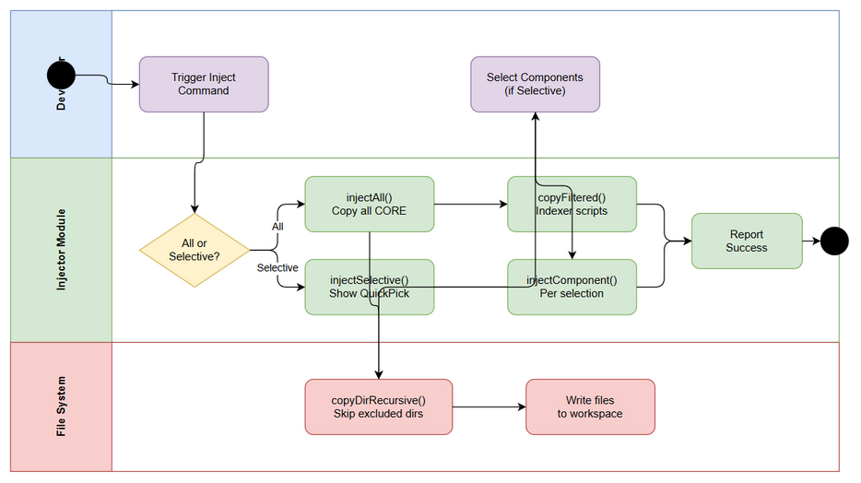 Edit in draw.io
Sequence Flow — Inject All Edit in draw.io
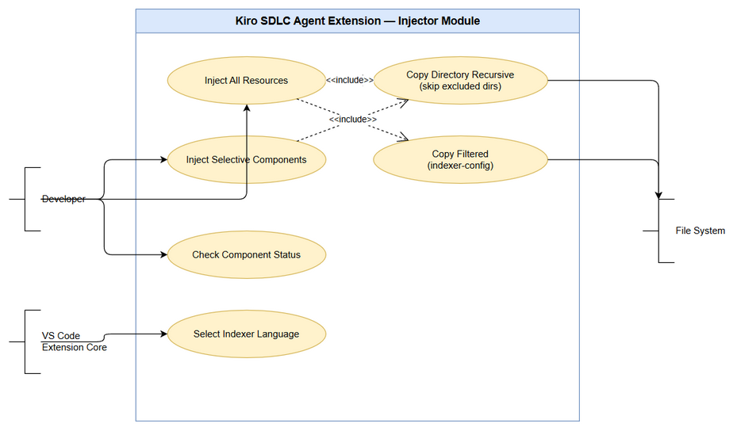 Edit in draw.io

2.2 List of User Stories / Use Cases
# | Story / Use Case | Priority | Source Ticket
1 | As a developer, I want to inject all SDLC resources into my workspace so that I can use the full agent pipeline immediately | MUST HAVE | KSA-3
2 | As a developer, I want to selectively inject specific components so that I only add what I need to my workspace | SHOULD HAVE | KSA-3
3 | As a developer, I want the injector to skip build artifacts and VCS directories so that my workspace stays clean | MUST HAVE | KSA-3
4 | As a developer, I want to inject only the indexer scripts for my language so that I don’t get unnecessary files | MUST HAVE | KSA-3
5 | As a developer, I want to check which components are already installed so that I know what’s missing | SHOULD HAVE | KSA-3

2.3 Details of User Stories

Business Flow
Step 1: User opens a workspace in VS Code with the Kiro SDLC Agent extension installed.
Step 2: User triggers an inject command (either “Inject All” or “Inject Selective”) via the Command Palette or programmatic API.
Step 3: For “Inject All”: The system copies all four CORE_COMPONENTS to their respective workspace paths, then copies the selected indexer language scripts using filtered copy.
Step 4: For “Inject Selective”: The system presents a QuickPick multi-select dialog listing available components. User selects desired components. System copies only selected components.
Step 5: During copy, the system recursively copies directories while skipping excluded patterns (node_modules, pycache, .git, out, dist).
Step 6: For indexer copy, the system reads the indexer-config to determine which files belong to the selected language and copies only those files.
Step 7: System reports success/failure to the user via VS Code notification.
Step 8: At any time, user can invoke checkStatus() to see which components exist in the workspace.
Note: If a component already exists in the workspace, it will be overwritten. No merge logic is applied.

STORY 1: Inject All Resources
As a developer, I want to inject all SDLC resources into my workspace so that I can use the full agent pipeline immediately.
Requirement Details:
- The injectAll() function copies all four CORE_COMPONENTS to the workspace:
  - agents → {workspaceRoot}/.kiro/agents
  - steering → {workspaceRoot}/.kiro/steering
  - hooks → {workspaceRoot}/.kiro/hooks
  - templates → {workspaceRoot}/documents/templates
- After copying core components, it copies the selected indexer language scripts using filtered copy based on indexer-config.
- The function accepts an indexerLanguage parameter to determine which indexer to include.
- All copies are recursive — subdirectories are preserved.
Data Fields:
Field | Type | Required | Description | Example
indexerLanguage | string (enum) | Yes | The indexer language to inject | “python”, “java”, “powershell”, “bash”, “nodejs”
extensionPath | string | Yes | Path to extension installation directory | /home/user/.vscode/extensions/kiro-sdlc-1.0.0
workspaceRoot | string | Yes | Path to the open workspace root | /home/user/projects/my-app
Acceptance Criteria:
- All four CORE_COMPONENTS are copied to their correct workspace paths.
- Exactly one indexer language is copied based on the provided parameter.
- Directory structure is preserved during recursive copy.
- node_modules, pycache, .git, out, and dist directories are skipped during copy.
- Existing files at the destination are overwritten without error.
- Function completes without throwing if all paths are valid.
Validation Rules:
- indexerLanguage must be one of: “python”, “java”, “powershell”, “bash”, “nodejs”
- workspaceRoot must be a valid, writable directory path
- extensionPath must contain a resources/ subdirectory with the expected component folders
Error Handling:
- Source directory not found: Log error, skip that component, continue with remaining
- Destination not writable: Throw error with descriptive message indicating permission issue
- Invalid indexer language: Throw error listing valid options

STORY 2: Inject Selective Components
As a developer, I want to selectively inject specific components so that I only add what I need to my workspace.
Requirement Details:
- The injectSelective() function presents a VS Code QuickPick multi-select dialog.
- The dialog lists all available components (agents, steering, hooks, templates, and each indexer language).
- User can select one or more components.
- Only selected components are copied to the workspace.
- Each selected component is copied using injectComponent().
UI Specifications:
No. | Name | Type | Required | Description | Note
1 | Component List | QuickPick (multi-select) | Yes | List of injectable components | Shows label + description for each
2 | Component Label | Text | Yes | Display name of component | e.g., “Agents (.kiro/agents)”
3 | Component Description | Text | No | Brief description of what the component provides | e.g., “Multi-agent SDLC pipeline definitions”
4 | OK Button | Button | Yes | Confirms selection | Standard VS Code QuickPick confirm
5 | Cancel | Action | No | Dismisses dialog without action | ESC key or click outside
Acceptance Criteria:
- QuickPick dialog appears with all available components listed.
- User can select multiple components simultaneously.
- Only selected components are injected — unselected components are not touched.
- If user cancels (ESC), no files are copied.
- After successful injection, a success notification is shown listing what was injected.
Error Handling:
- User cancels QuickPick: No action taken, no error shown
- One component fails to copy: Log error for that component, continue copying remaining selections, report partial success

STORY 3: Skip Excluded Directories During Copy
As a developer, I want the injector to skip build artifacts and VCS directories so that my workspace stays clean.
Requirement Details:
- The copyDirRecursive() function performs recursive directory copy.
- During traversal, it checks each directory name against an exclusion list.
- Excluded directories: node_modules, __pycache__, .git, out, dist
- Excluded directories and all their contents are completely skipped — not copied.
- Files in non-excluded directories are copied normally.
Data Fields:
Field | Type | Required | Description | Example
source | string | Yes | Source directory path | {extensionPath}/resources/agents
destination | string | Yes | Destination directory path | {workspaceRoot}/.kiro/agents
excludeList | string[] | Yes | Directory names to skip | ["node_modules", "__pycache__", ".git", "out", "dist"]
Acceptance Criteria:
- Directories named node_modules are not copied.
- Directories named __pycache__ are not copied.
- Directories named .git are not copied.
- Directories named out are not copied.
- Directories named dist are not copied.
- All other directories and files are copied correctly.
- Exclusion check is case-sensitive (matches exact directory name).
Validation Rules:
- Exclusion is based on directory name only, not full path
- Exclusion applies at any depth in the directory tree
- Files with these names (not directories) are still copied

STORY 4: Filtered Copy for Indexer Scripts
As a developer, I want to inject only the indexer scripts for my language so that I don’t get unnecessary files.
Requirement Details:
- The copyFiltered() function copies only specific items from a source directory.
- It reads a filter list (from indexer-config) that specifies which files/directories to include.
- Only items matching the filter list are copied; everything else is ignored.
- This is used specifically for indexer injection where each language has its own set of files.
Data Fields:
Field | Type | Required | Description | Example
source | string | Yes | Source directory containing all indexer scripts | {extensionPath}/resources/scripts
destination | string | Yes | Target directory in workspace | {workspaceRoot}/.analysis/code-intelligence/scripts
filterList | string[] | Yes | List of items to include | ["python"] or ["nodejs", "package.json"]
Acceptance Criteria:
- Only files/directories listed in the filter are copied.
- Unlisted files/directories in the source are not copied.
- Filter list is derived from indexer-config for the selected language.
- Recursive copy rules (exclusion list) still apply within filtered items.
- If a filtered item doesn’t exist in source, it is silently skipped.
Validation Rules:
- Filter list must contain at least one item
- Filter matching is exact (no glob/regex patterns)
Error Handling:
- Empty filter list: Log warning, copy nothing, return success
- Filter item not found in source: Skip silently, continue with remaining items

STORY 5: Check Component Status
As a developer, I want to check which components are already installed so that I know what’s missing.
Requirement Details:
- The checkStatus() function examines the workspace to determine which components exist.
- It checks for the existence of each CORE_COMPONENT’s target directory.
- It returns a status object indicating which components are present/absent.
- This information can be used by the UI to show installation status or by other extension features to determine if injection is needed.
Data Fields:
Field | Type | Required | Description | Example
workspaceRoot | string | Yes | Path to workspace root | /home/user/projects/my-app
Output Data:
Field | Type | Description | Example
agents | boolean | Whether .kiro/agents exists | true
steering | boolean | Whether .kiro/steering exists | true
hooks | boolean | Whether .kiro/hooks exists | false
templates | boolean | Whether documents/templates exists | true
indexer | boolean | Whether .analysis/code-intelligence/scripts exists | false
Acceptance Criteria:
- checkStatus() returns a status for each of the four CORE_COMPONENTS plus indexer.
- Status is true if the component’s directory exists in the workspace.
- Status is false if the component’s directory does not exist.
- Function does not modify any files — read-only operation.
- Function works even if workspace has no Kiro components installed (all false).
Error Handling:
- Workspace path invalid: Return all statuses as false with an error flag
- Permission denied on directory check: Treat as “not exists” (false)

3. Dependencies
Dependency | Type | Related Ticket | Description
Extension Core | System | KSA-2 | Provides VS Code command registration that invokes Injector functions
VS Code API | System | N/A | Required for QuickPick UI, workspace path resolution, notifications
File System (Node.js fs) | System | N/A | Required for all file copy operations
Indexer Config | Data | KSA-3 | JSON configuration defining which files belong to each indexer language
Indexer Selection UI | System | KSA-4 | Provides the UI for selecting indexer language (calls injectAll with selection)
Auto-detect Runtime | System | KSA-5 | Can auto-detect runtime to suggest default indexer language

4. Stakeholders
Role | Name / Team | Responsibility | Source
Developer | Extension Users | End users who inject resources into their workspaces | Target audience
Extension Developer | Kiro SDLC Team | Implements and maintains the Injector module | KSA-3 assignee
Product Owner | Kiro SDLC Team | Defines which components are injectable | Epic KSA-1

5. Risks and Assumptions

5.1 Risks
Risk | Impact | Likelihood | Mitigation
Overwriting user-customized files | High | Medium | Consider adding a confirmation prompt before overwriting existing files
Large resource directories causing slow copy | Medium | Low | Implement progress indicator for large copy operations
Permission issues on target workspace | Medium | Low | Provide clear error messages with remediation steps
Extension path resolution fails on some OS | Medium | Low | Use VS Code API extensionUri for reliable path resolution

5.2 Assumptions
- The extension’s resources/ directory is always present and correctly structured after installation.
- The workspace root is always available when inject commands are triggered (commands are disabled when no workspace is open).
- File overwrite without merge is acceptable behavior for v1.0.
- The indexer-config file is bundled with the extension and defines all supported languages.
- Node.js fs module is available in the VS Code extension host environment.

6. Non-Functional Requirements
Category | Requirement | Details
Performance | Copy operation completes within 5 seconds | For typical resource sets (< 500 files total)
Reliability | Atomic component copy | If a component copy fails midway, partial files should not corrupt workspace
Compatibility | Cross-platform file operations | Must work on Windows, macOS, and Linux
Usability | Clear feedback on completion | User receives notification with summary of what was injected

7. Related Tickets
Ticket Key | Summary | Status | Type | Relationship
KSA-3 | Injector — Copy Resources to Workspace | To Do | Task | Main ticket
KSA-1 | Kiro SDLC Agent Extension | To Do | Epic | Parent epic
KSA-2 | Extension Core | To Do | Task | Dependency (provides commands)
KSA-4 | Indexer Selection UI | To Do | Task | Related (consumes injectAll)
KSA-5 | Auto-detect Runtime | To Do | Task | Related (suggests indexer language)

8. Appendix

Glossary
Term | Definition
CORE_COMPONENTS | The four main injectable resource sets: agents, steering, hooks, templates
Injector | The module responsible for copying extension resources to the workspace
Indexer | Language-specific scripts that analyze source code and generate intelligence files
extensionPath | The filesystem path where the VS Code extension is installed
workspaceRoot | The root directory of the currently open VS Code workspace
QuickPick | VS Code’s built-in multi-select dropdown UI component
Filtered Copy | Copy operation that only includes items matching a whitelist

Reference Documents
Document | Link / Location
VS Code Extension API | https://code.visualstudio.com/api
Node.js fs module | https://nodejs.org/api/fs.html
Epic: Kiro SDLC Agent | KSA-1

CORE_COMPONENTS Mapping
Component | Source (in extension) | Destination (in workspace) | Description
agents | resources/agents | .kiro/agents | Multi-agent SDLC pipeline definitions
steering | resources/steering | .kiro/steering | Code standards and rules
hooks | resources/hooks | .kiro/hooks | Auto-trigger hook definitions
templates | resources/templates | documents/templates | Document templates (BRD, FSD, TDD, etc.)

INDEXER_OPTIONS
Language | Filter Items | Target Path
Python | python/ | .analysis/code-intelligence/scripts/python
Java | java/ | .analysis/code-intelligence/scripts/java
PowerShell | powershell/ | .analysis/code-intelligence/scripts/powershell
Bash | bash/ | .analysis/code-intelligence/scripts/bash
Node.js | nodejs/ | .analysis/code-intelligence/scripts/nodejs

