Software Test Plan (STP)

Kiro SDLC Agent — KSA-3: Injector — Copy Resources to Workspace

Document Information
Field | Value
Jira Ticket | KSA-3
Title | Injector — Copy Resources to Workspace
Author | QA Agent
Version | 1.0
Date | 2025-01-20
Status | Draft
Related BRD | BRD-v1.0-KSA-3.docx
Related FSD | FSD-v1.0-KSA-3.docx

Author Tracking
Role | Name - Position | Responsibility
Author | QA Agent – QA Engineer | Create document
Peer Reviewer | SM Agent – Scrum Master | Review document

Revision History
Version | Date | Author | Changes
1.0 | 2025-01-20 | QA Agent | Initiate document — auto-generated from BRD and FSD

Sign-Off
Name | Signature and date
 | ☐ I agree and confirm the test plan in this STP
 | ☐ I agree and confirm the test plan in this STP

1. Introduction

1.1 Purpose
This test plan defines the testing strategy, scope, schedule, and resources for the Injector module (KSA-3) of the Kiro SDLC Agent VS Code extension. The Injector is responsible for copying bundled resource files from the extension’s installation directory into the user’s workspace, supporting full injection, selective injection, recursive copy with exclusions, filtered copy, and status checking.

1.2 Test Objectives
- Verify all five functional features (injectAll, injectSelective, copyDirRecursive, copyFiltered, checkStatus) work per FSD specifications
- Validate all 17 business rules (BR-1 through BR-17) are correctly enforced
- Ensure directory exclusion logic is case-sensitive and applies at any depth
- Verify cross-platform path handling (Windows, macOS, Linux)
- Confirm error handling produces correct user-facing messages per FSD Section 9
- Validate non-functional requirements (performance ≤ 5s, async I/O, reliability)

1.3 References
Document | Location
BRD | documents/KSA-3/BRD.md
FSD | documents/KSA-3/FSD.md
Source Code | kiro-sdlc-agents/src/injector.ts, kiro-sdlc-agents/src/config.ts

2. Test Strategy

2.1 Test Levels
Level | Scope | Automation | Tools
PBT | Correctness properties for exclusion logic, filter matching, path handling | Automated | vitest + fast-check
UT | Unit tests for individual functions (copyDirRecursive, copyFiltered, checkStatus) | Automated | vitest + mock-fs
IT | Integration tests with real file system operations | Automated | vitest + tmp directories
E2E-API | N/A (no REST API — VS Code extension module) | N/A | N/A
E2E-UI | VS Code extension command execution via test harness | Automated | @vscode/test-electron
SIT | Manual exploratory testing in VS Code | Manual | VS Code + manual

2.2 Test Types
Type | Description | Applicable
Functional Testing | Verify features work per FSD use cases (UC-1 to UC-5) | Yes
Regression Testing | Ensure existing extension features are not broken | Yes
Performance Testing | Verify copy completes within 5 seconds for < 500 files | Yes
Security Testing | Verify no path traversal, permission handling | Yes
Compatibility Testing | Verify cross-platform (Windows, macOS, Linux) | Yes
Usability Testing | Verify QuickPick UI behavior | Yes

2.3 Test Approach
- Risk-based prioritization: High-priority tests cover core copy logic and exclusion rules (most likely to have defects)
- Property-based testing: Use random inputs to verify exclusion and filter invariants hold for any valid input
- Mock file system: Unit tests use mock-fs to simulate directory structures without real I/O
- Real file system: Integration tests create temporary directories to verify actual copy behavior
- VS Code test harness: E2E-UI tests use @vscode/test-electron to run commands in a real VS Code instance
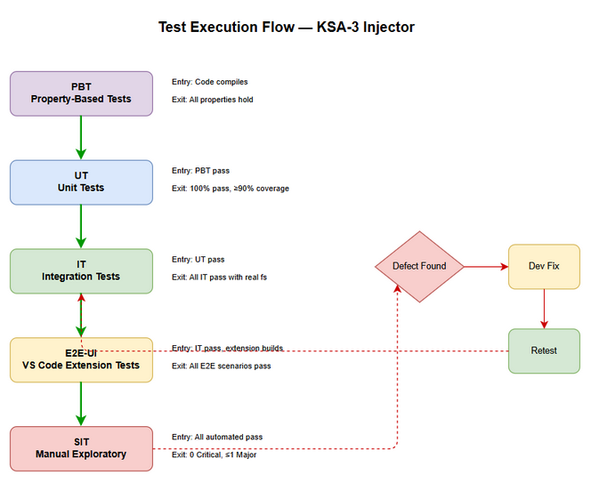
Test Execution Flow

2.4 Entry Criteria
Level | Entry Criteria
UT/PBT | Source code compiles without errors
IT | Unit tests pass, temp directory utilities available
E2E-UI | Extension builds and loads in test VS Code instance
SIT | All automated tests pass, extension packaged (.vsix)

2.5 Exit Criteria
Level | Exit Criteria
UT/PBT | 100% test cases pass, code coverage ≥ 90% for injector.ts
IT | All integration tests pass with real file system
E2E-UI | All E2E scenarios pass in VS Code test harness
SIT | 100% manual test cases executed, 0 Critical defects, ≤ 1 Major defect

2.6 Test Cases Summary
Level | Count | Automated | Manual
PBT | 5 | 5 | 0
UT | 17 | 17 | 0
IT | 8 | 8 | 0
E2E-UI | 5 | 5 | 0
SIT | 4 | 0 | 4
Total | 39 | 35 (90%) | 4 (10%)

3. Test Scope

3.1 Features In Scope
# | Feature / Story | Priority | FSD Reference | Test Type
1 | injectAll() — Copy all CORE_COMPONENTS + indexer | High | UC-1, BR-1, BR-2, BR-3, BR-4 | Functional, Integration
2 | injectSelective() — QuickPick multi-select | High | UC-2, BR-5, BR-6, BR-7 | Functional, UI
3 | copyDirRecursive() — Recursive copy with exclusions | High | UC-3, BR-8, BR-9, BR-10, BR-11 | Functional, PBT
4 | copyFiltered() — Filtered copy for indexer | High | UC-4, BR-12, BR-13, BR-14, BR-15 | Functional, PBT
5 | checkStatus() — Component status reporting | Medium | UC-5, BR-16, BR-17 | Functional
6 | Cross-platform path handling | High | FSD Section 8 | Compatibility
7 | Performance (< 5s for 500 files) | Medium | FSD Section 8 | Non-Functional
8 | Error handling and notifications | High | FSD Section 9 | Functional
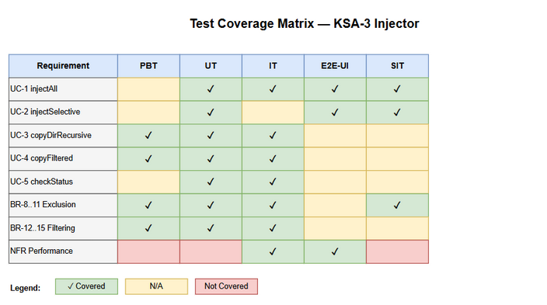
Test Coverage

3.2 Features Out of Scope
# | Feature | Reason
1 | Indexer Selection UI (KSA-4) | Separate ticket, tested independently
2 | Auto-detect Runtime (KSA-5) | Separate ticket, tested independently
3 | Extension Core activation (KSA-2) | Separate ticket, dependency only
4 | Content of resource files | Maintained separately, not Injector responsibility
5 | File watching / auto-sync | Explicitly out of scope per BRD

4. Test Environment

4.1 Environment Requirements
Environment | Platform | Node.js | VS Code | Purpose
Dev/UT | Windows 11 | 18.x+ | 1.85+ | Unit + Integration tests
CI | Linux (GitHub Actions) | 18.x+ | Latest | Automated test pipeline
SIT | Windows 11 / macOS 14 / Ubuntu 22.04 | 18.x+ | 1.85+ | Manual cross-platform testing

4.2 Test Data Requirements
Data Type | Description | Source | Preparation
Extension resources | Mock directory structure with agents, steering, hooks, templates, scripts | Test fixtures | Create in test setup
Workspace directory | Empty temp directory simulating workspace | OS temp | Create per test
Nested directories | Deep directory tree with excluded dirs at various depths | Test fixtures | Create in test setup
Large file set | 500+ files for performance testing | Generated | Script to create dummy files

4.3 External Dependencies
System | Dependency | Mock/Stub Available
VS Code API | vscode.window.showQuickPick, vscode.workspace | Yes — @vscode/test-electron provides real API
Node.js fs | File system operations | Yes — mock-fs for UT, real fs for IT
OS file system | Cross-platform path resolution | Yes — test on all 3 platforms in CI

5. Test Schedule
Phase | Start Date | End Date | Duration | Milestone
Test Planning | 2025-01-20 | 2025-01-21 | 2 days | STP + STC approved
Test Data Preparation | 2025-01-21 | 2025-01-22 | 1 day | Test fixtures ready
UT/PBT Development | 2025-01-22 | 2025-01-24 | 3 days | All unit + PBT tests pass
IT Development | 2025-01-24 | 2025-01-25 | 2 days | Integration tests pass
E2E-UI Development | 2025-01-25 | 2025-01-27 | 2 days | E2E tests pass
SIT Execution | 2025-01-27 | 2025-01-28 | 2 days | SIT sign-off
Defect Fix & Retest | 2025-01-28 | 2025-01-29 | 1 day | All Critical/Major fixed

6. Resources & Responsibilities
Role | Name | Responsibility
Test Lead | QA Agent | Test planning, coordination, reporting
QA Engineer | QA Agent | Test case design, execution, defect reporting
BA | BA Agent | Acceptance criteria clarification
Developer | DEV Agent | Bug fixing, unit test coverage
DevOps | DevOps Agent | CI pipeline setup, environment provisioning

7. Risk & Mitigation
# | Risk | Impact | Likelihood | Mitigation
1 | Cross-platform path differences cause failures | High | Medium | Test on all 3 OS in CI; use path.join() consistently
2 | Mock-fs doesn’t accurately simulate real fs behavior | Medium | Low | Supplement with real-fs integration tests
3 | VS Code test harness instability | Medium | Medium | Pin @vscode/test-electron version; retry flaky tests
4 | Large directory trees cause timeout in tests | Low | Low | Set generous timeout; use smaller fixtures for UT
5 | Permission issues differ across OS | Medium | Medium | Test with restricted permissions on each platform

8. Defect Management

8.1 Severity Levels
Severity | Definition | Example
Critical | Core copy logic broken, data loss | Files silently not copied; workspace corrupted
Major | Feature not working, workaround exists | Exclusion list not applied at nested depth
Minor | UI issue, cosmetic defect | QuickPick description text incorrect
Trivial | Typo, minor alignment issue | Log message typo

8.2 Priority Levels
Priority | Definition | SLA (Fix Time)
P1 | Must fix immediately | 4 hours
P2 | Must fix before release | 1 business day
P3 | Should fix if time permits | 3 business days
P4 | Nice to fix, can defer | Next release

8.3 Defect Lifecycle
New → Open → In Progress → Fixed → Ready for Retest → Verified → Closed
→ Reopened → In Progress

9. Test Metrics & Reporting

9.1 Metrics
Metric | Formula | Target
Test Execution Rate | Executed / Total × 100% | 100%
Pass Rate | Passed / Executed × 100% | ≥ 95%
Defect Density | Defects / Test Cases | ≤ 0.1
Critical Defect Count | Count of Critical severity | 0
Code Coverage (injector.ts) | Lines covered / Total lines × 100% | ≥ 90%
Automation Rate | Automated / Total × 100% | ≥ 85%

9.2 Reporting Schedule
Report | Frequency | Audience
Daily Test Status | Daily during SIT | Project team
Defect Summary | Per defect found | Dev team
Test Completion Report | End of each test level | All stakeholders

10. Appendix

Glossary
Term | Definition
SIT | System Integration Testing
STP | Software Test Plan
STC | Software Test Cases
PBT | Property-Based Testing
UT | Unit Testing
IT | Integration Testing
E2E-UI | End-to-End UI Testing
CORE_COMPONENTS | agents, steering, hooks, templates

Assumptions
- VS Code extension host provides stable Node.js fs module access
- Extension resources directory is always correctly structured after installation
- Test fixtures can accurately represent real-world directory structures
- CI environment supports all three target platforms (Windows, macOS, Linux)

