Technical Design Document (TDD)

SDLC Memory Engine — KSA-37: [Memory] Project Setup — Kotlin MCP Server skeleton with dual-transport (stdio + HTTP)

Document Information
Field | Value
Jira Ticket | KSA-37
Title | [Memory] Project Setup — Kotlin MCP Server skeleton with dual-transport (stdio + HTTP)
Author | SA Agent
Version | 1.0
Date | 2025-01-20
Status | Draft
Related BRD | documents/KSA-37/BRD.md
Related FSD | documents/KSA-37/FSD.md

Revision History
Version | Date | Author | Changes
1.0 | 2025-01-20 | SA Agent | Initiate document — auto-generated from BRD and FSD

1. Introduction

1.1 Purpose
Technical design cho SDLC Memory MCP Server skeleton — Kotlin project với dual-transport architecture (stdio JSON-RPC + Ktor HTTP), following patterns established in mcp-code-intelligence-kotlin.

1.2 Scope
- Project structure và Gradle build configuration
- stdio JSON-RPC 2.0 transport implementation
- Ktor HTTP server with health endpoint
- CLI argument parsing
- Coroutine-based concurrent transport management

1.3 Technology Stack
Layer | Technology | Version
Language | Kotlin | 2.0.21
Build Tool | Gradle (Kotlin DSL) | 8.10
HTTP Framework | Ktor (Netty) | 3.0.3
Serialization | kotlinx.serialization | 1.7.3
Concurrency | kotlinx.coroutines | 1.9.0
JVM Target | JDK | 11
Fat JAR | Shadow Plugin | 8.1.1

1.4 Design Principles
- Single Responsibility: Each file handles one concern (max 200 lines)
- Separation of Transports: stdio and HTTP are independent, share common dispatcher
- Fail Fast: Invalid config → immediate exit with clear error
- Protocol Compliance: Strict JSON-RPC 2.0 and MCP 2024-11-05 adherence
- Pattern Reuse: Follow mcp-code-intelligence-kotlin patterns where applicable

1.5 Constraints
- Max 200 lines per file (code-standards)
- Max 20 lines per function (code-standards)
- JVM 11 target for broad compatibility
- No external dependencies beyond Ktor + kotlinx ecosystem
- stdout reserved exclusively for JSON-RPC responses

1.6 References
Document | Location
BRD | documents/KSA-37/BRD.md
FSD | documents/KSA-37/FSD.md
Reference Project | mcp-code-intelligence-kotlin/
MCP Spec | https://modelcontextprotocol.io/

2. System Architecture

2.1 Architecture Overview
The server runs as a single JVM process with two concurrent communication channels: 1. Main thread: stdio read loop processing JSON-RPC messages 2. Coroutine: Ktor HTTP server on configurable port
Both transports share a common RequestDispatcher that routes to method handlers.
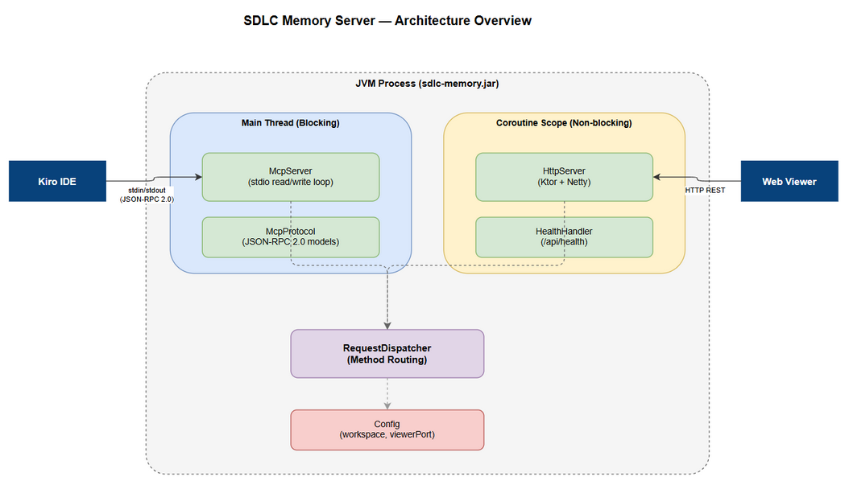
Architecture Diagram

2.2 Component Diagram
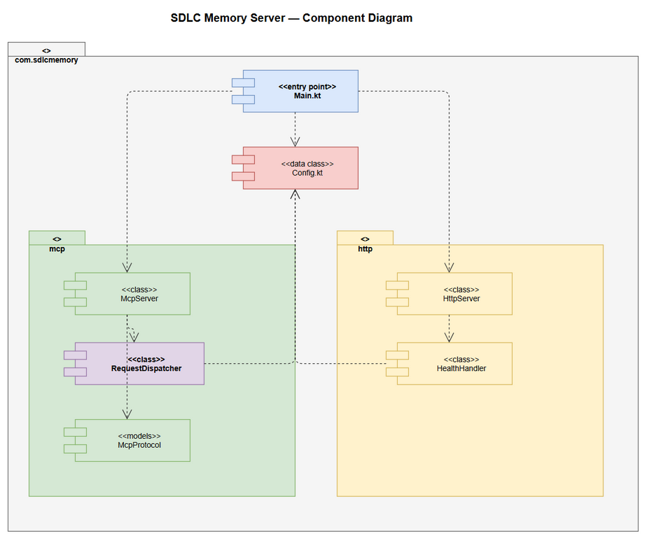
Component Diagram
Component | Responsibility | Technology
Main | Entry point, CLI parsing, orchestration | Kotlin stdlib
Config | CLI arg parsing, configuration model | Kotlin stdlib
McpServer | stdio transport, JSON-RPC read/write loop | kotlinx.serialization
HttpServer | Ktor HTTP server, REST endpoints | Ktor + Netty
RequestDispatcher | Route MCP methods to handlers | Kotlin
McpProtocol | JSON-RPC 2.0 message models | kotlinx.serialization
HealthHandler | Health check response builder | Kotlin

2.3 Deployment Architecture
Single JAR deployment — no containers needed for Phase 1:
java -jar sdlc-memory.jar --workspace /path/to/project --viewer-port 3200
- Process communicates via stdin/stdout with parent (Kiro)
- HTTP server binds to 0.0.0.0:{port} for Web Viewer access
- No database in Phase 1 (added in KSA-38)

2.4 Communication Patterns
From | To | Protocol | Pattern | Description
Kiro IDE | McpServer | stdio JSON-RPC 2.0 | Sync request/response | One JSON per line
Web Viewer | HttpServer | HTTP REST | Sync request/response | Standard HTTP
McpServer | RequestDispatcher | In-process | Direct call | Method routing
HttpServer | RequestDispatcher | In-process | Direct call | Shared dispatcher

3. API Design

3.1 API Overview
# | Endpoint/Method | Protocol | Description | Source
1 | initialize | MCP/stdio | MCP handshake | UC-01
2 | tools/list | MCP/stdio | List available tools | UC-01
3 | tools/call | MCP/stdio | Execute a tool | UC-01
4 | ping | MCP/stdio | Heartbeat | UC-01
5 | GET /api/health | HTTP | Health check | UC-02

3.2 MCP Method: initialize
Attribute | Value
Method | initialize
Transport | stdio
Auth | None
Request:
{
"jsonrpc": "2.0",
"id": 1,
"method": "initialize",
"params": {
"protocolVersion": "2024-11-05",
"capabilities": {},
"clientInfo": { "name": "kiro", "version": "1.0.0" }
}
}
Response — Success:
{
"jsonrpc": "2.0",
"id": 1,
"result": {
"protocolVersion": "2024-11-05",
"capabilities": {
"tools": { "listChanged": false }
},
"serverInfo": {
"name": "sdlc-memory",
"version": "0.1.0"
}
}
}

3.3 MCP Method: tools/list
Response:
{
"jsonrpc": "2.0",
"id": 2,
"result": {
"tools": []
}
}

3.4 MCP Method: tools/call
Request:
{
"jsonrpc": "2.0",
"id": 3,
"method": "tools/call",
"params": {
"name": "some_tool",
"arguments": {}
}
}
Response (unknown tool):
{
"jsonrpc": "2.0",
"id": 3,
"result": {
"content": [{ "type": "text", "text": "Unknown tool: some_tool" }]
}
}

3.5 HTTP: GET /api/health
Attribute | Value
Method | GET
Path | /api/health
Auth | None
Content-Type | application/json
Response — 200 OK:
{
"status": "ok",
"version": "0.1.0",
"workspace": "/absolute/path/to/workspace"
}

4. Database Design
Not applicable for KSA-37 (skeleton). Database will be introduced in KSA-38 (SQLite + FTS5).

5. Class / Module Design

5.1 Package Structure
sdlc-memory-server/
├── build.gradle.kts
├── settings.gradle.kts
├── gradle/
│ └── libs.versions.toml
├── src/main/kotlin/com/sdlcmemory/
│ ├── Main.kt # Entry point + CLI parsing
│ ├── Config.kt # Configuration data class
│ ├── mcp/
│ │ ├── McpServer.kt # stdio transport read/write loop
│ │ ├── RequestDispatcher.kt # Method routing
│ │ └── McpProtocol.kt # JSON-RPC models + helpers
│ └── http/
│ ├── HttpServer.kt # Ktor server setup + routing
│ └── HealthHandler.kt # Health endpoint handler
└── src/test/kotlin/com/sdlcmemory/
├── ConfigTest.kt
├── mcp/
│ ├── McpServerTest.kt
│ └── RequestDispatcherTest.kt
└── http/
└── HealthHandlerTest.kt

5.2 Key Interfaces & Classes
// Config.kt — Configuration data class
data class Config(
val workspace: String, // Absolute path
val viewerPort: Int = 3200 // HTTP server port
)
// mcp/RequestDispatcher.kt — Method routing
class RequestDispatcher(private val config: Config) {
fun dispatch(method: String, params: JsonObject): JsonObject
}
// mcp/McpServer.kt — stdio transport
class McpServer(private val dispatcher: RequestDispatcher) {
fun run() // Main read loop (blocking)
}
// http/HttpServer.kt — Ktor HTTP server
class HttpServer(private val config: Config) {
suspend fun start() // Starts Ktor on config.viewerPort
fun stop() // Graceful shutdown
}
// http/HealthHandler.kt — Health endpoint
class HealthHandler(private val config: Config) {
fun handle(): HealthResponse
}

5.3 Design Patterns
Pattern | Where Used | Rationale
Dispatcher | RequestDispatcher | Central routing, easy to extend with new methods
Builder | JsonObject builders | kotlinx.serialization buildJsonObject pattern
Facade | HttpServer | Wraps Ktor complexity behind simple start/stop

5.4 Error Handling
Error Type | JSON-RPC Code | When
Parse error | -32700 | Invalid JSON on stdin
Invalid request | -32600 | Missing method field
Method not found | -32601 | Unknown method name
Internal error | -32603 | Handler throws exception

6. Integration Design

6.1 Kiro IDE Integration (stdio)
Attribute | Value
Protocol | JSON-RPC 2.0 over stdin/stdout
Message Format | One JSON object per line (newline-delimited)
Encoding | UTF-8
Timeout | None (persistent connection)
Error Recovery | Log to stderr, continue processing

6.2 Web Viewer Integration (HTTP)
Attribute | Value
Protocol | HTTP/1.1
Endpoint | http://localhost:{port}/api/*
Content-Type | application/json
CORS | Enabled (all origins for dev)
Timeout | 30s default

7. Security Design

7.1 Authentication
None for Phase 1 — local development only. Both transports are unauthenticated.

7.2 Network Security
Transport | Binding | Access
stdio | Process-level | Only parent process
HTTP | 0.0.0.0:{port} | Local network

7.3 Input Validation
Input | Validation | Action on Failure
JSON from stdin | Valid JSON parse | Return -32700 error
CLI –workspace | Path exists check | Exit with error
CLI –viewer-port | Integer 1024-65535 | Exit with error

8. Performance & Scalability

8.1 Performance Targets
Operation | Target | Notes
Server startup | < 3s | Cold start to ready
MCP handshake | < 50ms | initialize + tools/list
Health endpoint | < 10ms | Simple JSON response
Memory footprint | < 100MB | Skeleton without data

8.2 Concurrency Model
- Main thread: stdio read loop (blocking I/O)
- Coroutine scope: Ktor HTTP server (non-blocking)
- Shared dispatcher accessed from both (thread-safe via immutable config)

9. Monitoring & Observability

9.1 Logging
Log Event | Level | Destination | Format
Server starting | INFO | stderr | [sdlc-memory] Server starting...
Workspace resolved | INFO | stderr | [sdlc-memory] Workspace: {path}
HTTP server ready | INFO | stderr | [sdlc-memory] HTTP server on port {port}
Request received | DEBUG | stderr | [sdlc-memory] Method: {method}
Error | ERROR | stderr | [sdlc-memory] Error: {message}

9.2 Health Checks
Endpoint | Checks | Response
GET /api/health | Server running | 200 + status JSON

10. Deployment Considerations

10.1 Build & Package
# Build fat JAR
./gradlew shadowJar
# Output: build/libs/sdlc-memory-0.1.0.jar

10.2 Runtime Configuration
Property | Source | Default | Description
workspace | CLI –workspace | (required) | Workspace root path
viewerPort | CLI –viewer-port | 3200 | HTTP server port

10.3 Kiro MCP Configuration
{
"mcpServers": {
"sdlc-memory": {
"command": "java",
"args": ["-jar", "path/to/sdlc-memory.jar", "--workspace", "${workspaceFolder}", "--viewer-port", "3200"]
}
}
}

11. Appendix

Glossary
Term | Definition
MCP | Model Context Protocol
JSON-RPC 2.0 | Remote procedure call protocol
Ktor | Kotlin async web framework
Shadow JAR | Fat JAR with all dependencies bundled
stdio | Standard input/output process streams

Implementation File Breakdown
File | Lines (est.) | Responsibility
Main.kt | ~40 | Entry point, CLI parsing, launch
Config.kt | ~30 | Config data class + validation
mcp/McpServer.kt | ~80 | stdio read loop, JSON-RPC I/O
mcp/RequestDispatcher.kt | ~60 | Method routing + handlers
mcp/McpProtocol.kt | ~50 | JSON-RPC models + builders
http/HttpServer.kt | ~50 | Ktor setup + routing
http/HealthHandler.kt | ~25 | Health response builder
Total | ~335 | 7 files, all under 200 lines

