Functional Specification Document (FSD)

Kiro SDLC Agents Extension — KSA-4: Indexer Selection — Choose ONE Language

Document Information
Field | Value
Jira Ticket | KSA-4
Title | Indexer Selection — Choose ONE Language
Author | BA Agent + TA Agent
Version | 1.0
Date | 2025-07-10
Status | Draft
Related BRD | BRD-v1-KSA-4.docx

Revision History
Version | Date | Author | Changes
1.0 | 2025-07-10 | BA Agent | Initiate document — functional specification from BRD
1.0 | 2025-07-10 | TA Agent | Enriched with API contracts, technical integration details

1. Introduction

1.1 Purpose
This FSD specifies the functional behavior of the Indexer Selection feature — a VS Code QuickPick UI that allows users to choose exactly one code indexer language during the SDLC resource injection flow.

1.2 Scope
- QuickPick UI presentation and interaction behavior
- Single-selection constraint enforcement
- Integration with injectAll() and injectSelective() flows
- Base config copy behavior (always included)
- Selected language script copy behavior

1.3 Definitions & Acronyms
Term | Definition
QuickPick | VS Code’s built-in list/dropdown UI component
INDEXER_OPTIONS | Array of 5 Component objects defining available indexer languages
INDEXER_BASE | Component object defining base config files always copied
canPickMany | VS Code QuickPick property controlling single vs multi-select
Component | TypeScript interface with id, label, description, sourcePath, targetPath, filter

1.4 References
Document | Location
BRD | BRD-v1-KSA-4.docx
VS Code QuickPick API | https://code.visualstudio.com/api/references/vscode-api#window.showQuickPick
Extension config.ts | kiro-sdlc-agents/src/config.ts
Injector module | kiro-sdlc-agents/src/injector.ts

2. System Overview

2.1 System Context Diagram
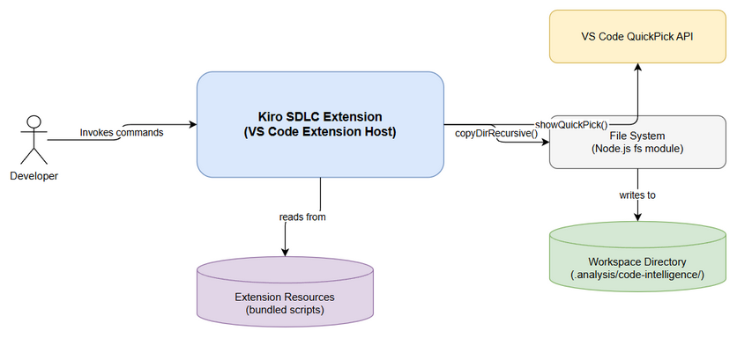
System Context
The Indexer Selection feature operates within the VS Code extension host. It is invoked by the Injector module during injection flows and interacts with the VS Code QuickPick API to present options to the user. Upon selection, it returns the chosen Component to the Injector which handles the actual file copy.

2.2 System Architecture
The feature consists of: - pickIndexer() function in injector.ts — orchestrates the QuickPick - INDEXER_OPTIONS config in config.ts — defines the 5 options - INDEXER_BASE config in config.ts — defines base files always copied - VS Code QuickPick API — renders the UI

3. Functional Requirements

3.1 Feature: Indexer Language Picker
Source: BRD Story 1, Story 2

3.1.1 Description
The pickIndexer() function displays a VS Code QuickPick dialog with 5 indexer language options. The user selects exactly one option. The function returns the selected Component object or undefined if cancelled.

3.1.2 Use Case: UC-1 — Select Indexer Language
Use Case ID: UC-1 Actor: Developer Preconditions: - VS Code workspace is open - User has triggered “Inject All” or “Inject Selective” (with indexer selected) - Extension is activated
Postconditions: - Selected: pickIndexer() returns the chosen Component - Cancelled: pickIndexer() returns undefined
Main Flow:
Step | Actor | System | Description
1 | Triggers inject command |  | User invokes kiroSdlc.injectAll or kiroSdlc.injectSelective
2 |  | Calls pickIndexer() | Injector module invokes the picker function
3 |  | Displays QuickPick | Shows 5 options with labels and descriptions
4 | Selects one language |  | User clicks or presses Enter on an option
5 |  | Returns Component | pickIndexer() returns the selected INDEXER_OPTIONS entry
6 |  | Copies INDEXER_BASE | Injector copies base config (filtered copy)
7 |  | Copies selected scripts | Injector copies language directory (recursive copy)
8 |  | Shows success message | “✅ Injected {N} components: …, indexer-{lang}”
Alternative Flows:
ID | Condition | Steps
AF-1 | User types filter text | QuickPick filters options by typed text; user selects from filtered list
AF-2 | User uses keyboard navigation | Arrow keys navigate options; Enter confirms selection
Exception Flows:
ID | Condition | Steps
EF-1 | User presses ESC | QuickPick returns undefined; no indexer files copied; injection continues without indexer
EF-2 | User clicks outside QuickPick | Same as EF-1 — treated as cancellation
EF-3 | Source directory missing | injectComponent logs warning “Source not found: {path}”; returns false; injection reports partial success

3.1.3 Business Rules
Rule ID | Rule | Source
BR-1 | Exactly ONE indexer language can be selected per injection operation | BRD Story 2
BR-2 | Base config (INDEXER_BASE) is ALWAYS copied when any language is selected | BRD Story 3
BR-3 | Cancellation results in NO indexer files copied (but core components still injected) | BRD Story 2
BR-4 | QuickPick options are static — no async loading or runtime detection in this feature | BRD NFR
BR-5 | Existing indexer files in workspace are NOT deleted — only new files are added/overwritten | BRD Story 2 AC4

3.1.4 Data Specifications
Input Data:
Field | Type | Required | Validation | Description
INDEXER_OPTIONS | Component[] | Yes | Array length = 5 | Static config array of indexer choices
canPickMany | boolean | Yes | Must be false | Enforces single-select
placeHolder | string | Yes | Non-empty | “Choose ONE indexer language for this workspace”
Output Data:
Field | Type | Description
selected | Component | undefined | The chosen indexer Component, or undefined if cancelled
selected.id | string | One of: “indexer-python”, “indexer-java”, “indexer-powershell”, “indexer-bash”, “indexer-nodejs”
selected.sourcePath | string | Relative path to source scripts in extension resources
selected.targetPath | string | Relative path to target in workspace

3.1.5 UI Specifications
Screen: Indexer Language Picker (QuickPick)
No. | Element | Type | Required | Behavior | Validation
1 | QuickPick Container | vscode.QuickPick | Yes | Modal overlay at top of editor | canPickMany: false
2 | Placeholder Text | string | Yes | “Choose ONE indexer language for this workspace” | Shown when input is empty
3 | Filter Input | TextInput | Yes | Filters options as user types | Built-in VS Code behavior
4 | Option: Python | QuickPickItem | Yes | label + description; first in list | —
5 | Option: Java | QuickPickItem | Yes | label + description; second in list | —
6 | Option: PowerShell | QuickPickItem | Yes | label + description; third in list | —
7 | Option: Bash | QuickPickItem | Yes | label + description; fourth in list | —
8 | Option: Node.js | QuickPickItem | Yes | label + description; fifth in list | —
QuickPick Item Details:
# | Label | Description | Component ID
1 | Python Indexer (recommended — zero dependency) | Python 3.7+ standard library only | indexer-python
2 | Java Indexer | Java 17+ (for JVM projects) | indexer-java
3 | PowerShell Indexer | PowerShell 5.1+ (Windows built-in) | indexer-powershell
4 | Bash Indexer | Bash 4+ (Linux/Mac built-in) | indexer-bash
5 | Node.js Indexer (most accurate) | Node.js 18+ (needs npm install) | indexer-nodejs

3.1.6 API Contract (Functional View)
Note: This is an internal TypeScript function API, not an HTTP endpoint.
Function: pickIndexer(): Promise<Component | undefined>
Purpose: Present indexer language selection UI and return user’s choice.
Input Parameters:
Parameter | Type | Required | Business Rule | Description
(none) | — | — | — | Function reads from INDEXER_OPTIONS config directly
Output Data:
Field | Type | Description
return value | Component | undefined | Selected Component object, or undefined if user cancelled
Business Error Scenarios:
Scenario | User Message | Trigger Condition
User cancels | (none — silent) | User presses ESC or clicks outside QuickPick
Source not found | “Source not found: {sourcePath}” | Extension resources missing (corrupt install)
Copy failure | “Failed to inject {id}: {error}” | File system permission error or disk full

3.2 Feature: Base Config Injection
Source: BRD Story 3

3.2.1 Description
When a user selects any indexer language, the system first copies the INDEXER_BASE component using filtered copy. This ensures the workspace has the necessary configuration infrastructure regardless of which language was chosen.

3.2.2 Use Case: UC-2 — Copy Base Config
Use Case ID: UC-2 Actor: System (automatic) Preconditions: User has selected an indexer language (UC-1 returned a Component) Postconditions: Base config files exist in workspace at .analysis/code-intelligence/
Main Flow:
Step | Actor | System | Description
1 |  | Reads INDEXER_BASE.filter | Gets list: [“index-config.json”, “modules”, “scripts/README.md”]
2 |  | Calls injectComponent(INDEXER_BASE) | Triggers filtered copy
3 |  | copyFiltered() executes | Copies only items in filter list from source to target
4 |  | Creates target directories | mkdirSync with recursive: true
5 |  | Copies each filtered item | Files copied, directories recursively copied
Exception Flows:
ID | Condition | Steps
EF-1 | Filter item not found in source | Silently skipped; continues with remaining items
EF-2 | Target directory not writable | Throws error; caught by injectComponent; shows error message

3.2.3 Business Rules
Rule ID | Rule | Source
BR-6 | INDEXER_BASE is copied BEFORE the language-specific scripts | BRD Story 3
BR-7 | Filter list is exact match — no glob patterns | KSA-3 Story 4
BR-8 | If a filter item doesn’t exist in source, it is silently skipped | KSA-3 Story 4

3.2.4 Data Specifications
INDEXER_BASE Configuration:
Field | Value | Description
id | “indexer-config” | Unique identifier
label | “Code Intelligence — Config (always included)” | Display name
sourcePath | “.analysis/code-intelligence” | Source in extension resources
targetPath | “.analysis/code-intelligence” | Target in workspace
filter | [“index-config.json”, “modules”, “scripts/README.md”] | Items to copy
Workspace Result After Base Config Copy:
{workspaceRoot}/
└── .analysis/
└── code-intelligence/
├── index-config.json ← Configuration for indexer
├── modules/ ← Output directory for module analysis
└── scripts/
└── README.md ← Documentation for scripts directory

3.3 Feature: Language-Specific Script Copy
Source: BRD Story 2

3.3.1 Description
After base config is copied, the system copies the selected language’s script directory using recursive directory copy (with exclusion of build artifacts).

3.3.2 Use Case: UC-3 — Copy Selected Language Scripts
Use Case ID: UC-3 Actor: System (automatic) Preconditions: Base config copied (UC-2 complete), selected Component available Postconditions: Selected language scripts exist in workspace
Main Flow:
Step | Actor | System | Description
1 |  | Reads selected.sourcePath | e.g., “.analysis/code-intelligence/scripts/python”
2 |  | Resolves full source path | path.join(extensionPath, “resources”, sourcePath)
3 |  | Resolves full target path | path.join(workspaceRoot, targetPath)
4 |  | Calls copyDirRecursive() | Recursively copies directory contents
5 |  | Skips excluded dirs | node_modules, pycache, .git, out, dist
6 |  | Returns true | Injection successful
Workspace Result After Language Copy (example: Python):
{workspaceRoot}/
└── .analysis/
└── code-intelligence/
├── index-config.json
├── modules/
└── scripts/
├── README.md
└── python/
├── main.py
├── config.py
├── detector.py
├── discovery.py
├── scanner.py
├── parser.py
├── patterns.py
├── generator.py
└── utils.py

3.3.3 Business Rules
Rule ID | Rule | Source
BR-9 | Only ONE language directory is copied per injection | BRD Story 2
BR-10 | Excluded directories (node_modules, pycache, .git, out, dist) are never copied | KSA-3 Story 3
BR-11 | Existing files at destination are overwritten without prompt | KSA-3 Story 1
BR-12 | Other language directories already in workspace are NOT deleted | BRD Story 2 AC4

4. Data Model

4.1 Entity Relationship Diagram
This feature uses configuration objects (not database entities). The data model is the TypeScript interface hierarchy.

4.2 Logical Entities

Entity: Component
Attribute | Type | Required | Business Rule | Description
id | string | Yes | Unique across all components | Identifier (e.g., “indexer-python”)
label | string | Yes | Displayed in QuickPick | Human-readable name with key trait
description | string | Yes | Displayed as secondary text | Version requirement and notes
sourcePath | string | Yes | Relative to extension resources | Where to copy from
targetPath | string | Yes | Relative to workspace root | Where to copy to
filter | string[] | No | Only for INDEXER_BASE | Whitelist of items to copy

Entity: QuickPickItem (VS Code API)
Attribute | Type | Required | Business Rule | Description
label | string | Yes | From Component.label | Primary display text
description | string | Yes | From Component.description | Secondary display text
component | Component | Yes | Internal reference | Maps pick back to config
Relationships:
From Entity | To Entity | Cardinality | Description
INDEXER_OPTIONS | Component | 1:5 | Array contains exactly 5 Component entries
QuickPickItem | Component | 1:1 | Each pick item wraps one Component
INDEXER_BASE | Component | 1:1 | Single Component for base config

5. Integration Specifications

5.1 Internal Integration: Injector Module
Attribute | Value
Purpose | pickIndexer() is called by injectAll() and injectSelective()
Direction | Inbound (Injector calls Picker)
Data Format | TypeScript function call/return
Frequency | On-demand (each injection operation)
Data Exchange:
Our Data | External Data | Direction | Business Rule
Component | undefined | injectAll() receives selection | Return | BR-1: exactly one or none
INDEXER_BASE | injectComponent() receives base config | Pass | BR-2: always copied first

5.2 External Integration: VS Code QuickPick API
Attribute | Value
Purpose | Render the selection UI to the user
Direction | Outbound (extension calls VS Code API)
Data Format | QuickPickItem[] → Promise<QuickPickItem | undefined>
Frequency | Once per injection operation
API Call:
vscode.window.showQuickPick(picks, {
canPickMany: false,
placeHolder: "Choose ONE indexer language for this workspace"
}): Promise<QuickPickItem | undefined>

6. Processing Logic

6.1 pickIndexer() Process
Trigger: Called by injectAll() or injectSelective() during injection flow Input: INDEXER_OPTIONS config array (static) Output: Component | undefined
Processing Steps:
Step | Description | Error Handling
1 | Map INDEXER_OPTIONS to QuickPickItem[] | N/A (static data)
2 | Call vscode.window.showQuickPick() | Returns undefined on cancel
3 | Return selected?.component | undefined propagates to caller
State Diagram:
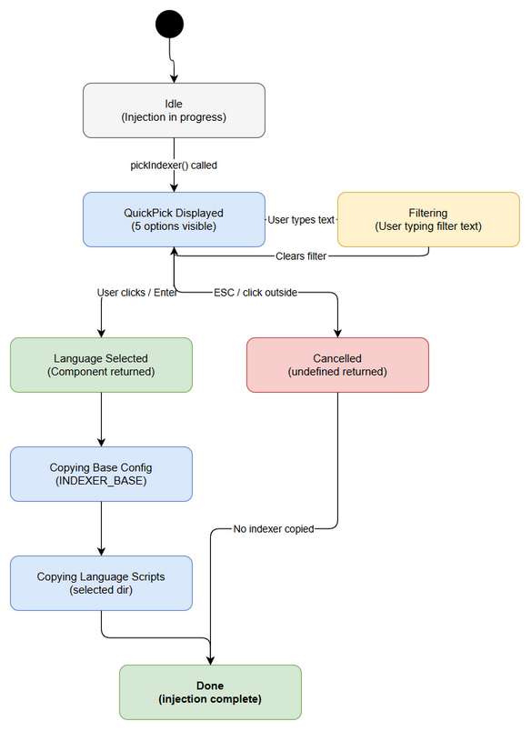
State Diagram

6.2 Injection Flow with Indexer Selection
Trigger: User confirms “Inject All” or selects indexer in “Inject Selective” Input: workspaceRoot, extensionPath Output: string[] (list of injected component IDs)
Processing Steps:
Step | Description | Error Handling
1 | Copy CORE_COMPONENTS (agents, steering, hooks, templates) | Log + skip on failure
2 | Call pickIndexer() | If undefined → skip indexer, continue
3 | Call injectComponent(INDEXER_BASE) | Log warning if source missing
4 | Call injectComponent(selectedLanguage) | Log error if copy fails
5 | Save workspace version | —
6 | Return injected component IDs | —

7. Security Requirements

7.1 Authentication & Authorization
Role | Permissions | Screens/Features
Any VS Code user | Full access | Indexer selection (no auth required — local extension)

7.2 Data Sensitivity Classification
Data Type | Classification | Business Requirement
Indexer scripts | Public | Open-source scripts bundled with extension
Workspace paths | Internal | Used only locally, never transmitted

7.3 Audit Trail
Event | Logged Fields | Retention | Business Reason
Indexer selected | Language ID, timestamp | Session only (Output Channel) | Debugging injection issues

8. Non-Functional Requirements
Category | Business Requirement | Acceptance Criteria
Performance | QuickPick appears instantly | < 100ms from function call to UI display
Usability | Clear option differentiation | Each option has unique label + description
Usability | Keyboard-first workflow | Arrow keys + Enter to select without mouse
Accessibility | Screen reader support | VS Code QuickPick natively accessible
Extensibility | Easy to add 6th language | Add one entry to INDEXER_OPTIONS array

9. Error Handling (User-Facing)

9.1 Error Scenarios
Scenario | Severity | User Message | Expected Behavior
User cancels QuickPick | Info | (none) | Silent — no indexer copied, core components still injected
Source directory missing | Warning | “Source not found: {path}” | VS Code warning notification; injection continues without indexer
Copy fails (permission) | Error | “Failed to inject {id}: {error}” | VS Code error notification; partial injection reported
Extension resources corrupt | Error | “Source not found: {path}” | All indexer options fail; user must reinstall extension

9.2 Notification Requirements
Event | Who is Notified | Channel | Timing
Successful injection | Developer | VS Code info message | Immediate after completion
Source not found | Developer | VS Code warning message | Immediate on detection
Copy failure | Developer | VS Code error message | Immediate on failure

10. Testing Considerations

10.1 Test Scenarios
ID | Scenario | Input | Expected Output | Priority
TC-1 | Select Python indexer | User picks “Python Indexer” | indexer-python copied + base config | High
TC-2 | Select Java indexer | User picks “Java Indexer” | indexer-java copied + base config | High
TC-3 | Select PowerShell indexer | User picks “PowerShell Indexer” | indexer-powershell copied + base config | High
TC-4 | Select Bash indexer | User picks “Bash Indexer” | indexer-bash copied + base config | High
TC-5 | Select Node.js indexer | User picks “Node.js Indexer” | indexer-nodejs copied + base config | High
TC-6 | Cancel selection (ESC) | User presses ESC | No indexer files copied; returns undefined | High
TC-7 | Cancel by clicking outside | User clicks outside QuickPick | Same as TC-6 | Medium
TC-8 | QuickPick shows 5 options | Function called | 5 items displayed with correct labels | High
TC-9 | Single-select enforced | canPickMany = false | Only one item selectable | High
TC-10 | Base config always copied | Any language selected | index-config.json + modules/ + README exist | High
TC-11 | Only selected language copied | Select Python | Only python/ dir exists in scripts/ (others not added) | High
TC-12 | Existing files not deleted | Had bash/, select python | bash/ still exists, python/ added | Medium
TC-13 | Filter text works | Type “node” | Only Node.js option visible | Low

11. Appendix

Sequence Diagram
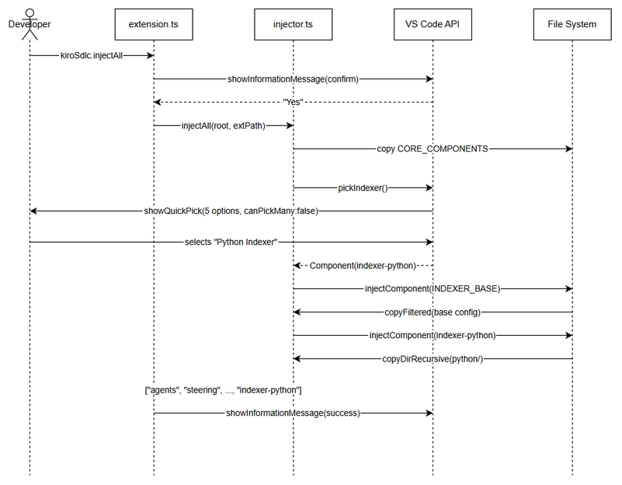
Sequence Diagram — Inject All with Indexer Selection

Diagrams
Diagram | File
System Context | system-context.png
Sequence — Inject All | sequence-inject-all.png
State — Picker | state-picker.png

Change Log from BRD
- No deviations from BRD. All 4 user stories mapped to functional use cases.
- Added technical detail on copyFiltered() vs copyDirRecursive() behavior.
- Clarified that existing language directories are NOT deleted (BR-12).

Diagram Index
# | Diagram | Image | Source (editable)
1 | System Context | system-context.png | system-context.drawio
2 | Sequence — Inject All | sequence-inject-all.png | sequence-inject-all.drawio
3 | State — Picker | state-picker.png | state-picker.drawio

