Technical Design Document (TDD)

Kiro SDLC Agents Extension — KSA-4: Indexer Selection — Choose ONE Language

Document Information
Field | Value
Jira Ticket | KSA-4
Title | Indexer Selection — Choose ONE Language
Author | SA Agent
Version | 1.0
Date | 2025-07-10
Status | Draft
Related BRD | BRD-v1-KSA-4.docx
Related FSD | FSD-v1-KSA-4.docx

Author Tracking
Role | Name - Position | Responsibility
Author | SA Agent – Solution Architect | Create document
Peer Reviewer | TA Agent – Technical Analyst | Review document

Revision History
Version | Date | Author | Changes
1.0 | 2025-07-10 | SA Agent | Initiate document — technical design from FSD

Sign-Off
Name | Signature and date
 | ☐ I agree and confirm the technical design in this TDD
 | ☐ I agree and confirm the technical design in this TDD

1. Introduction
Scope Boundary: This TDD specifies HOW to implement the Indexer Selection feature defined in the FSD. It does NOT repeat functional requirements, business rules, or use cases — refer to the FSD for those. This document focuses on: implementation patterns, code structure, and integration with existing modules.

1.1 Purpose
This TDD describes the technical implementation of the Indexer Selection QuickPick UI within the Kiro SDLC Agents VS Code extension. The feature is already implemented in the current codebase (injector.ts → pickIndexer() function). This document serves as the authoritative technical reference for the implementation.

1.2 Scope
- pickIndexer() function implementation in injector.ts
- INDEXER_OPTIONS and INDEXER_BASE configuration in config.ts
- Integration with injectAll() and injectSelective() flows
- File copy mechanics (filtered copy for base, recursive copy for language)

1.3 Technology Stack
Layer | Technology | Version
Language | TypeScript | ^5.4.0
Runtime | Node.js (VS Code Extension Host) | ^20.0.0
Framework | VS Code Extension API | ^1.85.0
Build Tool | tsc (TypeScript Compiler) | ^5.4.0
Package Tool | @vscode/vsce | ^2.24.0
Module System | CommonJS (compiled from ES modules) | —

1.4 Design Principles
- Single Responsibility: pickIndexer() only handles UI selection; file copy is delegated to injectComponent()
- Configuration-Driven: All indexer options defined in config.ts — no hardcoded values in logic
- Graceful Degradation: Cancellation returns undefined; callers handle gracefully
- No External Dependencies: Uses only VS Code API and Node.js stdlib

1.5 Constraints
- Must work within VS Code Extension Host (no direct DOM access)
- QuickPick API is async — must use await
- File operations use synchronous fs methods (acceptable for small file sets)
- Extension resources path resolved via context.extensionPath

1.6 References
Document | Location
BRD | BRD-v1-KSA-4.docx
FSD | FSD-v1-KSA-4.docx
VS Code Extension API | https://code.visualstudio.com/api

2. System Architecture

2.1 Architecture Overview
The Indexer Selection feature is a thin UI layer within the existing extension architecture. It follows the Command → Handler → Module → File System pattern established by KSA-2 and KSA-3.
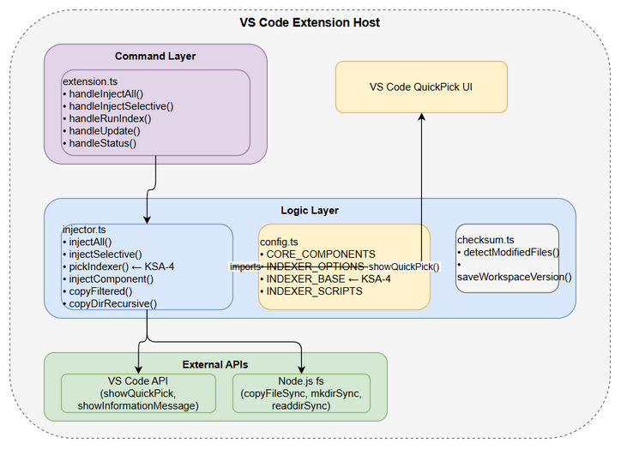
Architecture Diagram
┌─────────────────────────────────────────────────────────┐
│ VS Code Extension Host │
│ │
│ ┌──────────────┐ ┌──────────────┐ ┌───────────┐ │
│ │ extension.ts │───▶│ injector.ts │───▶│ config.ts │ │
│ │ (commands) │ │ (logic) │ │ (data) │ │
│ └──────────────┘ └──────┬───────┘ └───────────┘ │
│ │ │
│ ┌────────┴────────┐ │
│ │ │ │
│ ┌─────▼─────┐ ┌──────▼──────┐ │
│ │ QuickPick │ │ File System │ │
│ │ (VS Code) │ │ (Node.js fs) │ │
│ └────────────┘ └─────────────┘ │
└─────────────────────────────────────────────────────────┘

2.2 Component Diagram
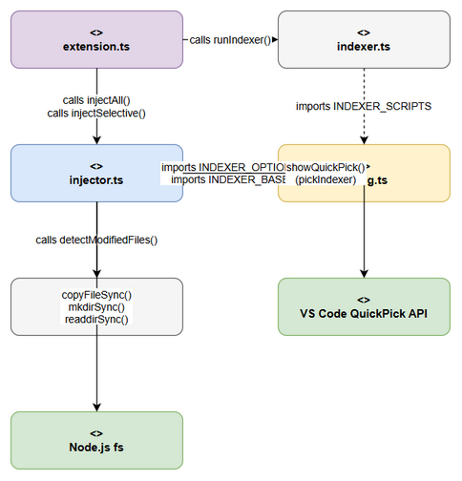
Component Diagram
Component | Responsibility | Technology
extension.ts | Command registration, entry point | VS Code Extension API
injector.ts | Injection orchestration, pickIndexer() | TypeScript, VS Code API
config.ts | Static configuration (INDEXER_OPTIONS, INDEXER_BASE) | TypeScript constants
checksum.ts | File modification detection | Node.js crypto + fs
indexer.ts | Runtime detection and indexer execution | Node.js child_process

2.3 Deployment Architecture
The extension is packaged as a .vsix file and installed in VS Code’s extension directory. No server-side deployment — entirely client-side.
Extension Package (.vsix)
├── out/ ← Compiled JavaScript
│ ├── extension.js
│ ├── injector.js
│ ├── config.js
│ ├── checksum.js
│ └── indexer.js
├── resources/ ← Bundled SDLC resources
│ └── .analysis/
│ └── code-intelligence/
│ ├── index-config.json
│ ├── modules/
│ └── scripts/
│ ├── README.md
│ ├── python/
│ ├── java/
│ ├── powershell/
│ ├── bash/
│ └── nodejs/
└── package.json

2.4 Communication Patterns
From | To | Protocol | Pattern | Description
extension.ts | injector.ts | Function call | Sync (await) | handleInjectAll → injectAll()
injector.ts | VS Code API | Function call | Async (Promise) | showQuickPick() returns selection
injector.ts | Node.js fs | Function call | Sync | copyDirRecursive(), copyFiltered()
injector.ts | config.ts | Import | Static | Reads INDEXER_OPTIONS, INDEXER_BASE

3. API Design
Prerequisite: Functional API contracts are defined in FSD §3.1.6. This section specifies the technical implementation details.

3.1 API Overview
# | Function | Module | Description | Source
1 | pickIndexer() | injector.ts | Shows QuickPick, returns Component | UC-1
2 | injectAll() | injector.ts | Full injection with indexer selection | UC-1, UC-2, UC-3
3 | injectSelective() | injector.ts | Selective injection with optional indexer | UC-1
4 | injectComponent() | injector.ts | Copies single component to workspace | UC-2, UC-3
5 | copyFiltered() | injector.ts | Copies only whitelisted items | UC-2
6 | copyDirRecursive() | injector.ts | Recursive directory copy with exclusions | UC-3

3.2 Function: pickIndexer()
Implements: UC-1 (Select Indexer Language)
Attribute | Value
Module | injector.ts
Visibility | async function (module-private)
Returns | Promise<Component \| undefined>
Side Effects | Displays VS Code QuickPick UI
Implementation:
async function pickIndexer(): Promise<Component | undefined> {
const picks = INDEXER_OPTIONS.map(c => ({
label: c.label,
description: c.description,
component: c
}));
const selected = await vscode.window.showQuickPick(picks, {
canPickMany: false,
placeHolder: "Choose ONE indexer language for this workspace"
});
return selected?.component;
}
Parameters: None (reads from INDEXER_OPTIONS import)
Return Value:
Case | Return | Description
User selects an option | Component | The INDEXER_OPTIONS entry matching selection
User cancels (ESC) | undefined | No selection made
User clicks outside | undefined | QuickPick dismissed
Error Handling:
Error | Handling | Recovery
VS Code API unavailable | Not possible — extension host guarantees API | —
INDEXER_OPTIONS empty | QuickPick shows empty list | User cancels → undefined

3.3 Function: injectAll()
Implements: UC-1 + UC-2 + UC-3
Attribute | Value
Module | injector.ts
Visibility | export async function
Returns | Promise<string[]> (injected component IDs)
Relevant Indexer Section:
// After copying CORE_COMPONENTS...
const indexerChoice = await pickIndexer();
if (indexerChoice) {
await injectComponent(INDEXER_BASE, root, extensionPath); // Always copy base
if (await injectComponent(indexerChoice, root, extensionPath)) {
injected.push(indexerChoice.id);
}
}
Flow: 1. Copy all 4 CORE_COMPONENTS (agents, steering, hooks, templates) 2. Call pickIndexer() → get user’s language choice 3. If choice is not undefined: a. Copy INDEXER_BASE (filtered: index-config.json, modules/, scripts/README.md) b. Copy selected language directory (recursive) 4. Save workspace version 5. Return list of injected component IDs

3.4 Function: injectComponent()
Implements: File copy for any Component
Attribute | Value
Module | injector.ts
Visibility | async function (module-private)
Returns | Promise<boolean>
Logic:
async function injectComponent(
component: Component, workspaceRoot: string, extensionPath: string
): Promise<boolean> {
const source = path.join(extensionPath, "resources", component.sourcePath);
const target = path.join(workspaceRoot, component.targetPath);
if (!fs.existsSync(source)) {
vscode.window.showWarningMessage(`Source not found: ${component.sourcePath}`);
return false;
}
try {
if (component.filter) {
copyFiltered(source, target, component.filter);
} else {
copyDirRecursive(source, target);
}
return true;
} catch (err) {
vscode.window.showErrorMessage(`Failed to inject ${component.id}: ${err}`);
return false;
}
}
Decision Logic:
Condition | Action | Used By
component.filter exists | copyFiltered() | INDEXER_BASE
component.filter is undefined | copyDirRecursive() | INDEXER_OPTIONS entries

4. Database Design
Not applicable — this feature has no database. All data is static TypeScript configuration.

5. Class / Module Design

5.1 Package Structure
kiro-sdlc-agents/src/
├── extension.ts ← Entry point: command registration
├── injector.ts ← Core logic: injectAll, pickIndexer, copy functions
├── config.ts ← Configuration: INDEXER_OPTIONS, INDEXER_BASE, CORE_COMPONENTS
├── checksum.ts ← File modification detection (not KSA-4 scope)
└── indexer.ts ← Runtime detection & execution (not KSA-4 scope)

5.2 Key Interfaces
// config.ts
export interface Component {
id: string; // Unique identifier (e.g., "indexer-python")
label: string; // QuickPick primary text
description: string; // QuickPick secondary text
sourcePath: string; // Relative to extension resources/
targetPath: string; // Relative to workspace root
filter?: string[]; // Optional whitelist for filtered copy
}
// Internal QuickPick item type (injector.ts)
interface IndexerPickItem {
label: string; // From Component.label
description: string; // From Component.description
component: Component; // Reference back to config
}

5.3 Design Patterns
Pattern | Where Used | Rationale
Configuration Object | config.ts INDEXER_OPTIONS | Separates data from logic; easy to extend
Adapter | picks mapping in pickIndexer() | Adapts Component to VS Code QuickPickItem
Strategy | injectComponent() filter check | Chooses copy strategy based on component config
Null Object | undefined return from pickIndexer() | Callers handle absence without null checks

5.4 Error Handling
Exception | Behavior | Error Code | When Thrown
Source not found | Warning message + return false | — | Extension resources missing/corrupt
Copy failure (EACCES) | Error message + return false | — | Target directory not writable
Copy failure (ENOSPC) | Error message + return false | — | Disk full

6. Integration Design
Prerequisite: Business integration requirements defined in FSD §5.

6.1 Internal Integration: Extension Commands → Injector
Attribute | Value
Protocol | TypeScript function call (async/await)
Caller | extension.ts → handleInjectAll()
Callee | injector.ts → injectAll()
Timeout | None (user-driven — QuickPick blocks until selection)
Retry Policy | None (user can re-invoke command)
Sequence Diagram:
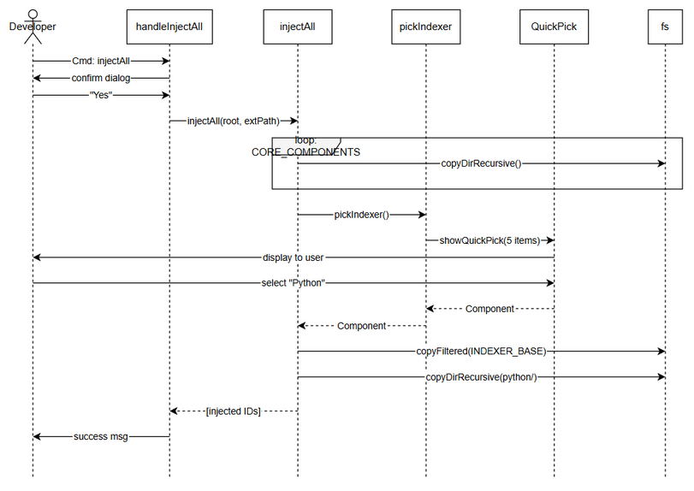
API Sequence — Inject All

6.2 External Integration: VS Code QuickPick API
Attribute | Value
Protocol | VS Code Extension API (in-process)
Endpoint | vscode.window.showQuickPick()
Authentication | None (extension host context)
Timeout | None (waits for user interaction)
Retry Policy | None
API Signature:
function showQuickPick<T extends QuickPickItem>(
items: T[],
options?: QuickPickOptions
): Thenable<T | undefined>
Options Used:
{
canPickMany: false, // Single-select
placeHolder: "Choose ONE indexer language for this workspace" // Hint text
}

7. Security Design

7.1 Authentication
Not applicable — local extension, no network calls, no authentication required.

7.2 Authorization
Role | Access | Permissions
Any VS Code user | Full | Can select any indexer, copy files to workspace

7.3 Data Protection
Data Type | At Rest | In Transit | In Logs
Indexer scripts | Plain text (source code) | N/A (local only) | Not logged
Workspace paths | Plain text | N/A (local only) | Logged in Output Channel

7.4 Input Validation
Field | Validation | Sanitization
QuickPick selection | Must be from INDEXER_OPTIONS (type-safe) | None needed — VS Code API guarantees valid item
File paths | fs.existsSync() check before copy | path.join() prevents path traversal

8. Performance & Scalability

8.1 Caching Strategy
Cache | What | TTL | Eviction | Technology
None | — | — | — | —
No caching needed — INDEXER_OPTIONS is a static array (5 items), QuickPick renders instantly.

8.2 Connection Pooling
Not applicable — no network connections.

8.3 Performance Targets
Operation | Target | Measurement
QuickPick display | < 50ms | Time from pickIndexer() call to UI visible
Base config copy | < 100ms | Time to copy 3 items (config, modules dir, README)
Language script copy | < 500ms | Time to recursively copy one language directory
Total injection (all) | < 2s | End-to-end including all CORE_COMPONENTS + indexer

9. Monitoring & Observability

9.1 Logging
Log Event | Level | Fields | Destination
Injection started | INFO | component IDs | VS Code Output Channel
Source not found | WARN | sourcePath | VS Code Warning Message
Copy failed | ERROR | component ID, error message | VS Code Error Message
Injection complete | INFO | injected count, component list | VS Code Info Message

9.2 Metrics
Not applicable — VS Code extensions don’t typically emit metrics for local operations.

9.3 Health Checks
Check | Method | Expected
Extension activated | Status bar visible | “$(check) SDLC Agents" or "$(warning) SDLC Agents”
Indexer present | checkStatus() | indexer: true if index-config.json exists

10. Deployment Considerations

10.1 Environment Configuration
Property | DEV | Production (installed)
Extension path | ./out (local) | ~/.vscode/extensions/kiro-sdlc-agents-x.x.x/
Resources path | ./resources | {extensionPath}/resources/
Compile | tsc -watch | vsce package → .vsix

10.2 Feature Flags
Flag | Default | Description
kiroSdlc.preferredIndexer | “auto” | If set to specific language, runIndex uses it directly (bypasses picker for execution, not injection)
kiroSdlc.autoIndex | true | Auto-run indexer after injection if indexer was injected

10.3 Rollback Strategy
- Extension can be downgraded via VS Code extension management
- Injected files can be deleted manually from workspace
- No persistent state beyond copied files — safe to re-inject at any time

11. Implementation Checklist

Files to Create/Modify
# | File | Action | Description
1 | src/config.ts | EXISTS | INDEXER_OPTIONS and INDEXER_BASE already defined
2 | src/injector.ts | EXISTS | pickIndexer() already implemented
3 | src/extension.ts | EXISTS | Command handlers already call injectAll/injectSelective
4 | package.json | EXISTS | Commands and settings already registered

Implementation Status
This feature is already fully implemented in the current codebase. The TDD documents the existing implementation for reference and future maintenance.
Component | Status | Location
INDEXER_OPTIONS config | ✅ Done | src/config.ts lines 47-82
INDEXER_BASE config | ✅ Done | src/config.ts lines 39-45
pickIndexer() function | ✅ Done | src/injector.ts (pickIndexer function)
injectAll() integration | ✅ Done | src/injector.ts (injectAll function)
injectSelective() integration | ✅ Done | src/injector.ts (injectSelective function)
copyFiltered() for base | ✅ Done | src/injector.ts (copyFiltered function)
copyDirRecursive() for language | ✅ Done | src/injector.ts (copyDirRecursive function)

12. Appendix

Glossary
Term | Definition
QuickPick | VS Code’s built-in list selection UI component
Component | TypeScript interface representing an injectable resource set
INDEXER_OPTIONS | Array of 5 Component objects for indexer languages
INDEXER_BASE | Component object for base config (always copied)
Filtered Copy | Copy only whitelisted items from a directory
Recursive Copy | Copy entire directory tree, skipping excluded dirs

Open Questions
# | Question | Status | Answer
1 | Should we pre-select based on detected runtime? | Resolved | No — KSA-5 handles runtime detection separately for runIndex
2 | Should we allow changing indexer after initial injection? | Resolved | Yes — user can re-inject; old language dir stays, new one added
3 | Should we show a “recommended” badge on Python? | Resolved | Yes — included in label text “(recommended — zero dependency)”

⛔ MANDATORY: Diagram Requirements

Required draw.io Diagrams
# | Diagram | File | Section | Required
1 | Architecture Overview | diagrams/architecture.drawio + .png | §2.1 | ✅ MANDATORY
2 | Component Diagram | diagrams/component.drawio + .png | §2.2 | ✅ MANDATORY
3 | API Sequence — Inject All | diagrams/api-sequence-inject-all.drawio + .png | §6.1 | ✅ MANDATORY
4 | Class Diagram | diagrams/class-diagram.drawio + .png | §5.x | ✅ MANDATORY

Diagram Index
# | Diagram | Image | Source (editable)
1 | Architecture Overview | architecture.png | architecture.drawio
2 | Component Diagram | component.png | component.drawio
3 | API Sequence — Inject All | api-sequence-inject-all.png | api-sequence-inject-all.drawio
4 | Class Diagram | class-diagram.png | class-diagram.drawio

