Functional Specification Document (FSD)

Kiro SDLC Agents Extension — KSA-6: Bundled Resources — Agents, Steering, Hooks, Templates

Document Information
Field | Value
Jira Ticket | KSA-6
Title | Bundled Resources — Agents, Steering, Hooks, Templates
Author | BA Agent + TA Agent
Version | 1.0
Date | 2026-05-10
Status | Draft
Related BRD | BRD-v1-KSA-6.docx

Revision History
Version | Date | Author | Changes
1.0 | 2026-05-10 | BA Agent | Initial FSD from BRD
1.1 | 2026-05-10 | TA Agent | Technical enrichment — API contracts, build scripts detail

1. Introduction

1.1 Purpose
This FSD specifies the functional behavior of the bundled resources system within the Kiro SDLC Agents VS Code extension. It defines how resources are structured, bundled during build, and injected into target workspaces at runtime.

1.2 Scope
- Resource file structure and naming conventions
- Build-time bundling process (copy + checksum generation)
- Runtime injection behavior (all/selective/update commands)
- Modification detection and safe update logic
- Resource inventory validation (counts match acceptance criteria)

1.3 Definitions & Acronyms
Term | Definition
Agent | AI agent definition consisting of JSON config + MD description + prompt file
Steering | Workspace-level rule file that guides agent behavior
Hook | Automated trigger that fires on file system events in Kiro IDE
Template | Markdown document template with placeholder variables
Injection | Process of copying bundled resources into a target workspace
Manifest | .sdlc-checksums.json — SHA-256 hash registry of all bundled files
VSIX | VS Code Extension package format

1.4 References
Document | Location
BRD | BRD-v1-KSA-6.docx
Extension package.json | kiro-sdlc-agents/package.json
Config definitions | kiro-sdlc-agents/src/config.ts

2. System Overview

2.1 System Context Diagram
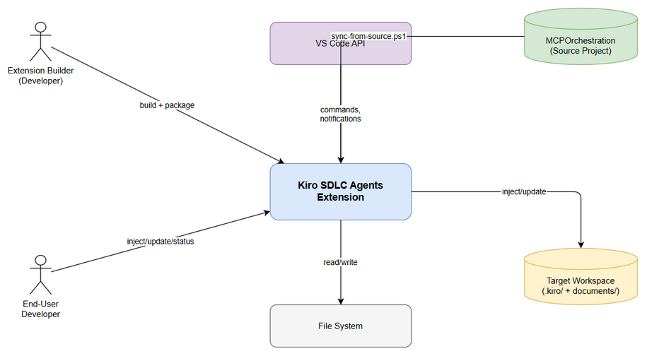
System Context
The extension operates in two contexts: 1. Build-time — Developer machine running build scripts to bundle resources 2. Runtime — End-user’s VS Code/Kiro IDE executing injection commands
External Actors: - Extension Builder (runs sync + build) - End-User Developer (runs inject/update commands) - Source Project (MCPOrchestration — provides source files) - Target Workspace (receives injected resources) - VS Code Marketplace (distributes VSIX)

2.2 System Architecture
The bundled resources system consists of: - Source Layer — MCPOrchestration project with canonical agent/steering/hook/template files - Sync Layer — PowerShell script that copies changed files to extension workspace - Build Layer — Node.js scripts that copy resources into extension package and generate checksums - Runtime Layer — TypeScript extension code that injects resources into target workspaces

3. Functional Requirements

3.1 Feature: Resource Bundling (Build-Time)
Source: BRD Story 5, Story 6

3.1.1 Description
During the extension build process (npm run vscode:prepublish), all SDLC resources are copied from the workspace root into the resources/ directory inside the extension, and a checksum manifest is generated.

3.1.2 Use Case: UC-1 — Bundle Resources
Use Case ID: UC-1 Actor: Extension Builder Preconditions: Source files exist in workspace root directories (.kiro/, documents/templates/) Postconditions: All resources copied to resources/ with valid checksum manifest
Main Flow:
Step | Actor | System | Description
1 | Builder |  | Runs npm run vscode:prepublish
2 |  | copy-resources.js | Reads MAPPINGS array for source→destination pairs
3 |  | copy-resources.js | For each mapping, recursively copies files (skipping excluded dirs)
4 |  | gen-checksums.js | Scans all files in resources/
5 |  | gen-checksums.js | Computes SHA-256 hash for each file
6 |  | gen-checksums.js | Writes .sdlc-checksums.json with version from package.json
7 |  | tsc | Compiles TypeScript source
8 | Builder |  | Runs vsce package to create VSIX
Alternative Flows:
ID | Condition | Steps
AF-1 | Source directory missing | Log warning “SKIP: Source not found”, continue with other mappings
AF-2 | File in SKIP_FILES list | Skip file silently, continue
Exception Flows:
ID | Condition | Steps
EF-1 | Write permission denied | Throw error, build fails
EF-2 | Disk full | Throw error, build fails

3.1.3 Business Rules
Rule ID | Rule | Source
BR-1 | SKIP_DIRS: node_modules, pycache, out, dist, .git, settings | copy-resources.js
BR-2 | SKIP_FILES: mcp.json, mcp.json,bk | copy-resources.js
BR-3 | Checksum algorithm MUST be SHA-256 | BRD Story 6
BR-4 | Manifest version MUST match package.json version | BRD Story 6
BR-5 | All 9 agents MUST be present after copy | BRD Story 1
BR-6 | All 9 steering files MUST be present after copy | BRD Story 2
BR-7 | All 8 hooks MUST be present after copy | BRD Story 3
BR-8 | At minimum 10 templates MUST be present after copy | BRD Story 4

3.1.4 Data Specifications
Input Data (MAPPINGS):
Source Path | Destination Path | Type
.kiro/agents | .kiro/agents | Directory (recursive)
.kiro/hooks | .kiro/hooks | Directory (recursive)
.kiro/steering | .kiro/steering | Directory (recursive)
documents/templates | documents/templates | Directory (recursive)
.analysis/code-intelligence/index-config.json | .analysis/code-intelligence/index-config.json | Single file
Output Data (Checksum Manifest):
Field | Type | Description
version | string | Extension version from package.json
generatedAt | ISO 8601 string | Timestamp of generation
files | Record<string, FileChecksum> | Map of relative path → checksum entry
files[path].hash | string (64 hex chars) | SHA-256 hash of file content
files[path].version | string | Version when file was added
files[path].injectedAt | ISO 8601 string | Same as generatedAt

3.2 Feature: Resource Injection (Runtime)
Source: BRD Story 1, 2, 3, 4

3.2.1 Description
When a user runs an injection command, the extension copies resources from its bundled resources/ directory into the target workspace, creating the standard SDLC directory structure.

3.2.2 Use Case: UC-2 — Inject All Agents
Use Case ID: UC-2 Actor: End-User Developer Preconditions: Extension installed, workspace folder open Postconditions: All resources injected, .kiro/.sdlc-version created
Main Flow:
Step | Actor | System | Description
1 | User |  | Runs command “Kiro SDLC: Inject All Agents”
2 |  | Extension | Shows confirmation dialog
3 | User |  | Clicks “Yes”
4 |  | Extension | Iterates CORE_COMPONENTS (agents, steering, hooks, templates)
5 |  | Extension | For each component, copies source→target recursively
6 |  | Extension | Prompts user to pick indexer language
7 | User |  | Selects indexer (e.g., Python)
8 |  | Extension | Copies indexer base config + selected language scripts
9 |  | Extension | Saves .kiro/.sdlc-version with current version
10 |  | Extension | Shows success message with count of injected components
11 |  | Extension | If autoIndex enabled, runs code indexer
Alternative Flows:
ID | Condition | Steps
AF-1 | User cancels confirmation | Abort, no files copied
AF-2 | User cancels indexer pick | Skip indexer, inject core components only
AF-3 | Source component missing | Show warning, skip that component, continue

3.2.3 Use Case: UC-3 — Inject Selective
Use Case ID: UC-3 Actor: End-User Developer Preconditions: Extension installed, workspace folder open Postconditions: Selected resources injected
Main Flow:
Step | Actor | System | Description
1 | User |  | Runs command “Kiro SDLC: Inject (Select Components)”
2 |  | Extension | Shows multi-select QuickPick with all components
3 | User |  | Selects desired components (checkboxes)
4 |  | Extension | Injects only selected components
5 |  | Extension | If “indexer” selected, prompts for language choice
6 |  | Extension | Saves version file

3.2.4 Use Case: UC-4 — Safe Update
Use Case ID: UC-4 Actor: End-User Developer Preconditions: Resources previously injected, new extension version available Postconditions: Resources updated while respecting user modifications
Main Flow:
Step | Actor | System | Description
1 | User |  | Runs command “Kiro SDLC: Update Agents (Keep Customizations)”
2 |  | Extension | Loads bundled manifest, compares hashes with workspace files
3 |  | Extension | Identifies modified files (hash mismatch)
4a |  | Extension | If NO modifications: force update all files
4b |  | Extension | If modifications found: show warning with file list
5 | User |  | Chooses action: Skip Modified / Backup & Overwrite / Overwrite All / Cancel
6 |  | Extension | Executes chosen strategy
7 |  | Extension | Updates version file
Alternative Flows:
ID | Condition | Steps
AF-1 | “Skip Modified” chosen | Update all files EXCEPT those user modified
AF-2 | “Backup & Overwrite” chosen | Copy modified files to .kiro/.sdlc-backup/{timestamp}/, then overwrite all
AF-3 | “Overwrite All” chosen | Force overwrite everything
AF-4 | “Cancel” chosen | Abort, no changes

3.2.5 Business Rules
Rule ID | Rule | Source
BR-9 | Injection target paths mirror source paths (.kiro/agents → .kiro/agents) | config.ts
BR-10 | Skip directories during copy: node_modules, pycache, out, dist, .git | injector.ts
BR-11 | Version file location: .kiro/.sdlc-version | checksum.ts
BR-12 | Backup location: .kiro/.sdlc-backup/{ISO-timestamp}/ | injector.ts
BR-13 | Modification detection compares SHA-256 of workspace file vs manifest hash | checksum.ts
BR-14 | Only files matching current version in manifest are checked for modifications | checksum.ts

3.3 Feature: Status Check
Source: BRD Story 6

3.3.1 Use Case: UC-5 — Show Status
Use Case ID: UC-5 Actor: End-User Developer Preconditions: Workspace folder open Postconditions: Status displayed (no file changes)
Main Flow:
Step | Actor | System | Description
1 | User |  | Runs command “Kiro SDLC: Show Status” or clicks status bar
2 |  | Extension | Checks existence of each component’s target path
3 |  | Extension | Detects modified files via checksum comparison
4 |  | Extension | Shows info message with ✅/❌ per component + modification count
5 | User |  | Optionally clicks “Inject Missing” or “Show Modified”

3.4 Feature: Upgrade Notification

3.4.1 Use Case: UC-6 — Auto Upgrade Check
Use Case ID: UC-6 Actor: System (on extension activation) Preconditions: Extension activated, workspace has .kiro/.sdlc-version Postconditions: User notified if upgrade available
Main Flow:
Step | Actor | System | Description
1 |  | Extension | On activation, reads workspace version file
2 |  | Extension | Compares workspace version with bundled manifest version
3 |  | Extension | If versions differ, shows notification with “Update Now” / “Later”
4 | User |  | Clicks “Update Now”
5 |  | Extension | Triggers safe update flow (UC-4)

4. Data Model

4.1 Logical Entities

Entity: Component
Attribute | Type | Required | Description
id | string | Yes | Unique identifier (e.g., “agents”, “steering”)
label | string | Yes | Display name for QuickPick UI
description | string | Yes | Short description for QuickPick
sourcePath | string | Yes | Relative path within resources/
targetPath | string | Yes | Relative path in target workspace
filter | string[] | No | If set, only copy these items from source

Entity: ChecksumManifest
Attribute | Type | Required | Description
version | string | Yes | Extension version
generatedAt | ISO 8601 | Yes | Generation timestamp
files | Record | Yes | Map of path → FileChecksum

Entity: FileChecksum
Attribute | Type | Required | Description
hash | string (64 hex) | Yes | SHA-256 hash
version | string | Yes | Version when added
injectedAt | ISO 8601 | Yes | Injection timestamp

Entity: VersionInfo
Attribute | Type | Required | Description
version | string | Yes | Injected extension version
injectedAt | ISO 8601 | Yes | When injection occurred

5. Integration Specifications

5.1 External System: Source Project (MCPOrchestration)
Attribute | Value
Purpose | Provides canonical source files for all agents, steering, hooks, templates
Direction | Inbound (source → extension)
Data Format | Markdown, JSON, Shell scripts
Frequency | On-demand (developer runs sync script)
Data Exchange:
Our Data | External Data | Direction | Rule
resources/.kiro/agents/* | .kiro/agents/* | Receive | Byte-identical copy
resources/.kiro/steering/* | .kiro/steering/* | Receive | Byte-identical copy
resources/.kiro/hooks/* | .kiro/hooks/* | Receive | Byte-identical copy
resources/documents/templates/* | documents/templates/* | Receive | Byte-identical copy

5.2 External System: VS Code API
Attribute | Value
Purpose | Extension host providing commands, QuickPick, notifications
Direction | Bidirectional
Data Format | TypeScript API calls
Frequency | Real-time (user interactions)

6. Processing Logic

6.1 Copy Resources Process
Trigger: npm run copy-resources (build script) Input: Workspace root directories Output: Populated resources/ directory
Processing Steps:
Step | Description | Error Handling
1 | Read MAPPINGS array | Fatal if script fails to load
2 | For each mapping, resolve absolute source path | Skip if source doesn’t exist
3 | Check if source is file or directory | Handle both cases
4 | If directory: recursively copy, skipping SKIP_DIRS | Log skipped dirs
5 | If file: copy single file | Skip if in SKIP_FILES
6 | Count and report total files copied | Print summary

6.2 Checksum Generation Process
Trigger: npm run gen-checksums (build script, after copy-resources) Input: All files in resources/ directory Output: .sdlc-checksums.json
Processing Steps:
Step | Description | Error Handling
1 | Read package.json for version | Fatal if missing
2 | Recursively scan resources/ for all files | Skip directories
3 | For each file, compute SHA-256 hash | Fatal on read error
4 | Build manifest object with version + timestamp | —
5 | Write JSON to resources/.sdlc-checksums.json | Fatal on write error

6.3 Modification Detection Process
Trigger: Update command or status check Input: Bundled manifest + workspace files Output: List of ModifiedFile objects
Processing Steps:
Step | Description | Error Handling
1 | Load bundled manifest from extension path | Return empty if missing
2 | Load workspace version file | Use manifest version as fallback
3 | For each file in manifest matching current version | —
4 | Check if workspace file exists | Skip if not exists (not modified, just missing)
5 | Compute SHA-256 of workspace file | Skip on read error
6 | Compare with manifest hash | If different → add to modified list

7. Security Requirements

7.1 Data Sensitivity
Data Type | Classification | Requirement
Agent prompts | Internal | No secrets in prompts; prompts are distributable
Steering rules | Internal | No secrets; workspace-level guidance only
Checksums | Public | Integrity verification, not security-sensitive
User workspace files | User-owned | Extension must not transmit workspace data externally

7.2 Security Rules
Rule | Description
No network calls | Extension does NOT make any network requests during injection
Local-only operations | All file operations are local filesystem only
No telemetry | Extension does not collect or send usage data
Safe file operations | Never delete user files; only create/overwrite with confirmation

8. Non-Functional Requirements
Category | Requirement | Acceptance Criteria
Performance | Injection completes quickly | < 3 seconds for full inject on SSD
Performance | Checksum generation fast | < 2 seconds for ~60 files
Reliability | No data loss during update | Backup option preserves all modified files
Compatibility | VS Code 1.85+ | Extension activates without errors
Package Size | VSIX stays small | < 5 MB total (text-only resources)

9. Error Handling

9.1 Error Scenarios
Scenario | Severity | User Message | Expected Behavior
No workspace open | Warning | “No workspace folder open.” | Command aborts gracefully
Source component missing | Warning | “Source not found: {path}” | Skip component, continue others
Injection write fails | Error | “Failed to inject {id}: {error}” | Report error, continue others
Manifest missing | Info | (silent) | Treat as no modifications detected
Version file missing | Info | (silent) | Treat as upgrade available

10. Testing Considerations

10.1 Test Scenarios
ID | Scenario | Input | Expected Output | Priority
TC-1 | Inject all into empty workspace | Empty workspace | All 4 components + indexer injected | High
TC-2 | Inject selective (agents only) | Select “agents” | Only .kiro/agents/ created | High
TC-3 | Update with no modifications | Previously injected, no changes | All files updated silently | High
TC-4 | Update with modifications | User edited steering file | Warning shown with options | High
TC-5 | Backup and overwrite | Modified files exist | Backup created, then overwrite | Medium
TC-6 | Status check — all present | All components injected | All ✅ in status | Medium
TC-7 | Status check — missing components | Only agents injected | Mix of ✅ and ❌ | Medium
TC-8 | Upgrade notification | Workspace v1.0.2, extension v1.0.3 | Notification shown | Medium
TC-9 | Count validation — 9 agents | After inject | Exactly 9 agent .json + .md pairs | High
TC-10 | Count validation — 9 steering | After inject | Exactly 9 .md files in steering/ | High
TC-11 | Count validation — 8 hooks | After inject | Exactly 8 files in hooks/ | High
TC-12 | Count validation — 12 templates | After inject | 12 .md files in templates/ | High
TC-13 | Checksum integrity | After gen-checksums | All hashes match file content | High

11. Appendix

Component Registry (CORE_COMPONENTS)
ID | Source Path | Target Path | File Count
agents | .kiro/agents | .kiro/agents | 27 files (9×json + 9×md + 9×prompts)
steering | .kiro/steering | .kiro/steering | 9 files
hooks | .kiro/hooks | .kiro/hooks | 8 files
templates | documents/templates | documents/templates | 12 files

State Diagram — Update Flow
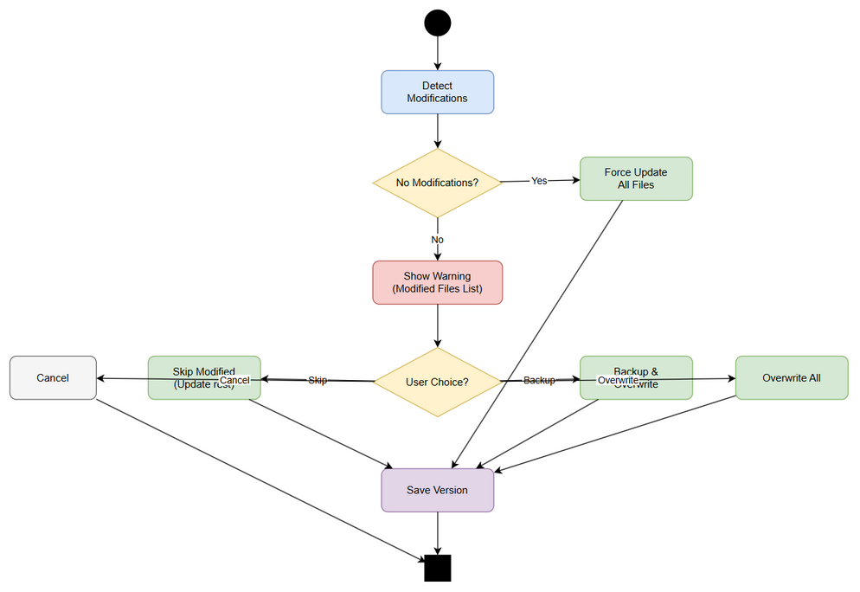
State Diagram

Sequence Diagram — Inject All
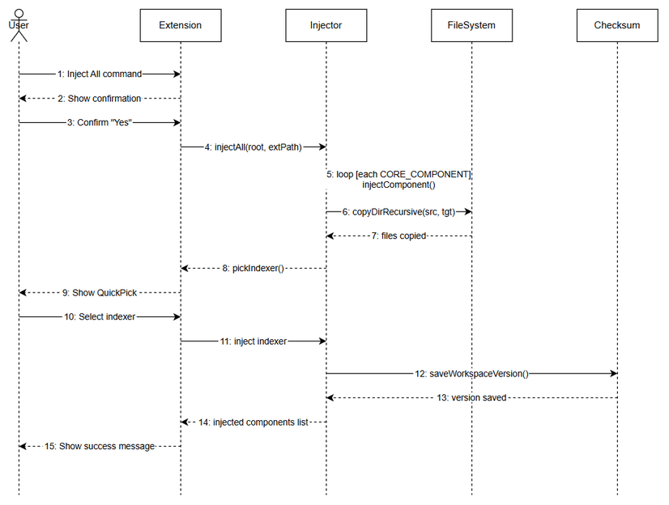
Sequence Diagram

Diagram Index
# | Diagram | Image | Source (editable)
1 | System Context | system-context.png | system-context.drawio
2 | Sequence — Inject All | sequence-inject-all.png | sequence-inject-all.drawio
3 | State — Update Flow | state-update-flow.png | state-update-flow.drawio

