Technical Design Document (TDD)

Kiro SDLC Agents Extension — KSA-6: Bundled Resources — Agents, Steering, Hooks, Templates

Document Information
Field | Value
Jira Ticket | KSA-6
Title | Bundled Resources — Agents, Steering, Hooks, Templates
Author | SA Agent
Version | 1.0
Date | 2026-05-10
Status | Draft
Related BRD | BRD-v1-KSA-6.docx
Related FSD | FSD-v1-KSA-6.docx

Revision History
Version | Date | Author | Changes
1.0 | 2026-05-10 | SA Agent | Initial TDD from FSD

1. Introduction

1.1 Purpose
This TDD specifies the technical implementation of the bundled resources system for the Kiro SDLC Agents VS Code extension. It covers the build-time bundling scripts, runtime injection logic, checksum integrity system, and the resource directory structure.

1.2 Scope
- Build scripts: copy-resources.js, gen-checksums.js
- Runtime modules: config.ts, injector.ts, checksum.ts
- Resource directory layout and file conventions
- Sync script: sync-from-source.ps1

1.3 Technology Stack
Layer | Technology | Version
Language | TypeScript | 5.4+
Runtime | Node.js | 18+
Platform | VS Code Extension API | 1.85+
Build Tool | npm + tsc | —
Packaging | vsce | 2.24+
Sync Script | PowerShell | 5.1+

1.4 Design Principles
- Zero external runtime dependencies — extension uses only Node.js built-in modules + VS Code API
- Immutable bundled resources — resources in extension package are read-only reference
- Checksum-based integrity — SHA-256 hashes detect modifications without storing original content
- Convention over configuration — source paths mirror target paths (.kiro/agents → .kiro/agents)

1.5 Constraints
- Extension must work offline (no network calls)
- Build scripts use only Node.js stdlib (fs, path, crypto)
- PowerShell sync script must work on Windows (PowerShell 5.1+)
- VSIX package size must stay under 5 MB

2. System Architecture

2.1 Architecture Overview
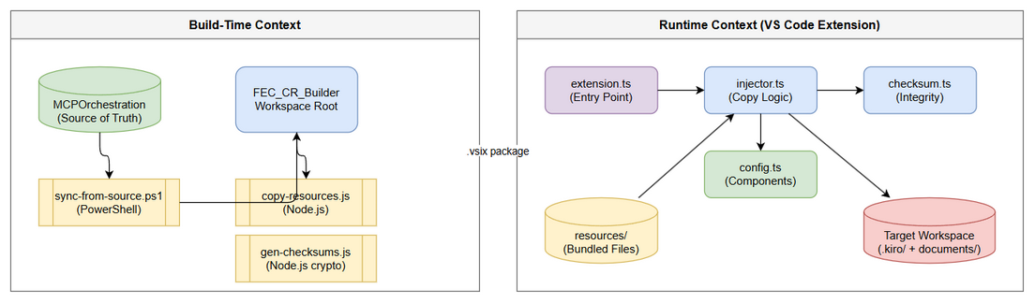
Architecture Diagram
The system has two execution contexts:
Build-Time (Developer Machine):
MCPOrchestration/ ──[sync-from-source.ps1]──> FEC_CR_Builder/
FEC_CR_Builder/ ──[copy-resources.js]────> kiro-sdlc-agents/resources/
resources/ ──[gen-checksums.js]─────> .sdlc-checksums.json
Runtime (End-User VS Code):
Extension resources/ ──[injector.ts]──> Target Workspace (.kiro/, documents/)
Workspace files ──[checksum.ts]──> Modification detection

2.2 Component Diagram
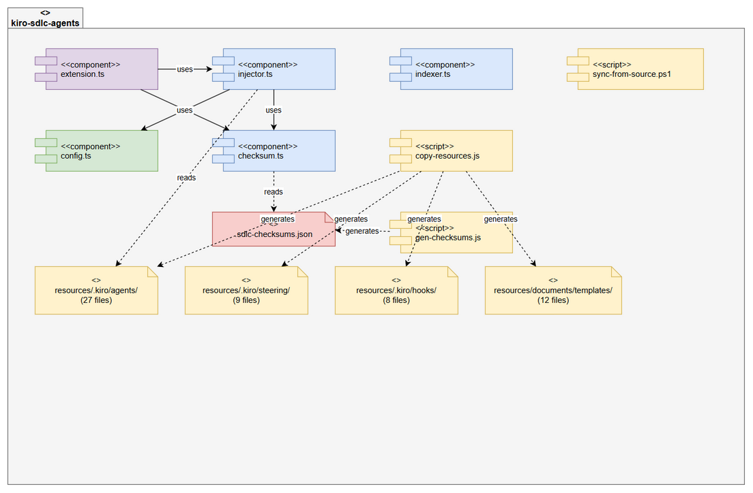
Component Diagram
Component | Responsibility | Technology
extension.ts | Command registration, activation, status bar | VS Code API
config.ts | Component definitions (CORE_COMPONENTS, INDEXER_OPTIONS) | TypeScript constants
injector.ts | File copy logic, user prompts, safe update | Node.js fs + VS Code API
checksum.ts | Hash computation, manifest loading, modification detection | Node.js crypto
indexer.ts | Code intelligence indexer execution | Node.js child_process
copy-resources.js | Build-time resource bundling | Node.js fs
gen-checksums.js | Build-time checksum manifest generation | Node.js crypto
sync-from-source.ps1 | Cross-project file synchronization | PowerShell

2.3 Deployment Architecture
The extension is distributed as a .vsix file containing:
kiro-sdlc-agents-{version}.vsix
├── extension/
│ ├── out/ ← Compiled JS (extension.js, injector.js, etc.)
│ ├── resources/ ← Bundled SDLC resources
│ │ ├── .kiro/agents/
│ │ ├── .kiro/steering/
│ │ ├── .kiro/hooks/
│ │ ├── documents/templates/
│ │ ├── .analysis/code-intelligence/
│ │ └── .sdlc-checksums.json
│ ├── package.json
│ └── node_modules/ ← (empty, no runtime deps)
└── [Content_Types].xml

3. Build Scripts Design

3.1 copy-resources.js
Implements: UC-1 (Bundle Resources), BR-1, BR-2
Algorithm:
function main():
for each mapping in MAPPINGS:
src = resolve(WORKSPACE_ROOT, mapping.src)
dst = resolve(RESOURCES_DIR, mapping.dst)
count = copyRecursive(src, dst)
log("{mapping.src} → resources/{mapping.dst} ({count} files)")
log("Copied {total} files into resources/")
function copyRecursive(src, dst):
if src is file:
if basename(src) in SKIP_FILES: return 0
mkdirSync(dirname(dst))
copyFileSync(src, dst)
return 1
if src is directory:
mkdirSync(dst)
for entry in readdirSync(src):
if entry.isDirectory and entry.name in SKIP_DIRS: continue
if entry.isFile and entry.name in SKIP_FILES: continue
count += copyRecursive(join(src, entry.name), join(dst, entry.name))
return count
MAPPINGS Configuration:
# | Source | Destination | Type
1 | .kiro/agents | .kiro/agents | Directory
2 | .kiro/hooks | .kiro/hooks | Directory
3 | .kiro/steering | .kiro/steering | Directory
4 | documents/templates | documents/templates | Directory
5 | .analysis/code-intelligence/index-config.json | .analysis/code-intelligence/index-config.json | File
6 | .analysis/code-intelligence/scripts/python | .analysis/code-intelligence/scripts/python | Directory
7 | .analysis/code-intelligence/scripts/java | .analysis/code-intelligence/scripts/java | Directory
8 | .analysis/code-intelligence/scripts/powershell | .analysis/code-intelligence/scripts/powershell | Directory
9 | .analysis/code-intelligence/scripts/bash | .analysis/code-intelligence/scripts/bash | Directory
10 | .analysis/code-intelligence/scripts/nodejs/src | .analysis/code-intelligence/scripts/nodejs/src | Directory
11 | .analysis/code-intelligence/scripts/nodejs/package.json | .analysis/code-intelligence/scripts/nodejs/package.json | File
12 | .analysis/code-intelligence/scripts/nodejs/tsconfig.json | .analysis/code-intelligence/scripts/nodejs/tsconfig.json | File

3.2 gen-checksums.js
Implements: UC-1, BR-3, BR-4
Algorithm:
function main():
version = readPackageVersion()
timestamp = new Date().toISOString()
files = {}
scanRecursive(RESOURCES_DIR, (filePath) => {
relativePath = relative(RESOURCES_DIR, filePath)
hash = sha256(readFileSync(filePath))
files[relativePath] = { hash, version, injectedAt: timestamp }
})
manifest = { version, generatedAt: timestamp, files }
writeFileSync(".sdlc-checksums.json", JSON.stringify(manifest, null, 2))
Output Schema (.sdlc-checksums.json):
{
"version": "1.0.3",
"generatedAt": "2026-05-10T03:09:17.371Z",
"files": {
".kiro/agents/ba-agent.json": {
"hash": "180a3a21d3a94ffce110df1273b3a8bee8771f77e74fa53a3d3170d4f36d5532",
"version": "1.0.3",
"injectedAt": "2026-05-10T03:09:17.371Z"
}
}
}

3.3 sync-from-source.ps1
Implements: Resource synchronization from MCPOrchestration
Algorithm:
for each mapping in MAPPINGS:
srcDir = join(SOURCE_ROOT, mapping.Src)
dstDir = join(DEST_ROOT, mapping.Dst)
for each file in Get-ChildItem(srcDir, -Recurse):
if Should-Skip(relativePath): continue
if Should-SkipFile(fileName): continue
dstFile = join(dstDir, relativePath)
if not exists(dstFile):
copy(file → dstFile) // NEW
else:
if MD5(file) != MD5(dstFile):
copy(file → dstFile) // CHANGED
Key Design Decisions: - Uses MD5 for sync comparison (speed over security — not integrity-critical) - Supports -DryRun flag for preview - Reports summary: new/changed/skipped counts

4. Runtime Module Design

4.1 config.ts — Component Definitions
Implements: BR-5 through BR-8 (resource counts), BR-9 (path mirroring)
interface Component {
id: string; // Unique identifier
label: string; // QuickPick display name
description: string; // QuickPick description
sourcePath: string; // Path within resources/
targetPath: string; // Path in target workspace
filter?: string[]; // Optional: only copy these items
}
const CORE_COMPONENTS: Component[] = [
{ id: "agents", sourcePath: ".kiro/agents", targetPath: ".kiro/agents" },
{ id: "steering", sourcePath: ".kiro/steering", targetPath: ".kiro/steering" },
{ id: "hooks", sourcePath: ".kiro/hooks", targetPath: ".kiro/hooks" },
{ id: "templates", sourcePath: "documents/templates", targetPath: "documents/templates" }
];

4.2 injector.ts — Injection Logic
Implements: UC-2, UC-3, UC-4 (Inject All, Selective, Safe Update)
Key Functions:
Function | Purpose | Complexity
injectAll(root, extPath) | Copy all CORE_COMPONENTS + indexer | O(n files)
injectSelective(root, extPath) | User picks components via QuickPick | O(n files)
safeUpdate(root, extPath) | Detect modifications, prompt user, update | O(n files)
injectComponent(component, root, extPath) | Copy single component recursively | O(n files in component)
copyDirRecursive(source, target) | Recursive directory copy with skip rules | O(n)
copyDirRecursiveFiltered(source, target, root, skipPaths) | Copy excluding user-modified files | O(n)
Safe Update Strategy Matrix:
Modified Files? | User Choice | Action
None | (auto) | Force update all
Some | Skip Modified | Update all except modified
Some | Backup & Overwrite | Backup to .kiro/.sdlc-backup/{timestamp}/, then overwrite
Some | Overwrite All | Force overwrite everything
Some | Cancel | No changes

4.3 checksum.ts — Integrity System
Implements: UC-4, UC-5, UC-6 (modification detection, status, upgrade check)
Key Functions:
Function | Purpose | Returns
computeFileHash(filePath) | SHA-256 of file content | 64-char hex string
loadBundledManifest(extPath) | Read .sdlc-checksums.json from extension | ChecksumManifest or null
loadWorkspaceVersion(root) | Read .kiro/.sdlc-version | VersionInfo or null
saveWorkspaceVersion(root, version) | Write .kiro/.sdlc-version | void
detectModifiedFiles(root, extPath) | Compare workspace vs manifest | ModifiedFile[]
isUpgradeAvailable(root, extPath) | Compare versions | boolean
Modification Detection Algorithm:
function detectModifiedFiles(workspaceRoot, extensionPath):
manifest = loadBundledManifest(extensionPath)
if not manifest: return []
wsVersion = loadWorkspaceVersion(workspaceRoot)
checkVersion = wsVersion?.version ?? manifest.version
modified = []
for (relativePath, entry) in manifest.files:
if entry.version != checkVersion: continue // Only check current version
fullPath = join(workspaceRoot, relativePath)
if not exists(fullPath): continue // Missing = not modified, just not injected
currentHash = sha256(readFile(fullPath))
if currentHash != entry.hash:
modified.push({ relativePath, expectedHash: entry.hash, actualHash: currentHash, injectedVersion: entry.version })
return modified

4.4 extension.ts — Entry Point
Implements: Command registration, status bar, upgrade notification
Activation Flow: 1. Register 5 commands (injectAll, injectSelective, runIndex, update, status) 2. Create status bar item (right-aligned, shows ✅/⚠️) 3. Check for upgrade (compare workspace version vs bundled manifest version) 4. If upgrade available → show notification

5. File Structure Design

5.1 Extension Package Structure
kiro-sdlc-agents/
├── src/
│ ├── extension.ts ← Entry point (command registration)
│ ├── config.ts ← Component definitions
│ ├── injector.ts ← Core injection logic
│ ├── checksum.ts ← Integrity/modification detection
│ └── indexer.ts ← Code indexer runner
├── scripts/
│ ├── copy-resources.js ← Build: copy files to resources/
│ └── gen-checksums.js ← Build: generate manifest
├── resources/ ← Bundled SDLC resources (generated)
│ ├── .sdlc-checksums.json
│ ├── .kiro/agents/ (27 files)
│ ├── .kiro/steering/ (9 files)
│ ├── .kiro/hooks/ (8 files)
│ ├── documents/templates/ (12 files)
│ └── .analysis/code-intelligence/
├── package.json
├── tsconfig.json
└── .vscodeignore

5.2 Target Workspace Structure (After Injection)
workspace/
├── .kiro/
│ ├── .sdlc-version ← Version tracking
│ ├── agents/
│ │ ├── {agent}.json ← Agent config (9 agents)
│ │ ├── {agent}.md ← Agent description (9 agents)
│ │ └── prompts/
│ │ └── {agent}.md ← Detailed prompts (9 agents)
│ ├── steering/
│ │ └── *.md ← Steering rules (9 files)
│ └── hooks/
│ └── * ← Hook definitions (8 files)
├── documents/
│ └── templates/
│ └── *-TEMPLATE.md ← Document templates (12 files)
└── .analysis/
└── code-intelligence/
└── index-config.json

6. Resource Inventory Validation

6.1 Expected Counts (Acceptance Criteria)
Resource Type | Expected Count | Actual Count | Location
Agents (.json + .md) | 9 pairs | 9 pairs (18 files) | .kiro/agents/
Agent Prompts | 9 | 9 | .kiro/agents/prompts/
Steering Files | 9 | 9 | .kiro/steering/
Hooks | 8 | 8 | .kiro/hooks/
Templates | 10 (min) | 12 (actual) | documents/templates/

6.2 Agent Inventory Validation
# | Agent | .json | .md | prompts/.md | Status
1 | ba-agent | ✅ | ✅ | ✅ | Complete
2 | dev-agent | ✅ | ✅ | ✅ | Complete
3 | devops-agent | ✅ | ✅ | ✅ | Complete
4 | qa-agent | ✅ | ✅ | ✅ | Complete
5 | sa-agent | ✅ | ✅ | ✅ | Complete
6 | security-agent | ✅ | ✅ | ✅ | Complete
7 | sm-agent | ✅ | ✅ | ✅ | Complete
8 | ta-agent | ✅ | ✅ | ✅ | Complete
9 | ui-agent | ✅ | ✅ | ✅ | Complete

6.3 Steering Inventory Validation
# | File | Purpose | Status
1 | agent-self-learning.md | Agent learning rules | ✅
2 | backend-structure.md | Backend conventions | ✅
3 | code-intelligence.md | Indexing rules | ✅
4 | code-standards.md | General code standards | ✅
5 | drawio.md | Diagram creation rules | ✅
6 | file-writing.md | File writing conventions | ✅
7 | frontend-structure.md | Frontend conventions | ✅
8 | jira-workflow.md | Jira integration rules | ✅
9 | kotlin-code-standards.md | Kotlin standards | ✅

6.4 Hook Inventory Validation
# | File | Type | Status
1 | code-index-create.json | JSON hook | ✅
2 | code-index-delete.json | JSON hook | ✅
3 | code-index-edit.json | JSON hook | ✅
4 | code-index-full.json | JSON hook | ✅
5 | file-watcher.sh | Shell script | ✅
6 | validate-drawio-edit.kiro.hook | Kiro hook | ✅
7 | validate-drawio-xml.kiro.hook | Kiro hook | ✅
8 | validate-drawio.sh | Shell script | ✅

6.5 Template Inventory Validation
# | File | SDLC Phase | Status
1 | BRD-TEMPLATE.md | Requirements | ✅
2 | FSD-TEMPLATE.md | Specification | ✅
3 | TDD-TEMPLATE.md | Design | ✅
4 | STP-TEMPLATE.md | Test Planning | ✅
5 | STC-TEMPLATE.md | Test Cases | ✅
6 | DPG-TEMPLATE.md | Deployment | ✅
7 | RLN-TEMPLATE.md | Release Notes | ✅
8 | UG-TEMPLATE.md | User Guide | ✅
9 | TEST-REPORT-TEMPLATE.md | Test Report | ✅
10 | SECURITY-REPORT-TEMPLATE.md | Security | ✅
11 | DESIGN-SYSTEM.md | UI Design | ✅
12 | UI-SPEC-TEMPLATE.md | UI Spec | ✅

7. Security Design

7.1 Threat Model
Threat | Mitigation
Malicious file in resources | Checksums verify integrity; resources are text-only
User data exfiltration | Extension makes zero network calls
Path traversal in injection | All paths resolved relative to workspace root
Symlink attacks | copyFileSync follows symlinks safely (Node.js default)

7.2 Security Rules
- No eval() or dynamic code execution
- No network requests (no http, https, fetch imports)
- No telemetry or analytics
- File operations restricted to workspace root and extension path
- No secrets stored in bundled resources

8. Performance Design

8.1 Performance Targets
Operation | Target | Measurement
Inject All (cold) | < 3 seconds | Time from command to success message
Inject All (warm) | < 1 second | Files already exist, overwrite
Checksum generation | < 2 seconds | ~60 files × SHA-256
Modification detection | < 500 ms | Compare ~60 hashes
Status check | < 200 ms | Check file existence only

8.2 Optimization Strategies
- Lazy manifest loading — only load manifest when needed (update/status)
- Early termination — stop scanning if all components found (status check)
- Synchronous I/O — simpler code, acceptable for small file counts (<100)
- No file content caching — files are small, re-read is fast

9. Error Handling Design

9.1 Error Categories
Category | Example | Handling
Missing source | Component source path doesn’t exist | Warning message, skip, continue
Write failure | Permission denied on target | Error message, skip component
Corrupt manifest | Invalid JSON in checksums file | Return null, treat as no manifest
Missing workspace | No folder open | Error message, abort command

9.2 Error Recovery
- All injection operations are idempotent — re-running produces same result
- Failed partial injection leaves workspace in usable state (some components injected)
- Backup operation creates timestamped directory — never overwrites previous backups

10. Implementation Checklist

10.1 Files to Verify (Already Exist)
# | File | Status | Notes
1 | src/config.ts | ✅ Exists | CORE_COMPONENTS + INDEXER_OPTIONS defined
2 | src/injector.ts | ✅ Exists | All injection functions implemented
3 | src/checksum.ts | ✅ Exists | Hash + manifest + detection implemented
4 | src/extension.ts | ✅ Exists | Commands registered
5 | src/indexer.ts | ✅ Exists | Indexer runner
6 | scripts/copy-resources.js | ✅ Exists | Build-time copy
7 | scripts/gen-checksums.js | ✅ Exists | Build-time checksums
8 | scripts/sync-from-source.ps1 | ✅ Exists | Cross-project sync

10.2 Resources to Verify (Bundled)
# | Resource | Expected Count | Verification Command
1 | Agents | 9 × (.json + .md) + 9 prompts = 27 | ls resources/.kiro/agents/ | wc -l
2 | Steering | 9 | ls resources/.kiro/steering/ | wc -l
3 | Hooks | 8 | ls resources/.kiro/hooks/ | wc -l
4 | Templates | 12 | ls resources/documents/templates/ | wc -l
5 | Checksums | 1 manifest | cat resources/.sdlc-checksums.json | jq '.files | length'

10.3 Build Verification
# Full build pipeline
npm run copy-resources # Copy from workspace to resources/
npm run gen-checksums # Generate .sdlc-checksums.json
npm run compile # TypeScript → JavaScript
npm run package # Create .vsix
# Verify counts
node -e "const m=require('./resources/.sdlc-checksums.json'); console.log(Object.keys(m.files).length, 'files in manifest')"

11. Appendix

Diagram Index
# | Diagram | Image | Source (editable)
1 | Architecture Overview | architecture.png | architecture.drawio
2 | Component Diagram | component.png | component.drawio

Open Questions
# | Question | Status | Answer
1 | Should acceptance criteria be updated from 10 to 12 templates? | Open | Source has 12, AC says 10
2 | Should scrum-master-agent count as separate from sm-agent? | Resolved | sm-agent IS scrum-master-agent (short name)

