Functional Specification Document (FSD)

MCP Code Intelligence — KSA-64: Session Replay: Redesign for richer event data and AI context value

Document Information
Field | Value
Jira Ticket | KSA-64
Title | Session Replay: Redesign for richer event data and AI context value
Author | BA Agent + TA Agent
Version | 1.0
Date | 2026-05-20
Status | Draft
Related BRD | BRD-v1-KSA-64.docx

Revision History
Version | Date | Author | Changes
1.0 | 2026-05-20 | BA Agent | Initiate document — auto-generated from BRD KSA-64

1. Introduction

1.1 Purpose
This FSD specifies the functional behavior of the redesigned Session Replay feature. It defines use cases, API contracts, data model changes, and UI specifications needed to deliver richer event data capture and AI context export.

1.2 Scope
- Kotlin: Schema migration + AuditRepository expansion (new columns, new log method signature)
- Node.js: Enhanced session/event API endpoints + new export endpoint
- Viewer: Redesigned timeline UI with task grouping, duration display, richer event cards, and export button

1.3 Definitions & Acronyms
Term | Definition
Session | A logical grouping of agent operations from SESSION_START to SESSION_END
Audit Entry | A single row in memory_audit table representing one operation
Task Group | Consecutive events sharing the same task_id within a session
Context Export | Markdown representation of session for AI agent consumption
Duration | Milliseconds between operation start and completion

1.4 References
Document | Location
BRD | documents/KSA-64/BRD.md
Current AuditRepository | mcp-code-intelligence-kotlin/src/main/kotlin/com/codeintel/memory/repository/AuditRepository.kt
Current sessions.js | shared/viewer/sessions.js
Current api-routes.ts | mcp-code-intelligence-nodejs/src/http/api-routes.ts

2. System Overview

2.1 System Context Diagram
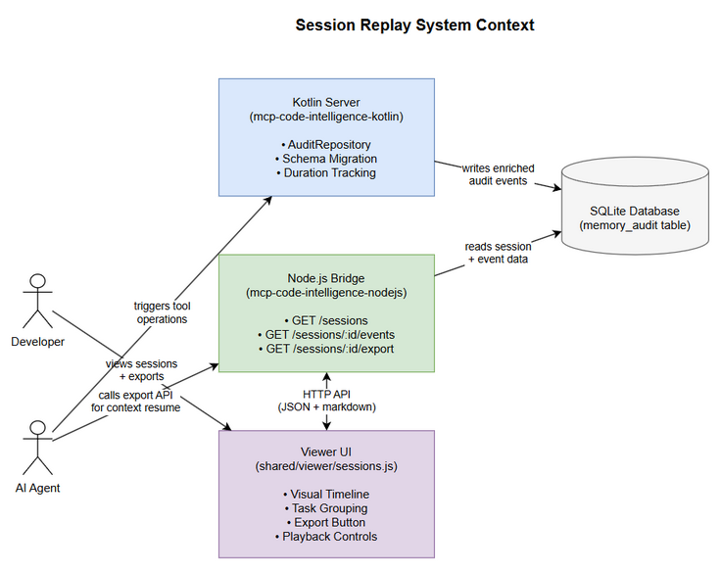
System Context
Edit in draw.io
The Session Replay system spans three layers: 1. Kotlin Server — writes enriched audit data to SQLite 2. Node.js Bridge — reads audit data and serves via HTTP API 3. Viewer UI — renders session timeline and provides export functionality

2.2 System Architecture

System Architecture
Edit in draw.io

3. Functional Requirements

3.1 Feature: Rich Event Data Capture
Source: BRD Story 1, Story 2

3.1.1 Description
Expand the audit logging system to capture full tool arguments, result summaries, operation duration, task context, and specific tool names. This data is persisted in new columns added to the memory_audit table.

3.1.2 Use Case
Use Case ID: UC-01 Actor: Kotlin Server (automated) Preconditions: Agent is executing a tool operation within an active session Postconditions: Audit entry created with all available enriched fields
Main Flow:
Step | Actor | System | Description
1 | Agent |  | Invokes a tool (e.g., kb_search, mem_ingest)
2 |  | Kotlin Server | Records start timestamp
3 |  | Kotlin Server | Executes tool operation
4 |  | Kotlin Server | Records end timestamp, calculates duration_ms
5 |  | Kotlin Server | Calls AuditRepository.log() with enriched fields
6 |  | SQLite | Persists audit entry with arguments, result_summary, duration_ms, task_id, tool_name
Alternative Flows:
ID | Condition | Steps
AF-01 | Tool has no arguments | arguments field stored as null
AF-02 | Result exceeds 2000 chars | Truncate to 2000 chars + append “[truncated]”
AF-03 | No active task context | task_id stored as null
Exception Flows:
ID | Condition | Steps
EF-01 | Tool execution throws exception | Log with duration_ms up to error point, result_summary = error message
EF-02 | DB write fails | Log error to stderr, operation continues (audit is non-blocking)

3.1.3 Business Rules
Rule ID | Rule | Source
BR-01 | Arguments stored as JSON string, max 10KB | BRD Story 1, NFR
BR-02 | Result summary max 2000 chars with truncation indicator | BRD Story 1
BR-03 | Duration measured in milliseconds (Long/INTEGER) | BRD Story 2
BR-04 | All new fields are nullable for backward compatibility | BRD Story 1 AC-4
BR-05 | Existing callers of AuditRepository.log() must continue working without changes | BRD Story 1 AC-4

3.1.4 Data Specifications
Input Data (AuditRepository.log parameters):
Field | Type | Required | Validation | Description
operation | String | Y | Non-empty, max 50 chars | Operation type (INGEST, SEARCH, etc.)
entryId | Long? | N | Positive integer if present | Related memory entry ID
sessionId | String? | N | UUID format | Active session identifier
agentName | String? | N | Max 100 chars | Agent performing operation
details | String? | N | Max 500 chars | Legacy details field (backward compat)
arguments | String? | N | Valid JSON, max 10KB | Full tool input arguments as JSON
resultSummary | String? | N | Max 2000 chars | Truncated operation result
durationMs | Long? | N | Non-negative | Operation duration in milliseconds
taskId | String? | N | Max 100 chars | Logical task grouping identifier
toolName | String? | N | Max 100 chars | Specific tool name
Output Data (stored in memory_audit):
Field | Type | Description
id | Long | Auto-increment primary key
operation | String | Operation type
entry_id | Long? | Related entry ID
session_id | String? | Session identifier
agent_name | String? | Agent name
details | String? | Legacy details
arguments | String? | JSON tool arguments
result_summary | String? | Truncated result
duration_ms | Long? | Duration in ms
task_id | String? | Task group ID
tool_name | String? | Tool name
created_at | String | ISO timestamp (auto)

3.2 Feature: Enhanced Session List API
Source: BRD Story 1, Story 2

3.2.1 Description
Enhance the /sessions endpoint to include aggregate duration and richer metadata per session.

3.2.2 Use Case
Use Case ID: UC-02 Actor: Developer (via Viewer UI) Preconditions: At least one session exists in the database Postconditions: Session list displayed with duration and event counts
Main Flow:
Step | Actor | System | Description
1 | Developer |  | Opens Sessions tab in viewer
2 |  | Viewer | Calls GET /sessions
3 |  | Node.js API | Queries sessions with aggregate stats
4 |  | Viewer | Renders session list with duration badges
Alternative Flows:
ID | Condition | Steps
AF-01 | Filter by agent name | Add agent query param, filter results
AF-02 | Filter by status | Add status query param (active/ended)
AF-03 | No sessions found | Display “No sessions found” message

3.2.3 API Contract (Functional View)
Endpoint: GET /sessions Purpose: List sessions with aggregate metadata
Input Parameters:
Parameter | Type | Required | Business Rule | Description
agent | String | N | Partial match | Filter by agent name
status | String | N | “active” or “ended” | Filter by session status
limit | Integer | N | Default 50, max 200 | Max results
Output Data:
Field | Type | Description
id | String | Session ID
agentName | String | Agent name
startedAt | String | ISO timestamp
endedAt | String? | ISO timestamp (null if active)
status | String | “active” or “ended”
observationCount | Integer | Total events in session
totalDurationMs | Integer | Sum of all event durations
taskCount | Integer | Number of distinct task groups
Business Error Scenarios:
Scenario | User Message | Trigger Condition
Memory not initialized | “Memory not initialized” | Engine not ready (503)

3.3 Feature: Enhanced Session Events API
Source: BRD Story 1, Story 2, Story 3

3.3.1 Description
Enhance the /sessions/:id/events endpoint to return enriched event data including arguments, results, duration, and task grouping.

3.3.2 Use Case
Use Case ID: UC-03 Actor: Developer (via Viewer UI) Preconditions: A session exists with events Postconditions: Event list displayed with full details
Main Flow:
Step | Actor | System | Description
1 | Developer |  | Clicks on a session in the list
2 |  | Viewer | Calls GET /sessions/:id/events
3 |  | Node.js API | Queries events for session, ordered by created_at ASC
4 |  | Viewer | Renders timeline with enriched event cards

3.3.3 API Contract (Functional View)
Endpoint: GET /sessions/:id/events Purpose: Get all events for a session with enriched data
Input Parameters:
Parameter | Type | Required | Business Rule | Description
id | String (path) | Y | Must exist | Session ID
limit | Integer | N | Default 200, max 1000 | Max events
Output Data (per event):
Field | Type | Description
id | Long | Event ID
operation | String | Operation type
toolName | String? | Specific tool name
entryId | Long? | Related entry ID
sessionId | String | Session ID
details | String? | Legacy details
arguments | String? | Full JSON arguments
resultSummary | String? | Truncated result
durationMs | Long? | Duration in ms
taskId | String? | Task group ID
createdAt | String | ISO timestamp

3.4 Feature: Session Export as Markdown
Source: BRD Story 4

3.4.1 Description
New API endpoint that exports a session’s events as structured markdown optimized for AI agent context resumption.

3.4.2 Use Case
Use Case ID: UC-04 Actor: Developer or AI Agent Preconditions: Session exists with at least one event Postconditions: Markdown string returned representing the session
Main Flow:
Step | Actor | System | Description
1 | Actor |  | Requests export (button click or API call)
2 |  | Node.js API | Fetches all events for session
3 |  | Node.js API | Groups events by task_id
4 |  | Node.js API | Generates markdown with metadata + events
5 |  | Response | Returns markdown string
Alternative Flows:
ID | Condition | Steps
AF-01 | No task groups (all task_id null) | Render flat chronological list
AF-02 | Session still active | Include note “Session in progress” at top
Exception Flows:
ID | Condition | Steps
EF-01 | Session not found | Return 404 with error message
EF-02 | Session has 0 events | Return markdown with “No events recorded”

3.4.3 API Contract (Functional View)
Endpoint: GET /sessions/:id/export Purpose: Export session as markdown for AI context
Input Parameters:
Parameter | Type | Required | Business Rule | Description
id | String (path) | Y | Must exist | Session ID
format | String | N | Default “markdown” | Export format
Output Data:
Field | Type | Description
(body) | String | Markdown content (Content-Type: text/markdown)
Export Format Template:
# Session: {agent_name} — {start_time}
Duration: {total_duration} | Events: {event_count} | Tasks: {task_count}
## Task: {task_id}
- [{HH:MM:SS}] **{tool_name}** ({duration}ms): {arguments_summary} → {result_summary}
## Ungrouped Events
- [{HH:MM:SS}] **{operation}**: {details}
Business Error Scenarios:
Scenario | User Message | Trigger Condition
Session not found | “Session not found” | Invalid session ID (404)
Memory not initialized | “Memory not initialized” | Engine not ready (503)

3.5 Feature: Visual Timeline with Task Grouping
Source: BRD Story 3, Story 5, Story 6

3.5.1 Description
Redesign the session replay viewer to display events in a visual timeline with task grouping, duration indicators, and richer event cards.

3.5.2 Use Case
Use Case ID: UC-05 Actor: Developer Preconditions: Session selected, events loaded Postconditions: Timeline rendered with grouped events and playback controls
Main Flow:
Step | Actor | System | Description
1 | Developer |  | Selects a session from list
2 |  | Viewer | Fetches events via API
3 |  | Viewer | Groups events by task_id
4 |  | Viewer | Renders timeline with task group headers
5 | Developer |  | Clicks play or steps through events
6 |  | Viewer | Highlights current event, shows detail card
Alternative Flows:
ID | Condition | Steps
AF-01 | No task groups | Render flat list (backward compatible)
AF-02 | User collapses a task group | Hide events in group, show summary only
AF-03 | User changes playback speed | Adjust interval (500ms/1000ms/2000ms/4000ms)

3.5.3 UI Specifications
Screen: Session Timeline
No. | Element | Type | Required | Behavior | Validation
1 | Session Header | Label | Y | Shows agent name, duration, event count | —
2 | Progress Bar | Slider | Y | Shows position in timeline, clickable to scrub | —
3 | Play/Pause Button | Button | Y | Toggle playback | —
4 | Step Back/Forward | Button | Y | Move one event at a time | —
5 | Speed Selector | Dropdown | Y | Options: 0.5x, 1x, 2x, 4x | Default 1x
6 | Export Button | Button | Y | Exports session as markdown | —
7 | Task Group Header | Collapsible | N | Shows task summary, event count, duration | Only if task_id present
8 | Event Card | Card | Y | Shows operation, tool, duration, timestamp | —
9 | Arguments Panel | Expandable | N | Shows formatted JSON arguments | Only if arguments present
10 | Result Preview | Text | N | First 200 chars, expandable | Only if result_summary present
11 | Duration Badge | Badge | Y | Color-coded: green/yellow/red | Based on duration thresholds
12 | Position Counter | Label | Y | Shows “N/M” current position | —

3.5.4 Business Rules
Rule ID | Rule | Source
BR-06 | Duration badge green: < 500ms | BRD Story 5
BR-07 | Duration badge yellow: 500ms - 2000ms | BRD Story 5
BR-08 | Duration badge red: > 2000ms | BRD Story 5
BR-09 | Task groups are collapsible, default expanded | BRD Story 3
BR-10 | Playback does not rebuild DOM, only updates highlight | BRD Story 6
BR-11 | Controls sticky at top during scroll | BRD Story 6
BR-12 | Keyboard shortcuts: Space=play/pause, ←/→=step, Home/End=first/last | BRD Story 6

3.6 Feature: Export Button in Viewer
Source: BRD Story 4

3.6.1 Description
Add an “Export as Markdown” button in the session detail view that calls the export API and copies the result to clipboard.

3.6.2 Use Case
Use Case ID: UC-06 Actor: Developer Preconditions: Session detail view is open Postconditions: Markdown copied to clipboard (or downloaded)
Main Flow:
Step | Actor | System | Description
1 | Developer |  | Clicks “Export” button
2 |  | Viewer | Calls GET /sessions/:id/export
3 |  | Viewer | Copies markdown to clipboard
4 |  | Viewer | Shows success toast “Copied to clipboard”
Alternative Flows:
ID | Condition | Steps
AF-01 | Clipboard API not available | Offer download as .md file instead
AF-02 | Export fails (API error) | Show error toast with message

4. Data Model

4.1 Entity: memory_audit (Extended)
Current columns (unchanged):
Attribute | Type | Required | Description
id | INTEGER | Y (PK) | Auto-increment
operation | TEXT | Y | Operation type
entry_id | INTEGER | N | FK to memory entries
session_id | TEXT | N | Session identifier
agent_name | TEXT | N | Agent name
details | TEXT | N | Legacy details (max 500)
created_at | TEXT | Y | ISO timestamp (DEFAULT CURRENT_TIMESTAMP)
New columns (added via migration):
Attribute | Type | Required | Business Rule | Description
arguments | TEXT | N | BR-01: max 10KB JSON | Full tool input arguments
result_summary | TEXT | N | BR-02: max 2000 chars | Truncated operation result
duration_ms | INTEGER | N | BR-03: non-negative | Operation duration in ms
task_id | TEXT | N | Max 100 chars | Task group identifier
tool_name | TEXT | N | Max 100 chars | Specific tool name

4.2 Migration SQL
ALTER TABLE memory_audit ADD COLUMN arguments TEXT;
ALTER TABLE memory_audit ADD COLUMN result_summary TEXT;
ALTER TABLE memory_audit ADD COLUMN duration_ms INTEGER;
ALTER TABLE memory_audit ADD COLUMN task_id TEXT;
ALTER TABLE memory_audit ADD COLUMN tool_name TEXT;

4.3 Indexes (for query performance)
CREATE INDEX IF NOT EXISTS idx_audit_session_task ON memory_audit(session_id, task_id);
CREATE INDEX IF NOT EXISTS idx_audit_duration ON memory_audit(duration_ms) WHERE duration_ms IS NOT NULL;

5. Integration Specifications

5.1 Kotlin → SQLite (Write Path)
Attribute | Value
Purpose | Persist enriched audit events
Direction | Outbound (Kotlin writes to SQLite)
Data Format | SQL INSERT with prepared statements
Frequency | Real-time (on every tool operation)

5.2 Node.js → SQLite (Read Path)
Attribute | Value
Purpose | Read session and event data for API
Direction | Inbound (Node.js reads from SQLite)
Data Format | SQL SELECT with JSON mapping
Frequency | On-demand (API requests)

5.3 Viewer → Node.js API (HTTP)
Attribute | Value
Purpose | Fetch session data and export markdown
Direction | Bidirectional (request/response)
Data Format | JSON (sessions, events) / text/markdown (export)
Frequency | On-demand (user interaction)

6. Processing Logic

6.1 Duration Calculation
Trigger: Tool operation starts Input: Start timestamp (System.currentTimeMillis()) Output: duration_ms field in audit entry
Processing Steps:
Step | Description | Error Handling
1 | Record startTime before tool execution | —
2 | Execute tool operation | On exception: still calculate duration
3 | Record endTime after completion | —
4 | Calculate: duration_ms = endTime - startTime | If negative (clock skew): set to 0
5 | Pass duration_ms to AuditRepository.log() | —

6.2 Markdown Export Generation
Trigger: GET /sessions/:id/export request Input: Session ID Output: Markdown string
Processing Steps:
Step | Description | Error Handling
1 | Fetch session metadata (agent, start, end) | 404 if not found
2 | Fetch all events for session (ordered by created_at ASC) | Empty list → “No events”
3 | Group events by task_id (null task_id → “Ungrouped”) | —
4 | For each group: generate markdown section | —
5 | For each event: format as list item with tool, duration, args summary | Truncate args to 200 chars
6 | Concatenate all sections | —
7 | Return as text/markdown response | —

6.3 Task Grouping in Viewer
Trigger: Events loaded for a session Input: Array of events with optional task_id Output: Grouped DOM structure
Processing Steps:
Step | Description | Error Handling
1 | Sort events by createdAt ASC | Already sorted from API
2 | Iterate events, group consecutive same task_id | —
3 | For each group: create collapsible section | —
4 | Calculate group stats: count, total duration | Handle null duration_ms
5 | Render group header with stats | —
6 | Render event cards within group | —

7. Security Requirements

7.1 Authentication & Authorization
Role | Permissions | Screens/Features
Any local user | Full access | All session replay features
Note: Session replay is a local development tool. No authentication required (same as current behavior).

7.2 Data Sensitivity Classification
Data Type | Classification | Business Requirement
Tool arguments | Internal | May contain file paths, queries — local only
Result summaries | Internal | May contain code snippets — local only
Session metadata | Internal | Agent names, timestamps — local only

7.3 Audit Trail
Event | Logged Fields | Retention | Business Reason
All tool operations | operation, arguments, result, duration | Indefinite (SQLite) | Debugging and context resumption

8. Non-Functional Requirements
Category | Business Requirement | Acceptance Criteria
Performance | Event list renders smoothly for 200+ events | No DOM rebuild on step; render < 100ms
Performance | API response fast for large sessions | /sessions/:id/events < 200ms for 500 events
Storage | Arguments don’t bloat database excessively | Max 10KB per arguments field
Compatibility | Existing features unaffected | All current viewer functionality preserved
Usability | Export useful for AI agents | Markdown < 50KB for typical session

9. Error Handling (User-Facing)

9.1 Error Scenarios
Scenario | Severity | User Message | Expected Behavior
Session not found | Warning | “Session not found” | Show error in detail panel
API unavailable | Critical | “Cannot connect to server” | Show retry button
Export fails | Warning | “Export failed: {reason}” | Show error toast, allow retry
Empty session | Info | “No events recorded” | Show empty state message

10. Testing Considerations

10.1 Test Scenarios
ID | Scenario | Input | Expected Output | Priority
TC-01 | Log event with all enriched fields | Full arguments + result + duration | All fields persisted in DB | High
TC-02 | Log event with null optional fields | Only operation + sessionId | Entry created, new fields null | High
TC-03 | Arguments exceeding 10KB | 15KB JSON string | Truncated to 10KB | Medium
TC-04 | Session list with duration aggregates | 3 sessions with events | totalDurationMs calculated correctly | High
TC-05 | Export session as markdown | Session with 10 events, 2 tasks | Valid markdown with task groups | High
TC-06 | Task grouping in viewer | Events with mixed task_ids | Correct visual grouping | High
TC-07 | Playback without DOM rebuild | Step through 50 events | No innerHTML rebuild, only highlight update | Medium
TC-08 | Duration badge colors | Events with 100ms, 1000ms, 3000ms | Green, yellow, red badges | Medium
TC-09 | Keyboard shortcuts | Press Space, ←, → | Play/pause, step back/forward | Low
TC-10 | Export with clipboard API | Click export button | Markdown in clipboard | Medium

11. Appendix

State Diagram: Session Lifecycle
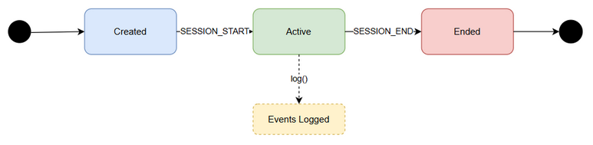
State Diagram
Edit in draw.io

Sequence Diagram: Export Flow
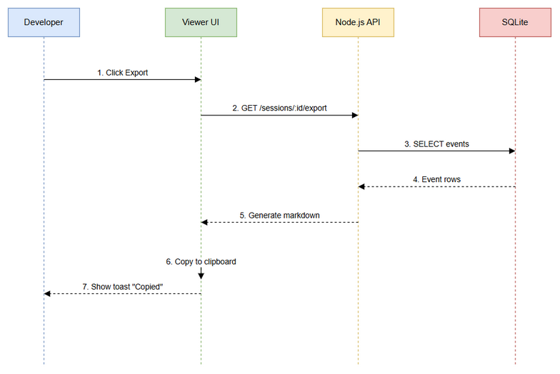
Sequence Diagram
Edit in draw.io

Diagram Index
# | Diagram | Image | Source (editable)
1 | System Context | system-context.png | system-context.drawio
2 | Sequence — Export | sequence-export.png | sequence-export.drawio
3 | State — Session Lifecycle | state-session-lifecycle.png | state-session-lifecycle.drawio

Change Log from BRD
- No deviations from BRD. All 6 user stories addressed in functional specifications.
- Added specific API contracts with request/response schemas.
- Added migration SQL for schema changes.
- Added processing logic for duration calculation and export generation.

