Technical Design Document (TDD)

MCP Code Intelligence — KSA-64: Session Replay: Redesign for richer event data and AI context value

Document Information
Field | Value
Jira Ticket | KSA-64
Title | Session Replay: Redesign for richer event data and AI context value
Author | SA Agent
Version | 1.0
Date | 2026-05-20
Status | Draft
Related BRD | BRD-v1-KSA-64.docx
Related FSD | FSD-v1-KSA-64.docx

Revision History
Version | Date | Author | Changes
1.0 | 2026-05-20 | SA Agent | Initiate document — technical design for session replay redesign

1. Introduction

1.1 Purpose
This TDD specifies the technical implementation of the Session Replay redesign across three modules: Kotlin server (audit schema expansion), Node.js bridge (API enhancements), and shared viewer (UI redesign).

1.2 Scope
- Kotlin: Schema migration, AuditRepository expansion, duration measurement wrapper
- Node.js: Enhanced API handlers, new export endpoint, response mapping
- Viewer: Refactored sessions.js with task grouping, duration badges, export functionality

1.3 Technology Stack
Layer | Technology | Version
Server Language | Kotlin | 1.9+
Server Runtime | JVM | 17+
Bridge Language | TypeScript | 5.x
Bridge Runtime | Node.js | 18+
UI | Vanilla JavaScript | ES2020
Database | SQLite | 3.x
Build (Kotlin) | Gradle (Kotlin DSL) | 8.x
Build (Node.js) | npm | 9+

1.4 Design Principles
- Backward Compatibility: All new fields nullable, existing callers unchanged
- Single Responsibility: Each module handles one concern (write/read/display)
- Incremental Enhancement: New features additive, no breaking changes
- Performance First: No DOM rebuild on playback step, efficient SQL queries

1.5 Constraints
- SQLite ALTER TABLE only supports ADD COLUMN (no DROP/RENAME in older versions)
- Viewer must work without build tools (vanilla JS, no bundler)
- Node.js bridge reads same SQLite file that Kotlin writes (shared file access)
- Max file size for sessions.js: 200 lines (per code standards)

2. System Architecture

2.1 Architecture Overview
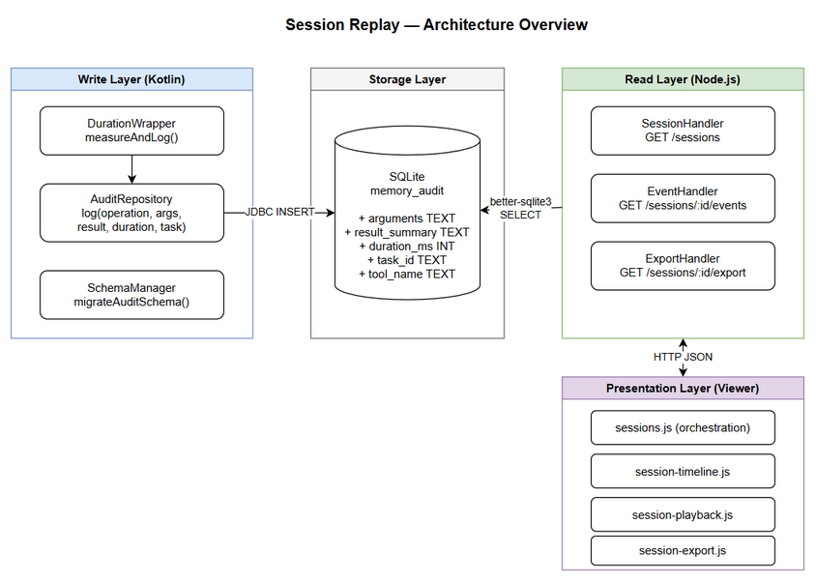
Architecture Diagram
The system follows a layered architecture with clear separation: - Write Layer (Kotlin): Captures enriched audit data during tool execution - Storage Layer (SQLite): Persists audit entries with new schema columns - Read Layer (Node.js): Serves data via HTTP API with JSON/markdown responses - Presentation Layer (Viewer): Renders timeline UI with interactive controls

2.2 Component Diagram
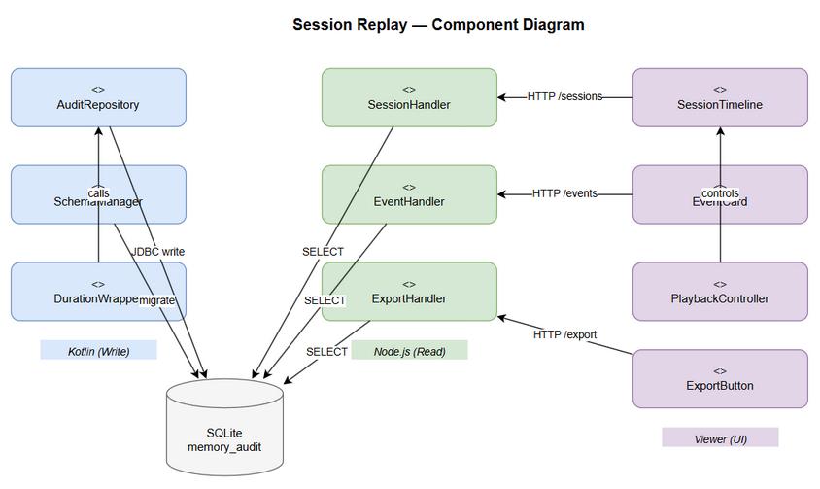
Component Diagram
Component | Responsibility | Technology
AuditRepository | Write enriched audit entries to SQLite | Kotlin + JDBC
SchemaManager | Run ALTER TABLE migrations on startup | Kotlin + SQL
DurationWrapper | Measure operation duration (start/end) | Kotlin
SessionHandler | Handle /sessions API requests | Node.js + http
EventHandler | Handle /sessions/:id/events API requests | Node.js + http
ExportHandler | Generate markdown export | Node.js + http
SessionTimeline | Render visual timeline with task groups | JavaScript
EventCard | Render rich event detail cards | JavaScript
ExportButton | Trigger export and clipboard copy | JavaScript
PlaybackController | Manage play/pause/step/speed controls | JavaScript

2.3 Communication Patterns
From | To | Protocol | Pattern | Description
Kotlin Server | SQLite | JDBC | Sync write | INSERT audit entries
Node.js Bridge | SQLite | better-sqlite3 | Sync read | SELECT sessions/events
Viewer | Node.js | HTTP/JSON | Async request | Fetch session data
Viewer | Node.js | HTTP/text | Async request | Fetch markdown export

3. API Design

3.1 API Overview
# | Endpoint | Method | Description | Source
1 | /sessions | GET | List sessions with aggregates | UC-02
2 | /sessions/:id/events | GET | Get enriched events for session | UC-03
3 | /sessions/:id/export | GET | Export session as markdown | UC-04

3.2 API: List Sessions (Enhanced)
Implements: UC-02
Attribute | Value
Method | GET
Path | /sessions
Auth | None (local tool)
Query Parameters:
Parameter | Type | Required | Default | Description
agent | string | No | "" | Filter by agent name (partial match)
status | string | No | "" | Filter: “active” or “ended”
limit | integer | No | 50 | Max results (1-200)
Response — 200 OK:
[
{
"id": "sess_abc123",
"agentName": "kiro-agent",
"startedAt": "2026-05-20T10:00:00Z",
"endedAt": "2026-05-20T10:05:30Z",
"status": "ended",
"observationCount": 42,
"totalDurationMs": 12500,
"taskCount": 3
}
]
Error Responses:
Status | Message | Description
503 | “Memory not initialized” | Engine not ready

3.3 API: Get Session Events (Enhanced)
Implements: UC-03
Attribute | Value
Method | GET
Path | /sessions/:id/events
Auth | None
Path Parameters:
Parameter | Type | Required | Description
id | string | Yes | Session ID
Query Parameters:
Parameter | Type | Required | Default | Description
limit | integer | No | 200 | Max events (1-1000)
Response — 200 OK:
[
{
"id": 1234,
"operation": "SEARCH",
"toolName": "kb_search",
"entryId": null,
"sessionId": "sess_abc123",
"details": "query: session replay",
"arguments": "{\"query\":\"session replay\",\"top_k\":5}",
"resultSummary": "Found 3 entries matching query",
"durationMs": 245,
"taskId": "task_001",
"createdAt": "2026-05-20T10:00:01Z"
}
]

3.4 API: Export Session (New)
Implements: UC-04
Attribute | Value
Method | GET
Path | /sessions/:id/export
Auth | None
Path Parameters:
Parameter | Type | Required | Description
id | string | Yes | Session ID
Query Parameters:
Parameter | Type | Required | Default | Description
format | string | No | “markdown” | Export format
Response — 200 OK:
Content-Type: text/markdown; charset=utf-8
# Session: kiro-agent — 2026-05-20T10:00:00Z
Duration: 5m 30s | Events: 42 | Tasks: 3
## Task: task_001
- [10:00:01] **kb_search** (245ms): query="session replay", top_k=5 → Found 3 entries
- [10:00:02] **mem_ingest** (120ms): content="..." → Entry #456 created
## Ungrouped Events
- [10:05:00] **SESSION_END**: Session completed
Error Responses:
Status | Message | Description
404 | “Session not found” | Invalid session ID
503 | “Memory not initialized” | Engine not ready

4. Database Design

4.1 Schema Migration
Migration Strategy: ALTER TABLE ADD COLUMN (safe for SQLite, no data loss)
-- Migration: V_KSA64_expand_audit_schema.sql
-- Run on Kotlin server startup (idempotent)
ALTER TABLE memory_audit ADD COLUMN arguments TEXT;
ALTER TABLE memory_audit ADD COLUMN result_summary TEXT;
ALTER TABLE memory_audit ADD COLUMN duration_ms INTEGER;
ALTER TABLE memory_audit ADD COLUMN task_id TEXT;
ALTER TABLE memory_audit ADD COLUMN tool_name TEXT;
-- Performance indexes
CREATE INDEX IF NOT EXISTS idx_audit_session_task
ON memory_audit(session_id, task_id);
CREATE INDEX IF NOT EXISTS idx_audit_tool_name
ON memory_audit(tool_name) WHERE tool_name IS NOT NULL;

4.2 Migration Implementation (Kotlin)
// In MemoryDatabaseManager.ensureSchema() or similar startup hook
private fun migrateAuditSchema() {
val existingColumns = getColumnNames("memory_audit")
val migrations = mapOf(
"arguments" to "ALTER TABLE memory_audit ADD COLUMN arguments TEXT",
"result_summary" to "ALTER TABLE memory_audit ADD COLUMN result_summary TEXT",
"duration_ms" to "ALTER TABLE memory_audit ADD COLUMN duration_ms INTEGER",
"task_id" to "ALTER TABLE memory_audit ADD COLUMN task_id TEXT",
"tool_name" to "ALTER TABLE memory_audit ADD COLUMN tool_name TEXT"
)
for ((col, sql) in migrations) {
if (col !in existingColumns) {
conn.createStatement().execute(sql)
}
}
// Create indexes (IF NOT EXISTS is idempotent)
conn.createStatement().execute(
"CREATE INDEX IF NOT EXISTS idx_audit_session_task ON memory_audit(session_id, task_id)"
)
}

4.3 Query Patterns
Operation | Query Pattern | Expected Performance
List sessions with aggregates | SELECT + GROUP BY session_id with SUM(duration_ms), COUNT(DISTINCT task_id) | < 50ms for 1000 sessions
Get events for session | SELECT WHERE session_id = ? ORDER BY created_at ASC | < 100ms for 500 events
Export (same as events) | Same query, processed in Node.js | < 200ms total

5. Class / Module Design

5.1 Kotlin — AuditRepository Changes
File: mcp-code-intelligence-kotlin/src/main/kotlin/com/codeintel/memory/repository/AuditRepository.kt
data class AuditEntry(
val id: Long = 0,
val operation: String,
val entryId: Long? = null,
val sessionId: String? = null,
val agentName: String? = null,
val details: String? = null,
// New fields (KSA-64)
val arguments: String? = null,
val resultSummary: String? = null,
val durationMs: Long? = null,
val taskId: String? = null,
val toolName: String? = null,
val createdAt: String = ""
)
class AuditRepository(private val db: MemoryDatabaseManager) {
/** Log an operation with enriched data. Backward compatible. */
fun log(
operation: String,
entryId: Long? = null,
sessionId: String? = null,
agentName: String? = null,
details: String? = null,
// New optional params (KSA-64)
arguments: String? = null,
resultSummary: String? = null,
durationMs: Long? = null,
taskId: String? = null,
toolName: String? = null
) {
val sql = """
INSERT INTO memory_audit
(operation, entry_id, session_id, agent_name, details,
arguments, result_summary, duration_ms, task_id, tool_name)
VALUES (?, ?, ?, ?, ?, ?, ?, ?, ?, ?)
""".trimIndent()
// ... prepared statement execution
}
}

5.2 Node.js — Enhanced Handlers
File: mcp-code-intelligence-nodejs/src/http/api-routes.ts
New/modified functions:
// Enhanced: includes aggregate fields
function handleSessions(url: URL, res: http.ServerResponse, engine: MemoryEngine | null): void {
// Query sessions with: totalDurationMs, taskCount
}
// Enhanced: includes new fields in response
function handleSessionEvents(path: string, url: URL, res: http.ServerResponse, engine: MemoryEngine | null): void {
// Map: arguments, resultSummary, durationMs, taskId, toolName
}
// NEW: Export session as markdown
function handleSessionExport(path: string, url: URL, res: http.ServerResponse, engine: MemoryEngine | null): void {
// Generate markdown from events grouped by taskId
}

5.3 Viewer — File Split (Code Standards: max 200 lines)
Current sessions.js is ~130 lines. With new features it would exceed 200 lines. Split into:
File | Responsibility | Est. Lines
sessions.js | Session list + main orchestration | ~80
session-timeline.js | Timeline rendering + task grouping | ~120
session-playback.js | Playback controls + keyboard shortcuts | ~80
session-export.js | Export button + clipboard logic | ~40

5.4 Design Patterns
Pattern | Where Used | Rationale
Default Parameters | AuditRepository.log() | Backward compatibility without overloads
Idempotent Migration | SchemaManager | Safe to run multiple times on startup
Incremental DOM Update | session-timeline.js | Performance: no rebuild on step
Strategy (duration format) | Duration badge rendering | Different display for different ranges

6. Integration Design

6.1 Kotlin → SQLite (Write Path)
Attribute | Value
Protocol | JDBC (SQLite)
Connection | Single file, shared with Node.js
Timeout | N/A (local file)
Concurrency | WAL mode enabled (concurrent read/write)
Key Consideration: Both Kotlin and Node.js access the same SQLite file. WAL mode must be enabled to allow concurrent reads while Kotlin writes.

6.2 Node.js → SQLite (Read Path)
Attribute | Value
Protocol | better-sqlite3 (synchronous)
Connection | Read-only mode
Timeout | N/A (local file)

6.3 Duration Measurement Integration
// Wrapper pattern for measuring tool execution duration
fun <T> measureAndLog(
operation: String,
toolName: String,
sessionId: String?,
taskId: String?,
arguments: String?,
block: () -> T
): T {
val start = System.currentTimeMillis()
return try {
val result = block()
val duration = System.currentTimeMillis() - start
audit.log(
operation = operation,
toolName = toolName,
sessionId = sessionId,
taskId = taskId,
arguments = arguments?.take(10240), // BR-01: max 10KB
resultSummary = result.toString().take(2000), // BR-02: max 2000
durationMs = duration
)
result
} catch (e: Exception) {
val duration = System.currentTimeMillis() - start
audit.log(
operation = operation,
toolName = toolName,
sessionId = sessionId,
taskId = taskId,
arguments = arguments?.take(10240),
resultSummary = "ERROR: ${e.message}".take(2000),
durationMs = duration
)
throw e
}
}

7. Security Design

7.1 Authentication
No authentication required — this is a local development tool. All endpoints accessible without credentials.

7.2 Data Protection
Data Type | At Rest | In Transit | In Logs
Tool arguments | Plain (SQLite file) | Plain (localhost HTTP) | Truncated to 200 chars
Result summaries | Plain | Plain | Truncated to 100 chars
Session metadata | Plain | Plain | Full

7.3 Input Validation
Field | Validation | Sanitization
arguments (write) | Max 10KB, must be valid JSON or null | Truncate if exceeds
result_summary (write) | Max 2000 chars | Truncate + “[truncated]”
limit (API param) | Integer, 1-1000 | Clamp to range
session ID (path) | Non-empty string | No SQL injection (prepared stmt)

8. Performance & Scalability

8.1 Performance Targets
Operation | Target | Measurement
AuditRepository.log() | < 5ms | Time from call to INSERT complete
GET /sessions | < 50ms | Response time for 50 sessions
GET /sessions/:id/events | < 100ms | Response time for 200 events
GET /sessions/:id/export | < 200ms | Response time for 500 events
Timeline render (200 events) | < 100ms | Time from data received to DOM ready
Playback step | < 16ms | Time to update highlight (1 frame)

8.2 Optimization Strategies
Strategy | Component | Description
Prepared statements | Kotlin AuditRepository | Reuse statement for repeated inserts
Index on session_id + task_id | SQLite | Fast session event lookup
Incremental DOM update | Viewer timeline | Only update highlight + detail, not rebuild list
Lazy argument display | Viewer event card | Don’t parse JSON until user expands

9. Monitoring & Observability

9.1 Logging
Log Event | Level | Fields | Destination
Schema migration applied | INFO | column_name | stderr
Audit write failure | ERROR | operation, error_message | stderr
Export generated | DEBUG | session_id, event_count, markdown_size | stderr

10. Implementation Checklist

10.1 Files to Create/Modify
# | File | Action | Description
1 | mcp-code-intelligence-kotlin/.../AuditRepository.kt | MODIFY | Add new fields to AuditEntry + log()
2 | mcp-code-intelligence-kotlin/.../MemoryDatabaseManager.kt | MODIFY | Add schema migration
3 | mcp-code-intelligence-nodejs/src/http/api-routes.ts | MODIFY | Enhance handlers + add export
4 | mcp-code-intelligence-nodejs/src/memory/session-repository.ts | MODIFY | Add aggregate queries
5 | shared/viewer/sessions.js | MODIFY | Refactor to orchestration only
6 | shared/viewer/session-timeline.js | CREATE | Timeline + task grouping
7 | shared/viewer/session-playback.js | CREATE | Playback controls + keyboard
8 | shared/viewer/session-export.js | CREATE | Export button + clipboard
9 | shared/viewer/index.html | MODIFY | Add new script tags + speed selector

10.2 Implementation Order
- Kotlin schema migration (no dependencies)
- Kotlin AuditRepository expansion (depends on #1)
- Node.js enhanced handlers (depends on #1 for new columns)
- Node.js export endpoint (depends on #3)
- Viewer file split (independent)
- Viewer timeline + task grouping (depends on #3 for API data)
- Viewer playback + export (depends on #4, #6)

10.3 Rollback Strategy
- Schema migration is additive (new nullable columns) — no rollback needed
- If issues found: revert Node.js/viewer code, new columns remain but unused
- No data migration required — existing entries have NULL for new fields

11. Appendix

Diagram Index
# | Diagram | Image | Source (editable)
1 | Architecture Overview | architecture.png | architecture.drawio
2 | Component Diagram | component.png | component.drawio

Open Questions
# | Question | Status | Answer
1 | Should task_id be auto-generated or passed by caller? | Resolved | Passed by caller (agent decides task boundaries)
2 | Max session export size limit? | Resolved | 50KB soft limit (truncate oldest events if exceeded)
3 | Should we add WebSocket for live session streaming? | Deferred | Out of scope for KSA-64, future enhancement

