Technical Design Document (TDD)

Code Indexer Python — KSA-7: Code Indexer — Python version

Document Information
Field | Value
Jira Ticket | KSA-7
Title | Code Indexer — Python version
Author | SA Agent
Version | 1.0
Date | 2026-05-10
Status | Draft
Related BRD | BRD-v1-KSA-7.docx
Related FSD | FSD-v1-KSA-7.docx

Revision History
Version | Date | Author | Changes
1.0 | 2026-05-10 | SA Agent | Initiate document from FSD KSA-7

1. Introduction

1.1 Purpose
This TDD specifies the technical design for the Code Indexer Python tool — a standalone CLI script that analyzes source code projects and generates structured metadata. It covers architecture, module design, parsing strategies, and implementation details.

1.2 Scope
- Python CLI application with 12+ source files
- Regex-based parsing for 7 programming languages
- File I/O for reading source and writing JSON/Markdown output
- No network, no database, no external dependencies

1.3 Technology Stack
Layer | Technology | Version
Language | Python | 3.10+
Build Tool | None (stdlib only) | —
Testing | unittest (stdlib) | —
CLI | argparse (stdlib) | —
Data Classes | dataclasses (stdlib) | —
File I/O | pathlib (stdlib) | —
Hashing | hashlib (stdlib) | —
Pattern Matching | re (stdlib) | —

1.4 Design Principles
- Single Responsibility — each file handles one concern
- Zero Dependencies — stdlib only, no pip install
- 200-Line Limit — every file ≤ 200 lines
- 20-Line Functions — every function ≤ 20 lines
- Early Return — avoid deep nesting
- Plugin Architecture — one parser file per language for extensibility

1.5 Constraints
- Python 3.10+ required (for match statements, modern type hints)
- No external packages (no pip install step)
- All files ≤ 200 lines (code standards enforcement)
- Regex-only parsing (no AST libraries)
- Cross-platform (Windows/macOS/Linux path handling via pathlib)

1.6 References
Document | Location
BRD | BRD-v1-KSA-7.docx
FSD | FSD-v1-KSA-7.docx
Code Standards | .kiro/steering/code-standards.md

2. System Architecture

2.1 Architecture Overview
The Code Indexer follows a pipeline architecture — data flows sequentially through stages, each transforming input into output for the next stage.
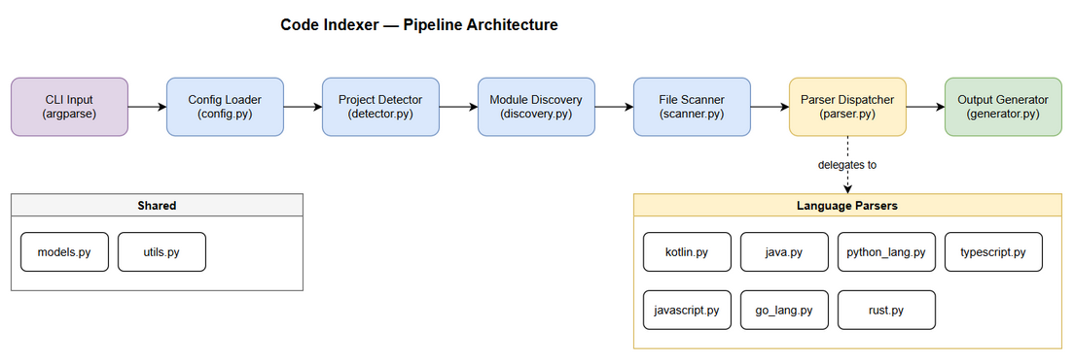
Architecture Diagram
┌─────────────────────────────────────────────────────────┐
│ Code Indexer Pipeline │
│ │
│ CLI Args → Config → Detect → Discover → Scan → Parse → Generate
│ │
│ main.py orchestrates the pipeline │
└─────────────────────────────────────────────────────────┘
Architecture Style: Pipeline / Pipes-and-Filters Rationale: Each stage is independent, testable, and replaceable. No shared mutable state between stages.

2.2 Component Diagram
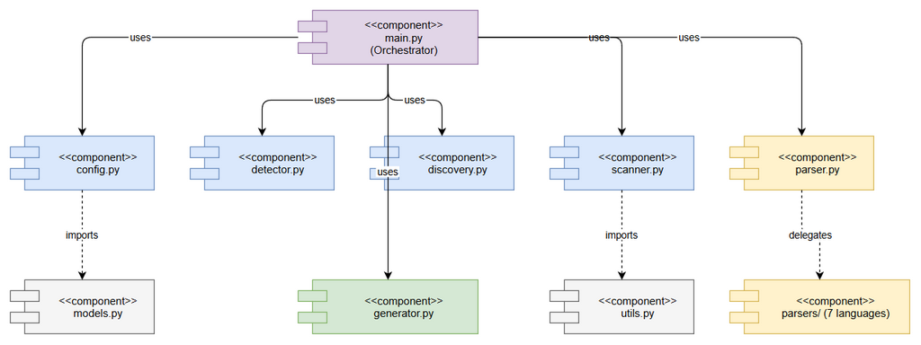
Component Diagram
Component | Responsibility | File
CLI / Orchestrator | Parse args, run pipeline, handle errors | main.py
Config Loader | Load/validate index-config.json | config.py
Project Detector | Detect project types from build files | detector.py
Module Discovery | Find modules/packages in project | discovery.py
File Scanner | Walk directories, filter files | scanner.py
Parser Dispatcher | Route files to language-specific parsers | parser.py
Language Parsers | Extract signatures via regex | parsers/*.py
Output Generator | Write all output files | generator.py
Data Models | Dataclass definitions | models.py
Utilities | Hash, path helpers, file I/O | utils.py

2.3 Deployment Architecture
No deployment infrastructure needed. This is a local CLI tool.
Distribution: Single directory of .py files, copied to .analysis/code-intelligence/scripts/python/
Execution: python main.py <project-root>

2.4 Communication Patterns
From | To | Pattern | Data
main.py | config.py | Function call | Config dataclass
main.py | detector.py | Function call | list[str] project types
main.py | discovery.py | Function call | list[Module]
main.py | scanner.py | Function call | list[SourceFile]
main.py | parser.py | Function call | list[Signature] per file
main.py | generator.py | Function call | Output files written
All communication is synchronous function calls. No async, no threads, no IPC.

3. API Design

3.1 CLI Interface (the “API”)
This tool has no HTTP API. The CLI is the interface.
Argument | Type | Required | Default | Description
project_root | positional | Yes | — | Path to project directory
–config | optional | No | auto | Path to index-config.json
–verbose | flag | No | false | Enable detailed logging
–output | optional | No | .analysis/code-intelligence | Output directory

3.2 Module Public APIs

config.py
def load_config(project_root: Path, config_path: Path | None = None) -> Config:
"""Load configuration from file or return defaults."""

detector.py
def detect_project_types(root: Path) -> list[str]:
"""Detect project types from build files in root + 1 level deep."""

discovery.py
def discover_modules(root: Path, project_types: list[str]) -> list[Module]:
"""Discover modules based on project type conventions."""

scanner.py
def scan_module_files(module: Module, config: Config) -> list[SourceFile]:
"""Scan module directory for source files matching config."""

parser.py
def parse_file(source_file: SourceFile) -> list[Signature]:
"""Parse a source file and extract signatures."""

generator.py
def generate_outputs(project: ProjectInfo, output_dir: Path) -> None:
"""Generate all output files (project-structure.md, modules/*.md, metadata, payloads)."""

4. Data Design

4.1 No Database
This tool has no persistent storage. All data is in-memory during execution and written to files at the end.

4.2 Output File Schemas

index-metadata.json
{
"project_name": "string",
"project_types": ["string"],
"indexed_at": "ISO-8601",
"total_files": 0,
"total_modules": 0,
"total_signatures": 0,
"files": [
{
"path": "relative/path.kt",
"hash": "sha256-hex",
"lines": 0,
"signatures": 0,
"language": "kotlin",
"module": "module-name"
}
]
}

kb-payloads.json
[
{
"title": "Code Index — module-name",
"content": "Module: module-name\nLanguage: kotlin\nFiles: 15\n\nKey Classes:\n- MyClass\n- MyService\n\nKey Functions:\n- processData()\n- validateInput()",
"tags": "code-index, module-name, kotlin"
}
]

5. Class / Module Design

5.1 Package Structure
code-indexer/
├── main.py ← Entry point (CLI parsing + pipeline orchestration)
├── config.py ← Config loading, defaults, validation
├── detector.py ← Project type detection logic
├── discovery.py ← Module discovery strategies
├── scanner.py ← File walking + filtering
├── parser.py ← Parser dispatcher (routes to language parsers)
├── parsers/
│ ├── __init__.py ← Parser registry
│ ├── kotlin.py ← Kotlin regex patterns
│ ├── java.py ← Java regex patterns
│ ├── python_lang.py ← Python regex patterns (named to avoid conflict)
│ ├── typescript.py ← TypeScript regex patterns
│ ├── javascript.py ← JavaScript regex patterns
│ ├── go_lang.py ← Go regex patterns (named to avoid conflict)
│ └── rust.py ← Rust regex patterns
├── generator.py ← Output file generation
├── models.py ← All dataclass definitions
└── utils.py ← Shared utilities

5.2 Data Models (models.py)
from dataclasses import dataclass, field
from pathlib import Path
@dataclass
class Config:
extensions: list[str]
exclude_dirs: list[str]
exclude_patterns: list[str]
max_file_size_kb: int
@dataclass
class Signature:
name: str
kind: str # class/function/interface/enum/struct/trait/impl/method
visibility: str # public/private/internal/protected
line: int
params: str = ""
decorators: list[str] = field(default_factory=list)
@dataclass
class SourceFile:
path: Path
relative_path: str
language: str
lines: int = 0
hash: str = ""
signatures: list[Signature] = field(default_factory=list)
@dataclass
class Module:
name: str
path: Path
language: str
files: list[SourceFile] = field(default_factory=list)
@dataclass
class ProjectInfo:
name: str
root_path: Path
types: list[str]
modules: list[Module]
total_files: int = 0
total_signatures: int = 0

5.3 Parser Design (Strategy Pattern)
Each language parser implements the same interface:
# parsers/kotlin.py
PATTERNS: list[tuple[str, re.Pattern]] = [
("class", re.compile(r"^(?:(?:public|private|internal|abstract|open|data|sealed)\s+)*class\s+(\w+)")),
("interface", re.compile(r"^(?:(?:public|private|internal)\s+)*interface\s+(\w+)")),
("function", re.compile(r"^(?:(?:public|private|internal|override|suspend)\s+)*fun\s+(\w+)\s*\(")),
("object", re.compile(r"^(?:(?:public|private|internal)\s+)*object\s+(\w+)")),
("enum", re.compile(r"^(?:(?:public|private|internal)\s+)*enum\s+class\s+(\w+)")),
]
def parse(content: str) -> list[Signature]:
"""Extract Kotlin signatures from file content."""
Parser Registry (parsers/init.py):
from parsers import kotlin, java, python_lang, typescript, javascript, go_lang, rust
PARSER_MAP: dict[str, module] = {
".kt": kotlin, ".kts": kotlin,
".java": java,
".py": python_lang,
".ts": typescript, ".tsx": typescript,
".js": javascript, ".jsx": javascript,
".go": go_lang,
".rs": rust,
}

5.4 Design Patterns
Pattern | Where Used | Rationale
Pipeline | main.py orchestration | Sequential data transformation
Strategy | parsers/ directory | One parser per language, same interface
Registry | parsers/init.py | Map extensions to parser modules
Data Transfer Object | models.py dataclasses | Structured data passing between stages
Early Return | All functions | Avoid deep nesting, handle errors first

5.5 Error Handling Strategy
Error Type | Handling | User Impact
Invalid CLI args | Print usage, exit(2) | Immediate feedback
Directory not found | Print error, exit(1) | Clear error message
Config parse error | Log warning, use defaults | Continues with defaults
File read error | Log warning, skip file | File excluded from results
Binary file detected | Skip silently | File excluded from results
Encoding error | Log warning, skip file | File excluded from results
Regex parse failure | Log warning, return empty | File has 0 signatures
Output write error | Print error, exit(1) | Fatal — cannot produce output

6. Integration Design

6.1 Filesystem Integration
Attribute | Value
Protocol | Local filesystem (pathlib)
Read | Source code files (UTF-8)
Write | Output files (JSON, Markdown)
Error Handling | Try/except on every I/O operation

6.2 Knowledge Base Integration (Indirect)
The indexer generates kb-payloads.json. A separate process (SM agent) reads this file and calls kb_ingest for each payload. The indexer itself does NOT call any API.

7. Security Design

7.1 Security Constraints
Constraint | Implementation
Read-only source access | Never open source files in write mode
No network access | No socket/http imports used
No code execution | Never eval/exec parsed content
No secrets in output | Output contains only signatures, not file contents

7.2 Input Validation
Input | Validation | Sanitization
project_root | Must be existing directory | Resolve to absolute path
config JSON | Must be valid JSON with expected keys | Ignore unknown keys
File content | Check for null bytes (binary detection) | Skip binary files
File paths | Use pathlib for safe path handling | No string concatenation

8. Performance Design

8.1 Performance Targets
Operation | Target | Strategy
100-file project | < 5 seconds | Sequential I/O, compiled regex
1000-file project | < 30 seconds | Pre-compiled regex, minimal allocations
Single file parse | < 10 ms | Compiled regex patterns

8.2 Optimization Strategies
- Pre-compile all regex patterns at module load time (not per-file)
- Read file once — compute hash and parse from same content buffer
- Skip early — check extension before reading, check size before parsing
- Minimal string operations — use regex groups directly
- No unnecessary copies — pass references, not copies of large strings

8.3 Memory Usage
- Files read one at a time (not all loaded into memory)
- Signatures stored as lightweight dataclass instances
- Output generated incrementally (modules/*.md written per-module)

9. Monitoring & Observability

9.1 Logging
Event | Level | Output
Start indexing | INFO | stdout
Config loaded | DEBUG | stdout (–verbose)
Project type detected | INFO | stdout
Module discovered | DEBUG | stdout (–verbose)
File skipped (binary) | DEBUG | stdout (–verbose)
File skipped (encoding) | WARNING | stderr
Parse error | WARNING | stderr
Output written | INFO | stdout
Summary | INFO | stdout (always)

9.2 Summary Output
Always printed at end:
Code Indexer — Python v1.0
Project: {name}
Types: {types}
Modules: {count}
Files indexed: {count}
Signatures: {count}
Skipped: {count} (binary: {n}, encoding: {n}, too large: {n})
Time: {seconds}s
Output: {path}

10. Testing Strategy

10.1 Test Structure
tests/
├── test_config.py ← Config loading tests
├── test_detector.py ← Project type detection tests
├── test_discovery.py ← Module discovery tests
├── test_scanner.py ← File scanning tests
├── test_parser.py ← Parser dispatcher tests
├── test_parsers/
│ ├── test_kotlin.py ← Kotlin parser tests
│ ├── test_java.py ← Java parser tests
│ ├── test_python.py ← Python parser tests
│ ├── test_typescript.py
│ ├── test_javascript.py
│ ├── test_go.py
│ └── test_rust.py
├── test_generator.py ← Output generation tests
├── test_integration.py ← End-to-end tests
└── fixtures/ ← Sample project structures for testing
├── gradle-project/
├── npm-project/
├── python-project/
└── mixed-project/

10.2 Test Approach
Level | What | How
Unit | Each parser, detector, scanner | unittest with fixtures
Integration | Full pipeline on sample projects | Run main.py on fixtures/
Self-test | Index the indexer itself | Verify correct self-analysis

11. Implementation Checklist

Files to Create
# | File | Lines (est.) | Responsibility
1 | main.py | ~80 | CLI args, pipeline orchestration
2 | config.py | ~60 | Config loading, defaults
3 | detector.py | ~70 | Project type detection
4 | discovery.py | ~90 | Module discovery
5 | scanner.py | ~70 | File walking, filtering
6 | parser.py | ~40 | Parser dispatcher
7 | parsers/init.py | ~30 | Parser registry
8 | parsers/kotlin.py | ~60 | Kotlin regex patterns
9 | parsers/java.py | ~60 | Java regex patterns
10 | parsers/python_lang.py | ~50 | Python regex patterns
11 | parsers/typescript.py | ~60 | TypeScript regex patterns
12 | parsers/javascript.py | ~50 | JavaScript regex patterns
13 | parsers/go_lang.py | ~50 | Go regex patterns
14 | parsers/rust.py | ~60 | Rust regex patterns
15 | generator.py | ~120 | Output file generation
16 | models.py | ~60 | Dataclass definitions
17 | utils.py | ~50 | Hash, path helpers, I/O
Total estimated: ~1,110 lines across 17 files (avg 65 lines/file)

Implementation Order
- models.py (data structures first)
- utils.py (shared helpers)
- config.py (configuration)
- detector.py (project detection)
- discovery.py (module finding)
- scanner.py (file walking)
- parsers/ (all 7 language parsers)
- parser.py (dispatcher)
- generator.py (output writing)
- main.py (orchestration)
- tests/ (all test files)

12. Appendix

Regex Pattern Examples
Kotlin class detection:
^(?:(?:public|private|internal|abstract|open|data|sealed)\s+)*class\s+(\w+)
Python function detection:
^(\s*)(?:async\s+)?def\s+(\w+)\s*\(
Go function detection:
^func\s+(?:\(\w+\s+\*?\w+\)\s+)?(\w+)\s*\(

Diagram Index
# | Diagram | Image | Source (editable)
1 | Architecture Overview | architecture.png | architecture.drawio
2 | Component Diagram | component.png | component.drawio
3 | Class Diagram | class-diagram.png | class-diagram.drawio

