Business Requirements Document (BRD)

Kiro SDLC Agents — KSA-233: LangGraph Self-Correction Patterns: Auto-Retry, Verify Node, Strategy Switch

Document Information
Field | Value
Jira Ticket | KSA-233
Title | LangGraph Self-Correction Patterns: Auto-Retry, Verify Node, Strategy Switch
Author | BA Agent
Version | 1.0
Date | 2026-06-05
Status | Draft

Author Tracking
Role | Name - Position | Responsibility
Author | BA Agent – Business Analyst | Create document
Peer Reviewer | SA Agent – Solution Architect | Review document

Revision History
Version | Date | Author | Changes
1.0 | 2026-06-05 | BA Agent | Initiate document — auto-generated from Jira ticket KSA-233

Sign-Off
Name | Signature and date
 | ☐ I agree and confirm all criteria on this BRD as expected requirements
 | ☐ I agree and confirm all criteria on this BRD as expected requirements

1. Introduction

1.1 Scope
This change request adds self-correction patterns to the existing LangGraph SDLC pipeline so that agent nodes can automatically detect failures, retry with exponential backoff, verify output quality via dedicated verification nodes, and switch to alternative strategies when retries are exhausted — similar to the self-correction behavior of the Kiro IDE agent.
The current pipeline already has Quality Gates, Feedback Loop (BA↔SA), RetryCount tracking in state, and a ReAct loop for the Chat Graph. This CR extends those foundations with three new capabilities:
- Auto-Retry with Backoff — nodes automatically retry on failure (max 2 attempts) before marking as failed.
- Verification Nodes — dedicated nodes that assess output quality after every agent node execution.
- Strategy Switch — when verification fails twice, the system switches to an alternate prompt/approach; if that also fails, the pipeline pauses for human intervention.

1.2 Out of Scope
- Changes to the Chat Graph ReAct loop (already has its own iteration limit)
- Changes to the existing BA↔SA Feedback Loop (that is a business-level review, not a self-correction pattern)
- External monitoring or alerting infrastructure
- Changes to the LLM provider interface itself
- Quality Gate approval flow modifications (quality gates remain as-is; verify nodes are a separate concern)

1.3 Preliminary Requirement
- KSA-210 (LangGraph Pipeline Foundation) must be complete — provides base-node.ts, state.ts, edges.ts, and sdlc-graph.ts
- The existing BaseNode class, PipelineState type, and StreamHandler must be stable
- Node timeout (300s) and tool call timeout (60s) constraints remain unchanged

2. Business Requirements

2.1 High Level Process Map
The self-correction patterns add a retry-verify-switch layer around each agent node execution. The high-level flow is:
- Agent node executes its task (e.g., BA creates BRD)
- If execution throws an error → Auto-Retry (up to 2 times with exponential backoff)
- If execution succeeds → output passes to Verify Node
- Verify Node checks output quality against criteria
- If verification passes → continue to next node (Quality Gate, etc.)
- If verification fails → agent receives feedback and retries (up to 2 times)
- After 2 verify failures → Strategy Switch (alternate prompt)
- If alternate strategy also fails → Pipeline Pause (human intervention required)
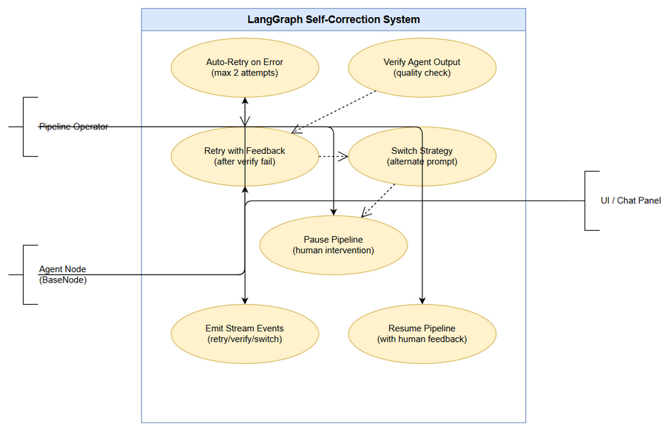
Use Case Diagram
Edit in draw.io
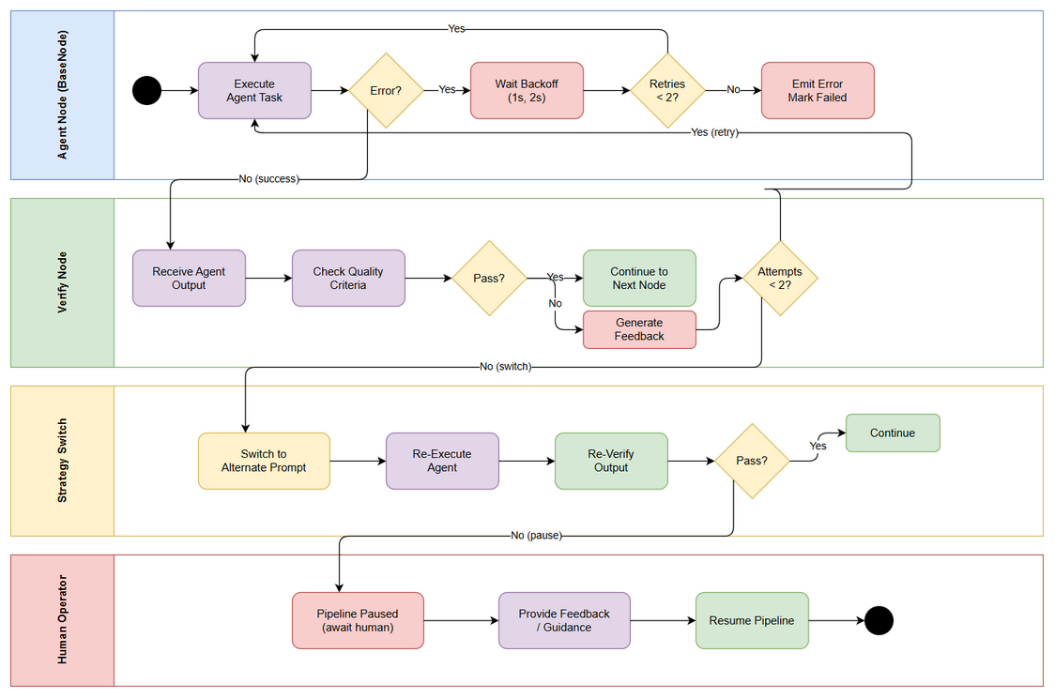
Business Flow
Edit in draw.io

2.2 List of User Stories / Use Cases
# | Story / Use Case / Epic | Priority | Source Ticket
1 | As a pipeline operator, I want agent nodes to auto-retry on errors so that transient failures don’t halt the entire pipeline | MUST HAVE | KSA-233
2 | As a pipeline operator, I want a verification node after each agent so that output quality is validated before proceeding | MUST HAVE | KSA-233
3 | As a pipeline operator, I want the system to switch strategy after repeated failures so that alternative approaches are attempted automatically | MUST HAVE | KSA-233
4 | As a pipeline operator, I want the pipeline to pause and ask for human intervention when all strategies fail so that I can make a decision | MUST HAVE | KSA-233
5 | As a UI developer, I want retry and verify events streamed so that the Chat Panel can display self-correction progress to users | SHOULD HAVE | KSA-233
6 | As a developer, I want unit tests for all retry/verify logic so that self-correction behavior is reliable and regression-free | MUST HAVE | KSA-233

2.3 Details of User Stories

Business Flow
Step 1: Agent node execute() is called by the run() wrapper in BaseNode.
Step 2: If execute() throws an error, the Auto-Retry mechanism catches it: - Retry attempt 1: wait 1 second (backoff), then re-execute - Retry attempt 2: wait 2 seconds (backoff), then re-execute - If all retries fail: mark node as failed, emit error event, proceed to pipeline failure handling
Step 3: If execute() succeeds, the output is passed to the Verify Node for the corresponding agent.
Step 4: Verify Node evaluates output quality (completeness, format, criteria adherence).
Step 5: If verification passes: output is forwarded to the next graph node (Quality Gate or next agent).
Step 6: If verification fails: specific feedback is generated and passed back to the agent node for retry.
Step 7: Agent node retries with the feedback incorporated (up to 2 verify-retry cycles).
Step 8: After 2 verification failures: Strategy Switch activates — an alternate prompt/approach is used.
Step 9: If the alternate strategy also fails verification: pipeline status is set to “paused” and a human-intervention event is emitted.
Note: The retry counter is per-node-per-execution. Retries reset between pipeline invocations. Stream events are emitted for every retry, verify, and strategy-switch action to keep the UI informed.

STORY 1: Auto-Retry with Backoff
As a pipeline operator, I want agent nodes to auto-retry on errors so that transient failures don’t halt the entire pipeline.
Requirement Details:
- When execute() throws an error (any Error subclass), the run() method in BaseNode must catch it and retry automatically.
- Maximum retry count: 2 (total attempts = 3 including initial).
- Backoff strategy: exponential — 1s delay before retry 1, 2s delay before retry 2.
- The retry count must be tracked in state.retryCount[nodeId] (already exists in PipelineState).
- If all retries are exhausted, the node returns pipelineStatus: "failed" with error details.
- StreamHandler must emit a retry event for each retry attempt with: nodeId, attemptNumber, maxAttempts, delayMs.
Data Fields:
Field | Type | Required | Description | Example
retryCount | Record<string, number> | Yes | Tracks retry attempts per node | { "ba_brd": 2 }
retryDelayMs | number | Yes | Backoff delay before next attempt | 1000, 2000
maxRetries | number | Yes | Maximum retry attempts | 2
Acceptance Criteria:
- AC1: When an agent node throws an error, the system automatically retries up to 2 times before marking as failed.
- Each retry uses exponential backoff (1s, 2s).
- After successful retry, the pipeline continues as if no error occurred.
- StreamHandler emits a retry event for each attempt.
Validation Rules:
- maxRetries must be a positive integer (default: 2)
- retryDelayMs must not exceed NODE_TIMEOUT_MS (300,000ms)
- Retry counter resets when pipeline is re-invoked with a new threadId
Error Handling:
- All retries exhausted → return PipelineError with recoverable: false, emit error event
- Timeout during retry → count as a failed attempt, proceed to next retry
- Non-recoverable errors (e.g., missing configuration) → skip retry, fail immediately

STORY 2: Verification Nodes
As a pipeline operator, I want a verification node after each agent so that output quality is validated before proceeding.
Requirement Details:
- A new VerifyNode class must be created (nodes/verify-node.ts) that evaluates agent output against quality criteria.
- A Verify Node is placed after each agent node in the graph: ba_brd → verify_ba_brd, ba_fsd → verify_ba_fsd, sa_tdd → verify_sa_tdd, dev_code → verify_dev_code, qa_plan → verify_qa_plan.
- VerifyNode receives the previous agent’s output from state.agentOutputs (last entry) and evaluates it.
- Verification criteria are defined per-phase (e.g., BRD must have ≥3 user stories, FSD must have use cases with flows).
- If verification passes: VerifyNode returns { verifyPassed: true } and the graph proceeds to the next node.
- If verification fails: VerifyNode returns { verifyPassed: false, verifyFeedback: "specific feedback" } and the graph routes back to the agent.
Data Fields:
Field | Type | Required | Description | Example
verifyPassed | boolean | Yes | Whether verification succeeded | true
verifyFeedback | string | No | Specific feedback when verify fails | "BRD missing acceptance criteria for Story 2"
verifyAttempts | Record<string, number> | Yes | Verify retry count per node | { "verify_ba_brd": 1 }
maxVerifyAttempts | number | Yes | Max verify retries before strategy switch | 2
Acceptance Criteria:
- AC2: After every BA/SA/DEV/QA node execution, a verify node checks the output.
- AC3: When verification fails, the agent receives specific feedback and retries.
- Verify node does NOT re-execute the agent — it only checks the output and provides feedback.
- StreamHandler emits a verify event with: nodeId, passed, feedback (if failed).
UI Specifications:
No. | Name | Type | Required | Description | Note
1 | Verify Status Badge | Label | Yes | Shows ✓ or ✗ after each node | Green for pass, red for fail
2 | Verify Feedback Panel | Text Area | No | Displays verification feedback | Only shown when verify fails
3 | Retry Counter | Badge | Yes | Shows attempt X/N | Updates in real-time via stream
Validation Rules:
- VerifyNode must complete within NODE_TIMEOUT_MS (300s)
- Verify feedback must be non-empty string when verifyPassed: false
- Verify criteria must be configurable per phase (not hardcoded)
Error Handling:
- VerifyNode itself throws error → treat as verify pass (don’t block pipeline on verify infrastructure failure)
- Agent output is empty/null → automatic verify fail with feedback “No output produced”
- Verify criteria not configured for a phase → skip verification, pass through

STORY 3: Strategy Switch
As a pipeline operator, I want the system to switch strategy after repeated failures so that alternative approaches are attempted automatically.
Requirement Details:
- After 2 consecutive verification failures for the same agent node, the system must switch to an alternate strategy (different prompt template or approach).
- The alternate strategy is defined per-node (e.g., a simpler prompt, different LLM temperature, different document structure).
- The strategy switch is transparent — the agent node receives an alternateStrategy: true flag in state.
- If the alternate strategy also fails verification: the pipeline pauses for human intervention.
- Strategy switch must be tracked in state for observability.
Data Fields:
Field | Type | Required | Description | Example
activeStrategy | Record<string, string> | Yes | Current strategy per node | { "ba_brd": "alternate" }
strategyHistory | Array<{nodeId, strategy, timestamp}> | No | History of strategy switches | [{nodeId: "ba_brd", strategy: "alternate", timestamp: "..."}]
Acceptance Criteria:
- AC4: After 2 verification failures, the system switches to an alternate strategy (e.g., alternate prompt).
- AC5: If the alternate strategy also fails verification, the pipeline pauses and asks for human intervention.
- The strategy switch event is streamed to UI.
- Human can resume the pipeline after providing guidance.
Validation Rules:
- Strategy switch only triggers after exactly 2 verify failures (not 1, not 3)
- Alternate strategy must be defined; if not defined for a node, skip strategy switch and go directly to human intervention
- Pipeline pause sets pipelineStatus: "paused" and approvalRequired: true
Error Handling:
- Alternate strategy not configured → pipeline pauses immediately (AC5 path)
- Human does not respond → pipeline remains paused indefinitely (no auto-timeout)
- Human provides feedback → feedback stored in state.userFeedback, pipeline resumes with original strategy + human guidance

STORY 4: Pipeline Pause for Human Intervention
As a pipeline operator, I want the pipeline to pause and ask for human intervention when all strategies fail so that I can make a decision.
Requirement Details:
- When both primary and alternate strategies fail, the pipeline sets pipelineStatus: "paused".
- A human_intervention_required stream event is emitted with context: which node failed, what was tried, verify feedback history.
- The pipeline checkpoint is saved so it can be resumed later.
- When resumed, the human’s feedback is incorporated into the next execution attempt.
Acceptance Criteria:
- AC5 (continued): Pipeline pauses with full context available to the human operator.
- Checkpoint is persisted — pipeline survives process restart.
- Resume path re-enters at the failed node with human feedback in state.

STORY 5: Stream Events for Self-Correction
As a UI developer, I want retry and verify events streamed so that the Chat Panel can display self-correction progress to users.
Requirement Details:
- StreamHandler must support new event types: retry, verify, strategy_switch, human_intervention_required.
- Each event includes: nodeId, timestamp, and type-specific metadata.
- Events are emitted in real-time via the existing streaming infrastructure (currentStreamId).
Data Fields:
Field | Type | Required | Description | Example
eventType | string | Yes | Type of self-correction event | "retry", "verify", "strategy_switch"
nodeId | string | Yes | Which node triggered the event | "ba_brd"
metadata | object | Yes | Event-specific details | { attempt: 1, maxAttempts: 2, delayMs: 1000 }
Acceptance Criteria:
- AC6: StreamHandler emits retry/verify events that the UI can consume.
- Events are emitted in real-time (no batching/buffering).
- Events follow the existing StreamHandler event format.

STORY 6: Unit Tests for Self-Correction
As a developer, I want unit tests for all retry/verify logic so that self-correction behavior is reliable and regression-free.
Requirement Details:
- Unit tests must cover: auto-retry with backoff, verify node pass/fail paths, strategy switch trigger, human intervention pause, stream event emission.
- Tests must use mocks for LLM calls and MCP tool calls.
- Test coverage target: 100% of retry/verify/switch logic paths.
Acceptance Criteria:
- AC7: All retry/verify logic has unit tests.
- Tests verify: correct retry count, correct backoff timing, correct state transitions, correct stream events emitted.
- Edge cases tested: immediate success (no retry needed), all retries fail, verify passes on second attempt, strategy switch activates correctly.

3. Dependencies
Dependency | Type | Related Ticket | Description
KSA-210 | System | KSA-210 | LangGraph Pipeline Foundation — provides BaseNode, PipelineState, StreamHandler, graph structure
BaseNode class | System | KSA-210 | The run() method in base-node.ts is the integration point for auto-retry
PipelineState | System | KSA-210 | State channels for retryCount, pipelineStatus, errors already exist
StreamHandler | System | KSA-210 | Must be extended with new event types (retry, verify, strategy_switch)
LangGraph StateGraph | Infrastructure | N/A | @langchain/langgraph package provides graph compilation and conditional edges
WorkspaceCheckpointer | System | KSA-210 | Must persist state across pauses for human intervention resume

4. Stakeholders
Role | Name / Team | Responsibility | Source
Developer | Dev Team | Implement self-correction patterns | KSA-233 assignee
Solution Architect | SA Team | Review architecture, approve TDD | KSA-233 reviewer
QA Engineer | QA Team | Write and execute tests (AC7) | KSA-233
Pipeline Operator | DevOps / End Users | Primary beneficiary — improved pipeline reliability | KSA-233 reporter

5. Risks and Assumptions

5.1 Risks
Risk | Impact | Likelihood | Mitigation
Retry loops increase LLM token consumption | Medium | High | Cap at 2 retries; track token usage per retry cycle
Verify node adds latency to every agent execution | Medium | Medium | Verify criteria should be lightweight; consider parallel verification for non-blocking checks
Strategy switch alternate prompts not well-defined per node | High | Medium | Define alternate strategies as part of implementation; default to human intervention if not configured
Infinite loop if verify → retry → verify cycle has a bug | High | Low | Hard cap on verify attempts (maxVerifyAttempts=2); integration tests for the cycle
Exponential backoff delays may exceed node timeout | Low | Low | Validate total retry time < NODE_TIMEOUT_MS before starting retry loop

5.2 Assumptions
- The existing retryCount field in PipelineState is sufficient for tracking retry state (no schema migration needed)
- LLM providers support the same API for retried calls (no session/context issues)
- The StreamHandler.emitStatus() pattern can be extended for new event types without breaking existing consumers
- Alternate strategy prompts will be defined in configuration files, not hardcoded in node implementations
- The existing graph structure (conditional edges) can accommodate verify nodes without requiring a full graph rebuild

6. Non-Functional Requirements
Category | Requirement | Details
Performance | Retry backoff must not exceed total node timeout | Total retry time (initial + 1s + 2s = 3s overhead max) well within 300s timeout
Performance | Verify node must complete within 30s | Verification should be a quick LLM call or rule-based check
Reliability | Self-correction must not introduce data corruption | Each retry starts fresh; no partial state from failed attempts persisted
Observability | All self-correction actions must emit stream events | UI can track retry count, verify status, strategy changes in real-time
Testability | 100% path coverage for retry/verify/switch logic | Unit tests with mocked LLM and MCP
Scalability | Patterns apply uniformly to all agent nodes | BaseNode implements retry; VerifyNode is generic and reusable
Maintainability | Verify criteria and alternate strategies are configurable | Not hardcoded; can be updated without code changes

7. Related Tickets
Ticket Key | Summary | Status | Type | Relationship
KSA-233 | LangGraph Self-Correction Patterns: Auto-Retry, Verify Node, Strategy Switch | To Do | Story | Main ticket
KSA-210 | LangGraph Pipeline Foundation | Done | Epic | Prerequisite — provides base infrastructure

8. Appendix

Files Affected
File | Change Type | Description
kiro-sdlc-agents/src/langgraph/nodes/base-node.ts | Modify | Add auto-retry with backoff to run() method
kiro-sdlc-agents/src/langgraph/edges.ts | Modify | Add routing edges for verify nodes and strategy switch paths
kiro-sdlc-agents/src/langgraph/graphs/sdlc-graph.ts | Modify | Register verify nodes, add conditional edges for retry/switch routing
kiro-sdlc-agents/src/langgraph/state.ts | Modify | Add verifyPassed, verifyFeedback, verifyAttempts, activeStrategy fields
kiro-sdlc-agents/src/langgraph/nodes/verify-node.ts | New | Dedicated verification node class

Glossary
Term | Definition
Auto-Retry | Automatic re-execution of a failed node without human intervention
Backoff | Increasing delay between retry attempts (exponential: 1s, 2s)
Verify Node | A dedicated graph node that validates the output of the preceding agent node
Strategy Switch | Changing to an alternate prompt/approach after repeated failures
Human Intervention | Pipeline pause requiring a human operator to provide guidance before resuming
Quality Gate | Existing approval checkpoints (separate from verify nodes — QG requires human approval, verify is automatic)

Reference Documents
Document | Link / Location
LangGraph Pipeline TDD | documents/KSA-210/TDD.md
BaseNode Source | kiro-sdlc-agents/src/langgraph/nodes/base-node.ts
PipelineState Source | kiro-sdlc-agents/src/langgraph/state.ts
SDLC Graph Source | kiro-sdlc-agents/src/langgraph/graphs/sdlc-graph.ts
Edges Source | kiro-sdlc-agents/src/langgraph/edges.ts

Diagram Index
# | Diagram | Image | Source (editable)
1 | Use Case Diagram | use-case.png | use-case.drawio
2 | Business Flow | business-flow.png | business-flow.drawio

