Business Requirements Document (BRD)

Chatbox UI — KSA-255: Spinner + Working Indicator on Input Area during AI Processing

Document Information
Field | Value
Jira Ticket | KSA-255
Title | Chat Panel: Spinner + Working indicator on Input Area during AI processing
Author | BA Agent
Version | 1.0
Date | 2026-06-09
Status | Draft
Related BRD | BRD-v1-KSA-255.docx
Architecture Pattern | Plugin (VS Code Extension)

Author Tracking
Role | Name - Position | Responsibility
Author | BA Agent – Business Analyst | Create document
Peer Reviewer | TA Agent – Technical Analyst | Review document

Revision History
Version | Date | Author | Changes
1.0 | 2026-06-09 | BA Agent | Initiate document — auto-generated from Jira ticket KSA-255

Sign-Off
Name | Signature and date
 | ☐ I agree and confirm all criteria on this BRD as expected requirements
 | ☐ I agree and confirm all criteria on this BRD as expected requirements

1. Introduction

1.1 Scope
This document defines the business requirements for the Spinner + Working Indicator feature on the Chat Panel Input Area. When the user submits a message and the AI is processing a response, the Input Area must display a spinner animation accompanied by “working” text, providing clear visual feedback that the system is actively processing.
This behavior mirrors the Kiro IDE native chat panel UX pattern. The feature is part of the Chatbox UI VS Code extension (webview-based) and follows the Plugin architecture pattern. It communicates with the Extension Host via postMessage protocol to receive AI processing state signals.

1.2 Out of Scope
- AI response streaming/rendering logic — handled by the Message Display component
- Stop button implementation — covered separately (exists from Chat Panel Foundation KSA-210)
- Network error handling / retry UI — separate concern
- Message history persistence during processing state
- Token usage display during processing

1.3 Preliminary Requirement
- Chat Panel Foundation must be implemented (KSA-210 — Done)
- Tool Call UI blocks must be implemented (KSA-247 — Done)
- Input Area component must exist and be functional
- VS Code Webview API communication layer (postMessage) must be established
- AI response streaming infrastructure must signal start/end of processing

2. Business Requirements

2.1 High Level Process Map
The Spinner + Working Indicator provides real-time processing feedback within the chat input area:
- User types a message in the Input Area
- User submits the message (Enter key or Send button)
- Input Area transitions to “processing” state — spinner + “working” text appears within 100ms
- Input textarea becomes disabled (not editable)
- AI processes the request (variable duration)
- AI response completes OR user clicks Stop button
- Spinner disappears, Input Area returns to normal state with placeholder text restored
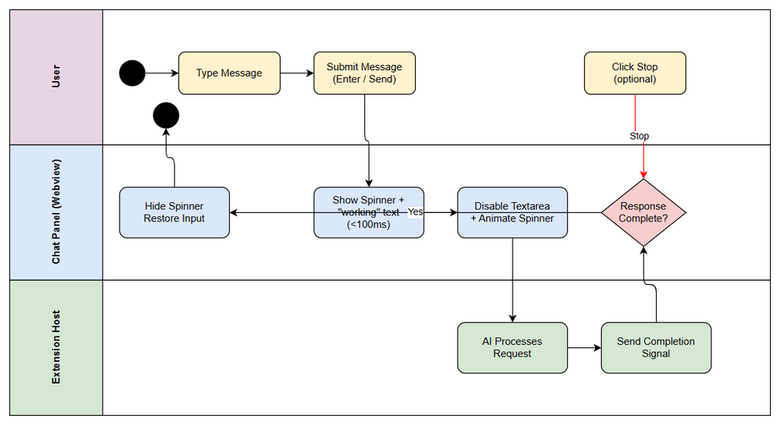 Edit in draw.io

2.2 List of User Stories / Use Cases
# | Story / Use Case | Priority | Source Ticket
1 | Display Spinner on Message Submit | MUST HAVE | KSA-255
2 | Continuous Spinner Animation during Processing | MUST HAVE | KSA-255
3 | Remove Spinner on AI Response Complete | MUST HAVE | KSA-255
4 | Remove Spinner on Stop Button Click | MUST HAVE | KSA-255
5 | Disable Input during Processing | MUST HAVE | KSA-255
6 | Dark Theme Consistent Styling | MUST HAVE | KSA-255

2.3 Details of User Stories

Business Flow
Step 1: User composes a message in the Input Area textarea
Step 2: User submits the message (pressing Enter or clicking Send button)
Step 3: Within 100ms, the Input Area displays a spinner animation + “working” text overlay, and the textarea becomes disabled (read-only, not editable)
Step 4: The spinner animates continuously (CSS rotation or pulse animation) while the AI is processing
Step 5: Processing ends via one of two paths: - Path A (Normal): AI response completes (last token received) → spinner disappears, input restored - Path B (Cancelled): User clicks Stop button → spinner immediately disappears, input restored
Step 6: Input Area returns to normal editable state with original placeholder text
Note: The spinner and “working” text must NOT block or obscure the Stop button or any other interactive element. The user must always be able to cancel the operation.

STORY 1: Display Spinner on Message Submit
As a user, I want to see a spinner animation + “working” text immediately after submitting my message, so that I know the system is processing my request.
Requirement Details:
- When a message is submitted (Enter key or Send button), the Input Area SHALL display a spinner animation accompanied by “working” text
- The spinner must appear within 100 milliseconds of message submission
- The spinner is rendered WITHIN the Input Area (not as a separate component)
- The “working” text is displayed alongside the spinner (inline)
UI Specifications:
No. | Name | Type | Required | Description | Note
1 | Spinner Icon | CSS Animation (SVG/span) | Yes | Rotating or pulsing circle/dots | 16px size, Kiro theme color
2 | Working Text | Label | Yes | Static text “working” next to spinner | Font: inherit from input, opacity: 0.7
3 | Input Overlay | Container | Yes | Wraps spinner + text within textarea area | Centered vertically in input
Acceptance Criteria:
- WHEN a message is submitted, THE Input_Area SHALL display a spinner animation + “working” text within 100ms

STORY 2: Continuous Spinner Animation during Processing
As a user, I want the spinner to animate continuously while the AI processes my request, so that I can confirm the system is still working.
Requirement Details:
- The spinner SHALL animate continuously using CSS rotation or pulse animation
- Animation must be smooth (60fps target via CSS animation/transition)
- Animation continues uninterrupted for the entire processing duration
- No flickering or stuttering during animation
Acceptance Criteria:
- WHILE the AI is processing, THE spinner SHALL animate continuously (CSS rotation or pulse)

STORY 3: Remove Spinner on AI Response Complete
As a user, I want the spinner to disappear and the input to restore when the AI finishes responding, so that I can immediately type my next message.
Requirement Details:
- When the AI response completes (last token/chunk received), the spinner SHALL disappear
- The input placeholder text SHALL be restored to its original value
- The textarea SHALL become editable again
- Transition from “processing” to “ready” state should be immediate (no fade-out delay)
Acceptance Criteria:
- WHEN the AI response completes (last token received), THE spinner SHALL disappear and input placeholder text restores

STORY 4: Remove Spinner on Stop Button Click
As a user, I want the spinner to disappear immediately when I click the Stop button, so that I have instant feedback that cancellation was acknowledged.
Requirement Details:
- When the Stop button is clicked during processing, the spinner SHALL disappear immediately
- “Immediately” means within 1 frame (~16ms), no animation delay
- Input placeholder text restores and textarea becomes editable
- The Stop button interaction is NOT blocked by the spinner UI
Acceptance Criteria:
- WHEN the Stop button is clicked, THE spinner SHALL immediately disappear

STORY 5: Disable Input during Processing
As a user, I want the input textarea to be disabled while the AI is processing, so that I don’t accidentally type into the field during processing.
Requirement Details:
- While the spinner is showing, the input textarea SHALL be disabled (not editable)
- Disabled state means: no text input, no paste, no cursor shown in the field
- The field visually appears inactive (reduced opacity or grayed out per dark theme)
- Re-enabled immediately when processing ends (response complete or Stop clicked)
Acceptance Criteria:
- WHILE spinner is showing, THE input textarea SHALL be disabled (not editable)

STORY 6: Dark Theme Consistent Styling
As a user, I want the spinner and “working” text to be styled consistently with the Kiro IDE dark theme, so that the UI feels cohesive and professional.
Requirement Details:
- Spinner color SHALL use Kiro IDE theme variables (e.g., --vscode-progressBar-background or similar)
- “working” text color SHALL match muted text in dark theme (e.g., --vscode-descriptionForeground)
- No bright/contrasting colors that break the dark theme aesthetic
- Consistent with Kiro IDE’s own spinner behavior as reference
Acceptance Criteria:
- THE spinner + working text SHALL be styled consistently with Kiro IDE dark theme

Non-Blocking Requirement (Cross-cutting)
Requirement Details:
- The spinner + working text SHALL NOT block the Stop button or any other interactive element
- z-index and positioning must ensure clickable elements remain accessible
- No pointer-events on spinner overlay that would intercept clicks meant for other controls
Acceptance Criteria:
- THE spinner SHALL NOT block the Stop button or any other interactive element

3. Dependencies
Dependency | Type | Related Ticket | Description
Chat Panel Foundation | System | KSA-210 (Done) | Panel layout, Input Area, and Stop button must exist
Tool Call UI Blocks | System | KSA-247 (Done) | Tool call UI interactions must not conflict with spinner state
VS Code Webview API | Infrastructure | N/A | postMessage protocol for extension-webview state communication
AI Response Stream | System | N/A | Extension Host must signal processing start and end events
CSS Custom Properties | Infrastructure | N/A | VS Code theme variables must be accessible in webview

4. Stakeholders
Role | Name / Team | Responsibility | Source
Product Owner | Development Team Lead | Approve requirements, UAT | Ticket creator
Developer | Frontend Developer | Implement spinner + state management in TypeScript | Assignee
QA Engineer | QA Team | Test all 7 acceptance criteria, timing validation | Ticket watcher
UX Designer | Design Team | Validate visual consistency with Kiro IDE | Reviewer

5. Risks and Assumptions

5.1 Risks
Risk | Impact | Likelihood | Mitigation
CSS animation performance on low-end devices | Medium | Low | Use GPU-accelerated transforms (rotate, opacity) only
State synchronization issue — spinner stuck | High | Medium | Add timeout fallback (30s max) to auto-clear spinner
Race condition between Stop click and response arrival | Medium | Medium | Use a single state variable; whichever event fires first wins
Theme variable unavailability in webview | Low | Low | Fallback hardcoded dark theme colors if CSS vars undefined
Spinner overlapping Stop button on small panels | Medium | Low | Use flex layout with explicit spacing; test at min panel width

5.2 Assumptions
- The Extension Host reliably signals AI processing start (on message submit) and end (on last token or error)
- The Stop button already exists and functions (from KSA-210 Chat Panel Foundation)
- VS Code CSS custom properties (theme variables) are accessible within the webview iframe
- The Input Area is implemented as a standard HTML textarea or contenteditable element
- The webview supports CSS animations without vendor prefixes (modern Chromium-based)
- Processing state is managed in the webview (not round-tripped to Extension Host for spinner toggle)

6. Non-Functional Requirements
Category | Requirement | Details
Performance | Spinner display latency | Must appear within 100ms of message submission
Performance | Spinner disappear latency | Must disappear within 1 frame (16ms) of completion/stop signal
Performance | Animation smoothness | 60fps CSS animation, no jank (use transform/opacity only)
Accessibility | Screen reader | ARIA live region announcing “AI is processing” on spinner show, “Ready” on hide
Accessibility | Reduced motion | Respect prefers-reduced-motion — show static indicator instead of animation
Compatibility | VS Code versions | Must work with VS Code 1.80+ (Webview API v2)
Reliability | Stuck spinner protection | Auto-clear spinner after 60s timeout if no completion signal received
Visual | Theme consistency | Use VS Code CSS custom properties, no hardcoded colors

7. Related Tickets
Ticket Key | Summary | Status | Type | Relationship
KSA-255 | Chat Panel: Spinner + Working indicator on Input Area during AI processing | To Do | Task | Main ticket
KSA-210 | Chat Panel Foundation | Done | Task | Dependency (provides Input Area + Stop button)
KSA-247 | Tool Call UI blocks | Done | Task | Dependency (UI state interactions)

8. Appendix

Glossary
Term | Definition
Input_Area | The textarea/input field at the bottom of the Chat Panel where users type messages
Spinner | A CSS-animated visual indicator (rotating circle or pulsing dots) showing processing state
Working Text | The text label “working” displayed alongside the spinner
Stop Button | An interactive button that cancels the current AI processing operation
Processing State | The period between message submission and AI response completion
postMessage | VS Code API for bidirectional communication between webview and extension host

Reference Documents
Document | Link / Location
Chatbox UI Spec | .kiro/specs/chatbox-ui/requirements.md
VS Code Webview API | https://code.visualstudio.com/api/extension-guides/webview
Kiro IDE Chat Panel (reference implementation) | Kiro IDE v1.x native chat panel behavior
KSA-210 BRD | BRD-v1-KSA-210.docx

Use Case Diagram
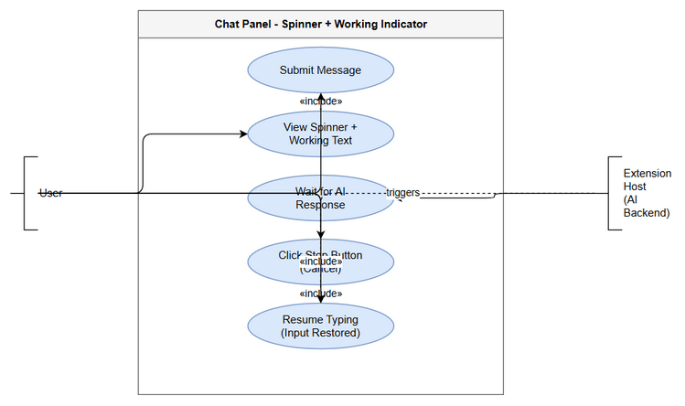 Edit in draw.io

Diagram Index
# | Diagram | Image | Source (editable)
1 | Business Flow | business-flow.png | business-flow.drawio
2 | Use Case Diagram | use-case.png | use-case.drawio

