Technical Design Document (TDD)

Pi Harness — SA4E-360: Multi-Resolution Context Supply for Pi Harness — P1: Code Skeletonization + Agentic Context Loading

Document Information
Field | Value
Jira Ticket | SA4E-360
Title | Multi-Resolution Context Supply for Pi Harness — P1: Code Skeletonization + Agentic Context Loading (wire dormant foundation)
Issue Type / Priority | Story / High
Labels | context-governance, pi-harness, wire-only
Project | SA4E — SDLC Agents 4 Enterprise
Author | SA Agent (Solution Architect)
Version | 1.1
Date | 2026-10-14
Status | Draft — Ready for SM review
Related BRD | documents/SA4E-360/BRD.md (v1.1)
Related FSD | documents/SA4E-360/FSD.md (v1.2, TA-ENRICHED — DISC-1..7 applied)
Governance baseline | documents/SA4E-355/TDD.md (v1.3 — §13 3-point budget gate architecture, UNTOUCHED)
Discrepancy report | documents/SA4E-360/DISCREPANCY.md (7 findings, 0 Critical)

Revision History
Version | Date | Author | Changes
1.0 | 2026-10-13 | SA Agent | Initiate TDD from FSD v1.1 + BRD v1.1 + SA4E-355 TDD v1.3 §13. Codebase verified 2026-10-13: dormant components (SymbolOutlineExtractor, SummaryTreeBuilder, McpSearchProvider, ContextRetriever), wire points (pi-agent-session-host.ts createHost L240/L325/L378, workspace-info-tool.ts, pi-coding-tools.ts, pi-workflow-gate.ts L103, pi-provider.ts L273), backend index (SCHEMA_V1 files/symbols/symbols_fts, QueryLayer, code_symbols/code_search/code_index_status tools, incremental checksum indexer, signature-extractor with ReDoS C2 guard, grammar-config.json 21 languages). Resolves OI-1..OI-6 (§3). 2 new thin backend tools designed (code_symbol_locate, code_extract_signatures). 4 draw.io diagrams created + exported. Discrepancy report DISC-1..DISC-7.
1.1 | 2026-10-14 | SA Agent | Corrected budget arithmetic @32k per resolver-true values (BA feedback, DISC-7 arithmetic slip: ceil(2621.44)=2622) — §2.2 now states margin 2,622 / usable 28,098 / staticBudget 19,668 / skeleton cap 13,767 (~13.8K); @65k values already correct (5,243/58,245/40,771/28,539 — unchanged). Related FSD ref updated to v1.2 (DISC-1..7 applied). DISCREPANCY.md Resolution section added — ALL RESOLVED. No other sections, diagrams, or OI decisions changed.

Sign-Off
Name | Signature and date
 | ☐ I agree and confirm all criteria on this TDD as expected design
 | ☐ I agree and confirm all criteria on this TDD as expected design

1. Introduction

1.1 Purpose
This TDD specifies technically how SA4E-360 wires the dormant multi-resolution context supply foundation into the Pi Harness session lifecycle, so that a whole-workspace review on local LLMs (qwen 32k/65k) fits inside the model context window.
The design is bound by two invariants inherited from the FSD and the SA4E-355 baseline:
- Governance plane unchanged — the 3-point budget gate architecture shipped by SA4E-355 (TDD v1.3 §13) remains the ONLY enforcement mechanism. SA4E-360 adds measured static content (skeleton + functional map) and ordinary tool results (read_method, extended get_workspace_info). No 4th gate is created; every content output flows through the existing gates: turn-start legacy (governLegacyTurn) / session turn-start (gate #2, runSessionBudgetGate in createHost) / intra-turn (gate #3, governIntraTurnRequest in Agent.streamFn).
- Wire-only (BR-11) — compose existing shipped/dormant mechanisms. No new skeleton engine, router, or token estimator. The only new backend surface is 2 THIN MCP tools that serialize existing QueryLayer / signature-extractor capabilities for the extension host (boundary wiring, same class of change as SA4E-355’s transcript grouping).

1.2 Scope
In scope (per FSD §1.2):
- UC-360-01 — Budget-aware code skeleton injection at session assembly (gate #2 measured, ≤ 70% staticBudget per BR-360-01, module-priority truncation, REJECT per BR-09 on persisting overflow).
- UC-360-02 — read_method(class, method) core tool returning a single symbol slice (startLine..endLine from the index), ordinary tool result under gate #3.
- UC-360-03 — Functional map (SummaryTreeBuilder) wired into get_workspace_info + the session assembly path, riding the existing 60s layoutCache (C-360-M2).
- UC-360-04 — Regex signature fallback (signature-extractor.ts) for languages without a bundled tree-sitter grammar, with RAW_HEAD/SKIPPED degradation (BR-360-03).
- UC-360-05 — Governance regression safety: all 3 gates untouched, test-first, full suite green after every task.
Out of scope: P2 Contextual RAG wire, P3 Map-Reduce wire, P4 call-graph pruning, any new tree-sitter dependency (grammars already bundled), UI changes (none — FSD §3.x.6), multi-root merged skeleton (OI-3 → P3).

1.3 Technology Stack (verified against codebase 2026-10-13)
Layer | Technology | Evidence
Extension host | TypeScript, VS Code extension, vitest | extension/package.json ("test": "vitest run"), src under extension/src/
Agent harness | pi-agent-core / pi-coding-agent (AgentTool, AgentSession, streamFn) | pi-agent-session-host.ts imports @earendil-works/pi-coding-agent
Tool schema | TypeBox (same style as workspace-info-tool.ts L91) | parameters: Type.Object({...})
Governance (SA4E-355) | context-budget-resolver, session-budget-gate, intra-turn-budget-gate, transcript-compaction, TurnBudgetGuard | extension/src/pi-agent/, extension/src/pi-workflow/
Backend index | Node/TS MCP server; SQLite (@sqlite.org/sqlite-wasm, SCHEMA_V1 with symbols_fts FTS5 external-content) OR PostgreSQL (pg-schema-ensure.ts); dual-engine via DatabaseAdapter + DialectHelper | backend/src/engine/db/schema.ts L17-60; backend/src/database/migration/pg-schema-ensure.ts L29-61
MCP transport | loopback JSON-RPC wrapper POST /mcp; loopback-only URL validation, X-Session-Nonce, 5s AbortSignal timeout | search-provider.ts L16-19, L171-194, L204-234
Parsers | web-tree-sitter + bundled grammars (grammar-config.json: 21 language entries); regex multi-language extractor (ReDoS C2 guard: MAX_LINE_LENGTH 8192) | backend/src/engine/parsers/grammar-config.json; signature-extractor.ts L40-51

1.4 Design Principles & Constraints
# | Principle | Source
P-1 | Wire-only: reuse SymbolOutlineExtractor, signature-extractor.ts, SummaryTreeBuilder, QueryRouter, McpSearchProvider, path-containment.ts — no new engine/router/estimator | BR-360-05, BR-11
P-2 | Every content path measures tokens via the existing estimateTokenCount (pi-agent/prompt-compressor.ts) / TokenCounter / BudgetCalculator.calculateBudget — no parallel estimation | INV-2 (FSD §2.2), BR-360-01
P-3 | Fail-safe, never fail-open: persisting overflow → REJECT PI_CONTEXT_BUDGET_EXCEEDED; provider NEVER called oversized | INV-3, BR-360-02, BR-09
P-4 | Skeleton + functional map are STATIC context: measured once at gate #2 per session creation, never grow intra-turn; only tool results grow and are absorbed by gate #3 + compaction | INV-1 (FSD §2.2)
P-5 | No 4th gate. Content-plane outputs are inputs to the shipped gates, never enforcement points | SA4E-355 TDD §13 (consistency constraint)
P-6 | Code standards: ≤ 200 lines/file, ≤ 20 lines/function, SOLID, TSDoc, test-first, npm test green after every task | Ticket constraint, FSD §3.5.3
P-7 | Diagrams: draw.io only (no Mermaid) — every diagram embedded as PNG with editable .drawio source | Project rule (AGENTS.md)
P-8 | Multi-engine index agnostic: all symbol queries go through QueryLayer methods (SQLite symbols_fts OR PostgreSQL ILIKE behind the adapter) — no raw FTS5 SQL in the extension host | Verified dual-engine schema (DISC-6)

1.5 References
Document | Location
BRD (primary input) | documents/SA4E-360/BRD.md (v1.1)
FSD (functional contract — C-360-* identifiers are binding) | documents/SA4E-360/FSD.md (v1.1)
SA4E-355 TDD v1.3 — §13 Intra-Turn Request Governance | documents/SA4E-355/TDD.md
SA4E-355 FSD §3.8 — inherited business rules BR-01/02/09/11 | documents/SA4E-355/FSD.md
Dormant skeleton renderer | extension/src/pi-agent/context-retrieval/symbol-outline-extractor.ts
Dormant functional map builder | extension/src/pi-agent/context-retrieval/summary-tree.ts
Production workspace info tool (wire point) | extension/src/pi-workflow/workspace-info-tool.ts
Session host (wire point) | extension/src/pi-workflow/pi-agent-session-host.ts (createHost L240, gate L325, createAgentSession L378, ensureSessionHost L507)
Regex signature fallback | backend/src/engine/parsers/signature-extractor.ts (extractSymbols L43, MAX_LINE_LENGTH L40)
Grammar registry config | backend/src/engine/parsers/grammar-config.json (21 language entries — DISC-3)
Index schema (SCHEMA_V1 + FTS5) | backend/src/engine/db/schema.ts (files L17, symbols L36, symbols_fts L52)
PostgreSQL index schema | backend/src/database/migration/pg-schema-ensure.ts (files L29, symbols L46)
QueryLayer (symbol queries) | backend/src/engine/query/query-layer.ts (findSymbols L169, getFileSymbols L187)
Existing MCP tools | backend/src/engine/tools/code-symbols.ts, code-search.ts, code-index-status.ts, register-tools.ts
Incremental indexer (checksum skip) | backend/src/engine/indexer/checksum-service.ts, index-helper.ts (isFileUnchanged L18)
Path containment (SEC-325-D1) | extension/src/pi-agent/context-retrieval/path-containment.ts
Loopback MCP caller (SEC-325-D2/D4) | extension/src/pi-agent/context-retrieval/search-provider.ts

2. System Architecture

2.1 Two-Plane Composition (verified)
SA4E-360 operates entirely inside the Pi Harness extension session lifecycle. The content plane (this ticket) supplies skeleton, functional map, and symbol-slice reads; the governance plane (SA4E-355, shipped v1.52.0) measures and enforces the token budget at 3 execution points. The code-intel backend index (loopback MCP wrapper) and the local LLM provider are external to the extension host.
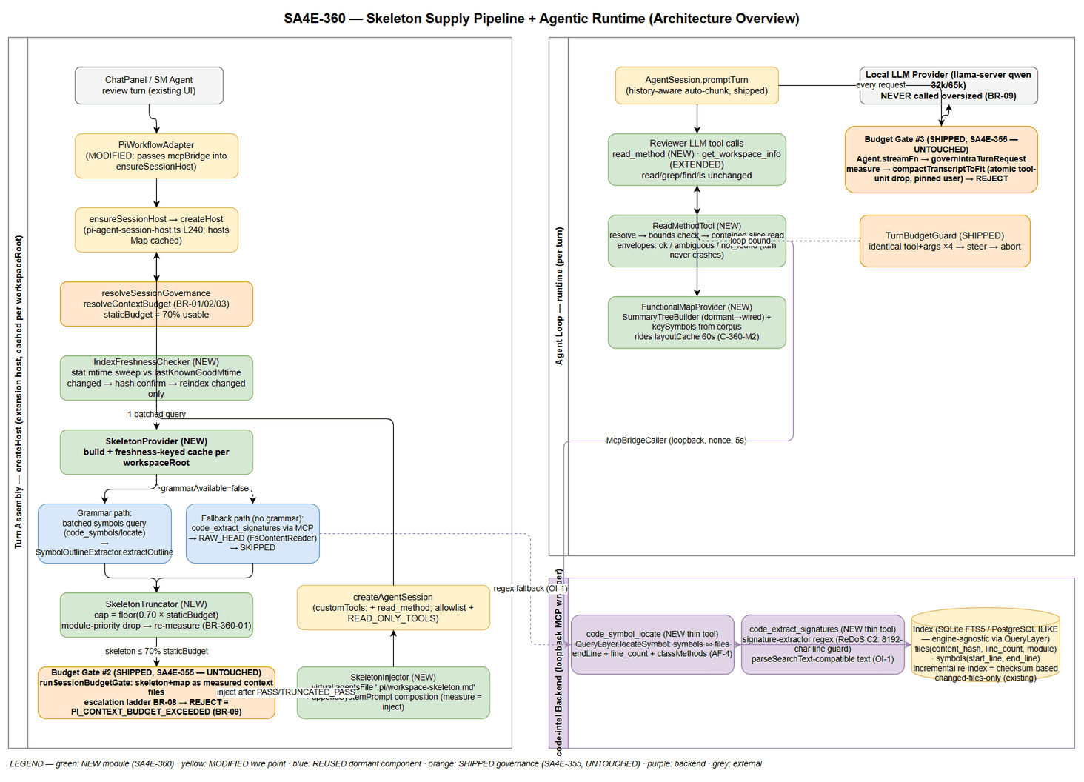 Edit in draw.io
Verified component inventory (ground truth for this design):
Component | Verified Location | State | Role in SA4E-360
SymbolOutlineExtractor.extractOutline(filePath, symbols, maxTokens) | extension/src/pi-agent/context-retrieval/symbol-outline-extractor.ts L35 | Dormant (tests-only) | Skeleton renderer — reused as-is
FsContentReader.readHead + MAX_READ_BYTES = 1_048_576 | same file L12-27 | Dormant | RAW_HEAD fallback (extension-local, never blocks on backend)
SummaryTreeBuilder.build(rootDir, options) → {text, tokens} | extension/src/pi-agent/context-retrieval/summary-tree.ts L30 (defaults maxDepth 3, maxTokens 1500, filesPerDir 8, pageSize 100) | Dormant | Functional map builder — reused as-is
McpSearchProvider / parseSearchText / validateLoopbackWrapperUrl | extension/src/pi-agent/context-retrieval/search-provider.ts L105 / L27 / L171 | Dormant provider class; production bridge caller exists | Loopback index query chain (skeleton corpus + fallback extraction)
ContextRetriever | extension/src/pi-agent/context-retriever.ts (parent dir — DISC-5) | Dormant (constructed only in tests) | NOT wired in P1 (P2 scope); its sub-components are wired individually
createHost(opts) | extension/src/pi-workflow/pi-agent-session-host.ts L240; budget resolve L291; gate #2 runSessionBudgetGate L325; createAgentSession L378; host cache hosts Map L62/L507-522 | Shipped (SA4E-355) | Wire point — skeleton build inserted between budget resolution and gate #2
runSessionBudgetGate / measureStaticAssembly | extension/src/pi-agent/session-budget-gate.ts L56 / budget-gate.ts L157 | Shipped | Gate #2 — skeleton+map enter as measured context files
PI_GATE_DECISION | extension/src/pi-agent/budget-gate.ts L141 (payload: decision, usagePercent, staticTokens, escalations) | Shipped | OI-5 — payload enriched, values unchanged
governIntraTurnRequest / measureIntraTurnRequest | extension/src/pi-workflow/intra-turn-budget-gate.ts L93 / L71 | Shipped | Gate #3 — absorbs read_method/map tool results (module NOT modified)
streamWithBudgetGate / streamFn wiring | extension/src/pi-workflow/pi-provider.ts L226 / L273 | Shipped | Untouched
TurnBudgetGuard (DEFAULT_MAX_SAME_TOOL_REPEATS = 4, MIN 2, CAP 20) | extension/src/pi-workflow/turn-budget-guard.ts L24; pi-provider.ts L399/L424 | Shipped | Loop bound for read_method — no new loop protection
READ_ONLY_TOOLS | extension/src/pi-workflow/pi-workflow-gate.ts L103: [‘read’,‘grep’,‘find’,‘ls’,‘get_workspace_info’] | Shipped | + ‘read_method’ (approval semantics)
layoutCache (Map keyed by workspaceRoot, TTL 60s) | extension/src/pi-workflow/workspace-info-tool.ts L18-20, clearLayoutCache L43 | Shipped | Extended value { at, text, map? } (C-360-M2)
McpBridge / McpBridgeCaller | extension/src/mcp/mcp-bridge.ts L21; mcp-bridge-caller.ts L13; adapter instantiation pi-workflow-adapter.ts L78 | Shipped | Transport for locate/extract queries (DI into session host)
code_symbols MCP tool (name prefix / file listing) | backend/src/engine/tools/code-symbols.ts L9-33 → QueryLayer.findSymbols L169 (name LIKE 'name%') | Shipped | Symbol corpus source for the skeleton build (batched)
code_search MCP tool | backend/src/engine/tools/code-search.ts (QueryLayer.searchCode — ILIKE, NOT FTS5 MATCH — DISC-6) | Shipped | Not used by SA4E-360 paths (fuzzy); referenced only in not_found steering
code_index_status MCP tool (reindex=true → indexer.runFullIndex) | backend/src/engine/tools/code-index-status.ts L18-23 | Shipped | On-demand re-index delegate (freshness recovery)
Incremental indexer (checksum-based skip) | backend/src/engine/indexer/checksum-service.ts, index-helper.ts L18 (isFileUnchanged content_hash compare) | Shipped | “Changed files only” re-index mechanics (FSD §5.4 maps onto this)
signature-extractor.ts (extractSymbols(content, language)) | backend/src/engine/parsers/signature-extractor.ts L43; ReDoS C2 L40-51; getPatterns L133 → LANGUAGE_PATTERNS / GENERIC_PATTERNS | Shipped | Regex fallback for grammar-less languages (OI-1: invoked backend-side)
Index schema | backend/src/engine/db/schema.ts — files (content_hash, line_count, module, UNIQUE(project_id, path)), symbols (start_line, end_line, parent_symbol), symbols_fts FTS5 external-content (name, signature, doc_comment, kind) + sync triggers; PostgreSQL twin pg-schema-ensure.ts | Shipped | Consumed; NO new tables (FSD §4)

2.2 Skeleton Supply Pipeline (UC-360-01, session assembly)
- Turn start — ChatPanel → PiWorkflowAdapter → ensureSessionHost(opts) (pi-workflow-adapter.ts L276-277; MODIFIED: opts now carries mcpBridge). Host is cached per workspaceRoot (hosts Map) with a 30s ensure timeout — the pipeline below runs once per host creation, satisfying INV-1 (measured once per session).
- Budget resolution (gate #2 input, shipped) — resolveSessionGovernance → resolveContextBudget (BR-01 chain: provider meta.n_ctx → ModelRegistry → default 8192) → usable = nCtx − reserveOutput − ceil(nCtx × 8%) (BR-02) → staticBudget = floor(usable × 0.70) (BR-03). @32k (resolver-authoritative math — DISC-7): margin 2,622 (ceil(32,768 × 0.08) = ceil(2,621.44)), usable 28,098, staticBudget 19,668, skeleton cap = floor(0.70 × 19,668) = 13,767 tokens (~13.8K). @65k: usable 58,245, staticBudget 40,771, cap ≈ 28,539 (~28.5K).
- Index freshness check (NEW — IndexFreshnessChecker) — ONE light stat sweep over indexed files (per-file mtime vs session-scoped lastKnownGoodMtime map); on change: hash-confirm ONLY the changed file against files.content_hash; STALE → on-demand re-index delegate (code_index_status reindex → backend incremental indexer skips unchanged files via checksum) → retry ONCE. Re-index failure → DEGRADED_NO_SKELETON (session proceeds with agentic steering — never REJECT for missing content, EF-5).
- Skeleton build (NEW — SkeletonProvider) — ONE batched symbol corpus query (code_symbols name-prefix batches via McpSearchProvider chain; fallback files via code_extract_signatures) → per-file extractOutline(filePath, symbols, maxTokens = floor(0.70 × staticBudget)) (the per-file bound EQUALS the whole-skeleton cap — extractor enforces incrementally). Grammar-less languages take the regex fallback path (UC-360-04) without blocking (BR-360-03). Single-file failure → skip + PI_SKELETON_FILE_SKIPPED warn (EF-3).
- Budget-aware sizing (NEW — SkeletonTruncator) — measure skeletonTokens = estimateTokenCount(joined); while > cap: drop lowest-priority module part (ModuleSummarizer-metrics order), re-measure after EVERY drop; loop terminates (parts strictly shrink). Persisting overflow → REJECT (defect/forced-harness case — BR-360-02; unreachable in normal operation because per-file bounds ≤ cap).
- Gate #2 (SHIPPED, untouched) — skeleton + functional-map sections are passed as ADDITIONAL context-file entries into runSessionBudgetGate’s loadFiles; measureStaticAssembly measures them with the same estimateTokenCount (compress-aware ladder). Escalation ladder BR-08 (compress → drop steering → min loadout) → REJECT throws PiContextBudgetExceededError (provider never called). Gate #2 remains the session-level REJECT of record.
- Injection (NEW — SkeletonInjector) — after PASS/TRUNCATED_PASS: agentsFilesOverride composes a virtual context file .pi/workspace-skeleton.md (content = the SAME measured string) so measurement and injected content are structurally identical; createAgentSession proceeds. Functional map rides the same mechanism (§4.4).
- Telemetry — PI_SKELETON_BUILT / PI_SKELETON_TRUNCATED / PI_SKELETON_FALLBACK / PI_SKELETON_FILE_SKIPPED / PI_SKELETON_INDEX_STALE (C-360-S3) + PI_GATE_DECISION payload enriched (OI-5).

2.3 Agentic Runtime Loop (UC-360-02/03, intra-turn)
- Skeleton + map sit in the system context as static content (never grow).
- read_method (NEW core tool, registered in customTools + allowlist + READ_ONLY_TOOLS): resolve exact symbol (code_symbol_locate → QueryLayer exact/prefix rows with endLine + line_count) → bounds check (corrupt → INDEX_STALE freshness path, never a wrong slice) → path-contained line-range read → JSON envelope tool result. Every result is an ordinary tool result: measured by gate #3, droppable atomically by compaction (BR-360-04). Repetition bounded by shipped TurnBudgetGuard (4× identical → steer → abort) — no new loop protection (BR-11).
- get_workspace_info (EXTENDED, zero-arg unchanged): cached layout (60s TTL preserved) + functional-map section (≤ 1,500 tokens, SummaryTreeBuilder output as-is; whole result ≤ 16,000 chars = shipped MAX_TOOL_RESULT_CHARS).
- Gate #3 (SHIPPED, untouched): EVERY intra-turn request measured at Agent.streamFn; over → compactTranscriptToFit (atomic tool-unit drop, pinned newest user); REJECT only when the pinned user query cannot fit (BR-09).
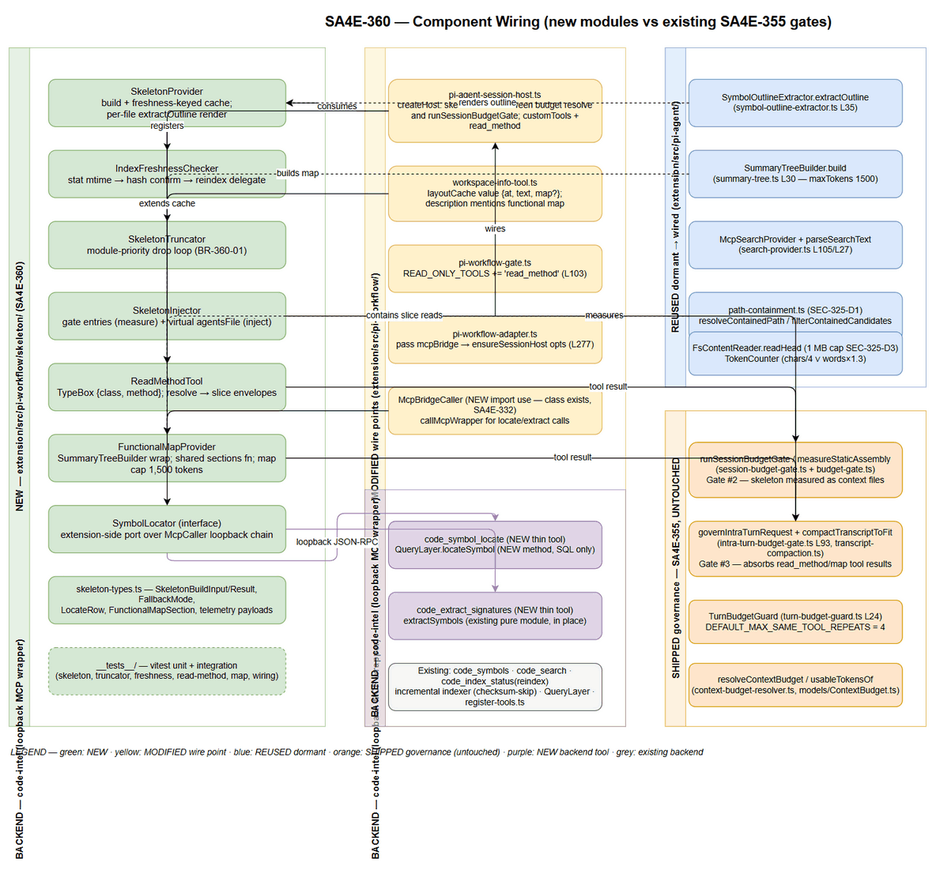 Edit in draw.io

2.4 Deployment Architecture
Unchanged from the SA4E-355 baseline — all logic executes in the two existing local processes:
Node | Process | Contents
VS Code Extension Host | extension (bundled by esbuild) | NEW: pi-workflow/skeleton/* modules; MODIFIED: pi-agent-session-host.ts, workspace-info-tool.ts, pi-coding-tools.ts, pi-workflow-gate.ts, pi-workflow-adapter.ts
code-intel Backend | Node MCP server, loopback only | NEW: 2 thin MCP tools (code_symbol_locate, code_extract_signatures) + QueryLayer.locateSymbol; MODIFIED: register-tools.ts
Index | SQLite (sqlite-wasm, SCHEMA_V1 + symbols_fts) or PostgreSQL (pg-schema-ensure) — engine-agnostic via DatabaseAdapter/DialectHelper | Consumed; NO schema change
Local LLM | llama-server (qwen 32k/65k), loopback | Untouched — never called oversized (BR-09)
No new process, port, container, or network path. The only network traffic is the EXISTING loopback extension→backend MCP wrapper (JSON-RPC POST /mcp, loopback-only validated, session-nonce header, 5s AbortSignal timeout).

2.5 Communication Patterns
Flow | Pattern | Bound
Skeleton build (assembly) | Synchronous, ONE batched corpus query + N fallback extractions (minority of files) | ≤ 2 s p95 wall-clock (§9)
read_method (runtime) | Async tool call → loopback MCP → bounded local slice read | p95 ≤ 300 ms (M4)
get_workspace_info (runtime) | Async, cached 60s; map build ≤ 500 ms p95 | Tool result ≤ 16,000 chars
Freshness recovery | Async re-index delegate (backend incremental, checksum-skip) | Retry ONCE, then degrade
LLM requests | Gated streams through gates #2/#3 (shipped) | Provider never oversized

3. Open Issue Decisions (FSD §11.4 — OI-1..OI-6 resolved)
All six open issues deferred to TDD by the TA enrichment are resolved here with binding decisions. Each decision is grounded in code-verified facts (Section 2.1 inventory).

OI-1 — Cross-package reuse path for signature-extractor.ts (UC-360-04)
 | Decision
Decision | Backend-side extraction behind the existing MCP bridge. One NEW thin MCP tool code_extract_signatures (backend/src/engine/tools/code-extract.ts) wraps the existing pure module extractSymbols(content, language) IN PLACE (no file move, no shared package). The extension host sends a batch of workspace-contained file paths; the backend reads each file bounded (1 MB cap mirroring SEC-325-D3), runs the regex extraction, and emits code_search-style text lines ([kind] name / File: path:line / Sig:) that the EXISTING parseSearchText (search-provider.ts L27) parses into SearchCandidate[] — zero new parsing.
Rejected alternative | Promoting signature-extractor.ts + languages/ (15+ per-language pattern files) to a shared package — larger blast radius across the backend import graph for zero functional gain; duplicating the module into the extension — code duplication violates single-source (BR-360-05 spirit).
Rationale | (1) The pure module stays where its 15+ language pattern sets live; (2) the loopback chain is already hardened (loopback-only URL validation, session nonce, 5s timeout — search-provider.ts L171/L204); (3) fallback files are the minority (21 bundled grammars cover common languages), so per-batch MCP latency stays inside the §8 budget; (4) the RAW_HEAD degradation rung (FsContentReader.readHead) is fully extension-local, so the fallback ladder NEVER blocks on backend availability.
Wire-only compliance | Thin tool over an existing function — boundary wiring, no new algorithm (same classification as SA4E-355 transcript grouping, TDD §13.4).

OI-2 — Skeleton artifact lifetime (rebuild per session vs reuse while index unchanged)
 | Decision
Decision | Tie reuse to index freshness (no time-based TTL) — exactly the FSD recommendation. SkeletonProvider holds a per-workspaceRoot cache entry { fingerprint, artifact } where fingerprint = the sorted [relativePath, mtimeMs] pairs from the IndexFreshnessChecker stat sweep. On every getSections call: sweep → fingerprint unchanged → serve cached artifact (build skipped); changed → hash-confirm changed files → re-index if needed → rebuild.
Rationale | (1) INV-1 intact — measurement at gate #2 still happens per session creation; only the BUILD is skipped on a fresh host re-creation; (2) the host itself is cached per workspaceRoot (hosts Map, pi-agent-session-host.ts L62/L507), so in the common case the skeleton is built once per workspace session lifetime and refreshed exactly when the index goes stale; (3) no TTL means no stale-window bugs and no gratuitous rebuilds (§8 build ≤ 2 s p95 stays a cold-path cost).
Multi-turn note | Files changed MID-session do not rebuild the static skeleton (INV-1: static context is fixed once measured); read_method covers freshness per call (AF-2), and the next host creation picks up the changes.

OI-3 — Multi-root workspace behavior
 | Decision
Decision | Ship P1 single-active-root. The skeleton and functional map are built for the SAME single workspaceRoot already used by createHost / get_workspace_info / createWorkspaceTools (pi-agent-session-host.ts / workspace-info-tool.ts). No merged-root skeleton in P1.
Rationale | (1) Consistency invariant: skeleton, map, read_method path containment, and TurnBudgetGuard tool args all resolve against ONE root — no cross-root path ambiguity in slices; (2) layoutCache and the hosts Map are already keyed per workspaceRoot, so multi-root workspaces are SAFE by construction (each root gets its own cache/host entry — no cross-root pollution); (3) merged-root skeleton (priority-interleaved) is deferred to P3 scope as the FSD suggests.
Action | DEV documents the single-root contract in the module TSDoc; STP adds a multi-root test case asserting per-root isolation (no cross-root cache bleed).

OI-4 — Fallback-extracted symbols are TRANSIENT (not persisted → read_method cannot resolve them)
 | Decision
Decision | Confirmed as designed: fallback symbols are rendered into the skeleton ONLY and never persisted to symbols (FSD §4 explicitly adds no tables). Consequences adopted: (1) M2 hit-rate measurement is scoped to indexed (grammar-parsed) symbols — QA operationalizes in STP; (2) read_method on a fallback-only symbol returns the actionable not_found envelope WITH steering (get_workspace_info / find_tools / code_search — the LLM keeps read/grep for grammar-less files); (3) telemetry reports fallback share separately (PI_SKELETON_FALLBACK per file, fallbackFiles count in PI_SKELETON_BUILT).
Rationale | Persisting transient symbols would require write access to the index from a read-path feature (schema + lifecycle cost, violates wire-only); the agentic fallback path already compensates (BRD Story 2 AC 4).

OI-5 — gateDecision vocabulary vs shipped PI_GATE_DECISION values
 | Decision
Decision | Keep shipped decision values UNCHANGED (BudgetDecision: ALLOW / WARN / REJECT — budget-gate.ts L141; tests assert decision: 'ALLOW'). The FSD skeleton-loop vocabulary maps onto the shipped events: skeleton-loop PASS / TRUNCATED_PASS → PI_GATE_DECISION decision ALLOW enriched with { skeletonTokens, usagePercent, truncationApplied, measurementPoint: 'turn-start gate #2, before createAgentSession' }; skeleton-loop REJECT and session-gate REJECT → the shipped PI_CONTEXT_BUDGET_EXCEEDED error event + PiContextBudgetExceededError throw (shape { staticTokens, staticBudget, nCtx } — unchanged). New skeleton events (PI_SKELETON_*) carry the FSD gateDecision field verbatim for traceability.
Rationale | Zero regression risk to SA4E-355 log consumers and tests; the enrichment is additive payload fields on an existing info event (no schema break), and the FSD vocabulary remains queryable via the enriched fields.

OI-6 — Skeleton has no cache vs map rides the 60s layoutCache
 | Decision
Decision | Accepted for P1 — no TTL cache for the skeleton beyond the OI-2 freshness-keyed provider cache. The map keeps its 60s layoutCache ride (C-360-M2) because it is a TOOL result cache; the skeleton is a STATIC-context artifact whose lifetime is already governed by host caching + index freshness. Revisit only if Phase 6 measures session-creation latency regression beyond the §8 budget.
Rationale | The two caches serve different lifecycles (tool-result freshness vs measured static context); unifying them would either over-invalidate the skeleton (TTL churn against INV-1) or under-invalidate the map (stale tool data).

4. API & Contract Design
The FSD §3.x.5 contracts (C-360-S1..S3, C-360-R1/R2, C-360-M1/M2, C-360-F1) are BINDING and are NOT redefined here — this section maps each to its concrete implementation surface and specifies the 2 new backend tool contracts that the contracts require (DISC-1/DISC-2).

4.1 C-360-S1/S2/S3 — Skeleton build, measure+inject ordering, telemetry
FSD contract | Implementation surface (this TDD)
SkeletonBuildInput / SkeletonBuildResult / buildWorkspaceSkeleton(input) | skeleton-types.ts + SkeletonProvider.getSections() (§6) — identical field shapes; gateDecision values PASS / TRUNCATED_PASS / REJECT / DEGRADED_NO_SKELETON carried in PI_SKELETON_BUILT.gateDecision (OI-5)
Binding order: resolve budget → build content → measure → decide → telemetry | createHost wire sequence (§2.2 steps 2-8) — build between resolveSessionGovernance (L291) and runSessionBudgetGate (L325), injection via resourceLoader overrides before createAgentSession (L378)
Telemetry PI_SKELETON_BUILT / PI_SKELETON_TRUNCATED / PI_SKELETON_FALLBACK / PI_SKELETON_FILE_SKIPPED / PI_SKELETON_INDEX_STALE | Emitted by SkeletonProvider / SkeletonTruncator / IndexFreshnessChecker — payload shapes per FSD C-360-S3 (§11)
C-360-S2 measurement semantics (binding): skeleton and map enter gate #2 as context-file entries (loadFiles composition) — measureStaticAssembly therefore measures them with the SAME estimateTokenCount (+ compressPrompt under ladder step 1) as every other static input; the injected virtual agentsFile carries the SAME string. Measure == inject, byte-identical (INV-2).

4.2 NEW backend tool — code_symbol_locate (serves C-360-R2)
Why new (DISC-1): the existing code_symbols text output prints only startLine (formatSymbolList L46-54) — no endLine, no line_count, no enclosing-type scoping. read_method requires exact slice bounds and the EF-4 bounds check. The tool serializes an EXISTING capability (symbols ⋈ files join, QueryLayer) — no new algorithm.
Registration: backend/src/engine/tools/code-locate.ts → register-tools.ts.
Input schema (zod, MCP convention — mirrors code-symbols.ts):
{
class: z.string().min(1).describe('Enclosing class/interface name as indexed'),
method: z.string().min(1).describe('Method/function name as indexed'),
limit: z.number().optional().default(25),
__projectId: z.string().optional() // SA4E-41 tenant scope (injected)
}
Output: single text block containing a compact JSON array (transport = MCP text protocol; extension parses JSON directly — read_method needs structured bounds, not SearchCandidate fuzz):
[
{ "name": "extractOutline", "kind": "method",
"signature": "extractOutline(filePath, symbols, maxTokens)",
"filePath": "extension/src/pi-agent/context-retrieval/symbol-outline-extractor.ts",
"startLine": 35, "endLine": 48, "lineCount": 68,
"parentSymbol": "SymbolOutlineExtractor" }
]
When the class matches but the method does not, the response appends "classMethods" (top 10 indexed method names of the matched class file(s)) — serves AF-4 enrichment in ONE call (C-360-R2 EF-1/AF-4).
Backend resolution query (QueryLayer.locateSymbol — NEW method, SQL only, engine-agnostic):
SELECT s.name, s.kind, s.signature,
f.relative_path AS filePath,
s.start_line AS startLine, s.end_line AS endLine,
f.line_count AS lineCount, s.parent_symbol AS parentSymbol
FROM symbols s
JOIN files f ON s.file_id = f.id
WHERE s.name = @method
AND s.kind IN ('method','function')
AND s.project_id = @projectId
AND ( s.parent_symbol = @class
OR s.file_id IN (SELECT id FROM symbols
WHERE name = @class
AND kind IN ('class','interface','struct','trait')
AND project_id = @projectId) )
ORDER BY f.relative_path, s.start_line
LIMIT @limit
Enclosing-type semantics: parent_symbol match when populated (tree-sitter path) with same-file-membership fallback (class row shares file_id) — robust against regex-indexed corpora where parent_symbol is null. Existed idx_symbols_name supports the lookup; bounded by LIMIT.

4.3 NEW backend tool — code_extract_signatures (serves C-360-F1, OI-1)
Registration: backend/src/engine/tools/code-extract.ts → register-tools.ts.
Input schema:
{
files: z.array(z.object({
path: z.string().min(1), // workspace-relative OR absolute (resolved + contained server-side)
language: z.string().min(1) // detected by the extension's existing language detection
})).max(50),
__projectId: z.string().optional()
}
Processing (per file, fail-soft): resolve + verify the path is inside the backend workspace root (defense-in-depth mirroring path-containment) → read bounded (1 MB cap — SEC-325-D3 server-side twin) → extractSymbols(content, language) (ReDoS C2 guard built-in) → skip file on ANY error (returned in skipped[], never fails the batch).
Output text (parseSearchText-compatible — zero new parser):
Found 2 files
[class] SymbolOutlineExtractor
File: extension/src/pi-agent/context-retrieval/symbol-outline-extractor.ts:29
Sig: class SymbolOutlineExtractor
[function] trimSignature
File: extension/src/pi-agent/context-retrieval/symbol-outline-extractor.ts:65
Sig: function trimSignature(signature: string): string
McpSearchProvider.parseSearchText converts these lines into SearchCandidate[] (source: 'code_search'); empty pattern sets return [] → the extension goes straight to RAW_HEAD (FSD C-360-F1 refinement). Extraction throw / unreadable → file SKIPPED + PI_SKELETON_FILE_SKIPPED (BR-360-03: session never blocked).

4.4 C-360-M1/M2 — Extended get_workspace_info (zero-arg signature UNCHANGED)
Aspect | Implementation
Tool shape | createWorkspaceInfoTool(workspaceRoot) (workspace-info-tool.ts L84) — parameters: Type.Object({}) unchanged; description text extended to mention the functional-map section (no schema change, no caller regression)
Result text | `text = layoutText + ’
’ + functionalMapSection— existing layout format preserved byte-for-byte (cache hit path returns the same layout text) | |details|{ functionalMap: [{module, summary, keySymbols}], mapTokens, cacheTtlSeconds: 60 }| | Map build |FunctionalMapProvider.buildSection()— consumesSummaryTreeBuilder.build(rootDir, {maxDepth:3, maxTokens:1500})output AS-IS (BR-360-05);keySymbolsdrawn from the skeleton build's real symbol corpus grouped by module (no fabricated modules; corpus unavailable → boundedcode_symbolsper top module); per-module failure → omit entry (EF-1, debug log); total failure → layout only +PI_FUNCTIONAL_MAP_UNAVAILABLEwarn (EF-2) | | Caps | map section ≤ 1,500 tokens (builder default, consumed as-is); whole result text ≤ 16,000 chars (MAX_TOOL_RESULT_CHARS— shipped pi-event-mapper.ts L29); cap pressure → trim entries by module priority, re-measuremapTokens(AF-1) | | Cache (C-360-M2) |layoutCachevalue EXTENDED:{ at: number, text: string, map?: FunctionalMapSection }— read sites usehit.text(backward compatible); TTL 60,000 ms unchanged;clearLayoutCache()` clears both (test hook preserved); key = workspaceRoot (multi-root safe per OI-3) | | Assembly path | Session assembly (UC-360-01 step 7) calls the SAME shared sections function — one build per TTL window serves static injection AND tool results (AF-3) |

4.5 C-360-R1/R2 — read_method tool contract (conformance)
Attribute | Value (binding per FSD §3.2.5) | Implementation
Name / kind | read_method, core read-only agent tool | createReadMethodTool(workspaceRoot, locator) — legacy AgentTool shape mirroring createWorkspaceInfoTool
Registration | customTools in createAgentSession (via toSessionToolDefinition, promptSnippet ‘Symbol-level code read’) + allowlist name in getSessionToolLoadout (pi-agent-session-host.ts L71-74) + READ_ONLY_TOOLS (pi-workflow-gate.ts L103) | pi-agent-session-host.ts (MODIFIED), pi-workflow-gate.ts (MODIFIED)
Parameter schema (TypeBox — lean, BR-06) | Type.Object({ class: Type.String({minLength:1, description:'Enclosing class/interface name as indexed in symbols'}), method: Type.String({minLength:1, description:'Method/function name as indexed in symbols'}) }) | read-method-tool.ts
Execution | execute(toolCallId, params, signal?, onUpdate?) → AgentToolResult; content[0].text = JSON envelope; details = same parsed envelope | read-method-tool.ts (§6)
Envelopes | ok / ambiguous (candidates, NO arbitrary pick) / not_found (suggestions + classMethods) — the turn NEVER crashes on error codes | §10 error mapping
Resolution | exact-match method within enclosing type class (§4.2 query); overloads → AMBIGUOUS; bounds-checked against files.line_count WITHOUT reading the file first (EF-4) | locate → bounds → slice
Loop bound | Shipped TurnBudgetGuard only (DEFAULT_MAX_SAME_TOOL_REPEATS = 4) — no new loop protection (BR-11) | untouched pi-provider.ts
Latency / hit-rate | p95 ≤ 300 ms (M4); ≥ 80% top-5 on golden set (M2, indexed-symbol scope per OI-4) | PI_READ_METHOD_RESULT telemetry (§11)

4.6 Internal DI contract (extension side)
/** Port over the loopback MCP chain — implemented by McpSymbolLocator (§6). */
interface SymbolLocator {
locate(cls: string, method: string): Promise<LocateResponse>; // code_symbol_locate
extractSignatures(files: FallbackFile[]): Promise<SearchCandidate[]>; // code_extract_signatures
fetchSymbolCorpus(): Promise<SearchCandidate[]>; // batched code_symbols
}
/** SessionHostOptions gains ONE optional DI field (fail-safe when absent): */
interface SessionHostOptions {
// ...existing fields (pi-agent-session-host.ts L34-54)...
mcpBridge?: unknown; // McpBridge — absent ⇒ DEGRADED_NO_SKELETON + read_method INDEX_UNAVAILABLE steering
}
Absent bridge = fail-safe degradation (never a crashed session): skeleton omitted, map layout-only, read_method returns INDEX_UNAVAILABLE steering — matching FSD UC-360-01 EF-2 / UC-360-02 EF-3 semantics.

5. Data Design

5.1 Data footprint summary
SA4E-360 adds NO new persisted tables (FSD §4 binding): the skeleton artifact and functional map are session/tool-scoped in-memory strings; the index schema is consumed as-is. All durable data lives in the PRE-EXISTING index (files, symbols, symbols_fts, modules — SCHEMA_V1 / pg-schema-ensure, verified §2.1).

5.2 Skeleton artifact (session-scoped, NOT persisted)
Shape per FSD §3.1.4 / C-360-S1 — carried in SkeletonSections:
Field | Type | Source
skeletonContent | string | Renderer output — per file: // <basename> header line, then <kind> <name> <signature> per symbol (signature normalized: whitespace collapsed; > 120 chars → first 117 + ...); incremental per-file token bound = whole-skeleton cap
skeletonTokens | number | estimateTokenCount(skeletonContent) (chars/4 ∨ words×1.3, max — TokenCounter.ts L5-11; same estimator as gate #2 — INV-2)
staticBudget | number | resolveContextBudget (BR-01/02/03 math — resolver-authoritative, DISC-7)
usagePercent | number | skeletonTokens / staticBudget; ≤ 0.70 after truncation (BR-360-01)
truncationApplied | boolean | SkeletonTruncator ran
modulePriorityOrder | string[] | Module names from ModuleSummarizer metrics (module file/symbol counts via code_symbols/module listing — truncation order; absent → insertion order)
gateDecision | ‘PASS’ | ‘TRUNCATED_PASS’ | ‘REJECT’ | ‘DEGRADED_NO_SKELETON’ | Skeleton loop output (OI-5 mapping)
fallbackFiles / skippedFiles | number | UC-360-04 telemetry
Skeleton cache entry (per workspaceRoot — OI-2):
Map<workspaceRoot, { fingerprint: string; artifact: SkeletonSections }>
fingerprint = JSON.stringify(sorted([relativePath, Math.round(mtimeMs)] pairs of indexed files))
Freshness sweep = 1 stat per indexed file (≤ ~2,000 files per §8 scale assumption → ~20 ms p95 on warm FS cache); hash confirm ONLY on mtime change; the fingerprint compare is O(files) in memory.

5.3 Functional map section (tool-scoped, rides layoutCache)
Field | Type | Rule
functionalMap[] | { module: string, summary: string, keySymbols: string[] }[] | module = REAL indexed module path (from SummaryTreeBuilder walk + module corpus grouping); keySymbols exist in symbols (corpus-derived); no fabricated modules (FSD §3.3.4)
mapTokens | number | ≤ 1,500 (builder default consumed as-is); trimmed by module priority under cap pressure
cache | { at, text, map? } in layoutCache keyed by workspaceRoot | TTL 60,000 ms unchanged; clearLayoutCache() clears both

5.4 Index queries (all through QueryLayer — engine-agnostic, P-8)
# | Query | Mechanism | Consumer
Q1 | Symbol corpus for skeleton build (batched) | code_symbols MCP tool with name prefix batches (e.g. per module/letter bucket) → QueryLayer.findSymbols (name LIKE 'name%', JOIN files; idx_symbols_name) — SearchCandidate rows with startLine/signature | SkeletonProvider (ONE batched pass, §8)
Q2 | Exact symbol locate | NEW code_symbol_locate → QueryLayer.locateSymbol (§4.2 SQL: name equality + enclosing-type scoping + files.line_count) | ReadMethodTool
Q3 | Fallback signatures | NEW code_extract_signatures → extractSymbols regex (no index read; server-side file read bounded 1 MB) | SkeletonProvider fallback path
Q4 | Re-index delegate | code_index_status {reindex:true} → indexer.runFullIndex; backend incremental checksum skip (isFileUnchanged — index-helper.ts L18) makes it changed-files-only in effect | IndexFreshnessChecker
Q5 | Module metrics (truncation priority) | code_symbols file listing / module listing rows (file_count, symbol_count) — ModuleSummarizer metrics basis | SkeletonProvider (priority order)
Bounds-check invariant (EF-4): endLine ≤ lineCount is verified from INDEX data (Q2 returns line_count) BEFORE any file read — a corrupt/stale row routes to the freshness path instead of a silently wrong slice (FSD §3.2.5).

5.5 Freshness model (light check — FSD §5.4, verified against real DDL)
checkFresh(file): // session-scoped lastKnownGoodMtime map
1. stat(file).mtimeMs vs lastKnownGoodMtime[file] // cheap stat — no I/O beyond stat
2. unchanged → FRESH // hot path: 1 stat per file
3. changed → hash(file content) vs files.content_hash// hash ONLY the changed file
4. hash equal → refresh cached mtime → FRESH // touch-only change: no reindex
5. hash differs → STALE → on-demand re-index (changed files ONLY — checksum skip) → retry resolution ONCE
6. re-index fails → DEGRADED (skeleton omitted / read_method INDEX_UNAVAILABLE steering)
Verified DDL note (DISC-4/DISC-6): files carries content_hash / size_bytes / line_count / last_indexed but NO file-mtime column — hence stat-then-hash order. symbols_fts (SQLite) indexes only name/signature/doc_comment/kind; start_line/end_line live in the base symbols table (joined in every query above). PostgreSQL path uses ILIKE fallback (no FTS) — all queries above are engine-agnostic through QueryLayer/DialectHelper.

5.6 Cache keys (complete inventory)
Cache | Key | Value | TTL / Invalidation
layoutCache (existing, extended) | workspaceRoot | { at, text, map? } | 60 s sliding; clearLayoutCache() test hook
SkeletonProvider cache (new) | workspaceRoot | { fingerprint, artifact } | Freshness-driven only (OI-2) — no TTL
lastKnownGoodMtime (new, per checker instance) | absolute filePath | mtimeMs | Refreshed on every FRESH/confirmed check; reset on re-index
hosts (existing, untouched) | workspaceRoot | Promise<SessionHost> | Cleared on ensure failure (L518-520); clearSessionHostCache() test hook

6. Class & Module Design

6.1 Package structure (new + modified files)
extension/src/pi-workflow/
skeleton/ ← NEW package (all ≤ 200 lines, ≤ 20 lines/function, TSDoc)
skeleton-types.ts ← SkeletonBuildInput/Result, SkeletonSections, FallbackMode,
| LocateResponse/LocateRow, FunctionalMapSection, freshness types
index-freshness-checker.ts ← IndexFreshnessChecker (stat→hash→reindex delegate)
symbol-locator.ts ← SymbolLocator interface + McpSymbolLocator (McpCaller adapter)
skeleton-provider.ts ← SkeletonProvider (build orchestration + OI-2 cache)
skeleton-truncator.ts ← SkeletonTruncator (module-priority loop, BR-360-01)
skeleton-injector.ts ← SkeletonInjector (gate entries + agentsFile override + telemetry)
functional-map-provider.ts ← FunctionalMapProvider (SummaryTreeBuilder wrap, C-360-M1/M2)
read-method-tool.ts ← createReadMethodTool (TypeBox C-360-R1, envelopes C-360-R2)
__tests__/
skeleton-truncator.test.ts ← unit (cap, priority order, termination, REJECT)
index-freshness-checker.test.ts ← unit (fresh/hash-confirm/stale/degrade, retry-once)
skeleton-provider.test.ts ← unit (build, fallback ladder, per-file skip, OI-2 cache)
read-method-tool.test.ts ← unit (envelopes, bounds, containment, steering)
functional-map-provider.test.ts ← unit (map shape, caps, EF-1/EF-2)
skeleton-wiring.integration.test.ts← createHost wiring (measure==inject, gate order, OI-5 payload)
pi-agent-session-host.ts ← MODIFIED (wire points — deltas §6.4)
workspace-info-tool.ts ← MODIFIED (cache value + map section + description)
pi-workflow-gate.ts ← MODIFIED (READ_ONLY_TOOLS += 'read_method')
pi-workflow-adapter.ts ← MODIFIED (pass mcpBridge into ensureSessionHost)
backend/src/engine/
tools/code-locate.ts ← NEW thin tool code_symbol_locate (§4.2)
tools/code-extract.ts ← NEW thin tool code_extract_signatures (§4.3)
tools/register-tools.ts ← MODIFIED (register both)
query/query-layer.ts ← MODIFIED (+ locateSymbol method — SQL §4.2)
tools/__tests__/code-locate.test.ts ← NEW (resolution, ambiguity, classMethods, tenant scope)
tools/__tests__/code-extract.test.ts ← NEW (patterns, ReDoS guard, skip-fail-soft, text format)
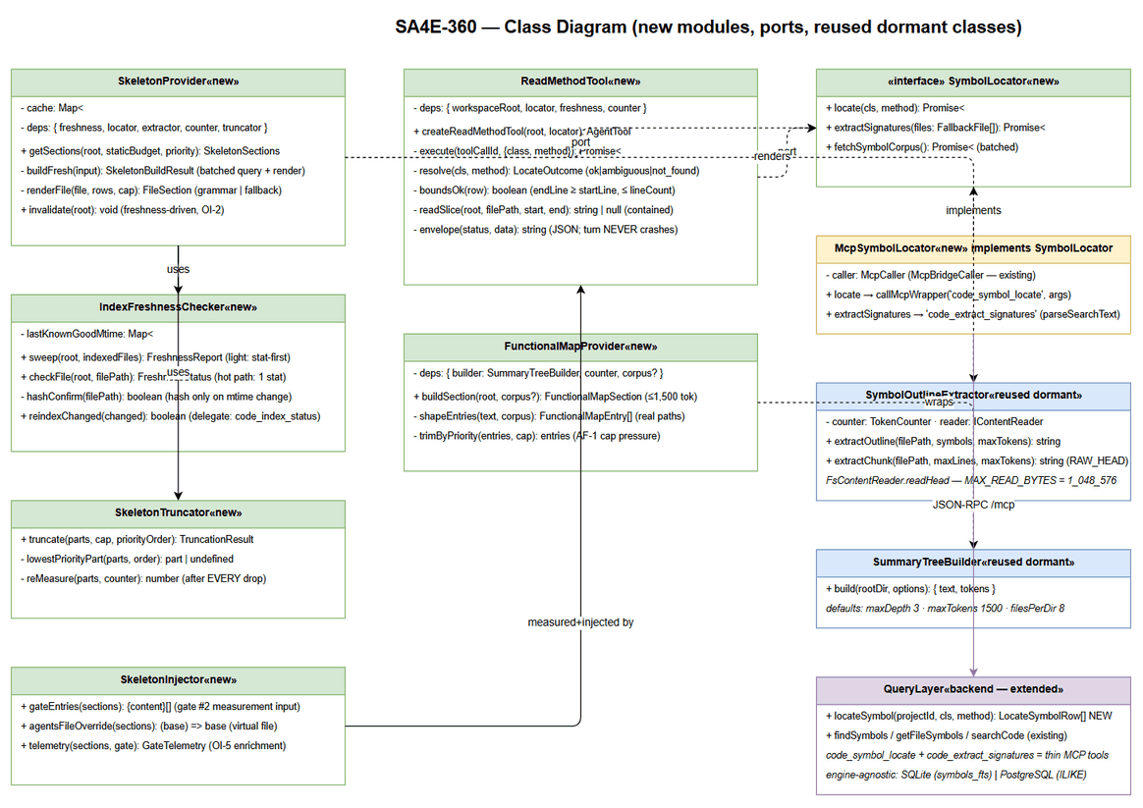 Edit in draw.io

6.2 Key interfaces and classes
/** skeleton-types.ts — data contracts (FSD C-360-S1 shapes). */
export type FallbackMode = 'GRAMMAR' | 'REGEX_SIGNATURES' | 'RAW_HEAD' | 'SKIPPED';
export interface SkeletonBuildInput { workspaceRoot: string; staticBudget: number; modulePriorityOrder: string[]; }
export interface SkeletonBuildResult {
skeletonContent: string; skeletonTokens: number; truncationApplied: boolean;
fallbackFiles: number; skippedFiles: number;
gateDecision: 'PASS' | 'TRUNCATED_PASS' | 'REJECT' | 'DEGRADED_NO_SKELETON';
}
export interface SkeletonSections { skeleton: SkeletonBuildResult; map?: FunctionalMapSection; }
export interface LocateRow { name: string; kind: string; signature?: string; filePath: string;
startLine: number; endLine: number; lineCount: number; parentSymbol?: string | null; }
/** index-freshness-checker.ts — light mtime-first guardrail (FSD §5.4). */
export class IndexFreshnessChecker {
constructor(deps: { reindex: () => Promise<boolean> }); // delegate → code_index_status
sweep(root: string, indexedFiles: ReadonlyArray<IndexedFileInfo>): Promise<FreshnessReport>;
checkFile(root: string, filePath: string): Promise<FreshnessStatus>; // hot path: 1 stat
private hashConfirm(filePath: string): boolean | undefined; // only on mtime change
}
/** symbol-locator.ts — port over the loopback MCP chain (DI seam). */
export interface SymbolLocator { /* §4.6 */ }
export class McpSymbolLocator implements SymbolLocator {
constructor(caller: McpCaller, config?: Partial<RetrievalConfig>); // 2s timeout, 1 retry, backoff 200ms
}
/** skeleton-provider.ts — orchestrates freshness → build → truncate (OI-2 cache). */
export class SkeletonProvider {
constructor(deps: { locator: SymbolLocator; freshness: IndexFreshnessChecker;
extractor: SymbolOutlineExtractor; counter: TokenCounter; truncator: SkeletonTruncator;
fallback: FallbackRunner; mapProvider: FunctionalMapProvider });
getSections(root: string, staticBudget: number, priority: string[]): Promise<SkeletonSections>;
invalidate(root: string): void;
}
/** skeleton-injector.ts — measure==inject composition (C-360-S2). */
export class SkeletonInjector {
gateEntries(sections: SkeletonSections): ReadonlyArray<{ content: string }>;
agentsFileOverride(sections: SkeletonSections): <T extends { path: string; content: string }>(base: { agentsFiles: T[] }) => { agentsFiles: T[] };
telemetry(sections: SkeletonSections, gate: SessionGateResult): SkeletonGateTelemetry; // OI-5
}
/** read-method-tool.ts — C-360-R1/R2 (TypeBox, legacy AgentTool shape). */
export function createReadMethodTool(workspaceRoot: string, locator: SymbolLocator,
freshness: IndexFreshnessChecker): AgentTool;

6.3 Design patterns applied
Pattern | Where | Purpose
Port / Adapter (hexagonal seam) | SymbolLocator ← McpSymbolLocator | Extension logic stays transport-agnostic; tests inject fakes; backend swap (or P2 hybrid) without touching consumers
Facade | SkeletonProvider | Single entry point composing freshness + corpus + render + fallback + truncation (createHost touches ONE module)
Strategy | FallbackRunner ladder (GRAMMAR → REGEX_SIGNATURES → RAW_HEAD → SKIPPED) | Degradation rungs selected per file without branching in the orchestrator (BR-360-03)
Decorator (composition) | SkeletonInjector.agentsFileOverride wraps the existing applyCompressedAgentsFiles composition in createHost | Additive override — shipped overrides untouched (fail-open pattern preserved)
Repository (consumed) | QueryLayer.locateSymbol | Existing data-access seam; NEW method is SQL-only (§4.2)
Cache-aside | SkeletonProvider cache (freshness-keyed) + layoutCache (TTL) | Two lifecycles, two caches (OI-6)

6.4 Wire-point deltas (exact, review-friendly)
File | Delta (minimal, additive)
pi-workflow-adapter.ts | At ensureSessionHost({...}) (L277): add mcpBridge: this.mcpBridge
pi-agent-session-host.ts createHost | After resolveSessionGovernance (L298) and BEFORE runSessionBudgetGate (L325): ① construct locator/checker/provider/injector from opts.mcpBridge (absent → degraded sections); ② const sections = await provider.getSections(workspaceRoot, budget.staticBudget, priority); ③ loadFiles composition gains injector.gateEntries(sections); ④ agentsFilesOverride composes injector.agentsFileOverride(sections) after the existing applyCompressedAgentsFiles; ⑤ customTools (L386-388) gains toSessionToolDefinition(createReadMethodTool(workspaceRoot, locator, checker)); ⑥ getSessionToolLoadout (L71-74) adds 'read_method'; ⑦ post-gate: injector.telemetry(sections, gate) → OI-5 enrichment
workspace-info-tool.ts | layoutCache value type { at, text, map? }; createWorkspaceInfoTool description + details extended; NEW exported getWorkspaceSectionsText(root, mapProvider) shared by tool + assembly path (C-360-M2 AF-3); clearLayoutCache unchanged
pi-workflow-gate.ts | READ_ONLY_TOOLS (L103) += 'read_method'
pi-coding-tools.ts | NO change in P1 (read_method ships on the session path; legacy engine path keeps get_workspace_info steering only — FSD scope §1.2 wires skeleton into session creation)

6.5 Error handling strategy (exception hierarchy)
- Tool boundary (read_method): NEVER throws for domain conditions — all error codes (INVALID_ARGS / NOT_FOUND / AMBIGUOUS / INDEX_STALE / FILE_UNREADABLE / INDEX_UNAVAILABLE) are conveyed inside the JSON envelope (C-360-R2) so the turn continues (FSD §9.1). Only true defects (unexpected throw) surface via the existing tool-failure event path.
- Assembly boundary (skeleton build): per-file errors are SKIPPED (never fatal); index staleness recovers or degrades (DEGRADED_NO_SKELETON); the ONLY REJECT path is the shipped gate #2 throw (PiContextBudgetExceededError) — SA4E-360 never throws budget errors of its own (P-3/P-5).
- Backend tools: fail-soft batch semantics (skipped[]), loopback timeouts bounded (5s wrapper / 2s search), tenant-scoped queries (__projectId injected — SA4E-41).

7. Integration Design

7.1 Loopback query chain (single existing integration — FSD §5.4, verified)
SkeletonProvider / ReadMethodTool (extension host)
→ McpSymbolLocator → McpBridgeCaller.callMcpWrapper(tool, args) (mcp-bridge-caller.ts L13)
→ McpBridge.callTool(name, args) (mcp-bridge.ts L28; 60s outer cap)
→ loopback MCP wrapper POST /mcp (JSON-RPC tools/call)
· loopback-only URL validation (fail-closed) — validateLoopbackWrapperUrl (L171)
· X-Session-Nonce header on every call — SESSION_NONCE_HEADER (L19)
· MCP_WRAPPER_FETCH_TIMEOUT_MS = 5_000 — AbortSignal.timeout (L16)
→ backend tools: code_symbol_locate | code_extract_signatures | code_symbols | code_index_status
Parameter | Value | Source (verified)
Search/tool timeout | searchTimeoutMs = 2,000 ms | DEFAULT_RETRIEVAL_CONFIG (types.ts L72)
Retry | 1 retry after retryBackoffMs = 200 ms | search-provider.ts withRetry (L124-131)
Query cap | MAX_QUERY_CHARS = 4096, fail-closed → RetrievalValidationError | query-router.ts L5; search-provider.ts L159-163
Wrapper timeout | MCP_WRAPPER_FETCH_TIMEOUT_MS = 5,000 ms, loopback-only, per-session nonce | search-provider.ts L16-19, L171-194
Fallback batch | ≤ 50 files per code_extract_signatures call; per-file fail-soft | §4.3
Re-index delegate | code_index_status {reindex:true}; backend checksum-skip makes it changed-files-only | code-index-status.ts L18-23; index-helper.ts L18

7.2 read_method runtime sequence (UC-360-02)
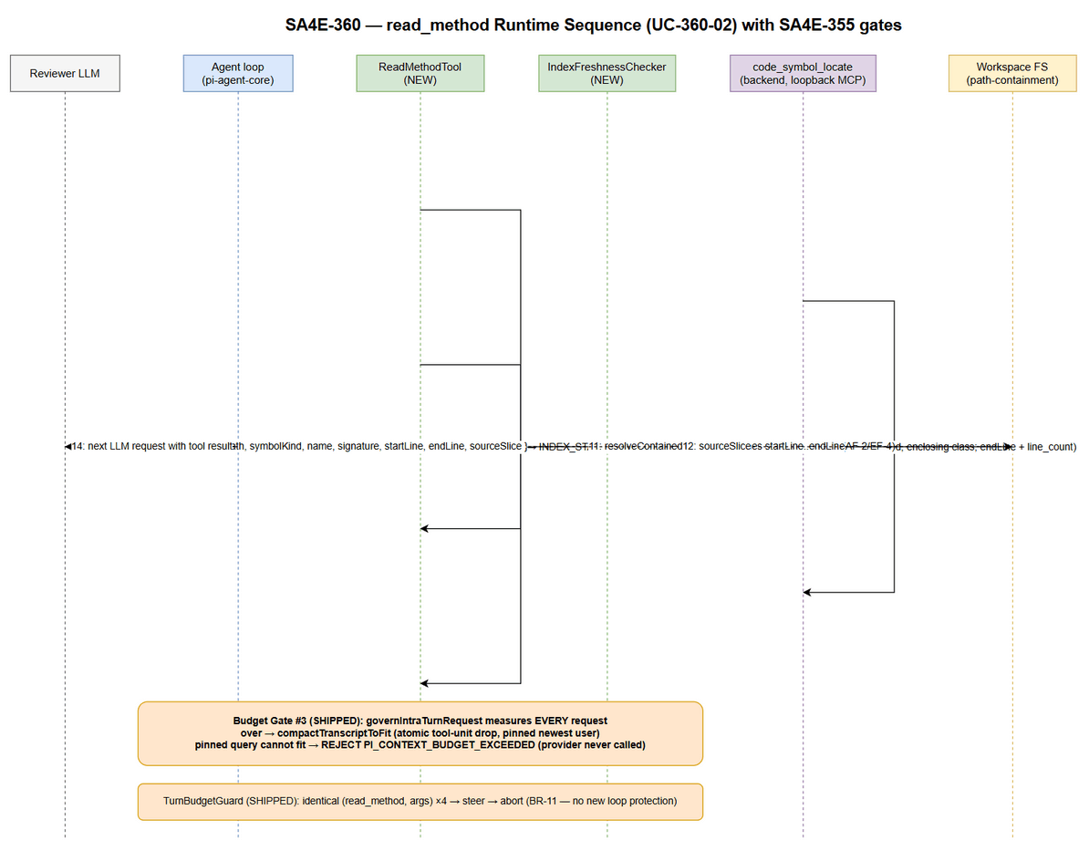 Edit in draw.io
Happy path (with shipped gates): LLM emits read_method(class, method) → validate → locate (Q2) → freshness check (1 stat hot path) → bounds check (index data) → contained slice read (resolveContainedPath → line-range read) → ok envelope → gate #3 measures the result in the NEXT request; over → COMPACT (atomic tool-unit drop, pinned user) → REJECT only if the pinned query cannot fit. Alternate/exception paths per FSD AF-1 (ambiguous), AF-2 (stale → reindex → retry once), AF-3 (TurnBudgetGuard), AF-4 (classMethods enrichment), EF-1..EF-4 (§10).

7.3 Existing FSD diagrams (reused, not duplicated)
Diagram | Source | Covers
System Context | documents/SA4E-360/diagrams/system-context.png (+.drawio) | Two-plane participants + data flows 1-13
Sequence — Happy Path (skeleton) | documents/SA4E-360/diagrams/sequence.png (+.drawio) | UC-360-01 → UC-360-02 assembly + first read
State — Skeleton Lifecycle | documents/SA4E-360/diagrams/state.png (+.drawio) | NOT_BUILT → BUILDING → MEASURED → INJECTED/TRUNCATING → REJECTED; INDEX_STALE recovery; DEGRADED_NO_SKELETON
ER — Index + Artifacts | documents/SA4E-360/diagrams/er-diagram.png (+.drawio) | files/symbols/modules + session artifacts

7.4 Timeout / retry / degradation summary
Failure | Detection | Action | Terminal state
Locate/extract timeout (2s ×2) | McpSearchProvider withRetry | Retry once → give up | read_method: INDEX_UNAVAILABLE steering; skeleton: file SKIPPED / corpus empty → DEGRADED_NO_SKELETON
Wrapper unreachable | McpServerNotRunningError / fetch error | No retry loop (fail fast) | Same as above — turn/session continue
Index stale | stat mtime → hash differ | Re-index changed files → retry ONCE | Recovery; else DEGRADED
Re-index slow | Backend async (checksum-skip bounded) | Extension awaits once; no nested retry | Recovery or DEGRADED
Slice read fails | fs error after containment | Actionable error envelope | Turn continues (EF-2)

8. Security Design
Implements FSD §7 (no new authn/authz surfaces) with concrete mechanisms, all verified in code:
Control | Mechanism | Verified source
Path containment (slices) | read_method resolves EVERY index-derived path via resolveContainedPath(root, path) — realpath canonicalization, \0 rejection, UNC rejection, lexical isWithin + symlink follow-within (SEC-325-D1). Slice reads happen ONLY on contained absolute paths | path-containment.ts L18-64
Path containment (fallback extraction) | Extension sends only corpus/index-derived paths; backend re-verifies containment against its workspace root before reading (defense-in-depth) | §4.3
Read caps | read_method slice = line-range read (startLine..endLine, bounded by index bounds ≤ line_count) — never a whole-file read; FsContentReader.readHead caps RAW_HEAD at MAX_READ_BYTES = 1_048_576 stat-first (SEC-325-D3); backend extraction applies the same 1 MB cap server-side | symbol-outline-extractor.ts L12-27; §4.3
ReDoS guard (regex fallback) | extractSymbols blanks lines > MAX_LINE_LENGTH = 8192 chars before matchAll (condition C2) + per-language bounded patterns; hostile content cannot force unbounded regex scans | signature-extractor.ts L40-51
Loopback-only MCP | validateLoopbackWrapperUrl fail-closed (malformed / remote / non-HTTP(S) rejected — stricter than general backend URL policy); HttpMcpCaller re-validates at construction | search-provider.ts L171-186, L209
Session nonce | X-Session-Nonce header on every wrapper call — anti-replay across sessions | search-provider.ts L19, L192-194, L218
Oversized-query fail-closed | enforceQueryCap (MAX_QUERY_CHARS 4096) before any MCP tool call | search-provider.ts L159-163
No secrets in skeleton output | Skeleton renders kind/name/signature ONLY (no file bodies, no doc comments by default, no env/config content); .env-style files excluded by the index’s own language scoping + isExcludedPath/EXCLUDED_DIRS hygiene in the corpus walk | symbol-outline-extractor.ts L35-48; file-exclusion-filter.ts
Data locality | Source code never leaves the machine: inference is the LOCAL provider (llama-server); backend is loopback; skeleton telemetry logs counts/decisions only (no code content) — error hygiene consistent with gate #2 (TDD-355 §7) | FSD §7.2; budget-gate.ts (counts-only logging)
Approval semantics | read_method registered in READ_ONLY_TOOLS — read-only approval flow (no confirm prompts for reads), consistent with get_workspace_info | pi-workflow-gate.ts L103
Tenant isolation | Backend queries carry injected __projectId scope (SA4E-41) — locate/extract cannot cross tenants | code-symbols.ts L18; query-isolation.test.ts
Audit trail: skeleton gate decision + REJECT + compaction events land in the extension log exactly as shipped (FSD §7.3); SA4E-360 adds the PI_SKELETON_* family + PI_READ_METHOD_RESULT (§11) — all counts/latencies/status, no code bodies.

9. Performance & Scalability

9.1 NFR mapping (FSD §8 → implementation)
NFR (FSD) | Target | Design mechanism | Verification
read_method resolution latency (M4) | p95 ≤ 300 ms FTS5 | One indexed locate query (idx_symbols_name, LIMIT 25) + 1-stat freshness hot path + bounded line-range read; loopback 2s timeout ceiling | TC-360-08
Budget resolution overhead | < 50 ms per session creation | UNCHANGED shipped resolver (in-process, no I/O) | SA4E-355 baseline suite
Skeleton build wall-clock | ≤ 2 s p95 (≤ 2,000-file workspace) | ONE batched corpus query (Q1, prefix buckets) + minority fallback extractions (≤ 50/batch) + renderer pass + single truncation loop (re-measure per drop, O(parts²) worst-case with tiny parts count) | TC-360-01; provider integration test with timing assert (loose CI bound)
Functional map build | ≤ 500 ms p95 | SummaryTreeBuilder walk (maxDepth 3, ≤ 1,500-token bound) + corpus grouping; ONE build per 60s TTL window feeds tool + assembly paths (C-360-M2 AF-3) | TC-360-15/16
Skeleton token share (M6) | ≤ 70% staticBudget, gate-measured | Per-file extractOutline bound = whole cap; truncation loop; gate #2 measures TOTAL static | TC-360-02/04
Zero context overflow (M5) | 0 × exceed_context_size_error | Gates #2/#3 shipped fail-safe (BR-09); provider never called oversized | TC-360-03/19/20
Coverage (M1) | ≥ 95% exported symbols incl. fallback | Grammar path + regex fallback + RAW_HEAD; fallback share reported separately | TC-360-12/13/14
Session artifact memory | ≤ ~114 KB chars @65k worst case + map ≤ ~6 KB | In-memory strings only (cache entries, no disk persistence) | Code review + §5 limits
Governance regression | Baseline 285 files / 2,748 tests green + new | Test-first per task (§12) | TC-360-19

9.2 Scalability notes
- Module-priority truncation scales the skeleton to workspace size (lowest-priority module dropped first, then file-level within modules — FSD §6.1); skeleton > staticBudget persists only as a defect/forced-harness case → REJECT (P3 map-reduce is the future escape hatch, out of scope).
- Freshness sweep is O(files) stats (~2,000 stats ≈ tens of ms) — acceptable per-session; per-call hot path is 1 stat (read_method).
- Corpus query batching: prefix-bucketed code_symbols calls keep each response bounded (limit per call ≤ 200 rows); total ≤ 2s p95 holds for ≤ 2,000-file workspaces per §8; larger workspaces rely on truncation + P3 (documented, not designed here).
- Horizontal scaling: N/A — single-user local IDE extension by design; no shared mutable state beyond the local index.

10. Error Handling (FSD §9.1 — 12 scenarios → implementation mapping)
# | Scenario (FSD) | Severity | Code / Signal | Implementation behavior
1 | Skeleton overflow persisting after truncation | Error | PI_CONTEXT_BUDGET_EXCEEDED (chat:error) | SkeletonTruncator returns gateDecision REJECT → session assembly throws via shipped enforceBudgetGate path; provider NEVER called (BR-360-02/BR-09). Normal-operation unreachable (per-file bounds ≤ cap) — defect/forced-harness case (TC-360-03)
2 | Intra-turn pinned query cannot fit (gate #3) | Error | PI_CONTEXT_BUDGET_EXCEEDED | SHIPPED governIntraTurnRequest REJECT→COMPACT semantics — SA4E-360 adds no code; read_method/map results are ordinary droppable tool units
3 | Index stale | Warning (recoverable) | PI_SKELETON_INDEX_STALE {staleFiles, action} | IndexFreshnessChecker: hash-confirm → re-index changed-only → retry ONCE → FRESH; else DEGRADED (skeleton omitted, agentic steering) — never silently oversize
4 | read_method: symbol not found | Info (actionable) | not_found envelope | Suggestions [get_workspace_info, find_tools, code_search] + AF-4 classMethods (matched class, missing method); turn continues
5 | read_method: ambiguous symbol | Info | ambiguous envelope | Candidates {name, kind, filePath, startLine} — overloads incl. kind-differing rows; NO arbitrary pick
6 | read_method: invalid arguments | Info (actionable) | INVALID_ARGS envelope | Non-empty trim validation + usage hint text; turn continues
7 | read_method: corrupt line bounds | Warning | INDEX_STALE result | endLine < startLine || endLine > lineCount → freshness path (re-index changed → retry once) → resolve or NOT_FOUND; never a silently wrong slice
8 | read_method: unreadable file | Warning | FILE_UNREADABLE envelope | Actionable error text inside the tool result; turn continues
9 | Grammar miss (no tree-sitter grammar) | Info (degradation) | PI_SKELETON_FALLBACK {filePath, language, fallbackMode} | Fallback ladder: REGEX_SIGNATURES (backend tool, empty pattern set → skip pass) → RAW_HEAD (extension-local readHead ≤ 1 MB) → SKIPPED; session NEVER blocked (BR-360-03)
10 | Skeleton overflow first pass | Info (recoverable) | PI_SKELETON_TRUNCATED + truncationApplied=true | Module-priority drop → re-measure per drop → TRUNCATED_PASS or REJECT
11 | Retrieval empty (map build fails) | Warning | PI_FUNCTIONAL_MAP_UNAVAILABLE {workspaceRoot, reason} | Layout-only result (existing behavior byte-identical); per-module failure omits entry (debug, no event); reviewer keeps read_method/find_tools steering
12 | Tool-call loop | Warning | TurnBudgetGuard steer | SHIPPED: identical (tool, args) ×4 → steer correction; persistent → abort; counts read_method like any tool (BR-11 — no new loop protection)
Plus shipped compaction observability (unchanged): PI_LEGACY_HISTORY_COMPACTED (info), PI_TRANSCRIPT_COMPACTED_NO_USER_QUERY (warn) — SA4E-355 TDD §13.7.

11. Monitoring & Observability

11.1 Event inventory (additive — shipped SA4E-355 events unchanged)
Event | Level | Emitter | Payload
PI_SKELETON_BUILT | info | SkeletonProvider | { workspaceRoot, files, symbols, skeletonTokens, staticBudget, fallbackFiles, skippedFiles, gateDecision, durationMs }
PI_SKELETON_TRUNCATED | info | SkeletonTruncator | { skeletonTokensBefore, skeletonTokensAfter, modulesDropped[], staticBudget }
PI_SKELETON_FALLBACK | info | SkeletonProvider (per fallback file) | { filePath, language, fallbackMode }
PI_SKELETON_FILE_SKIPPED | warn | SkeletonProvider (per skip) | { filePath, reason } — never fatal
PI_SKELETON_INDEX_STALE | warn | IndexFreshnessChecker | { staleFiles, action: ‘reindex’ | ‘degrade’ }
PI_FUNCTIONAL_MAP_UNAVAILABLE | warn | FunctionalMapProvider | { workspaceRoot, reason } — full-map failure only (EF-2)
PI_READ_METHOD_RESULT (new, enables M2/M4) | info | ReadMethodTool | { status, durationMs, sliceLines } — counts only, no code
PI_GATE_DECISION (enriched — OI-5) | info | budget-gate.ts L141 (existing emitter) | { decision, usagePercent, staticTokens, escalations } + { skeletonTokens, truncationApplied, measurementPoint }
PI_CONTEXT_BUDGET_EXCEEDED | error | shipped (budget-gate.ts L105 / intra-turn) | { staticTokens, staticBudget, nCtx } — shape unchanged

11.2 Metrics → BRD measurement
Metric | Derivation
M1 coverage ≥ 95% | Diff PI_SKELETON_BUILT symbol counts vs symbols table per module; fallback share from PI_SKELETON_FALLBACK count
M2 hit-rate ≥ 80% | PI_READ_METHOD_RESULT.status === 'ok' ratio on the QA golden query set (indexed-symbol scope — OI-4)
M4 p95 ≤ 300 ms | PI_READ_METHOD_RESULT.durationMs distribution
M5 zero overflow | Absence of provider exceed_context_size_error in the E2E run log
M6 ≤ 70% | PI_GATE_DECISION enriched payload (skeletonTokens/staticBudget)

11.3 Health
No new health endpoint. Backend availability is observable via the existing MCP wrapper (tool call success/latency); extension-side degradation states are logged (events above). QA manual verification per FSD UC-360-05 (turn-1 qwen 32k review; forced-overflow harness; incompressible tool-result case).

12. Implementation Checklist (test-first order)
Ordering rule (ticket constraint): every task is TEST-FIRST and npm test (extension vitest; backend vitest) stays green before the next task starts. Estimated totals: 9 tasks, ~13 files touched, ~70 new tests (12 direct backend + 58 extension incl. integration).
# | Task | Files (create † / modify ‡) | Tests (first) | Est.
T1 | Contracts + truncation core | † skeleton/skeleton-types.ts; † skeleton/skeleton-truncator.ts; † tests/skeleton-truncator.test.ts | Cap enforcement, priority order, termination (strict-shrink proof), re-measure per drop, REJECT unreachable-in-normal-op | 8
T2 | Freshness guardrail | † skeleton/index-freshness-checker.ts; † tests/index-freshness-checker.test.ts | 1-stat hot path, hash-confirm on change, touch-only refresh, reindex retry-once, degrade | 10
T3 | Backend locate (serves C-360-R2) | ‡ backend query/query-layer.ts (+locateSymbol); † backend tools/code-locate.ts; ‡ backend tools/register-tools.ts; † backend tools/tests/code-locate.test.ts | Exact match, enclosing-type scoping (parent_symbol + same-file fallback), overloads→multi-row, classMethods enrichment, tenant isolation, engine-agnostic adapter test | 10
T4 | read_method tool (C-360-R1/R2) | † skeleton/read-method-tool.ts; † skeleton/symbol-locator.ts (port + MCP adapter); † tests/read-method-tool.test.ts | TypeBox validation, ok/ambiguous/not_found envelopes, bounds→INDEX_STALE, contained slice read, FILE_UNREADABLE, INDEX_UNAVAILABLE steering | 12
T5 | Backend fallback extraction (OI-1) | † backend tools/code-extract.ts; ‡ backend tools/register-tools.ts; † backend tools/tests/code-extract.test.ts | extractSymbols wiring, parseSearchText-compatible text, 1 MB cap, containment re-check, fail-soft batch, empty-patterns→[] | 8
T6 | Skeleton provider (build + OI-2 cache) | † skeleton/skeleton-provider.ts; † tests/skeleton-provider.test.ts | Batched corpus render, per-file bound = cap, fallback ladder, per-file skip (EF-3), empty index → DEGRADED_NO_SKELETON (EF-5), fingerprint reuse + invalidation | 10
T7 | Functional map (C-360-M1/M2) | † skeleton/functional-map-provider.ts; ‡ workspace-info-tool.ts (cache value + section + description); † tests/functional-map-provider.test.ts | Map shape (real paths/corpus keySymbols), 1,500-token cap, 16k-char result cap + priority trim, EF-1 omit, EF-2 layout-only + event, 60s cache preserved | 8
T8 | Wiring (measure==inject, gates untouched) | ‡ pi-agent-session-host.ts (§6.4 deltas); ‡ pi-workflow-gate.ts (READ_ONLY_TOOLS); ‡ pi-workflow-adapter.ts (bridge DI); † tests/skeleton-wiring.integration.test.ts | Gate order (measure BEFORE createAgentSession — TC-360-04), measure==inject byte-identical, escalation ladder over skeleton content, OI-5 PI_GATE_DECISION payload, REJECT path (forced oversized — TC-360-03), multi-root cache isolation (OI-3), bridge-absent degradation | 10
T9 | E2E + regression sweep | † tests/skeleton-agentic.e2e.test.ts (session-level, mocked provider) | TC-360-01 happy path @32k (0 × exceed), TC-360-20 intra-turn growth absorbed by gate #3 compaction; full suite green (TC-360-19); manual qwen 32k checklist handoff to QA | 4 + manual
Definition of done per task: file ≤ 200 lines, function ≤ 20 lines, TSDoc on every export, npm test green (extension + backend), governance suites (context-governance, context-budget, budget-gate, session-tier, transcript-compaction) green, no new dependency added (P-1).
Notes for DEV: - T3/T5 are the only backend touches — keep tools THIN (serialization only); any logic temptation belongs to QueryLayer/parsers (BR-11). - The bridge is OPTIONAL DI (§4.6): every consumer must degrade (never crash) when absent — covered by T8 tests. - Reuse toSessionToolDefinition (workspace-info-tool.ts L100) for read_method session shape; mirror its promptSnippet/promptGuidelines style (C-360-R1).

13. Traceability Matrix (FSD → TDD)
FSD element | TDD section | Verification artifact
UC-360-01 (skeleton injection) | §2.2, §4.1, §6.2-6.4, §10-1/3/9/10 | T1/T2/T6/T8; TC-360-01..06
UC-360-02 (read_method) | §4.2, §4.5, §6.2, §7.2, §10-4..8/12 | T3/T4; TC-360-07..11
UC-360-03 (functional map) | §4.4, §5.3, §6.4, §10-11 | T7; TC-360-15..18
UC-360-04 (regex fallback) | §4.3, §6.3 (Strategy), §10-9 | T5; TC-360-12..14
UC-360-05 (governance regression) | §2.2 step 6, §9.1, §12 (per-task gates) | T8/T9; TC-360-03/19/20
BR-360-01 (≤70% cap, measure before create) | §2.2 steps 2/5/6, §6.4 ①-⑦ | T1/T6/T8; TC-360-02/04
BR-360-02 (fail-safe REJECT) | §6.5, §10-1 | T8; TC-360-03
BR-360-03 (fallback never blocks) | §4.3, §10-9 | T5; TC-360-12/13
BR-360-04 (ordinary tool results) | §2.3, §7.2 | T8/T9; TC-360-20
BR-360-05 / BR-11 (reuse, no new engines) | §1.4 P-1, §6.3, DISCREPANCY | Full checklist
C-360-S1..S3 | §4.1 | T1/T6/T8
C-360-R1/R2 | §4.5 | T3/T4
C-360-M1/M2 | §4.4 | T7
C-360-F1 | §4.3 | T5
§5.4 query path + light freshness | §7.1, §5.5 | T2/T4
§6.1 sizing loop / §6.2 disambiguation | §2.2 step 5, §4.2, §7.2 | T1/T3
OI-1..OI-6 | §3 (all resolved) | T3/T5/T6/T7/T8

Appendix A — Diagram Index
# | Diagram | Image (PNG) | Editable Source | Embedded In
1 | Architecture — skeleton supply pipeline + agentic runtime | architecture.png | architecture.drawio | §2.1
2 | Component — module wiring vs SA4E-355 gates | component.png | component.drawio | §2.3
3 | Class Diagram — new modules, ports, reused dormant classes | class-diagram.png | class-diagram.drawio | §6.1
4 | Sequence — read_method runtime (UC-360-02 with gates) | sequence-read-method.png | sequence-read-method.drawio | §7.2
5 | System Context (from FSD, reused) | system-context.png | system-context.drawio | FSD §2.1
6 | Sequence — Happy Path (from FSD, reused) | sequence.png | sequence.drawio | FSD §3.1.2
7 | State — Skeleton Lifecycle (from FSD, reused) | state.png | state.drawio | FSD §6.1
8 | ER — Index + Session Artifacts (from FSD, reused) | er-diagram.png | er-diagram.drawio | FSD §4.1
All diagrams are draw.io sources exported to PNG per project rule (no Mermaid).

End of TDD — SA4E-360 v1.0. Design verified against the codebase 2026-10-13 (file:line citations throughout). OI-1..OI-6 resolved (§3); discrepancies DISC-1..DISC-7 reported in DISCREPANCY.md (0 Critical — no FSD rewrite required; SA decisions documented here are binding for DEV). Next: SM review → QA (STP/STC from §10/§12) → DEV (test-first checklist §12).

