Technical Design Document (TDD)

SA4E-337 — Document Indexer: Fix auto-ingest into KB Memory with correct type/tags

Document Information
Field | Value
Jira Ticket | SA4E-337
Title | Document Indexer: Index khong ingest vao KB Memory + thieu tags
Author | SA Agent
Version | 1.1
Date | 2026-10-05
Status | Final (retroactive — design reflects code as fixed for QA defect SA4E-337-QA-001)
Related BRD | documents/SA4E-337/BRD.md
Related FSD | documents/SA4E-337/FSD.md
Implementation Status | 6/6 bug fixes merged (STATUS.json → phases.implementation = done)
Retroactive notice: this TDD documents the design as implemented. Code verified against backend/src/server/routes/api-index.ts, backend/src/server/routes/api-index-ingest.ts, backend/src/modules/memory/MemoryModule.ts, backend/src/modules/memory/task-queue/TaskWorker.ts, backend/src/modules/memory/dispatchers/crud.ts, extension/src/services/IndexerHttpClient.ts, extension/src/services/DocumentIndexer.ts, extension/src/indexer.ts, extension/src/indexer-discovery.ts on 2026-10-05. Where the implementation deviates from FSD, the deviation is recorded in Section 14 and in documents/SA4E-337/DISCREPANCY.md.
v1.1 update (defect SA4E-337-QA-001): the original v1.0 §6.2 described a call to mem.getDispatcher().dispatch(...) — a method that does not exist on MemoryModule (it only exposes the dispatcher field and setDispatcher()), so POST /api/index/ingest-docs always failed with HTTP 500 (mem.getDispatcher is not a function). This revision corrects §6.2 (and §3.2/§5/§12) to the implemented design: mem.getToolHandlers().get('mem_ingest_file') with the full SA4E-337 args contract, and documents the new backend/src/server/routes/api-index-ingest.ts module (SRP split, per-file isolation, fail-closed summarizeIngestResult()).

Author Tracking
Agent | Role | Output
BA Agent | Requirements | BRD.md v1.0
BA Agent | Specification | FSD.md v1.0
DEV Agent | Implementation | 4 source files modified (6 bug fixes)
SA Agent | Design | TDD.md v1.0 (this document) + diagrams/architecture + diagrams/component + diagrams/class-diagram

Revision History
Version | Date | Author | Changes
1.0 | 2026-10-05 | SA Agent | Initial TDD (retroactive). Architecture, API, data model, class design, security, E2E test architecture for the 6 bug fixes.
1.1 | 2026-10-05 | SA Agent | Fix §6.2 design mismatch after defect SA4E-337-QA-001: mem.getDispatcher().dispatch(...) (nonexistent method → HTTP 500) replaced by mem.getToolHandlers().get('mem_ingest_file') with full args (type, tags, scope, _projectContext, __userId, __projectId). Document new api-index-ingest.ts module (§1.2, §2.2, §5.1, §5.2, §5.3), fail-closed summarizeIngestResult() verification (§3.2, §5.4, §12), updated diagrams.

1. Introduction

1.1 Purpose
The Document Indexer discovered 1727 workspace files but produced only 3 KB Memory entries. Root cause (from STATUS.json → bugfix.rootCause): handleIngestDocsFromTemp hardcoded type = CONTEXT, passed no tags, and never verified the ingest result. This TDD specifies the technical design of the fix — how document type derivation, tag extraction, ingest verification, .drawio support, fallback tag extraction, and UI result display are implemented across the VS Code extension and the Hono backend.
A subsequent QA defect (SA4E-337-QA-001, found after the initial fix merged) showed the route’s memory-module entry point mem.getDispatcher() does not exist on MemoryModule, so /api/index/ingest-docs returned HTTP 500 for every call — none of the 6 bug fixes were reachable. Version 1.1 of this TDD corrects §6.2 to the implemented design (mem.getToolHandlers().get('mem_ingest_file')) and documents the refactored ingest module backend/src/server/routes/api-index-ingest.ts.

1.2 Scope
In scope:
Bug | Fix | Primary file
#1 | Type derivation inferTypeFromPath() | backend/src/server/routes/api-index-ingest.ts
#2 | Tag extraction extractTagsFromPath() | backend/src/server/routes/api-index-ingest.ts
#3 | Ingest result verification (JSON parse) | extension/src/services/IndexerHttpClient.ts
#4 | .drawio inclusion in ingest walk (isIngestableFile() / collectIngestFiles()) | backend/src/server/routes/api-index-ingest.ts
#5 | Fallback tag extraction (LLM unavailable) | backend/src/modules/memory/task-queue/TaskWorker.ts
#6 | UI result display showIndexResults() | extension/src/indexer.ts
QA-001 | Memory-module entry point: getToolHandlers().get('mem_ingest_file') instead of nonexistent getDispatcher() (HTTP 500 → fixed) | backend/src/server/routes/api-index.ts + api-index-ingest.ts
Out of scope: backend Knowledge Service API redesign (SA4E-85); Pega rule indexing (SA4E-230); Jira ticket indexing pipeline; refactoring unrelated to the index/ingest flow; new DB migrations (no schema change — see Section 4).

1.3 Technology Stack
Layer | Technology | Evidence
Extension | TypeScript, VS Code extension API (OutputChannel, QuickPick, window.showInformationMessage) | extension/src/indexer.ts
HTTP client | Native fetch + AbortSignal.timeout, singleton OutputChannel | IndexerHttpClient.ts
Backend | Hono routes on Node, pino logger | backend/src/server/routes/api-index.ts
Memory module | ModuleRegistry → getToolHandlers().get('mem_ingest_file') (decorated: withErrorHandling(withScopeContext(withResultFormat(...)))) → MemoryEngine.insert() | MemoryModule.ts, dispatchers/crud.ts
Async enrichment | pending_tasks queue polled by TaskWorker (first poll delayed 6 s) | TaskWorker.ts
Storage | SQLite (WAL) .code-intel/knowledge.db, knex migrations, FTS5 | migrations/000-init-system-tables.cjs
Tests | vitest (unit + integration + e2e), in-repo sa4e-testkit | backend/tests/, extension/src/__tests__/

1.4 Design Principles
- Derive at the server, once — KB type and tags are derived in handleIngestDocsFromTemp from the canonical temp path; the client-sent DocEntry.type is not trusted for persistence (single source of truth).
- Two-phase staging (SA4E-99) — write phase (POST /api/index/documents) and ingest phase (POST /api/index/ingest-docs) are separate: the backend ingests each temp file exactly once after all batches are written (no per-file KB write during batching).
- Fail-safe defaults, never fail the run — unknown filename → CONTEXT (BR-02); LLM absent → heuristic fallback tags (Bug #5); JSON parse failure → treated as failure but indexing continues.
- Reuse existing security infra — session auth, KB_WRITE RBAC, JWT project binding, path sanitizer: no new framework (SA4E-300 pattern).
- No new dependencies — all fixes are pure TypeScript within existing modules.

1.5 Constraints
- mem_ingest_file tool schema exposes only { file_path, content_base64, type } — tags and scope are passed by the route but handleIngestFile ignores a.tags and persists tags = '' (Section 4.3, Section 14 DISC-2). Tags materialize asynchronously via TAG_ENRICHMENT / fallbackTagExtraction.
- Only supported entry point into the memory module for routes is MemoryModule.getToolHandlers() (returns Map<string, ToolHandler>; each handler is decorated with withErrorHandling → withScopeContext → withResultFormat). MemoryModule exposes no getDispatcher() method — calling it throws TypeError → HTTP 500 (defect SA4E-337-QA-001, see §6.2). Calling the bare mem.dispatcher.dispatch() instead would skip withScopeContext() and write project_id = NULL (tenant leak) — also forbidden.
- Retroactive document: code is already merged; design must match code, not the other way around.
- FSD Section 3.1.6/5.1 API contract (POST /api/v1/ingestDocuments) does not exist in the codebase — the real endpoints are /api/index/documents + /api/index/ingest-docs (Section 14 DISC-1).

1.6 References
Ref | Document / File
BRD | documents/SA4E-337/BRD.md (6 stories, §2.3)
FSD | documents/SA4E-337/FSD.md (UC-01..UC-06, BR-01..BR-28)
STATUS | documents/SA4E-337/STATUS.json
Backend route | backend/src/server/routes/api-index.ts
Ingest helpers (QA-001) | backend/src/server/routes/api-index-ingest.ts
Memory module tool handlers | backend/src/modules/memory/MemoryModule.ts (getToolHandlers())
Memory dispatcher | backend/src/modules/memory/dispatchers/crud.ts
Task worker | backend/src/modules/memory/task-queue/TaskWorker.ts
HTTP client | extension/src/services/IndexerHttpClient.ts
Document runner | extension/src/services/DocumentIndexer.ts
Discovery | extension/src/indexer-discovery.ts
UI | extension/src/indexer.ts
Schema | backend/src/database/migrations/000-init-system-tables.cjs
Code intelligence | .analysis/code-intelligence/project-structure.md

2. System Architecture

2.1 Architecture Overview
The fix spans two processes — the VS Code / Kiro extension (client) and the backend Hono server (owner of KB Memory). The index flow is a two-phase pipeline: staged write then single-pass KB ingest, followed by asynchronous tag enrichment.
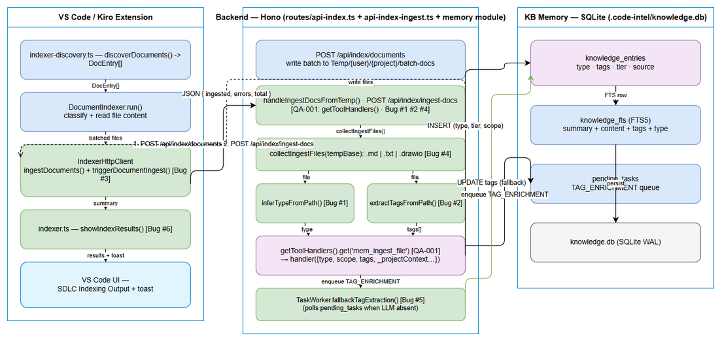 Edit in draw.io
Data flow (FSD §2.2, as implemented):
Workspace Scan → File Classification → Staged Temp Write → (server) Type Derivation
→ Tag Extraction → mem_ingest_file (scoped tool handler) → pending_tasks TAG_ENRICHMENT
→ Result JSON → UI Display

2.2 Component Diagram
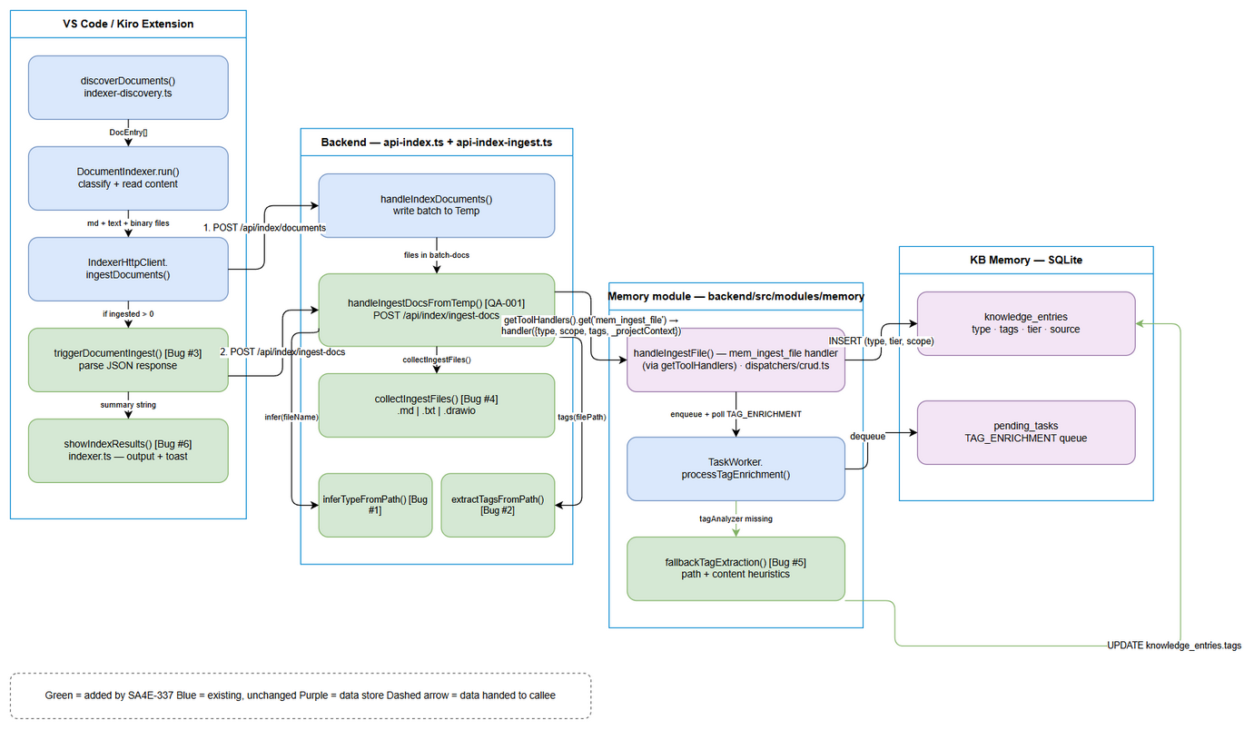 Edit in draw.io
Component | Location | Responsibility | Bug
discoverDocuments() | extension/src/indexer-discovery.ts | BFS scan of documents/, denylist, DOCUMENT_TYPES classification, ticket label | —
DocumentIndexer.run() | extension/src/services/DocumentIndexer.ts | Split markdown/text (read locally) vs binary (server convert), build summary | —
IndexerHttpClient.ingestDocuments() | extension/src/services/IndexerHttpClient.ts | Batched temp write (20/batch, 200 ms pause, retry 3→2), then trigger KB ingest | #3
triggerDocumentIngest() | extension/src/services/IndexerHttpClient.ts | POST /api/index/ingest-docs, JSON.parse → { ingested, errors, total } | #3
handleIndexDocuments() | backend/src/server/routes/api-index.ts | Write batch to Temp/{user}/{project}/batch-docs/ via resolveSafeTargetPath | —
handleIngestDocsFromTemp() | backend/src/server/routes/api-index.ts | Resolve scoped mem_ingest_file handler via getToolHandlers() (QA-001; missing/not-ready → 503) → delegate to ingestFilesFromTemp() → { ingested, errors, total, failedFiles } | #1 #2 #4 QA-001
inferTypeFromPath() | backend/src/server/routes/api-index-ingest.ts | Regex on basename → REQUIREMENT / ARCHITECTURE / PROCEDURE / CONTEXT | #1
extractTagsFromPath() | backend/src/server/routes/api-index-ingest.ts | Path segments → sa4e, sa4e-337, feature, f3… | #2
isIngestableFile() / collectIngestFiles() | backend/src/server/routes/api-index-ingest.ts | .md / .txt / .drawio filter + recursive temp walk (single pass) | #4
buildIngestFileArgs() | backend/src/server/routes/api-index-ingest.ts | Handler args: { file_path, content_base64, type, scope: 'PROJECT', tags, _projectContext, __userId, __projectId } (tenant scope keys — QA-001) | QA-001
summarizeIngestResult() | backend/src/server/routes/api-index-ingest.ts | Fail-closed verdict on each handler result (5 branches: isError / empty / Error: / JSON status≠ingested / ok) — prevents ingested++ on failures | QA-001
ingestOneFile() / ingestFilesFromTemp() | backend/src/server/routes/api-index-ingest.ts | Per-file isolation: read → handler → verify → count; one bad file never aborts the run | QA-001
handleIngestFile() | backend/src/modules/memory/dispatchers/crud.ts | UPSERT entry (type, tier, scope, source), tags='', enqueue enrichment | —
processTagEnrichment() | backend/src/modules/memory/task-queue/TaskWorker.ts | LLM tag analysis when tagAnalyzer available, else fallback | #5
fallbackTagExtraction() | backend/src/modules/memory/task-queue/TaskWorker.ts | Path + content heuristics → UPDATE knowledge_entries.tags | #5
showIndexResults() / describeSummaryTitle() | extension/src/indexer.ts | Summary title per selected ops, results + next steps, toast with “Open Output” | #6

2.3 Deployment Architecture
No deployment change. Both processes run on the developer machine:
- Backend: Node/Hono service, default http://127.0.0.1:48721 (extension/src/config/backend-url.ts → DEFAULT_BACKEND_URL), overridable via backend.url setting.
- Extension: VS Code/Kiro extension host; talks to backend over HTTP with Bearer session/JWT.
- Storage: single SQLite file .code-intel/knowledge.db (WAL) shared by backend routes, dispatcher and TaskWorker. PostgreSQL (pg) remains an alternative adapter; nothing in this fix is engine-specific (all SQL goes through the adapter).
- Temp staging: {indexTempDir}/{userId}/{projectId}/batch-docs/ where indexTempDir = CODE_INTEL_INDEX_TEMP_DIR or os.tmpdir()/CodeIntel.

2.4 Communication Patterns & End-to-End Request Flow
- Sync: extension → backend REST/JSON — one round-trip per batch write + one round-trip for ingest (AbortSignal.timeout(60000) on the ingest trigger).
- Async: backend → pending_tasks queue; TaskWorker polls (first poll delayed 6 s to allow LLM health-check / setTagAnalyzer), executes TAG_ENRICHMENT (LLM) or fallback, then UPDATE knowledge_entries SET tags = ?.
- Backpressure: INDEX_CONCURRENCY_LIMIT = 3 returns 429 — enforced on POST /api/index/source only (Section 3.3).
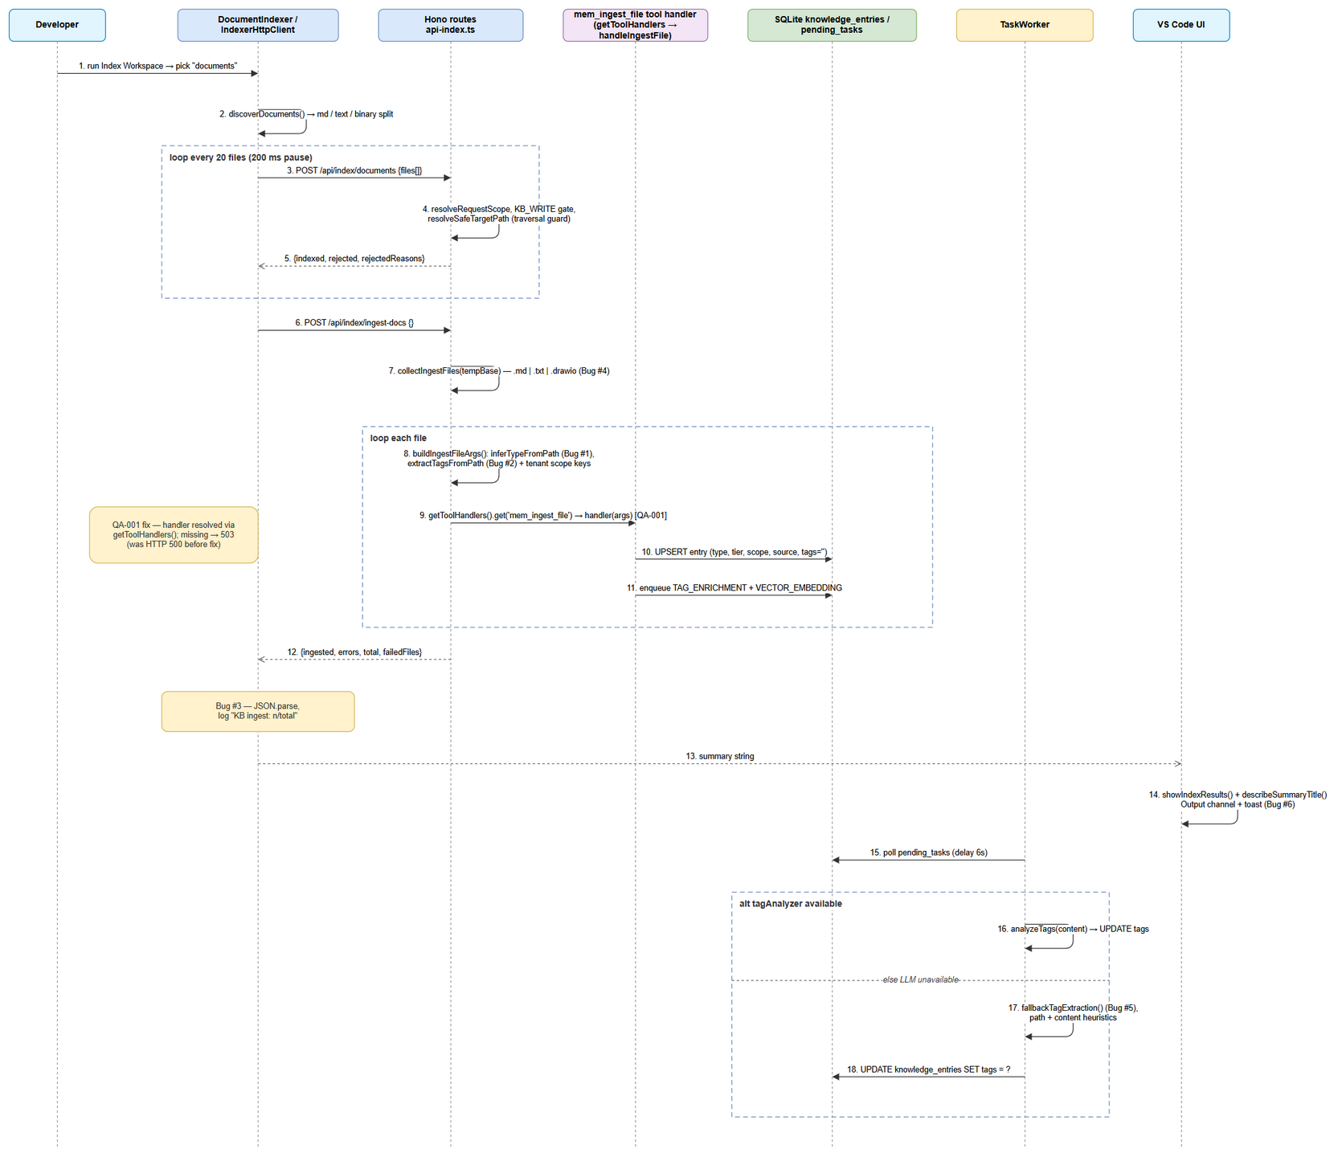 Edit in draw.io

3. API Design
FSD contract vs reality: FSD §3.1.6/§5.1 specifies POST /api/v1/ingestDocuments. That endpoint does not exist. The implemented contract is two endpoints under /api/index/* (see mapping in Section 3.4 and DISC-1 in Section 14). This section documents the actual contract verified in api-index.ts.

3.1 POST /api/index/documents — staged write (batch)
Writes file contents into the per-user/per-project temp staging area. It does not touch KB.
Headers
Header | Required | Value
Authorization | Yes | Bearer <session-or-JWT-token>
X-Project-Id | Yes | project id (fail-closed if missing → 400 PROJECT_REQUIRED)
X-Workspace-Root | No | display/scan hint only — never identity
Content-Type | Yes | application/json
Request body
{
"files": [
{
"path": "documents/SA4E-337/BRD.md",
"content": "# Functional Specification Document (FSD)
..."
}
]
}
Field | Type | Required | Validation
files | SourceFile[] | Yes | must be an array (400 otherwise)
files[].path | string | Yes | relative path; resolveSafeTargetPath() rejects absolute paths, drive letters, .., null bytes, URI-encoded traversal; result must stay inside tempBase
files[].content | string | Yes | UTF-8 text (binary docs arrive as converted text or are listed without content)
Success response — 200
{
"indexed": 150,
"rejected": [],
"rejectedReasons": []
}
Field | Type | Description
indexed | number | files written to batch-docs/
rejected | string[] | unsafe path values refused
rejectedReasons | {file, code, message}[] | EACCES for traversal, OS error codes for I/O failures
Error responses (standard envelope { error, details, action })
Status | error | Trigger
400 | files array required | body missing/not array
400 | X-Project-Id required for indexing | missing X-Project-Id (indexError maps PROJECT_REQUIRED)
401 | Unauthorized | missing/invalid Bearer token (requireAuth → validateSession)
403 | Forbidden | principal lacks KB_WRITE, or JWT project outside grant (verifyIndexProjectBinding)
500 | Internal error / Disk full / Permission denied | write failure (indexError maps ENOSPC/EACCES)
Example (rejected traversal)
{
"indexed": 3,
"rejected": ["../../etc/passwd"],
"rejectedReasons": [
{ "file": "../../etc/passwd", "code": "EACCES",
"message": "Unsafe path: must be a relative path staying within the temp directory" }
]
}

3.2 POST /api/index/ingest-docs — KB ingest from temp (single pass)
Headers: same as §3.1 (Authorization, X-Project-Id required). Body: {} (empty JSON object — all inputs are server-side).
Processing (server):
- resolveRequestScope(c) → requireProjectId (fail-closed).
- requireIndexPermission(c, userId, 'KB_WRITE') + verifyIndexProjectBinding.
- resolveIndexTempBase(userId, projectId, 'batch-docs'); if missing → early return.
- collectIngestFiles(tempBase) collecting *.md | *.txt | *.drawio (Bug #4, isIngestableFile).
- Resolve the memory-module tool handler (QA-001): const mem = registry.getModule('memory') (typed IModule, no any) → status must be ready else 503 → const ingestHandler = mem.getToolHandlers().get('mem_ingest_file') → handler absent → 503 { details: 'mem_ingest_file tool handler is unavailable' }. (The previous mem.getDispatcher().dispatch(...) call referenced a nonexistent method — HTTP 500 on every request; see §6.2.)
- ingestFilesFromTemp(files, tempBase, ingestHandler, tenant, logger) — per file: inferTypeFromPath(filePath) (Bug #1) + extractTagsFromPath(filePath) (Bug #2) → buildIngestFileArgs() → handler({ file_path, content_base64, type, scope: 'PROJECT', tags: tags.join(','), _projectContext: { userId, projectId }, __userId, __projectId }) (tenant scope keys are required — withScopeContext() prefers _projectContext, canonical fallback __userId/__projectId).
- summarizeIngestResult(result) verifies the result before counting: the decorated handler chain (withErrorHandling → withScopeContext → withResultFormat) never throws — failures surface as { isError: true }, a "Error: ..." string, or JSON { status: 'unconvertible' | ... } → classified as failure (fail-closed, empty = failure).
- Aggregate { ingested, errors, total, failedFiles } (per-file isolation — one bad file never aborts the run).
Success response — 200
{
"ingested": 150,
"errors": 2,
"total": 152,
"failedFiles": [
{ "file": "SA4E-337/attachments/spec.pdf", "reason": "no-tool" }
]
}
Empty staging area (not an error):
{ "ingested": 0, "message": "No documents in Temp folder" }
Error responses
Status | error | Trigger
400 | X-Project-Id required for indexing | missing project identity
401 | Unauthorized | no/invalid Bearer token
403 | Forbidden | missing KB_WRITE or project outside JWT grant
503 | Memory module not ready | memory module status ≠ ready, or getToolHandlers() map has no mem_ingest_file entry (details: 'mem_ingest_file tool handler is unavailable')
500 | Error ingesting documents from Temp | unexpected exception (indexError)
Type derivation rules (Bug #1 — inferTypeFromPath, uppercased basename, regex prefix):
Pattern (basename, uppercased) | Type
^BRD, ^FSD | REQUIREMENT
^TDD | ARCHITECTURE
^STP\|^STC\|^DPG\|^RLN\|^UG\|^RUN-LOG | PROCEDURE
everything else (incl. .drawio, meeting-notes.md) | CONTEXT
Tag extraction rules (Bug #2 — extractTagsFromPath, path segments, \ → /):
Segment pattern | Tags added
^SA4E-\d+$ (case-insensitive) | sa4e, lowercased key (e.g. sa4e-337)
^F\d+$ (case-insensitive) | feature, lowercased key (e.g. f3)
no match | [] — server passes empty list; final tags come from TAG_ENRICHMENT / fallbackTagExtraction (§4.3)
Example: Temp/{u}/{p}/batch-docs/documents/SA4E-337/BRD.md → tags sa4e, sa4e-337.

3.3 Cross-cutting API behaviour
Concern | Behaviour
Auth | Every /api/index/* route: requireAuth → opaque session via validateSession, else 401 {error, details, action}
Authorization | getUserPermissions(userId) must include KB_WRITE (fail-closed on DB error → 403)
Tenant binding | verifyJwtToken + allowedProjectsFromClaims: opaque session tokens carry no per-project grant (global gate only, documented PO risk-accept); JWT principals must have pid/pids covering X-Project-Id
Rate limiting | INDEX_CONCURRENCY_LIMIT = 3 → 429 {error:'Server busy', retryAfter: 2} — enforced only on POST /api/index/source; /documents and /ingest-docs rely on the client’s single-flight sequencing (Section 8.4)
Error envelope | always { error: string, details: string, action: string }; details truncated to 2000 chars
Pagination | none (batch-oriented, not resource-oriented)
Idempotency | re-running ingest is safe: handleIngestFile deletes prior entries/graph nodes/tasks with the same source (+ project_id) before inserting (SA4E-163 UNIQUE(source, project_id) UPSERT)

3.4 FSD contract mapping
FSD (§3.1.6, §5.1) | Implemented | Note
POST /api/v1/ingestDocuments | POST /api/index/documents then POST /api/index/ingest-docs | DISC-1
docs[] with path, type, tags, relativePath | files[] with path, content only — type/tags derived server-side | DISC-6
response { success, ingested, converted, skipped, unconvertible } | write {indexed, rejected, rejectedReasons} + ingest {ingested, errors, total, failedFiles} | DISC-1
client verifies JSON (BR-12) | triggerDocumentIngest() parses JSON, logs KB ingest: n/total, e errors, returns zeros on failure | Bug #3 ✅

4. Database Design

4.1 Change Impact: none
SA4E-337 introduces no new tables, columns, or indexes and requires no migration. The fix writes into the existing KB schema; deployment Section 10.4 confirms zero migration steps.

4.2 Existing tables used (actual DDL, 000-init-system-tables.cjs)
CREATE TABLE IF NOT EXISTS knowledge_entries (
id INTEGER PRIMARY KEY AUTOINCREMENT,
content TEXT NOT NULL,
summary TEXT NOT NULL,
type TEXT NOT NULL, -- Bug #1 target: REQUIREMENT|ARCHITECTURE|PROCEDURE|CONTEXT
tier TEXT NOT NULL DEFAULT 'WORKING', -- derived: tierForType(type)
scope TEXT NOT NULL DEFAULT 'USER', -- ingest path forces 'PROJECT'
user_id TEXT DEFAULT NULL,
project_id TEXT DEFAULT NULL, -- from X-Project-Id (tenant binding)
source TEXT, -- temp file path — idempotency key
source_ref TEXT,
tags TEXT NOT NULL DEFAULT '', -- Bug #2/#5 target: comma-separated list
confidence REAL NOT NULL DEFAULT 1.0,
access_count INTEGER NOT NULL DEFAULT 0,
created_at TEXT NOT NULL DEFAULT (datetime('now')),
updated_at TEXT NOT NULL DEFAULT (datetime('now')),
last_accessed_at TEXT,
expires_at TEXT,
pinned INTEGER NOT NULL DEFAULT 0,
pin_order INTEGER NOT NULL DEFAULT 0,
structured_map TEXT NOT NULL DEFAULT '{}',
quality_score INTEGER DEFAULT NULL,
archived INTEGER NOT NULL DEFAULT 0,
agent_name TEXT DEFAULT NULL,
owner TEXT DEFAULT NULL,
needs_verification INTEGER NOT NULL DEFAULT 0,
epoch_id TEXT DEFAULT NULL,
superseded_by INTEGER DEFAULT NULL
);
CREATE VIRTUAL TABLE IF NOT EXISTS knowledge_fts USING fts5(
summary, content, tags, type,
content=knowledge_entries, content_rowid=id,
tokenize='porter unicode61'
);
-- triggers knowledge_fts_ai / _ad / _au keep FTS in sync on INSERT/DELETE/UPDATE
-- (UPDATE tags by TaskWorker therefore refreshes the tags FTS column automatically)
CREATE TABLE IF NOT EXISTS pending_tasks (
id INTEGER PRIMARY KEY,
task_type TEXT NOT NULL, -- 'TAG_ENRICHMENT' | 'VECTOR_EMBEDDING'
entry_id INTEGER NOT NULL,
status TEXT NOT NULL DEFAULT 'pending', -- pending → running → completed | failed
payload TEXT NOT NULL, -- { entry_id, content, existing_tags, options }
error TEXT, error_message TEXT,
retry_count INTEGER NOT NULL DEFAULT 0,
max_retries INTEGER NOT NULL DEFAULT 3,
priority INTEGER NOT NULL DEFAULT 5,
created_at TEXT NOT NULL DEFAULT (datetime('now')),
started_at, completed_at, updated_at, claimed_at, dead_lettered_at TEXT,
FOREIGN KEY (entry_id) REFERENCES knowledge_entries(id) ON DELETE CASCADE
);
CREATE INDEX IF NOT EXISTS idx_pending_tasks_status_created ON pending_tasks(status, created_at);
CREATE INDEX IF NOT EXISTS idx_pending_tasks_entry_id ON pending_tasks(entry_id);

4.3 Write paths exercised by this fix
Step | Statement | Location
Ingest | engine.insert({ content, summary, type, tier: tierForType(type), scope, user_id, project_id, source: filePath, tags: '' }) — UPSERT on UNIQUE(source, project_id) | crud.ts → handleIngestFile
Mark pending | UPDATE knowledge_entries SET enrichment_status = 'pending' WHERE id = ? | handleIngestFile
Enqueue | INSERT pending_tasks (TAG_ENRICHMENT, payload {existing_tags: ''}) + optional VECTOR_EMBEDDING | handleIngestFile
Tags (LLM) | UPDATE knowledge_entries SET tags = ? WHERE id = ? AND enrichment_status = 'pending' | TaskWorker.processTagEnrichment
Tags (fallback, Bug #5) | UPDATE knowledge_entries SET tags = ? WHERE id = ? (merges existing_tags + derived) | TaskWorker.fallbackTagExtraction
⚠️ Design fact: the tags argument computed by buildIngestFileArgs() (extractTagsFromPath(...).join(','), sent by handleIngestDocsFromTemp) is dropped in handleIngestFile (tags: '' at insert). Effective tags therefore always come from the async enrichment step — LLM analysis of content, or the path/content heuristics of fallbackTagExtraction (which reads payload.source = temp path, preserving SA4E-* / doc-type tags). See DISC-2.
tierForType() mapping (dispatchers/helpers.ts): REQUIREMENT | ARCHITECTURE | PROCEDURE | API_DESIGN → SEMANTIC; DECISION | LESSON_LEARNED | ERROR_PATTERN → EPISODIC; else WORKING.

4.4 Query patterns
# | Pattern | Plan notes
Q1 | UPSERT by source (+ project_id) | backed by the SA4E-163 uniqueness on (source, project_id) — one row per file; re-ingest replaces content instead of duplicating
Q2 | UPDATE knowledge_entries SET tags = ? WHERE id = ? (PK lookup) | O(1); triggers knowledge_fts_au → tags searchable via FTS immediately
Q3 | SELECT ... FROM pending_tasks WHERE status = 'pending' ORDER BY created_at | covered by idx_pending_tasks_status_created
Q4 | FTS search knowledge_fts(tags, type, ...) | refreshed by triggers — no manual reindex
Q5 | Stale cleanup DELETE FROM knowledge_entries WHERE source = ? [AND project_id = ?] before insert | graph nodes + stale pending_tasks deleted first (FK ordering, D3 fix)

4.5 Data volume
Metric | Estimate
Files discovered per workspace run | ~1727 (BRD baseline)
knowledge_entries growth | ≈1 row per indexable file (deduped by source)
pending_tasks peak | 2 tasks/entry (TAG_ENRICHMENT + VECTOR_EMBEDDING), drained by worker poll
FTS rows | 1:1 with entries, maintained by triggers

4.6 Entity lifecycle (KB entry enrichment)
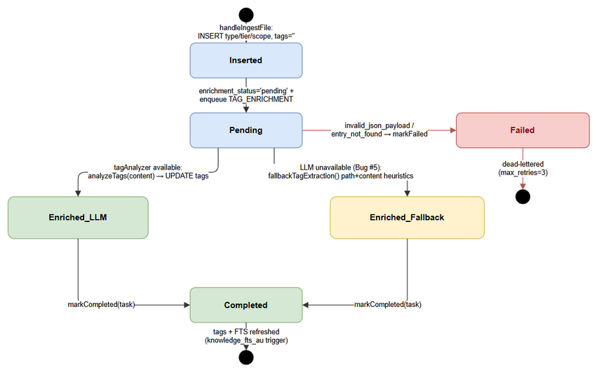 Edit in draw.io

5. Class / Module Design

5.1 Package Structure (files touched by SA4E-337)
extension/src/
├── indexer-discovery.ts # discoverDocuments(), DOCUMENT_TYPES, INDEXABLE_EXTENSIONS (unchanged)
├── indexer.ts # [Bug #6] showIndexResults(), describeSummaryTitle()
└── services/
├── DocumentIndexer.ts # run(), readTextDocs(), buildSummary() (unchanged)
└── IndexerHttpClient.ts # [Bug #3] ingestDocuments(), triggerDocumentIngest()
backend/src/
├── server/routes/
│ ├── api-index.ts # [QA-001] handleIngestDocsFromTemp (route wiring: resolve
│ │ # getToolHandlers().get('mem_ingest_file') + 503 guards,
│ │ # delegate to ingestFilesFromTemp), handleIndexDocuments,
│ │ # writeFilesPhase, resolveIndexTempBase, resolveSafeTargetPath,
│ │ # sanitizePathSegment, registerIndexRoutes, indexError
│ ├── api-index-ingest.ts # [NEW — Bug #1 #2 #4 + QA-001, SRP split, ~190 LOC]
│ │ # inferTypeFromPath, extractTagsFromPath, isIngestableFile,
│ │ # collectIngestFiles, buildIngestFileArgs,
│ │ # summarizeIngestResult, ingestOneFile, ingestFilesFromTemp,
│ │ # IngestTenant, IngestOutcome
│ └── __tests__/api-index-errors.test.ts # auth/path unit tests + QA-001 root-cause guard
│ # (mock MemoryModule deliberately has NO getDispatcher)
└── modules/memory/
├── MemoryModule.ts # getToolHandlers() — withErrorHandling(withScopeContext(
│ # withResultFormat(dispatch))) ← QA-001 entry point
├── dispatchers/crud.ts # handleIngestFile() (consumes type/scope; ignores tags)
├── dispatchers/helpers.ts # tierForType(), inferOwner(), resolvePath()
└── task-queue/TaskWorker.ts # [Bug #5] processTagEnrichment(), fallbackTagExtraction()

5.2 Key Interfaces (actual TypeScript)
// extension/src/services/IndexerHttpClient.ts
export interface DocEntry {
path: string; // relative path e.g. documents/SA4E-337/BRD.md
type: string; // classified client-side (server re-derives on ingest)
ticket: string; // folder label (e.g. SA4E-337 / documents / GRAPH-EMAIL)
format?: string; // 'markdown' | 'text' | extension-derived
content?: string; // loaded for md/text; undefined for binary (server converts)
}
export interface FileEntry { path: string; content: string; } // /api/index/documents body
export interface UnconvertibleEntry { file: string; reason: string; }
export interface IngestResult {
ingested: number;
errors: number;
summary: string; // "✅ Indexed: n files, 📚 KB: n ingested"
unconvertible: UnconvertibleEntry[];
}
// extension/src/services/IndexerHttpClient.ts (Bug #3 — actual return)
private async triggerDocumentIngest(token?: string):
Promise<{ ingested: number; errors: number; total: number }>
// backend/src/server/routes/api-index-ingest.ts (pure helpers — Bug #1/#2/#4 + QA-001)
export interface IngestTenant { userId: string; projectId: string; }
export interface IngestOutcome {
ingested: number; errors: number; total: number;
failedFiles: { file: string; reason: string }[];
}
export function inferTypeFromPath(filePath: string): string
export function extractTagsFromPath(filePath: string): string[]
export function isIngestableFile(fileName: string): boolean
export function collectIngestFiles(tempBase: string): string[]
export function buildIngestFileArgs(filePath: string, content: string,
tenant: IngestTenant): Record<string, unknown>
export function summarizeIngestResult(result: ToolResult | null | undefined):
{ ok: boolean; reason: string } // fail-closed, 5 branches
export async function ingestFilesFromTemp(files: string[], tempBase: string,
handler: ToolHandler, tenant: IngestTenant, logger: Logger): Promise<IngestOutcome>
// backend/src/server/routes/api-index.ts (route wiring — QA-001 fix)
// const mem = registry.getModule('memory'); // IModule, no `any`
// if (!mem || mem.status !== 'ready') → 503 'Memory module not ready'
// const ingestHandler = mem.getToolHandlers().get('mem_ingest_file');
// if (!ingestHandler) → 503 { details: 'mem_ingest_file tool handler is unavailable' }
export function resolveIndexTempBase(userId?: string, projectId?: string, subdir: string): string
export function resolveSafeTargetPath(tempBase: string, rawPath: string): string | null
export function sanitizePathSegment(segment?: string, fallback: string): string
export function registerIndexRoutes(app: Hono, registry: ModuleRegistry, logger: Logger): void
// backend/src/modules/memory/task-queue/TaskWorker.ts (Bug #5)
private async processTagEnrichment(task: PendingTask, payload: any): Promise<void>
private async fallbackTagExtraction(task: PendingTask, payload: any): Promise<void>
// fallback inputs: payload.source (path segments) + payload.content (#### STORY, ## Architecture, ...)
// output: UPDATE knowledge_entries SET tags = ? WHERE id = ? → markCompleted(task.id)
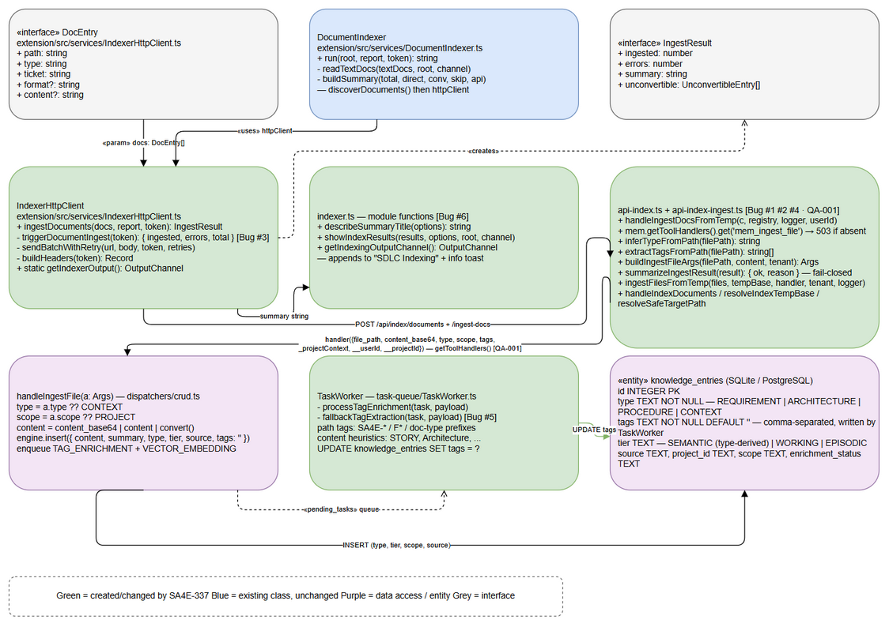 Edit in draw.io

5.3 Design Patterns Used
Pattern | Where | Why
Two-phase staging (write → ingest) | /documents + /ingest-docs | one KB pass per run; retryable write phase without duplicate inserts (SA4E-99)
Single-responsibility module split | ingest helpers extracted to api-index-ingest.ts; api-index.ts keeps route wiring + auth gates only (SRP) | route file stays small; helpers unit-tested without Hono (api-index-errors.test.ts imports them directly)
Scoped tool-handler entry (QA-001) | mem.getToolHandlers().get('mem_ingest_file') — decorated withErrorHandling(withScopeContext(withResultFormat(dispatch))) | the ONLY supported memory-module entry point; injects trusted tenant scope → knowledge_entries.project_id populated. getDispatcher() does not exist; bare mem.dispatcher.dispatch() would leak project_id = NULL
Fail-closed result verification (QA-001) | summarizeIngestResult() before ingested++ | handler chain never throws — verdict derived from isError / "Error:" prefix / JSON status ≠ 'ingested' / empty content; fixes the “count successes unconditionally” bug
Per-file isolation | ingestOneFile() catch → failedFiles[{file, reason}] | one bad file never aborts the run (SA4E-99)
Pure helper functions | inferTypeFromPath, extractTagsFromPath, summarizeIngestResult, describeSummaryTitle | unit-testable without Hono/VS Code context (≤20 LOC each)
Fail-closed authorization guards | requireAuth → requireIndexPermission → verifyIndexProjectBinding (composed per route) | consistent gate ordering; reused SA4E-300 infra
Strategy (with fallback) | processTagEnrichment: LLM TagAnalyzerService → fallbackTagExtraction heuristics | degradation path when LLM/health-check unavailable (Bug #5)
Idempotent UPSERT | UNIQUE(source, project_id) replace-on-ingest | re-index replaces rows instead of duplicating
Background enrichment queue | pending_tasks + polling worker | keeps /ingest-docs latency independent of LLM
Aggregate result object | IngestResult, {ingested, errors, total, failedFiles} | feeds UI summary (Bug #3/#6)

5.4 Exception / Error Strategy
- Backend: route body wrapped in try/catch → indexError(c, err, logger, context) which special-cases PROJECT_REQUIRED → 400 and ENOSPC/EACCES → 500 with actionable action; details truncated to 2000 chars. Per-file ingest failures are collected (failedFiles) and do not abort the batch.
- Ingest result verification (QA-001): the decorated handler chain (withErrorHandling → withScopeContext → withResultFormat) never throws — failures come back as { isError: true } or as strings ("Error: file not found", {"status":"unconvertible","reason":"no-tool"}). summarizeIngestResult() therefore classifies every result fail-closed (empty content = failure) and only ok results increment ingested; failures are logged logger.warn({ file, reason }, '[ingest-docs] Failed to ingest document') and pushed to failedFiles.
- Extension: triggerDocumentIngest catches fetch/timeout errors → logs ⚠️ Document ingest error: ... → returns {ingested:0, errors:0, total:0} (run continues); non-OK status logged as ⚠️ Document ingest failed: status N.
- Worker: JSON.parse(payload) failure → markFailed(task.id, 'invalid_json_payload'); missing entry → entry_not_found; fallback extraction errors are logged (logger.warn) but the task still markCompleted so the queue does not stall.

6. Integration Design

6.1 Extension ↔ Backend (HTTP)
Setting | Value | Source
Base URL | http://127.0.0.1:48721 (configurable backend.url) | config/backend-url.ts
Auth header | Authorization: Bearer <token> via buildHeaders() | IndexerHttpClient
Batch size | 20 files per POST /api/index/documents (DOCS_BATCH_SIZE), 200 ms pause between batches | ingestDocuments()
Retry | sendBatchWithRetry(url, body, token, 3) for writes; ingest trigger has no retry (single call) | IndexerHttpClient
Timeout | AbortSignal.timeout(60000) on /api/index/ingest-docs | triggerDocumentIngest
Backoff/failure | write batch failure → errors += entries.length + Output line ⚠️ Doc batch N: ..., channel auto-shown | ingestDocuments()
Message format: JSON over HTTP, Content-Type: application/json; responses are plain JSON (no SSE). Progress is reported client-side via vscode.Progress (report.report({message})).

6.2 Backend ↔ Memory module (scoped tool-handler call)
v1.1 correction — defect SA4E-337-QA-001. The previous revision of this section described mem.getDispatcher().dispatch('mem_ingest_file', {...}). MemoryModule has no getDispatcher() method (it only exposes the public dispatcher field and setDispatcher()), so that call threw TypeError: mem.getDispatcher is not a function → every POST /api/index/ingest-docs returned HTTP 500 and none of the 6 bug fixes were reachable. The implemented — and only supported — entry point is MemoryModule.getToolHandlers().
Actual flow (verified in api-index.ts + api-index-ingest.ts):
handleIngestDocsFromTemp (api-index.ts)
→ registry.getModule('memory') // typed IModule (no `any`)
if (!mem || mem.status !== 'ready')
→ 503 { error: 'Memory module not ready',
details: 'Memory service is initializing',
action: 'Retry after a short delay' }
→ ingestHandler = mem.getToolHandlers().get('mem_ingest_file') // ← QA-001 FIX
if (!ingestHandler)
→ 503 { error: 'Memory module not ready',
details: 'mem_ingest_file tool handler is unavailable',
action: 'Retry after a short delay' }
→ ingestFilesFromTemp(files, tempBase, ingestHandler,
{ userId, projectId: scope.projectId }, logger) // api-index-ingest.ts
per file (sequential, isolated):
content = fs.readFileSync(filePath, 'utf-8')
result = await ingestHandler(buildIngestFileArgs(filePath, content, tenant))
where args = {
file_path: filePath,
content_base64: base64(content),
type: inferTypeFromPath(filePath), // Bug #1 (SA4E-337 contract)
scope: 'PROJECT',
tags: extractTagsFromPath(filePath).join(','), // Bug #2
_projectContext: { userId, projectId }, // withScopeContext() PREFERS this key
__userId: userId, // canonical fallback (stampScope shape)
__projectId: projectId, // → knowledge_entries.project_id set
}
verdict = summarizeIngestResult(result) // fail-closed — BEFORE counting
if (verdict.ok) ingested++
else { errors++; failedFiles.push({ file, reason: verdict.reason }) }
→ { ingested, errors, total, failedFiles[] }
Inside the handler (MemoryModule.getToolHandlers()):
withErrorHandling(logger, 'mem_ingest_file')( // catches all throws → { isError: true }
withScopeContext(this.dispatcher)( // injects tenant scope from args
withResultFormat( // normalizes to ToolResult { content, isError }
async (args) => this.dispatcher.dispatch('mem_ingest_file', args),
),
),
)
- The chain never throws — hence summarizeIngestResult() must inspect isError / "Error:" prefix / JSON status !== 'ingested' / empty content (5 branches, fail-closed) before incrementing ingested.
- withScopeContext() reads the trusted scope keys from the args (_projectContext first, __userId/__projectId as canonical fallback) and injects it into the dispatcher → knowledge_entries.project_id is populated.
Why not the alternatives:
Alternative | Verdict
mem.getDispatcher().dispatch(...) | ❌ method does not exist → TypeError → HTTP 500 (QA-001 root cause)
mem.dispatcher.dispatch(...) (bare field) | ❌ skips withScopeContext() → project_id = NULL → tenant-isolation leak
mem.getToolHandlers().get('mem_ingest_file') | ✅ implemented — scoped, decorated, uniform ToolResult

6.3 Backend ↔ TaskWorker (async queue)
Aspect | Configuration
Trigger | handleIngestFile creates TAG_ENRICHMENT (+ VECTOR_EMBEDDING when embedding available)
Poll | worker loop with 6 s initial delay (LLM health check / setTagAnalyzer init)
Payload | { entry_id, content, existing_tags, options: { threshold: 0.6, autoApply: true } }
Retry | max_retries = 3, status failed with error code
Failure isolation | one bad payload marks that task failed; queue continues

6.4 Fallback strategy summary
Failure | Fallback
Unknown filename | type CONTEXT (BR-02)
No ticket-key tag segment | no server tags → async fallback/LLM tags; never blocks ingest
LLM/tagAnalyzer unavailable | fallbackTagExtraction() path + content heuristics (Bug #5)
Non-OK / invalid JSON from ingest API | zeros + Output warning; summary still rendered (Bug #3)
Missing memory module | 503 Memory module not ready + retry guidance
mem_ingest_file handler absent from getToolHandlers() map | 503 with details: 'mem_ingest_file tool handler is unavailable' (QA-001 guard)
Handler result indicates failure (isError / "Error:" / status≠ingested) | counted in errors + failedFiles[{file, reason}]; run continues (§6.2)
Unsafe client path | rejected file reported in rejectedReasons, run continues

6.5 Circuit breaker
None. The pipeline is single-caller (one VS Code command) and bounded by batch size + worker retries; introducing a breaker would be a new dependency with no failure mode to protect against (see constraint §1.4.5).

7. Security Design

7.1 Authentication
Every /api/index/* route runs requireAuth(c) before any handler work:
- Read Authorization: Bearer <token> (empty → 401 Unauthorized / "Provide valid Bearer token").
- validateSession(token) (opaque admin/session token) — invalid/expired → 401.

7.2 Authorization (layered, fail-closed)
Order inside handleIndexDocuments / handleIngestDocsFromTemp (SA4E-300 SEC High #1):
resolveRequestScope(c) // X-Project-Id required — PROJECT_REQUIRED → 400
requireIndexPermission(c, userId, 'KB_WRITE') // getUserPermissions; DB error → 403 (fail-closed)
verifyIndexProjectBinding(c, projectId) // JWT pid/pids must cover projectId → 403
Gate | Rule | Notes
KB_WRITE | same permission id used by kb-tags.ts, kb-operations.ts | no new permission invented
Tenant binding | verifyJwtToken + allowedProjectsFromClaims; opaque session tokens carry no per-project grant → allowed at global gate only | documented PO risk-accept (no membership table)

7.3 Input validation & path safety
resolveSafeTargetPath(tempBase, rawPath) (write phase) rejects, in order: null bytes; URI-encoded traversal (decodeURIComponent then re-check); Windows drive-absolute (C:\, C:/); leading / or \; path.normalize absolute results; any .. segment in raw, normalized, or decoded form; and finally verifies path.relative(tempBase, target) stays inside tempBase. Rejections surface as rejectedReasons[] with code: 'EACCES' and are logged via logger.warn({rejectedReasons, projectId}).
Additionally: sanitizePathSegment() strips every char outside [A-Za-z0-9._-] from userId/projectId before they join a filesystem path (empty/./.. → fallback). Null bytes are stripped from document text before insert (SA4E-53, PostgreSQL 0x00 rejection).

7.4 Data protection
Aspect | Implementation
In transit | HTTP to 127.0.0.1 loopback only by default (no TLS needed on-box); remote backends configured by user
At rest | SQLite file in workspace .code-intel/ — inherits workspace permissions
Sensitivity | workspace documents = Internal (FSD §7.2); API responses transient
Audit | engine.auditLog('INGEST_FILE') per ingest; pino logs for [index], [ingest-docs]; rejected-path warnings include projectId

7.5 Non-goals
No new auth framework, no secrets in code, no permission escalation introduced by this ticket.

8. Performance & Scalability

8.1 Performance targets (BRD/FSD NFR)
Target | Design answer
1727 files < 5 min | discovery is O(n) BFS; write phase = ~87 HTTP calls at batch 20; ingest phase = 1 HTTP call + in-process loop (no per-file HTTP)
5000+ files | batch size fixed at 20 with 200 ms inter-batch pause → bounded memory (only one batch FileEntry[] alive at a time)
Single ingest pass | collectIngestFiles() walks temp once, then ingestFilesFromTemp() loops over the file list (SA4E-99)

8.2 Bottleneck analysis
Phase | Cost | Mitigation
Discovery | file system BFS | denylist prunes diagrams/testdata/templates/node_modules/.git + dot-folders
Write phase | N/20 HTTP round-trips | batch + retry(3) with backoff
Ingest phase | N × (read file + engine.insert + 2 task inserts + graph upsert) | synchronous but DB-local; 60 s client timeout; per-file failures isolated
Enrichment | N LLM/heuristic tasks | async worker; fallback path is CPU-only heuristics (no network)

8.3 Concurrency model
- INDEX_CONCURRENCY_LIMIT = 3 guards POST /api/index/source with 429 + retryAfter: 2.
- /api/index/documents and /api/index/ingest-docs are not individually throttled; the extension runs them single-flight (sequential batches → one ingest call), and IndexingService prevents overlapping index commands (SA4E-300/SA4E-300 concurrency guard, TC-29).
- SQLite WAL: writer is the single backend process; TaskWorker shares the same adapter.

8.4 Horizontal scaling
Not applicable — single-user local tool. The design scales vertically (larger workspaces) via batching + async enrichment; nothing here assumes multiple ingest replicas.

8.5 Query optimization notes
No slow queries introduced: all statements are PK/source-keyed (Section 4.4). FTS stays current via triggers instead of re-scan.

9. Monitoring & Observability

9.1 Logging (pino, structured)
Logger | Event | Fields
api-index | [index] rejected unsafe paths | rejectedReasons[{file, code, message}], projectId
api-index | [index] permission lookup failed — denying / missing required permission | err, userId, permissionId
api-index | [index] project outside principal grant — rejected | projectId, sub
api-index | [ingest-docs] Failed to ingest document | file + reason (result verdict) or err (thrown), from ingestOneFile()
api-index | [ingest-docs] Document ingest complete | ingested, errors, total
TaskWorker | Fallback tag extraction applied | entry_id, tags
TaskWorker | Fallback tag extraction failed | err, entry_id
Client-side logs go to the “SDLC Indexing” Output channel: per-file 📄 Text read, 📤 Server-convert, ⚠️ Cannot read, batch failures, and the verification line KB ingest: {ingested}/{total} files ingested, {errors} errors (Bug #3).

9.2 Metrics to collect (from logs — no new telemetry dependency)
Metric | Healthy | Alert
ingest.total vs ingest.ingested ratio | ≥ 0.95 | < 0.9 → investigate failedFiles reasons
ingest.errors per run | 0 | > 0 sustained → check memory module status / converter
rejectedReasons count | 0 | > 0 → traversal/path bug or client regression
403 rate on /api/index/* | 0 | > 0 → permission regression (SA4E-300 gate)
fallbackTagExtraction log frequency | occasional | dominant path → LLM health-check failing
pending_tasks backlog (status='pending' age) | drained within minutes | > 15 min → worker not polling / crashed

9.3 Health checks
- GET /api/index/progress (authenticated) — existing index progress endpoint.
- Memory module readiness is self-reported (status === 'ready') and surfaced as 503 with action: "Retry after a short delay".
- E2E smoke: empty-run returns "ℹ️ No documents found in documents/ folder" (proves discovery + HTTP path without touching KB).

10. Deployment

10.1 Environment configuration
Variable / setting | Default | Required by fix
backend.url (VS Code setting) | http://127.0.0.1:48721 | yes (already exists)
CODE_INTEL_INDEX_TEMP_DIR / config.indexTempDir | os.tmpdir()/CodeIntel | existing — staging base
X-Project-Id header | sent by extension | existing tenant identity
— | no new env vars introduced

10.2 Feature flags
None. All six fixes are unconditional code paths (flagging a bug fix would allow the bug to persist).

10.3 Rollback strategy
- Revert the modified files (git): api-index.ts, api-index-ingest.ts (new in this fix), TaskWorker.ts, IndexerHttpClient.ts, indexer.ts.
- No DB rollback needed (no schema change) — entries ingested with derived type remain valid (CONTEXT was the previous universal value; correct types are supersets of behaviour).
- Extension-only rollback (client) is not sufficient for Bug #1/#2/#4/#5 (server-side); full rollback requires both artifacts — deploy them together.

10.4 Migration plan
Zero migrations. knex schema unchanged; no ALTER, no backfill. Verify post-deploy by checking knowledge_entries.type != 'CONTEXT' for known BRD/FSD/TDD files and non-empty tags after enrichment completes.

10.5 Release checklist
- Backend + extension released in the same version (contract §3.2 must exist server-side first)
- Run one full “Index Documents” on a real workspace; confirm 📚 KB: n ingested (Bug #3)
- Spot-check 3 rows: type (REQUIREMENT/ARCHITECTURE/PROCEDURE), tags non-empty, FTS hit
- Confirm Output channel summary + toast (Bug #6)

11. E2E Test Architecture

11.1 Framework & Language
- Framework: vitest (npm run test, test:unit, test:integration, test:e2e-api); Playwright only for the admin web UI (test:e2e-ui) — not applicable to VS Code extension UI.
- Language: TypeScript everywhere (shares types with production code).
- HTTP client: native fetch against the running server (BASE_URL), or Hono app.request() for in-process unit/route tests (pattern used by backend/src/server/routes/__tests__/api-index-errors.test.ts).
- Extension tests: extension package → vitest run (extension/src/__tests__/), e2e config vitest.e2e.config.ts.

11.2 Test Structure
Layer | Location | Command
Unit (backend) | backend/src/**/__tests__/*.test.ts | npm run test:unit
Unit (extension) | extension/src/__tests__/*.test.ts (incl. indexer.test.ts UT-010..017) | npm test (extension)
Integration | backend/tests/integration/*.it.test.ts | npm run test:integration
E2E-API | backend/tests/e2e/*.e2e.test.ts | npm run test:e2e-api
E2E-UI | admin web only (*.e2e / Playwright) | npm run test:e2e-ui

11.3 Reusable Components (existing — reuse, do not rebuild)
- Shared E2E config — backend/tests/e2e/setup/e2e-config.ts: E2E_PORT (dynamic, written by global-setup to %TEMP%/sa4e-e2e-port.txt), BASE_URL, API_URL = BASE_URL + /api/admin, E2E_PASSWORD = 'test-admin-pw-01'. Never hardcode a port.
- Setup — backend/tests/e2e/setup/global-setup.ts (boots server, assigns port), env-setup.ts.
- Auth pattern — POST ${API_URL}/auth/login with admin credentials → { token } → Authorization: Bearer ${token} (see admin-api.e2e.test.ts, multi-tenant.e2e.test.ts).
- Route-test harness (unit) — makeApp() + mocked validateSession / getUserPermissions / verifyJwtToken + mockGrantedCaller() in api-index-errors.test.ts (copy this file’s setup).
- Test kit — backend/src/__tests__/sa4e-testkit.ts: makeTempDb(), stubModule(), silentLogger() for memory-module-backed tests.
- Extension discovery fixtures — indexer.test.ts builds a temp documents/ tree with fs.mkdtempSync(os.tmpdir()/indexer-test-) (UT-010..017, IT-009..012 already assert denylist, classification, ticket extraction).

11.4 E2E-API Test Design for SA4E-337
File: backend/tests/e2e/index-documents.e2e.test.ts (new)
Case | Steps | Expected
E2E-01 happy path | login → POST /api/index/documents with 3 seeded .md → POST /api/index/ingest-docs | write {indexed:3}; ingest {ingested:3, errors:0, total:3}
E2E-02 type derivation (UC-01/BR-01..05) | ingest files BRD-x.md, TDD-x.md, STP-x.md, note.md | KB rows type = REQUIREMENT / ARCHITECTURE / PROCEDURE / CONTEXT
E2E-03 tags (UC-02/BR-06..11) | seed path containing SA4E-999/ | after enrichment, tags contains sa4e + sa4e-999 (fallback path — LLM off)
E2E-04 ingest verification (UC-03/BR-12..15) | call ingest endpoint, assert response is parseable JSON with ingested/errors/total | {ingested, errors, total} present; total = files written
E2E-05 .drawio walk (UC-04/BR-16..19) | stage a .drawio file directly under batch-docs/ → ingest | file counted in total, ingested as type=CONTEXT
E2E-06 denial (security) | no token / no X-Project-Id / user without KB_WRITE | 401 / 400 PROJECT_REQUIRED / 403
E2E-07 path traversal | POST /api/index/documents with path: "../../evil.md" | rejected + rejectedReasons[0].code='EACCES', no file outside temp
E2E-08 empty staging | ingest with no temp dir | {ingested:0, message:'No documents in Temp folder'}
E2E-09 memory-not-ready | registry module status initializing (stub) | 503 {error:'Memory module not ready'}
E2E-10 handler unavailable (QA-001) | memory ready but getToolHandlers() returns a map without mem_ingest_file | 503 details: 'mem_ingest_file tool handler is unavailable'; no TypeError, no 500
E2E-11 result verification (QA-001) | handler returns {isError:true} / "Error: ..." / {"status":"unconvertible"} | counted in errors + failedFiles[{file, reason}], not in ingested (fail-closed summarizeIngestResult)
Regression guard: backend/src/server/routes/__tests__/api-index-errors.test.ts mocks the memory module with getToolHandlers() and deliberately omits getDispatcher — a root-cause guard so the QA-001 defect (mem.getDispatcher is not a function) can never silently return.
Auth setup: loginAdmin() helper → token; every request sends Authorization: Bearer <token> + X-Project-Id: <test-project>.
Data cleanup: delete resolveIndexTempBase(userId, projectId, 'batch-docs') after the suite; DELETE FROM knowledge_entries WHERE source LIKE '<tempBase>/%' (and its graph_nodes / pending_tasks children) in afterAll; use a dedicated test project id to avoid cross-suite bleed.

11.5 E2E-UI / Extension Test Design
Bug #6 (showIndexResults, toast, describeSummaryTitle) runs inside the VS Code extension host — not Playwright-testable. Cover it as:
- Unit — extension/src/__tests__/indexer.test.ts (extend): assert describeSummaryTitle(['documents']) === 'Document Indexing Summary', describeSummaryTitle(['code','documents']) === 'Workspace Indexing Summary', and summary line ordering (title → results → Next Steps → toast text).
- Unit — IndexerHttpClient.triggerDocumentIngest with a mocked fetch: OK + valid JSON, OK + invalid JSON (returns zeros, logs warning — BR-12), non-OK status, timeout.
- Manual UI test — run Index Workspace → documents, verify Output channel content and the 📋 Indexing complete — see Output panel. toast with working Open Output action (record in test report).
New helpers needed: loginAdmin() (backend e2e), postIndex(url, body, token, projectId), seedTempDocs(files); extension: mockFetch(response) fixture. Reused: e2e-config.ts, mockGrantedCaller() harness, mkdtemp fixture pattern from indexer.test.ts.

12. Error Handling (consolidated)
Scenario | Severity | Response / message | Behaviour | Ref
Type inference falls through | Low | (none) | default CONTEXT, run continues | BR-02
No ticket-key tag segment | Low | — | server tags [] → async enrichment/fallback fills them | BR-11
LLM unavailable during enrichment | Medium | log Fallback tag extraction applied | heuristic tags from payload.source + content | Bug #5
JSON.parse of ingest response fails | High | ⚠️ Document ingest error: ... | return {ingested:0,...}, run continues | BR-12
/ingest-docs non-OK status | High | ⚠️ Document ingest failed: status N | zeros + Output channel line | Bug #3
Per-file ingest throws | Medium | failedFiles[{file, reason}], logger.warn | counted in errors, batch continues | §3.2
Handler result indicates failure (isError / "Error:" / status≠ingested) | Medium | failedFiles[{file, reason}] | summarizeIngestResult() fail-closed → NOT counted as ingested | §6.2 (QA-001)
mem_ingest_file handler missing from getToolHandlers() map | High | 503 details: 'mem_ingest_file tool handler is unavailable' | no partial writes; never 500 (QA-001) | §6.2
Unsafe write path | High | rejectedReasons[{code:'EACCES'}] | file skipped + warned | §7.3
Missing X-Project-Id | High | 400 X-Project-Id required for indexing | fail-closed | §7.2
Missing/invalid token | High | 401 {error, details, action} | request rejected before handler | §7.1
Missing KB_WRITE / project outside grant | High | 403 | request rejected | §7.2
Memory module not ready | Medium | 503 + action: Retry after a short delay | no partial writes | §3.2
Concurrent index requests > 3 | Medium | 429 + retryAfter: 2 | only /api/index/source | §3.3
Bad enrichment payload | Medium | markFailed('invalid_json_payload') | task isolated, queue continues | §5.4
Empty documents/ folder | Info | ℹ️ No documents found in documents/ folder | early return, no HTTP ingest | FSD EF-3
Output/toast display failure | Low | silent | results still in Output channel | FSD §3.6 EF

13. Traceability Matrix (FSD → TDD → Code)
FSD UC | Business Rules | TDD Section | Implementation
UC-01 Derive type | BR-01..BR-05 | §3.2, §5.2, §12 | api-index-ingest.ts → inferTypeFromPath() (Bug #1)
UC-02 Extract tags | BR-06..BR-11 | §3.2, §4.3, §12 | api-index-ingest.ts → extractTagsFromPath() (Bug #2)
UC-03 Verify ingest | BR-12..BR-15 | §3.2, §6.1, §12 | IndexerHttpClient.ts → triggerDocumentIngest() (Bug #3) + server-side summarizeIngestResult() (QA-001)
UC-04 .drawio files | BR-16..BR-19 | §3.2, §12 | api-index-ingest.ts → collectIngestFiles()/isIngestableFile() (Bug #4) — partial, see DISC-3
UC-05 Fallback tags | BR-20..BR-24 | §4.3, §5.3, §6.4 | TaskWorker.ts → fallbackTagExtraction() (Bug #5)
UC-06 UI results | BR-25..BR-28 | §2.4, §11.5, §12 | indexer.ts → showIndexResults()/describeSummaryTitle() (Bug #6)
QA-001 (defect) | — | §1.5, §6.2, §12 | api-index.ts → mem.getToolHandlers().get('mem_ingest_file') + api-index-ingest.ts → buildIngestFileArgs()/summarizeIngestResult()
FSD §6 Processing | — | §2.4 sequence | two-phase flow as documented
FSD §7 Security | — | §7 | gates verified in registerIndexRoutes
FSD §8 NFR | — | §8, §9 | batching, limits, log metrics
FSD §10 TC-01..TC-30 | — | §11.4, §11.5 | E2E/API + unit design (Section 11)

14. FSD ↔ Implementation Discrepancy Notes
Full report: documents/SA4E-337/DISCREPANCY.md (severity + recommended FSD fix per item). Summary:
ID | Severity | One-line
DISC-1 | High | FSD API contract POST /api/v1/ingestDocuments does not exist — real endpoints are POST /api/index/documents + POST /api/index/ingest-docs
DISC-2 | High | handleIngestFile ignores the tags argument (INSERT tags=''); Bug #2’s tags only persist indirectly via TAG_ENRICHMENT / fallbackTagExtraction
DISC-3 | High | FSD BR-16 requires .drawio in INDEXABLE_EXTENSIONS (indexer-discovery.ts); only the backend temp walk got .drawio — extension discovery still skips .drawio (and diagrams/), so Bug #4 is only half-delivered
DISC-4 | Medium | Type derivation exists twice with different tables (extension DOCUMENT_TYPES vs server inferTypeFromPath); server wins, TEST-REPORT/DOCUMENTATION differ
DISC-5 | Medium | FSD BR-07 generic {PROJECT}-{NUMBER}; implementation hardcodes ^SA4E-\d+$ (both server + worker) → non-SA4E tickets get no ticket tag
DISC-6 | Medium | FSD puts tag extraction client-side on DocEntry; real DocEntry has no tags field — extraction is server-side from the temp path
DISC-7 | Low | FSD fallback = “no ticket key in folder”; actual fallback trigger = “LLM tagAnalyzer unavailable”, different implementation/location
DISC-8 | Low | FSD DOCUMENTATION type (DISCREPANCY*, SECURITY-REPORT*) does not exist in backend; mappings differ from FSD table
No Critical discrepancies — data model (Section 4) matches the real schema; no DB impact.

15. Diagram Index
Diagram | Type | Files | Section
Architecture — ingest pipeline | draw.io (PNG) | diagrams/architecture.{drawio,png} | §2.1
Component overview | draw.io (PNG) | diagrams/component.{drawio,png} | §2.2
Request flow — end-to-end | draw.io (PNG) | diagrams/sequence-e2e.{drawio,png} | §2.4
Class structure | draw.io (PNG) | diagrams/class-diagram.{drawio,png} | §5.3
KB entry enrichment lifecycle | draw.io (PNG) | diagrams/state-enrichment.{drawio,png} | §4.6
Reused: System Context | draw.io | diagrams/system-context.{drawio,png} | FSD §2.1
Reused: Sequence UC-01..03 | draw.io | diagrams/sequence-uc{1,2,3}.{drawio,png} | FSD §3.1–3.3
Reused: State — Document | draw.io | diagrams/state-document.{drawio,png} | FSD §4
Reused: Use Case / Business Flow | draw.io | diagrams/use-case.*, diagrams/business-flow.* | BRD

16. Appendix

16.1 Glossary
Term | Definition
Temp / staging | {indexTempDir}/{userId}/{projectId}/batch-docs/ — files written before KB ingest
mem_ingest_file | memory-module tool handler (via MemoryModule.getToolHandlers()) that inserts a KB entry from a file path (+ optional base64 content)
getToolHandlers() | MemoryModule method returning Map<string, ToolHandler>; each handler decorated withErrorHandling(withScopeContext(withResultFormat(...))) — the only supported route entry point (QA-001)
summarizeIngestResult() | fail-closed classifier of mem_ingest_file handler results — decides ingested vs failedFiles (§6.2)
TAG_ENRICHMENT | async pending_tasks job that computes tags (LLM) or applies heuristics (fallback)
KB_WRITE | admin permission id gating KB writes (also used by kb-tags, kb-operations)
Denylist | FOLDER_DENYLIST = {diagrams, testdata, templates, node_modules, .git}

16.2 Assumptions
- Retroactive TDD: code reviewed on 2026-10-05 is the shipped behaviour; deviations are reported (Section 14) rather than designed around.
- Backend port 48721 and temp-dir conventions are pre-existing configuration (SA4E-99/SA4E-300).
- LLM tag analysis may be unavailable (offline / health-check failing) — hence Bug #5’s fallback.

16.3 Open Questions (for BA/PO)
- DISC-3: should .drawio also be added to INDEXABLE_EXTENSIONS + classification in indexer-discovery.ts to complete Bug #4 end-to-end? (recommended: yes, as a follow-up fix)
- DISC-2: should handleIngestFile honour a.tags at insert time (faster, deterministic tags)? (recommended: yes — small change, removes reliance on async enrichment)
- DISC-5: generalise ticket-key regex from SA4E-\d+ to any project key?

