Deployment Guide (DPG)

SDLC Agents 4 Enterprise — SA4E-84: [drawio] Upgrade drawio_auto_layout to FIX mode — auto-layout reduce edge crossings with elkjs

Document Information
Field | Value
Jira Ticket | SA4E-84
Title | [drawio] Upgrade drawio_auto_layout to FIX mode — auto-layout reduce edge crossings with elkjs
Author | DevOps Agent
Version | 1.0
Date | 2026-08-30
Status | Final
Related TDD | TDD-v1.2-SA4E-84.docx

Revision History
Version | Date | Author | Changes
1.0 | 2026-08-30 | DevOps Agent | Initiate document — auto-generated from TDD v1.2 and project context (backend tool library, bundled into server build)

Sign-Off
Name | Role | Signature and date
 | Dev Lead | ☐ Approved for deployment
 | QA Lead | ☐ Testing completed
 | Ops Lead | ☐ Infrastructure ready

1. Overview

1.1 Feature Summary
Nâng cấp MCP tool drawio_auto_layout (backend/src/engine/tools/drawio-tool.ts) sang detect + auto-fix (FIX) mode sử dụng engine bố cục elkjs (thuần JS/TS, không binary). Tool nhận file_path, tự phát hiện chồng lấp / giao cắt cạnh / cạnh chéo, chạy ELK layered layout để tính lại tọa độ node + edge routing, và ghi thẳng kết quả vào file .drawio qua fs.writeFileSync. Response tối giản { status, message } hoặc { error }.

1.2 Deployment Scope
Item | Type | Description
drawio_auto_layout MCP tool | Modified | NEW FIX mode (elkjs) — replaces old review-only behavior. Bundled into backend server build.
elkjs npm dependency | New (runtime) | Added to backend/package.json dependencies; lazy-loaded at runtime.
4 new backend modules | New | drawio-layout-models.ts, elk-layout.ts, drawio-writer.ts, drawio-apply.ts
Extension package (VSIX) | Rebuilt | SDLC-Agents-4-Enterprise VSIX rebuilt — tool ships inside extension’s bundled backend.
Database | None | No DB changes — feature has no persistence.
Configuration | Optional | Env vars SA4E_ELK_MAX_NODES / SA4E_ELK_TIMEOUT_MS with safe defaults; no mandatory config.

1.3 Target Environments
Environment | URL | Deploy Order | Approval Required
DEV | Local build / branch SA4E-84 | 1st | No
SIT | CI build artifact | 2nd | No
UAT | Extension VSIX install | 3rd | QA Sign-off
PROD | Marketplace / packaged VSIX | 4th | PM + Business Sign-off
Deployment Model: This is a backend tool library bundled into the server/extension build. There is no separate runtime deployment, container, or service to roll out. “Deployment” = build + package + publish the VSIX (already executed at v1.20.0). See Section 5.

2. Prerequisites

2.1 Infrastructure
Requirement | Status | Notes
Backend build host (Node >= 18.14.1) | Ready | VSIX build + tsc compile. Done at v1.20.0.
Extension packaging tooling | Ready | vsce / npm run package. Done.
Runtime (Kiro extension host) | Ready | elkjs is pure JS — no Graphviz/draw.io CLI needed.

2.2 Software Dependencies
Dependency | Version | Status
Node.js | >= 18.14.1 | Installed (engines in backend/package.json)
elkjs | ^0.9.3 | Added to backend/package.json dependencies; bundled in build
TypeScript | per backend | Compiled clean (0 errors)

2.3 Access Requirements
Access | Type | Who Needs It
Git repo (branch SA4E-84) | SSH / token | Developer / DevOps
npm registry | Service account | CI build
VSIX publish | Marketplace token | Release Manager

2.4 Backup Requirements
- ☒ Source committed on branch SA4E-84 (commit 2f100fa) and merged to master.
- ☒ Git tag v1.20.0 created — rollback = checkout previous tag.
- ☒ Previous VSIX artifact retained for downgrade.

3. Pre-Deployment Checklist
# | Item | Responsible | Status
1 | Code merged to release branch (master) | Developer | ✅ Done (merge SA4E-84 → master)
2 | All unit tests passed (drawio-tool.test.ts 14 pass) | Developer | ✅ Done
3 | All integration tests passed (drawio-export / mcp-dispatch) | QA | ✅ Done
4 | SIT/UAT sign-off obtained (UAT tool test: “Fixed 10 issues… 16 nodes repositioned”) | QA + BA | ✅ Done
5 | Database backup completed | DBA | N/A — no DB
6 | Configuration files prepared | DevOps | ✅ N/A — env vars optional w/ defaults
7 | Feature flags configured | Developer | N/A — no flags
8 | Monitoring/alerting configured | DevOps | N/A — tool is stateless, logged via pino
9 | Rollback plan reviewed | Team | ✅ Done (git tag revert)
10 | Deployment window confirmed | PM | ✅ Done (v1.20.0 release)

4. Database Migration

4.1 Migration Scripts
N/A — Feature SA4E-84 does not introduce any database schema, table, or data migration. The data model is TypeScript interfaces (ElkNode, ElkEdge, etc.) used only in-memory during layout. No DDL required.

4.2 Execution Steps
# No database migration required for SA4E-84.
echo "N/A — no DB changes"

4.3 Verification Queries
-- N/A

4.4 Rollback Scripts
-- N/A

5. Application Deployment

5.1 Deployment Flow
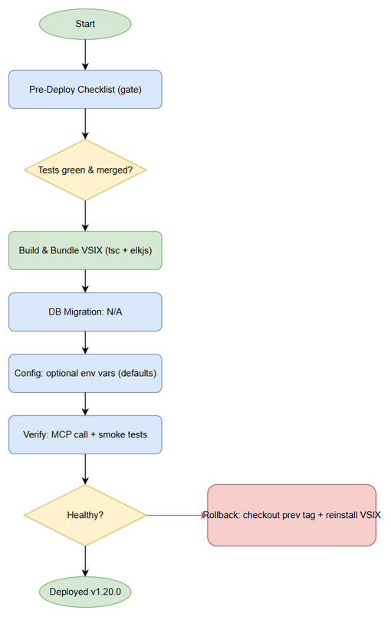
Deployment Flow
Flow: Build (tsc + bundle elkjs) → Package VSIX → Publish/Install → Verify tool via MCP drawio_auto_layout. For this ticket the build & package step was already executed at release v1.20.0.

5.2 Deployment Steps (Build / Bundle)
This feature is delivered as part of the backend bundled inside the SDLC-Agents-4-Enterprise VSIX. Steps below are the canonical build/deploy procedure (already executed for v1.20.0; re-run on any patch).
Step | Action | Command | Verification
1 | Install deps (incl. elkjs) | cd backend && npm install | npm ls elkjs shows ^0.9.3
2 | Type-check / compile | cd backend && npm run build (tsc) | 0 TypeScript errors
3 | Run test gate | cd backend && npx vitest run | drawio-tool.test.ts 14 pass; no regression
4 | Package extension | npm run package (vsce) | sdlc-agents-4-enterprise-<ver>.vsix produced
5 | Install / publish VSIX | Install in Kiro OR publish to marketplace | Extension loads; backend starts
6 | Health / smoke check | Call drawio_auto_layout on a sample .drawio | Response status:"fixed" or already_good

5.3 Docker Deployment
N/A — No container image for this component. The backend runs inside the Kiro extension host process; elkjs is bundled into the build.

6. Configuration Changes

6.1 New Environment Variables
All optional with safe defaults — no mandatory configuration.
Variable | Description | DEV | SIT | UAT | PROD
SA4E_ELK_MAX_NODES | Max nodes per diagram (guard) | 500 | 500 | 500 | 500 (default)
SA4E_ELK_TIMEOUT_MS | ELK layout timeout | 10000 | 10000 | 10000 | 10000 (default)
Values validated via parseEnvInt() with bounds (SEC-02). Out-of-range → safe default; no secret involved.

6.2 Application Properties Changes
Property | Old Value | New Value | File
(none) | — | — | No config file changes required

6.3 Feature Flags
Flag | DEV | SIT | UAT | PROD
(none) | — | — | — | —
FIX mode is always-on (no mode param, per ADR-6). No flags to toggle.

7. Post-Deployment Verification

7.1 Health Checks
Check | Endpoint/Command | Expected Result | Timeout
Backend startup | Start extension backend | No elkjs import at startup (lazy-load); pino logs clean | 30s
Tool availability | tools/call drawio_auto_layout with file_path | JSON {status, message} or {error} | 10s

7.2 Smoke Tests
# | Scenario | Steps | Expected Result
1 | Fix crossing diagram | Provide fixture w/ edge crossing → call tool | status:"fixed", “N nodes repositioned”; file rewritten
2 | Already-good diagram | Provide clean diagram → call tool | status:"already_good"; file unchanged
3 | Path traversal blocked | file_path:"../../etc/passwd" | {error:"file_path is required"} (SEC-01)
4 | UAT replay | architecture.drawio via MCP | Fixed 10 issues ... 16 nodes repositioned (observed in UAT)

7.3 Log Verification
Log Entry | Level | Expected | Location
Backend started | INFO | Within 30s | pino log
Layout fixed | INFO | After tool call | pino log (no XML content — NFR-P7)
ELK error (if any) | ERROR | Generic msg to caller; detail to console.error | console.error

7.4 Monitoring Dashboard
- ☒ No new infra metrics required (stateless tool).
- ☒ Error rate within normal range (generic errors returned as JSON, not exceptions).
- ☒ No unexpected alerts.

8. Rollback Plan

8.1 Rollback Flow
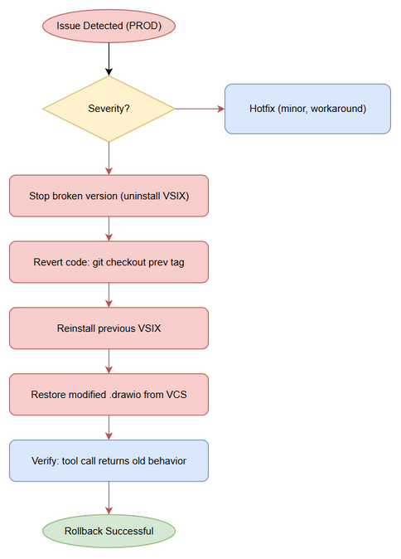
Rollback Flow

8.2 Rollback Decision Criteria
Condition | Action
Tool throws / breaks MCP dispatch in PROD | Immediate rollback to previous VSIX
Error rate spike (> 5%) on drawio_auto_layout | Rollback to previous tag
Data corruption of .drawio files | Rollback + restore affected files from VCS
Minor issue, workaround available | Hotfix — no rollback

8.3 Rollback Steps
Because the feature is bundled into the build, rollback = revert the packaged version.
Step | Action | Command | Verification
1 | Stop using broken version | Uninstall VSIX v1.20.0 | Extension unloaded
2 | Revert code | git checkout v1.19.x (previous tag) | Source at prior state
3 | Reinstall previous VSIX | Install sdlc-agents-4-enterprise-1.19.x.vsix | Extension loads
4 | Verify | Call drawio_auto_layout | Old behavior restored
5 | Restore any modified files | git checkout -- <file.drawio> | User diagrams intact
Implicit file-safety rollback: The tool only writes the fixed XML after validateReparse succeeds (BR-7). On any ELK failure the original file is left untouched — so a “bad fix” never corrupts the source diagram.

8.4 Rollback Time Estimate
Action | Estimated Time
Code revert (git checkout tag) | 1 min
VSIX reinstall | 2 min
Verification | 2 min
Total | ~5 min

9. Environment-Specific Notes

9.1 DEV
Built and tested on branch SA4E-84 (commit 2f100fa). npm run build + npx vitest run green.

9.2 SIT
CI build artifact validated; drawio-export / mcp-drawio-dispatch regression tests pass.

9.3 UAT
User tested via MCP on architecture.drawio: “Fixed 10 issues with ELK layered layout. 16 nodes repositioned.” — PASSED.

9.4 PROD
- Deployment Window: Release v1.20.0 (2026-08-30).
- Approval Required From: PM + Business Sign-off (obtained via merge + tag).
- Communication Plan: Release notes attached to Jira SA4E-84; CHANGELOG.md updated.
- On-Call Contact: Backend team (extension owner).

10. Appendix

Contacts
Role | Name | Contact
DevOps Lead | DevOps Agent | —
DBA | N/A | N/A (no DB)
On-Call Dev | Backend Team | —

Related Tickets
Ticket | Summary | Relationship
SA4E-84 | drawio_auto_layout FIX mode (elkjs) | Main ticket

Release Artifacts
- Git tag: v1.20.0
- VSIX: sdlc-agents-4-enterprise-1.20.0.vsix
- Commit: 2f100fa (branch SA4E-84, merged to master)

