Deployment Guide (DPG)

SDLC Agents for Enterprise — SA4E-360: Multi-Resolution Context Supply (P1: Code Skeletonization + Agentic Context Loading)

Document Information
Field | Value
Jira Ticket | SA4E-360
Title | Multi-Resolution Context Supply for Pi Harness — P1: Code Skeletonization + Agentic Context Loading
Author | DevOps Agent
Version | 1.0
Date | 2026-10-15
Status | Released (UAT passed 2026-10-15; GA via git tag v1.53.0)
Related TDD | TDD-v1.1-SA4E-360.docx

Revision History
Version | Date | Author | Changes
1.0 | 2026-10-15 | DevOps Agent | Initiate document — generated from TDD v1.1, STP/STC, TEST-REPORT v1.0 and UAT round-3 evidence

Sign-Off
Name | Role | Signature and date
 | Dev Lead | ☐ Approved for deployment
 | QA Lead | ☐ Testing completed (UAT PASSED 2026-10-15 — CDP round 3)
 | Ops Lead | ☐ Infrastructure ready

1. Overview

1.1 Feature Summary
SA4E-360 delivers P1 of the Multi-Resolution Context Supply architecture for the Pi harness. Instead of injecting whole files into the LLM context, the extension injects a code skeleton (signatures + structural outline, token-budgeted) and lets the agent pull details on demand via the new read_method tool — backed by two new loopback-backend MCP tools (code_symbol_locate, code_extract_signatures) and a functional map. A fallback ladder preserves pre-360 behavior whenever skeleton supply cannot be satisfied (index missing, stale, bridge absent, budget pressure), and a secret-redaction pass (SEC-360-01) keeps credentials out of prompts.
Deployed on top of the SA4E-355 3-gate context-budget governance (shipped in v1.52.0), multi-turn sessions on large workspaces complete with 0 context-exceed errors (UAT: 6-turn journey, compaction 47k–56k tokens ≤ 58,293 usable).

1.2 Deployment Scope
Item | Type | Description
Kiro/VS Code extension (sdlc-agents-4-enterprise) | Modified + New module | New extension/src/pi-workflow/skeleton/ (8 modules: SkeletonProvider, IndexFreshnessChecker, SkeletonTruncator, SkeletonInjector, ReadMethodTool, FunctionalMapProvider, SymbolLocator port, wiring); read_method added to READ_ONLY_TOOLS + lean tool loadout; PI_GATE_DECISION enriched (OI-5). Shipped as VSIX 1.53.0 (~12.5 MB).
Loopback backend server | Modified | 2 new thin MCP tools registered additively: code_symbol_locate (backend/src/engine/tools/code-locate.ts) and code_extract_signatures (backend/src/engine/tools/code-extract.ts). No changes to existing endpoints.
Database | None | No schema changes; SQLite/PostgreSQL untouched.
Configuration | None | No new settings keys, env vars or feature flags; skeleton auto-activates on the Pi session path.

1.3 Target Environments
This product deploys to developer workstations (IDE extension + loopback backend), not server farms:
Environment | Target | Deploy Order | Approval Required
Build (DEV) | Repo build machine — npm test + npm run package:prod | 1st | No
UAT — user workstation (Kiro IDE) | SDLC Chat panel, CDP-verified | 2nd | QA + User sign-off — DONE 2026-10-15
PROD / GA | Git tag v1.53.0 + README changelog (source of truth for all workstations) | 3rd | SM sign-off
npm publish (backend server) | Out of scope this release | — | Deferred — optional follow-up, SM decision

2. Prerequisites

2.1 Infrastructure
Requirement | Status | Notes
Kiro IDE installed with kiro.cmd on PATH | Ready | Verified at C:\Users\<user>\AppData\Local\Programs\Kiro\bin\kiro.cmd
Backend runs locally (loopback 127.0.0.1:48721) | Ready | node dist/index.js after build; no external network needed
Node.js + npm toolchain | Ready | esbuild, vsce, vitest, tsc via npm scripts
Rollback artifacts retained | Ready | extension/sdlc-agents-4-enterprise-1.51.0.vsix + -1.52.0.vsix kept on disk

2.2 Software Dependencies
Dependency | Version | Status
Node.js / npm | ≥ 20 (repo toolchain) | Installed
Kiro IDE | current (Chromium-based, CDP-capable) | Installed
Backend dependencies | npm ci in backend/ | Installed

2.3 Access Requirements
Access | Type | Who Needs It
Local file system write (extension/dist, Kiro extensions dir) | Current user | DevOps / installer
Git push rights (tag v1.53.0, push main) | SSH/HTTPS credential | DevOps / Release
VPN / external credentials | Not required | — (feature is local-loopback only)

2.4 Backup Requirements
- ☒ Previous VSIX artifacts retained (1.51.0, 1.52.0 in extension/)
- ☒ Git last-known-good tagged: v1.52.0
- ☒ Workspace code-intel index is runtime-generated and self-healing — no user data at risk; chat sessions are recreatable
- N/A — no database backup required (no DB changes)

3. Pre-Deployment Checklist
# | Item | Responsible | Status
1 | Code on main; implementation commits verified: 5d92322, 5225170, 9b44169+83c32ab, f60999e (impl), 0d33706+ea84217 (security F-1..F-3 + regression), cac13a7/1b822b0 (bumps), 3da3376 (test report), aa44bb8/4617265/02e6506 (pentest/UAT) | Developer | ✅
2 | Extension full suite green — 298 files / 2,896 tests at impl; Phase-7 re-run logged to documents/SA4E-360/evidence/phase7-npm-test.log | Developer | ✅
3 | tsc clean (production build compiles) | Developer | ✅
4 | SIT/UAT sign-off — SIT-01/02/04/07 PASS on SDLC Chat panel (CDP round 3), 0 exceed errors | QA + User | ✅ 2026-10-15
5 | Pentest verdict SECURE-WITH-NOTES (120 attempts, 0 Crit/High/Med) | QA | ✅
6 | Database backup | N/A — no DB changes | —
7 | Configuration files prepared | N/A — no new settings | —
8 | Feature flags configured | N/A — skeleton auto-active on session path | —
9 | Rollback plan reviewed (§8); previous VSIX retained | DevOps | ✅
10 | Deployment window confirmed — workstation install immediate; GA = tag + README | SM | ✅
11 | VSIX artifact present, ~12.5 MB (extension/sdlc-agents-4-enterprise-1.53.0.vsix) | DevOps | ✅

4. Database Migration
Not applicable. SA4E-360 introduces no database schema changes. The skeleton supply reads the code-intel SQLite index — a runtime artifact, auto-generated and self-healing via IndexFreshnessChecker (stale → reindex or degrade, event PI_SKELETON_INDEX_STALE).
- Migration scripts: N/A
- Verification queries: N/A
- Rollback scripts: N/A

5. Application Deployment

5.1 Deployment Flow
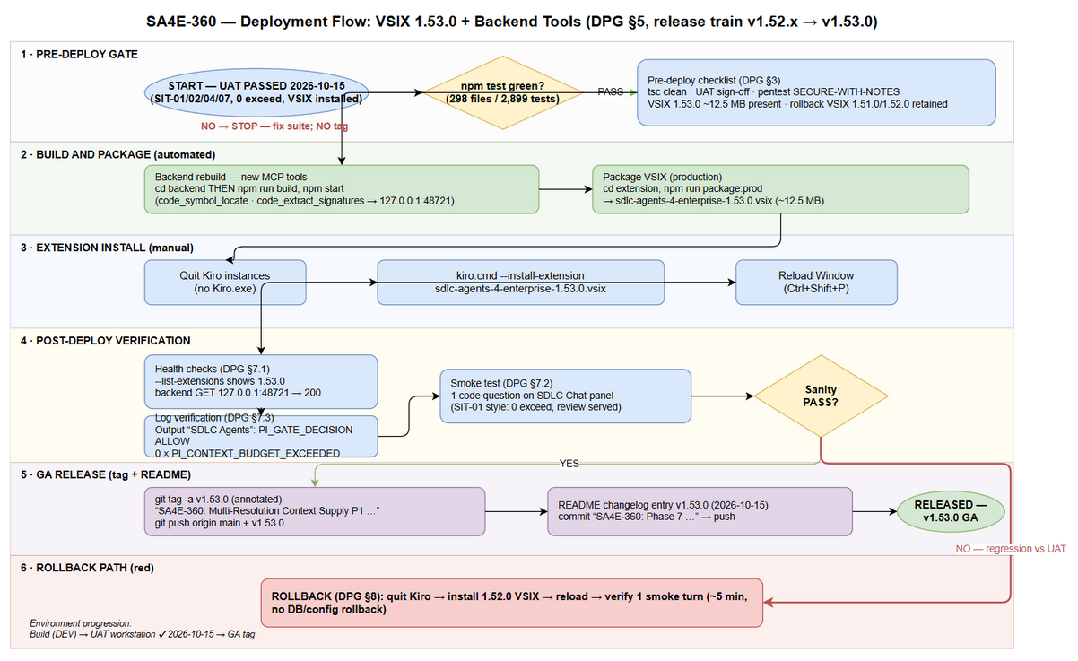
Deployment Flow

5.2 Deployment Steps
Step | Action | Command | Verification
1 | Quit running Kiro instances | Close all Kiro windows (File → Exit) | Task Manager: no Kiro.exe process
2 | Rebuild backend (adds 2 new tools) | cd backend; npm run build | tsc exits 0; dist/engine/tools/code-locate.js + code-extract.js exist
3 | Restart backend | npm start (or restart existing service) | Console: server listening on 127.0.0.1:48721
4 | Package VSIX (production) | cd extension; npm run package:prod | sdlc-agents-4-enterprise-1.53.0.vsix created, ~12.5 MB
5 | Install VSIX | kiro.cmd --install-extension sdlc-agents-4-enterprise-1.53.0.vsix | CLI reports “Successfully installed … 1.53.0”
6 | Reload Window | Kiro: Ctrl+Shift+P → “Developer: Reload Window” | Extension host restarts cleanly, no activation errors
7 | Verify install | kiro.cmd --list-extensions | Lists sdlc-agents-4-enterprise-1.53.0
Note: For this release, steps 1–7 were already executed and verified on the user workstation on 2026-10-15 (VSIX 1.53.0 built + installed into Kiro; user actively using it). Section 5.2 remains the canonical procedure for fresh workstations.

5.3 Docker Deployment (if applicable)
N/A — desktop deployment. If the workstation runs the backend in Docker, rebuild additively:
cd backend
docker compose build
docker compose up -d
Feature parity is identical (additive tools only); no volumes or ports change.

6. Configuration Changes

6.1 New Environment Variables
None. No environment variables are introduced by this release.

6.2 Application Properties Changes
None. Existing SA4E-355 context-budget settings (gate thresholds, tiering, safety margin) are unchanged and reused as-is.

6.3 Feature Flags
None. Skeleton supply auto-activates on the Pi session path; degradation is telemetry-driven (PI_SKELETON_* events), not config-driven. Diagnostics are visible in the Kiro Output channel “SDLC Agents” (see §7.3).

7. Post-Deployment Verification

7.1 Health Checks
Check | Endpoint/Command | Expected Result | Timeout
Extension installed | kiro.cmd --list-extensions | sdlc-agents-4-enterprise-1.53.0 listed | 30s
Backend up | GET http://127.0.0.1:48721/ (loopback) | HTTP 200 (API index) | 10s
Extension activated | Kiro Output channel “SDLC Agents” | No activation errors; status bar “KB: Ready” | 60s

7.2 Smoke Tests
# | Scenario | Steps | Expected Result
1 | Skeleton in system context (SIT-01 replay) | Open SDLC Chat panel; ask a code question about a workspace file | Turn completes; 0 exceed errors; ~2–3 min on local model (UAT: 138 s)
2 | Agentic detail loading (SIT-02 replay) | Ask agent for workspace overview | get_workspace_info correct; repeat call served from cache
3 | Multi-turn budget stability (SIT-04 replay) | 6-turn conversation on large workspace | 0 context-exceed; compaction keeps usage ≤ usable budget (UAT: 47k–56k ≤ 58,293)
4 | Interactive verify (SIT-07 replay) | Frame-anchored typing in panel; send message | User-visible turn + response rendered in panel
5 | Fallback ladder | Open chat in a workspace with no code-intel index | PI_SKELETON_FALLBACK / PI_SKELETON_BRIDGE_ABSENT logged; turn still completes (pre-360 behavior)

7.3 Log Verification
Output channel: “SDLC Agents” (Kiro → View → Output).
Log Entry | Level | Expected | Meaning
PI_GATE_DECISION | INFO | Every turn; decision: ALLOW|WARN; OI-5 enriched payload | 3-gate verdict with skeleton audit fields
PI_GATE_WARN | WARN | Only when budget > 85% | Advisory; turn proceeds
PI_GATE_ESCALATION | INFO | Auto-split steps when budget pressure | measure==inject invariant held
PI_SKELETON_TRUNCATED | INFO | At most one per run, only when sections dropped | Truncator ran (STC UT-03)
PI_SKELETON_FALLBACK | WARN | When index missing/stale/budget pressure | Fallback ladder engaged (expected pre-index)
PI_SKELETON_INDEX_STALE | WARN | Stale detected | action: reindex or degrade
PI_SKELETON_BRIDGE_ABSENT | WARN | MCP bridge unavailable | Degraded mode, non-fatal
PI_CONTEXT_BUDGET_EXCEEDED (REJECT claim) | — | MUST BE ABSENT | 0 exceed in UAT; presence = regression → §8 rollback

7.4 Monitoring Dashboard
Local workstation only — no external dashboards. Evidence of healthy state:
- Output channel shows PI_GATE_DECISION … ALLOW on first turn
- 0 PI_CONTEXT_BUDGET_EXCEEDED across a 6-turn session
- PI_SKELETON_* events only of the expected fallback kinds (no SECTIONS_FAILED storms)
- Turn durations comparable to UAT (27–421 s band on local models; limitation #6 in RLN)
- Reference evidence: documents/SA4E-360/evidence/uat3/ (SIT-01/02/04/07 artifacts)

8. Rollback Plan

8.1 Rollback Flow
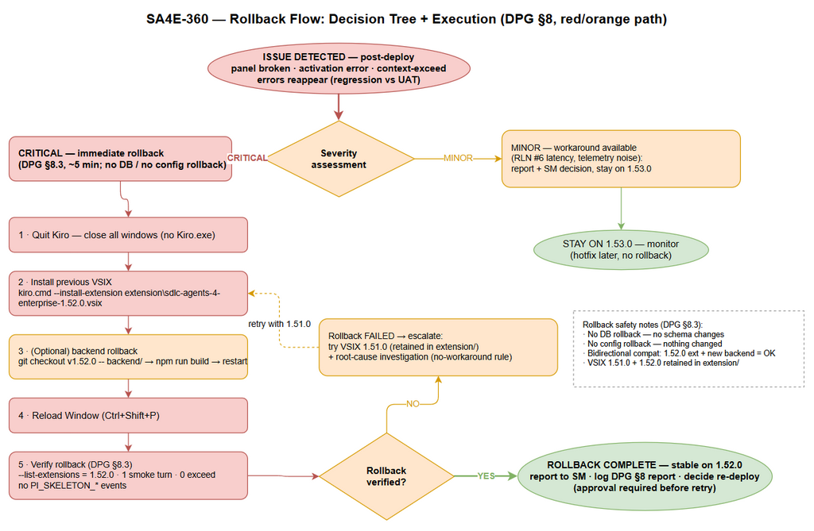
Rollback Flow

8.2 Rollback Decision Criteria
Condition | Action
Extension activation error / SDLC Chat panel broken | Immediate rollback to 1.52.0
Context-exceed errors reappear on session path (regression vs UAT) | Immediate rollback to 1.52.0
Turn duration persistently ≫ 421 s (unusable) | Report + SM decision; rollback if no workaround accepted (see RLN limitation #6)
New backend tool errors (code_symbol_locate / code_extract_signatures) | Optional backend rollback; extension alone degrades gracefully — extension rollback is sufficient
Minor telemetry noise / cosmetic issues | Hotfix — no rollback

8.3 Rollback Steps
Step | Action | Command | Verification
1 | Quit Kiro | Close all Kiro windows | No Kiro.exe process
2 | Install previous VSIX | kiro.cmd --install-extension extension\sdlc-agents-4-enterprise-1.52.0.vsix | “Successfully installed … 1.52.0”
3 | (Optional) backend rollback | git checkout v1.52.0 -- backend/ → cd backend; npm run build → restart | Old toolset registered; new tool routes unused
4 | Reload Window | Ctrl+Shift+P → “Developer: Reload Window” | Clean activation, no errors
5 | Verify rollback | kiro.cmd --list-extensions; run 1 smoke turn | Version 1.52.0; no PI_SKELETON_* events; 0 exceed
Notes: no DB rollback (no DB changes); no config rollback (nothing changed). VSIX 1.51.0 is also retained in extension/ if 1.52.0 is itself suspect. Backward compatibility is bidirectional (RLN §6.3): old backend + new extension = fallback ladder; new backend + old extension = additive tools unused.

8.4 Rollback Time Estimate
Action | Estimated Time
Extension rollback (install + reload) | ~2 min
Backend rollback (optional, from tag) | ~5 min
Verification (smoke turn + logs) | ~3 min
Total | ~5 min (extension only) / ~10 min incl. backend

9. Environment-Specific Notes

9.1 Build (DEV)
- Node ≥ 20; npm ci in both extension/ and backend/ before building.
- Gate: npm test in extension/ must be green before packaging and before tagging (Phase-7 run: 298 files / 2,899 tests passed — evidence/phase7-npm-test.log).
- Package with npm run package:prod (esbuild production bundle + checksums), never package:debug.

9.2 UAT — user workstation
- Executed & PASSED 2026-10-15 (CDP automation round 3, single window, frame-anchored typing, panel SDLC Chat):
  - SIT-01 PASS (138 s, 7,034-char review, 0 exceed)
  - SIT-02 PASS (get_workspace_info correct, cache verified)
  - SIT-04 PASS 6/6 turns (27–421 s; compaction 47k–56k ≤ usable 58,293)
  - SIT-07 PASS (driver saved response sit07.txt; user confirmed turn + response in panel)
  - SIT-08 PASS with exception (Finding E: 2 files 211/229 lines > 200, recorded)
  - SIT-03/05/06 NOT RUN (harness-specific, user-discretion) — see RLN §4
- Evidence: documents/SA4E-360/evidence/uat3/.

9.3 PROD / GA
- Deployment Window: immediate (workstation release; no shared-infra window needed).
- Approval Required From: SM sign-off; QA UAT record (obtained).
- GA artifact set: annotated git tag v1.53.0 + README changelog entry + this DPG/RLN pair.
- Communication Plan: notify users via README changelog; SM attaches DPG/RLN to Jira SA4E-360.
- On-Call Contact: DevOps agent (via SM).

9.4 npm publish (backend server)
Deferred — the loopback backend ships from source in this release. Publishing sdlc-agent-4-enterprise-server to npm is an optional follow-up requiring SM approval (README Quick Start already documents the npm path for older versions).

10. Appendix

Contacts
Role | Name | Contact
Release Manager / SM | (per Jira SA4E-360 assignee) | Jira
Dev Lead | (per Jira component owner) | Jira
QA Lead | (per Phase 6 owner) | Jira
On-Call DevOps | DevOps agent (via SM) | Jira

Related Tickets
Ticket | Summary | Relationship
SA4E-360 | Multi-Resolution Context Supply P1 | Main ticket
SA4E-355 | Context Budget Governance (3-gate) | Predecessor — foundation shipped in v1.52.0
SA4E-361 | Skeleton into legacy chat path | Follow-up — future work, not in this release
SA4E-356 / SA4E-358 | MCP path resolution / CORS Origin-Host gate | Same release train (v1.52.x security hardening)

Evidence Index
Evidence | Location
Extension full suite (impl) | evidence/extension-full-suite.log, evidence/round2-ext-full-suite.log
Backend unit + E2E-API suites | evidence/backend-unit-suite.log, evidence/backend-e2e-api-suite.log, evidence/round2-backend-focused.log, evidence/round2-e2e-api.log
Security-fix verification | evidence/f-fix-verification-2026-10-15.log
Pentest run | evidence/pentest-360-run.log, testdata/pentest-360-results.csv
UAT round 3 | evidence/uat3/ (screenshots, console, driver logs, UAT3-SUMMARY.md)
Phase-7 pre-tag suite | evidence/phase7-npm-test.log

