Software Test Plan (STP)

SDLC Agents 4 Enterprise — SA4E-360: Multi-Resolution Context Supply for Pi Harness — P1: Code Skeletonization + Agentic Context Loading

Document Information
Field | Value
Jira Ticket | SA4E-360
Title | Multi-Resolution Context Supply for Pi Harness — P1: Code Skeletonization + Agentic Context Loading (wire dormant foundation)
Author | QA Agent
Version | 1.0
Date | 2026-10-14
Status | Draft — pending BA review (Review Gate)
Related BRD | documents/SA4E-360/BRD.md (v1.1)
Related FSD | documents/SA4E-360/FSD.md (v1.2, SA-DISCREPANCY-ALIGNED)
Related TDD | documents/SA4E-360/TDD.md (v1.1)
Security Review | documents/SA4E-360/SECURITY-REVIEW.md (v1.0 — PASS WITH NOTES)
Governance baseline | documents/SA4E-355/TDD.md (v1.3 §13 — 3-point budget gate, UNTOUCHED)

Author Tracking
Role | Name - Position | Responsibility
Author | QA Agent – QA Engineer | Create document
Peer Reviewer | BA Agent – Business Analyst | Business-coverage review (Review Gate)

Revision History
Version | Date | Author | Changes
1.0 | 2026-10-14 | QA Agent | Initiate document — auto-generated from BRD v1.1 (5 stories, BR-360-01..05, M1–M6), FSD v1.2 (UC-360-01..05, C-360-* contracts, 12 error scenarios, §10.1 test scenarios TC-360-01..22), TDD v1.1 (T1–T9 checklist, 8 new skeleton modules + 2 backend tools), and SECURITY-REVIEW v1.0 (SEC-360-01..08). 6 test levels (PBT/UT/IT/E2E-API/E2E-UI/SIT), 78 test cases, 11 test data CSVs.
1.1 | 2026-10-14 | QA Agent | SM review fix (Step 4b — CSV test data coverage gap): 6 STC IDs (PBT-08, UT-11, IT-02, IT-07, IT-11, E2E-API-12) were referenced only inside composite A;B test_case_id values, so the CSV coverage script counted them as uncovered. Added 5 dedicated test data CSVs (16 total) giving each of the 78 STC IDs an exact-ID row; extended FIX-01 signature to 133 chars to satisfy the “>120-char fixture” precondition. Coverage re-verified: 78/78 (script: Import-Csv → unique test_case_id vs STC ### LEVEL-xx sections).

Sign-Off
Name | Signature and date
 | ☐ I agree and confirm the test plan in this STP
 | ☐ I agree and confirm the test plan in this STP

1. Introduction

1.1 Purpose
This Test Plan (STP) defines the test strategy, scope, environment, schedule, and defect management for SA4E-360 — wiring the dormant multi-resolution context supply foundation into the Pi Harness chat path so that whole-workspace review on local LLMs (qwen 32k/65k) fits inside the model context window without overflow.
SA4E-360 is a wire-only ticket (BR-11): it composes existing mechanisms (governance plane SA4E-355 + dormant content modules) and adds 8 new skeleton modules (extension/src/pi-workflow/skeleton/) plus 2 thin backend MCP tools (code_symbol_locate, code_extract_signatures). The test plan therefore emphasizes:
- Governance non-regression — the 3-point budget gate (SA4E-355) must remain byte-for-byte effective (UC-360-05).
- Budget arithmetic exactness — resolver-true values are binding test oracles (@32k: margin 2,622 / usable 28,098 / staticBudget 19,668 / skeleton cap 13,767; @65k: 5,243 / 58,245 / 40,771 / 28,539 — DISC-7 resolver-authoritative).
- Security remediation verification — SEC-360-01 (secret redaction), SEC-360-02 (global budget bound), SEC-360-03 (rate limit / reindex cooldown), SEC-360-04 (backend path-containment twin — 4 vectors), SEC-360-05 (LIKE sanitization), SEC-360-06 (MAX_SLICE cap) are treated as DEV requirements with dedicated test cases.
- Metrics M1–M6 — each quantitative acceptance target has a designated measurement test case.

1.2 Test Objectives
- Verify all 5 user stories (BRD §2.3) and their acceptance criteria are implemented per FSD UC-360-01..05.
- Exercise every new business rule BR-360-01..05 and inherited rules BR-01/BR-02/BR-09/BR-11 in their SA4E-360 context.
- Validate the API contracts C-360-S1..S3, C-360-R1/R2, C-360-M1/M2, C-360-F1 (FSD §3.x.5 — binding for DEV).
- Prove the 12 error scenarios (FSD §9.1) degrade gracefully — the turn/session NEVER crashes, and the provider is NEVER called oversized (BR-09).
- Verify the 12 FSD §10.1 test scenarios (TC-360-01..22) with reproducible steps and concrete expected results.
- Verify security requirements SEC-360-01..08 from the Security Design Review, including redaction and path-containment 4-vector coverage.
- Measure the 6 success metrics M1–M6 (coverage ≥ 95%, hit-rate ≥ 80% top-5, findings parity ≥ 80%, p95 ≤ 300 ms FTS5, 0 × exceed_context_size_error, skeleton ≤ 70% staticBudget).
- Prove zero regression to the SA4E-355 governance baseline (285 test files / 2,748 tests green) after every task.

1.3 References
Document | Location
BRD v1.1 | documents/SA4E-360/BRD.md
FSD v1.2 (TA-enriched, DISC-1..7 applied) | documents/SA4E-360/FSD.md
TDD v1.1 (§12 implementation checklist T1–T9) | documents/SA4E-360/TDD.md
Security Design Review v1.0 (SEC-360-01..08) | documents/SA4E-360/SECURITY-REVIEW.md
SA4E-355 TDD v1.3 §13 (governance baseline) | documents/SA4E-355/TDD.md
SA4E-355 FSD §3.8 (inherited BR-01/02/09/11) | documents/SA4E-355/FSD.md
Test Cases (STC) | documents/SA4E-360/STC.md
Test data | documents/SA4E-360/testdata/*.csv (16 files)

2. Test Strategy

2.1 Test Levels
Level | Scope | Automation | Tools | Location
PBT | Property-based: budget arithmetic invariants (resolver-true values), truncation loop invariants (strict-shrink, termination), skeleton sizing ≤ 70% staticBudget, signature normalization, redaction completeness | ✅ Automated | vitest + fast-check | extension/src/pi-workflow/skeleton/tests/*.property.test.ts
UT | Unit: SkeletonProvider, SkeletonTruncator, IndexFreshnessChecker, ReadMethodTool (envelopes + disambiguation), FunctionalMapProvider, redactSecretLike (SEC-360-01) | ✅ Automated | vitest | extension/src/pi-workflow/skeleton/tests/, backend/src/engine/tools/tests/
IT | Integration: createHost wiring (gate #2 measure==inject byte-identical), read_method → code_symbol_locate chain (in-process Hono), gate #3 interaction (read_method results compactable), TurnBudgetGuard interplay | ✅ Automated | vitest + Hono in-process | extension/src/pi-workflow/skeleton/tests/skeleton-wiring.integration.test.ts
E2E-API | REST/MCP endpoint E2E on real backend server: code_symbol_locate + code_extract_signatures over real QueryLayer (SQLite + PostgreSQL dual-engine), loopback wrapper timeout/retry, rate limit | ✅ Automated | vitest + fetch (real server) | backend/tests/e2e/sa4e-360-tools.e2e.test.ts
E2E-UI | Browser/extension UI E2E — minimal by design (“no UI changes” invariant): usage indicators regression + transcript tool-activity rendering | ✅ Automated | Playwright | tests/e2e/sa4e-360-ui.e2e.test.ts
SIT | Manual exploratory: skeleton injection visible in system context, functional map in get_workspace_info, degraded mode (index stale), multi-turn review session on qwen 32k, REJECT surface, findings parity (M3) | ❌ Manual | VS Code + llama-server + browser checklist | documents/SA4E-360/testdata/sit-checklist-testdata.csv
STP Test Cases Summary (consistent with STC v1.0):
Level | Count | Automated | Manual
PBT | 10 | 10 | 0
UT | 34 | 34 | 0
IT | 12 | 12 | 0
E2E-API | 12 | 12 | 0
E2E-UI | 2 | 2 | 0
SIT | 8 | 0 | 8
Total | 78 | 70 (89.7%) | 8 (10.3%)

2.2 Test Types
Type | Description | Applicable
Functional Testing | UC-360-01..05 main/alternative/exception flows per FSD §3 | Yes
Regression Testing | SA4E-355 governance suites green (context-governance, context-budget, budget-gate, session-tier, transcript-compaction) + E2E-UI indicators | Yes — gate after every task (TDD §12)
Performance Testing | p95 latency M4 ≤ 300 ms, skeleton build ≤ 2 s p95, map build ≤ 500 ms p95, budget resolution < 50 ms | Yes (measurable ACs in FSD §8)
Security Testing | SEC-360-01..08: redaction, containment 4 vectors, rate limit, LIKE sanitization, MAX_SLICE cap, ReDoS guard | Yes
Usability Testing | Manual SIT — reviewer UX with skeleton + functional map on qwen 32k | Yes (SIT only)
Compatibility Testing | Dual-engine index (SQLite + PostgreSQL) parity | Yes (E2E-API-04)

2.3 Test Approach
- Risk-based, wire-first. The highest-risk areas are (a) gate interaction — any wiring defect that skips/weaken a gate is Critical; (b) budget arithmetic — resolver-true values are the single source of truth (DISC-7); (c) fail-safe dominance — REJECT must be provable with the provider never called. These get the deepest coverage (PBT + IT + E2E-API + SIT).
- Redundancy avoidance between levels. Each property/behavior is asserted at exactly ONE primary level; lower levels cover construction mechanics, higher levels cover composition:
  - Budget arithmetic FORMULA → PBT (PBT-01..03); its USE in gate ordering → IT-02; its TELEMETRY → SIT-01. No duplicated arithmetic asserts in UT.
  - Truncation MECHANICS (cap, priority, re-measure) → UT-01..05; loop INVARIANTS (shrink, termination, global bound) → PBT-04..07/10; forced-overflow END-TO-END → IT-03 + SIT-05.
  - Symbol resolution SQL semantics → E2E-API (real engine); envelope/steering logic → UT; full chain (extension tool → loopback → backend) → IT-04. E2E-API never re-asserts envelope shapes already covered by UT.
- Real dependencies over mocks (IT/E2E-API quality gate). IT uses the real createHost, real gates, real compaction, in-process Hono app for the backend chain — only the LLM provider is a scripted fake (a real llama-server is unavailable in CI). E2E-API runs against a REAL backend server with real SQLite/PostgreSQL QueryLayer — no mock-all. Local infrastructure (SQLite, Postgres, HTTP server, filesystem) MUST be real; mocking them classifies the test as UT and is a defect per the test-implementation review rule.
- Test-first alignment with TDD §12. Test IDs are grouped to the T1–T9 task checklist so DEV can implement tests first per task and keep npm test green after each task (ticket constraint).
- Security remediations are first-class requirements. SEC-360-01/02 (Medium) and SEC-360-03..06 (Low) each have designated test cases (RTM §10); the Security Review’s STP-recommended tests (secret-in-source → [REDACTED]; 200-file RAW_HEAD wall-clock; multi-root isolation) are included.

2.4 E2E Automation Coverage (SIT → E2E classification)
Scenario Type (candidate SIT) | Classification | Rationale
Budget arithmetic oracle values | PBT (PBT-01..03) | Pure functions — deterministic, property-expressible
Truncation loop invariants | PBT (PBT-04..07, PBT-10) | Random-input invariants; manual testing cannot enumerate inputs
Skeleton tool envelopes, validation, steering | UT (UT-17..25) | Pure logic with injected fakes
createHost wiring + measure==inject | IT (IT-01..02) | In-process, deterministic
Forced oversized skeleton → REJECT, provider never called | IT (IT-03) | Deterministic with scripted fake provider; SIT-05 keeps only the user-visible chat:error demo
read_method → backend chain | IT (IT-04) for chain + E2E-API (E2E-API-02..04) for real-engine SQL semantics | Splits chain wiring vs engine correctness
Gate #3 compaction absorption of read_method results | IT (IT-05) | Deterministic transcript construction
Locate latency p95 ≤ 300 ms (M4) | E2E-API-12 | Measurable on real server
Golden-set hit-rate (M2) | IT-11 | Drives real tool over fixture index
Usage indicators / transcript rendering regression | E2E-UI (E2E-UI-01..02) | DOM assertions
Skeleton visible in system context; reviewer UX | SIT (SIT-01, SIT-04) | Requires real LLM quality judgment
Degraded mode (stale index recovery UX) | SIT (SIT-03) — mechanics automated in UT-06..10/IT-09 | End-to-end recovery demo needs live workspace mutation
REJECT chat:error surface + provider-never-called proof | SIT (SIT-05) | Cross-process log inspection (llama-server)
Findings parity (M3) | SIT (SIT-06) | Human review-quality comparison
Code standards compliance | SIT-08 | Line-count/TSDoc spot-check (CI-assisted)
Result: 70/78 (89.7%) automated; only 8 manual SIT cases remain, all requiring human judgment, a real LLM, or cross-process evidence.

2.5 Entry Criteria
Level | Entry Criteria
PBT | skeleton-types.ts + truncator/resolver interfaces merged (T1 contracts); fast-check available in devDependencies
UT | Module under test exists per TDD §6.1; fixture CSVs loaded (documents/SA4E-360/testdata/); baseline suite green
IT | T1–T7 merged; createHost wire points implemented (T8); in-process Hono backend test harness available
E2E-API | Backend server boots on loopback with SQLite AND PostgreSQL adapters; 2 new tools registered (T3/T5 done)
E2E-UI | Extension builds (esbuild); SA4E-355 UI indicators present; Playwright harness configured
SIT | All automated levels green; llama-server running with qwen 32k (n_ctx 32,768 / maxOutput 2,048); code-intel backend indexed on the test workspace; STC SIT checklist printed

2.6 Exit Criteria
Level | Exit Criteria
PBT | 10/10 pass; no shrinking counterexamples unresolved
UT | 34/34 pass; every error envelope asserted (INVALID_ARGS/NOT_FOUND/AMBIGUOUS/INDEX_STALE/FILE_UNREADABLE/INDEX_UNAVAILABLE)
IT | 12/12 pass; measure==inject byte-identical proven; REJECT path proves provider never called
E2E-API | 12/12 pass on BOTH engines (where applicable); containment 4-vector rejection proven
E2E-UI | 2/2 pass; zero diff in SA4E-355 indicator behavior
SIT | 8/8 executed with evidence screenshots/log excerpts; M1–M6 values recorded; 0 Critical / 0 Major open
Overall | Full suite green (baseline 285 files / 2,748 tests + ~78 new); RTM 100%; STP/STC signed off

2.7 Test Execution Flow
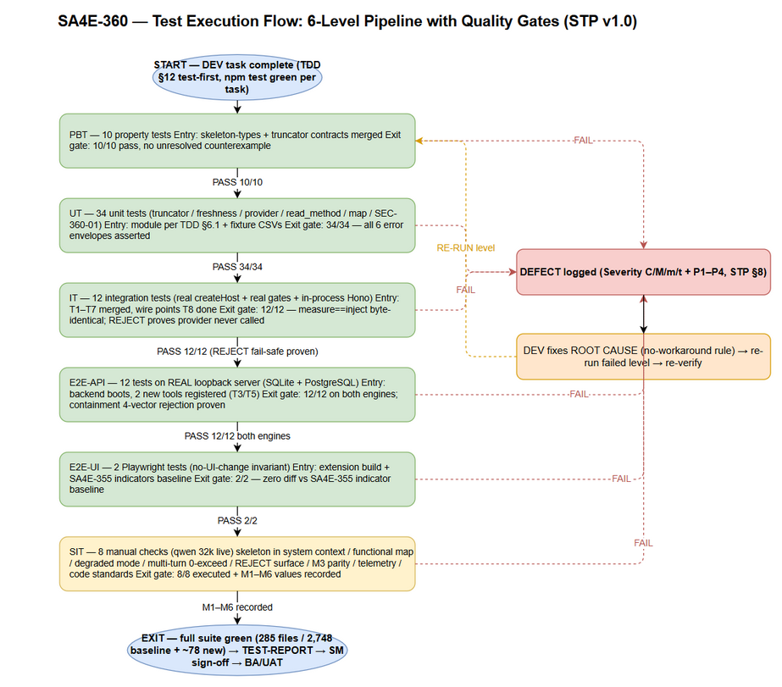 Edit in draw.io

3. Test Scope

3.1 Features In Scope
# | Feature / Story | Priority | FSD Reference | Levels Applied
1 | UC-360-01 Budget-aware code skeleton injection (gate #2, ≤ 70% cap, truncation, REJECT, DEGRADED) | High | FSD §3.1 | PBT, UT, IT, SIT
2 | UC-360-02 read_method tool (resolve, disambiguation, envelopes, bounds, containment) | High | FSD §3.2 | UT, IT, E2E-API, E2E-UI, SIT
3 | UC-360-03 Functional map in get_workspace_info (caps, cache, EF-1/EF-2) | High | FSD §3.3 | UT, IT, E2E-UI, SIT
4 | UC-360-04 Regex signature fallback (backend code_extract_signatures, RAW_HEAD, SKIPPED) | High | FSD §3.4 | UT, E2E-API, SIT
5 | UC-360-05 Governance regression safety (3 gates untouched, compaction, TurnBudgetGuard) | High | FSD §3.5 | IT, SIT
6 | SEC-360-01 Secret redaction (redactSecretLike + secret-file exclusion) | High | SECURITY-REVIEW §SEC-360-01 | PBT, UT
7 | SEC-360-02 Global budget bound + O(parts) truncator + termination cap | High | SECURITY-REVIEW §SEC-360-02 | PBT, UT
8 | SEC-360-03 Rate limit /mcp + reindex cooldown | Medium | SECURITY-REVIEW §SEC-360-03 | UT, E2E-API
9 | SEC-360-04 Backend path-containment twin (4 vectors: null-byte / UNC / dotdot / symlink) | High | SECURITY-REVIEW §SEC-360-04 | UT, E2E-API
10 | SEC-360-05 LIKE wildcard sanitization (findSymbols) | Medium | SECURITY-REVIEW §SEC-360-05 | E2E-API
11 | SEC-360-06 MAX_SLICE cap for read_method | Medium | SECURITY-REVIEW §SEC-360-06 | UT
12 | SEC-360-07 Control-character strip (defense-in-depth) | Low | SECURITY-REVIEW §SEC-360-07 | UT
13 | SEC-360-08 Inherited controls verified (containment, loopback-only, 1 MB cap, telemetry counts-only) | Medium | SECURITY-REVIEW §SEC-360-08 | UT, IT, E2E-API (re-verification)
14 | Metrics M1–M6 (coverage, hit-rate, parity, latency, zero-overflow, 70% share) | High | BRD §2.5 | IT, E2E-API, SIT
15 | Contracts C-360-S1..S3 / R1/R2 / M1/M2 / F1 | High | FSD §3.x.5 | UT, IT, E2E-API, SIT
16 | Dual-engine index parity (SQLite symbols_fts / PostgreSQL ILIKE) | Medium | FSD §1.3, TDD P-8 | E2E-API
17 | FSD §10.1 scenarios TC-360-01..22 | High | FSD §10.1 | Mapped in STC Appendix B

3.2 Features Out of Scope
# | Feature | Reason
1 | P2 Contextual RAG wire (ContextRetriever, RRF merger) | BRD §1.2 — future ticket; P1 validates skeleton + targeted reads only
2 | P3 Map-Reduce wire (MapReduceOrchestrator) | BRD §1.2 — escape hatch reserved; trigger condition (skeleton > staticBudget) is REJECT territory in P1
3 | P4 Call-graph pruning | Deferred (TA roadmap T6)
4 | Hybrid retrieval latency (≤ 1.5 s target) | M4 hybrid half validated only when P2 wires the hybrid path (BRD §2.5)
5 | New UI screens/controls | FSD §3.x.6 — “No UI changes”; only regression verification of SA4E-355 indicators (E2E-UI)
6 | Rate limiting of /api/admin/, /api/v1/pega/ | Pre-existing surfaces, unchanged by SA4E-360 (SEC-360-03 covers /mcp only)
7 | SA4E-355 gate internals re-design | Governance plane is UNTOUCHED — only interaction/regression is tested (UC-360-05)
8 | M2 hit-rate on fallback-extracted (non-indexed) symbols | OI-4 — fallback symbols are TRANSIENT; M2 scoped to indexed symbols
9 | Multi-root merged skeleton | OI-3 — P1 ships single-active-root; only per-root isolation is tested (IT-08)

3.3 Test Coverage Overview
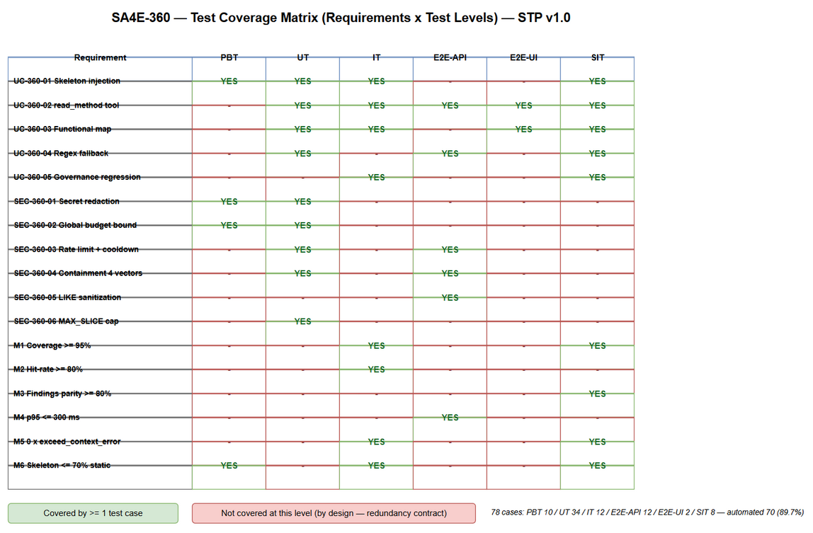 Edit in draw.io

4. Test Environment

4.1 Environment Requirements
Environment | Configuration | Purpose
DEV-CI (PBT/UT/IT) | Node LTS, vitest, fast-check; extension + backend packages; in-process Hono app; temp fixture workspaces | Automated levels 1–3
E2E-API | Real backend MCP server on loopback (JSON-RPC POST /mcp); SQLite (SCHEMA_V1 + symbols_fts) AND PostgreSQL adapters; fixture workspace indexed | Levels 4 — real QueryLayer, no mocks
E2E-UI | VS Code extension dev host (or webview harness) + Playwright Chromium | Level 5 — DOM regression
SIT | Windows dev machine: VS Code + SA4E extension build; llama-server qwen 32k (contextWindow 32,768 / maxOutput 2,048); code-intel backend indexed on a representative workspace (≥ 200 files incl. Svelte/grammar-less) | Level 6 — end-to-end human-verified

4.2 Tooling
Tool | Use
vitest | PBT/UT/IT runner (extension + backend)
fast-check | Property-based tests (PBT)
Hono in-process (app.request()) | IT for /mcp backend chain without network
fetch against real loopback server | E2E-API
Playwright | E2E-UI + SIT browser evidence
llama-server (qwen 32k/65k) | SIT reviewer LLM
VS Code extension log | Telemetry evidence (PI_SKELETON_*, PI_GATE_DECISION, PI_READ_METHOD_RESULT)

4.3 Test Data Requirements
All test data is versioned as CSV under documents/SA4E-360/testdata/ — every STC test case ID appears in at least one CSV as an exact test_case_id value (78/78, verified by the coverage script: Import-Csv *.csv → Sort-Object -Unique test_case_id vs the 78 ### LEVEL-xx sections in STC.md; v1.0 covered 72/78 because 6 IDs appeared only inside composite A;B references).
# | File | Covers | Rows
1 | pre-seeded-index-fixtures.csv | Baseline files/symbols fixtures for build/render/cache/multi-root/coverage (PBT-08, UT-11/12/16, IT-08/09/12, E2E-API-01/02/04) | 14
2 | index-freshness-testdata.csv | Freshness states: fresh/touch-only/content-changed/reindex-fail/cooldown/wrapper-timeout (UT-06..10, IT-09, E2E-API-08, SIT-03) | 9
3 | budget-scenarios-testdata.csv | Resolver oracle values @32k/@65k/default + arbitrary nCtx (PBT-01..03, IT-01/02/07) | 8
4 | truncation-scenarios-testdata.csv | Module priority parts, forced-overflow, global-bound properties (PBT-04..07/10, UT-01..05, IT-03) | 12
5 | read-method-testdata.csv | read_method inputs → envelopes (UT-17..25, IT-04/05/06, E2E-API-02/03/04/09) | 20
6 | skeleton-fallback-testdata.csv | Grammar-less files, fallback ladder, empty corpus (UT-13/14/15, E2E-API-05/06, SIT-07) | 9
7 | secret-redaction-testdata.csv | Secret-like patterns → [REDACTED] (PBT-09, UT-30..34) | 12
8 | backend-security-testdata.csv | Containment 4 vectors + rate limit + LIKE sanitize + tenant (UT-24, E2E-API-07/09/10/11) | 12
9 | golden-query-set.csv | M2 hit-rate + M4 latency golden queries — 12-query FROZEN set, composite refs IT-11;E2E-API-12 (exact-ID metric/benchmark rows live in files #12 and #13) | 12
10 | functional-map-testdata.csv | Map entries, caps, EF-1/EF-2 (UT-26..29, IT-10, SIT-02) | 8
11 | sit-checklist-testdata.csv | Manual SIT + E2E-UI execution checklist (SIT-01..08, E2E-UI-01/02) | 10
12 | signature-normalization-testdata.csv | PBT-08 signature samples — >120/120-boundary/121 just-over/whitespace-collapse inputs → expected normalized ≤ 120 chars (input uses literal \t/ escapes interpreted as tab/newline) | 6
13 | golden-hitrate-testdata.csv | IT-11 M2 metric rows — hit-rate ≥ 80% top-5 over the frozen 12-query set (11 ok + GQ-12 designed miss = 91.7%) | 3
14 | latency-benchmark-testdata.csv | E2E-API-12 M4 benchmark — 12 golden queries × 20 iterations = 240 latencies, p95 ≤ 300 ms; hybrid-scope exclusion row | 14
15 | skeleton-render-testdata.csv | UT-11 batched corpus render format per FSD §3.1.4 — file header line, kind+name lines, no bodies, single fetchSymbolCorpus call | 6
16 | gate-order-escalation-testdata.csv | IT-02 gate-order wiring (measure BEFORE createAgentSession) + IT-07 BR-08 escalation ladder tiers (compress → drop steering → min loadout → REJECT) | 7

4.4 External Dependencies
System | Dependency | Mock/Stub Policy
code-intel backend | REAL server for E2E-API/IT (in-process Hono for IT) | ❌ Never mocked in IT/E2E-API (quality gate)
SQLite / PostgreSQL | REAL engines for dual-engine parity | ❌ Never mocked
llama-server (qwen 32k/65k) | Required for SIT only | ✅ Scripted fake provider in IT (CI has no local LLM) — acceptable, external paid-equivalent boundary
VS Code extension host | Required for E2E-UI/SIT | ❌ Real

5. Test Schedule
Phase | Start Date | End Date | Duration | Milestone
Test Planning | 2026-10-14 | 2026-10-15 | 1 d | STP + STC BA-approved
Test Data Preparation | 2026-10-15 | 2026-10-15 | 0.5 d | 16 CSVs + fixture workspace ready
PBT + UT execution (T1–T7) | 2026-10-16 | 2026-10-20 | 3 d | 44 automated cases green
IT execution (T8) | 2026-10-20 | 2026-10-21 | 1 d | 12 wiring cases green
E2E-API + E2E-UI (T9) | 2026-10-21 | 2026-10-22 | 1 d | 14 cases green on both engines
SIT execution (manual) | 2026-10-22 | 2026-10-23 | 1.5 d | 8 SIT executed + evidence
Defect Fix & Retest | 2026-10-23 | 2026-10-24 | 1 d | 0 Critical/Major open
UAT / Sign-off | 2026-10-24 | 2026-10-24 | 0.5 d | TEST-REPORT + metrics recorded

6. Resources & Responsibilities
Role | Name | Responsibility
Test Lead | QA Agent | Test planning, RTM, metrics reporting, BA review coordination
QA Engineer | QA Agent | STC authoring, automated suite review (implementation-vs-spec), SIT execution, evidence collection
BA | BA Agent | Business-coverage review gate (STC vs BRD/FSD), UAT acceptance
Developer | DEV Agent | Test-first implementation (T1–T9), bug fixing, fixture hooks
Solution Architect | SA Agent | Clarifies TDD §4/§6 contracts when tests expose design ambiguity
Security Agent | Security Agent | Re-verification of SEC-360-01..06 remediations at Phase 5.7
DevOps | DevOps Agent | CI wiring for vitest + Playwright jobs, PostgreSQL test service

7. Risk & Mitigation
# | Risk | Impact | Likelihood | Mitigation
1 | Budget arithmetic drift between docs and resolver (DISC-7-type slips) | High | Medium | PBT-01..03 hard-code resolver-true oracles; any doc/resolver mismatch fails CI immediately
2 | Truncation loop latency blow-up on large grammar-less workspaces (SEC-360-02) | High | Medium | PBT-10 + UT-01..05 enforce global incremental bound; SIT workspace includes ≥ 100 RAW_HEAD files; wall-clock assert in IT-01
3 | Secrets leaking into skeleton/system context (SEC-360-01) | High | Medium | PBT-09 + UT-30..34 redaction suite; secret-file exclusion rows; Phase 5.7 re-verification
4 | Backend containment twin weaker than extension path-containment (SEC-360-04) | High | Low | E2E-API-07 runs all 4 vectors against the REAL server; UT-24 asserts rejection before read
5 | Governance regression from wiring (gate skipped/weakened) | High | Low | IT-01/02/03/05/07 gate-interaction suite + full baseline suite green gate after every TDD task
6 | Test environment: llama-server unavailable/flaky for SIT | Medium | Medium | SIT scheduled in dedicated window; IT uses scripted fake provider so automation never blocks on LLM
7 | Dual-engine behavior divergence (SQLite FTS5 vs PostgreSQL ILIKE) | Medium | Medium | E2E-API-04 runs the same fixture set on both engines and diffs row-for-row
8 | Golden query set bias (M2/M4) | Medium | Low | Golden set drawn from real indexed symbols across ≥ 5 modules; scope limited to indexed symbols (OI-4), documented in STC Appendix C

8. Defect Management

8.1 Severity Levels
Severity | Definition | Example (SA4E-360 context)
Critical | Security breach or governance broken | Secret appears unredacted in skeleton (SEC-360-01); provider called oversized (BR-09 violated); gate skipped
Major | Feature not working, workaround exists | read_method returns wrong slice; map never served; REJECT not raised on persisting overflow
Minor | Degraded behavior with workaround | Fallback share not logged separately; telemetry payload field missing
Trivial | Cosmetic/logging | Typo in event payload, log level mismatch

8.2 Priority Levels
Priority | Definition | SLA (Fix Time)
P1 | Must fix immediately | 4 hours
P2 | Must fix before release | 1 business day
P3 | Should fix if time permits | 3 business days
P4 | Nice to fix, can defer | Next release

8.3 Defect Lifecycle
New → Open → In Progress → Fixed → Ready for Retest → Verified → Closed
→ Reopened → In Progress
Quality-gate defects (test-implementation review): an IT/E2E test that mocks local infrastructure (SQLite/Postgres/HTTP server) instead of using real instances, or that bypasses the real createHost chain, is itself a Major defect — sent back to DEV with the STC spec reference.

9. Test Metrics & Reporting

9.1 Test Execution Metrics
Metric | Formula | Target
Test Execution Rate | Executed / 78 × 100% | 100%
Pass Rate (automated) | Passed / 70 × 100% | 100% at exit
Automation Ratio | Automated / Total × 100% | ≥ 89% (achieved: 89.7%)
Requirement Coverage (RTM) | Covered requirements / 48 × 100% | 100%
Defect Density | Defects / 78 test cases | ≤ 0.15
Critical Defects | Count | 0

9.2 BRD Metric Measurement Procedures (M1–M6)
Metric | Target | Measurement Test | Procedure
M1 Skeleton coverage | ≥ 95% exported symbols | IT-12 | Diff skeleton-rendered symbol names vs symbols table for the fixture workspace; fallback share reported separately from PI_SKELETON_FALLBACK count (OI-4 scope)
M2 read_method hit-rate | ≥ 80% top-5 | IT-11 | Run golden-query-set.csv (12 queries) through ReadMethodTool with real locator; hit = status ok; ratio ≥ 80%
M3 Findings parity | ≥ 80% | SIT-06 | Same 10-file subset reviewed twice (skeleton+targeted reads vs full-context baseline); findings matched by file+issue; ratio ≥ 80%
M4 Retrieval p95 latency | FTS5 ≤ 300 ms | E2E-API-12 | 12 golden locate queries × 20 iterations on real server; p95 from PI_READ_METHOD_RESULT.durationMs / measured fetch times
M5 Zero context overflow | 0 × exceed_context_size_error | SIT-04 (+IT-03/05) | Turn-1 + 10-turn review on qwen 32k; grep run log for exceed_context_size_error — count must be 0
M6 Skeleton token share | ≤ 70% staticBudget | PBT-07, IT-02, SIT-01 | PI_GATE_DECISION enriched payload skeletonTokens/staticBudget per session; usagePercent ≤ 0.70

9.3 Reporting Schedule
Report | Frequency | Audience
Automated suite status | Per CI run / per TDD task | DEV + SM
SIT execution report | End of SIT window | SM + BA
TEST-REPORT (TEST-REPORT-TEMPLATE) | Phase 6 exit | All stakeholders

10. Appendix

10.1 Glossary
Term | Definition
PBT | Property-Based Testing — invariant assertions over random inputs (fast-check)
IT | Integration test — real createHost/gates/in-process Hono backend; only the LLM provider is scripted
E2E-API | Automated test against the REAL loopback backend server (JSON-RPC POST /mcp)
E2E-UI | Playwright browser assertions on the extension webview
SIT | System Integration Testing — manual, human-verified scenarios
staticBudget | 70% share of usable tokens — 19,668 @32k / 40,771 @65k (resolver-authoritative)
Skeleton cap | floor(0.70 × staticBudget) — 13,767 @32k / 28,539 @65k (BR-360-01)
Golden query set | 12 read_method queries over real indexed symbols used for M2/M4 (Appendix C)
Resolver-true values | Budget numbers produced by the shipped resolveContextBudget (DISC-7) — the only accepted oracle
Fallback ladder | GRAMMAR → REGEX_SIGNATURES → RAW_HEAD → SKIPPED (UC-360-04)

10.2 Assumptions
- estimateTokenCount (chars/4 ∨ words×1.3, max) precision is acceptable, backed by the 8% safety margin (BR-02) — consistent with SA4E-355 A-6.
- qwen 32k is the primary SIT target; 65k is secondary (AF-3).
- CI provides a PostgreSQL service for the dual-engine E2E job; if not, E2E-API-04 runs in the nightly job with a containerized Postgres.
- The golden query set (Appendix C / golden-query-set.csv) is frozen at test-planning time; changes require SM approval.

10.3 Deliverables
# | Deliverable | Location
1 | STP (this document) | documents/SA4E-360/STP.md
2 | STC (78 test cases + RTM) | documents/SA4E-360/STC.md
3 | Test data (16 CSVs) | documents/SA4E-360/testdata/*.csv
4 | Coverage + execution flow diagrams | documents/SA4E-360/diagrams/test-coverage.{drawio,png}, test-execution-flow.{drawio,png}
5 | Test execution report | documents/SA4E-360/TEST-REPORT-SA4E-360.md (+ CSV tracker) — Phase 6
6 | Evidence | documents/SA4E-360/evidence/ (screenshots, log excerpts)

End of STP — SA4E-360 v1.0. Traceability: every section maps to BRD v1.1 / FSD v1.2 / TDD v1.1 / SECURITY-REVIEW v1.0. Pending: BA review gate (STC business-coverage review) → then DOCX/XLSX export + Jira attachment by SM.

