Technical Design Document (TDD)

Pi Chatbox Extension — SA4E-369: Intra-instance agent-to-agent messaging between chatbox tabs (local PeerBus, zero-config)

Document Information
Field | Value
Jira Ticket | SA4E-369
Title | Intra-instance agent-to-agent messaging between chatbox tabs (local PeerBus, zero-config)
Author | SA Agent
Version | 1.0
Date | 2026-10-20
Status | Draft
Related BRD | documents/SA4E-369/BRD.md
Related FSD | FSD v1.1 (TA-enriched) — documents/SA4E-369/FSD.md
Related UI Spec | documents/SA4E-369/UI-SPEC.md
Locked Decisions | documents/SA4E-369/STATUS.json (D1–D5, AC1–AC8 — do not reopen)

Revision History
Version | Date | Author | Changes
1.0 | 2026-10-20 | SA Agent | Initiate document — technical design translated from FSD v1.1 (TA-enriched) and verified against actual codebase (extension/src/).

Sign-Off
Name | Signature and date
 | ☐ I agree and confirm the technical design in this TDD
 | ☐ I agree and confirm the technical design in this TDD

1. Introduction
Scope Boundary: This TDD specifies HOW to implement the requirements defined in FSD v1.1. It does NOT repeat functional requirements, business rules, use cases, or UI specifications — refer to the FSD for those. This document focuses on: component architecture, TypeScript interfaces, in-process data structures, concurrency design, error mapping, and testability.

1.1 Purpose
SA4E-369 adds intra-instance agent-to-agent messaging: every chatbox tab in one VS Code extension host registers as a peer, and an agent running in any tab can message an agent in another tab via an in-process PeerBus — with blocking request/response and async dispatch/poll modes, auto-run delivery with anti-loop guards, and zero configuration (no config files, no sockets, no persistence).
This TDD translates the FSD’s technical enrichment (§2.2.1–2.2.2, §3.4.4, §3.5.3, §3.6.3, §5.5.1) into an implementable design for the DEV agent: exact module layout, TypeScript shapes, wiring points in extension/src/, and the concurrency discipline that the single-threaded extension host requires.

1.2 Scope
In scope (technical): 1. New additive module extension/src/peer/ — PeerRegistry, PeerBus, PeerTaskManager, AntiLoopGuards, PeerThreadStore, session tools (peer_list / peer_send / peer_status). 2. D1 per-tab session integration: consume the LANDED session host (pi-workflow/session-host/ — key workspaceRoot+tabId, "default" rejected) — wire chat tab lifecycle to PeerRegistry, per-tab identity into ensureSessionHost, evictSessionHost on close; per-tab token accounting and compaction are inherited (AC6). 3. Wiring points: extension activation, chat tab lifecycle, SessionHost promptTurn reply capture, context-governance pass-through. 4. In-memory data structures and their bounds (thread 50 FIFO, rate window 10/60s, inbound queue cap 20, blocking timeout 300s).
Out of scope (locked D5 + FSD §1.2 Non-Goals NG-1..NG-6): cross-machine/cross-window transport (pi-a2a’s job), mDNS/HTTP/gateway, network sockets, persistence, replacing pi-subagents/acp_delegate, human inbox approval.

1.3 Technology Stack
Layer | Technology | Version / Note
Language | TypeScript | strict mode, matches extension/tsconfig.json
Runtime | VS Code Extension Host (Node.js) | single-threaded JS event loop
Runtime library | Node.js events.EventEmitter | PeerBus event backbone (D3 “EventEmitter-style”)
Identity | uuid v4 | tabId / taskId generation (pattern already used by ConversationManager)
Test framework | vitest | 4.1.8 — test:unit, test:e2e scripts in extension/package.json
Database | None | in-memory only (BR-12, D5)
Network | None | no sockets/ports/tokens (AC7, D5)
No new dependencies are introduced — everything uses what the extension already ships.

1.4 Design Principles
- Single-tick atomicity — every check-then-mutate sequence (guard evaluation, register/deregister, task state transition) runs synchronously inside one event-loop tick; no await between check and commit (FSD §2.2.1).
- Update-then-emit — mutate internal state first, broadcast on the bus after; subscribers never observe stale state.
- Defensive copies at boundaries — peer_list() and peer_status() return deep-copied snapshots; no internal mutable object escapes the peer/ module.
- Zero-state rejection — guards run BEFORE a PeerTask object exists; a rejected send leaves no task, no counter increment, no thread entry (FSD §2.2.2 backpressure principle).
- Additive integration — peer prompts enter the governance pipeline at the SAME entry point as user prompts; no semantic change to existing governance or session-routing code paths (FR-10, AC8).
- Shape-compatible contract (D4) — the pi-a2a adapter point is isolated to one module (peer/bus.ts send/result envelope) so a future transport swap touches only that file.
- Singletons per extension host — PeerBus/PeerRegistry/PeerTaskManager are created once in extension.ts activation, never per tab (FSD §2.2.1 item 4).
- Code standards — SOLID, ≤200 lines/file, ≤20 lines/function, types separated into peer/types.ts.

1.5 Constraints
# | Constraint | Source
C-1 | D1–D5 are LOCKED (STATUS.json) — this design details them, it does not reopen them | STATUS.json
C-2 | All peer state is in-memory only; discarded on tab close / host deactivation | BR-12, D5
C-3 | Zero configuration: no config files/keys, no settings UI, no sockets | AC7, D5
C-4 | maxPingpongTurns = 5 is LOCKED; other constants (rate 10/60s, thread 50, timeout 300s, queue cap 20) are TDD-tunable internal constants | AC3, FSD §11.4
C-5 | Existing suites context-governance.*, auto-chunk, session routing must stay green | AC8, FR-10
C-6 | Extension host is single-threaded — no locks/mutexes anywhere in the design | FSD §2.2.1

1.6 References
Document | Location
BRD v1.0 | documents/SA4E-369/BRD.md
FSD v1.1 (TA-enriched) | documents/SA4E-369/FSD.md
UI Specification v1.0 | documents/SA4E-369/UI-SPEC.md
STATUS.json (D1–D5, AC1–AC8) | documents/SA4E-369/STATUS.json
Template | documents/templates/TDD-TEMPLATE.md
Verified source files | extension/src/pi-agent/*, extension/src/chat-panel/conversation-manager.ts, extension/src/logger.ts, extension/package.json

2. System Architecture

2.1 Architecture Overview
Everything lives inside ONE VS Code extension host process. There is no server, no socket, no port (AC7). The new peer/ module is a pure in-process layer that sits between the session tools (agent-facing) and the existing per-tab session stack (pi-agent/), with a UI event fan-out to the chat webview.
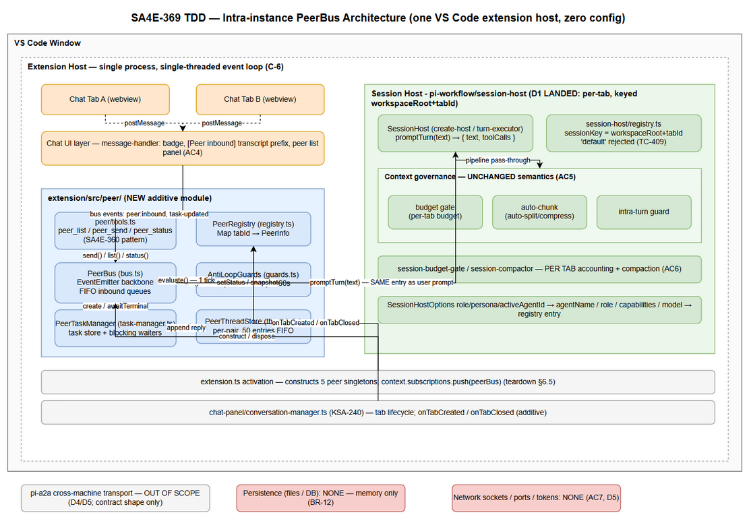 Edit in draw.io
Key structural facts (verified in codebase): - Chat tab lifecycle (open/close/switch) lives in extension/src/chat-panel/conversation-manager.ts (ConversationManager, KSA-240) — tabs already carry UUID ids; tab messages (tab:switch, tab:close, tab:rename) flow via chat-panel/message-protocol.ts. - D1 per-tab session host ALREADY EXISTS (parent epic SA4E-370 S3 landed): extension/src/pi-workflow/session-host/ — sessionKey(workspaceRoot, tabId) = workspaceRoot+tabId, validateTabId rejects "default" (TC-409), ensureSessionHost(...): Promise<SessionHost> cached per key, evictSessionHost(workspaceRoot, tabId) on close, SessionHost.promptTurn(text) → { text, toolCalls, sessionFile }. - Governance pipeline is reachable through the same host stack (budget/auto-chunk/intra-turn inside the turn executor and pi-agent/ helpers — session-budget-gate.ts, budget-gate.ts, context-budget-auto-split.ts, prompt-compressor.ts); peer prompts enter via the SAME promptTurn API (AC5). - Structured logging via extension/src/logger.ts (logger.debug/info/warn/error(msg, data?) — JSON lines).

2.2 Component Diagram
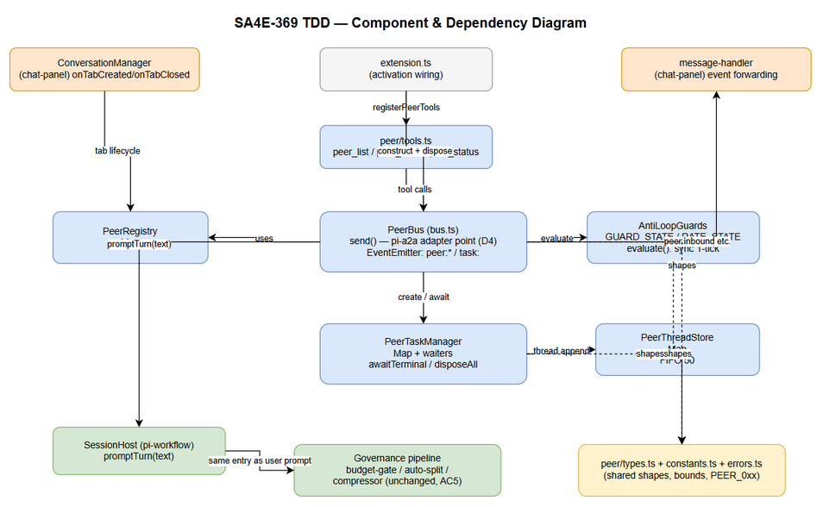 Edit in draw.io
Component | File (new unless noted) | Responsibility
PeerRegistry | extension/src/peer/registry.ts | In-memory Map<tabId, PeerInfo>; register/deregister/setStatus; deep-copy snapshots; collision-safe (BR-1, BR-2)
AntiLoopGuards | extension/src/peer/guards.ts | Owns GUARD_STATE (pair ping-pong chain) + RATE_STATE (per-tab rolling window); synchronous evaluate-or-reject (BR-7/BR-8/BR-9)
PeerBus | extension/src/peer/bus.ts | EventEmitter backbone; guard evaluation → task creation → delivery → FIFO inbound queues; emits peer:registered, peer:deregistered, peer:inbound, peer:task-updated; pi-a2a adapter point (D4)
PeerTaskManager | extension/src/peer/task-manager.ts | PeerTask store; state transitions; blocking waiter registry (task:<id> once-events + timeout timers); teardown cancellation
PeerThreadStore | extension/src/peer/threads.ts | Per-pair bounded conversation threads (50 entries FIFO, normalized pair key) — TDD refinement of FSD’s peer/ file list; separation-of-concerns per code standards
Session tools | extension/src/peer/tools.ts | peer_list / peer_send / peer_status registered per tab via the SA4E-360 custom tool plug-in pattern
Shared types | extension/src/peer/types.ts | All peer_* TypeScript shapes (single source of truth, “separate models” rule)
Constants | extension/src/peer/constants.ts | Guard/thread/timeout/queue bounds — the ONLY place values may be tuned (C-4)
ConversationManager (existing) | extension/src/chat-panel/conversation-manager.ts | Source of tab lifecycle; gains onTabCreated / onTabClosed event hooks (additive) that PeerRegistry subscribes to
Session Host (existing, D1 landed) | extension/src/pi-workflow/session-host/ — registry.ts, create-host.ts, turn-executor.ts, governance.ts | Per-tab sessions keyed workspaceRoot+tabId; promptTurn(text) executes the turn; evictSessionHost on tab close
Governance pipeline (existing) | turn executor + pi-agent/budget-gate.ts, context-budget-auto-split.ts, prompt-compressor.ts | Unchanged semantics; peer prompts pass through promptTurn like user prompts (AC5)
Chat UI (existing webview) | extension/src/chat-panel/* | Badge, transcript prefix, optional peer list panel — consumes bus events via message protocol

2.3 Deployment Architecture
Single-process deployment. The feature ships inside the existing extension bundle — no new process, container, or service.
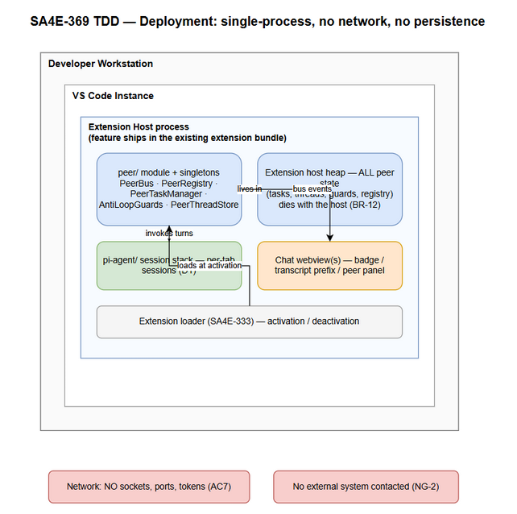 Edit in draw.io
Element | Location | Notes
peer/ module | Extension host (same bundle as pi-agent/, chat-panel/) | Loaded at activation (SA4E-333)
Peer state | Extension host heap | Dies with the host — no cleanup worker needed (BR-12)
Chat webview | VS Code webview (existing) | Receives bus events over the existing postMessage bridge
Network | Nothing | Verification point TC-08: no socket/port activity during exchange (AC7)

2.4 Communication Patterns
All communication is in-process, single-threaded, event-driven. There are no remote calls.
From | To | Mechanism | Sync/Async | Description
Agent tool call (peer_send) | PeerBus | Direct function call | Sync entry, async continuation | Blocking mode returns a Promise resolved by a task-terminal event (or timeout)
PeerBus | PeerRegistry / Guards / TaskManager | Direct function calls | Sync | Guard + create + deliver in ONE tick (§5.3)
PeerBus | Chat UI | EventEmitter → existing postMessage bridge | Async (events) | peer:inbound, peer:registered, peer:deregistered
PeerTaskManager | SessionHost (pi-workflow/session-host) | Direct call: ensureSessionHost(...) + promptTurn(text) | Async | Peer prompt enters the SAME turn API as user prompts (AC5)
SessionHost | PeerTaskManager | Promise resolution of promptTurn (SessionTurnResult.text) | Async | Reply (or failure) captured into the task (§6.2)
Caller | PeerTaskManager | peer_status(taskId) | Sync | Deep-copied task snapshot; side-effect free (UC-3 AF-1)

3. API Design
Note on paradigm: SA4E-369 exposes session tools (agent-invoked functions), not HTTP endpoints. The FSD functional contracts (UC-1/2/3) are authoritative for behavior; this section specifies the implementable TypeScript signatures, payload shapes, and error mapping. All shapes are defined in peer/types.ts and mirror pi-a2a field-for-field (D4, FSD §5.5.1).

3.1 API Overview
# | Tool | Signature | Mode | Source
1 | peer_list | peer_list(): PeerListResult | Sync | UC-1, FR-1
2 | peer_send | peer_send(tabId, message, async?): Promise<SendResult> | Blocking or Async | UC-2, UC-3; FR-2, FR-3
3 | peer_status | peer_status(taskId): PeerStatusResult | Sync | UC-3, FR-3
Registration: SA4E-360 custom tool plug-in pattern — each tool gets registerTool(name, description, { inputSchema, handler }), available to the agent in every tab, automatic (AC7).

3.2 Tool: peer_list
Implements: UC-1 (FR-1, BR-1, BR-2, BR-12)
Attribute | Value
Signature | peer_list(): PeerListResult
Input | none
I/O | Synchronous registry read; deep-copied snapshot; no state mutation
Response — success:
{
"peers": [
{
"tabId": "3f8a1c2e-...",
"agentName": "Reviewer",
"role": "reviewer",
"capabilities": ["code-review"],
"model": "glm-5.3",
"status": "idle",
"self": false
},
{
"tabId": "9b2d4f01-...",
"agentName": "Coder",
"role": "coder",
"capabilities": ["implement"],
"model": "glm-5.3",
"status": "busy",
"self": true
}
]
}
Error Responses:
Code | When | Behavior
PEER_0xx (unexpected) | Registry read fails (EF-1 of UC-1) | Tool error result, no partial data; tab remains functional

3.3 Tool: peer_send
Implements: UC-2 (blocking), UC-3 (async) — FR-2, FR-3, FR-4; BR-3, BR-4, BR-5, BR-7, BR-8, BR-13
Attribute | Value
Signature | peer_send(tabId: string, message: string, async?: boolean): Promise<SendResult>
async default | false (blocking)
Validation order | 1) target exists (PEER_001) → 2) not self (PEER_002) → 3) guards (PEER_004, PEER_005) → 4) queue cap (PEER_005) — ALL BEFORE task creation (zero-state rejection, §1.4 principle 4)
Request (JSON shape passed by the tool layer):
{
"tabId": "3f8a1c2e-...",
"message": "Review the changes in src/auth.ts and report findings",
"async": false
}
Response — blocking, success (200-equivalent):
{
"taskId": "t-7c31e9...",
"state": "completed",
"reply": "Findings: 1) missing null check at line 42 ..."
}
Response — async, immediate:
{
"taskId": "t-7c31e9...",
"state": "queued"
}
Error Responses (result envelope { error: { code, message } }):
Code | When | Task object created?
PEER_001 | Target tabId not in registry (BR-4) | No — immediate rejection
PEER_002 | tabId === caller self-send (BR-3) | No — immediate rejection
PEER_004 | Pair ping-pong cap 5 exceeded (BR-7) | No — immediate rejection; zero state
PEER_005 | Rate limit >10/60s for target OR inbound queue cap 20 hit (BR-8, §8.2) | No — immediate rejection
PEER_003 | Turn/session execution error in target | Yes — task created, fails during run
PEER_006 | Blocking caller timeout 300s (BR-13) | Yes — caller-side only; task keeps running and stays pollable
PEER_007 | Governance rejection in receiving turn (AC5) | Yes — task created, fails at governance stage
Blocking resolution semantics (FSD §2.2.2 ported): the returned Promise is settled by exactly one internal task:<taskId> event where state ∈ {completed, failed}; a 300s timer rejects the caller with PEER_006 without cancelling the task. On host teardown every pending waiter is rejected with a descriptive failure (§6.5).

3.4 Tool: peer_status
Implements: UC-3 (FR-3, BR-14); side-effect free, unlimited poll frequency (UC-3 AF-1)
Attribute | Value
Signature | peer_status(taskId: string): PeerStatusResult
I/O | Synchronous store lookup; deep-copied snapshot
Response — success:
{
"taskId": "t-7c31e9...",
"state": "completed",
"reply": "Findings: ...",
"fromTabId": "9b2d4f01-...",
"toTabId": "3f8a1c2e-...",
"createdAt": "2026-10-20T03:12:00.000Z",
"startedAt": "2026-10-20T03:12:00.100Z",
"completedAt": "2026-10-20T03:12:41.500Z"
}
state enum: queued | running | completed | failed | cancelled — terminal set is exactly {completed, failed, cancelled} (AC2). No extra terminal states are added locally; PEER_006 never appears as a task state (§3.3).
Error Responses:
Code | When | Behavior
PEER_008 | Unknown taskId (BR-14) | Tool error result

3.5 pi-a2a Shape Compatibility (D4)
The result envelope and parameter positions are field-compatible with pi-a2a a2a_call / a2a_status per FSD §5.5.1. Design consequence: the swap adapter is peer/bus.ts alone — tools.ts handlers and the state machine never reference the transport. Error codes remain local (PEER_0xx) but travel in the pi-a2a envelope shape (error.code + error.message) so a future adapter can translate 1:1.

4. Database Design
There is NO physical database (BR-12, D5, FSD §4). This section specifies the in-memory implementation structures: exact TypeScript shapes, containers, invariants, and bounds. The template’s DDL/migration/query-pattern subsections are N/A by design — replaced by structure definitions and invariant lists that DEV implements verbatim.

4.1 Data Structure Overview
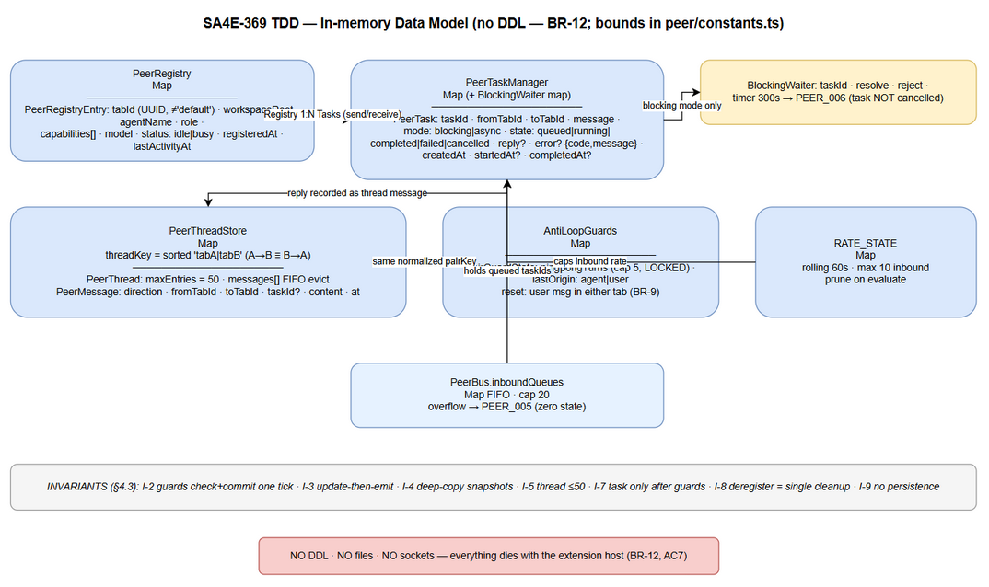 Edit in draw.io

4.2 Structures (“DDL equivalent” — TypeScript)

Structure: PeerRegistryEntry (D3)
// peer/types.ts
export type PeerStatus = 'idle' | 'busy';
export interface PeerRegistryEntry {
tabId: string; // UUID v4; never 'default' (BR-2)
workspaceRoot: string; // D1: part of session key workspaceRoot+tabId (pi-workflow/session-host)
agentName: string;
role: string;
capabilities: string[];
model: string;
status: PeerStatus; // busy set BEFORE first token; idle only after terminal capture (§2.2.1)
registeredAt: string; // ISO 8601
lastActivityAt: string; // ISO 8601; updated on each inbound turn start
}
Container: Map<string, PeerRegistryEntry> inside PeerRegistry. No locks (C-6).

Structure: PeerTask
export type PeerTaskState = 'queued' | 'running' | 'completed' | 'failed' | 'cancelled';
export type PeerTaskMode = 'blocking' | 'async';
export interface PeerError {
code: 'PEER_001' | 'PEER_002' | 'PEER_003' | 'PEER_004' | 'PEER_005'
| 'PEER_006' | 'PEER_007' | 'PEER_008' | 'PEER_009';
message: string; // descriptive per FSD §9.1
details?: Record<string, unknown>; // pair, cap, tabId, governance reason...
}
export interface PeerTask {
taskId: string; // `t-` + UUID v4
fromTabId: string;
toTabId: string; // ≠ fromTabId; must exist in registry at creation
message: string;
mode: PeerTaskMode;
state: PeerTaskState;
reply?: string; // set on completed
error?: PeerError; // set on failed
createdAt: string;
startedAt?: string; // set on queued→running
completedAt?: string; // set on any terminal transition
}
Container: Map<string, PeerTask> inside PeerTaskManager, bounded by the rate limit + queue cap (§8.2); entries removed after terminal state is delivered (blocking resolved / thread-recorded) and the task exceeds a 60s post-terminal retention — then deleted. Retention keeps peer_status useful for late async polls without unbounded growth.

Structure: PeerThread / PeerMessage (D3, FR-9, BR-11)
export type PeerMessageDirection = 'inbound' | 'outbound'; // relative to one tab of the pair
export interface PeerMessage {
direction: PeerMessageDirection;
fromTabId: string;
toTabId: string;
taskId?: string; // link to originating/answering task
content: string; // in-memory only (BR-12)
at: string; // ISO 8601
}
export interface PeerThread {
threadKey: string; // normalized unordered pair: sorted 'tabA|tabB'
maxEntries: number; // THREAD_MAX_ENTRIES = 50
messages: PeerMessage[]; // FIFO — evict from front when length > maxEntries
}
Container: Map<string /*threadKey*/, PeerThread> inside PeerThreadStore. A→B and B→A share ONE thread (order-independent key). Threads involving a deregistered tab are dropped entirely (§6.4).

Structure: GuardState / RateState (AC3)
export interface PairGuardState {
pairKey: string; // normalized 'tabA|tabB' — same key as threads
pingpongTurns: number; // consecutive agent→agent turns; cap MAX_PINGPONG_TURNS = 5
lastOrigin: 'agent' | 'user';
}
export interface TabRateState {
tabId: string;
inboundTimestamps: number[]; // epoch ms, rolling RATE_WINDOW_MS = 60_000 window
}
Containers: Map<string /*pairKey*/, PairGuardState> and Map<string /*tabId*/, number[]> inside AntiLoopGuards. Counter ownership is PeerBus-side ONLY — never in sessions, never in threads (FSD §3.4.4).

Structure: InboundQueue
// inside PeerBus
private inboundQueues: Map<string /*tabId*/, string[] /*taskIds, FIFO*/> = new Map();
// hard cap INBOUND_QUEUE_CAP = 20 → overflow rejects with PEER_005 BEFORE enqueue (§8.2)

Structure: BlockingWaiter
// inside PeerTaskManager
interface BlockingWaiter {
taskId: string;
resolve: (result: SendResult) => void;
reject: (err: PeerError) => void;
timer: NodeJS.Timeout; // BLOCKING_TIMEOUT_MS = 300_000 → PEER_006; task NOT cancelled
}
// waiters: Map<string /*taskId*/, BlockingWaiter>

4.3 Invariants (enforced in code, asserted in tests)
# | Invariant | Enforcement point
I-1 | tabId unique; collision → regenerate BEFORE insert; re-register on same id is idempotent (update in place, no duplicate event) | PeerRegistry.register (BR-2)
I-2 | Guard check + counter commit in ONE synchronous block; rejection mutates NO state | AntiLoopGuards.evaluate (§5.3)
I-3 | Map updated BEFORE any emit (update-then-emit) | All mutating components
I-4 | Every snapshot leaving the module is a deep copy | registry.snapshot / taskManager.get / threads
I-5 | Thread length ≤ 50 after every append | PeerThreadStore.append
I-6 | Rate window length ≤ 10 within any 60s rolling span per tab | AntiLoopGuards.evaluate
I-7 | Task exists ONLY after guards pass; terminal states are exactly {completed, failed, cancelled} | PeerBus.send / PeerTaskManager
I-8 | Deregister is the SINGLE cleanup point: cancels queued tasks (PEER_009), drops threads + guard/rate state involving the tab | PeerRegistry → bus peer:deregistered handler
I-9 | No persistence: no fs writes, no sockets, no globals that survive host teardown | module design (BR-12, AC7)

4.4 Migration Plan
N/A — no schema, no files, no persistence (C-2). The only “migration” is the D1 code change in the session stack (§6.1), which ships as a code commit and is reverted as a whole (§10.3).

5. Class / Module Design

5.1 Module Structure
extension/src/peer/ # NEW additive module (all ≤200 lines/file)
├── types.ts # ALL peer_* TypeScript shapes (§4.2)
├── constants.ts # MAX_PINGPONG_TURNS=5, RATE_LIMIT_MAX=10, RATE_WINDOW_MS=60_000,
│ # THREAD_MAX_ENTRIES=50, BLOCKING_TIMEOUT_MS=300_000, INBOUND_QUEUE_CAP=20,
│ # POST_TERMINAL_RETENTION_MS=60_000
├── errors.ts # peerError(code, message, details?) factory + descriptive message templates (FSD §9.1)
├── registry.ts # PeerRegistry
├── guards.ts # AntiLoopGuards
├── threads.ts # PeerThreadStore
├── task-manager.ts # PeerTaskManager (+ blocking waiter registry)
├── bus.ts # PeerBus (EventEmitter backbone; pi-a2a adapter point)
└── tools.ts # registerPeerTools(): peer_list / peer_send / peer_status (SA4E-360 pattern)
Modified existing files (additive wiring only — D1 per-tab session host already exists in pi-workflow/session-host/ — see §6.1 for the full diff map): extension.ts, chat-panel/conversation-manager.ts, chat-panel/message-handler.ts.

5.2 Class Diagram
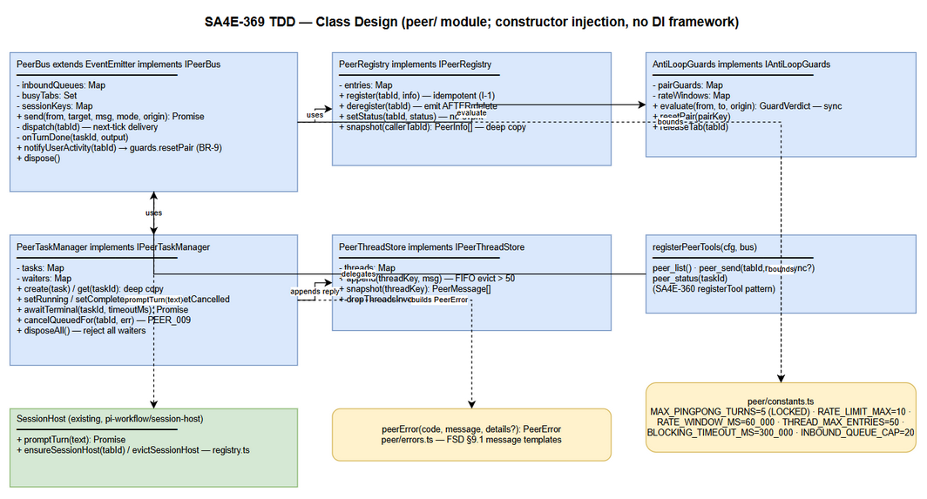 Edit in draw.io

5.3 Key Interfaces
// peer/registry.ts
export interface IPeerRegistry {
register(tabId: string, info: Omit<PeerRegistryEntry, 'tabId' | 'registeredAt' | 'lastActivityAt'>): void;
deregister(tabId: string): void; // emits peer:deregistered AFTER Map.delete
setStatus(tabId: string, status: PeerStatus): void; // in-place; NO event (§2.2.1)
has(tabId: string): boolean;
snapshot(callerTabId: string): PeerInfo[]; // deep copies + self flag (I-4)
}
// peer/guards.ts
export type GuardVerdict = { pass: true } | { pass: false; error: PeerError };
export interface IAntiLoopGuards {
evaluate(from: string, to: string, origin: 'agent' | 'user'): GuardVerdict; // sync; check+commit one tick (I-2)
resetPair(pairKey: string): void; // BR-9: user message in either tab
releaseTab(tabId: string): void; // drop all pair/rate state involving tabId
}
// peer/threads.ts
export interface IPeerThreadStore {
append(threadKey: string, msg: PeerMessage): void; // FIFO evict at 50 (I-5)
snapshot(threadKey: string): PeerMessage[]; // deep copy
dropThreadsInvolving(tabId: string): void;
}
// peer/task-manager.ts
export interface IPeerTaskManager {
create(task: PeerTask): void;
get(taskId: string): PeerTask | undefined; // deep copy (I-4)
setRunning(taskId: string): void; // queued→running (stamp startedAt)
setCompleted(taskId: string, reply: string): void; // → terminal; emits task:<id> + peer:task-updated
setFailed(taskId: string, error: PeerError): void; // → terminal; PEER_003 / PEER_007
setCancelled(taskId: string, error: PeerError): void; // → terminal; PEER_009
awaitTerminal(taskId: string, timeoutMs: number): Promise<SendResult>; // blocking waiter + PEER_006 timer
cancelQueuedFor(tabId: string, reason: PeerError): void; // PEER_009 on tab close
disposeAll(): void; // teardown: reject ALL waiters descriptively (§6.5)
}
// peer/bus.ts
export interface IPeerBus {
// The ONLY transport entry — future pi-a2a swap rewrites this class alone (D4):
send(fromTabId: string, targetTabId: string, message: string,
mode: PeerTaskMode, origin: 'agent' | 'user'): Promise<SendResult>;
onTabRegistered / onTabDeregistered hooks from ConversationManager wiring (§6.1)
// EventEmitter events: peer:registered, peer:deregistered, peer:inbound,
// peer:task-updated, task:<taskId> (internal, once-per-waiter)
dispose(): void;
}
PeerBus.send — the exact orchestration (ported from FSD §2.2.2 + §6.1, all synchronous until delivery):
async send(fromTabId, targetTabId, message, mode, origin): Promise<SendResult> {
// Tick 1 — validate + guards + create + enqueue + emit (NO await inside this block):
if (!this.registry.has(targetTabId)) throw peerError('PEER_001', ...); // BR-4, no task
if (targetTabId === fromTabId) throw peerError('PEER_002', ...); // BR-3, no task
const verdict = this.guards.evaluate(fromTabId, targetTabId, origin);
if (!verdict.pass) throw verdict.error; // PEER_004/005, no task (I-2)
const queue = this.inboundQueues.get(targetTabId) ?? [];
if (queue.length >= INBOUND_QUEUE_CAP) throw peerError('PEER_005', ...); // §8.2, no task
const task = this.taskManager.create({ fromTabId, toTabId: targetTabId, message, mode, state: 'queued', ... });
queue.push(task.taskId); this.inboundQueues.set(targetTabId, queue);
this.emit('peer:inbound', { tabId: targetTabId, fromTabId, taskId: task.taskId });
setImmediate(() => this.dispatch(targetTabId)); // delivery exits the tick
// Tick 2 — settle caller:
if (mode === 'async') return { taskId: task.taskId, state: 'queued' };
return this.taskManager.awaitTerminal(task.taskId, BLOCKING_TIMEOUT_MS); // PEER_006 on timeout, task survives
}

5.4 PeerTask State Machine
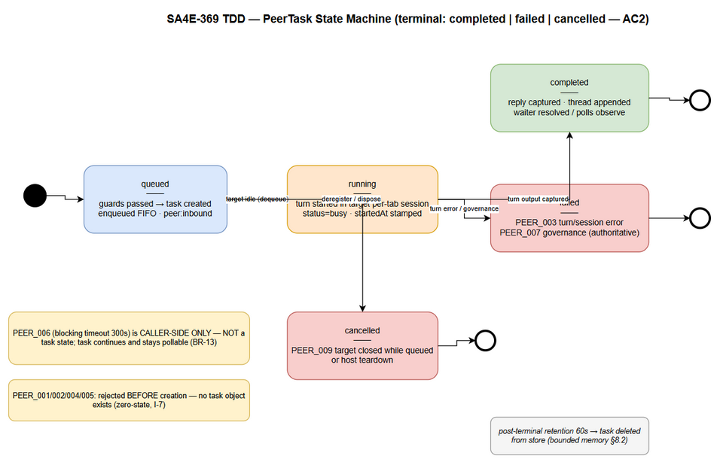 Edit in draw.io
Transition | Trigger | Side effects | Error code
(none) → queued | Guards passed; task created | enqueue FIFO; peer:inbound | —
queued → running | Target idle (dequeue) OR busy-target turn finishes | startedAt; registry status→busy BEFORE first token | —
queued → cancelled | Target deregistered while queued (I-8) or host teardown | peer:task-updated; blocking waiters rejected | PEER_009
running → completed | Turn output captured via promptTurn resolution (SessionTurnResult.text) | reply recorded; thread append; guards counters already committed at send | —
running → failed | Turn/session error, OR governance rejection at any stage | error recorded; thread records failure marker; governance reason verbatim (AC5) | PEER_003 / PEER_007
terminal (any) | Post-terminal retention elapsed (60s) after delivery | task removed from store (bounded memory) | —
Not a task state: PEER_006 (blocking timeout) is caller-side only — the task keeps running and remains pollable (BR-13). Send-time rejections (PEER_001/002/004/005) never create a task (zero-state, I-7).

5.5 Design Patterns
Pattern | Where | Rationale
Singleton (per host) | PeerBus, PeerRegistry, PeerTaskManager, Guards, ThreadStore | One bus per extension host; constructed in extension.ts activation (FSD §2.2.1 item 4)
Mediator / EventBus | PeerBus | Decouples tools, task lifecycle, UI, and session host via named events
Observer | UI + PeerTaskManager subscribe to bus events | Badge/transcript updates and waiter resolution without polling the registry
Registry | PeerRegistry | D3 verbatim
State | PeerTask state transitions | Single transition table (§5.4) owned by PeerTaskManager
Strategy (guard, isolated) | AntiLoopGuards | Guard rules are one injectable unit — tunable constants stay in constants.ts (C-4)
Adapter (contract-only, D4) | bus.ts send/result envelope | Future pi-a2a transport swap touches exactly one file
Snapshot (defensive copy) | registry/thread/task reads | I-4: no shared mutable objects escape

5.6 Dependency Injection & Wiring
Plain-constructor injection (matches existing pi-agent style — e.g. SessionOrchestrator takes { workspaceResolver, agentDirResolver }); no DI framework:
// extension.ts activation (additive block)
const peerRegistry = new PeerRegistry();
const peerGuards = new AntiLoopGuards();
const peerThreads = new PeerThreadStore();
const peerTaskManager = new PeerTaskManager();
const peerBus = new PeerBus(peerRegistry, peerGuards, peerTaskManager, peerThreads);
context.subscriptions.push(peerBus); // dispose on deactivation (§6.5)
conversationManager.onTabCreated((tabId, meta) => peerRegistry.register(tabId, meta));
conversationManager.onTabClosed ((tabId) => peerRegistry.deregister(tabId));
registerPeerTools(sessionConfigurator, peerBus); // peer_list/send/status per tab (SA4E-360)

5.7 Concurrency & Single-thread Discipline (extension host)
The VS Code extension host is single-threaded JavaScript — no locks, no atomics, no worker threads. Correctness comes from tick discipline (FSD §2.2.1):
- One-tick atomic sections. Validate → guard → create → enqueue → emit run inside a single synchronous block (send Tick 1 above, evaluate in §4.2). There is no await between check and commit, so no interleaving is possible.
- Update-then-emit. Map mutations always precede emit(); a handler fired by the event can never read pre-update state.
- Deep-copy at boundaries. peer_list, peer_status, thread snapshots return deep copies — external holders cannot corrupt internal state, and event payloads carry only primitive fields or copies.
- Async work starts on the NEXT tick. dispatch() (turn execution, governance, model calls — all await-heavy) is scheduled via setImmediate AFTER the atomic section completes; it re-enters the store through state-transition methods only.
- Exactly-once waiter settlement. A blocking task’s waiter is settled by exactly one task:<id> once-event; the PEER_006 timer and the terminal event race is resolved by clearing the timer inside the once-handler, and the waiter map entry is deleted before settling (no double settle possible).
- Busy-target sequencing. The per-tab FIFO queue + status: busy flag guarantee at most one in-flight turn per tab; queued tasks are dispatched from the turn-complete callback, preserving FIFO order (BR-6).
- Teardown. peerBus.dispose() (from context.subscriptions) rejects all pending waiters with a descriptive failure, cancels queued tasks (PEER_009), and clears all maps — state dies with the host (BR-12).

5.8 Error Handling Strategy
Class | Mechanism | Mapping
PeerError (from peer/errors.ts) | Plain object factory peerError(code, message, details?) — NOT thrown across module boundaries except as the send-time rejection value | FSD §9.1 messages verbatim
Send-time rejection | PeerBus.send throws/rejects with PeerError BEFORE task creation; tools.ts wraps into the pi-a2a error envelope | PEER_001/002/004/005
Run-time failure | PeerTaskManager.setFailed records error on the task; terminal event fans out | PEER_003/007
Caller timeout | Waiter timer rejects caller only | PEER_006
Lookup miss | peer_status handler returns error envelope | PEER_008
Target lost | cancelQueuedFor on deregistration / teardown | PEER_009
Unexpected internal error | logger.error + tool error result; never partial data; tab stays functional | FSD UC-1 EF-1
Anti-loop guard matrix (PEER_001..009 consolidated):
Code | Origin | Task object | Recovery | Reset trigger
PEER_001 | send-time validation | none | retry after opening target tab | —
PEER_002 | send-time validation | none | correct addressing | —
PEER_003 | target turn/session error | created, failed | retry send | —
PEER_004 | pair ping-pong cap (5) | none | pair auto-run suspended; BOTH tabs functional | user message in either tab (BR-9)
PEER_005 | rate window (>10/60s) or queue cap 20 | none | automatic after window rolls off | rolling 60s
PEER_006 | blocking caller 300s | task keeps running | peer_status polling | —
PEER_007 | governance rejection (budget gate / auto-chunk abort / intra-turn) | created, failed | none — governance authoritative, NO bypass (AC5) | —
PEER_008 | unknown taskId | none | use taskId from send result | —
PEER_009 | target closed while queued / teardown | created, cancelled | resend after tab reopen | —

6. Integration Design
All integrations are IN-PROCESS within the single extension host (FSD §5). No external system, protocol, timeout policy, or circuit breaker applies — those template subsections are N/A; the equivalent in-process contracts are specified below.

6.1 Integration: Per-tab Session Stack (D1 — already implemented, peer module consumes it)
Ground truth (verified): the D1 prerequisite has LANDED as part of parent epic SA4E-370 S3 — extension/src/pi-workflow/session-host/registry.ts implements sessionKey(workspaceRoot, tabId) = workspaceRoot+tabId (STATUS D1 verbatim), validateTabId throws on empty/"default" (TC-409), ensureSessionHost(...) caches hosts per key (30s ensure timeout), and evictSessionHost(workspaceRoot, tabId) disposes on tab close (TC-315). FSD §3.5.3’s workspaceRoot + '::' + tabId separator and its pi-agent/session-factory.ts diff map are therefore superseded — see DISCREPANCY.md DISC-2/DISC-3.
PeerBus → SessionHost contract (the ONLY session integration the peer module needs):
API (pi-workflow/session-host/) | PeerBus usage
ensureSessionHost({ workspaceRoot, providerId, configuredModelId, role, activeAgentId, tabId }) → Promise<SessionHost> | Called in dispatch() for the receiving tab — create-on-miss, cached (never per send)
SessionHost.promptTurn(text) → Promise<SessionTurnResult> | Peer message passed as text — SAME entry as user prompts (AC5); result.text = reply → setCompleted
SessionHost.promptTurn rejection | Governance rejection → PEER_007 (verbatim reason); other errors → PEER_003
evictSessionHost(workspaceRoot, tabId) | Called on tab deregistration, together with cancelQueuedFor (I-8)
SessionHostOptions.role / personaBody / activeAgentId | Source of the PeerRegistry entry’s agentName/role/model (FR-1, via session-configurator metadata already flowing into the adapter)
Exact diff map (additive only):
File | Change | Source
peer/* (NEW) | All new modules — no semantic change to existing paths | FR-10
extension.ts | Activation: construct the 5 peer singletons (§5.6); context.subscriptions.push(peerBus); teardown wiring | §5.4 FSD
chat-panel/conversation-manager.ts | ADD onTabCreated/onTabClosed event hooks (additive emitter); tabId stays UUID v4 (already unique; I-1 covers collisions) | UC-5, FR-1; supersedes FSD §3.5.3’s webview-panel-manager.ts (DISC-1 — that file is the KB panel manager, unrelated to chat tabs)
chat-panel/message-handler.ts | Forward bus events to webview (peer:inbound → badge + transcript prefix); user-send path calls peerBus.notifyUserActivity(tabId) for BR-9 guard reset | AC4, FR-7, BR-9
pi-workflow/session-host/* | No change required — consumed as-is via ensureSessionHost / promptTurn / evictSessionHost. Any gap found during DEV (e.g., tab→host identity wiring in the chat adapter) is logged against D1/SA4E-370, not patched here | D1, FR-10
Regression constraint (AC8/FR-10): the peer module never modifies governance or session-routing code semantically; promptTurn is the shared entry point, so existing suites (context-governance.*, auto-chunk, pi-workflow/session-host tests TC-313/314/315/407/409) stay green unchanged.

6.2 Integration: SessionHost ↔ PeerBus (auto-run + reply capture)
Turn entry: PeerBus auto-run calls the receiving tab’s SessionHost.promptTurn(text) with the peer message as the turn prompt — the SAME API a user prompt takes (AC5, no separate peer entry function):
// peer/bus.ts dispatch (next tick after send Tick 1)
private async dispatch(tabId: string): Promise<void> {
if (this.busyTabs.has(tabId)) return; // stays queued FIFO (BR-6)
const taskId = this.dequeue(tabId); if (!taskId) return;
this.busyTabs.add(tabId); this.registry.setStatus(tabId, 'busy');
this.taskManager.setRunning(taskId); // stamps startedAt
try {
const host = await ensureSessionHost({ // D1: cached per workspaceRoot+tabId
workspaceRoot: this.roots.get(tabId), providerId: this.providers.get(tabId),
configuredModelId: this.models.get(tabId), role: this.roles.get(tabId),
activeAgentId: this.agents.get(tabId), tabId,
});
const result = await host.promptTurn(this.taskManager.getMessage(taskId)); // SAME entry as user prompt
this.onTurnDone(taskId, result.text); // SessionTurnResult.text = reply
} catch (err) {
const gov = isGovernanceRejection(err); // budget gate / intra-turn guard verdicts
this.taskManager.setFailed(taskId, gov
? peerError('PEER_007', 'Peer task rejected by context governance in ' + tabId + ': ' + err.reason)
: peerError('PEER_003', 'Peer task failed in ' + tabId + ': ' + err.message));
} finally {
this.busyTabs.delete(tabId); this.registry.setStatus(tabId, 'idle');
setImmediate(() => this.dispatch(tabId)); // drain FIFO (BR-6)
}
}
Governance hook points (AC5, FSD §3.6.3) are inherited unchanged because the turn API is shared:
Stage | Module | Peer-prompt behavior | Forbidden
Turn entry | pi-workflow/session-host/turn-executor.ts (promptTurn) | Same turn API as user prompts | Separate peer entry function
Budget gate | session-budget-gate.ts / budget-gate.ts | Runs first, against receiving tab’s per-tab budget | Skip flag on turn options
Auto-chunk | context-budget-auto-split.ts / prompt-compressor.ts | Existing chunking rules, transparent to sender | Size pre-trim before the gate
Intra-turn guard | turn-executor in-turn stages | Unchanged; trip → abort → PEER_007 | Retry-around-guard

6.3 Sequence Diagrams

Blocking exchange (UC-2)
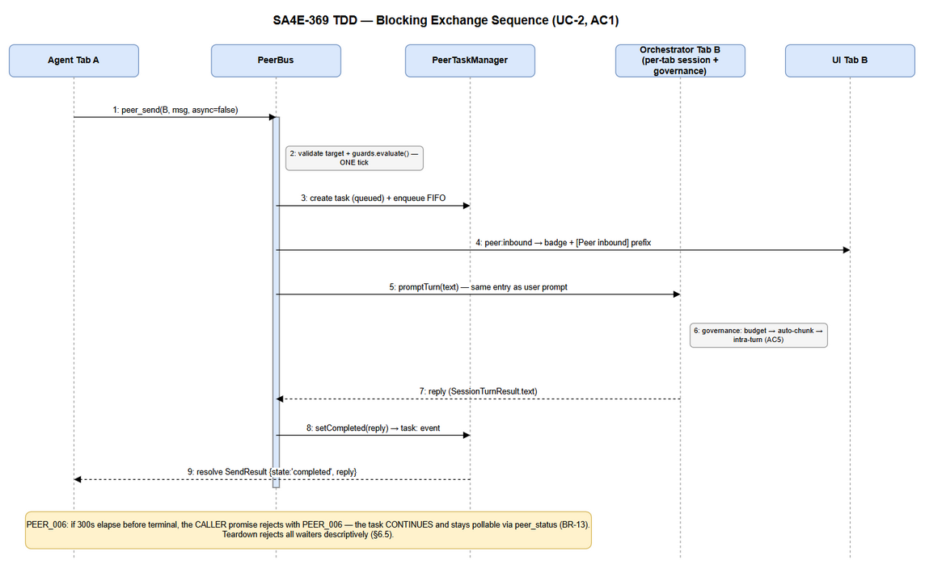 Edit in draw.io

Async dispatch fire/poll (UC-3)
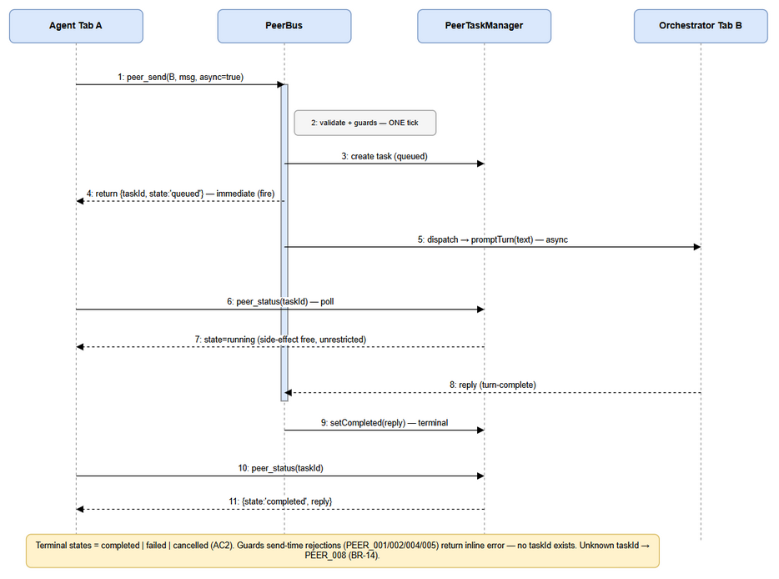 Edit in draw.io

6.4 Registry Lifecycle & Cleanup (§6.4 FSD)
Step | Trigger | Actions
1 | Tab created | registry.register(tabId, meta) → emit peer:registered; duplicate tabId → regenerate BEFORE insert (I-1)
2 | Tab closed | registry.deregister(tabId) → taskManager.cancelQueuedFor(tabId, PEER_009); threads.dropThreadsInvolving(tabId); guards.releaseTab(tabId); emit peer:deregistered — SINGLE cleanup point (I-8)
3 | Host deactivation | peerBus.dispose(): reject all blocking waiters descriptively, cancel queued tasks (PEER_009 semantics), clear all maps (BR-12)

6.5 Teardown & Waiter Semantics
On dispose(): every pending task:<id> once-listener is removed; every waiter’s timer is cleared; the waiter is rejected with peerError('PEER_003', 'Extension host shutting down; peer task state discarded (BR-12).'). In-flight turns are abandoned (their completion callbacks resolve against a cleared store — handlers are no-ops after the disposed flag is set, checked synchronously).

7. Security Design

7.1 Authentication & Network Surface
None — by design (AC7, D5). The feature opens no sockets, ports, or tokens; there is no auth surface to secure. The trust boundary is the extension host process itself: only tabs of THIS instance appear in the registry, so agents cannot address other windows or machines (NG-1). Any future cross-machine reach goes through pi-a2a, never through this feature (§3.5).

7.2 Authorization
Actor | Permission | Scope
Agent in a registered tab | peer_list, peer_send, peer_status | Same-instance tabIds only; self-send rejected (BR-3)
Developer user | Full control via normal UI (badge, transcript, focus) | In-process
Tools are registered for every tab automatically (AC7) — no per-tab tool ACLs are introduced; the existing tool execution sandbox of the extension applies.

7.3 Data Protection
Data Type | At Rest | In Transit | In Logs
Peer messages / replies | Nothing at rest — memory only (BR-12) | Never leaves process | Content excluded; only taskId, tabIds, state, code
PeerRegistry entries | Memory only | Never leaves process | tabId + role/model only
Guard/rate counters | Memory only | Never leaves process | Metrics only

7.4 Input Validation
Field | Validation | Sanitization
tabId (peer_send) | Must exist in registry (PEER_001); ≠ caller (PEER_002); type string | Passed through as opaque id — never interpolated into prompts
message | Non-empty, type string; length bounded by governance budget gate (existing) | No transformation — passes through governance verbatim (BR-10)
taskId (peer_status) | Type string; lookup (PEER_008) | Opaque — no parsing
Prompt content in transcript | Rendered by existing transcript renderer | Existing UI escaping applies ([Peer inbound] prefix is display-only)

7.5 Audit Trail
Session-scoped structured logs via logger.* (existing JSON channel); no new output files, no telemetry export of content (BR-12, FSD §7.3):
- Guard trips (PEER_004/005): taskId, pair, reason — logger.warn
- Task failures (any PEER_0xx): taskId, code, message, pair, timestamps — logger.warn
- State transitions: taskId, from → to — logger.debug

8. Performance & Scalability

8.1 Caching Strategy
N/A — all state is live in-process; the registry IS the cache (FSD §2.2.1: registry reads are synchronous, no I/O).

8.2 Bounded Memory & Backpressure
Mechanism | Bound (constant in peer/constants.ts) | Behavior at bound | Enforcement
Pair ping-pong chain | MAX_PINGPONG_TURNS = 5 (LOCKED) | Send rejected PEER_004, zero state | guards.evaluate
Per-tab inbound rate | RATE_LIMIT_MAX = 10 per RATE_WINDOW_MS = 60_000 rolling | Send rejected PEER_005, zero state | guards.evaluate
Per-tab inbound queue | INBOUND_QUEUE_CAP = 20 | Send rejected PEER_005, zero state | PeerBus.send Tick 1
Pair thread history | THREAD_MAX_ENTRIES = 50 | FIFO eviction of oldest message on append | PeerThreadStore.append
Task store | post-terminal retention POST_TERMINAL_RETENTION_MS = 60_000, plus rate cap upstream | Terminal tasks deleted after retention | PeerTaskManager sweep on transition
Blocking waiters | one per blocking task; timeout BLOCKING_TIMEOUT_MS = 300_000 | Caller rejected PEER_006; task survives | waiter timer
Backpressure principle: guards run BEFORE a PeerTask exists — rejection leaves zero state; only accepted tasks enter bounded structures, so memory stays bounded regardless of chatter (FSD §2.2.2).

8.3 Performance Targets
Operation | Target | Measurement
Bus dispatch + guard evaluation (excl. agent turn) | ≤ 50 ms p95 (FSD §8 NFR) | Unit test timing harness around PeerBus.send (async mode)
peer_list / peer_status latency | ≤ 1 ms (in-memory Map + deep copy of tens of entries) | Unit test
Registry scale | tens of open tabs — Map lookups O(1) | TC-11
Blocking exchange end-to-end | dominated by agent turn; bus overhead ≤ 50 ms | TC-01

8.4 Scalability Approach
Horizontal scaling does not apply (single host by definition, D5). Within the host: all containers are bounded (§8.2); event fan-out is O(subscribers) with 2–3 subscribers per event; no unbounded arrays exist anywhere in peer/.

9. Monitoring & Observability

9.1 Logging (existing logger.ts — structured JSON lines)
Event | Level | Fields
Peer registered / deregistered | info | tabId, agentName, role
Peer send accepted (async mode) | info | taskId, fromTabId, toTabId, mode
Guard trip PEER_004 / PEER_005 | warn | taskId (or null for pre-creation), pair, tabId, reason, counters
Task failed (PEER_003 / PEER_007) | warn | taskId, code, message, pair, durationMs
Blocking timeout PEER_006 | warn | taskId, timeoutMs
Task cancelled PEER_009 | info | taskId, toTabId, reason
State transition | debug | taskId, from → to
Thread eviction | debug | threadKey, evictedCount
Rule: never log peer message/reply content (§7.3).

9.2 Metrics
No telemetry pipeline is added (AC7, BR-12 — no export of peer activity). Observable proxies for local diagnosis:
Metric | Source | Use
Guard trip counts | warn-log aggregation per session | Detect runaway agent loops (AC3)
Task terminal distribution | debug-log aggregation | Supportability
Bus dispatch latency | unit/e2e timing harness (§8.3) | Regression gate

9.3 Health Checks
Not applicable to a UI extension process; the equivalent is AC8: existing suites (context-governance.*, auto-chunk, session routing) stay green, plus new peer suites (§11).

10. Deployment Considerations

10.1 Environment Configuration
No configuration exists — by requirement (AC7, D5). All tunables are compile-time constants in peer/constants.ts (§8.2); changing them is a code change, never a settings change. Verification point (TC-08): no new entries in extension configuration after install/enable.
Property | DEV/SIT/UAT/PROD
peer config keys | none, by design
feature flags | none, by design (zero-config IS the acceptance criterion)

10.2 Feature Flags
None. The feature is always-on the moment two tabs are open (AC1, AC7). Gating would violate the zero-config decision D5.

10.3 Rollback Strategy
- Code revert — the feature is a self-contained additive module (peer/) + small D1 diffs (§6.1); reverting the merge commit restores prior behavior entirely.
- D1 dependency — D1 (per-tab sessions) lands BEFORE this feature; rollback of SA4E-369 alone must NOT revert D1 (it is the parent-epic prerequisite). The revert scope is peer/ + wiring lines in extension.ts / conversation-manager.ts / message-handler.ts only.
- No data migration — nothing is persisted (BR-12); there is nothing to roll back on disk.

11. E2E Test Architecture

11.1 Framework & Language
- Framework: vitest 4.1.8 — same as the extension (extension/package.json: test:unit = vitest run, test:e2e = vitest run --config vitest.e2e.config.ts).
- Language: TypeScript — shares peer/types.ts shapes with production code.
- No Playwright: the chat UI is a VS Code webview; existing UI verification is via message-handler unit tests + manual web tests. Badge/transcript behavior is covered by event→message mapping unit tests (§11.4), not browser automation.

11.2 Test Structure (verified: extension/src/__tests__/)
Layer | Location | Naming
Unit + integration (colocated) | extension/src/__tests__/ (flat and chat/ subfolder) | *.test.ts, e.g. conversation-manager.test.ts, chat/*.unit.test.ts
E2E | extension/src/__tests__/ | *.e2e.test.ts, e.g. regression-sa4e-356.e2e.test.ts, cross-process.e2e.test.ts
New peer suites live in extension/src/__tests__/peer/ (new subfolder — mirrors the chat/ grouping convention):
extension/src/__tests__/peer/
├── registry.unit.test.ts # I-1 idempotent register, snapshot deep copy, deregister cleanup
├── guards.unit.test.ts # §5.3 evaluate: cap 5, rate 10/60s, reset BR-9, zero-state on reject (I-2)
├── threads.unit.test.ts # I-5 FIFO bound 50, normalized pair key, dropThreadsInvolving
├── task-manager.unit.test.ts # state machine §5.4, waiter exactly-once settle, PEER_006 timer, disposeAll
├── bus.integration.test.ts # Tick-1 atomicity, FIFO busy-target queue (BR-6), events order
├── tools.unit.test.ts # tool envelopes: peer_list self flag, peer_send validation order, peer_status PEER_008
├── governance-passthrough.it.test.ts # TC-06: peer prompt hits budget gate → PEER_007; no bypass (AC5)
├── peer-bus.e2e.test.ts # TC-01 blocking AC1, TC-02 async AC2 (mock session host)
├── peer-guards.e2e.test.ts # TC-03 cap trip AC3, TC-04 rate limit, both tabs functional
└── peer-regression.e2e.test.ts # TC-09: runs with existing context-governance/auto-chunk suites (AC8)

11.3 Reusable Components
- Mock session host: ensureSessionHost is imported by PeerBus — tests mock the module (pattern proven in pi-workflow/__tests__/adapter-wiring-session.test.ts) with a fake promptTurn returning canned SessionTurnResult or throwing governance-shaped errors. No network, no model calls.
- Fake tab lifecycle: ConversationManager is standalone (constructor works headless: new ConversationManager(10) — verified) — tests create/close real tabs to drive registry events.
- vitest fake timers for rate window (60s roll-off), blocking timeout (300s), post-terminal retention sweeps — no real waits.
- No global server/DB setup needed — the feature is pure in-process; e2e tests run in the standard vitest environment.

11.4 E2E Test Design for SA4E-369
- peer-bus.e2e.test.ts (TC-01, TC-02): two tabs via ConversationManager → register tools with a stub session → peer_send(B, msg, async=false) resolves with B’s mock reply; async=true returns {taskId, state:'queued'} then polls to completed. Asserts badge/transcript mapping: peer:inbound → webview message payload contains [Peer inbound] from <tabA>.
- peer-guards.e2e.test.ts (TC-03, TC-04): drive 6 consecutive agent-originated sends in one pair → 6th rejected PEER_004 with pair+cap in error.message, both tabs accept user input afterwards (BR-9 reset verified); >10 sends in 60s to one tab → PEER_005, recovered after fake window roll-off.
- Data cleanup: none required — every test constructs fresh singletons per suite; no shared state (I-9).

11.5 UI Verification Note
Per UI-SPEC.md, badge + transcript prefix are rendered by the existing webview. Automated coverage = unit tests that assert the exact webview message payloads emitted on peer:inbound / peer:task-updated (badge increment payload, prefix text, badge-clear on focus ack). Visual QA follows the manual-web-test checklist; no new UI automation framework is introduced.

12. Appendix

12.1 Requirement Traceability (FSD → TDD)
FSD Requirement | TDD Section
FR-1 / UC-1 (peer_list, auto-register) | §3.2, §5.3 (IPeerRegistry), §6.4
FR-2 / UC-2 (blocking exchange) | §3.3, §5.3 (PeerBus.send), §6.3 blocking sequence
FR-3 / UC-3 (async fire/poll) | §3.3, §3.4, §6.3 async sequence
FR-4 / UC-4 (auto-run + guards AC3) | §5.3, §5.8 matrix, §6.2, §8.2
FR-5 / UC-5 (per-tab sessions D1) | §6.1 diff map
FR-6 / AC5 (governance pass-through) | §6.2 hook table
FR-7 / AC4 (UI visibility) | §2.2 component table, §11.5
FR-8 / AC7 (zero-config, no network) | §7.1, §10.1–10.2, §8.2
FR-9 (bounded threads) | §4.2 PeerThread, §8.2
FR-10 / AC8 (regression) | §6.1 constraint, §11.2
BR-1..BR-15 | §4.3 invariants, §5.8 matrix, §6.4
D1–D5 (locked) | §1.5 C-1, §6.1 (D1), §5.6 (D3), §3.5 (D4), §7.1/§10 (D5)

12.2 Diagram Index (this TDD)
Diagram | Files | Section
TDD Architecture | tdd-architecture.png / .drawio | §2.1
TDD Component | tdd-component.png / .drawio | §2.2
TDD Deployment | tdd-deployment.png / .drawio | §2.3
TDD Data Model | tdd-data-model.png / .drawio | §4.1
TDD Class Diagram | tdd-class-diagram.png / .drawio | §5.2
TDD PeerTask State Machine | tdd-state-peertask.png / .drawio | §5.4
TDD Blocking Sequence | tdd-sequence-blocking.png / .drawio | §6.3
TDD Async Sequence | tdd-sequence-async.png / .drawio | §6.3
FSD-phase diagrams (use-case, business-flow, wireframes, system-context, sequence-peer-delivery, state-peertask, er-peer-data) remain authoritative for requirements — see FSD §11.1; they are NOT duplicated here.

12.3 Glossary
Term | Definition
Tick | One synchronous turn of the single-threaded extension-host event loop
Zero-state rejection | A guard/validation failure that creates no task, no counter change, no thread entry
Waiter | Blocking-mode promise registered against task:<taskId> with a 300s timer
Normalized pair key | [tabA, tabB].sort().join('|') — order-independent thread/guard identity
Session key | workspaceRoot+tabId (D1 — implemented in pi-workflow/session-host/registry.ts)
Terminal state | completed, failed, cancelled (AC2)

12.4 Open Questions
# | Question | Status | Answer
1 | threadKey separator (|) safe for tabIds? | Resolved | tabIds are UUID v4 (no |); normalization confirmed safe
2 | Post-terminal task retention 60s — enough for late async polls? | Resolved | Yes — polls are agent-driven; 60s covers practical poll gaps; tunable in constants.ts (C-4)
3 | Guard reset on UI-initiated user message — who calls resetPair? | Resolved | message-handler.ts user-send path calls peerBus.notifyUserActivity(tabId) → guards.resetPair for all pairs involving tabId (BR-9)

End of TDD — SA4E-369 v1.0 (2026-10-20)

