Business Requirements Document (BRD)

iCollect — BRD - ICL2-1762 [CRP-6703] Identify the parent appID of the appID in iCollect
Draft note: Generated from Jira tickets ICL2-1762 (implementation story, iCollect scope), CRP-6703 (original business ticket), and dependency tickets DBA-2525 and CRP-7025. Items not yet confirmed are marked [TBD].

Document Information
Field | Value
System | iCollect (iCollect 2 — ICL2)
Jira Ticket | ICL2-1762
CRP Reference | CRP-6703
Title | [Mobile] [iCollect] Identify the parent appID of the appID in iCL
Author | Tien Pham Tran Diem
Version | 1.0.0.0
Date | 14-October-2026
Status | Draft

Author Tracking
Role | Name - Position | Department | Responsibility
Author | Tien Pham Tran Diem – Business Architect | Pega Development Department | Create document
Peer Reviewer | [TBD] | iCollect BA Team | Review document
Peer Reviewer | [TBD] | Collection Division | Review document
Add one Peer Reviewer row per reviewer. Include full Name - Position and Department for every entry.

Revision History
Version | Date | Author | Changes
1.0.0.0 | 14-October-2026 | Tien Pham Tran Diem | Initiate document — auto-generated from Jira ticket ICL2-1762 and linked tickets CRP-6703, DBA-2525, CRP-7025

Sign-Off
Name | Title / Department | Signature and date
[TBD] | Head of Collection Division
[TBD] | iCollect Product Owner
[TBD] | IT PMO

Table of Contents
- Introduction
  - 1.1 Scope
  - 1.2 Out of Scope
- Business Requirement
  - 2.1 High Level Process Map
  - 2.2 List of User Stories / Use Cases
  - 2.3 User Stories / Use Cases / Epic
- Non-Functional Requirements
- High-Level Description for Integration
  - 4.1 List of Integration Points
  - 4.2 DB and Relevant Information
  - 4.3 Error Handling
- Appendixes
- Glossary

1. Introduction

1.1 Scope
This BRD covers the iCollect-side implementation to identify and display the parent loan application of a contract that is distributed in iCollect. Field Collectors (FCs) currently face incidents where a contract shows images of a different customer, or no image at all, which hinders customer identity verification during the collection process. The root cause is that iCollect references the related appID directly rather than the parent appID. This change enhances the iCollect data pipeline to carry the ParentLoanAppID from the core data source and to surface it on the Contract Details screen so FCs can reference the correct parent application.
This BRD governs STEP 2 — the new data flow for all contracts going forward. The ParentLoanAppID is sourced from the already UAT-approved and released work by the DBA and EDB teams (refer to Dependencies). The one-time historical data patching is tracked as STEP 1 and its cut-off date is [TBD — mutually agreed later].
Attribute | Value
System | iCollect Mobile App
Impacted Systems | Pega ULOS, EDW, ODS, DBAccount (cifdbv2), ECM
Product Lines | All (contracts distributed in iCollect)

1.2 Out of Scope
- The rule / logic / integration to display data on the current iCollect Contract Details screen remains unchanged and keeps its current behavior.
- The rule / logic / data / integration between ECM and iCollect remains unchanged and keeps its current behavior.
- The upstream parsing and storage of ParentLoanAppID into ULOS APPLICATION DIM (DBA) and DBACCOUNT.BOD_CA_CUST (EDB) is handled by the dependency tickets DBA-2525 and CRP-7025 — not re-implemented here.
- BLOS-sourced contracts are handled under a separate ticket scope.
- STEP 1 historical data patching logic (one-time migration) is a separate workstream; this BRD states its dependency but the detailed migration approach is [TBD].
- What is not described in this document should be considered out of scope.

2. Business Requirement
As-is: - The iCollect database does not carry ParentLoanAppID data. - iCollect displays all images associated with the related appID directly, which can show a different customer’s images or none at all. - The iCollect Mobile App Contract Details screen does not present any ParentLoanAppID data.
To-be: 1. Enhance the iCollect ETL process to additionally fetch ParentLoanAppID from the core data source DBACCOUNT.BOD_CA_CUST and store it in the iCollect database. 2. Display the ParentLoanAppID on the iCollect Mobile App Contract Details screen as a new labelled section — only when the current application has a parent — while keeping all existing display logic and the ECM integration unchanged.

2.1 High Level Process Map
The ParentLoanAppID originates from the Pega ULOS application message, is parsed and stored by DBA, exposed by EDB into the CIF database, then pulled into iCollect by its ETL job and finally presented on the Contract Details screen.
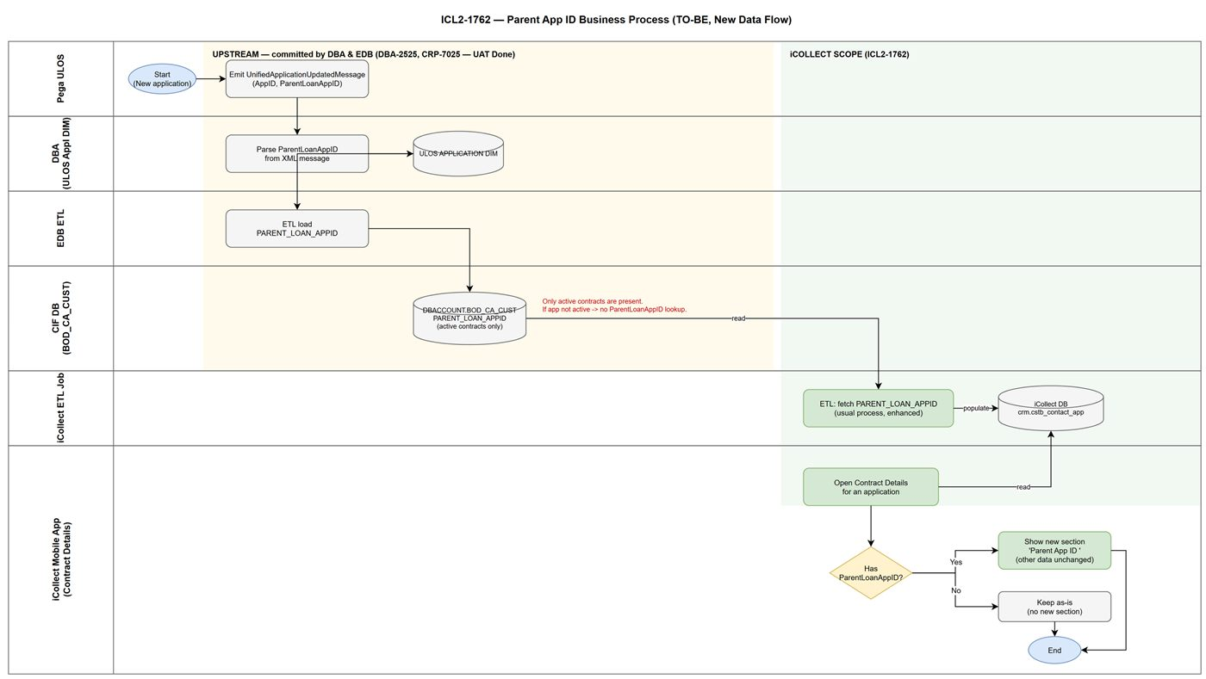
High Level Process Map
Data lineage (committed across dependency tickets): Pega ULOS (UnifiedApplicationUpdatedMessage XML) → DBA parses ParentLoanAppID into ULOS APPLICATION DIM (DBA-2525) → EDB ETL into DBACCOUNT.BOD_CA_CUST.PARENT_LOAN_APPID (CRP-7025, UAT Done) → iCollect ETL into crm.cstb_contact_app → iCollect Mobile App Contract Details screen (this BRD).
The cross-system in/out sequence (STEP 2 — new data flow) is shown below.
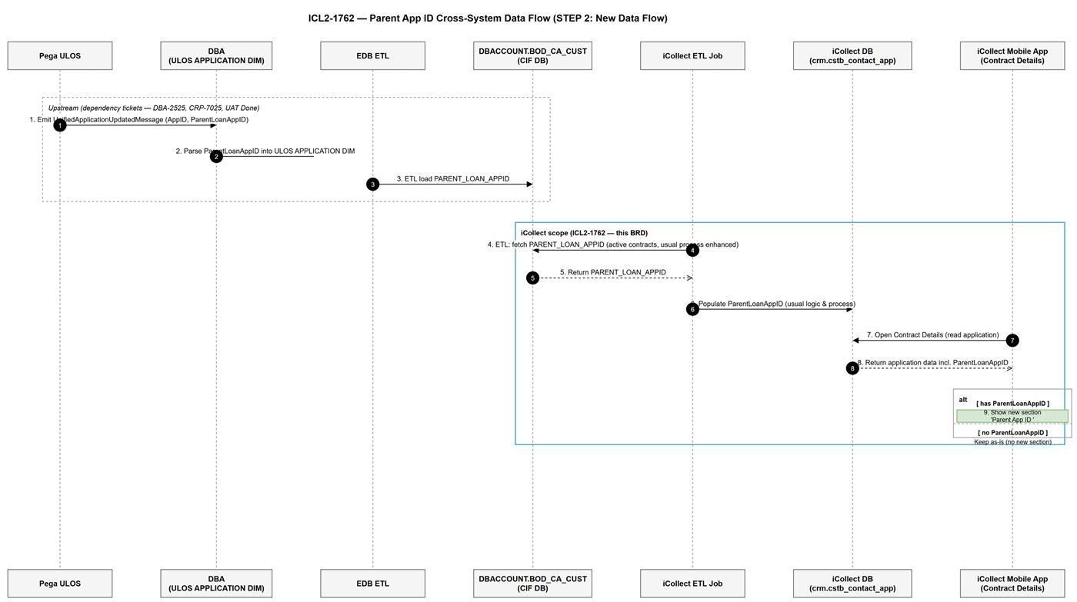
Parent App ID — Cross-System Sequence

2.2 List of User Stories / Use Cases
# | Story / Use Case / Epic | Priority | Source Ticket
1 | Populate a new field ParentLoanAppID from the CIF database (DBACCOUNT.BOD_CA_CUST) to store in the iCollect database | MUST HAVE | ICL2-1762
2 | The iCollect Mobile App displays the ParentLoanAppID data on the Contract Details screen | MUST HAVE | ICL2-1762

2.3 User Stories / Use Cases / Epic

Story #1 | Populate a new field ParentLoanAppID from the CIF database to store in the iCollect database
As a Collection business user, I want iCollect to obtain the ParentLoanAppID of each contract from the CIF database and store it in the iCollect database, so that the parent application of a contract can be identified and used by downstream iCollect features.
Acceptance Criteria
AC #1 — Enhance the ETL to fetch ParentLoanAppID from DBACCOUNT.BOD_CA_CUST
Enhance the existing iCollect ETL job (its usual process) so that it additionally retrieves the ParentLoanAppID data from the core data source DBACCOUNT.BOD_CA_CUST.
Data Mapping Table
No | Source: DBACCOUNT.BOD_CA_CUST | Target: iCollect staging (via ETL) | Type | Default Value | Length | Description | Remarks
1 | PARENT_LOAN_APPID | ParentLoanAppID | String | ” ” | [TBD — per current standard] | The parent loan application ID of the current application | Fetched by ETL (usual process, enhanced to pull this field)
In which: - The ParentLoanAppID data is made available (if any) in DBACCOUNT.BOD_CA_CUST by the DBA and EDB teams — refer to Dependencies and Section 4. - DBACCOUNT.BOD_CA_CUST holds only active contracts at daily processing time. If an application is no longer active, it is not present in this table and its PARENT_LOAN_APPID cannot be looked up. Contracts shown in iCollect are active, so this constraint is acceptable (confirmed in CRP-7025). - The ETL retrieval follows the usual process, enhanced only to additionally obtain the ParentLoanAppID data.
AC #2 — Populate ParentLoanAppID into the iCollect database
Populate the retrieved ParentLoanAppID and store it in the iCollect database under crm.cstb_contact_app, following the usual logic and process.
Data Mapping Table
No | Source: iCollect staging | Target: iCollect DB | Type | Default Value | Length | Description | Remarks
1 | ParentLoanAppID | crm.cstb_contact_app.[ParentLoanAppID column] | String | ” ” | [TBD — per current standard] | Stored parent loan application ID for the contact/application | Populated as the usual logic and process
In which: - Storage into crm.cstb_contact_app follows the existing iCollect logic and process; the column name/type/length follow the current iCollect data standard — [TBD — confirm exact column definition with iCollect DEV]. - When the source provides no ParentLoanAppID for an application (e.g. the application has no parent, or the record is not available in BOD_CA_CUST), the field is stored empty — refer to Story #2 for display behavior.

Story #2 | The iCollect Mobile App displays the ParentLoanAppID on the Contract Details screen
As a Field Collector (FC), I want the iCollect Mobile App to display the ParentLoanAppID on the Contract Details screen, so that I can reference the correct parent application of the contract I am collecting.
Acceptance Criteria
AC #1 — DISPLAY PARENT APP ID ON CONTRACT DETAILS SCREEN
GIVEN: I am a Field Collector using the iCollect Mobile App and I open a contract on the Contract Details screen.
WHEN: The system renders the Contract Details screen for the current application (refer to Story #1 for the stored ParentLoanAppID).
THEN: the system presents the Contract Details screen according to the business scenarios below, keeping all existing display logic and behavior unchanged.
UI MOCK UP:
- Path: [Screen]Contract Details
- Current UI reference (as-is): Jira attachment image-20261014-084446.png on ICL2-1762.
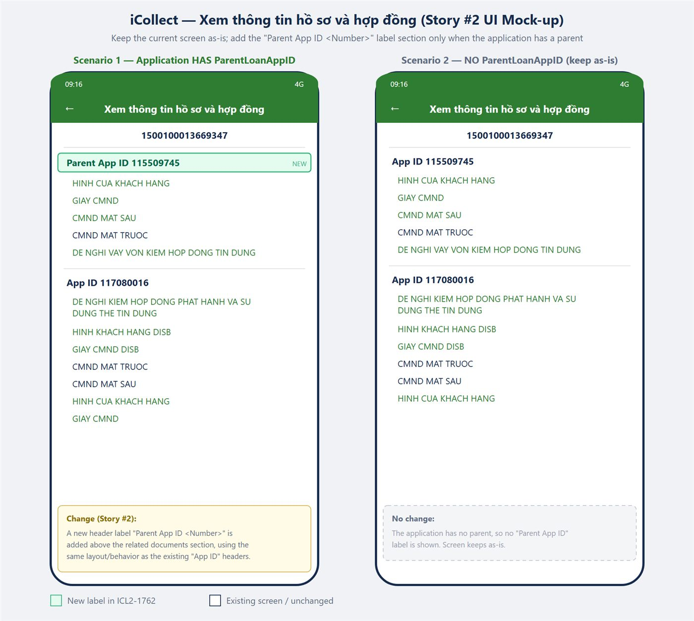
Contract Details screen — Parent App ID
BUSINESS RULE — Display behavior:
Business Scenario | iCollect Mobile App / Contract Details screen next action
The current application does not have its ParentLoanAppID | Keep as-is — no new section is shown; existing screen and data remain unchanged
The current application has its ParentLoanAppID | Show a new ParentLoanAppID data section on the current UI with the proper label Parent App ID <Number>; all data underneath remains unchanged
In which: - The rule / logic / integration to display data on the current Contract Details screen remains unchanged. - The rule / logic / data / integration between ECM and iCollect remains unchanged and keeps its current behavior. - <Number> is the stored ParentLoanAppID value from Story #1.
UI Field → System Field Mapping
No | Field on the UI | iCollect Field | Presented Value | Path
1 | Parent App ID <Number> | crm.cstb_contact_app.[ParentLoanAppID column] | Refer to Story #1 (stored ParentLoanAppID) | [Screen]Contract Details >> [Section]Parent App ID

3. Non-Functional Requirements
Category | Requirement | Details
Performance | ETL within existing batch window | The enhanced ETL to fetch ParentLoanAppID must run within the current iCollect ETL batch window; no additional real-time call introduced.
Security | No new sensitive data exposure | ParentLoanAppID is an application identifier; follow existing iCollect data handling and access controls.
Scalability / Sizing | No material increase | One additional string field per contact record; negligible storage impact.
Availability | Follow current SLA | iCollect data availability follows the current ETL/process SLA; dependent on BOD_CA_CUST being populated by DBA/EDB.
If further non-functional requirements are identified, they will be confirmed with the technical team.

4. High-Level Description for Integration

4.1 List of Integration Points
# | Story / Use Case | Integration Purpose | Input | Output — Logic to fetch data
1 | Story #1 | iCollect ETL fetches ParentLoanAppID from CIF DB | Active contract records in DBACCOUNT.BOD_CA_CUST | PARENT_LOAN_APPID per active application; retrieved via the usual ETL job (enhanced to pull this field), then stored into crm.cstb_contact_app
Upstream lineage (handled by dependency tickets, for context): - Pega ULOS emits UnifiedApplicationUpdatedMessage. AppID = /UnifiedApplicationUpdatedMessage/LoanProcessing/General/AppID; Parent AppID = /ns1:UnifiedApplicationUpdatedMessage/ns1:LoanProcessing/ns1:PreOriginationDetails/ns1:EligibleBase/ns1:ParentLoanAppID. - DBA parses ParentLoanAppID into ULOS APPLICATION DIM (DBA-2525). - EDB ETL loads it into DBACCOUNT.BOD_CA_CUST.PARENT_LOAN_APPID (CRP-7025, UAT Done).

4.2 DB and Relevant Information
# | DB Name / Service | Variables | TNS Information / Endpoint / Authentication
1 | DBACCOUNT.BOD_CA_CUST (CIF DB / cifdbv2) | PARENT_LOAN_APPID (source) | [TBD — per current iCollect ETL connection to CIF DB]
2 | iCollect DB — crm.cstb_contact_app | ParentLoanAppID (target column) | iCollect internal DB; follows existing ETL process
3 | ULOS APPLICATION DIM (DBA) | ParentLoanAppID (upstream) | Owned by DBA (DBA-2525) — context only

4.3 Error Handling
# | Scenario | Behavior | Action / Description
1 | Application has no parent / PARENT_LOAN_APPID empty | Store empty; display keeps as-is | No new UI section shown (refer to Story #2 business rule)
2 | Application not active (not present in BOD_CA_CUST) | No lookup possible | Accepted limitation — iCollect only shows active contracts (confirmed CRP-7025)
3 | ETL job failure | Follow current ETL error handling | No change to existing ETL error/retry behavior — [TBD — confirm current ETL error policy]

5. Appendixes
# | Document | File | Note
1 | Current Contract Details UI (as-is) | image-20261014-084446.png (ICL2-1762 attachment) | Reference for Story #2 current UI
2 | Parent AppID data flow — Sequence diagram | diagrams/sequence-parent-appid.drawio / .png | Cross-system in/out picture (STEP 2 new data flow)
3 | DBA parse spec | DBA-2525 | Parse ParentLoanAppID into ULOS APPLICATION DIM
4 | EDB store spec | CRP-7025 (UAT Done) | Store PARENT_LOAN_APPID into DBACCOUNT.BOD_CA_CUST
5 | Original business ticket | CRP-6703 | Business context / background

6. Glossary
Key Word | Description
iCollect | FE Credit collection mobile app / platform used by Field Collectors
FC | Field Collector — collection staff using iCollect
ParentLoanAppID / Parent App ID | The loan application ID of the parent (original) application from which the current application derives
AppID | Loan application identifier
Pega ULOS | Unified Loan Origination System (Pega) — source of the application message
DBA | Database Administration team / layer parsing the ULOS message into ULOS APPLICATION DIM
EDB / EDW | Enterprise Data (Warehouse) team / layer that loads data into the CIF database
ODS | Operational Data Store
DBACCOUNT.BOD_CA_CUST | CIF database table (cifdbv2) holding active contracts; carries PARENT_LOAN_APPID
crm.cstb_contact_app | iCollect database table where ParentLoanAppID is stored
ECM | Enterprise Content Management — document/image store (integration unchanged in this BRD)
ETL | Extract-Transform-Load batch job
CIF | Customer Information File

