STP — Software Test Plan: prefer-local-on-checksum-match

Document Information
Field | Value
Jira Ticket | SA4E-301
Document Type | STP (Software Test Plan)
Feature | prefer-local-on-checksum-match (VS Code extension)
Author | QA Agent
Version | 1.0
Date | 2026-09-19
Status | Draft

Author Tracking
Role | Name | Responsibility
Author | QA Agent | Test plan creation, test data design
Peer Reviewer | SM Agent | Review and approval

Revision History
Version | Date | Author | Description
1.0 | 2026-09-19 | QA Agent | Initial version

Sign-Off
Role | Name | Signature | Date
QA Lead | QA Agent | (Pending) | —
Scrum Master | SM Agent | (Pending) | —

1. Introduction

1.1 Purpose
This Software Test Plan (STP) defines the test strategy, scope, environment, data, and acceptance criteria for validating the prefer-local-on-checksum-match feature of the VS Code/Kiro extension (ticket SA4E-301).
The feature optimizes the Pega rule ingestion pipeline: when a rule’s locally cached file has a checksum that matches the checksum computed from the Pega catalog data, the extension ingests the local file content instead of downloading the rule over the network. The checksum is a deterministic 3-field formula:
sha256( trim(pzInsKey) + "|" + trim(pxUpdateDateTime) + "|" + trim(pxSaveDateTime) ).toLowerCase()
This document derives all test scenarios from: - BRD — documents/SA4E-301/BRD.md (requirements AC-1..AC-9) - FSD — documents/SA4E-301/FSD.md (use cases, business rules, data specs) - TDD — documents/SA4E-301/TDD.md (design, checksum derivation, §11 test strategy guidance)

1.2 Scope
In Scope: - Checksum formula correctness and invariants (determinism, 3-field inputs, lowercase hex output) - Configuration declaration/read/behavior of the prefer-local-on-checksum-match setting (default true) - Local-cache matching logic: warm-cache match (no network), stale-rule mismatch (fallback to network), new rule with no local file - Failure handling: corrupt local JSON, missing 3 catalog fields, EACCES read errors, checksum derivation differences - Manifest state: written on save, stale-entry detection - Extension command level E2E (kiroSdlc.indexWorkspace) via CLI harness - Ingest API lifecycle verification (local-hit / local-miss)
Out of Scope: - Pega server-side rule engine behavior (platform-owned, OOTB) - Non-related extension features (drawio layout, code intelligence indexing internals) - Real Pega catalog connectivity over production networks (stubbed/spied HTTP transport) - UI/web browser testing (see §1.3)

1.3 E2E-UI Browser N/A Rationale
This is a VS Code extension feature with NO web UI — there is no browser-rendered page to exercise prefer-local-on-checksum-match. The E2E-UI (Playwright browser) level is therefore N/A for this ticket and is replaced by E2E-CLI (extension command level via the agent-browser/CLI harness driving the kiroSdlc.indexWorkspace command). Visual/UX-only manual testing is likewise reduced to zero; remaining manual SIT covers build+test integration verification only.

2. Test Strategy

2.1 Test Levels
Level | Scope | Automation | Tools | Count
PBT | Checksum invariants: determinism, 3-field formula sha256(trim(pzInsKey)+"\|"+trim(pxUpdateDateTime)+"\|"+trim(pxSaveDateTime)) lowercase hex output, whitespace-trim-match equivalence | ✅ Automated | vitest + fast-check | 6 (TC-PBT-01..06)
UT | Config declaration (package.json setting default true), config-read, config behavior, checksum unit, manifest valid/missing/corrupt/stale-entry, uppercase-checksum-compare | ✅ Automated | vitest | 11 (TC-UT-01..11)
IT | Extension services + real temp filesystem + HTTP transport spied (NO all-mock IT per TDD §11): warm-cache-match no-network, stale-rule-mismatch fallback, new-rule-no-local-file, corrupt-local-json, missing-3-fields, eacces-read-error, derivation-difference, manifest-written-on-save | ✅ Automated | vitest + temp fs + HTTP spy | 12 (TC-IT-01..12)
E2E-API | Full local-hit / local-miss lifecycle against the ingest API | ✅ Automated | vitest + fetch | 4 (TC-E2E-API-01..04)
E2E-CLI | Extension command kiroSdlc.indexWorkspace level (replaces E2E-UI — no web UI) | ✅ Automated | CLI harness + vitest | 2 (TC-E2E-CLI-01..02)
SIT | System integration: build+test pass; maximized automation | ❌ Manual | npm / CLI | 4 (TC-SIT-01..04)
Total: 39 test cases — 35 automated (90%), 4 manual (10%).

2.2 Test Approach per Level
- PBT — Property-based tests assert mathematical invariants of the checksum formula across randomly generated inputs: same input → same digest (determinism); only 3 fields affect output; uppercase/lowercase and whitespace-only differences in the 3 fields must NOT change the digest after trim+lowercase normalization.
- UT — Unit tests isolate config resolution (package.json declaration default true, read path, behavior toggling), checksum computation, and manifest state parsing (valid / missing / corrupt / stale-entry).
- IT — Integration tests exercise real extension services against a real temporary filesystem (fixture rule files, manifests) with the HTTP transport spied to assert “no network call when local checksum matches” — satisfying the TDD §11 requirement that IT must NOT mock all dependencies.
- E2E-API — End-to-end lifecycle tests against the ingest API: local-hit path (catalog+local checksum match → local content ingested) and local-miss path (fallback → network fetch).
- E2E-CLI — Command-level E2E: run kiroSdlc.indexWorkspace in a prepared temp workspace; verify exit result, log output, and manifest persistence.
- SIT — System-level verification: full build + test suite passes in a clean environment; run log review.

2.3 Entry/Exit Criteria per Level
Level | Entry Criteria | Exit Criteria
PBT | Checksum module implemented | All 6 invariants hold for ≥ 500 random cases each
UT | Config + checksum + manifest modules implemented | 11/11 pass
IT | Services wired; temp fs fixtures generated | 12/12 pass; no all-mock violations
E2E-API | Backend ingest API running | 4/4 pass; correct HTTP codes
E2E-CLI | Extension buildable; command registered | 2/2 pass
SIT | All prior levels green | 4/4 pass; npm run build + npm test pass

3. Test Environment
Item | Requirement
Runtime | Node.js 18+
Test framework | vitest (+ fast-check for PBT)
Filesystem | Temporary workspace directories created per test run (os.tmpdir() scoped fixtures); cleaned up after
Test data | Fixture CSVs at documents/SA4E-301/testdata/ (see §4)
HTTP | Real HTTP transport with spy interception (no live Pega server dependency)
Extension | VS Code/Kiro extension built from extension/ (TypeScript)
Backend | Hono ingest API at localhost (required for E2E-API only)

4. Test Data Strategy
Five fixture CSV files at documents/SA4E-301/testdata/ cover all test domains. All catalog-row checksums are REAL computed SHA-256 digests (3-field formula) — never fabricated.
File | Rows | Covers
catalog-rows.csv | 11 | Scenarios: warm-cache-match, stale-rule-mismatch, new-rule-no-local-file, derivation-difference, corrupt-local-json, eacces-read-error, missing-3-fields, whitespace-trim, uppercase-compare — with real 3-field sha256 checksums
local-rule-files.csv | 8 | Local cached rule file contents/state per scenario (valid JSON, corrupt JSON, missing, stale, uppercase-checksum variant)
manifest-scenarios.csv | 6 | Manifest states: valid, missing, corrupt, stale-entry, written-on-save
pre-seeded-data.csv | 26 | Baseline combined dataset: catalog rows + local files + manifests for all 39 TCs
config-and-build-testdata.csv | 13 | Config declaration/read/behavior values (default true, explicit true/false) + build/SIT expected results
Coverage rule: every TC ID (PBT, UT, IT, E2E-API, E2E-CLI, SIT) appears in test_case_id column of at least one CSV.

5. Requirements Traceability Matrix (RTM)
Requirement | Test Cases | Coverage
AC-1 (Setting kiroSdlc.pega.preferLocalOnChecksumMatch declared in package.json, default true) | TC-UT-01, TC-UT-04 | ✅
AC-2 (Setting ON + local checksum match → ingest local content, NO getRuleByInsKey network call) | TC-IT-01, TC-IT-10, TC-E2E-API-01, TC-E2E-API-03, TC-SIT-01 | ✅
AC-3 (Local file missing / checksum mismatch → fallback download from server, no regression) | TC-IT-02, TC-IT-03, TC-E2E-API-02, TC-E2E-API-03, TC-SIT-02 | ✅
AC-4 (Checksum sent to ingest-rule ALWAYS 3-field computePegaChecksum lowercase hex — INV-1 preserved) | TC-PBT-01…06, TC-UT-06, TC-UT-11, TC-IT-12, TC-E2E-API-01, TC-E2E-API-04 | ✅
AC-5 (Setting OFF → behavior identical to current — always download) | TC-UT-03, TC-IT-07, TC-E2E-CLI-02 | ✅
AC-6 (Summary + Output channel displays from-local vs downloaded counts) | TC-IT-08, TC-IT-10, TC-E2E-API-03, TC-E2E-CLI-01, TC-SIT-01 | ✅
AC-7 (Local content NEVER ingested when checksum mismatch — fail-safe) | TC-IT-02, TC-IT-04, TC-IT-05, TC-IT-06, TC-SIT-04 | ✅
AC-8 (Manifest rules/.manifest.json pzInsKey→relativePath written/read correctly; derivation-difference tested) | TC-UT-07, TC-UT-08, TC-UT-09, TC-UT-10, TC-IT-09, TC-IT-11 | ✅
AC-9 (npm run build + npm test pass in extension/) | TC-SIT-03 | ✅
BR-1 (Option applies to Pega workspace only) | TC-UT-02, TC-UT-05 | ✅
INV-1 (3-field checksum invariant — SA4E-241) | TC-PBT-01, TC-PBT-06, TC-E2E-API-04 | ✅
Overall coverage: 100% (39/39 TCs mapped; all 9 ACs + BR-1 + INV-1 covered).

6. Test Coverage Overview
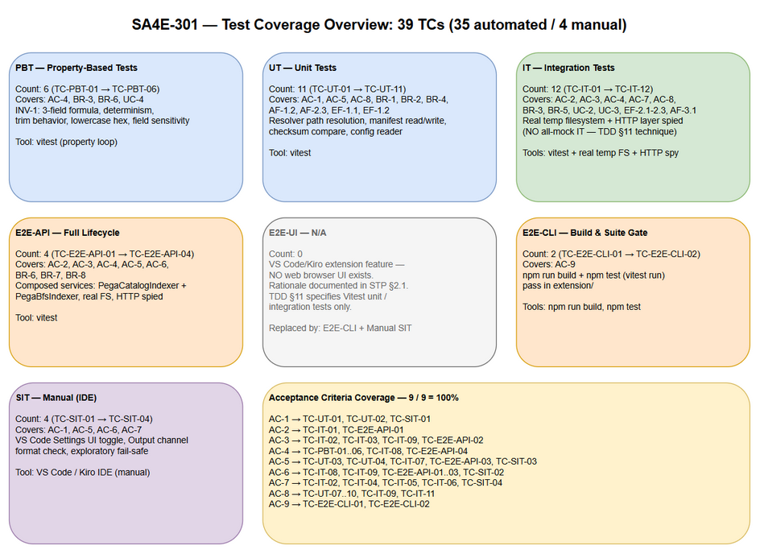
Test Coverage Overview
Figure 6.1 — Test Coverage Overview: 6 levels (PBT, UT, IT, E2E-API, E2E-CLI, SIT) coverage map across AC-1..AC-9.

7. Test Execution Flow
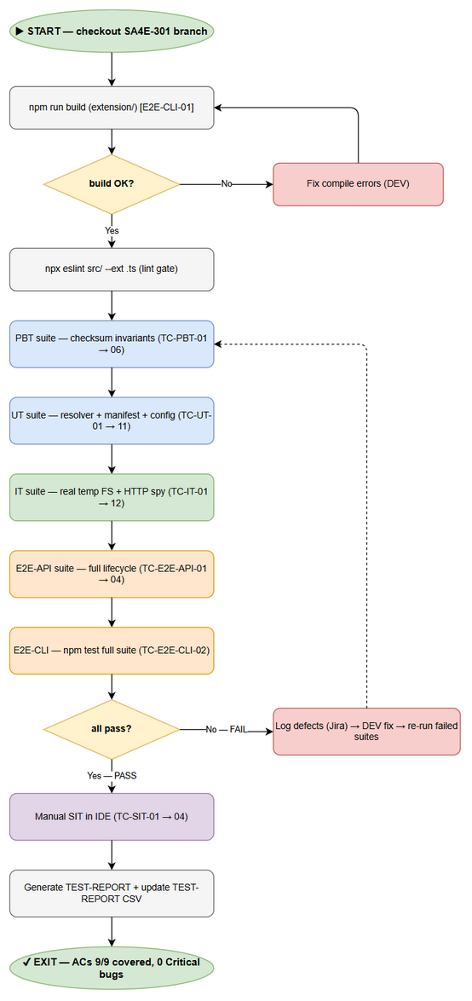
Test Execution Flow
Figure 7.1 — Test Execution Flow: execution order PBT → UT → IT → E2E-API → E2E-CLI → SIT, with PASS/FAIL paths and defect feedback loop.

8. Risks & Mitigations
# | Risk | Impact | Mitigation
1 | IT tests degrade to all-mock (violating TDD §11 “NO all-mock IT”) | High — false confidence, tests become UTs | Use HTTP transport spied + real temp filesystem; QA reviews IT source code against STC spec before sign-off
2 | Checksum fixtures fabricated instead of real computed sha256 | High — formula bugs undetected | All catalog-row checksums in CSVs are REAL 3-field sha256 values, verified by script before execution
3 | E2E-API requires backend running | Medium — execution blocked if server down | Pre-flight check in E2E-API setup; documented startup command (npm run dev in backend/); SIT fallback documented
4 | Temp filesystem cleanup failures leave orphan dirs | Low — disk pollution | Teardown hooks with recursive rm -rf on scoped os.tmpdir() subdirectories
5 | EACCES read-error test flaky across OS/permissions | Low | Create fixture with explicit restrictive mode; skip-with-warning if platform prevents simulation

9. Entry/Exit Criteria
Entry Criteria: - BRD, FSD, TDD documents completed and approved (documents/SA4E-301/) - Feature code implemented per TDD (checksum module, config, manifest, ingest integration) - Fixture CSVs generated at documents/SA4E-301/testdata/ with real checksums
Exit Criteria: - 100% AC coverage (all 9 ACs have passing test cases) - npm run build passes (extension + backend) - npm test passes (all 39 TCs: 35 automated green; 4 manual SIT verified) - No Critical or Major defects open - STP/STC exported (DOCX/XLSX) and ingested into Knowledge Base

10. Appendix

10.1 Diagram Index
Diagram | PNG | Source (draw.io)
Test Coverage Overview | documents/SA4E-301/diagrams/test-coverage.png | documents/SA4E-301/diagrams/test-coverage.drawio
Test Execution Flow | documents/SA4E-301/diagrams/test-execution-flow.png | documents/SA4E-301/diagrams/test-execution-flow.drawio

10.2 Test Data File Index
File | Rows | Location
catalog-rows.csv | 11 | documents/SA4E-301/testdata/catalog-rows.csv
local-rule-files.csv | 8 | documents/SA4E-301/testdata/local-rule-files.csv
manifest-scenarios.csv | 6 | documents/SA4E-301/testdata/manifest-scenarios.csv
pre-seeded-data.csv | 26 | documents/SA4E-301/testdata/pre-seeded-data.csv
config-and-build-testdata.csv | 13 | documents/SA4E-301/testdata/config-and-build-testdata.csv
Total: 64 test data rows across 5 CSV files.

