Business Requirements Document (BRD)

Pi Harness — SA4E-360: Multi-Resolution Context Supply for Pi Harness — P1: Code Skeletonization + Agentic Context Loading

Document Information
Field | Value
Jira Ticket | SA4E-360
Title | Multi-Resolution Context Supply for Pi Harness — P1: Code Skeletonization + Agentic Context Loading (wire dormant foundation)
Issue Type / Priority | Story / High
Labels | context-governance, pi-harness, wire-only
Project | SA4E — SDLC Agents 4 Enterprise
Author | BA Agent
Version | 1.1
Date | 2026-10-13
Status | Draft

Author Tracking
Role | Name - Position | Responsibility
Author | BA Agent – Business Analyst | Create document
Peer Reviewer | TA Agent – Technical Architect | Review business requirements and token math (source: TA Review sections T1–T6 of the context compaction proposal)

Revision History
Version | Date | Author | Changes
1.0 | 2026-10-13 | BA Agent | Initiate document — auto-generated from Jira ticket SA4E-360, TA review of documents/SA4E-355/context_compaction_strategies.md (TA Review T1–T6), and SA4E-355 TDD v1.3 (§13 budget gate architecture)
1.1 | 2026-10-13 | BA Agent | v1.1: removed Mermaid inline (project rule Draw.io Only), replaced with drawio PNG references

Sign-Off
Name | Signature and date
 | ☐ I agree and confirm all criteria on this BRD as expected requirements
 | ☐ I agree and confirm all criteria on this BRD as expected requirements

1. Introduction

1.1 Scope
SA4E-360 wires the dormant multi-resolution context supply foundation into the Pi Harness chat path so that reviewing an entire workspace on local LLMs (32K/65K context windows) becomes feasible without overflowing the model context window.
Per the TA review of the context compaction proposal (documents/SA4E-355/context_compaction_strategies.md, sections TA Review T1–T6), approximately 80% of the required foundation ALREADY EXISTS but is DORMANT — not wired into the chat path. This ticket is therefore wire-only (inherits BR-11 from SA4E-355): it composes existing mechanisms; it does not build new engines, routers, or algorithms.
SA4E-355 (shipped, v1.52.0) is the governance plane — it decides “how many tokens” may be loaded (3-point budget gate + transcript compaction, BR-01..BR-16). This ticket is the content plane — it decides “what” is loaded. The two planes are complementary, NOT redundant: every mechanism delivered by SA4E-360 must operate INSIDE the existing budget of SA4E-355 and must never replace or weaken it.
In scope (P1 — two strategies, per Jira ticket description):
- Agentic Context Loading completion (proposal Strategy 2):
  - Wire a new read_method(class, method) tool that reads a single symbol slice (startLine/endLine from the existing symbols FTS5 table) instead of whole files.
  - Wire the functional map (from the dormant SummaryTreeBuilder) into the production tool get_workspace_info (already wired, layout cached 60s).
- Code Skeletonization, budget-aware (proposal Strategy 1):
  - Wire the dormant SymbolOutlineExtractor.extractOutline (extension/src/pi-agent/context-retrieval/) into session creation.
  - Inject the workspace skeleton (classes, interfaces, method signatures, parameters, imports, doc comments — no method bodies) into the system context via createHost overrides.
  - Mandatory budget-aware sizing: skeleton ≤ 70% of staticBudget (~13.8K tokens @32k), measured with BudgetCalculator BEFORE createAgentSession; persisting overflow → REJECT per BR-09.
  - Regex fallback (signature-extractor.ts) for languages without a tree-sitter grammar (e.g., Svelte).

1.2 Out of Scope
The following items are explicitly excluded from SA4E-360 and are reserved for follow-up tickets (TA roadmap T6):
# | Excluded Item | Reason | Follow-up
1 | P2 — Contextual RAG wire: wire ContextRetriever (McpSearchProvider → RRF merger) pre-turn for query-specific review | P1 must first measure the hit-rate baseline of skeleton + targeted reads | Future ticket (P2, to be created)
2 | P3 — Map-Reduce wire: wire MapReduceOrchestrator for very large workspaces | Over-engineering while skeleton fits staticBudget; trigger condition is skeleton > staticBudget | Future ticket (P3, to be created)
3 | P4 — Call-graph pruning (depth=1) | Call-edge quality for TS/JS not yet proven for review purposes; deferred until a feature-flow review need exists | Deferred
4 | Hybrid/vector retrieval latency optimization | The hybrid path is wired at P2; P1 validates the FTS5 path only | P2
5 | Any new Tree-sitter dependency | tree-sitter + 16 grammar .wasm bundles are already shipped in backend/src/engine/parsers/ | N/A (prohibited)
6 | Any new router / engine / algorithm (e.g., replacing QueryRouter, rewriting budget math) | No-workaround rule + BR-11 wire-only | N/A (prohibited)

1.3 Preliminary Requirement
- SA4E-355 shipped (v1.52.0) — 3-point budget gate (legacy turn-start auto-chunk; session turn-start createHost gate with escalation ladder BR-08; intra-turn streamFn gate, TDD v1.3 §13) and transcript compaction (pin newest user message; atomic tool-unit drop) fully operational. Baseline test suite: 285 test files / 2,748 tests green (Phase 6 PASS).
- code-intel index fresh — the symbols table (FTS5: name, kind, signature, startLine, endLine, docComment) must be current; mtime check + re-index on demand per the “code-index freshness” guardrail.
- Tree-sitter + 16 grammars bundled in backend/src/engine/parsers/ (ts, js, py, go, java, kotlin, c, cpp, c#, php, ruby, rust, scala, swift, apex, jsp) — no new dependency required.
- Dormant components available for wiring: SymbolOutlineExtractor.extractOutline (tests-only today), signature-extractor.ts (regex multi-language), SummaryTreeBuilder (dormant), workspace-info-tool.ts (get_workspace_info, wired production, cached 60s), TurnBudgetGuard (anti-livelock, shipped).

2. Business Requirements

2.1 High Level Process Map
The P1 feature turns every workspace-review turn into a budget-aware, multi-resolution context supply pipeline: the harness first resolves the token budget (governance plane, SA4E-355), then builds and measures a code skeleton (content plane, this ticket), injects it as static context only if it fits ≤ 70% of staticBudget, and finally lets the reviewer LLM pull detail lazily via tool calls that remain subject to the intra-turn gate.
Use Case view (actors SM / DEV / QA):
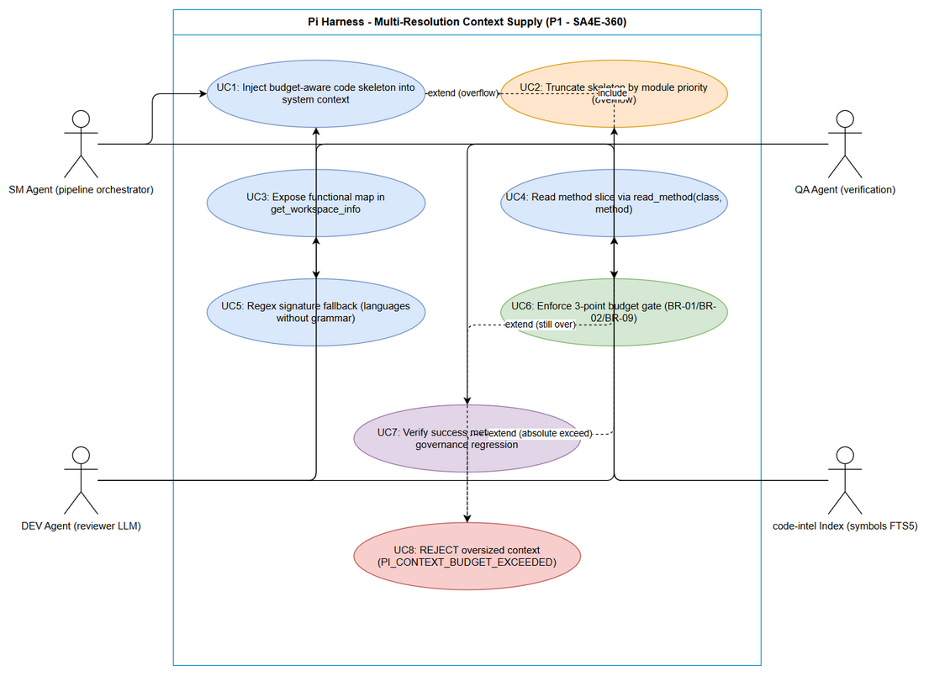 Edit in draw.io
High-level process map — end-to-end business flow (swimlane view):
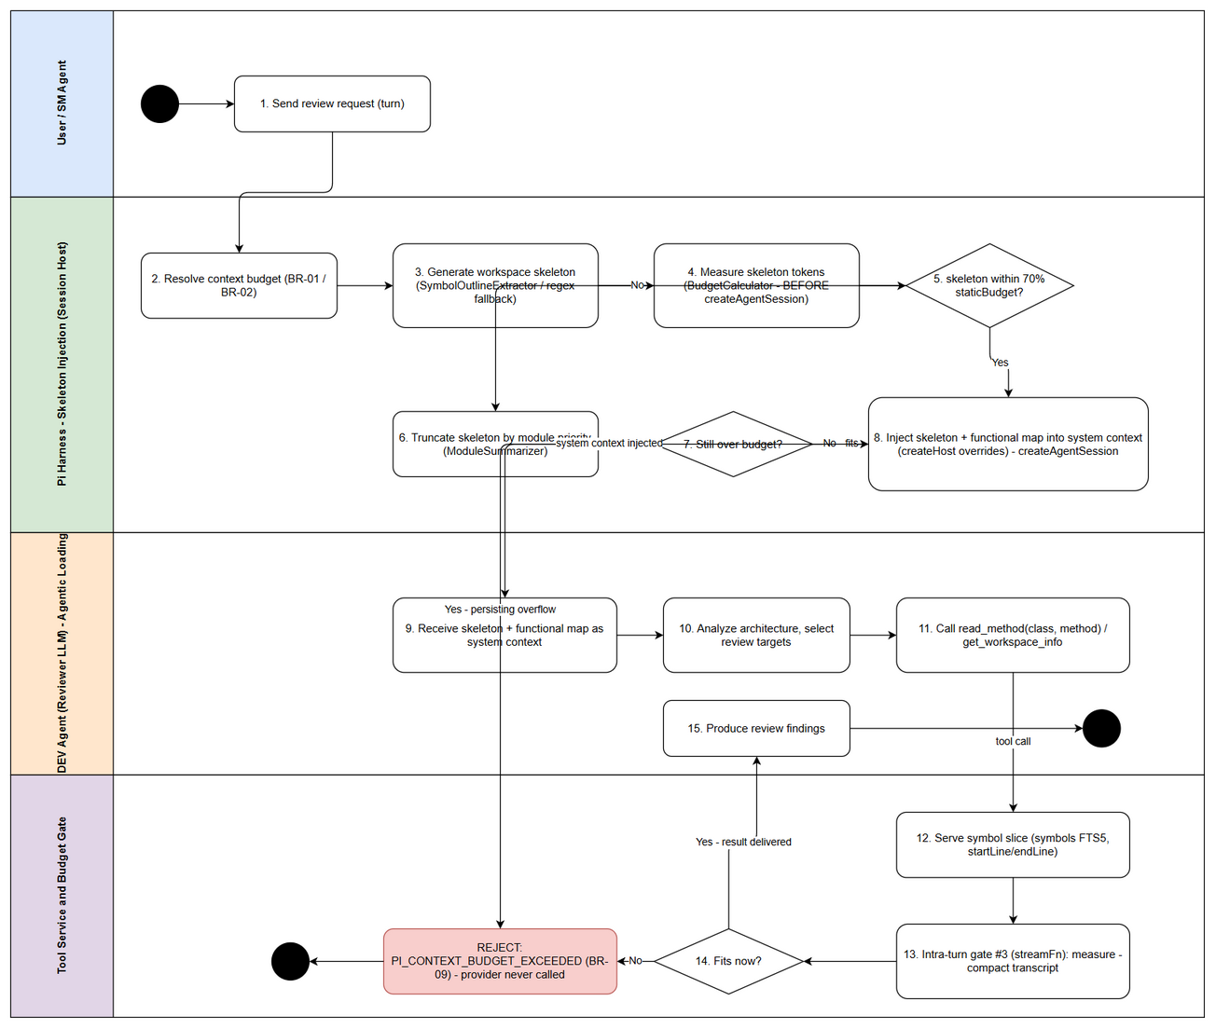 Edit in draw.io

2.2 List of User Stories / Use Cases
# | Story / Use Case | Priority | Source Ticket
1 | As a developer agent reviewing an entire workspace on a 32K/65K local LLM, I want a token-budgeted code skeleton injected into my system context so that I understand the full architecture without overflowing the context window | MUST HAVE | SA4E-360
2 | As a reviewer LLM, I want to read only the specific method I need via read_method(class, method) so that each inspection consumes minimal tokens and tool results stay compact | MUST HAVE | SA4E-360
3 | As a reviewer LLM, I want a functional summary map inside get_workspace_info so that I can decide which files/methods to read without scanning the raw directory tree | MUST HAVE | SA4E-360
4 | As the harness, I want regex-based signature extraction for languages without a tree-sitter grammar so that skeleton coverage stays high and session creation never blocks on missing grammars | MUST HAVE | SA4E-360
5 | As a Scrum Master, I want the existing 3-point budget governance and transcript compaction to remain fully effective after the new wiring so that context budget enforcement is never weakened | MUST HAVE | SA4E-360

2.3 Details of User Stories

Business Flow
Step 1: The user (or SM Agent on behalf of the pipeline) sends a workspace review request as a chat turn.
Step 2: The Session Host resolves the context budget via the existing chain: provider-detected n_ctx → ModelRegistry → default 8192 (BR-01), then usable = nCtx − reserveOutput − ceil(nCtx × 8%) with 70/30 static/history split (BR-02/BR-03). At 32k (qwen): usable = 28,098; staticBudget = 19,668; historyBudget = 8,430. At 65k: usable = 58,245; staticBudget = 40,771; historyBudget = 17,474.
Step 3: The harness generates the workspace skeleton by wiring SymbolOutlineExtractor.extractOutline(file, symbols, maxTokens) over the indexed symbols; languages without a tree-sitter grammar fall back to regex extraction (signature-extractor.ts).
Step 4: Skeleton tokens are measured with estimateTokenCount and gated with BudgetCalculator.calculateBudget — BEFORE createAgentSession (turn-start gate, execution point #2).
Step 5: Decision — skeleton ≤ 70% staticBudget (~13.8K @32k)? If yes, go to Step 7. If no, the skeleton is truncated by module priority (using metrics from ModuleSummarizer) and re-measured (Step 6).
Step 6: After truncation, if the skeleton still exceeds 70% staticBudget, the session is REJECTED with PI_CONTEXT_BUDGET_EXCEEDED (BR-09) — the provider is NEVER called with an oversized prompt. If it now fits, continue.
Step 7: The skeleton plus the functional map (from SummaryTreeBuilder, served inside get_workspace_info) are injected into the system context via createHost overrides, and the agent session is created. The reviewer LLM now holds the whole-workspace architecture in ~≤70% of staticBudget, leaving the remainder for steering, tool schemas, and history.
Step 8: The reviewer LLM analyzes the architecture and lazily pulls detail: it calls read_method(class, method) to read a single symbol slice (startLine/endLine from the symbols FTS5 table) and consults the functional map in get_workspace_info to choose targets. Read loops are bounded by the existing TurnBudgetGuard (4× identical tool+args → steer → abort).
Step 9: Every tool result flows through the intra-turn gate (execution point #3, Agent.streamFn, TDD v1.3 §13): measure → compact transcript (trim-oldest tool units atomically, pin newest user message) → REJECT only if the pinned user query itself cannot fit (BR-09).
Step 10: The reviewer produces review findings. Success is measured against the metrics in section 2.5 (coverage, hit-rate, findings parity, latency, zero exceed_context_size_error).
Note: The skeleton is a STATIC context component — it is measured once at the turn-start gate (point #2) and never grows during the turn. Only tool results (read_method slices, workspace info) grow intra-turn and are absorbed by gate #3 + transcript compaction. This is exactly the division of responsibility between the governance plane (SA4E-355) and the content plane (this ticket).
End-to-end sequence view:
The end-to-end interaction across participants (User / SM Agent → Session Host → Skeleton Builder → Budget Gate → Reviewer LLM → Tool Service), including the two budget-gate decision points (turn-start gate #2 and intra-turn gate #3) and the truncate → REJECT path (BR-09), is visualized in the swimlane business-flow diagram:
Edit in draw.io

STORY 1: Budget-Aware Code Skeleton Injection
As a developer agent reviewing an entire workspace on a 32K/65K local LLM, I want a token-budgeted code skeleton (class/interface names, method signatures with parameter types, imports, doc comments — no method bodies) injected into my system context, so that I understand the full architecture and its dependencies without overflowing the context window.
Requirement Details: (Source: SA4E-360 description; TA Review T2, T5)
- Wire the dormant SymbolOutlineExtractor.extractOutline(file, symbols, maxTokens) (extension/src/pi-agent/context-retrieval/symbol-outline-extractor.ts, currently tests-only) into session creation.
- Inject the rendered skeleton as static context via createHost overrides so it is measured at the turn-start budget gate (execution point #2) BEFORE createAgentSession.
- Budget-aware sizing: skeleton MUST target ≤ 70% of staticBudget — ~13.8K tokens @32k (staticBudget 19,668), ~28.5K @65k (staticBudget 40,771). Fixed-size skeletons (e.g., the proposal’s original “15K”) are explicitly wrong at 32k (would be 76% of staticBudget).
- Measurement MUST use estimateTokenCount + BudgetCalculator.calculateBudget before session creation (early measurement, in the spirit of BR-12: detect BEFORE assembly).
- On overflow: truncate the skeleton by module priority (metrics from ModuleSummarizer), then re-measure. If it still exceeds → REJECT per BR-09 (fail-safe, never fail-open).
- The skeleton keeps the existing 70/30 split untouched: tool calls continue to consume historyBudget, not staticBudget.
Data Fields (business-level; FSD formalizes):
Field | Type | Required | Description | Example
skeletonContent | string | Yes | Rendered outline: classes, interfaces, signatures, imports, doc comments (no bodies) | “class BudgetCalculator { calculateBudget(…): ContextBudget }”
skeletonTokens | number | Yes | Token estimate via estimateTokenCount | 13,200
staticBudget | number | Yes | 70% share of usable budget (BR-01/BR-02/BR-03 math) | 19,668 (@32k)
usagePercent | number | Yes | skeletonTokens / staticBudget | 0.67
truncationApplied | boolean | Yes | Whether module-priority truncation ran | true
modulePriorityOrder | list | No | Module ordering used for truncation (ModuleSummarizer metrics) | [engine, extension, backend]
measurementPoint | string | Yes | Where measurement happened | “turn-start gate #2, before createAgentSession”
gateDecision | enum | Yes | PASS / TRUNCATED_PASS / REJECT | TRUNCATED_PASS
Acceptance Criteria:
- On a supported-language workspace, the skeleton is injected into the system context at session creation; turn-1 review on qwen 32k produces 0 × exceed_context_size_error (inherits BR-09).
- Every session satisfies skeletonTokens ≤ 70% staticBudget (13.8K @32k; 28.5K @65k) — verified by the gate measurement.
- Skeleton tokens are measured with BudgetCalculator BEFORE createAgentSession; no provider call may occur before the measurement.
- When the raw skeleton exceeds the limit, truncation by module priority runs; if it still exceeds, the turn is REJECTED with PI_CONTEXT_BUDGET_EXCEEDED and the provider is never called (BR-09).
- Skeleton coverage ≥ 95% of exported symbols, verified against the symbols table.
- The 70/30 static/history budget split and escalation ladder (BR-08) behavior are unchanged (see STORY 5).
Validation Rules:
- skeletonTokens = estimateTokenCount(skeletonContent); reject any session where skeletonTokens / staticBudget > 0.70 after truncation (BR-360-01/02).
- Tree-sitter-supported language → AST path (extractOutline); unsupported language → regex fallback (STORY 4); the same 70% cap applies to both paths.
- Empty or unparseable file → skip that file, continue, and log (never fail the whole session for one file).
Error Handling:
- Skeleton build fails for a single file → skip file, log warning, continue with the rest.
- Token estimation fails → treat as unknown-size (conservative overflow path) → truncate → REJECT if persisting.
- Index missing/stale → mtime check triggers on-demand re-index; if re-index fails → proceed without skeleton and steer the LLM to get_workspace_info + read_method (agentic fallback), never silently oversize the context.

STORY 2: read_method Tool — Symbol-Level Agentic Reading
As a reviewer LLM, I want to read only the specific method I need via read_method(class, method) so that each inspection consumes minimal tokens and tool results stay compact under the intra-turn budget gate.
Requirement Details: (Source: SA4E-360 description; TA Review T3, T5)
- Supply a new core tool read_method(class, method) in the existing toolset (BR-06 core tools + get_workspace_info + find_tools chain). It resolves the symbol from the symbols FTS5 table (name, kind, signature, startLine, endLine) and returns ONLY that line range from the source file.
- This is the primary replacement for whole-file reads during review: symbol-targeted inspection consumes a fraction of the tokens and directly reduces intra-turn transcript growth.
- Tool results remain ordinary tool results: they are measured by the intra-turn gate (execution point #3, Agent.streamFn) and are droppable atomically by transcript compaction (pin-newest-user rule, TDD v1.3 §13.3).
- Repeated identical reads are bounded by the shipped TurnBudgetGuard (4× identical tool+args → steer → abort) — no new loop protection may be written (BR-11).
- Retrieval is served from FTS5 (p95 ≤ 300ms).
Data Fields:
Field | Type | Required | Description | Example
class | string | Yes | Target class/interface name (as indexed in symbols table) | “SymbolOutlineExtractor”
method | string | Yes | Target method name | “extractOutline”
filePath | string | Output | Resolved source file of the symbol | “extension/src/pi-agent/context-retrieval/symbol-outline-extractor.ts”
startLine / endLine | number | Output | Symbol line range from the symbols table | 42 / 88
signature | string | Output | Indexed signature | “extractOutline(file, symbols, maxTokens)”
sourceSlice | string | Output | Exact source lines startLine..endLine | —
symbolKind | string | Output | method / function / class | method
Acceptance Criteria:
- read_method(class, method) returns the exact symbol slice matching the symbols-table line range for supported languages.
- Retrieval p95 latency FTS5 ≤ 300ms.
- The result token size is smaller than a whole-file read for the same target; the result is counted as a tool result and passes the intra-turn gate like any other tool result.
- Unknown class/method → an actionable “not found” tool result with steering suggestions (use get_workspace_info / find_tools), NOT an exception that crashes the turn.
- Retrieval hit-rate ≥ 80% top-5 on the golden query set (TA Review T5).
- A read loop (identical call ×4) triggers the existing TurnBudgetGuard steer/abort behavior.
Validation Rules:
- Both arguments required and non-empty; resolution must match exactly one symbol when possible; ambiguous names (e.g., overloads) → return the candidate list with locations instead of an arbitrary pick.
- startLine/endLine must satisfy 1 ≤ startLine ≤ endLine; a stale line range (file changed vs index) → trigger index refresh per the code-index freshness guardrail before answering.
Error Handling:
- Symbol not found → “not found” result + suggestion (see AC 4).
- Index stale → mtime check → on-demand re-index → retry once → then “not found” guidance.
- File unreadable/permission error → actionable error message in the tool result; the turn continues.

STORY 3: Functional Map in get_workspace_info
As a reviewer LLM, I want a functional summary map (what each module does + its key symbols) served inside get_workspace_info, so that I can decide which files/methods to read without scanning the raw directory tree.
Requirement Details: (Source: SA4E-360 description; TA Review T3)
- Wire the dormant SummaryTreeBuilder into the production tool workspace-info-tool.ts (get_workspace_info — already wired, layout cached 60s). The tool returns the existing layout PLUS a functional-map section (module → functional summary → key symbols).
- The functional map is token-bounded (capped result size) so the tool result itself cannot blow up the transcript.
- The functional map the LLM receives as system context (Step 7 of the business flow) is part of static context and is measured at the turn-start gate together with the skeleton.
- Reuse only — no new summarization algorithm (BR-11); SummaryTreeBuilder output is consumed as-is.
Data Fields:
Field | Type | Required | Description | Example
layout | object | Yes | Existing directory layout (unchanged behavior) | —
functionalMap | list | Yes | Entries: module path, functional summary, key symbols | [{module: “extension/src/pi-agent”, summary: “agent session + query routing”, keySymbols: [“QueryRouter”, “SymbolOutlineExtractor”]}]
mapTokens | number | Yes | Token cost of the functional-map section | 1,800
cacheTtlSeconds | number | Yes | Existing 60s cache preserved | 60
Acceptance Criteria:
- get_workspace_info returns both the layout and the functional map; the map is built by the wired SummaryTreeBuilder.
- The existing 60s cache behavior is preserved (no regression to get_workspace_info callers).
- The functional map section is token-bounded; its cost is included in the static context measurement at the turn-start gate.
- Building the map for a large workspace never exceeds the tool-result cap; on cap pressure, entries are trimmed by module priority (consistent with STORY 1 truncation semantics).
Validation Rules:
- mapTokens measured with estimateTokenCount before serving; result size ≤ tool-result cap (FSD to quantify the cap).
- Every functionalMap entry must reference real indexed module paths (no fabricated modules).
Error Handling:
- SummaryTreeBuilder fails for a module → omit that module’s entry, log, serve the rest.
- Map build fails entirely → return layout only (existing behavior) and log PI_FUNCTIONAL_MAP_UNAVAILABLE (name to be finalized in FSD); the reviewer still has read_method/find_tools steering.

STORY 4: Regex Signature Fallback for Languages Without Grammar
As the harness, I want regex-based signature extraction (signature-extractor.ts) for languages without a tree-sitter grammar (e.g., Svelte), so that skeleton coverage stays high and session creation never blocks on missing grammars.
Requirement Details: (Source: SA4E-360 description; TA Review T3, T5 failure modes)
- For a file whose language has no bundled tree-sitter grammar (16 grammars shipped; Svelte is the named example), extract signatures with the existing regex multi-language extractor backend/src/engine/parsers/signature-extractor.ts instead of failing.
- Regex-extracted symbols feed the same skeleton renderer (SymbolOutlineExtractor.extractOutline) and are subject to the same 70% staticBudget cap.
- Coverage of the fallback path is tracked separately but counts toward the ≥ 95% coverage metric.
- If regex extraction yields nothing usable → degrade to raw head-of-file (imports + declarations region) rather than crashing.
Data Fields:
Field | Type | Required | Description | Example
language | string | Yes | Detected file language | “svelte”
grammarAvailable | boolean | Yes | Whether a tree-sitter grammar is bundled | false
fallbackMode | enum | Yes | REGEX_SIGNATURES / RAW_HEAD / SKIPPED | REGEX_SIGNATURES
extractedSymbols | list | Yes | Regex-extracted signatures (name, kind, line) | [“export function load(…)”, …]
Acceptance Criteria:
- A Svelte (or any grammar-less) file produces a skeleton contribution via regex signatures; session creation is never blocked by a missing grammar.
- Fallback output is included in the ≥ 95% coverage metric and reported separately (fallback share visible in logs).
- Fallback output is subject to the same ≤ 70% staticBudget rule as grammar-based output.
- When regex extraction yields nothing, the head-of-file degradation applies and the file is marked SKIPPED in skeleton telemetry (never a hard failure).
Validation Rules:
- grammarAvailable must be resolved from the bundled grammar list (16 languages) — never hardcoded per file extension guesswork outside the existing detection.
- Fallback extraction results must carry real line numbers (1 ≤ line ≤ fileLines).
Error Handling:
- Regex extraction throws → log, mark SKIPPED, continue.
- Malformed/unreadable file → mark SKIPPED, continue.
- Fallback produces oversized output → truncation path of STORY 1 applies unchanged.

STORY 5: Governance Regression Safety (3-Point Budget Enforcement Untouched)
As a Scrum Master, I want the existing 3-point budget governance and transcript compaction to remain fully effective after skeleton injection and new tool wiring, so that context budget enforcement is never weakened by the content plane.
Requirement Details: (Source: SA4E-360 description constraints; SA4E-355 TDD v1.3 §13; TA Review T1)
- All three governance execution points must remain enforced and unchanged: (a) legacy turn-start auto-chunk (governLegacyTurn), (b) session turn-start gate in createHost with escalation ladder (BR-08) before createAgentSession, (c) intra-turn per-request gate in Agent.streamFn (streamWithBudgetGate).
- Transcript compaction rules remain untouched: trim-oldest tool-unit ATOMIC drop (including the newest), pin-newest-user rule (userReserveTokens), REJECT only when the pinned user query cannot fit (BR-09).
- Skeleton injection and the functional map only ADD measured static content at gate #2 — they must not bypass, weaken, or duplicate any gate.
- Development constraints from the ticket: test-first, npm test green after each task, ≤ 200 lines/file, ≤ 20 lines/function, SOLID, TSDoc.
Acceptance Criteria:
- Full test suite green after every task — baseline 285 test files / 2,748 tests (SA4E-355 Phase 6) plus new tests; zero regressions in governance suites (context-governance, context-budget, budget-gate, session-tier, transcript compaction).
- Turn-1 workspace review on qwen 32k: 0 × exceed_context_size_error end-to-end (skeleton + tool traffic included).
- A forced oversized skeleton (test harness) results in REJECT PI_CONTEXT_BUDGET_EXCEEDED with the provider never called — proving the fail-safe still dominates.
- Intra-turn growth from read_method traffic is absorbed by gate #3 + compaction; a forced incompressible tool result still triggers the shipped REJECT→COMPACT behavior (atomic tool-unit drop, pinned user message).
- Code-compliance checks pass: ≤ 200 lines/file, ≤ 20 lines/function, SOLID, TSDoc, test-first per task.
Validation Rules:
- Every new code path must measure tokens via estimateTokenCount/BudgetCalculator — no parallel estimation logic (BR-11).
- No new dependency; no new engine/router (BR-11, no-workaround rule).
Error Handling:
- Any wiring defect that would skip a gate must fail tests (gate regression tests are part of the definition of done), not be patched with workarounds.

2.4 Business Rules

2.4.1 Inherited Rules (reference only — defined in SA4E-355 FSD §3.8; NOT redefined here)
Rule | Definition (reference) | Source | Applies to
BR-01 | nCtx MUST be > 0 — fallback chain: provider detection → ModelRegistry → default 8192; never 0/unbounded | SA4E-355 FSD §3.8 | Budget resolution before skeleton sizing
BR-02 | safetyMargin = ceil(nCtx × 0.08) — compensates chars/4 under-estimation for Vietnamese/CJK | SA4E-355 FSD §3.8 | usable/staticBudget math used for the 70% skeleton cap
BR-09 | Absolute exceed → actionable chat:error PI_CONTEXT_BUDGET_EXCEEDED; provider is NEVER called with an oversized prompt | SA4E-355 FSD §3.8 | Skeleton overflow (after truncation) and intra-turn REJECT
BR-11 | Wire-only: reuse existing mechanisms (BudgetCalculator, compressPrompt, RoleScopeFilter, extractors, routers); writing new algorithms is prohibited | SA4E-355 FSD §3.8 | Entire ticket (label: wire-only)

2.4.2 New Rules (this ticket)
Rule | Definition | Source
BR-360-01 | The injected skeleton MUST satisfy skeletonTokens ≤ 70% staticBudget (~13.8K @32k, ~28.5K @65k), measured with estimateTokenCount + BudgetCalculator.calculateBudget BEFORE createAgentSession (turn-start gate #2). Fixed-size skeletons are prohibited. | SA4E-360; TA Review T2, T5
BR-360-02 | If the skeleton still exceeds the cap after module-priority truncation, the session is REJECTED per BR-09 — fail-safe, never fail-open; the provider is never called oversized. | SA4E-360
BR-360-03 | Languages without a bundled tree-sitter grammar MUST fall back to regex signature extraction (signature-extractor.ts); extraction failure degrades gracefully (raw head-of-file / SKIPPED) and MUST NOT block session creation. | SA4E-360; TA Review T5 failure modes
BR-360-04 | read_method results are ordinary tool results — subject to the intra-turn gate (#3) and transcript compaction (atomic tool-unit drop, pinned newest user). Symbol-slice reads are preferred over whole-file reads for symbol-targeted inspection. | SA4E-360
BR-360-05 | Skeleton/functional-map construction MUST reuse the existing modules (SymbolOutlineExtractor, signature-extractor.ts, SummaryTreeBuilder, QueryRouter) — building a new skeleton engine, router, or token estimator is prohibited (specialization of BR-11). | SA4E-360

2.5 Success Metrics (from TA Review T5 — quantitative acceptance)
# | Metric | Target | Measurement
M1 | Skeleton coverage of exported symbols | ≥ 95% | Diff skeleton symbols vs symbols table (fallback share reported separately)
M2 | read_method retrieval hit-rate | ≥ 80% top-5 | Golden query set
M3 | Findings parity vs full-context review baseline | ≥ 80% | Same subset of 10 files, skeleton + targeted reads vs full read
M4 | Retrieval p95 latency | FTS5 ≤ 300ms; hybrid ≤ 1.5s | Hybrid target validated when P2 wires the hybrid path
M5 | Turn-1 review on qwen 32k | 0 × exceed_context_size_error | End-to-end run log (inherits BR-09)
M6 | Skeleton token share of staticBudget | ≤ 70% | Gate measurement log per session

3. Dependencies
Dependency | Type | Related Ticket | Description
SA4E-355 shipped (v1.52.0) | System | SA4E-355 | 3-point budget gate + transcript compaction must be operational — skeleton injection rides on top of governance (BR-01..BR-16) and must not weaken it
code-intel index fresh | Infrastructure | N/A | symbols FTS5 table (name, kind, signature, startLine, endLine, docComment) must be current for skeleton + read_method; mtime check + on-demand re-index guardrail
Tree-sitter + 16 grammars bundled | System | SA4E-355 (shipped foundation) | backend/src/engine/parsers/tree-sitter-indexer.ts + grammar .wasm bundles; NO new dependency allowed
Dormant components available | System | N/A | SymbolOutlineExtractor (tests-only today), signature-extractor.ts, SummaryTreeBuilder, workspace-info-tool.ts (wired, cached 60s)
SA4E-355 TDD v1.3 §13 | Document | SA4E-355 | Gate architecture (3 execution points + compaction mechanics) that skeleton/RAG must be compatible with
TurnBudgetGuard + compaction shipped | System | SA4E-355 | Anti-livelock backstop for tool-call loops; atomic tool-unit compaction for read_method result growth

4. Stakeholders
Role | Name / Team | Responsibility | Source
Reporter / Creator | Duc Nguyen Minh | Requirements owner, approves scope and metrics | SA4E-360 Jira (reporter, creator)
Scrum Master (SM Agent) | SDLC pipeline | Pipeline coordination, phase transitions, Jira status (To Do until BRD approved → In Progress) | SA4E-360 Jira comment
TA Agent | Technical architecture | Requirement source and reviewer — TA Review T1–T6 (token math corrections, success metrics, roadmap) | documents/SA4E-355/context_compaction_strategies.md
BA Agent | Business analysis | Author of this BRD | This document
SA / QA / DEV Agents | SDLC pipeline | TDD design, STP/STC test planning, implementation (wire-only constraints) | SDLC pipeline

5. Risks and Assumptions

5.1 Risks
Risk | Impact | Likelihood | Mitigation
Skeleton size varies per workspace (large monorepo exceeds 70% staticBudget even after truncation) | High | Medium | Module-priority truncation (ModuleSummarizer metrics); REJECT per BR-09 as fail-safe; P3 map-reduce reserved as the future escape hatch
Missing grammar produces low-quality skeletons for some languages (Svelte…) | Medium | Medium | Regex fallback (STORY 4) + separate coverage tracking; head-of-file degradation as last resort
Stale index → wrong startLine/endLine → wrong read_method slices or broken skeleton | High | Medium | mtime check + on-demand re-index guardrail (code-index freshness) before serving
Tool-call loops (LLM repeatedly reading the same method) inflate transcript | Medium | Medium | Shipped TurnBudgetGuard (4× identical → steer → abort); lean tool schemas (BR-06)
Skeleton lacks implementation detail → reviewer misses body-level findings | Medium | Medium | Agentic lazy loading via read_method compensates; M3 findings-parity ≥ 80% measures it
Regression to existing 3-gate enforcement from new wiring | High | Low | STORY 5 regression AC + full suite (2,748 tests baseline) green gate after every task
Ambiguous symbol names (overloads) misdirect read_method | Low | Medium | Return candidate list with locations; hit-rate M2 tracks quality

5.2 Assumptions
- estimateTokenCount (chars/4) precision is acceptable, backed by the 8% safety margin (BR-02) — consistent with SA4E-355 assumption A-6.
- The symbols table line ranges are accurate for grammar-supported languages at index time.
- The existing 60s get_workspace_info cache freshness is acceptable for review sessions.
- qwen 32k is the primary target size (13.8K skeleton cap); 65k is secondary (28.5K cap).
- The golden query set for M2 and the 10-file subset for M3 are established during test planning (QA) — TA defines the targets, QA operationalizes the measurement.

6. Non-Functional Requirements
Category | Requirement | Details
Performance | Retrieval latency: p95 FTS5 ≤ 300ms for read_method symbol resolution; hybrid ≤ 1.5s reserved for P2 validation | TA Review T5; budget resolution itself stays in-process, synchronous, no I/O (< 50ms per session creation, SA4E-355 TDD baseline preserved)
Performance | Session creation overhead from skeleton build | Skeleton build + measure must not add provider-visible latency beyond the gate measurement; skeleton is built once per session, cached with index
Regression Safety | Existing budget governance must remain fully effective | 3-point gate (legacy auto-chunk, createHost gate, streamFn intra-turn gate) + transcript compaction unchanged; full suite green (baseline 285 files / 2,748 tests); skeleton injection may only add measured static content at gate #2
Reliability | Fail-safe behavior | Provider is NEVER called with an oversized prompt (BR-09); graceful degradation for missing grammar (STORY 4) and stale index (re-index guardrail)
Scalability | Large-workspace behavior | Truncation by module priority scales skeleton to workspace size; P3 map-reduce (out of scope) reserved for skeleton > staticBudget cases
Maintainability | Code standards | ≤ 200 lines/file, ≤ 20 lines/function, SOLID, TSDoc, test-first, npm test green after each task (ticket constraint)
Observability | Budget & skeleton telemetry | Skeleton tokens, staticBudget, truncation events, gate decisions, fallback-mode counts demoable in the extension log (consistent with SA4E-355 FSD §8 observability)

7. Related Tickets
Ticket Key | Summary | Status | Type | Relationship
SA4E-360 | Multi-Resolution Context Supply for Pi Harness — P1: Code Skeletonization + Agentic Context Loading (wire dormant foundation) | To Do | Story | Main ticket
SA4E-355 | Implement Context Budget Governance for Pi Harness | Shipped (v1.52.0, Phase 6 PASS) | Story | Predecessor — governance plane; BR-01..BR-16 inherited; 3-point gate + compaction reused (no issue link recorded in Jira at BRD time)
P2 ticket (to be created) | Contextual RAG wire — ContextRetriever pre-turn + RRF | Not created | Story | Follow-up (P2, TA roadmap T6) — blocked on P1 hit-rate baseline (M2)
P3 ticket (to be created) | Map-Reduce wire — MapReduceOrchestrator for oversized workspaces | Not created | Story | Follow-up (P3, TA roadmap T6) — trigger: skeleton > staticBudget
P4 (deferred) | Call-graph pruning depth=1 | Deferred | — | Follow-up only if feature-flow review is requested (TA roadmap T6)

8. Appendix

8.1 Budget Arithmetic Reference (TA Review T2 — corrections applied)
n_ctx | reserveOutput | margin 8% | usable | staticBudget (70%) | historyBudget (30%) | Skeleton cap (70% of static)
32,768 (qwen) | 2,048 | 2,622 | 28,098 | 19,668 | 8,430 | ~13.8K
65,536 | 2,048 | 5,243 | 58,245 | 40,771 | 17,474 | ~28.5K
Why the original proposal’s “15K fixed skeleton” was corrected: at 32k, 15K = 76% of staticBudget, leaving only ~4.7K for steering + tool schemas — hence the budget-aware ≤ 70% cap (BR-360-01).

8.2 Glossary
Term | Definition
Code Skeleton | AST-derived outline of a codebase: classes, interfaces, method signatures with parameter types, imports, doc comments — method bodies stripped
Skeletonization | Strategy 1 of the multi-resolution proposal — building the skeleton via tree-sitter AST parsing (or regex fallback)
Agentic Context Loading | Strategy 2 — the LLM starts with project map + functional map only and pulls detail lazily via tools (read_method, get_workspace_info, find_tools)
read_method | New core tool (this ticket): returns the source slice of one symbol (startLine/endLine from the symbols FTS5 table)
staticBudget | 70% share of the usable token budget for static context (system prompt + steering + tool schemas + skeleton); the other 30% is historyBudget
Budget Gate (3 points) | SA4E-355 governance execution points: #1 legacy turn-start auto-chunk, #2 session turn-start createHost gate (escalation ladder BR-08), #3 intra-turn Agent.streamFn per-request gate (TDD v1.3 §13)
Transcript Compaction | Trim-oldest tool-unit atomic drop (including newest), pin-newest-user rule; REJECT only when the pinned user query cannot fit (BR-09)
TurnBudgetGuard | Anti-livelock backstop: 4× identical tool+args signature → steer → abort (pi-provider.ts)
Wire-only (BR-11) | Implementation style: compose existing shipped/dormant mechanisms; no new engines, routers, or algorithms
Findings Parity (M3) | % of review findings reproduced with skeleton + targeted reads vs the full-context baseline on a fixed 10-file subset
Regex Fallback | signature-extractor.ts regex multi-language symbol extraction used when no tree-sitter grammar exists (e.g., Svelte)

8.3 Reference Documents
Document | Link / Location
Jira ticket SA4E-360 (description: scope P1 + success metrics + constraints) | https://jiraassist.atlassian.net/browse/SA4E-360
Context compaction proposal + TA Review T1–T6 (primary requirement source) | documents/SA4E-355/context_compaction_strategies.md
SA4E-355 TDD v1.3 — §13 Intra-Turn Request Governance (budget gate 3-point architecture) | documents/SA4E-355/TDD.md
SA4E-355 FSD v1.0 — §3.8 consolidated business rules BR-01..BR-16 | documents/SA4E-355/FSD.md
SA4E-355 BRD v1.0 — governance plane business requirements | documents/SA4E-355/BRD.md
Code intelligence index (.analysis/code-intelligence/) | .analysis/code-intelligence/
Dormant foundation modules | extension/src/pi-agent/context-retrieval/symbol-outline-extractor.ts; backend/src/engine/parsers/signature-extractor.ts; extension/src/pi-workflow/workspace-info-tool.ts

8.4 Diagram Index
# | Diagram | Image | Source (editable)
1 | Use Case | use-case.png | use-case.drawio
2 | Business Flow (high-level process map / swimlane) | business-flow.png | business-flow.drawio

End of BRD — SA4E-360 v1.1. Traceability: Stories 1–5 ↔ Jira description scope P1 + TA Review T4/T6 (P1 row); Business Rules §2.4 ↔ SA4E-355 FSD §3.8 (inherited) + TA Review T2/T5 (new); Success Metrics §2.5 ↔ TA Review T5; diagrams embedded in §2.1 and §2.3, indexed in §8.4.

