Software Test Plan (STP)

SDLC Agents 4 Enterprise — SA4E-354: Pega performance improvements – remove dead endpoints and latency probe caching

Document Information
Field | Value
Jira Ticket | SA4E-354
Title | Pega performance improvements – remove dead endpoints and latency probe caching
Author | QA Agent
Version | 1.0
Date | 2026-10-11
Status | Draft
Related BRD | documents/SA4E-354/BRD.md
Related FSD | documents/SA4E-354/FSD.md
Related TDD | documents/SA4E-354/TDD.md

Author Tracking
Role | Name - Position | Responsibility
Author | QA Agent – QA Engineer | Create document
Peer Reviewer | Duc Nguyen Minh – Reporter / BA Agent | Review document

Revision History
Version | Date | Author | Changes
1.0 | 2026-10-11 | QA Agent | Initiate document — auto-generated from BRD, FSD, and TDD

Sign-Off
Name | Signature and date
 | ☐ I agree and confirm the test plan in this STP
 | ☐ I agree and confirm the test plan in this STP

1. Introduction

1.1 Purpose
This Software Test Plan (STP) defines the test strategy, scope, environment, schedule, and defect management for SA4E-354, a performance improvement in the SDLC Agents 4 Enterprise VS Code extension. The change under test consists of two service-layer modifications:
- Dead endpoint removal — PegaHttpCore.getCustomRestPrefixes() (extension/src/services/pega/PegaHttpCore.ts) no longer returns ${base}/api/v1 and ${base}/PRRestService/v1, which do not exist on Pega Academy (instance 8b99ujcj), eliminating permanent 404 probes in the rules/query path.
- Latency probe caching — PegaCrawlHelper (extension/src/services/PegaCrawlHelper.ts) introduces a module-level probeLatencyCache Map<string, number> so that calibrateFetchConcurrency() measures latency via measureLatency() only once per operator ID; subsequent calls from PegaProjectIndexer and PegaBfsIndexer reuse the cached value and log 🎯 Latency probe cached for {operatorId}.
This plan verifies that both changes meet the acceptance criteria in BRD §2.3, the use cases/business rules in FSD §3.1–3.2, and the technical design and E2E test architecture in TDD §3, §8, and §11.

1.2 Test Objectives
- O1 — Verify getCustomRestPrefixes() returns only valid CodeIntelligence prefixes and never contains /api/v1 or /PRRestService/v1 for any base URL (AC 1.1, BR-01, BR-02).
- O2 — Verify no 404 probes are issued for dead endpoints on the rules/query path, at mocked-integration level and on the real Pega Academy instance (AC 1.2).
- O3 — Verify probeLatencyCache is populated on the first successful probe and reused on subsequent calls, with the exact log line Latency probe cached for {operatorId} (AC 2.1, AC 2.2, BR-04, BR-05).
- O4 — Verify duplicate calibrateFetchConcurrency probes are eliminated across PegaProjectIndexer and PegaBfsIndexer pipelines (AC 2.3, TDD §8.1: previously 16 duplicate calls for SSA@TGB, target 1 probe per session).
- O5 — Verify error-handling behavior per FSD §9: no operator configured → skip probe with default concurrency; measureLatency failure → default concurrency and cache NOT populated (BR-05).
- O6 — Verify non-functional bounds from TDD §8.3: cached probe reuse adds no additional network call (proxy for “< 1 ms cached probe” target); concurrency output remains within maxServerConnections = 15 and totalItems caps.
- O7 — Ensure zero regression in the existing prefix failover and read-path behavior (activePrefix promotion, rules/instance fallback across prefixes).

1.3 References
Document | Location
BRD | documents/SA4E-354/BRD.md
FSD | documents/SA4E-354/FSD.md
TDD | documents/SA4E-354/TDD.md
Source (dead endpoints) | extension/src/services/pega/PegaHttpCore.ts
Source (latency cache) | extension/src/services/PegaCrawlHelper.ts
Consumers | extension/src/services/PegaProjectIndexer.ts, extension/src/services/PegaBfsIndexer.ts
Test templates | documents/templates/STP-TEMPLATE.md, documents/templates/STC-TEMPLATE.md
Note: BRD/FSD/TDD currently exist as Markdown in the repository. DOCX exports are attached to Jira by the SM when required.

2. Test Strategy

2.1 Test Levels
SA4E-354 is a service-layer change inside a VS Code extension (TypeScript + Vitest). There is no HTTP API surface and no UI change (TDD §1.2, FSD §3.1.5/§3.2.5 = N/A), so the level mix is automation-heavy with a small manual SIT slice for real-instance validation.
STP Test Levels Table (MANDATORY):
Level | Scope | Automation | Tools
PBT | Correctness properties over prefix list (dead-endpoint absence, prefix closure, activePrefix ordering) and cache-key case sensitivity, with randomly generated inputs | ✅ Automated | fast-check + vitest
UT | Unit tests for getCustomRestPrefixes() and calibrateFetchConcurrency() — happy path, cache hit/miss, case sensitivity, no-operator, probe failure, concurrency bounds | ✅ Automated | vitest (extension/src/__tests__/)
IT | In-process integration with real modules: cross-pipeline shared cache, fetchRulesInParallel honoring calibrated concurrency, real read-path prefix failover via PegaRuleReadClient | ✅ Automated | vitest + mocked global fetch (real PegaHttpCore/PegaCrawlHelper/concurrency-tuner)
E2E-API | Full-stack service path: PegaHttpClient → PegaHttpCore → read clients → PegaCrawlHelper against a stubbed Pega Academy HTTP surface; URL audit, calibration cycle, probe-count reduction | ✅ Automated | vitest + fetch mock (vitest.e2e.config.ts)
E2E-UI | Browser/UI automation | ⛔ N/A — 0 cases | Playwright (not applicable)
SIT | Manual exploratory validation against real Pega Academy 8b99ujcj: 404 absence in Output channel logs, cached-probe log line, duplicate-call reduction, indexing regression | ❌ Manual | VS Code extension host + Output channel
Level objectives for this ticket:
Level | Objective (SA4E-354 specific)
PBT | Prove invariants that must hold for any base URL / operator ID, not just 8b99ujcj.pega.com and SSA@TGB
UT | Lock the exact prefix list contents and every branch of calibrateFetchConcurrency (miss/hit/empty-operator/throw/bounds)
IT | Prove the module-level cache is shared across both indexer call sites and that calibrated concurrency actually throttles parallel fetches
E2E-API | Prove the end-to-end rules/query path never emits a request to a dead endpoint and the second pipeline run issues zero additional probe calls (TDD §11.2 TC-01/TC-02/TC-03)
E2E-UI | Not applicable — no UI changes in scope
SIT | Prove the improvements are observable on the real Pega Academy instance (the only place true 404 elimination and the 16→reduced duplicate-call reduction can be observed)

2.2 Test Types
Type | Description | Applicable
Functional Testing | Verify UC-01/UC-02 main flows and FSD §10 scenarios TC-01…TC-05 | Yes
Regression Testing | Prefix failover, activePrefix promotion, read-path behavior unchanged (SA4E-350 semantics preserved) | Yes
Performance Testing | NFR bounds: concurrency caps (15 / totalItems), zero extra network call on cache hit; timing asserted via invocation counts (not wall-clock) to avoid flakiness | Yes (bounded)
Security Testing | No auth changes (TDD §7); operator ID used only as cache key — verified not leaked in error paths | Minimal
Usability Testing | N/A — no UI | No
Compatibility Testing | Node 20 LTS + VS Code 1.99+ extension host only | Minimal

2.3 Test Approach
- Automation-first, risk-based. The two highest risks are (a) a dead endpoint sneaking back into the prefix list and (b) the cache failing to deduplicate across pipelines. These get property-based (PBT), unit (UT), integration (IT), and E2E-API coverage simultaneously.
- Module-state isolation. probeLatencyCache is a module-level Map with no reset API. Every UT/IT/E2E-API test that imports PegaCrawlHelper MUST isolate state via vi.resetModules() + dynamic await import("../services/PegaCrawlHelper") inside the test (or a fresh module registry per test file). Tests that intentionally verify cross-call persistence must sequence calls within one isolated registry.
- Mock boundary. For UT/IT/E2E-API, the Pega Academy HTTP surface is stubbed by mocking global.fetch (established repo pattern, e.g. pega-codeintel-discovery.test.ts). Real modules (PegaHttpCore, PegaCrawlHelper, concurrency-tuner, read clients) are exercised — mocking is limited to vscode config/secrets and the network, never to the units under test.
- Timing assertions. TDD §8.3 performance targets (first probe < 2 s, cached probe < 1 ms) are asserted via invocation-count proxies (e.g., “second call issues 0 HTTP probe requests”) instead of wall-clock timing to keep CI deterministic.
- Manual slice. Only behaviors that require the real Pega Academy instance or human log inspection remain manual (SIT-01…SIT-03).

2.4 Entry Criteria
Level | Entry Criteria
PBT/UT | Code compiled (npm run compile passes); fast-check available as dev dependency (repo already contains *.pbt.test.ts files); target modules merged on feature branch
IT | UT level green for PegaHttpCore prefix tests; vi.resetModules() isolation pattern agreed with DEV
E2E-API | IT level green; vitest.e2e.config.ts includes new e2e test glob
E2E-UI | N/A
SIT | All automated levels green; extension packaged/loaded in VS Code; credentials for Pega Academy 8b99ujcj available; sdlcAgents.pegaEndpoint = https://8b99ujcj.pega.com/prweb and sdlcAgents.pegaUsername = SSA@TGB configured

2.5 Exit Criteria
Level | Exit Criteria
PBT/UT | 100% of PBT/UT cases pass (14/14); no known flaky property (100 fast-check runs stable)
IT | 100% of IT cases pass (3/3); probe-invocation counts match STC expected values
E2E-API | 100% of E2E-API cases pass (3/3); URL audit shows zero dead-endpoint requests
E2E-UI | N/A
SIT | 3/3 SIT cases executed on real instance; 0 Critical, 0 Major defects open; Output-channel evidence captured under documents/SA4E-354/evidence/
Overall | RTM coverage 100%; npm test (full suite) green — no regression in existing tests

2.6 E2E Automation Coverage — SIT → E2E Classification
SIT Scenario Type | Classified As | Reason
Prefix list content assertions | UT + PBT (automated) | Pure function, deterministic
Dead-endpoint 404 elimination in rules/query path | E2E-API-01 (automated URL audit) | Deterministic with fetch mock; real-instance check kept as SIT-01 only for confidence
Latency cache first-probe / cached-reuse + log line | UT-04/UT-05 + E2E-API-02 (automated) | Log string and invocation counts fully assertable
Duplicate probe reduction across 2 pipelines | IT-01 + E2E-API-03 (automated) | Both indexer call sites are in-process; count assertions deterministic
Error handling (no operator / probe failure) | UT-07/UT-08 (automated) | Branch logic
Real-instance 404 log absence, real log line ordering, real duplicate-call reduction on SSA@TGB, overall indexing regression | SIT-01…SIT-03 (manual) | Requires real Pega Academy 8b99ujcj and human reading of the VS Code Output channel
Result: manual SIT reduced to 3 cases (13.0% of 23 total); 87.0% automated.

2.7 Test Execution Flow
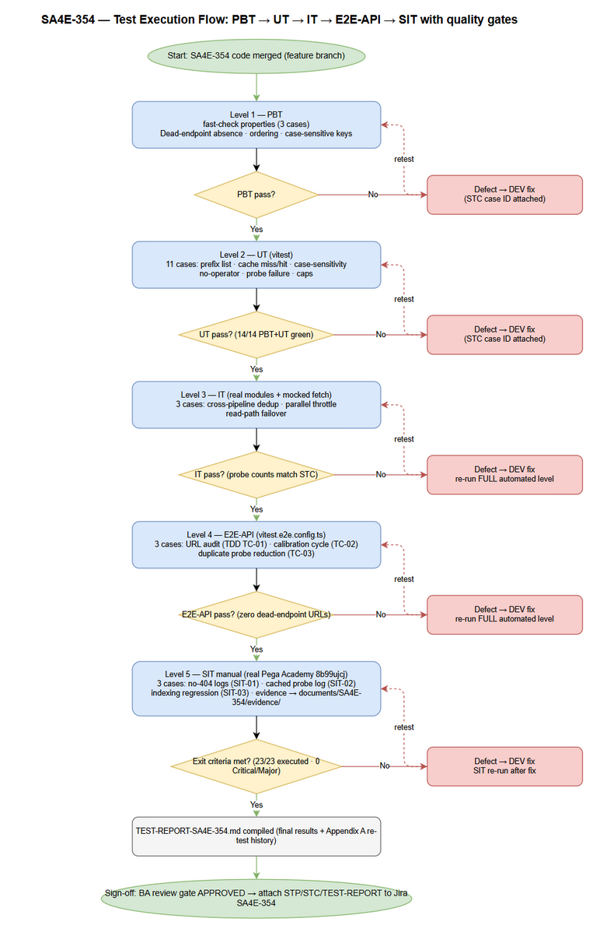 Edit in draw.io

3. Test Scope

3.1 Features In Scope
# | Feature / Story | Priority | FSD Reference | Test Type
1 | UC-01 — Remove dead Pega endpoints from prefix resolution (/api/v1, /PRRestService/v1) | High | FSD 3.1 (BR-01, BR-02; AF-1/EF-1 empty-list fallback) | PBT, UT, IT, E2E-API, SIT
2 | UC-02 — Cache latency probes per operator ID (probeLatencyCache) | High | FSD 3.2 (BR-03, BR-04, BR-05; AF-1/AF-2, EF-1/EF-2) | PBT, UT, IT, E2E-API, SIT
3 | Duplicate probe reduction across PegaProjectIndexer + PegaBfsIndexer | High | FSD 3.2.2, TDD 8.1 | IT, E2E-API, SIT
4 | Error handling per FSD §9 (no operator, probe failure, empty prefix list) | Medium | FSD 9.1, TDD 5.5 | UT
5 | NFR bounds — concurrency caps, zero-network cached probe (TDD §8.3) | Medium | FSD 8, TDD 8.3 | UT, E2E-API
6 | Regression — prefix failover + activePrefix promotion in read path (SA4E-350 semantics) | High | FSD 2.2, TDD 3.2 | UT, IT, E2E-API, SIT
7 | FSD §10 scenarios TC-01…TC-05 mapping | High | FSD 10.1 | Mapped to PBT/UT/IT/E2E-API/SIT IDs — see RTM

3.2 Features Out of Scope
# | Feature | Reason
1 | Pega Academy server configuration / endpoint definitions | BRD §1.2 — server side is read-only for this ticket
2 | UI / webview / command palette changes | BRD §1.2, TDD §1.2 — no UI changes; FSD §3.1.5, §3.2.5 = N/A
3 | Indexing accuracy / data extraction logic | BRD §1.2 — behavior-preserving change (verified only as SIT-03 regression, not re-validated feature-by-feature)
4 | Authentication (getAuthHeader), workspace trust, HTTPS enforcement internals | TDD §7 — unchanged by SA4E-354; only invoked as dependencies
5 | fetchWithRetry backoff internals | Unchanged; covered indirectly
6 | Cache persistence across extension sessions | TDD §12 Open Question #1 — design is session-scoped; persistence explicitly not tested
7 | Other Pega clients’ business logic (write client, hierarchy resolver, ruleset resolver) | Not modified; only their consumption of getCustomRestPrefixes() is exercised

3.3 Test Coverage Overview
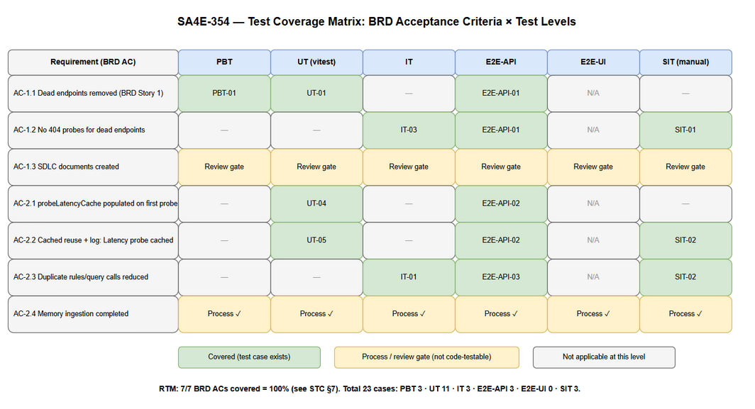 Edit in draw.io

3.4 Test Cases Summary (MANDATORY)
Level | Count | Automated | Manual
PBT | 3 | 3 | 0
UT | 11 | 11 | 0
IT | 3 | 3 | 0
E2E-API | 3 | 3 | 0
E2E-UI | 0 | 0 | 0
SIT | 3 | 0 | 3
Total | 23 | 20 (87.0%) | 3 (13.0%)

4. Test Environment

4.1 Environment Requirements
Environment | URL | Database | Purpose
Dev/Test (automated) | In-process (vitest); stubbed Pega via mocked global.fetch | None (in-memory cache only) | PBT, UT, IT, E2E-API
SIT (manual) | https://8b99ujcj.pega.com/prweb (Pega Academy) | None | SIT-01…SIT-03
Runtime | Node.js 20.x, VS Code 1.99+ extension host | — | All levels
Toolchain: npm test → vitest run (unit/integration); npm run test:e2e → vitest run --config vitest.e2e.config.ts; npm run compile for type check.

4.2 Browser / Device Requirements
Browser | Version | OS | Required
N/A — VS Code extension host | VS Code ≥ 1.99 | Windows (dev machines) | Yes (replaces browser)
Playwright browser | — | — | No (E2E-UI out of scope)

4.3 Test Data Requirements
Data Type | Description | Source | Preparation
Base URLs | https://8b99ujcj.pega.com/prweb, http://localhost:8080/prweb/ (default config + trailing slash), HTTPS-enforced variants | testdata/pre-seeded-data.csv | Loaded as config stubs (vi.mock("vscode"))
Operator IDs | SSA@TGB (main), ssa@tgb (case-sensitivity negative), "" (no operator) | testdata/pre-seeded-data.csv | Config stub pegaUsername
Prefixes | 2 valid (/api/CodeIntelligence/v1, /PRRestService/CodeIntelligence/v1), 2 dead (/api/v1, /PRRestService/v1) | testdata/pre-seeded-data.csv | Assertion constants
Scenario matrices | Per-test-case inputs + expected probe counts + expected log fragments | testdata/prefix-resolution-testdata.csv, testdata/latency-cache-testdata.csv | Referenced by each STC case
Pega Academy credentials | Basic-auth username/password for SIT | VS Code SecretStorage (manual entry) | QA configures before SIT
CSV note for UT/IT: UT/IT levels use in-code mocks (vi.mock, fetch stubs); no separate executable data files are required. The CSVs under testdata/ are the single source of truth for inputs/expected values used to author those tests (traceability per system test-data policy).

4.4 External Dependencies
System | Dependency | Mock/Stub Available
Pega Academy 8b99ujcj REST | Latency probe (DATA-ADMIN-OPERATOR-ID via CodeIntelligence prefixes), rules/query | Yes for automated levels — vi.stubGlobal("fetch", fetchMock) with scripted 200/404/500 responses; No for SIT (real instance required)
VS Code API | workspace.getConfiguration, SecretStorage | Yes — vi.mock("vscode", ...) (repo pattern)

5. Test Schedule
Phase | Start Date | End Date | Duration | Milestone
Test Planning (STP + STC) | 2026-10-11 | 2026-10-11 | 0.5 d | STP + STC approved (BA review gate)
Test Data Preparation | 2026-10-11 | 2026-10-11 | 0.5 d | testdata/*.csv reviewed
Automated Execution (PBT/UT/IT/E2E-API) | 2026-10-12 | 2026-10-12 | 0.5 d | 20/20 automated green
Defect Fix & Retest | 2026-10-13 | 2026-10-14 | 2 d | All Critical/Major fixed
SIT Execution (manual, real instance) | 2026-10-14 | 2026-10-14 | 0.5 d | SIT sign-off + evidence
UAT / Review sign-off | 2026-10-15 | 2026-10-15 | 0.5 d | TEST-REPORT approved
Dates are estimates aligned with a single-sprint ticket; SM adjusts per sprint cadence.

6. Resources & Responsibilities
Role | Name | Responsibility
Test Lead | QA Agent | STP/STC authorship, execution coordination, TEST-REPORT
QA Engineer | QA Agent | Test case design, automated + manual execution, defect reporting
BA | BA Agent | Acceptance-criteria clarification, STC business-coverage review gate
Developer | DEV Agent | Bug fixing, UT/PBT implementation in extension/src/__tests__/
DevOps | DevOps Agent | CI wiring for npm test / test:e2e if needed
Reporter | Duc Nguyen Minh | Business validation of SIT results on Pega Academy

7. Risk & Mitigation
# | Risk | Impact | Likelihood | Mitigation
1 | Module-level probeLatencyCache leaks state between tests → false cache hits | High | High | Mandate vi.resetModules() + dynamic import per test (STC §8.1 pattern); forbid static top-level import of PegaCrawlHelper in cache tests
2 | Wall-clock latency assertions flaky in CI | Medium | High | Assert via invocation counts / HTTP-call counts, never raw ms (see STC UT-04, E2E-API-02)
3 | fast-check property generates pathological base URLs (non-URL strings) → false failures | Medium | Medium | Constrain generators to valid https?://host[:port]/path shapes (STC PBT-01 preconditions)
4 | Real Pega Academy 8b99ujcj unavailable/slow during SIT window | High | Low | SIT window has fallback slot next day; automated levels already prove logic — SIT is confidence-only
5 | Dead-endpoint removal breaks other Pega environments that do have /api/v1 | Medium | Low | BRD §5.1 mitigation: prefix list validated per environment; SIT-03 regression covers read path; rollback per TDD §10.3
6 | Cache staleness if network latency changes mid-session | Low | Low | Accepted per BRD §5.1 (session-scoped); documented as out of scope
7 | FSD EF-1 (empty-prefix warn+fallback) contradicts actual fail-loud behavior — spec written before code evidence (found by UT-11) | Medium | Medium | BA adjudicated 2026-10-11 as spec correction (FSD/TDD/BRD EF-1 update routed via SM); UT-11 revised to fail-loud expectation; NOT a code defect

8. Defect Management

8.1 Severity Levels
Severity | Definition | Example (SA4E-354 context)
Critical | Indexing pipeline broken, data loss, crash of extension host | calibrateFetchConcurrency throws uncaught → indexing aborts
Major | Feature not working, workaround exists | Dead endpoint still probed → 404 spam returns; cache never hits → duplicates persist; FSD EF-1 fallback missing
Minor | Functional deviation with easy workaround / log-only issue | Cache-hit log line text deviates from spec (Latency probe cached for {operatorId})
Trivial | Cosmetic | Emoji/log formatting mismatch

8.2 Priority Levels
Priority | Definition | SLA (Fix Time)
P1 | Must fix immediately | 4 hours
P2 | Must fix before release | 1 business day
P3 | Should fix if time permits | 3 business days
P4 | Nice to fix, can defer | Next release

8.3 Defect Lifecycle
New → Open → In Progress → Fixed → Ready for Retest → Verified → Closed
→ Reopened → In Progress
Escalation rule: any Critical/Major defect found at IT or above sends the ticket back to DEV Agent with the failing STC case ID attached; QA re-runs the full automated level (not only the failing case) after fix.

9. Test Metrics & Reporting

9.1 Metrics
Metric | Formula | Target
Test Execution Rate | Executed / Total × 100% | 100% (23/23)
Pass Rate | Passed / Executed × 100% | ≥ 95%
RTM Coverage | Covered requirements / Total requirements × 100% | 100%
Defect Density | Defects / Test Cases | ≤ 0.1
Critical Defect Count | Count of Critical severity | 0
Defect Fix Rate | Fixed / Total Defects × 100% | ≥ 90%
Automation Rate | Automated cases / Total × 100% | ≥ 85% (planned: 87.0%)

9.2 Reporting Schedule
Report | Frequency | Audience
Automated run summary (vitest output) | Every npm test / CI run | DEV + QA
Defect Summary | Daily during fix window | DEV + SM
TEST-REPORT (TEST-REPORT-SA4E-354.md, template-based) | End of execution | SM, Reporter, BA

10. Appendix

Glossary
Term | Definition
SIT | System Integration Testing (manual, real instance)
UAT | User Acceptance Testing
STP / STC | Software Test Plan / Software Test Cases
PBT | Property-Based Testing (fast-check)
probeLatencyCache | Module-level Map<string, number> in PegaCrawlHelper caching measured latency per operator ID
Dead endpoint | REST prefix that does not exist on Pega Academy (/api/v1, /PRRestService/v1)
activePrefix | Prefix locked in on PegaHttpCore after first successful call; promoted to first position

Assumptions
- A1 — fast-check is available in the extension dev dependencies (repo already ships *.pbt.test.ts files); if absent, DEV adds it as devDependency before implementing PBT cases.
- A2 — Latency per operator is stable within a session (BRD §5.2); tests may therefore assert single-probe semantics.
- A3 — Both indexer pipelines share the same module instance of PegaCrawlHelper at runtime (BRD §5.2); IT-01 validates this assumption.
- A4 — Automated levels never require network access; only SIT does.
- A5 — DOCX/XLSX exports of STP/STC are produced after the BA review gate verdict = APPROVED (SM-triggered), then attached to Jira SA4E-354.

Test Data Files
File | Covers
testdata/pre-seeded-data.csv | Baseline config: base URLs, operator IDs, valid/dead prefixes, constants
testdata/prefix-resolution-testdata.csv | PBT-01…02, UT-01…03, UT-11, IT-03, E2E-API-01, SIT-01, SIT-03
testdata/latency-cache-testdata.csv | PBT-03, UT-04…UT-10, IT-01, IT-02, E2E-API-02, E2E-API-03, SIT-02

E2E-UI Justification
E2E-UI (Playwright) has 0 cases for SA4E-354: the change touches only extension service-layer modules (PegaHttpCore, PegaCrawlHelper); FSD §3.1.5 and §3.2.5 declare UI specifications N/A, and TDD §1.2 places UI modifications out of scope. Any future UI-facing behavior would be added under a separate ticket.

