Software Test Plan (STP)

SDLC-Agents-4-Enterprise — SA4E-337: Document Indexer — Index không ingest vào KB Memory + thiếu tags (Bug Fix)

Document Information
Field | Value
Jira Ticket | SA4E-337
Title | Document Indexer: Fix auto-ingest into KB Memory with correct type/tags
Author | QA Agent
Version | 1.0
Date | 2026-10-05
Status | Draft — pending BA review (Review Gate)
Related BRD | BRD-v1.0-SA4E-337.docx
Related FSD | FSD.md (v1.0) — documents/SA4E-337/FSD.md
Related TDD | TDD-v1.1-SA4E-337.docx

Author Tracking
Role | Name - Position | Responsibility
Author | QA Agent – QA Engineer | Create document
Peer Reviewer | BA Agent – Business Analyst | Business-coverage review of STC/RTM (Review Gate)
Coordinator | Scrum Master | Orchestrate review gate, quality gates

Revision History
Version | Date | Author | Changes
1.0 | 2026-10-05 | QA Agent | Initiate document — auto-generated from BRD, FSD, and TDD

Sign-Off
Name | Signature and date
 | ☐ I agree and confirm the test plan in this STP
 | ☐ I agree and confirm the test plan in this STP

1. Introduction

1.1 Purpose
This Software Test Plan defines the test strategy, scope, environment, schedule, and metrics for verifying the SA4E-337 bug-fix release of the Document Indexer subsystem (extension ↔ backend ingest pipeline).
SA4E-337 fixes six (6) defects in the document indexing → KB Memory ingest pipeline (root cause: handleIngestDocsFromTemp hardcodes type = "CONTEXT", passes no tags, and never verifies the ingest result), plus two QA-discovered defects (QA-001 CRITICAL, QA-002 MAJOR). This plan verifies all six fixed bugs, the six BRD user stories, FSD use cases UC-01..UC-06 and business rules BR-01..BR-28, and guards against regressions on the four (4) modified source files.

1.2 Test Objectives
- Verify Bug #1–#6 fixes behave per BRD §2.3 acceptance criteria and FSD §3 specifications (type derivation, tag extraction, result verification, .drawio inclusion, fallback tags, UI results).
- Verify QA-001 fix: /api/index/ingest-docs uses getToolHandlers().get('mem_ingest_file') (never getDispatcher()), fails closed with 503/failedFiles — never HTTP 500.
- Verify QA-002: happy-path unit coverage exists for the ingest route (200 {ingested, errors, total}).
- Validate all 28 business rules (BR-01..BR-28) and all FSD test scenarios (FSD §10 TC-01..TC-30).
- Enforce security gates: 401 (auth), 400 (X-Project-Id missing), 403 (KB_WRITE/grant scope), path traversal rejection (EACCES).
- Ensure no regression on modified files: api-index.ts, api-index-ingest.ts, TaskWorker.ts, indexer.ts, IndexerHttpClient.ts.
- Provide an executable Requirements Traceability Matrix (RTM) with 100% requirement coverage for BA review.

1.3 References
Document | Location
BRD | documents/SA4E-337/BRD.md → BRD-v1.0-SA4E-337.docx
FSD | documents/SA4E-337/FSD.md
TDD | documents/SA4E-337/TDD.md → TDD-v1.1-SA4E-337.docx
Discrepancy Report | documents/SA4E-337/DISCREPANCY.md (DISC-1..DISC-8)
STC (Test Cases) | documents/SA4E-337/STC.md → STC-v1.0-SA4E-337.xlsx
E2E Evidence | %TEMP%/opencode/sa4e337-e2e-results.json (14/14 PASS)
E2E Script | %TEMP%/opencode/sa4e337-e2e-test.mjs
Unit Evidence | Fresh runs 2026-10-05: 34/34, 14/14, 23/23, 23/23 PASS (see §9.3)

2. Test Strategy

2.1 Test Levels
This plan uses the six-level SDLC test model. Levels that do not apply to SA4E-337 are explicitly marked with the reason (this is a backend/extension bug-fix with no browser UI).
Level | Scope | Automation | Tools
PBT | Correctness properties (random inputs) | N/A — 0 cases | fast-check (available, not applicable)
UT | Unit/edge case tests for helpers, routes (Hono app.request() in-process), discovery, TaskWorker | Automated | vitest
IT | Component integration with real SQLite DB (TaskWorker queue lifecycle) | Automated | vitest
E2E-API | REST endpoint E2E against a real running server (session auth, ingest, KB rows) | Automated | vitest/fetch (Node script)
E2E-UI | Browser UI E2E | N/A — 0 cases | Playwright (admin web only — not applicable)
SIT | Manual exploratory testing of the VS Code extension UI (Output channel, toast) | Manual | VS Code / Kiro
Level applicability notes:
- PBT = 0 (N/A): the fixed logic is deterministic string/path mapping (inferTypeFromPath, extractTagsFromPath, summarizeIngestResult) covered by exhaustive pattern tables in UT; no random-input domain (no parser, no numeric invariant) justifies property-based tests for this bug-fix.
- E2E-UI = 0 (N/A): Bug #6 renders inside the VS Code extension host (Output channel + notification toast) — not a browser page; Playwright in this repo only targets the admin web UI (TDD §11.1/§11.5). Manual SIT covers it.
- IT vs UT: route-level tests that use the Hono app.request() in-process harness are counted under UT (they run in vitest run src/, no external process). IT is reserved for TaskWorker tests that exercise a real database (*.it.test.ts, npm run test:integration pattern).
- UAT: not a separate automated level — BA performs business-coverage review of STC/RTM (Review Gate) and accepts the SIT result.

2.2 Test Types
Type | Description | Applicable
Functional Testing | Verify features per FSD UC-01..UC-06, BR-01..BR-28, TC-01..TC-30 | Yes
Regression Testing | Modified files: api-index, api-index-ingest, TaskWorker, indexer, IndexerHttpClient | Yes
Security Testing | 401/400/403 gates, path traversal (EACCES), tenant scope (X-Project-Id), BOLA | Yes
Non-Functional — Performance | 1727-file scan < 5 min (FSD §8) | Deferred — see §3.2 Out of Scope
Usability Testing | Output channel, toast, Open Output action | Yes — via manual SIT
Compatibility Testing | Browser/device matrix | N/A — VS Code desktop, no browser UI

2.3 Test Approach
- Automated-first, evidence-based. All deterministic server-side and discovery behaviour is automated (UT/IT/E2E-API). Only visual/UX behaviour that requires human judgment in the VS Code host remains manual (SIT).
- Isolated test environment. E2E runs against a real backend instance on port 48721 with an isolated SQLite data dir (%TEMP%/opencode/sa4e337-sqlite-data) — never the production PostgreSQL KB (guardrail: test stack must not touch prod data).
- Real dependencies, minimal mocks. E2E-API exercises real HTTP + real DB rows (knowledge_entries); UT mocks only session/JWT middleware seams (mockGrantedCaller() harness). Acceptable per test-level rules: local infra (SQLite, Hono) is real; only auth context is stubbed at unit level.
- Fail-closed verification. Ingest results are asserted on {ingested, errors, total, failedFiles} semantics (summarizeIngestResult fail-closed: isError/"Error:"/status≠ingested must never count as ingested).
- Defect feedback loop. Fail → fix (dev) → retest same case → regression guard added (QA-001 case deliberately omits getDispatcher so the defect can never silently return).

2.4 Test Cases Summary
Level | Count | Automated | Manual
PBT | 0 | 0 | 0
UT | 82 | 82 | 0
IT | 9 | 9 | 0
E2E-API | 14 | 14 | 0
E2E-UI | 0 | 0 | 0
SIT | 4 | 0 | 4
Total | 109 | 105 (96.3%) | 4 (3.7%)
Execution status (as of 2026-10-05):
Status | Count | Detail
PASS (executed) | 101 | UT 78 + IT 9 + E2E-API 14 — all green (see §9.3 evidence)
NOT_RUN — planned unit (DEV to implement) | 4 | UT-79..UT-82 close identified coverage gaps (Bug #5 fallback, BR-12 client parse, nested/root tags)
NOT_RUN — manual SIT | 4 | SIT-01..SIT-04 — VS Code session required (Phase 6)

2.5 Entry Criteria
Level | Entry Criteria
PBT | N/A — level not applicable (see §2.1)
UT | Source code for fixes present in working tree; vitest configured (npm run test:unit / package vitest run)
IT | Testkit available (sa4e-testkit.ts); SQLite temp DB creatable
E2E-API | Backend boots on port 48721 (/health → modules.memory=ready); isolated SQLite data dir created; test staging files prepared (9 files)
E2E-UI | N/A — level not applicable (see §2.1)
SIT | Extension installed in VS Code/Kiro host; backend reachable; STC signed off by BA (Review Gate APPROVED)
UAT (BA review) | STP + STC + RTM delivered; BRD/FSD baselines frozen

2.6 Exit Criteria
Level | Exit Criteria
UT | 100% of defined UT cases executed; ≥ 95% pass; all SA4E-337-specific cases PASS
IT | 100% executed, 0 failures
E2E-API | 14/14 PASS on isolated env; evidence JSON written
SIT | 4/4 executed with screenshots/evidence recorded in TEST-REPORT; 0 Critical/Major open
UAT (BA) | RTM coverage = 100% for BRD AC / FSD UC / BR / TC-01..TC-30; BA verdict = APPROVED
Overall | 0 open Critical defects; ≤ 2 open Major defects with agreed workaround; TEST-REPORT completed
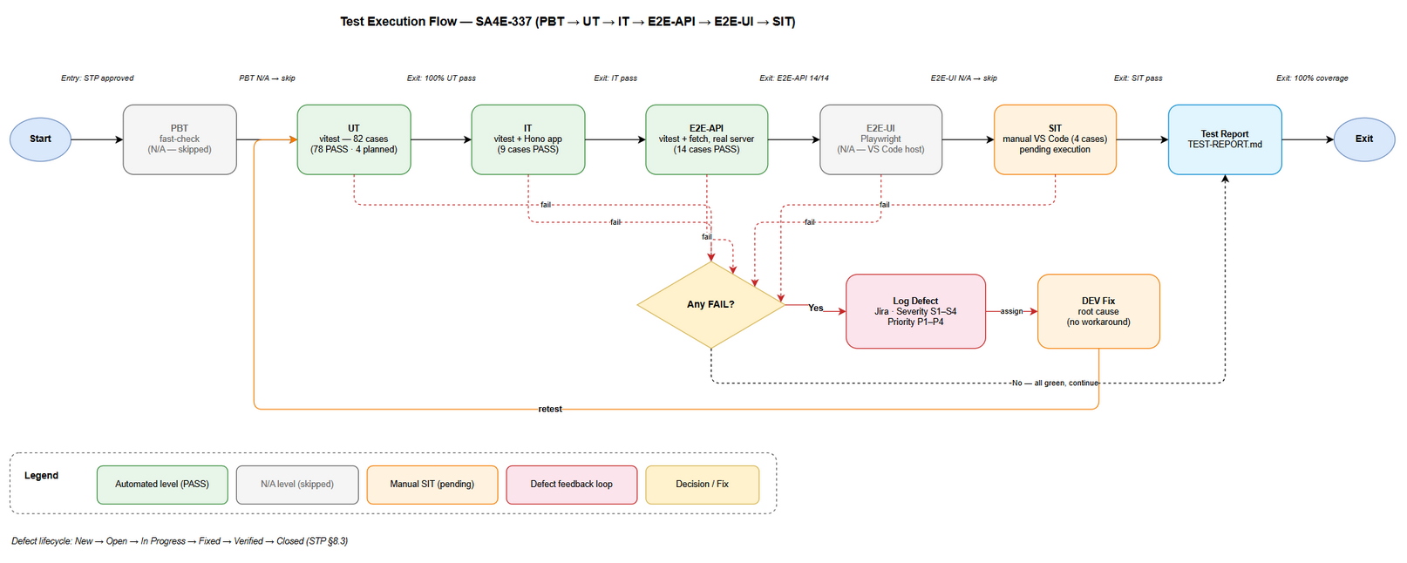
Test Execution Flow

3. Test Scope

3.1 Features In Scope
# | Feature / Story | Priority | FSD Reference | Test Type
1 | Bug #1 — Derive document type from file path (inferTypeFromPath) | MUST HAVE | UC-01, BR-01..BR-05, Story 1 | Functional (UT + E2E-API)
2 | Bug #2 — Extract tags from folder path (extractTagsFromPath) | MUST HAVE | UC-02, BR-06..BR-11, Story 2 | Functional (UT + E2E-API)
3 | Bug #3 — Verify ingest result ({ingested, errors, total, failedFiles}) | MUST HAVE | UC-03, BR-12..BR-15, Story 3 | Functional (UT + E2E-API)
4 | Bug #4 — Include .drawio files in document indexing | SHOULD HAVE | UC-04, BR-16..BR-19, Story 4 | Functional (UT + E2E-API)
5 | Bug #5 — Fallback tag extraction when LLM unavailable | SHOULD HAVE | UC-05, BR-20..BR-24, Story 5 | Functional (UT planned + E2E-API)
6 | Bug #6 — UI shows indexing results (Output channel + toast) | MUST HAVE | UC-06, BR-25..BR-28, Story 6 | Usability (manual SIT)
7 | QA-001 (CRITICAL) — mem.getDispatcher() → getToolHandlers().get('mem_ingest_file'), fail-closed summary | MUST HAVE | TDD §6.2, §12 | Functional + Security (UT + E2E-API)
8 | QA-002 (MAJOR) — happy-path unit coverage for ingest route | MUST HAVE | TDD §11.4 | Functional (UT)
9 | Security gates — 401 / 400 PROJECT_REQUIRED / 403 KB_WRITE / grant scope / EACCES traversal | MUST HAVE | FSD §7, TDD §7 | Security (UT + E2E-API)
10 | Regression — modified files: api-index.ts, api-index-ingest.ts, TaskWorker.ts, indexer.ts, IndexerHttpClient.ts | MUST HAVE | TDD §5.1 | Regression (UT + IT)
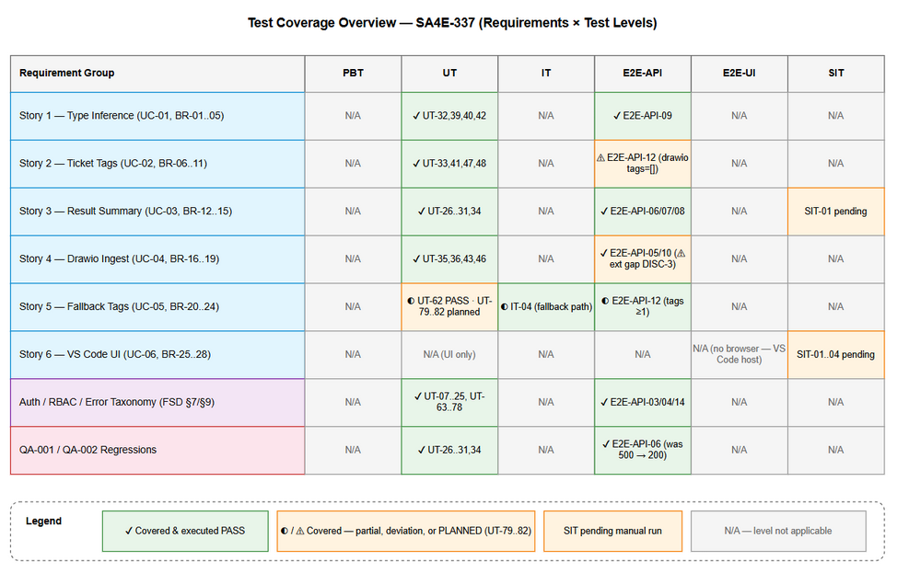
Test Coverage

3.2 Features Out of Scope
# | Feature | Reason
1 | Performance run with 1727 files < 5 min (FSD §8) | Requires full-workspace scale fixture; risk-based deferral — tracked as follow-up (R-7)
2 | Playwright browser E2E (E2E-UI level) | No browser UI in scope; VS Code extension host is not Playwright-testable (TDD §11.5)
3 | Property-based testing (PBT level) | Deterministic mapping logic; exhaustive tables in UT suffice (see §2.1)
4 | Semantic quality of LLM-generated tags | Tags asserted as non-empty + task COMPLETED only; content quality is out of functional scope
5 | Fixing FSD↔implementation discrepancies DISC-1..DISC-8 | Tracked in DISCREPANCY.md — BA/SA scope, not test scope; noted in Risk R-5
6 | Deep Pega sync functionality (sync-pega-rules) beyond auth/RBAC gates | Belongs to Pega feature tickets; only 403/202 gates verified here (UT-22/UT-23)
7 | Admin web UI / browser compatibility matrix | Unrelated to Document Indexer
8 | Salesforce-specific summary details (SIT-04 conditional) | Executed only if an SFDX project fixture is available; otherwise documented as skipped

4. Test Environment

4.1 Environment Requirements
Environment | URL | Database | Purpose
E2E (isolated) | http://127.0.0.1:48721 (backend, npx tsx backend/src/index.ts) | SQLite isolated dir: %TEMP%/opencode/sa4e337-sqlite-data/index.db | UT/E2E-API execution — must not use production PostgreSQL
KB (knowledge base, read/write via tools) | code-intel MCP (localhost:9181 wrapper → 48721) | PostgreSQL sa4e_db @ pgvector-db:5432 | KB ingest of STP/STC (planning artifacts only — no test writes)
VS Code / Kiro host | Local desktop, extension sdlc-agents-4-enterprise | — | Manual SIT (Output channel, toast)
SIT / UAT | Not applicable (no hosted web UI) | — | BA Review Gate (document-based UAT)

4.2 Browser / Device Requirements
Browser | Version | OS | Required
— | — | Windows 10/11 (VS Code / Kiro desktop) | Yes — SIT runs in VS Code host, not a browser
Chromium (draw.io CLI export) | draw.io desktop 24.x | Windows | Yes — diagram PNG export only (tooling, not product under test)

4.3 Test Data Requirements
Data Type | Description | Source | Preparation
Staged ingest files | 9 files: BRD.md, DPG.md, FSD.md, RLN.md, STC.md, STP.md, TDD.md, UG.md, test-coverage.drawio placed in resolveIndexTempBase(userId, projectId, 'batch-docs') | E2E script (sa4e337-e2e-test.mjs) | Created by E2E-05 step; CSV: testdata/pre-seeded-testdata.csv
Type-inference inputs | BRD.md, FSD.docx, TDD.pdf, STP.xlsx, meeting-notes.docx, TDD-v1-KSA-26.docx, BRD_STORY_8.md | testdata/type-inference-testdata.csv | Unit fixtures (in-test temp dirs)
Tag-extraction paths | SA4E-337/BRD.md, GRAPH-EMAIL/BRD.md, overview.md, SA4E-337/attachments/spec.pdf, attachments/spec.pdf | testdata/tag-extraction-testdata.csv | Unit fixtures
Auth negative data | no header / corrupted Bearer / missing X-Project-Id | testdata/auth-testdata.csv | E2E steps E2E-API-03/04/14
API response fixtures | {success, ingested, errors, total, failedFiles} variants, invalid JSON, non-OK status | testdata/ingest-verification-testdata.csv | Unit mocks (planned UT-81)
Test project & session | project id SA4E-337, admin session with KB_WRITE (perms=15) | E2E-02 session creation | Runtime-created; cleaned in afterAll

4.4 External Dependencies
System | Dependency | Mock/Stub Available
PostgreSQL KB (sa4e_db) | Not used during test execution (guardrail) — used only for planning-artifact ingest | Yes — isolated SQLite substitutes it for tests
LLM / tagAnalyzer | Async TAG_ENRICHMENT may run analyzer or fallback heuristics | Partial — tests assert non-empty tags + COMPLETED tasks, not tag content
Jira (Atlassian MCP) | Attaching STP/STC deliverables to SA4E-337 (step 9 of planning workflow) | Live MCP tool jira_attach_file
draw.io CLI | Export .drawio → .png for STP embeds | C:\Program Files\draw.io\draw.io.exe

5. Test Schedule
Phase | Start Date | End Date | Duration | Milestone
Test Planning (STP + STC + RTM + test data CSVs) | 2026-10-05 | 2026-10-05 | 1 day | STP + STC delivered
BA Review Gate (business coverage of RTM) | 2026-10-05 | 2026-10-06 | 1 day | BA verdict APPROVED
Automated execution (UT/IT/E2E-API) — initial run | 2026-10-05 | 2026-10-05 | Same day | 101/101 PASS (evidence captured)
Gap tests implementation (UT-79..UT-82) | 2026-10-06 | 2026-10-06 | 1 day | DEV implements, QA verifies
Manual SIT execution (SIT-01..SIT-04) | 2026-10-06 | 2026-10-06 | 0.5 day | SIT sign-off + evidence screenshots
Defect Fix & Retest | 2026-10-06 | 2026-10-07 | 1–2 days | All Critical/Major fixed & retested
Test Report + DOCX/XLSX export | 2026-10-07 | 2026-10-07 | 1 day | TEST-REPORT-v1.0-SA4E-337.docx
UAT (BA acceptance) / Go-Live readiness | 2026-10-07 | 2026-10-08 | 1 day | BA sign-off, Jira transition

6. Resources & Responsibilities
Role | Name | Responsibility
Test Lead / QA Engineer | QA Agent | Test planning (STP/STC/RTM), automated + manual execution, defect reporting, TEST-REPORT
Peer Reviewer | BA Agent | Review Gate: business coverage of STC/RTM vs BRD/FSD (APPROVED / CHANGES REQUESTED)
Coordinator | Scrum Master | Orchestrate Review Gate, quality gates, Jira transitions, RUN-LOG
Developer | DEV Agent | Implement gap tests UT-79..UT-82; fix defects found in Phase 6
DevOps | DevOps Agent | Environment stability (backend boot, isolated SQLite data dir), CI wiring
Tools | — | vitest (UT/IT), Node E2E script + fetch (E2E-API), VS Code host (SIT), draw.io CLI (diagrams), MCP (export_docx, jira_attach_file, mem_ingest_file)

7. Risk & Mitigation
# | Risk | Impact | Likelihood | Mitigation
R-1 | Bug #4 half-delivered (DISC-3): extension indexer-discovery.ts still skips .drawio; only backend temp-walk accepts it | High | High (known) | E2E stages .drawio directly at backend; DISC-3 explicitly tracked; BA/SM decide scope before close
R-2 | Production-PostgreSQL schema drift found during planning: missing tool_usage table crashed the backend (unhandled rejection in incrementToolUsage) | Critical | Confirmed 2026-10-05 | Additive DDL repair applied to dev KB; defects D-NEW-1/D-NEW-2 raised for DEV (see §8.4); tests kept on isolated SQLite
R-3 | Async TAG_ENRICHMENT timing — tags appear after queue completes; flaky assertions | Medium | Medium | E2E polls until tasks COMPLETED (observed 9/9); assert non-empty tags, not exact content
R-4 | Bug #5 fallbackTagExtraction (!tagAnalyzer branch) has no direct executed test | Medium | Confirmed | Planned UT-79/UT-80 (DEV to implement) closes the gap before exit; RTM marks status explicitly
R-5 | FSD↔implementation discrepancies (DISC-1..DISC-8): FSD API contract POST /api/v1/ingestDocuments does not exist; tags client-side vs server-side | High | Known | Test against actual endpoints (/api/index/documents, /api/index/ingest-docs); discrepancies logged for BA/SA — tests never assert the non-existent contract
R-6 | Test writes leaking into production KB | High | Low | Guardrail: E2E only on isolated SQLite dir; PostgreSQL KB receives planning artifacts (STP/STC) only
R-7 | 1727-file performance NFR untested (out of scope) | Low | Certain | Documented in §3.2; follow-up ticket recommended at release review
R-8 | Timeline pressure — SIT needs a human VS Code session | Medium | Medium | SIT kept to 4 focused cases; evidence checklist in TEST-REPORT

8. Defect Management

8.1 Severity Levels
Severity | Definition | Example (SA4E-337)
Critical | System crash, data loss, security breach | QA-001: mem.getDispatcher is not a function → HTTP 500, ingest pipeline dead; unhandled promise crash (D-NEW-2)
Major | Feature not working, workaround exists | Bug #1–#3 (wrong type, empty tags, unverified results); D-NEW-1 (tool_usage missing on PostgreSQL)
Minor | UI issue, cosmetic defect | Summary title wording, emoji indicator mismatch
Trivial | Typo, minor alignment issue | Log message typo

8.2 Priority Levels
Priority | Definition | SLA (Fix Time)
P1 | Must fix immediately | 4 hours
P2 | Must fix before release | 1 business day
P3 | Should fix if time permits | 3 business days
P4 | Nice to fix, can defer | Next release

8.3 Defect Lifecycle
New → Open → In Progress → Fixed → Ready for Retest → Verified → Closed
→ Reopened → In Progress

8.4 Current Defects (SA4E-337)
ID | Severity / Priority | Summary | Status | Evidence
Bug #1 | Major / P2 | Type hardcoded CONTEXT for all documents | Fixed | E2E-API-09: 8/8 types correct, CONTEXT=0
Bug #2 | Major / P2 | Tags not passed, left empty | Fixed | E2E-API-12: 8/8 .md tagged after async enrichment
Bug #3 | Major / P2 | Ingest result not verified client-side | Fixed | E2E-API-07: {ingested:9, errors:0, total:9, failedFiles:[]}
Bug #4 | Major / P2 | .drawio excluded from indexing | Fixed (partial — DISC-3) | E2E-API-10: row type=CONTEXT; extension discovery gap tracked as R-1
Bug #5 | Major / P3 | No fallback tag extraction when LLM unavailable | Fixed — test gap | Code present (TaskWorker.ts:374); direct test = planned UT-79/80
Bug #6 | Major / P2 | UI shows no KB ingest result | Fixed — pending SIT | Implementation in indexer.ts; SIT-01..SIT-02 verify manually
QA-001 | Critical / P1 | mem.getDispatcher() undefined → HTTP 500 on /api/index/ingest-docs | Fixed | UT-26..UT-31 + E2E-API-06 (regression: was 500, now 200); route mocks omit getDispatcher deliberately
QA-002 | Major / P2 | Missing happy-path unit test for ingest route | Fixed | UT-26 (happy path 200) + UT-27 (args contract) added
D-NEW-1 | Major / P2 | PostgreSQL schema drift: ensure-postgres-schema.ts never creates tool_usage (only mcp_tools) | Open — raised 2026-10-05 | Backend crash log: error: relation "tool_usage" does not exist
D-NEW-2 | Critical / P1 | MemoryEngine.incrementToolUsage() promise rejection is not caught (trackToolUsage has sync-only try/catch) → Node process exits on first tool call | Open — raised 2026-10-05 | Same crash log; toolUsageTracker.ts:11-21 vs engine/core.ts:292
D-NEW-1 / D-NEW-2 were discovered while booting the backend for planning-tooling (KB ingest, DOCX export). Both are outside the SA4E-337 product scope but must be logged in Jira by SM/DEV — see §10.3 Evidence Index for logs.

9. Test Metrics & Reporting

9.1 Metrics
Metric | Formula | Target
Test Execution Rate | Executed / Total × 100% | 100% at exit (105/109 automated executed + 4 SIT)
Pass Rate | Passed / Executed × 100% | ≥ 95% (observed: 101/101 = 100% on executed set)
Automation Rate | Automated / Total × 100% | ≥ 90% (observed: 105/109 = 96.3%)
Requirement Coverage | RTM covered requirements / total × 100% | 100% (STC §10 RTM)
Defect Density | Defects / Test Cases | ≤ 0.1 (10 defects / 109 cases ≈ 0.09)
Critical Defect Count | Count of Critical severity open at exit | 0
Defect Fix Rate | Fixed / Total Defects × 100% | ≥ 90% (8/10 fixed at planning time)

9.2 Reporting Schedule
Report | Frequency | Audience
Test Planning deliverables (STP/STC/RTM/CSV) | Once — 2026-10-05 | SM, BA, Jira SA4E-337
Daily Test Status (Phase 6) | Daily during execution | Project team
TEST-REPORT-v1.0-SA4E-337 | End of SIT | All stakeholders
Defect updates (D-NEW-1/2 → Jira) | Immediate | SM, DEV

9.3 Execution Evidence Summary (2026-10-05)
Suite | Command | Result | Time
UT — api-index-errors.test.ts | npx vitest run src/server/routes/__tests__/api-index-errors.test.ts (backend) | 34/34 PASS | 08:32
UT — indexer.test.ts | npx vitest run src/__tests__/indexer.test.ts (extension) | 14/14 PASS | 08:32
UT + IT — TaskWorker.test.ts + TaskWorker.it.test.ts | npx vitest run … (backend) | 23/23 PASS | 08:36
UT — IndexerHttpClient.error/token-refresh.test.ts | npx vitest run … (extension) | 23/23 PASS (16 cases incl. it.each rows) | 08:39
E2E-API — full pipeline | sa4e337-e2e-test.mjs vs isolated backend | 14/14 PASS — %TEMP%/opencode/sa4e337-e2e-results.json | 06:57
SIT — VS Code manual | Pending (Phase 6) | NOT_RUN (4 cases) | —

10. Appendix

Glossary
Term | Definition
STP | Software Test Plan
STC | Software Test Cases
SIT | System Integration Testing (manual exploratory / VS Code UI)
UAT | User Acceptance Testing (BA document review for this ticket)
KB Memory | Knowledge Base Memory (PostgreSQL knowledge_entries via mem_ingest_file)
E2E-API / E2E-UI | End-to-end tests at REST level / browser UI level
RTM | Requirements Traceability Matrix
DENYLIST | Folders excluded from scanning: diagrams, testdata, templates, node_modules, .git + hidden dirs

Assumptions
- Backend source with all 6 fixes + QA-001 fix is present in the working tree (uncommitted) — tests run against it.
- The isolated E2E backend (SQLite) faithfully reproduces production behaviour for the endpoints under test; PostgreSQL-only behaviours (schema drift) are handled as separate defects (D-NEW-1/2), not test failures.
- FSD endpoint contract discrepancies (DISC-1) are resolved in favour of actual endpoints; FSD will be corrected by BA/SA separately.
- BA Review Gate (APPROVED) is required before STC is treated as final (see Review Gate note in STC).

10.1 Evidence Index
Artifact | Path
E2E results (14/14) | %TEMP%/opencode/sa4e337-e2e-results.json
E2E script | %TEMP%/opencode/sa4e337-e2e-test.mjs
Isolated test DB | %TEMP%/opencode/sa4e337-sqlite-data/index.db (kept — 9 KB rows for SM inspection)
Backend boot log (crash evidence D-NEW-1/2) | %TEMP%/opencode/sa4e337-kb-backend-err.log
STC test data CSVs | documents/SA4E-337/testdata/*.csv
Execution tracking sheet | documents/SA4E-337/TEST-REPORT-SA4E-337.csv
Screenshots (SIT) | documents/SA4E-337/evidence/

10.2 Diagram Index
Diagram | File | Section
Test Coverage — requirements × test levels | diagrams/test-coverage.png (.drawio) | §3.1
Test Execution Flow — level pipeline with entry/exit gates & defect loop | diagrams/test-execution-flow.png (.drawio) | §2.6
(Reference) Architecture / Sequence / State — from BRD/FSD/TDD | diagrams/architecture.*, sequence-e2e.*, state-enrichment.*, … | TDD §15

10.3 Related Documents
- STC: documents/SA4E-337/STC.md → STC-v1.0-SA4E-337.xlsx
- Discrepancy Report: documents/SA4E-337/DISCREPANCY.md
- STATUS: documents/SA4E-337/STATUS.json

