Functional Specification Document (FSD)

Code-Intel MCP Server — SA4E-394: [MCP Tools] Multi-Worktree Support — Per-Call base_dir Parameter for All file_path Tools

Document Information
Field | Value
Jira Ticket | SA4E-394
Title | [MCP Tools] Hỗ trợ multi-worktree: tham số base_dir per-call (hoặc multi-root registry) cho mọi tool nhận file_path
Author | TA Agent (Technical Architect)
Version | 1.1
Date | 2026-11-01
Status | Draft
Related BRD | documents/SA4E-394/BRD.md

Author Tracking
Role | Name - Position | Responsibility
Author | TA Agent – Technical Architect | Create functional specification from BRD
Peer Reviewer | SA Agent – Solution Architect | Review document and produce TDD

Revision History
Version | Date | Author | Changes
1.0 | 2026-11-01 | TA Agent | Initiate document — auto-generated from BRD SA4E-394 (Option A selected: per-call base_dir)
1.1 | 2026-11-01 | BA Agent | Synced with TDD per DISCREPANCY.md (DISC-1..DISC-5)

1. Introduction

1.1 Purpose
This Functional Specification Document (FSD) defines the functional behavior of multi-worktree support for the Code-Intel MCP server. Today the server pins one workspace root at startup; agent sessions running in other Git worktrees (e.g., Orca worktrees) fail on both relative paths (resolved into the old checkout → FS_ERROR ENOENT) and absolute paths (PATH_REJECTED_OUTSIDE_WORKSPACE).
This document specifies the selected solution — Option A: an optional per-call base_dir parameter (alias workspace_root) on every path-accepting tool (per-tool path-argument names in §3.3.4), validated against a startup-loaded workspace allowlist. It covers: parameter semantics, path resolution and containment rules, allowlist configuration, uniform behavior across all 8 affected tools, business error scenarios, and functional test scenarios.

1.2 Scope
In scope (aligned with BRD §1.1):
- 8 MCP tools that accept a path argument (inherited scope from SA4E-357): mem_ingest_file, embed_image, drawio_export_png, drawio_auto_layout, jira_attach_file, confluence_add_attachment, sandbox_run (path argument: file), stream_write_file (path argument: path or file_path, both accepted — see §3.3.4).
- New optional parameters base_dir / workspace_root on each of these tools.
- Workspace allowlist loading at server startup from MCP_WORKSPACE_ROOTS (delimiter: ; on Windows, : on POSIX) or the MCP_WORKSPACE_ROOTS_FILE configuration file (normative line-based format in TDD §4.2 — see §3.2.4).
- A shared path-resolution utility (functional behavior defined here; implementation specified in TDD §3) used by all 8 tools, extending the existing path-safety helpers.
- Containment enforcement after resolution (blocks ../ traversal).
Out of scope (aligned with BRD §1.2):
- Tools that do NOT accept file_path.
- Changes to the MCP protocol specification itself.
- UI/UX changes to any frontend application (no UI screens exist for this feature — see §3.x.5 notes).
- Database schema migrations; authentication/authorization system changes.
- File-system permission model changes beyond path validation.
- Hot-reload of the allowlist (a server restart is required — see BR-16).

1.3 Definitions & Acronyms
Term | Definition
MCP | Model Context Protocol — the protocol used by the code-intelligence server to expose tools to agents
Worktree | Git worktree — a linked working directory attached to the same repository
Orca Worktree | A worktree managed by the Orca CLI for isolated agent sessions
Allowlist | The list of workspace root directories that a per-call base_dir is validated against
Pinned Root (legacy root) | The single workspace root fixed at server startup — legacy behavior when base_dir is omitted
base_dir | Optional per-call parameter naming the workspace root that relative file_path values resolve against
workspace_root | Deprecated alias of base_dir, kept for compatibility; behavior is identical
Path Containment | Security property ensuring a resolved path cannot escape its effective root (blocks ../ traversal)
PATH_REJECTED_OUTSIDE_ALLOWLIST | Business error code returned when base_dir (or a resolved path) is outside the allowlist/effective root
PATH_REJECTED_OUTSIDE_WORKSPACE | Legacy error code preserved when base_dir is omitted and the path escapes the pinned root
FS_ERROR | Business error code for filesystem-level failures (missing directory, permission denied)

1.4 References
Document | Location
BRD SA4E-394 | documents/SA4E-394/BRD.md
TDD SA4E-394 (v1.0 — technical source of truth for §2.2 handler locations, §3.3.4 parameter naming, §3.2.4 config format) | documents/SA4E-394/TDD.md
FSD Template | documents/templates/FSD-TEMPLATE.md
SA4E-98 FSD (style reference) | documents/SA4E-98/FSD.md
Parent ticket (tool scope) | Jira SA4E-357 (in progress); SA4E-356 (closed duplicate)
Existing path-safety helpers | backend/src/shared/path-safety.ts
MCP server entry points | backend/src/server/HttpServer.ts, backend/src/server/mcpServer.ts
Tool registration | backend/src/engine/tools/register-tools.ts
KB Entry 952 | code-intel memory: ERROR_PATTERN mem_ingest_file FS_ERROR
KB Entry 953 | code-intel memory: CONTEXT multi-worktree

2. System Overview

2.1 System Context Diagram
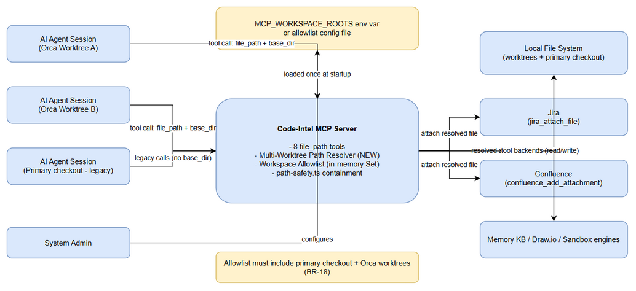
System Context
The Code-Intel MCP server is invoked by AI agent sessions that may run in the primary checkout or in any Orca worktree. Each session calls one of the 8 affected tools with a path argument and — with this feature — an optional base_dir naming the worktree it intends to operate on. The System Admin configures the workspace allowlist once, at server startup, via the MCP_WORKSPACE_ROOTS environment variable or a configuration file. The server then performs all file operations against the Local File System, and for two tools (jira_attach_file, confluence_add_attachment) forwards the resolved file to Atlassian services. The allowlist must include the primary checkout plus every Orca worktree the agents are expected to use.

2.2 System Architecture
The feature touches one new component and the existing path-safety helpers, server bootstrap, and the 8 tool handlers at their actual code locations (verified against the codebase per TDD §3.3; internal design specified in TDD §2–§3):
Component | Location | Responsibility
Multi-Worktree Path Resolver (NEW) | backend/src/shared/multi-worktree-path-resolver.ts (planned) | Shared utility: validate base_dir against allowlist → resolve relative path arguments → enforce containment. Single implementation shared by all 8 tools
Path Safety helpers (existing) | backend/src/shared/path-safety.ts | isPathSafe, isWithinRoot, resolveWithinWorkspace — extended by the resolver for allowlist validation
MCP server bootstrap (existing) | backend/src/server/mcpServer.ts, backend/src/server/HttpServer.ts | Read allowlist config at startup, build in-memory registry, log loaded roots
Tool handlers — backend engine tools (3 of 8) | backend/src/engine/tools/: drawio-tool.ts (drawio_auto_layout — handleDrawioLayout), drawio-export-png.ts (drawio_export_png — handleDrawioExportPng), code-intel-handlers.ts (stream_write_file code-intel variant — handleStreamWriteFile) | Accept new parameters; delegate path resolution to the shared resolver
Tool handlers — backend module tools | backend/src/modules/utility/UtilityModule.ts (stream_write_file module variant — path argument path); backend/src/modules/sandbox/tools/tool-handlers.ts (sandbox_run — path argument file); backend/src/modules/memory/definitions/search.ts (mem_ingest_file backend-fallback schema) | Same resolution delegation per TDD §3.3
Tool handlers — Atlassian server tools (2 of 8) | backend/src/servers/atlassian/tools/: jira-attachment-tools.ts (jira_attach_file), confluence-content-tools.ts (confluence_add_attachment) | These carry a second, divergent containment implementation today (ALLOWED_BASES = [process.cwd()] at jira-attachment-tools.ts:17; per-tool validateFilePath at :66 / :65) — replaced by the shared resolver per TDD §6.4 (one containment implementation, no-workaround rule)
Tool handlers — extension-side | extension/src/backend-local-tools/embed-image.ts (embed_image), extension/src/backend-local-tools/stream-write.ts (stream_write_file extension variant), extension/src/services/Base64ProxyService.ts (mem_ingest_file pre-read proxy) | Execute in the VS Code extension host and cannot import backend ESM modules — adopt base_dir through the existing extension PathResolver adapter with an identical resolution contract (TDD §6.3)
Resolution behaves as one decision pipeline: validate root → resolve path → contain path → execute tool. Omitting base_dir reproduces today’s behavior exactly (legacy pinned root, legacy error codes).
Handler-location note (synced with TDD §3.3, §6.3–§6.4): the 8 tools execute across three surfaces — backend engine/module handlers, backend Atlassian server tools, and the VS Code extension host (which cannot import backend ESM modules). Uniform behavior (BR-20) holds on every surface: backend handlers share the single resolver; the Atlassian tools’ local ALLOWED_BASES/validateFilePath containment is replaced by it; extension-side tools adopt base_dir via the extension PathResolver adapter with an identical resolution contract, verified behaviorally by the shared test matrix (§10).

3. Functional Requirements
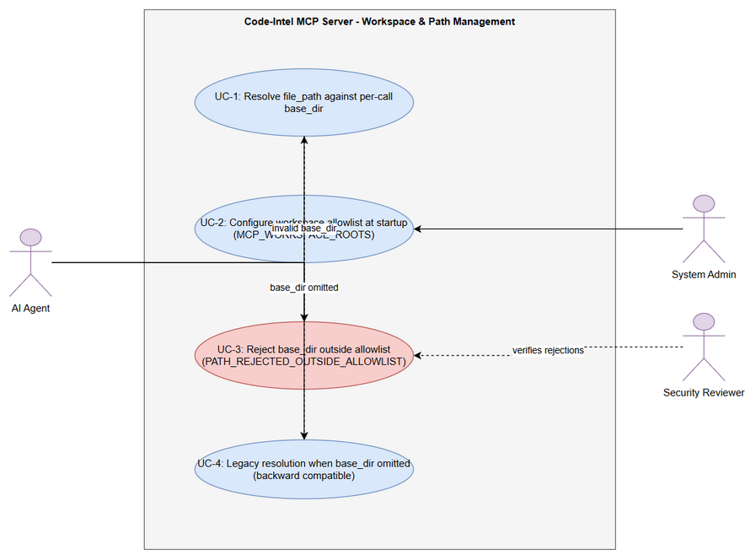
Use Case Diagram
The requirements are grouped into three features: (3.1) the per-call base_dir parameter, (3.2) the startup workspace allowlist, and (3.3) uniform enforcement across all 8 tools including the rejection use case.

3.1 Feature: Per-Call base_dir Path Resolution
Source: BRD Story #1 [Implements: BR-01…BR-10]; AC1–AC5 of BRD Story 1.

3.1.1 Description
Every tool that accepts a file_path parameter MUST also accept an optional base_dir parameter (alias: workspace_root). When base_dir is provided and registered in the startup allowlist, relative file_path values are resolved against it and absolute values are validated to be inside it. When base_dir is omitted, the tool falls back to the legacy pinned root with unchanged behavior (backward compatible). The containment check runs after resolution, so ../ traversal inside file_path cannot escape the effective root. This lets an agent session running in worktree A correctly operate on files in worktree B in a single call.

3.1.2 Use Case
Use Case ID: UC-1 Actor: AI Agent (session running in any worktree) Preconditions: MCP server is running; allowlist loaded at startup (Feature 3.2); agent holds a valid file_path (relative or absolute) and optionally base_dir. Postconditions: On success — the tool executed its file operation on exactly one resolved absolute path inside the effective root; on rejection — no file operation occurred and a business error was returned.
Main Flow:
Step | Actor | System | Description
1 | AI Agent |  | Calls a tool, e.g. mem_ingest_file, with file_path=“documents/SA4E-394/BRD.md” and base_dir=“/home/user/project-worktree-B”
2 |  | MCP Tool Handler | Accepts the call; recognizes base_dir (or alias workspace_root)
3 |  | Path Resolver | Normalizes base_dir to an absolute path (BR-09); checks it is registered in the allowlist (BR-05)
4 |  | Path Resolver | Checks base_dir exists and is a directory (BR-06)
5 |  | Path Resolver | Resolves file_path against base_dir → absolute path (BR-02)
6 |  | Path Resolver | Runs containment check: resolved path must be within base_dir (BR-07)
7 |  | Tool Handler | Executes the tool’s file operation on the resolved absolute path
8 |  | Tool Handler | Returns the tool’s normal success result, including the resolved path
Alternative Flows:
ID | Condition | Steps
AF-1 | base_dir omitted | Resolve relative file_path against the legacy pinned root (BR-03); preserve legacy error codes (PATH_REJECTED_OUTSIDE_WORKSPACE / FS_ERROR) — AC3
AF-2 | workspace_root alias used instead of base_dir | Treat identically to base_dir (BR-10); if both are provided, base_dir wins
AF-3 | base_dir provided as relative path | Normalize to absolute against the server’s working directory before validation (BR-09)
AF-4 | file_path provided as absolute path | Skip relative resolution; validate the absolute path is within the effective root (BR-04)
AF-5 | file_path contains ../ segments | Allowed only if the final resolved path is still within the effective root (BR-07); otherwise rejected
Exception Flows:
ID | Condition | Steps
EF-1 | base_dir not in allowlist | Return PATH_REJECTED_OUTSIDE_ALLOWLIST with message per §3.1.6; no FS access — AC2
EF-2 | base_dir does not exist on filesystem | Return FS_ERROR with message per §3.1.6
EF-3 | Resolved path escapes base_dir (traversal) | Return PATH_REJECTED_OUTSIDE_ALLOWLIST with message per §3.1.6 — AC4
EF-4 | Permission denied on the file operation | Return FS_ERROR with OS error details
EF-5 | Allowlist empty and base_dir provided | Any base_dir is rejected with PATH_REJECTED_OUTSIDE_ALLOWLIST (empty allowlist enables legacy mode only — BR-15)

3.1.3 Business Rules
Rule ID | Rule | Source
BR-01 | Every file_path-accepting tool accepts optional base_dir (alias workspace_root) | BRD Story 1, req 1
BR-02 | When base_dir is provided, relative file_path resolves against base_dir | BRD Story 1, req 2
BR-03 | When base_dir is omitted, relative file_path resolves against the legacy pinned root (backward compatible) | BRD Story 1, req 3
BR-04 | Absolute file_path must be within base_dir (if provided) or the legacy root (if omitted) | BRD Story 1, req 4
BR-05 | base_dir must be in the server’s startup allowlist; otherwise reject with PATH_REJECTED_OUTSIDE_ALLOWLIST | BRD Story 1, validation
BR-06 | base_dir must exist on the filesystem and be a directory; otherwise FS_ERROR | BRD Story 1, validation
BR-07 | Containment check runs AFTER resolution — resolved path must be within the effective root (blocks ../) | BRD Story 1, validation
BR-08 | base_dir is documented in every affected tool’s JSON schema with description and example | BRD Story 1, req 5
BR-09 | A relative base_dir input is normalized to an absolute path before validation | BRD Story 1, validation
BR-10 | workspace_root alias behaves identically to base_dir; if both are sent, base_dir takes precedence | BRD Story 1 data fields; TA clarification
BR-11 | Allowlist membership is checked before filesystem existence (error precedence: allowlist → existence → containment) | TA clarification of BRD error ordering

3.1.4 Data Specifications
Input Data (applies to each of the 8 tools):
Field | Type | Required | Validation | Description
file_path | string | Y | Non-empty; no null bytes; relative (no drive letter) or absolute | Relative or absolute path to the target file/directory
base_dir | string | N | Absolute after normalization; exists; is directory; in allowlist | Workspace root to resolve relative paths against (BR-05/06/09)
workspace_root | string | N | Same as base_dir | Deprecated alias of base_dir (BR-10)
(tool-specific params) | varies | varies | unchanged | All pre-existing parameters of each tool keep their current semantics
Per-tool path-parameter naming (verified against codebase — TDD §3.3): the path argument is file_path on mem_ingest_file, embed_image, drawio_export_png, drawio_auto_layout, jira_attach_file, confluence_add_attachment; file on sandbox_run; and both path and file_path on stream_write_file (module vs code-intel/extension variants). base_dir/workspace_root semantics are identical regardless of the path argument’s name.
Output Data:
Field | Type | Description
(tool-specific result) | varies | The tool’s normal success payload, unchanged
resolved_path | string | The absolute path the operation was performed on (where the tool already reports a path)
status | string | success or error
error_code | string | On failure: PATH_REJECTED_OUTSIDE_ALLOWLIST / PATH_REJECTED_OUTSIDE_WORKSPACE / FS_ERROR
message | string | Human-readable business error message (§3.1.6)

3.1.5 UI Specifications
Not applicable — MCP tools are consumed programmatically by AI agents; this feature has no screens, dialogs, or mockups. The “user-facing surface” is the tool JSON schema documentation (BR-08), specified functionally in §3.3.6.

3.1.6 API Contract (Functional View)
Note: This section defines the functional API contract (what data flows in/out and business error scenarios). Technical details (transport headers, JSON schema drafting, retry policies) are specified in the TDD §3 and §5.
Endpoint: MCP tools/call → {tool_name} where {tool_name} ∈ { mem_ingest_file, embed_image, drawio_export_png, drawio_auto_layout, jira_attach_file, confluence_add_attachment, sandbox_run, stream_write_file } Purpose: Execute a file-based tool operation against the correct workspace root for the calling agent session.
Input Parameters:
Parameter | Type | Required | Business Rule | Description
file_path | string | Y | BR-04, BR-07 | Relative or absolute path to the file
base_dir | string | N | BR-05, BR-06, BR-09 | Registered workspace root to resolve against
workspace_root | string | N | BR-10 | Alias of base_dir (deprecated)
(tool params) | varies | varies | unchanged | Existing parameters per tool
Output Data:
Field | Type | Description
tool result | object | Normal tool result on success (with resolved_path where applicable)
error.code | string | One of the business error codes below
error.message | string | Message shown to the calling agent
Business Error Scenarios:
Scenario | User Message | Trigger Condition
base_dir not registered | “Workspace root ‘{base_dir}’ is not registered in the allowlist. Configure MCP_WORKSPACE_ROOTS to include this path.” | base_dir ∉ allowlist (BR-05) — error code PATH_REJECTED_OUTSIDE_ALLOWLIST
base_dir missing on disk | “Workspace root ‘{base_dir}’ does not exist on filesystem” | base_dir not found / not a directory (BR-06) — error code FS_ERROR
Resolved path escapes root | “Resolved path ‘{resolved}’ is outside workspace root ‘{base_dir}’” | Containment failure after resolution (BR-07) — error code PATH_REJECTED_OUTSIDE_ALLOWLIST
Permission denied | “FS_ERROR: {OS error details}” | OS denies read/write on the resolved path (EF-4)
Legacy absolute path outside pinned root | (unchanged legacy behavior) | base_dir omitted and absolute path outside pinned root — error code PATH_REJECTED_OUTSIDE_WORKSPACE (AF-1)

3.2 Feature: Workspace Allowlist Configuration at Server Startup
Source: BRD Story #2 [Implements: BR-12…BR-17].

3.2.1 Description
At startup the MCP server loads a workspace allowlist — the set of workspace roots that base_dir may name. The allowlist is supplied via the MCP_WORKSPACE_ROOTS environment variable (semicolon-separated on Windows, colon-separated on POSIX) or the MCP_WORKSPACE_ROOTS_FILE configuration file — normative line-based format (one root per line, # comments, blank lines skipped) and source precedence (env var → config file → legacy mode) are defined in TDD §4.2. Entries are normalized to absolute, deduplicated paths with symlinks resolved; missing entries produce a startup warning but do not abort startup. The validated allowlist is cached in memory for O(1) lookups and logged at info level. An empty allowlist selects legacy single-root mode (pinned root only). Allowlist changes take effect on server restart.

3.2.2 Use Case
Use Case ID: UC-2 Actor: System Admin Preconditions: MCP server is about to start (or restarting); admin can set environment variables or edit the config file. Postconditions: Allowlist loaded, normalized, cached, and logged; legacy root registered when allowlist is empty.
Main Flow:
Step | Actor | System | Description
1 | System Admin |  | Sets MCP_WORKSPACE_ROOTS = “/home/user/project;/home/user/project-worktree-A;/home/user/project-worktree-B” (Windows ;, POSIX :) or writes the config file
2 |  | Server bootstrap | Reads the variable (or config file) at startup
3 |  | Allowlist builder | Splits on the platform delimiter; trims entries
4 |  | Allowlist builder | Normalizes each entry to an absolute path; deduplicates; resolves symlinks (BR-14)
5 |  | Allowlist builder | Validates each entry exists and is a directory (BR-15)
6 |  | Server bootstrap | Builds an in-memory Set of registered roots (O(1) lookup) and caches it (BR-13)
7 |  | Server bootstrap | Logs the loaded allowlist at info level
8 |  | Server bootstrap | Server becomes ready; every tool call can now validate base_dir against the Set
Alternative Flows:
ID | Condition | Steps
AF-1 | Allowlist empty / variable unset | Fall back to legacy single-root mode: only the pinned root is registered (BR-16)
AF-2 | Config file supplied instead of env var | Read entries from the config file using the same normalization and validation steps
AF-3 | An entry does not exist or is a file | Log a warning naming the entry; continue startup with the remaining entries (BR-15)
Exception Flows:
ID | Condition | Steps
EF-1 | Malformed entry (empty token after split) | Skip the empty token; warn at startup
EF-2 | Config file unreadable/unparseable | Warn, treat allowlist as empty → legacy mode (AF-1)

3.2.3 Business Rules
Rule ID | Rule | Source
BR-12 | Allowlist is supplied via MCP_WORKSPACE_ROOTS (; on Windows, : on POSIX) or a config file | BRD Story 2, req 1
BR-13 | Allowlist is loaded once at startup and cached in memory (Set); no per-call re-read of config | BRD Story 2, req 2
BR-14 | Entries are normalized to absolute paths, deduplicated, and symlinks resolved to real paths | BRD Story 2, validation
BR-15 | Startup validates each entry exists and is a directory; missing entries warn but do not abort startup | BRD Story 2, req 4 / AC 3
BR-16 | Empty allowlist → legacy single-root mode (pinned root only) | BRD Story 2, req 5 / AC 4
BR-17 | Allowlist changes require a server restart (no hot reload) | BRD Story 2, AC 5
BR-18 | The allowlist must support both the primary checkout and Orca worktrees | BRD Story 2, req 6
BR-19 | The loaded allowlist is logged at startup (info level) | BRD Story 2, AC 2

3.2.4 Data Specifications
Input Data:
Field | Type | Required | Validation | Description
MCP_WORKSPACE_ROOTS | string (env) | N | Delimited list; each entry absolute (or normalized per BR-14); non-empty tokens | Registered workspace roots, e.g. “/home/user/project:/home/user/project-worktree-A”
MCP_WORKSPACE_ROOTS_FILE | string (env var holding a path to a UTF-8 text file) | N | File must be readable; one root per line; # starts a comment; blank lines skipped (normative format: TDD §4.2) | Alternative allowlist source when MCP_WORKSPACE_ROOTS is not set; source precedence: env var → file → legacy mode
Output Data (startup artifacts):
Field | Type | Description
registeredRoots | string[] (in-memory Set) | Normalized absolute roots available for base_dir validation
startupLog | log lines (info) | The loaded allowlist; warnings for invalid/missing entries

3.2.5 UI Specifications
Not applicable — configuration is environment/file based; there is no admin UI. Startup logging (BR-19) is the admin’s verification surface.

3.2.6 API Contract (Functional View)
Endpoint: Server startup (configuration surface — not a runtime API) Purpose: Register the workspace roots that per-call base_dir values are validated against.
Input Parameters:
Parameter | Type | Required | Business Rule | Description
MCP_WORKSPACE_ROOTS | env string | N | BR-12, BR-14 | Delimited workspace roots (; Windows / : POSIX)
MCP_WORKSPACE_ROOTS_FILE | env string (file path) | N | BR-12 | Alternative allowlist source; file format defined in TDD §4.2 (one root per line, # comments, blank lines skipped)
Output Data:
Field | Type | Description
in-memory allowlist Set | string[] | Registered roots used by UC-1 step 3
startup log (info) | log entry | Lists loaded roots and any warnings (BR-19)
Business Error Scenarios:
Scenario | User Message | Trigger Condition
Non-existent allowlist entry | Startup warning: “Allowlist entry ‘{root}’ does not exist or is not a directory” (startup continues) | BR-15 / AF-3
Empty allowlist | Startup info: “MCP_WORKSPACE_ROOTS empty — legacy single-root mode active” | BR-16 / AF-1
Config file unreadable | Startup warning; legacy mode fallback | EF-2

3.3 Feature: Uniform Multi-Worktree Behavior Across All file_path Tools
Source: BRD Story #3 and Story #4 [Implements: BR-20…BR-23].

3.3.1 Description
All 8 path-accepting tools (§3.3.4 — path-argument names vary per tool) implement base_dir with identical semantics, delegated to one shared resolution utility — no tool-specific deviations. Every tool exposes the new parameters in its JSON schema (AC5), and every unauthorized-root attempt is rejected with the explicit PATH_REJECTED_OUTSIDE_ALLOWLIST error so security reviewers can identify misuse unambiguously (Story #4). Uniformity is verified by the common 5-scenario test matrix per tool (§10).

3.3.2 Use Case
Use Case ID: UC-3 Actor: AI Agent (primary); Security Reviewer (beneficiary) Preconditions: Server running; allowlist loaded; agent calls a tool with a base_dir that is not registered (or a path that resolves outside the effective root). Postconditions: Operation blocked; explicit business error returned; no file read/write occurred outside the allowlist.
Main Flow:
Step | Actor | System | Description
1 | AI Agent |  | Calls any of the 8 tools with base_dir = an unregistered directory
2 |  | Path Resolver | Allowlist lookup fails (BR-05, BR-11)
3 |  | Tool Handler | Returns PATH_REJECTED_OUTSIDE_ALLOWLIST with the §3.1.6 message; operation aborted before any FS access
4 |  | Tool Handler | Logs the rejection event (§7.3)
5 | AI Agent |  | Corrects the call (registered root / omit base_dir) or asks the admin to extend the allowlist
Alternative Flows:
ID | Condition | Steps
AF-1 | Resolved path escapes an allowed base_dir | Same rejection flow with the “Resolved path … outside workspace root” message (BR-07)
AF-2 | Security review scenario | Security Reviewer inspects rejection logs to confirm zero out-of-allowlist access (AC4)
Exception Flows:
ID | Condition | Steps
EF-1 | Allowlist empty and base_dir provided | Rejected per BR-16/EF-5 of UC-1
EF-2 | Resolver internal failure (unexpected) | Tool returns a generic error; no partial file operation is left behind

3.3.3 Business Rules
Rule ID | Rule | Source
BR-20 | All 8 tools accept base_dir with identical behavior via the shared resolver — no tool-specific deviations | BRD Story 3, req 2 / AC 4
BR-21 | Tool inventory is fixed to the SA4E-357 scope (8 tools listed in §3.3.6) | BRD Story 3, req 1
BR-22 | Every tool documents base_dir (description + example) in its JSON schema | BRD Story 1 req 5 / Story 3 AC 5
BR-23 | Unauthorized roots are always rejected with explicit PATH_REJECTED_OUTSIDE_ALLOWLIST before any filesystem access | BRD Story 4

3.3.4 Data Specifications
Input Data: same parameter set as §3.1.4, applied uniformly to the tool inventory below.
Output Data (per-tool applicability):
Tool | Path-argument role (name per TDD §3.3) | Operation class | base_dir effect
mem_ingest_file | Document to ingest into memory KB | Read | Resolve/validate ingest source
embed_image | Image to inline as base64 | Read | Resolve/validate image source
drawio_export_png | .drawio source file — backend file_path is reference-only (backend writes to a temp dir and returns output_base64); output_path write-back exists only in the extension output proxy | Read (backend) + write-back (extension proxy) | Backend: resolve/validate file_path (reference); extension adapter: resolve/validate output_path (TDD §3.3)
drawio_auto_layout | .drawio file to auto-layout | Read/Write | Resolve/validate diagram file
jira_attach_file | Local file to attach to a Jira issue | Read → upload | Resolve/validate upload source
confluence_add_attachment | Local file to attach to a Confluence page | Read → upload | Resolve/validate upload source
sandbox_run | Script input — path argument is file (not file_path); resolved host-side pre-mount into the sandbox; sandbox-internal path semantics unchanged | Execute (FS-bound) | Resolve/validate the host-side file value before sandbox mount
stream_write_file | Destination file to write — parameter name differs by surface: path (backend module variant), file_path (code-intel variant), file_path (extension variant); both path and file_path are accepted and routed through the resolver on every surface (TDD §3.3) | Write | Resolve/validate write target under either parameter name

3.3.5 UI Specifications
Not applicable — see §3.1.5.

3.3.6 API Contract (Functional View)
Endpoint: MCP tools/call — parameter applicability matrix (all tools share the contract of §3.1.6) Purpose: Guarantee uniform base_dir semantics and schema documentation across the toolset.
Input Parameters (per tool):
Parameter | Type | Required | Business Rule | Description
base_dir / workspace_root | string | N (all 8 tools) | BR-20, BR-22 | Same semantics as §3.1.6 on every tool
file_path | string | Y (7 of 8 tools) | BR-04, BR-07 | Role per tool listed in §3.3.4 — exceptions: sandbox_run requires file (its path argument name); stream_write_file accepts both path and file_path
Output Data:
Field | Type | Description
tool result | object | Tool-specific success payload (unchanged per tool)
schema description | string | Each tool’s JSON schema documents base_dir with description + example (AC5)
Business Error Scenarios:
Scenario | User Message | Trigger Condition
Unregistered root on ANY of the 8 tools | “Workspace root ‘{base_dir}’ is not registered in the allowlist. Configure MCP_WORKSPACE_ROOTS to include this path.” | BR-23 / UC-3 step 2
Schema gap (missing base_dir docs) | N/A — build/test failure | Tool schema lacks base_dir documentation → TC-5 fails

4. Data Model
Note: This section defines the logical data model (entities, relationships, business attributes). Physical implementation (DDL scripts, indexes, migration plans, query patterns) is specified in the TDD §4. This feature is configuration-centric — no database tables are added; entities below are logical/runtime structures.

4.1 Entity Relationship Diagram
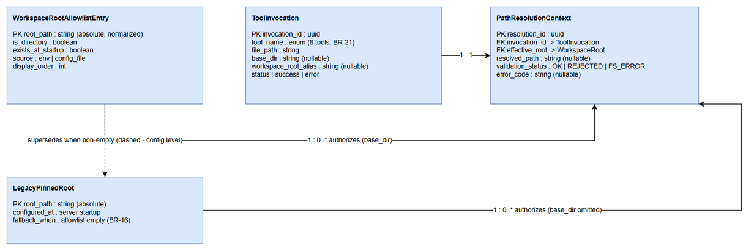
ER Diagram

4.2 Logical Entities

Entity: WorkspaceRootAllowlistEntry
A workspace root registered at startup and eligible as base_dir.
Attribute | Type | Required | Business Rule | Description
root_path | string (absolute path) | Y | BR-14 | Normalized absolute path; symlinks resolved; unique in the Set
is_directory | boolean | Y | BR-15 | Entry must be a directory at startup (warn if not)
exists_at_startup | boolean | Y | BR-15 | False entries trigger a warning but remain in config review
source | enum(env | config_file) | Y | BR-12
display_order | int | Y | BR-12 | Position in the delimited input (diagnostics only)

Entity: LegacyPinnedRoot
The single workspace root fixed at server startup — pre-existing behavior.
Attribute | Type | Required | Business Rule | Description
root_path | string (absolute path) | Y | BR-03 | The pinned workspace root used when base_dir is omitted
fallback_when | enum(allowlist empty) | Y | BR-16 | When the allowlist is empty this is the only registered root

Entity: ToolInvocation
One agent call to one of the 8 tools.
Attribute | Type | Required | Business Rule | Description
invocation_id | uuid | Y | — | Identifies a single tool call
tool_name | enum(8 tools) | Y | BR-21 | One of the tools in §3.3.4
file_path | string | Y | BR-04 | Relative or absolute path as sent by the agent
base_dir | string (nullable) | N | BR-05, BR-09 | Requested workspace root (null → legacy)
workspace_root_alias | string (nullable) | N | BR-10 | Alias value when the deprecated name is used
status | enum(success | error) | Y | —

Entity: PathResolutionContext
The per-call resolution outcome produced by the shared resolver.
Attribute | Type | Required | Business Rule | Description
resolution_id | uuid | Y | — | Identifies one resolution
invocation_id | uuid (FK) | Y | — | Owning tool invocation
effective_root | string (FK) | Y | BR-03, BR-05 | The root authorization is checked against (base_dir or pinned root)
resolved_path | string (nullable) | N | BR-02, BR-07 | Absolute path after resolution; null when rejected before resolution
validation_status | enum(OK | REJECTED | FS_ERROR) | Y
error_code | string (nullable) | N | §3.1.6 | PATH_REJECTED_OUTSIDE_ALLOWLIST / PATH_REJECTED_OUTSIDE_WORKSPACE / FS_ERROR
Relationships:
From Entity | To Entity | Cardinality | Description
ToolInvocation | PathResolutionContext | 1 : 1 | Every invocation produces exactly one resolution context
WorkspaceRootAllowlistEntry | PathResolutionContext | 1 : 0..* | A registered root authorizes many invocations that name it as base_dir
LegacyPinnedRoot | PathResolutionContext | 1 : 0..* | The pinned root authorizes all invocations that omit base_dir
WorkspaceRootAllowlistEntry | LegacyPinnedRoot | 1 : 0..1 | When the allowlist is non-empty it supersedes the pinned root as the only multi-root registry (dashed — configuration-level)

5. Integration Specifications
Note: This section defines what external systems are involved and what data is exchanged (business view). Technical details (timeout, retry, circuit breaker, connection strings) are specified in the TDD §6.

5.1 External System: AI Agent Sessions (MCP Clients — Orca worktrees / primary checkout)
Attribute | Value
Purpose | Consumers of the 8 tools; need per-worktree file operations
Direction | Inbound
Data Format | JSON (MCP tools/call)
Frequency | Real-time, per agent step
Data Exchange:
Our Data | External Data | Direction | Business Rule
Tool result / business error | file_path + base_dir (or workspace_root) in tool arguments | Receive | BR-01…BR-10
resolved_path | Agent’s intended worktree root | Send | Returned on success for traceability

5.2 External System: Local File System (worktrees + primary checkout)
Attribute | Value
Purpose | Actual read/write/execute target of every resolved path
Direction | Bidirectional (read for ingest/export/upload; write for stream_write_file, drawio output)
Data Format | Files/directories on disk
Frequency | Real-time, per tool call
Data Exchange:
Our Data | External Data | Direction | Business Rule
Resolved absolute path | File/directory content | Send/Receive | BR-04, BR-07 — only paths within the effective root are touched
base_dir existence query | Directory metadata | Receive | BR-06 (existence + is-directory check)

5.3 External System: Configuration Provider (env var / config file)
Attribute | Value
Purpose | Supplies the workspace allowlist at startup
Direction | Inbound
Data Format | Delimited string (; Windows / : POSIX) via MCP_WORKSPACE_ROOTS, or MCP_WORKSPACE_ROOTS_FILE line-based text file (one root per line, # comments — TDD §4.2)
Frequency | Once at server startup
Data Exchange:
Our Data | External Data | Direction | Business Rule
Normalized root set | MCP_WORKSPACE_ROOTS raw string (or MCP_WORKSPACE_ROOTS_FILE file content) | Receive | BR-12…BR-16
Startup warnings | Invalid/missing entries | Send (log) | BR-15, BR-19

5.4 External System: Atlassian (Jira / Confluence) — downstream of resolved files
Attribute | Value
Purpose | Receives files resolved by jira_attach_file / confluence_add_attachment
Direction | Outbound
Data Format | Multipart file upload (per existing integration)
Frequency | On-demand, per tool call
Data Exchange:
Our Data | External Data | Direction | Business Rule
File content from resolved_path | Attachment on issue/page | Send | Path must pass containment BEFORE upload (BR-07); upload behavior itself unchanged

6. Processing Logic

6.1 Server Startup — Allowlist Loading
Trigger: MCP server start (process launch / restart). Schedule: Once per server lifetime (BR-17 — restart required for changes). Input: MCP_WORKSPACE_ROOTS env var or MCP_WORKSPACE_ROOTS_FILE config file (format per TDD §4.2). Output: In-memory allowlist Set; startup log lines (info + warnings).
Processing Steps:
Step | Description | Error Handling
1 | Read raw allowlist from MCP_WORKSPACE_ROOTS (env) or MCP_WORKSPACE_ROOTS_FILE (config file) | Config unreadable → warn, treat as empty → legacy mode (EF-2 of UC-2)
2 | Split on platform delimiter (; Windows / : POSIX); trim tokens | Empty tokens skipped with warning
3 | Normalize each entry to absolute path; deduplicate; resolve symlinks | Non-absolute entries normalized against server working directory (BR-14, BR-09)
4 | Validate each entry exists and is a directory | Missing entry → warning naming the entry; startup continues (BR-15)
5 | Build in-memory Set of registered roots (O(1) lookup) | —
6 | Log loaded allowlist at info level; note legacy mode if empty | Empty set → info “legacy single-root mode active” (BR-16, BR-19)
Activity Diagram:
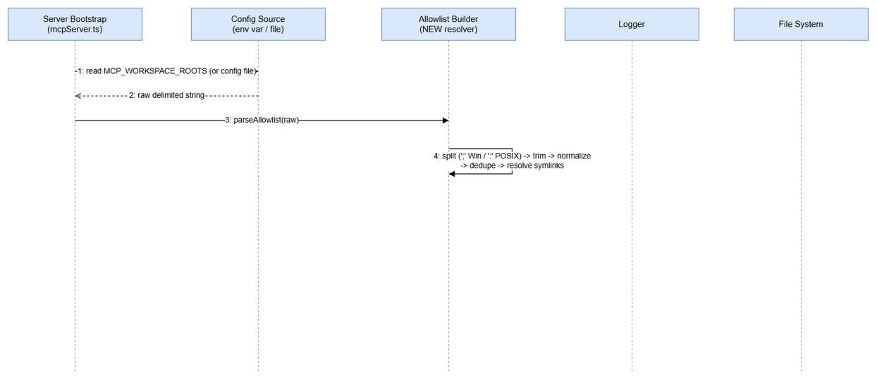
Startup Sequence

6.2 Per-Call Path Resolution and Execution
Trigger: Any of the 8 tools invoked with file_path (and optional base_dir/workspace_root). Schedule: Real-time, per tool call. Input: Tool arguments (file_path, base_dir/workspace_root, tool-specific params). Output: Tool success result (with resolved_path where applicable) or business error (§3.1.6).
Processing Steps:
Step | Description | Error Handling
1 | Detect base_dir (or alias workspace_root; base_dir wins — BR-10) | —
2 | base_dir provided? No → effective root = legacy pinned root; resolution and error codes unchanged (AF-1) | Legacy rejection keeps code PATH_REJECTED_OUTSIDE_WORKSPACE
3 | Normalize base_dir to absolute (BR-09) | —
4 | Allowlist membership check (BR-05, BR-11 — before FS checks) | Fail → PATH_REJECTED_OUTSIDE_ALLOWLIST, abort
5 | Existence + is-directory check on base_dir (BR-06) | Fail → FS_ERROR “does not exist on filesystem”, abort
6 | Resolve file_path: relative → resolve against base_dir; absolute → use as-is (BR-02, BR-04) | —
7 | Containment check AFTER resolution: resolved path within effective root (BR-07) | Fail → PATH_REJECTED_OUTSIDE_ALLOWLIST “Resolved path … outside workspace root”, abort
8 | Execute the tool’s file operation on the resolved path | OS permission failure → FS_ERROR with OS details (EF-4)
9 | Return tool result; include resolved_path where the tool reports paths; log invocation (§7.3) | Unexpected internal failure → generic error, no partial writes left behind
Activity Diagram (decision flow including all error branches):
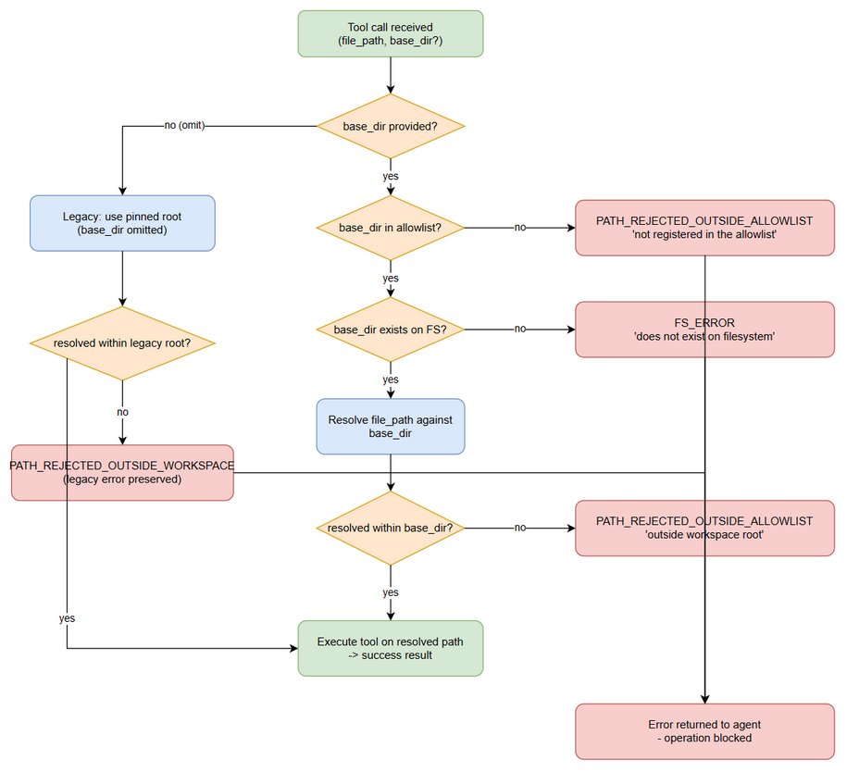
Path Resolution Decision Flow
Sequence view (happy path + rejection branches):
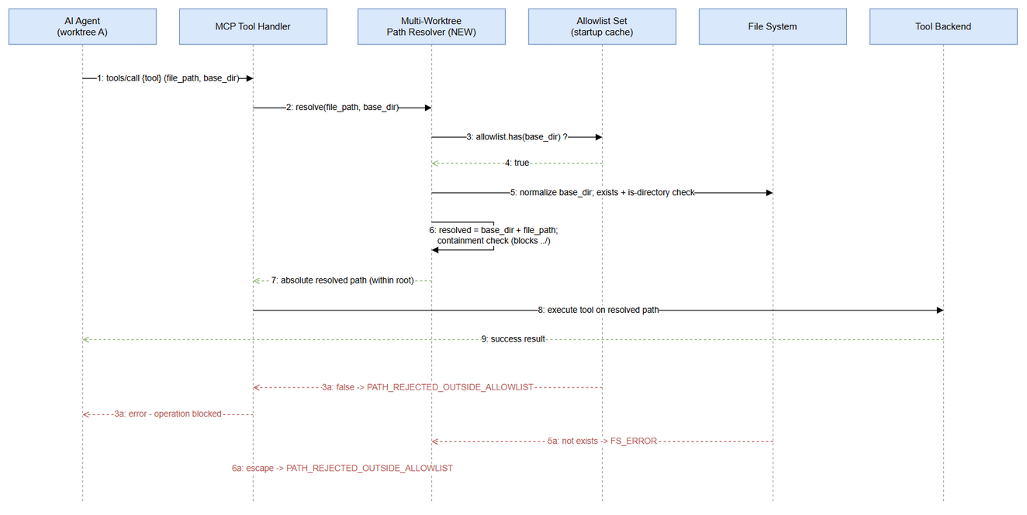
Path Resolution Sequence

7. Security Requirements
Note: This section defines business-level security requirements (who can do what). Technical implementation (transport auth config, encryption algorithms, input validation internals) is specified in the TDD §7.

7.1 Authentication & Authorization
Role | Permissions | Screens/Features
AI Agent (MCP client session) | Execute the 8 tools; may pass base_dir only for roots registered in the allowlist | All 8 file_path tools
System Admin | Configure MCP_WORKSPACE_ROOTS / config file; restart server to apply | Allowlist configuration (UC-2)
Security Reviewer | Read rejection logs; verify zero out-of-allowlist access (AC4) | Audit trail (§7.3)
Authorization model: the allowlist IS the authorization boundary for workspaces. An agent never gains filesystem reach beyond (a) the effective root derived from its call and (b) the containment check. Transport-level authentication of MCP clients is pre-existing behavior and is specified in TDD §7.

7.2 Data Sensitivity Classification
Data Type | Classification | Business Requirement
Workspace file contents (documents, diagrams, code) | Internal / Confidential | Ingested/exported only from within allowlisted roots — no cross-worktree leakage outside the allowlist
Allowlist configuration (root paths) | Internal | Reveals server-side directory layout; logged at info level to trusted server logs only
Resolved absolute paths in results/logs | Internal | Returned only to the calling agent; avoid logging secrets embedded in path names
Business error messages | Public (to calling agent) | Must not echo filesystem internals beyond the offending base_dir/resolved path already supplied by the caller

7.3 Audit Trail
Event | Logged Fields | Retention | Business Reason
Allowlist loaded at startup | All registered roots, source (env/config), warnings for invalid entries | Server log lifecycle | BR-19; admin verification of configuration
base_dir rejected (PATH_REJECTED_OUTSIDE_ALLOWLIST) | tool_name, base_dir, file_path, timestamp | Server log lifecycle | Story #4 — make unauthorized access attempts clearly identifiable
Path escape rejected (containment failure) | tool_name, resolved_path, effective_root, timestamp | Server log lifecycle | AC4 evidence — containment integrity
Successful cross-worktree operation | tool_name, base_dir, resolved_path, timestamp | Server log lifecycle | Traceability of multi-worktree usage

8. Non-Functional Requirements
Note: This section defines business-level NFR targets. Technical implementation (caching strategy, connection pooling, monitoring setup) is specified in the TDD §8–§9.
Category | Business Requirement | Acceptance Criteria
Performance | Path resolution adds negligible latency to tool calls | Allowlist lookup + normalization < 5 ms per call (Set-based O(1) lookup)
Security | Zero path traversal | 100% of resolved paths verified within the effective root; traversal attempts (../) always rejected
Security | Explicit allowlist enforcement | Any unregistered base_dir rejected with PATH_REJECTED_OUTSIDE_ALLOWLIST before FS access
Reliability | Backward compatibility | Omitting base_dir reproduces legacy behavior exactly (paths, results, error codes)
Maintainability | Shared utility | One shared resolver used by all 8 tools; zero tool-specific resolution logic
Testability | Full coverage of new logic | ≥ 40 unit test cases (5 scenarios × 8 tools) plus supplementary scenario tests (§10)

9. Error Handling (User-Facing)
Note: This section defines user-facing error scenarios and expected behavior. Technical logging specifications (log levels, destinations, formats) are specified in the TDD §9.

9.1 Error Scenarios
Scenario | Severity | User Message | Expected Behavior
base_dir not in allowlist | Warning | “Workspace root ‘{base_dir}’ is not registered in the allowlist. Configure MCP_WORKSPACE_ROOTS to include this path.” | Agent re-calls with a registered root, or admin extends the allowlist and restarts the server
base_dir does not exist / not a directory | Warning | “Workspace root ‘{base_dir}’ does not exist on filesystem” | Agent corrects the path or creates the directory; admin checks allowlist entry validity
Resolved path escapes effective root | Warning | “Resolved path ‘{resolved}’ is outside workspace root ‘{base_dir}’” | Agent fixes the relative path (remove ../ traversal)
Permission denied on operation | Warning | “FS_ERROR: {OS error details}” | Agent/admin fixes filesystem permissions on the worktree
Legacy: absolute path outside pinned root (base_dir omitted) | Info | (unchanged legacy message) | Agent passes a path within the pinned root or adopts base_dir — legacy code PATH_REJECTED_OUTSIDE_WORKSPACE preserved

9.2 Notification Requirements
Event | Who is Notified | Channel | Timing
Allowlist loaded (with warnings) | System Admin | Server startup log (info/warn) | Immediate at startup
Allowlist rejected a base_dir | Calling AI Agent | Tool error response | Immediate (same call)
Rejection pattern (repeated unauthorized roots) | Security Reviewer | Server audit log (§7.3) | Immediate logging; review is on-demand
Legacy mode active (empty allowlist) | System Admin | Server startup log (info) | Immediate at startup

10. Testing Considerations

10.1 Test Scenarios
TC-1…TC-5 map 1:1 to the BRD acceptance criteria and run for each of the 8 tools (5 × 8 = 40 minimum cases). TC-6…TC-11 are supplementary scenario tests.
ID | Scenario | Input | Expected Output | Priority
TC-1 | Cross-worktree success (AC1) — per tool | Agent “in worktree A” calls tool with relative file_path + base_dir = worktree B (registered) | Success; operation performed in worktree B; resolved_path under worktree B | High
TC-2 | Unregistered root rejected (AC2) — per tool | base_dir = directory NOT in allowlist | PATH_REJECTED_OUTSIDE_ALLOWLIST with §3.1.6 message; no FS access | High
TC-3 | Backward compatibility (AC3) — per tool | Same call with base_dir omitted | Legacy behavior: resolves against pinned root; results and error codes unchanged | High
TC-4 | Containment enforced (AC4) — per tool | file_path with ../ traversal escaping base_dir; also absolute path outside base_dir | PATH_REJECTED_OUTSIDE_ALLOWLIST (“Resolved path … outside workspace root”); no read/write outside allowlist | High
TC-5 | Schema documentation (AC5) — per tool | Inspect tool JSON schema | base_dir (and workspace_root alias) documented with description + example | Medium
TC-6 | Non-existent base_dir | base_dir = registered-format path that does not exist on disk | FS_ERROR “Workspace root ‘{base_dir}’ does not exist on filesystem” | High
TC-7 | Relative base_dir normalization | base_dir = relative path | Normalized to absolute before validation; behaves like its absolute form | Medium
TC-8 | Alias handling | workspace_root used instead of base_dir; both provided together | Alias behaves identically; when both present base_dir wins (BR-10) | Medium
TC-9 | Allowlist startup validation | MCP_WORKSPACE_ROOTS with a valid entry + a missing directory + a duplicate + a symlink | Missing entry warned (startup continues); duplicates deduplicated; symlink resolved to real path; allowlist logged | High
TC-10 | Empty allowlist → legacy mode | MCP_WORKSPACE_ROOTS unset/empty | Startup info “legacy single-root mode”; base_dir provided → rejected per EF-5; base_dir omitted → legacy success | High
TC-11 | Platform delimiters | Windows list with ;; POSIX list with : | Both parse into the same normalized root set | Medium

11. Appendix

Diagrams
Diagram | File
System Context Diagram | system-context.png
Use Case Diagram | use-case.png
Path Resolution Sequence | sequence-path-resolution.png
Startup Allowlist Sequence | sequence-startup.png
Error Handling Decision Flow | error-handling.png
Entity Relationship Diagram | er-diagram.png

Change Log from BRD
# | Clarification / Deviation | Rationale
1 | Option A (per-call base_dir) selected; Option B (implicit multi-root registry without per-call parameter) not pursued | BRD §1.1 presents both options; ticket decision record selects Option A as chosen solution
2 | Error precedence fixed as: allowlist membership → filesystem existence → containment | BRD lists validations without explicit ordering; ordering avoids confusing errors for unregistered AND missing roots (BR-11)
3 | workspace_root alias retained but marked deprecated; base_dir wins when both are sent | BRD data fields list the alias; precedence rule added for deterministic behavior (BR-10)
4 | Legacy error code named explicitly as PATH_REJECTED_OUTSIDE_WORKSPACE when base_dir is omitted | Ticket problem statement distinguishes legacy absolute-path rejection from the new allowlist rejection code
5 | UI Specifications sections marked Not Applicable | MCP tools have no UI; schema documentation is the agent-facing surface (BR-08)
6 | Logical ER model added (§4) for configuration/runtime entities | Template requires a data model; feature is config-centric — no DB migration (BRD out-of-scope)
7 | Supplementary test scenarios TC-6…TC-11 added beyond the 5-per-tool matrix | Cover BRD validation rules (relative base_dir, symlink, delimiters, empty allowlist) not explicitly enumerated as ACs

End of FSD for SA4E-394

