Technical Design Document (TDD)

Code-Intel MCP Server — SA4E-394: Multi-Worktree Support — Per-Call base_dir for All file_path Tools

Document Information
Field | Value
Jira Ticket | SA4E-394
Title | [MCP Tools] Hỗ trợ multi-worktree: tham số base_dir per-call (hoặc multi-root registry) cho mọi tool nhận file_path
Author | SA Agent
Version | 1.0
Date | 2026-11-01
Status | Draft
Related BRD | documents/SA4E-394/BRD.md (v1.0)
Related FSD | documents/SA4E-394/FSD.md (v1.0)

Author Tracking
Role | Name - Position | Responsibility
Author | SA Agent – Solution Architect | Create document
Peer Reviewer | TA Agent – Technical Architect | Review document

Revision History
Version | Date | Author | Changes
1.0 | 2026-11-01 | SA Agent | Initiate document — auto-generated from BRD and FSD; integration points verified against actual codebase

Sign-Off
Name | Signature and date
 | ☐ I agree and confirm the technical design in this TDD
 | ☐ I agree and confirm the technical design in this TDD

1. Introduction
Scope Boundary: This TDD specifies HOW to implement the requirements defined in the FSD. It does NOT repeat functional requirements, business rules, use cases, or UI specifications — refer to the FSD for those. This document focuses on: technology choices, architecture decisions, implementation patterns, and deployment concerns.

1.1 Purpose
The Code-Intel MCP server pins one workspace root at startup (legacy root from getWorkspacePath() in backend/src/config/index.ts:34). Agent sessions running in other Git/Orca worktrees fail on every file_path tool: relative paths resolve into the old checkout (FS_ERROR ENOENT) and absolute paths are rejected by containment (PATH_REJECTED_OUTSIDE_WORKSPACE).
This TDD specifies the technical design for Option A (per FSD §1.1): an optional per-call base_dir parameter (alias workspace_root) on all 8 file_path tools, validated against a startup-loaded workspace allowlist, enforced by one shared resolver (backend/src/shared/multi-worktree-path-resolver.ts) with containment checked after resolution. Omitting base_dir reproduces legacy behavior byte-for-byte (BR-03).
Design traceability: implements UC-1/UC-2/UC-3 and BR-01…BR-23 of the FSD; test scenarios TC-1…TC-11 (FSD §10.1).

1.2 Scope
Technical scope — covered by this TDD:
- New shared resolver module backend/src/shared/multi-worktree-path-resolver.ts (+ 2 supporting files under backend/src/shared/) implementing: base_dir normalization → allowlist check → existence check → path resolution → post-resolution containment.
- New allowlist loader backend/src/shared/workspace-allowlist.ts: parse MCP_WORKSPACE_ROOTS env var (or MCP_WORKSPACE_ROOTS_FILE config file), normalize/realpath/dedupe/validate, cache in an in-memory Set (BR-12…BR-16).
- Startup wiring in backend/src/index.ts + DI registration in backend/src/di/Container.ts; resolver injected into tool handler contexts.
- Schema updates (base_dir, workspace_root) on all 8 tool definitions (BR-08, BR-22).
- Integration changes in the 8 tool handlers at their actual code locations (§3.3, §6.2), including the extension-side local tools and the Atlassian server tools.
- Error codes PATH_REJECTED_OUTSIDE_ALLOWLIST, PATH_REJECTED_OUTSIDE_WORKSPACE (legacy, when base_dir omitted), FS_ERROR.
- Security hardening: post-resolution containment, symlink-escape rejection, null-byte rejection, log-forging sanitization, TOCTOU analysis (§7.4).
Not covered (aligned with FSD §1.2): tools without file_path; MCP protocol changes; UI; database migrations (§4.1 — no DB changes); auth system changes; allowlist hot-reload (BR-17).

1.3 Technology Stack
Layer | Technology | Version
Language | TypeScript (ESM, strict) | 5.x on Node.js 22.23.4
Runtime | Node.js | 22.23.4
MCP Protocol | @modelcontextprotocol/sdk (Server, WebStandardStreamableHTTPServerTransport, StdioServerTransport) | ^1.32.1
HTTP Framework | Hono + @hono/node-server (existing transport only — no new endpoints) | ^1.x
Logging | pino (child loggers per module) | existing
DI | backend/src/di/Container.ts (token-based manual DI) | existing
Testing | Vitest (+ fast-check for property tests, matching servers/atlassian/__tests__/pbt.test.ts conventions) | existing
Database | SQLite/PostgreSQL (existing, unchanged — this feature stores no DB data) | existing
Build Tool | tsc + tsx (npm scripts in backend/package.json) | existing
Container | Docker (existing deployment; no image changes required) | existing
NEW DEPENDENCY: none. The design reuses Node.js path/fs, the existing path-safety.ts helpers, and pino. No third-party library is added.

1.4 Design Principles
- SOLID / DRY: exactly ONE resolution pipeline shared by all 8 tools (BR-20) — zero tool-specific resolution logic. Decomposed into ≤200-line files with ≤20-line functions (code-standards).
- Error-as-value (no throws on business paths): resolver returns a discriminated union PathResolutionResult (mirrors the proven pattern in extension/src/services/PathResolver.ts, C-1/C-2 “NEVER throws”).
- Fail-closed security: containment is enforced after resolution (BR-07); allowlist membership is checked before any filesystem access (BR-11, BR-23); containment can only narrow, never widen (§7.2).
- Backward compatibility by default: empty/unset allowlist ⇒ legacy single-root mode (BR-16); omitted base_dir ⇒ legacy behavior byte-for-byte (BR-03, TC-3).
- Reuse existing patterns: pino child loggers, withErrorHandling decorator (backend/src/tool-router/ToolHandlerDecorators.ts), isPathSafe/isWithinRoot/resolveWithinWorkspace from backend/src/shared/path-safety.ts, CODE:-prefixed error messages (extension PathResolver convention, C-5).
- Pure resolution core: allowlist membership + path math are pure string ops (no I/O); filesystem syscalls (stat/realpath) are explicit, isolated steps — testable without disk fixtures.

1.5 Constraints
- C-1 — No new runtime dependencies (§1.3); resolver uses Node built-ins only.
- C-2 — Line budget: every new/modified file ≤ 200 lines, every new function ≤ 20 lines (repo gate npm run lint:lines).
- C-3 — Legacy parity: when base_dir is omitted, results and error codes must be byte-identical to current behavior (TC-3) — the legacy branch delegates to the existing resolveWithinWorkspace/resolveFilePath semantics unchanged.
- C-4 — No hot reload: allowlist changes require a server restart (BR-17); no config watcher is introduced.
- C-5 — Bundle boundary: the VS Code extension (extension/src) cannot import backend ESM modules; extension-executed tools (embed_image, mem_ingest_file pre-read, stream_write_file extension variant) integrate base_dir through the existing extension PathResolver with an identical contract (§6.3) — resolution order and error codes are duplicated by contract, verified by the shared TC matrix, not by shared code.
- C-6 — Multi-tenant scope stamps unaffected: __projectId/_projectContext injection in mcpServer.ts:79-86 is orthogonal to base_dir and must not be altered.
- C-7 — No DB writes: allowlist is process-local in-memory state (§4.1).

1.6 References
Document | Location
BRD SA4E-394 | documents/SA4E-394/BRD.md
FSD SA4E-394 | documents/SA4E-394/FSD.md
SA4E-356 PathResolver (pattern reference) | extension/src/services/PathResolver.ts
SA4E-356 extension local tools | extension/src/backend-local-tools/*.ts
Path safety helpers (existing) | backend/src/shared/path-safety.ts
MCP bootstrap (existing) | backend/src/server/mcpServer.ts, backend/src/server/HttpServer.ts, backend/src/index.ts
Tool registration (existing) | backend/src/engine/tools/register-tools.ts
Workspace config (existing) | backend/src/config/index.ts (getWorkspacePath, line 34)
Parent ticket (tool scope) | Jira SA4E-357 (in progress); SA4E-356 (closed)

2. System Architecture

2.1 Architecture Overview
The feature adds one shared resolution service and one startup configuration component to the existing Code-Intel MCP server, and rewires 8 tool handlers to route every path-bearing argument through the resolver before touching the filesystem.
Current flow (unchanged for omitted base_dir): MCP client → POST /mcp (streamable HTTP, backend/src/server/HttpRouteRegistrar.ts:165) or stdio → CallToolRequestSchema handler (backend/src/server/mcpServer.ts:64) → ModuleRegistry.getToolHandlers() → handler executes FS ops against the legacy pinned root from getWorkspacePath().
New flow: at startup, backend/src/index.ts loads the workspace allowlist from MCP_WORKSPACE_ROOTS (env) or MCP_WORKSPACE_ROOTS_FILE (config file) into a WorkspaceAllowlist (in-memory Set, BR-13), registers it in the DI Container, and injects a singleton MultiWorktreePathResolver into tool handler contexts. Per call, a handler passes { filePath, baseDir?, workspaceRoot? } to resolver.resolve(), which runs the 5-step pipeline (normalize → allowlist → existence → resolve → containment) and returns either an absolute resolvedPath or a typed business error — the handler then executes its normal FS operation or returns the error result.
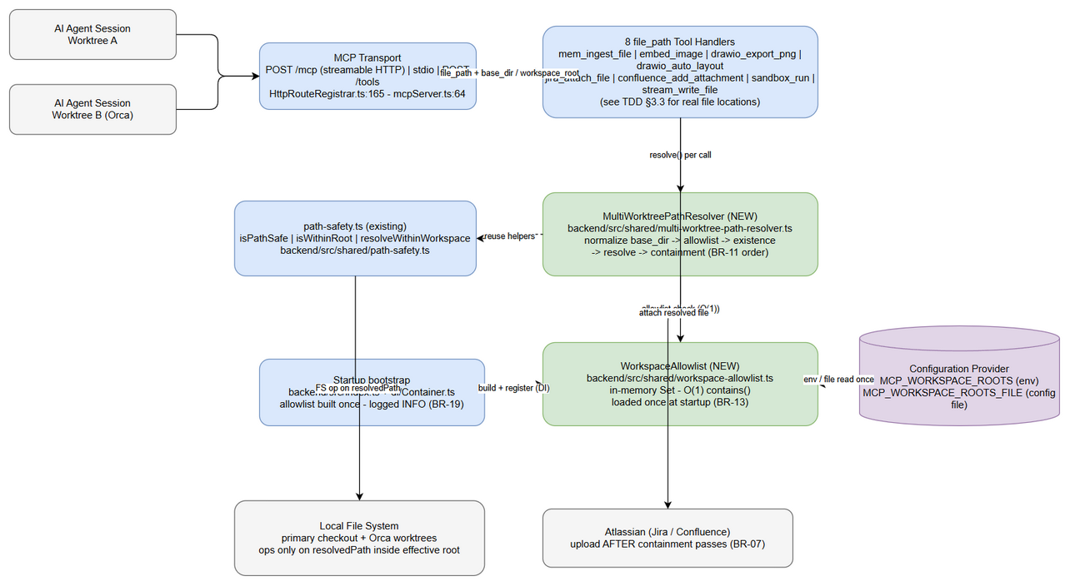
Architecture Diagram
Edit in draw.io
Key properties:
- The allowlist is the authorization boundary for workspaces (FSD §7.1): an effective root can only ever be (a) a registered allowlist root or (b) the legacy pinned root.
- Containment is checked after resolution against the effective root (BR-07) — ../ traversal inside file_path cannot escape.
- When the allowlist is empty, the resolver behaves as today (legacy mode, BR-16) — zero behavior change for existing deployments.

2.2 Component Diagram
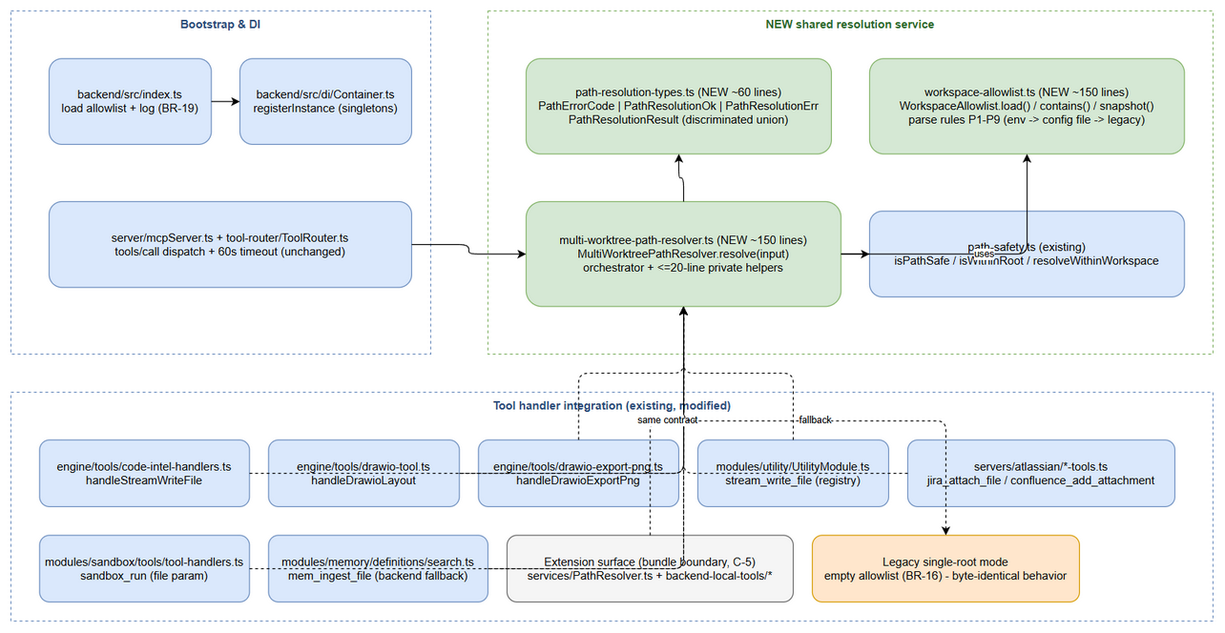
Component Diagram
Edit in draw.io
Component | Location | Responsibility | Technology
WorkspaceAllowlist (NEW) | backend/src/shared/workspace-allowlist.ts | Parse env/config file → normalize → realpath → dedupe → validate (warn on missing) → immutable in-memory Set<string>; O(1) contains(); startup snapshot for logging (BR-19) | Node path/fs + Set
MultiWorktreePathResolver (NEW) | backend/src/shared/multi-worktree-path-resolver.ts | Per-call pipeline: extract base_dir (alias handling BR-10) → normalize (BR-09) → allowlist (BR-05) → existence (BR-06) → resolve (BR-02/04) → containment (BR-07); returns PathResolutionResult | Node path/fs + path-safety helpers
path-resolution-types (NEW) | backend/src/shared/path-resolution-types.ts | Error codes + PathResolutionOk/PathResolutionErr discriminated union (single contract, no drift) | TypeScript types
Path Safety helpers (existing) | backend/src/shared/path-safety.ts | isPathSafe (null byte / absolute / traversal rejection), isWithinRoot, resolveWithinWorkspace — reused by the resolver; legacy branch delegates to resolveWithinWorkspace unchanged (C-3) | Node path
MCP bootstrap (existing) | backend/src/index.ts, backend/src/server/mcpServer.ts, backend/src/server/HttpServer.ts | Build allowlist + resolver at boot; register in DI Container; log allowlist at info (BR-19); tool-call pipeline unchanged | MCP SDK, Hono, pino
DI Container (existing) | backend/src/di/Container.ts | registerInstance for allowlist + resolver singletons (BR-13: load once) | existing token DI
Tool handlers (existing, 8 tools) | see §3.3 integration table | Accept base_dir/workspace_root; delegate ALL path decisions to the resolver; execute FS op on resolvedPath | per-tool
Extension adapter (existing surface) | extension/src/services/PathResolver.ts (+ 4 call sites) | Extension-executed tools adopt base_dir via resolveWorkspacePath extension; identical contract (§6.3, C-5) | VS Code extension TS

2.3 Deployment Architecture
The deployment topology is unchanged — this feature is code + configuration only (no new process, port, container, or database).
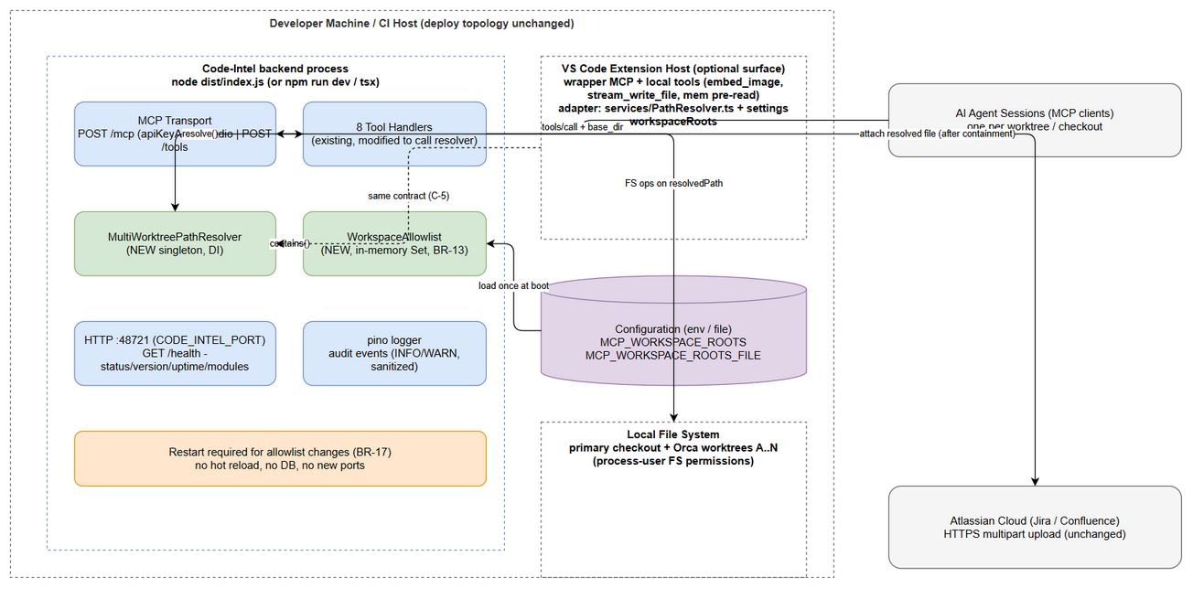
Deployment Diagram
Edit in draw.io
- Code-Intel backend process (node dist/index.js, port CODE_INTEL_PORT default 48721 — backend/src/config/index.ts:58; health at GET /health, backend/src/server/routes/health.ts:15). Holds: allowlist Set (in-memory), resolver singleton, 8 tool handlers.
- MCP clients (AI agent sessions) connect via streamable HTTP POST /mcp (API-key guarded, HttpRouteRegistrar.ts:86) or REST POST /tools; extension-hosted wrapper tools remain as-is.
- VS Code extension host (optional surface): wrapper MCP server + local tools; updated to forward base_dir (§6.3).
- Local filesystem: primary checkout + N Orca worktrees; all roots must be readable/writable by the backend process user.
- Configuration surface: process environment (MCP_WORKSPACE_ROOTS, MCP_WORKSPACE_ROOTS_FILE) set by the launch script / container env — the ONLY new deployment input (BR-12).

2.4 Communication Patterns
From | To | Protocol | Pattern | Description
AI Agent session | MCP server | MCP JSON-RPC (streamable HTTP /mcp, stdio, or REST /tools) | Sync, request/response | tools/call with file_path + optional base_dir/workspace_root; errors returned in-band as isError results
Tool handler | MultiWorktreePathResolver | In-process function call | Sync | resolve(input): PathResolutionResult — ≤5 ms, no I/O except 1-2 stat/realpath syscalls (§8)
Resolver | WorkspaceAllowlist | In-process (Set lookup) | Sync, O(1) | Allowlist membership; loaded once at startup (BR-13)
Bootstrap (index.ts) | Env / config file | process.env / fs.readFileSync | Sync, once at startup | Allowlist source; warnings logged (BR-15, BR-19)
jira_attach_file / confluence_add_attachment | Atlassian cloud | HTTPS multipart (existing client) | Sync, downstream | Unchanged — file content read from resolvedPath only AFTER containment passes (BR-07)
Extension local tools | Local FS | fs (extension host) | Sync | Same resolution contract via extension adapter (§6.3)

3. API Design
Prerequisite: Functional API contracts (parameters, business errors, data flows) are defined in FSD §3.x.6. This section specifies the technical implementation: transport, JSON schema additions, per-tool parameter mapping at real code locations, and error code → transport mapping.
Transport surface (no new endpoints): tools are invoked via (a) MCP tools/call over streamable HTTP POST /mcp (backend/src/server/HttpRouteRegistrar.ts:165, API-key guarded) or stdio, and (b) REST POST /tools (createToolsRoute, HttpRouteRegistrar.ts:108). The feature modifies tool input schemas and handler behavior only.

3.1 API Overview
# | Endpoint | Method | Description | Source
1 | MCP tools/call → mem_ingest_file | POST /mcp (or stdio / POST /tools) | Ingest document by path — gains base_dir | UC-1, BR-01
2 | MCP tools/call → embed_image | POST /mcp (extension local tool) | Inline image as base64 — gains base_dir | UC-1, BR-01
3 | MCP tools/call → drawio_export_png | POST /mcp | Export .drawio → PNG — gains base_dir | UC-1, BR-01
4 | MCP tools/call → drawio_auto_layout | POST /mcp | Auto-fix diagram layout — gains base_dir | UC-1, BR-01
5 | MCP tools/call → jira_attach_file | POST /mcp | Attach file to Jira — gains base_dir | UC-1, BR-01
6 | MCP tools/call → confluence_add_attachment | POST /mcp | Upload file to Confluence — gains base_dir | UC-1, BR-01
7 | MCP tools/call → sandbox_run | POST /mcp | Run code file — gains base_dir (applies to file param, §3.3) | UC-1, BR-01
8 | MCP tools/call → stream_write_file | POST /mcp | Write/append file — gains base_dir | UC-1, BR-01
All 8 share one identical parameter contract (§3.2) and one identical error contract (§3.4) — BR-20.

3.2 Common Parameter Contract: base_dir / workspace_root
Implements: UC-1, BR-01, BR-08, BR-09, BR-10, BR-22
Attribute | Value
Transport | MCP tools/call (JSON-RPC), REST /tools
Auth | API key (HTTP /mcp middleware, HttpRouteRegistrar.ts:86); project scope stamped by mcpServer.ts:79-86 (unchanged)
Rate Limit | Existing /mcp + /tools limits unchanged
Schema fragment added to each of the 8 tool inputSchema.properties:
{
"base_dir": {
"type": "string",
"description": "Optional workspace root to resolve relative file_path against. Must be registered in the server allowlist (MCP_WORKSPACE_ROOTS). Relative values are normalized to absolute. Example: /home/user/project-worktree-B"
},
"workspace_root": {
"type": "string",
"description": "Deprecated alias of base_dir (same semantics). Ignored when base_dir is present."
}
}
Rules: neither property is required (backward compatible, BR-03); both are plain strings — validation happens in the resolver, NOT in JSON-schema pattern (paths are platform-dependent; schema stays permissive, TC-5 asserts description + example presence).
Resolution order (normative, BR-11): normalize base_dir → allowlist check → filesystem existence/is-directory check → resolve file_path → containment check → execute.

3.3 Per-Tool Parameter Applicability & Integration Points (verified against codebase)
Tool | Path param(s) resolver applies to | Definition (schema) location | Handler / function to modify
stream_write_file | path (module variant) / file_path (code-intel variant) — both names accepted; both gain base_dir | backend/src/modules/utility/UtilityModule.ts:104; backend/src/engine/tools/register-tools.ts:74 | UtilityModule.ts:57 handler (resolveWithinWorkspace call at line 64); backend/src/engine/tools/code-intel-handlers.ts (handleStreamWriteFile, resolveWithinWorkspace at line 118)
mem_ingest_file | file_path (extension pre-read proxy); backend fallback when content_base64 sent directly | backend/src/modules/memory/definitions/search.ts:40; backend/src/modules/memory/tool-definitions.ts:9 | extension/src/services/Base64ProxyService.ts:177 (resolveWorkspacePath call); backend memory handler (backend fallback path)
embed_image | file_path, output_path | extension/src/backend-local-tools/definitions.ts | extension/src/backend-local-tools/embed-image.ts:34 (file_path), :57 (output_path)
drawio_export_png | file_path (reference) + output_path (extension output proxy) | backend/src/engine/tools/drawio-export-png.ts:14 | backend/src/engine/tools/drawio-export-png.ts:54 handleDrawioExportPng; extension output proxy (Base64ProxyService/output-proxy.ts:59)
drawio_auto_layout | file_path | backend/src/engine/tools/drawio-tool.ts:13 | backend/src/engine/tools/drawio-tool.ts:34 handleDrawioLayout + resolveFilePath
jira_attach_file | file_path | backend/src/servers/atlassian/models/jira-schemas.ts (AttachFileSchema) | backend/src/servers/atlassian/tools/jira-attachment-tools.ts:21 handler; validateFilePath (:66) and ALLOWED_BASES (:17) replaced by allowlist-driven resolver
confluence_add_attachment | file_path | backend/src/servers/atlassian/models/confluence-schemas.ts (AddAttachmentSchema) | backend/src/servers/atlassian/tools/confluence-content-tools.ts:26 handler; validateFilePath (:65) replaced likewise
sandbox_run | file (host-side input path; mapped into the sandbox after resolution) | backend/src/modules/sandbox/tools/tool-definitions.ts:70 | backend/src/modules/sandbox/tools/tool-handlers.ts:91 handler; resolution before buildRunCommand / executor mount (mountSecurity.ts unchanged)
Note (tracked as DISC-1 in DISCREPANCY.md): FSD §3.3.4 lists sandbox_run under “file_path tools”; the actual parameter is file. The design applies the same resolver to the file argument — behavior is identical, only the argument name differs.
Handler wiring pattern (uniform, OCP-safe): each handler extracts { filePath, baseDir, workspaceRoot } from args, calls resolver.resolve(...); on !result.ok returns the error ToolResult (§3.4); on ok proceeds with result.resolvedPath. Handlers currently receiving workspace: string (CodeIntelContext.workspace, register-tools.ts:95-102) receive the resolver via the context object instead — one field added to CodeIntelContext, no signature churn.

3.4 Response & Error Contract
Success — normal tool result, plus resolved_path where the tool already reports a path (FSD §3.1.4):
{
"content": [{ "type": "text", "text": "{\"success\":true, \"resolved_path\":\"/home/user/project-worktree-B/documents/SA4E-394/BRD.md\"}" }],
"isError": false
}
Error — in-band business error with CODE: prefix (extension PathResolver convention, C-5; tools forward the text verbatim):
{
"content": [{ "type": "text", "text": "PATH_REJECTED_OUTSIDE_ALLOWLIST: Workspace root '/home/user/other' is not registered in the allowlist. Configure MCP_WORKSPACE_ROOTS to include this path." }],
"isError": true
}
Error mapping matrix (all tools):
Condition | Error code | MCP/REST surface | Message (verbatim, after CODE: prefix) | Log level
base_dir (or alias) not in allowlist | PATH_REJECTED_OUTSIDE_ALLOWLIST | isError: true text result | Workspace root '{base_dir}' is not registered in the allowlist. Configure MCP_WORKSPACE_ROOTS to include this path. | WARN
base_dir missing / not a directory | FS_ERROR | isError: true text result | Workspace root '{base_dir}' does not exist on filesystem | WARN
Containment failure with base_dir set (incl. ../ traversal, absolute escape, symlink escape) | PATH_REJECTED_OUTSIDE_ALLOWLIST | isError: true text result | Resolved path '{resolved}' is outside workspace root '{base_dir}' | WARN
Legacy containment failure (base_dir omitted) | PATH_REJECTED_OUTSIDE_WORKSPACE | isError: true text result | unchanged legacy message (e.g. drawio-tool.ts:48 format: Path rejected: {sanitized} resolves to {resolved} — outside backend workspace {workspace}) | INFO
OS permission failure on the operation | FS_ERROR | isError: true text result | FS_ERROR: {OS error details} | WARN
Empty/invalid file_path, null byte | per-tool existing behavior (unchanged) | unchanged | unchanged (isPathSafe rejection) | unchanged
Error precedence is strict (BR-11): allowlist → existence → containment. An unregistered root must never produce FS_ERROR, and a registered-but-missing root must never produce PATH_REJECTED_*.

3.5 Per-Call Resolution Sequence
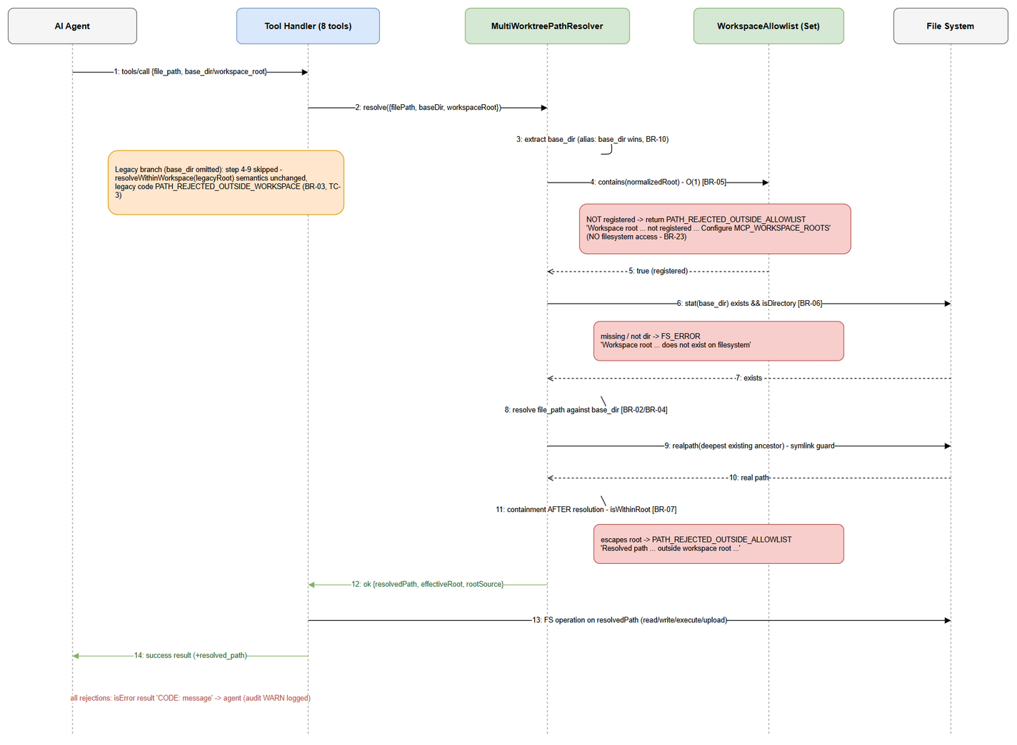
Per-Call Resolution Sequence
Edit in draw.io
Flow (maps 1:1 to FSD §6.2 steps): Agent → Tool Handler → Resolver → Allowlist/FS → back to handler → FS operation → result. Rejection branches abort before any FS access (BR-23).

4. Database Design
Prerequisite: Logical data model (entities, relationships, business attributes) is defined in FSD §4. This section specifies the physical implementation: DDL scripts, indexes, migration plans, and query performance patterns.

4.1 Schema Overview
⛔ NO DATABASE CHANGES. This feature is configuration-centric: the allowlist is process-local, in-memory state derived from the environment at startup (FSD §4 note; BRD §1.2 excludes DB migrations). There are no tables, no DDL, no indexes, and no migrations. The logical entities from FSD §4.2 (WorkspaceRootAllowlistEntry, LegacyPinnedRoot, ToolInvocation, PathResolutionContext) are runtime structures — the first two materialize as strings in an in-memory Set, the latter two exist only as log fields / result payloads.
The “data store” for this feature is the configuration pipeline below:
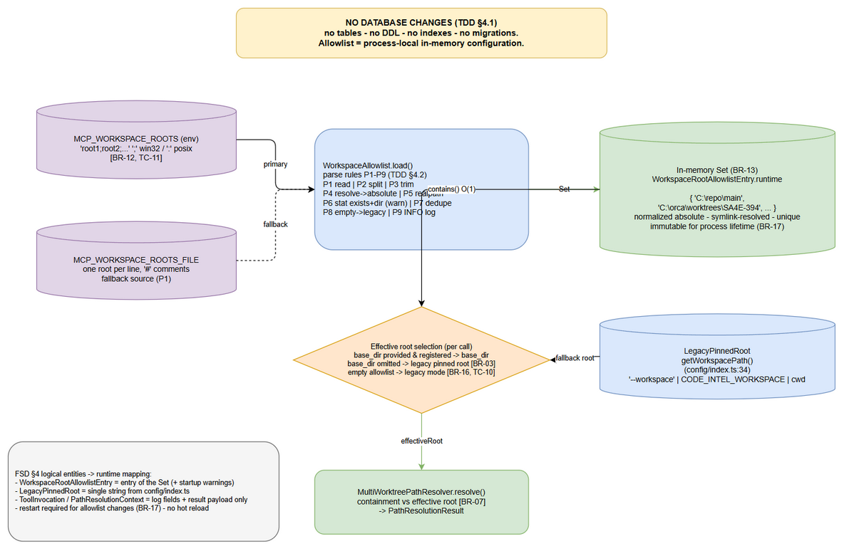
Config Store (no DB changes)
Edit in draw.io
Runtime structure | Representation | Lifecycle
Allowlist roots (WorkspaceRootAllowlistEntry.root_path) | Set<string> of normalized absolute paths (BR-13, BR-14) | Built once at startup; immutable; destroyed at shutdown
Legacy pinned root (LegacyPinnedRoot.root_path) | single string from getWorkspacePath() (backend/src/config/index.ts:34) | Existing behavior, unchanged
MCP_WORKSPACE_ROOTS raw value | process.env string | Read once at startup (BR-12); restart required to change (BR-17)
MCP_WORKSPACE_ROOTS_FILE raw value | UTF-8 text file, one root per line | Read once at startup when env var is unset (FSD UC-2 AF-2)

4.2 Configuration Schema (env var format & parsing rules)
Env variable (primary source, BR-12):
# Windows delimiter: ';' | POSIX delimiter: ':' (TC-11)
MCP_WORKSPACE_ROOTS="C:\repo\main;C:\orca\worktrees\SA4E-394;C:\orca\worktrees\feature-x"
Config file (fallback source, FSD UC-2 AF-2):
MCP_WORKSPACE_ROOTS_FILE=/etc/sdlc/mcp-workspace-roots.txt
# mcp-workspace-roots.txt — one root per line; '#' starts a comment; blank lines skipped
C:\repo\main
C:\orca\worktrees\SA4E-394
Source precedence (normative): MCP_WORKSPACE_ROOTS env → MCP_WORKSPACE_ROOTS_FILE → legacy single-root mode (empty allowlist, BR-16).
Parsing rules (normative, implemented in WorkspaceAllowlist.load):
# | Rule | Error handling | FSD ref
P1 | Read raw string from env, else read+parse file | File unreadable/unparseable → WARN, treat as empty → legacy mode (EF-2 of UC-2) | BR-12
P2 | Split on platform delimiter (path.delimiter: ; win32, : POSIX) | — | BR-12, TC-11
P3 | Trim each token; skip empty tokens | Empty token → WARN, skipped | UC-2 EF-1
P4 | Normalize each entry to absolute (path.resolve) | Relative entries resolved against server CWD | BR-09, BR-14
P5 | Resolve symlinks (fs.realpathSync) where the entry exists | ENOENT → keep resolved path + WARN | BR-14, BR-15
P6 | Validate exists && is a directory (fs.statSync().isDirectory()) | Missing/not-dir → WARN naming the entry; entry retained (per-call BR-06 check still guards it); startup continues | BR-15, UC-2 AF-3, TC-9
P7 | Deduplicate case-insensitively on win32, exactly on POSIX | Duplicates silently merged (Set semantics) | TC-9
P8 | If the resulting set is empty → legacyMode = true; register only the pinned root for diagnostics | INFO log “legacy single-root mode active” | BR-16, TC-10
P9 | Log the final allowlist at INFO (roots + source + warnings) | — | BR-19
Validation: entries must be absolute after P4 (relative entries are normalized, never rejected — BR-09); no URL/unc-validation is added (filesystem decides).

4.3 Migration Plan
Order | Script | Description | Estimated Time | Rollback
— | N/A | No database migration. Configuration rollout only: set MCP_WORKSPACE_ROOTS + restart (§10.1) | ~1 min per environment | Unset env var + restart → legacy mode

4.4 Query Patterns
Operation | Query Pattern | Expected Performance
Allowlist membership (base_dir check, per tool call) | Set<string>.has(normalizedRoot) | O(1), < 0.01 ms
Startup allowlist build | parse → stat/realpath per entry (n = typically 2–20) | < 50 ms total at boot (off the request path)
base_dir existence check (per call, BR-06) | fs.statSync(baseDir).isDirectory() | 1 syscall, ~0.05–0.3 ms (§8.3)
Containment (per call, BR-07) | isWithinRoot string compare + fs.realpathSync on the deepest existing ancestor | 1 syscall + O(

5. Class / Module Design

5.1 Package Structure
backend/src/shared/
├── path-safety.ts # EXISTING — reused (isPathSafe, isWithinRoot, resolveWithinWorkspace)
├── path-resolution-types.ts # NEW (~60 lines) — error codes + result union
├── workspace-allowlist.ts # NEW (~150 lines) — startup allowlist loader (Set)
├── multi-worktree-path-resolver.ts # NEW (~150 lines) — shared per-call resolver (public API)
└── __tests__/
├── workspace-allowlist.test.ts # NEW — P1..P9 rules, TC-9/10/11
└── multi-worktree-path-resolver.test.ts # NEW — TC-1..TC-8 core matrix
backend/src/index.ts # MODIFIED — build allowlist + resolver, register in DI, log (BR-19)
backend/src/di/Container.ts # MODIFIED — registerInstance tokens (no logic change)
backend/src/engine/tools/register-tools.ts # MODIFIED — CodeIntelContext gains resolver; defs gain base_dir
backend/src/engine/tools/code-intel-handlers.ts # MODIFIED — handleStreamWriteFile uses resolver
backend/src/engine/tools/drawio-tool.ts # MODIFIED — handleDrawioLayout uses resolver
backend/src/engine/tools/drawio-export-png.ts # MODIFIED — handleDrawioExportPng validates file_path via resolver
backend/src/modules/utility/UtilityModule.ts # MODIFIED — stream_write_file uses resolver (accepts path/file_path)
backend/src/modules/sandbox/tools/tool-handlers.ts # MODIFIED — sandbox_run resolves 'file' pre-mount
backend/src/servers/atlassian/tools/jira-attachment-tools.ts # MODIFIED — validateFilePath → resolver
backend/src/servers/atlassian/tools/confluence-content-tools.ts # MODIFIED — validateFilePath → resolver
backend/src/modules/memory/definitions/search.ts # MODIFIED — schema gains base_dir (backend fallback path)
extension/src/services/PathResolver.ts # MODIFIED — resolveWorkspacePath gains baseDir + allowlist opts (§6.3)
extension/src/backend-local-tools/embed-image.ts # MODIFIED — forward base_dir
extension/src/backend-local-tools/stream-write.ts # MODIFIED — forward base_dir
extension/src/services/Base64ProxyService.ts # MODIFIED — forward base_dir (mem_ingest_file pre-read)
extension/src/mcp/atlassian/jira-attachment-tools.ts # MODIFIED — forward base_dir
extension/src/mcp/atlassian/confluence-content-tools.ts # MODIFIED — forward base_dir
Rationale for 3 new files instead of 1: the repo gate enforces ≤200 lines/file (npm run lint:lines) and ≤20 lines/function; multi-worktree-path-resolver.ts remains the single public entry point (SOLID’s ISP for consumers — handlers import only the resolver), while types and allowlist loading are internal collaborators.

5.2 Key Interfaces
// ── backend/src/shared/path-resolution-types.ts (NEW) ──────────────────
/** Business error codes — FSD §3.1.6 (BR-05/06/07, AF-1). */
export type PathErrorCode =
| 'PATH_REJECTED_OUTSIDE_ALLOWLIST' // base_dir not registered; or resolved path escapes effective root
| 'PATH_REJECTED_OUTSIDE_WORKSPACE' // LEGACY: base_dir omitted, path escapes pinned root (BR-03)
| 'FS_ERROR'; // base_dir missing/not-dir; OS permission failures
export interface PathResolutionOk {
ok: true;
resolvedPath: string; // absolute — the ONLY path a handler may touch
effectiveRoot: string; // base_dir (normalized) or legacy pinned root
rootSource: 'base_dir' | 'legacy';
}
export interface PathResolutionErr {
ok: false;
code: PathErrorCode;
message: string; // full 'CODE: message' text — forwarded VERBATIM by handlers
effectiveRoot: string;
resolvedPath: string; // best-effort (may be '') for audit logs (FSD §7.3)
}
/** Discriminated union — callers MUST check .ok first (mirrors extension PathResolver). */
export type PathResolutionResult = PathResolutionOk | PathResolutionErr;
// ── backend/src/shared/workspace-allowlist.ts (NEW) ────────────────────
export class WorkspaceAllowlist {
private constructor(roots: ReadonlySet<string>, legacyMode: boolean, warnings: readonly string[]);
/** Load once at startup (BR-13). Precedence: env var → config file → legacy mode. */
static load(legacyRoot: string, logger: Logger, env?: NodeJS.ProcessEnv): WorkspaceAllowlist;
/** O(1) membership check (BR-05). */
contains(root: string): boolean;
isLegacyMode(): boolean; // BR-16
/** Startup log snapshot (BR-19). */
snapshot(): readonly string[];
get size(): number;
}
// ── backend/src/shared/multi-worktree-path-resolver.ts (NEW) ───────────
export interface ResolvePathInput {
filePath: unknown; // tool's file_path / path / file argument (validated inside)
baseDir?: unknown; // args.base_dir
workspaceRoot?: unknown; // args.workspace_root (deprecated alias, BR-10)
}
export class MultiWorktreePathResolver {
/** Injected once via DI Container; stateless per call (allowlist immutable). */
constructor(allowlist: WorkspaceAllowlist, legacyRoot: string, logger: Logger);
/**
* Pipeline (BR-11 order): extract base_dir (BR-10) → normalize (BR-09) →
* allowlist (BR-05) → existence (BR-06) → resolve (BR-02/04) →
* containment AFTER resolution (BR-07, incl. symlink escape).
* Legacy branch (baseDir absent) delegates to resolveWithinWorkspace
* semantics with legacy error codes — byte-for-byte parity (BR-03, C-3).
* Never throws on business paths; returns typed errors (§1.4).
*/
resolve(input: ResolvePathInput): PathResolutionResult;
}
Method budget (≤20 lines each, per code-standards): resolve is an orchestrator delegating to private helpers extractBaseDir, resolveLegacyPath, validateBaseDir (allowlist + existence), resolveFilePath, enforceContainment (string check + realpath anti-escape), sanitize (log-forging strip, pattern of drawio-tool.ts:42).

5.3 Class Diagram & Design Patterns
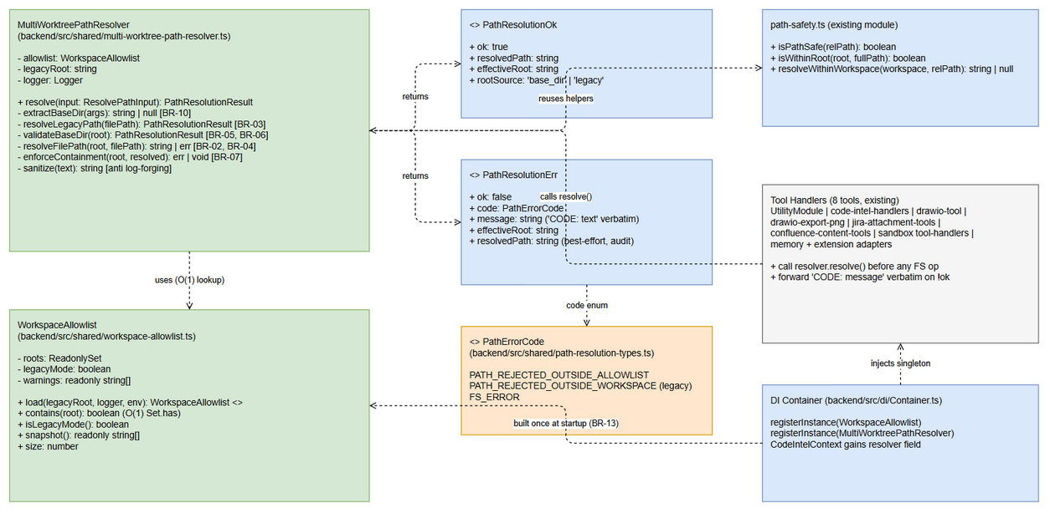
Class Diagram
Edit in draw.io
Pattern | Where Used | Rationale
Discriminated Union Result | PathResolutionResult (path-resolution-types.ts) | Error-as-value; no exceptions on business paths; identical to proven extension/src/services/PathResolver.ts pattern (C-1/C-2)
Facade | MultiWorktreePathResolver composes path-safety.ts helpers | Single entry point for 8 tools (BR-20); containment logic stays in one place (SEC-04/SEC-05 lineage)
Singleton (DI-managed) | WorkspaceAllowlist + resolver registered via Container.registerInstance | Load config once at startup (BR-13); immutable state ⇒ thread-safe reads
Dependency Injection | resolver passed via CodeIntelContext (register-tools.ts:95) and module constructors | Matches existing manual DI style; handlers stay unit-testable with a stub resolver
Adapter | extension PathResolver extension (§6.3) | Bundle boundary (C-5): same contract, independent implementation
Strategy (implicit) | rootSource: 'base_dir' | 'legacy' picks the effective root | Deterministic effective-root selection (BR-03/BR-10/BR-16)
Dependency injection configuration (backend/src/index.ts, boot order):
// Conceptual wiring (NOT implementation code — DEV implements in Phase 5)
const allowlist = WorkspaceAllowlist.load(config.workspace, logger, process.env); // BR-12..BR-19
logger.info({ roots: allowlist.snapshot(), legacyMode: allowlist.isLegacyMode() },
'MCP workspace allowlist loaded'); // BR-19
container.registerInstance(WorkspaceAllowlist, allowlist);
container.registerInstance(MultiWorktreePathResolver,
new MultiWorktreePathResolver(allowlist, config.workspace, logger));
// CodeIntelContext (register-tools.ts:95) gains: resolver: MultiWorktreePathResolver
// ModuleFactory passes the resolver into UtilityModule / sandbox / atlassian tool factories.

5.4 Error Handling
Resolver error flow (decisions in orange, rejections in red, success in green):
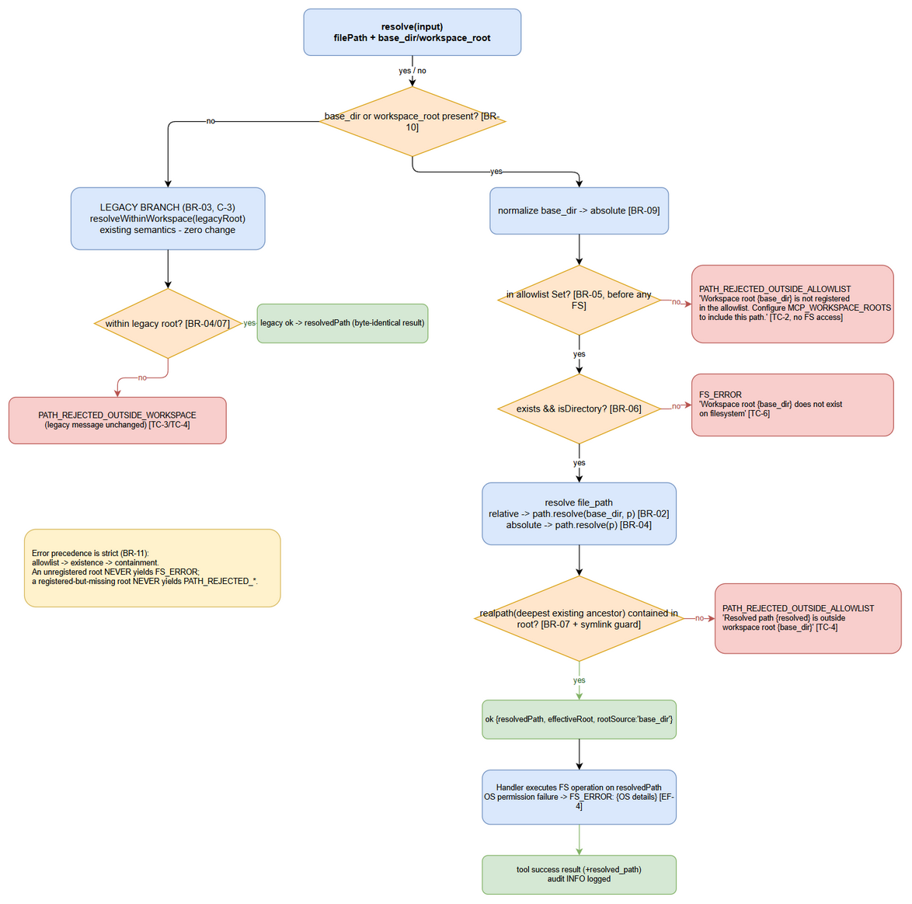
Error Flow with Exact Error Codes
Edit in draw.io
Exception / Condition | Transport (MCP ToolResult) | Error Code | When Thrown/Returned
base_dir ∉ allowlist | isError: true, text = PATH_REJECTED_OUTSIDE_ALLOWLIST: {FSD §3.1.6 message} | PATH_REJECTED_OUTSIDE_ALLOWLIST | BR-05, UC-1 EF-1, TC-2 — before any FS access
base_dir missing / not a directory | isError: true, FS_ERROR: Workspace root '{base_dir}' does not exist on filesystem | FS_ERROR | BR-06, UC-1 EF-2, TC-6 — after allowlist pass
Resolved path escapes effective root | isError: true, PATH_REJECTED_OUTSIDE_ALLOWLIST: Resolved path '{resolved}' is outside workspace root '{base_dir}' | PATH_REJECTED_OUTSIDE_ALLOWLIST | BR-07, UC-1 EF-3/AF-5, TC-4 — after resolution
Legacy escape (base_dir omitted) | isError: true, legacy message text (unchanged) | PATH_REJECTED_OUTSIDE_WORKSPACE | BR-03/AF-1, TC-3/TC-4-legacy — byte-for-byte legacy
OS permission denied on operation | isError: true, FS_ERROR: {OS details} | FS_ERROR | UC-1 EF-4 — raised by the tool’s own try/catch (e.g. withErrorHandling decorator), prefixed FS_ERROR:
Resolver internal failure (unexpected) | isError: true, generic message | n/a (tool-specific) | UC-3 EF-2 — caught by ToolRouter/mcpServer catch; no partial writes
Invariants (enforced by design + tests):
- Error precedence is fixed: allowlist → existence → containment (BR-11) — an unregistered root can never surface as FS_ERROR.
- Handlers never construct paths themselves — the only path used after resolve() is result.resolvedPath (single source of truth, SA4E-356 lineage).
- Error messages never contain raw control characters — all echoed paths pass through sanitize ( → ?), preventing log forgery (§7.4/T6).

6. Integration Design
Prerequisite: Business integration requirements (what systems, what data is exchanged, business rules) are defined in FSD §5. This section specifies the technical implementation: protocols, timeouts, retry policies, circuit breakers, and sequence diagrams.

6.1 External System: Configuration Provider (env var / config file)
Attribute | Value
Protocol | process environment + local file read (fs.readFileSync, UTF-8)
Endpoint | MCP_WORKSPACE_ROOTS env var; MCP_WORKSPACE_ROOTS_FILE env var pointing to a text file
Authentication | n/a (host-local configuration)
Timeout | n/a (synchronous one-shot read; file must be < 64 KB — larger files WARN and truncate to first 100 entries, defensive cap)
Retry Policy | none — startup-only (BR-13, BR-17)
Circuit Breaker | n/a — unreadable config degrades to legacy mode with WARN (FSD UC-2 EF-2), never blocks startup
Data Mapping:
Source Field | Target Field | Transformation
Raw delimited string / file lines | token list | split on path.delimiter (env) or newline (file); trim; drop empties (P1–P3, §4.2)
token | normalized root | path.resolve → fs.realpathSync (if exists) (P4–P5, BR-14)
normalized root | allowlist Set | dedupe (P7); missing entries retained with WARN (P6, BR-15)
empty set | legacy mode flag | pinned root remains the only effective root (P8, BR-16)
Startup Sequence (allowlist loading — env parse → normalize → validate → Set):
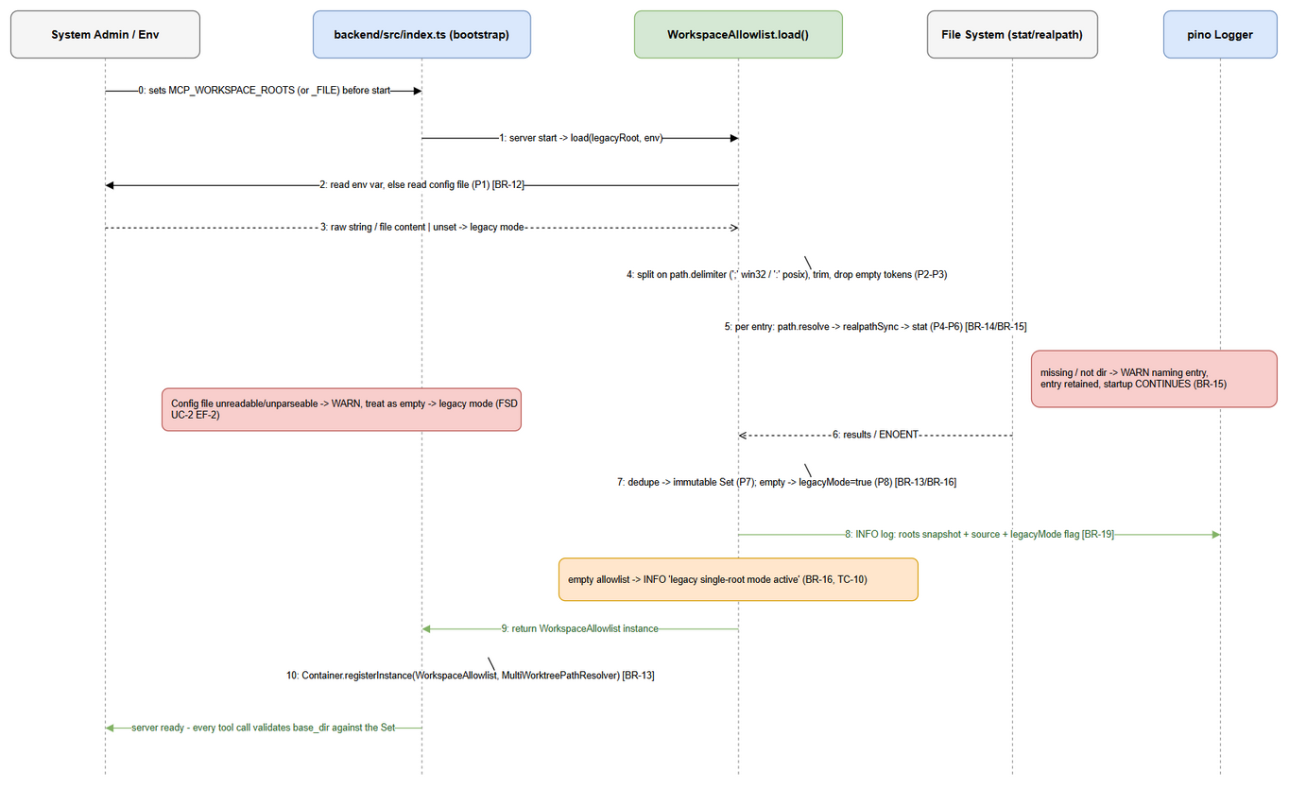
Startup Sequence
Edit in draw.io

6.2 External System: Local File System (per-call resolution)
Attribute | Value
Protocol | Node fs (stat/realpath + the tool’s own read/write/execute calls)
Endpoint | effective root (= base_dir or legacy pinned root) + resolved path
Authentication | filesystem permissions of the backend process user (unchanged)
Timeout | n/a — local syscalls; tool-level timeout already enforced by ToolRouter (60 s default, ToolRouter.ts:12)
Retry Policy | none (filesystem ops are not retried)
Circuit Breaker | n/a
Per-call resolution sequence (happy path + rejection branches):
Per-Call Resolution Sequence
Edit in draw.io
FS touch contract: the resolver performs at most (a) statSync on base_dir (BR-06) and (b) realpathSync on the deepest existing ancestor of the resolved path (symlink-escape guard, §7.4/T3). All content I/O stays in the tool handler, executed on resolvedPath only.

6.3 Extension Surface (bundle-boundary adapter — C-5)
Three of the 8 tools execute (pre-dominantly or partially) in the VS Code extension host and cannot import backend ESM modules (C-5). Uniformity (BR-20) is preserved by extending the existing extension resolver rather than duplicating a new one:
Extension touchpoint | File (real path) | Change
Core resolver | extension/src/services/PathResolver.ts | resolveWorkspacePath gains opts.baseDir + opts.allowlist: ReadonlySet<string>; when baseDir is present it becomes the effective root and runs the SAME order: normalize → allowlist → (existence is caller-side) → resolve → containment; on allowlist failure returns { ok:false, code:'PATH_REJECTED_OUTSIDE_ALLOWLIST', message:'CODE: …' }
embed_image | extension/src/backend-local-tools/embed-image.ts:34,57 | forward args.base_dir/args.workspace_root into resolveWorkspacePath
stream_write_file (extension variant) | extension/src/backend-local-tools/stream-write.ts:39 | same forwarding
mem_ingest_file pre-read | extension/src/services/Base64ProxyService.ts:177 | same forwarding
Atlassian wrappers | extension/src/mcp/atlassian/jira-attachment-tools.ts:35, confluence-content-tools.ts:34 | same forwarding
Allowlist mirror | VS Code settings kiro-code-intel.workspaceRoots (string[]) | extension-side allowlist; backend remains source of truth — deployments configure both from the same values (documented in DPG)
Contract duplication is intentional and verified behaviorally: the shared test matrix (TC-1…TC-5 per tool) asserts identical codes and messages on both surfaces; a contract-test fixture (shared JSON of scenarios) is used by both test suites to prevent drift (see §11 Test Plan Hooks).

6.4 External System: Atlassian (downstream of resolved files)
Unchanged behavior (FSD §5.4): jira_attach_file (backend/src/servers/atlassian/tools/jira-attachment-tools.ts:21) and confluence_add_attachment (backend/src/servers/atlassian/tools/confluence-content-tools.ts:26) read the file only after the resolver returns ok — i.e., containment passes before any upload (BR-07). The local ALLOWED_BASES = [process.cwd()] constant (jira-attachment-tools.ts:17) and the per-tool validateFilePath (:66, and confluence :65) are replaced by the shared resolver — removing a second, divergent containment implementation (root-cause fix, no-workaround rule). Upload client code (clients/jira-client.ts, clients/confluence-client.ts) is not modified. No retry/circuit-breaker changes.

7. Security Design
Prerequisite: Business security requirements (roles, permissions, data classification, audit needs) are defined in FSD §7. This section specifies the technical implementation: authentication mechanism, token configuration, encryption algorithms, and input validation rules.

7.1 Authentication
Unchanged (pre-existing): MCP streamable HTTP transport is API-key guarded (app.use('/mcp/*', apiKeyAuth), HttpRouteRegistrar.ts:86); REST /tools uses the existing tools-route auth; project/user context is stamped server-side (mcpServer.ts:79-86 — __projectId, _projectContext) and MUST NOT be influenced by base_dir (C-6). stdio/extension transports are host-local. base_dir is a workspace selector, not an identity — it never relaxes authentication.

7.2 Authorization
Role | Endpoints | Permissions
AI Agent (MCP client session) | all 8 file_path tools | May pass base_dir only for roots in the startup allowlist (BR-05, BR-23); may always omit base_dir (legacy root)
System Admin | env/config file + restart | Configure allowlist; no runtime mutation path exists (BR-17)
Security Reviewer | server logs (FSD §7.3) | Read rejection audit events; verify zero out-of-allowlist FS access
Authorization model: the allowlist IS the workspace authorization boundary (FSD §7.1). Hard invariants:
- An effective root is only ever a registered allowlist root or the legacy pinned root — there is no code path that widens containment beyond the effective root (containment never widened).
- Permitting a new worktree = admin edits env/config + restarts; agents cannot self-authorize.
- Containment check uses the effective root, and the effective root is always ⊆ (allowlist ∪ {legacy root}).

7.3 Data Protection
Data Type | At Rest | In Transit | In Logs
Workspace file contents | untouched by this feature (filesystem ACLs as-is) | n/a (local FS; Atlassian uploads use existing HTTPS) | never logged by resolver
Allowlist root paths (Internal) | env/file on host | n/a | INFO at startup only, trusted server log (BR-19)
Resolved absolute paths (Internal) | n/a | returned only to the calling agent in the tool result | sanitized before logging (sanitize: → ?; anti log-forging, pattern of drawio-tool.ts:42 / extension sanitizeLogText)
base_dir values in rejections | n/a | echoed only in the in-band error for the caller | sanitized; no filesystem internals beyond the caller-supplied value (FSD §7.2)

7.4 Input Validation & Threat Model
Field | Validation | Sanitization
file_path | non-empty string; null-byte rejected by isPathSafe (path-safety.ts:15); absolute paths allowed but containment-checked (BR-04) | control chars stripped before any echo/log
base_dir / workspace_root | must normalize to absolute (BR-09); must be in allowlist (BR-05); must exist and be a directory (BR-06) | sanitized in error/log output
MCP_WORKSPACE_ROOTS entries | parse rules P1–P9 (§4.2) | warnings carry only the offending entry
Threat model (attack → control):
ID | Threat | Vector | Control | Residual risk
T1 | Path traversal via ../ in file_path | file_path: "../../etc/passwd" | Containment AFTER resolution (BR-07) rejects when the final path leaves the effective root; in-root ../ allowed per FSD AF-5 | none
T2 | Absolute path escape | file_path: "/etc/passwd" with base_dir set | isWithinRoot(effectiveRoot, resolved) (BR-04/07) | none
T3 | Symlink escape | base_dir contains a symlink pointing outside the allowlist | startup realpath of allowlist entries (P5, BR-14); per-call realpathSync of the resolved path’s deepest existing ancestor with re-containment check | TOCTOU window (T7)
T4 | Null byte / control chars | file_path: "a\0b" | isPathSafe rejects \0 (existing); sanitize before logging | none
T5 | Windows drive-letter / UNC absolute path | C:\\Windows\\system32\\... | isPathSafe rejects drive-letter form (path-safety.ts:17); containment is case-folded on win32 (extension isPathWithinRoot fold pattern reused) | none
T6 | Log forgery via in echoed paths | malicious path text | sanitize on every echoed path (§5.4 invariant 3) | none
T7 | TOCTOU race between containment check and file open | path target swapped between check and use | realpath is performed immediately before the handler’s FS call, in the same tick; single-host, agent-scoped trust model; documented and accepted for V1 | accepted (documented) — candidate for future fd-based hardening
T8 | Allowlist poisoning via relative base_dir | base_dir: "." resolves to server CWD | relative input normalized (BR-09) BEFORE the allowlist check; only normalized values are looked up | none
T9 | Prefix confusion (trailing-separator / sibling dir) | /root-evil vs /root | isWithinRoot boundary uses root + path.sep semantics (path-safety.ts:26-31; extension UC-03 EF-2 pattern) | none
T10 | Containment bypass by passing both alias and base_dir with conflicting values | base_dir A, workspace_root B | base_dir wins deterministically (BR-10); alias ignored — no merge | none
Audit logging implementation (maps FSD §7.3 → §9.1): allowlist-loaded (INFO), base_dir rejected (WARN, fields tool_name, base_dir, file_path, code), containment rejected (WARN, tool_name, resolved_path, effective_root), successful cross-worktree operation (INFO, tool_name, base_dir, resolved_path).

8. Performance & Scalability
Prerequisite: Business NFR targets (response time, availability, scalability expectations) are defined in FSD §8. This section specifies how to achieve those targets: caching strategy, connection pooling, and technical performance benchmarks.

8.1 Caching Strategy
Cache | What | TTL | Eviction | Technology
Workspace allowlist | normalized absolute roots (Set) | process lifetime | none — immutable after startup (BR-13, BR-17) | in-memory Set<string> (O(1) has)
Legacy pinned root | single string | process lifetime | n/a | existing getWorkspacePath() value
Renderer/tool caches | unchanged (e.g. cachedRenderer in drawio-export-png.ts:29) | n/a | n/a | existing
Deliberately NOT cached: per-call stat/realpath results for base_dir/resolved paths — correctness beats microseconds (TOCTOU T7); syscall cost is bounded and small (§8.3).

8.2 Connection Pooling
Resource | Min | Max | Timeout | Idle Timeout
Database | n/a — no DB usage added (existing pools untouched, §4.1) | — | — | —
Filesystem syscalls | n/a | 2 per resolution (stat + realpath) | synchronous | n/a
Atlassian HTTP client | existing (unchanged) | existing | existing | existing

8.3 Performance Targets
Operation | Target | Measurement
Full resolve() with base_dir (normalize + allowlist + stat + resolve + containment + realpath) | < 5 ms p95 (FSD §8: “allowlist lookup + normalization < 5 ms”, Set-based O(1)) | unit benchmark in multi-worktree-path-resolver.test.ts (timing assertion with generous CI headroom) + pino duration_ms field on debug logs
resolve() legacy branch (base_dir omitted) | zero regression — identical code path to today (resolveWithinWorkspace), no added syscall | TC-3 parity tests; existing perf unchanged
Allowlist startup build | < 50 ms for ≤ 20 entries | startup log timestamp delta (BR-19)
Throughput impact on tools/call | no measurable change beyond §8.3 row 1 (resolution ≪ tool FS/IO work) | existing tool-call duration logging (ToolRouter.ts:59)
Horizontal scaling: stateless per call — any backend replica built from the same env sees the same allowlist; no cross-instance coordination needed. Scaling the allowlist (hundreds of roots) has no per-call cost impact (Set lookup is O(1)).

9. Monitoring & Observability

9.1 Logging
Framework: pino (existing; child loggers per module — pattern UtilityModule.ts:27, logger.child({ module: this.name })). Resolver uses logger.child({ module: 'mw-path-resolver' }).
Log Event | Level | Fields | Destination
Allowlist loaded (BR-19) | INFO | roots (snapshot), source (env/config_file), legacyMode, count | server stdout/log pipeline
Allowlist entry warning (BR-15) | WARN | entry (sanitized), reason (missing/not-directory/unreadable-file) | server log
Empty allowlist → legacy mode (BR-16) | INFO | legacyMode: true | server log
base_dir rejected (BR-23, FSD §7.3) | WARN | tool_name, base_dir (sanitized), file_path (sanitized), code: 'PATH_REJECTED_OUTSIDE_ALLOWLIST' | server log (audit trail)
Containment rejected | WARN | tool_name, resolved_path (sanitized), effective_root, code | server log (audit trail)
FS_ERROR on base_dir / operation | WARN | tool_name, base_dir or resolved_path, OS error details | server log
Successful cross-worktree operation | INFO | tool_name, base_dir, resolved_path (sanitized) | server log (traceability, FSD §7.3)
Resolution debug timing | DEBUG | tool_name, duration_ms | server log (dev/debug builds)
All path-valued fields pass through sanitize before logging (§7.4/T6). Legacy rejections keep their existing log levels/lines byte-for-byte (C-3).

9.2 Metrics
Metric | Type | Description | Alert Threshold
mcp_tool_path_rejections_total{tool,code} | Counter | Rejections per tool per error code (derived from WARN audit events; optional Prometheus exporter if already present in deployment) | spike review: > 10/min sustained → misconfigured allowlist or probing
mcp_workspace_allowlist_size | Gauge (startup) | Number of registered roots + legacyMode flag | 0 in environments that require multi-worktree → config drift alert
mcp_tool_call_duration_ms{tool} | Histogram | Existing tool-call duration logging (ToolRouter.ts:59) — resolution overhead visible as delta | p95 regression > 5 ms vs baseline
Metric emission reuses the existing trackToolUsage success-counting hook (mcpServer.ts:90) plus the WARN audit events; no new metrics framework is introduced (no new dependency, §1.3).

9.3 Health Checks
Endpoint | Checks | Expected Response
GET /health (backend/src/server/routes/health.ts:15) | existing: backend status, version, uptime, module health | 200 { status: 'healthy', ... } — unchanged by this feature
Startup log (BR-19) | allowlist snapshot + legacyMode + warnings | INFO line listing every registered root — the admin verification surface (FSD §3.2.6)
No new health endpoint is added: allowlist health is observable via the startup log and the mcp_workspace_allowlist_size gauge; runtime rejection behavior is diagnosable from audit logs.

10. Deployment Considerations

10.1 Environment Configuration
Property | DEV | SIT | UAT | PROD
MCP_WORKSPACE_ROOTS | primary checkout + 1–2 scratch worktrees (e.g. C:\repo\main;C:\orca\worktrees\SA4E-394) | primary + CI worktree clones | primary + UAT worktrees (absolute paths per host) | primary + all operator-approved Orca worktrees
MCP_WORKSPACE_ROOTS_FILE | unset (env used) | set on hosts where env is managed via file | optional | recommended for long lists (one root per line)
Legacy pinned root source | --workspace CLI arg or CODE_INTEL_WORKSPACE (unchanged, config/index.ts:34-41) | same | same | same
Restart required after change | yes (BR-17) | yes | yes | yes (change-window + restart)
Rollout order: set env → deploy new build → verify startup log shows the allowlist (BR-19) → run Feature Verification points (§10.4).

10.2 Feature Flags
Flag | Default | Description
(none — env-driven) | — | No feature flag is required: an empty/unset MCP_WORKSPACE_ROOTS IS the flag — it selects legacy single-root mode (BR-16) with byte-identical behavior (TC-3). The new code is active but inert until a base_dir is supplied.
MCP_WORKSPACE_ROOTS_FILE | unset | Optional alternate allowlist source (§4.2); acts as a config-only switch between env and file sourcing.

10.3 Rollback Strategy
- Config rollback (preferred, no code roll): unset MCP_WORKSPACE_ROOTS/MCP_WORKSPACE_ROOTS_FILE → restart → server is in legacy single-root mode; base_dir calls then fail with PATH_REJECTED_OUTSIDE_ALLOWLIST (empty allowlist, FSD UC-1 EF-5) while all legacy calls behave exactly as before — safe, deterministic fallback.
- Code rollback: revert the release commit(s); no schema/data rollback is needed (§4.3 — no DB changes). Extension rollback = revert extension bundle.
- Partial degradation: if only some tools misbehave, per-tool rejections are visible in audit logs (tool label) — narrowing the blast radius; no tool is forced to adopt base_dir (omission = legacy path).

10.4 Runtime Profile & Verification (for UG evidence)
Runtime Profile:
Item | Value
Start command (dev) | npm run dev in backend/ (tsx watch src/index.ts, backend/package.json:11)
Start command (prod-style) | npm run build && npm start → node dist/index.js
Port(s) | HTTP CODE_INTEL_PORT default 48721 (backend/src/config/index.ts:58); viewer 3202 (unchanged)
Health endpoint | GET http://localhost:48721/health (backend/src/server/routes/health.ts:15)
Config file(s) | env MCP_WORKSPACE_ROOTS / MCP_WORKSPACE_ROOTS_FILE; legacy root via --workspace / CODE_INTEL_WORKSPACE
Reuse check (already running?) | GET /health returns 200 → instance running — do NOT start a second instance; freshness: startup log line “MCP workspace allowlist loaded” with roots proves the new build (feature present)
Freshness check | startup log must show the allowlist snapshot (BR-19) — absent ⇒ old build, restart required
Screen Inventory (non-UI deliverable — MCP tool surface):
Surface | Route / command
MCP streamable HTTP | POST http://localhost:48721/mcp — tools/list, tools/call
REST tools | POST http://localhost:48729/tools (existing tools route, HttpRouteRegistrar.ts:108)
Health | GET /health
(No UI screens — MCP tools are agent-facing; FSD §3.1.5 N/A) | —
Feature Verification points (concrete proofs for UG/TEST-REPORT):
# | Proof | How
V1 | base_dir documented in all 8 schemas (TC-5) | tools/list → assert base_dir + workspace_root present with description+example in each of the 8 tools
V2 | Cross-worktree success (TC-1) | tools/call stream_write_file with {path:"tmp/ug-proof.txt", content:"ok", base_dir:"<worktree-B>"} → file exists under worktree-B; response cites worktree-B path
V3 | Unregistered root rejected (TC-2) | same call with base_dir:"/non-registered" → error text starts PATH_REJECTED_OUTSIDE_ALLOWLIST:
V4 | Backward compat (TC-3) | same call with no base_dir → written under legacy pinned root (pre-change behavior)
V5 | Traversal blocked (TC-4) | file_path:"../../../etc/passwd" with valid base_dir → PATH_REJECTED_OUTSIDE_ALLOWLIST: Resolved path ... outside workspace root
V6 | Startup allowlist logged (TC-9/TC-10) | restart with allowlist → INFO log lists roots; unset env → INFO “legacy single-root mode active”

11. Appendix

Glossary
Term | Definition
MCP | Model Context Protocol — protocol used by the code-intel server to expose tools to agents
Worktree | Git worktree — a linked working directory attached to the same repository
Orca Worktree | A worktree managed by the Orca CLI for isolated agent sessions
Allowlist | Startup-loaded set of workspace roots a per-call base_dir is validated against (BR-05)
Pinned Root (legacy root) | Single workspace root fixed at startup (getWorkspacePath()) — used when base_dir is omitted
base_dir | Optional per-call parameter naming the workspace root for relative file_path resolution
workspace_root | Deprecated alias of base_dir; base_dir wins when both are sent (BR-10)
Effective root | The root authorization/containment is enforced against for one call (base_dir or legacy root)
Path Containment | Post-resolution guarantee that the resolved path stays inside the effective root (BR-07)
PathResolutionResult | Discriminated union returned by the shared resolver (§5.2)
CODE: prefix | Error-message convention — machine-readable code followed by the human message (extension PathResolver C-5)

Open Questions
# | Question | Status | Answer
1 | Should extension-side tool updates (§6.3) ship in this ticket or a follow-up? | Open | Recommendation: same ticket (BR-20 uniformity); else DEV implements backend first, extension follow-up must not merge before backend
2 | Hot-reload of the allowlist? | Resolved | Out of scope — restart required (BR-17, BRD assumption)
3 | sandbox_run file param is sandbox-internal per its schema description — resolve host-side pre-mount? | Resolved by design | Yes: resolver runs on the host-side value before buildRunCommand/executor mount; sandbox-internal path semantics unchanged (§3.3, DISC-1)
4 | Config file format — line-based vs JSON? | Resolved by design | Line-based (one root per line, # comments) — simplest for admins, matches FSD “one entry per line or documented format” (FSD §3.2.4)
5 | Cap on allowlist size? | Resolved by design | Soft cap 100 entries (WARN beyond) — defensive only, no hard failure (§6.1)

Test Plan Hooks (unit test cases per tool — FSD §10.1 TC-1…TC-11)
Target files: backend/src/shared/__tests__/multi-worktree-path-resolver.test.ts (core matrix), backend/src/shared/__tests__/workspace-allowlist.test.ts (startup rules), plus one parametrized suite per tool (TC-1…TC-5) co-located with each handler’s existing tests (e.g. backend/src/tool-router/__tests__, servers/atlassian/__tests__, modules/sandbox, extension/src/__tests__/backend-local-tools.*). Framework: Vitest; property-based (fast-check) for containment invariants, matching servers/atlassian/__tests__/pbt.test.ts conventions. Minimum 40 per-tool cases (5 × 8) + supplementary.
ID | Scenario (per tool where applicable) | Expected | Maps to
TC-1 | Cross-worktree success: relative file_path + registered base_dir (worktree B) | ok; resolvedPath under worktree B; operation performed there | UC-1, BR-02, AC1
TC-2 | Unregistered base_dir | PATH_REJECTED_OUTSIDE_ALLOWLIST, FSD §3.1.6 message; no FS access (spy: 0 fs calls) | BR-05/23, AC2
TC-3 | base_dir omitted | legacy behavior byte-for-byte (same resolved path + legacy error codes) | BR-03, AC3
TC-4 | ../ traversal escaping root; absolute path outside root | PATH_REJECTED_OUTSIDE_ALLOWLIST (“Resolved path … outside workspace root”) | BR-07, AC4
TC-5 | Schema documentation | each of 8 schemas documents base_dir + workspace_root (description + example) | BR-08/22, AC5
TC-6 | Registered-format base_dir missing on disk | FS_ERROR “does not exist on filesystem” | BR-06
TC-7 | Relative base_dir | normalized to absolute before allowlist check; behaves as absolute form | BR-09
TC-8 | Alias: workspace_root alone ⇒ works; both present ⇒ base_dir wins | BR-10 | BR-10
TC-9 | Startup: valid + missing + duplicate + symlink entries | missing → WARN + startup continues; duplicates deduped; symlink → real path; allowlist logged | BR-14/15/19
TC-10 | Empty/unset allowlist | INFO legacy mode; base_dir provided → rejected (EF-5); omitted → legacy success | BR-16
TC-11 | Platform delimiters | ; on win32 / : on POSIX parse to identical normalized sets | BR-12
TC-extra | Error precedence | allowlist failure never yields FS_ERROR; existence failure never yields PATH_REJECTED_* | BR-11
TC-extra | Symlink escape (runtime) | resolved target symlinked outside effective root → rejected | §7.4/T3
TC-extra | Perf budget | resolve() p95 < 5 ms in benchmark test | §8.3
TC-extra | Containment property (fast-check) | for random path pairs, resolve never returns ok with a resolvedPath outside the effective root | BR-07

Traceability Matrix (FSD BR/TC → TDD sections)
FSD ref | TDD design coverage
BR-01 (base_dir on all 8 tools) | §3.1, §3.2, §3.3 (integration table), §5.1
BR-02 (resolve against base_dir) | §5.2 resolve() pipeline step 4; §3.5 sequence
BR-03 (legacy fallback) | §5.2 legacy branch (C-3); §5.4 legacy row; TC-3
BR-04 (absolute within root) | §5.2 resolve step 4/5; §7.4 T2
BR-05 (allowlist membership) | §5.2 step 3; §4.2 P-rules; §7.2
BR-06 (exists + is-directory) | §5.2 step (validateBaseDir); §4.4; TC-6
BR-07 (containment AFTER resolution) | §5.2 enforceContainment; §7.4 T1/T2; TC-4
BR-08 / BR-22 (schema documentation) | §3.2 schema fragment; TC-5
BR-09 (normalize relative base_dir) | §5.2 extractBaseDir; §4.2 P4; TC-7
BR-10 (alias precedence) | §5.2 extractBaseDir; §7.4 T10; TC-8
BR-11 (error precedence) | §3.4 invariants; §5.4; TC-extra
BR-12 (env/config source, delimiters) | §4.2; §6.1; TC-11
BR-13 (load once, in-memory Set) | §5.3 DI wiring; §8.1
BR-14 (normalize/realpath/dedupe) | §4.2 P4–P7; TC-9
BR-15 (warn, continue startup) | §4.2 P6; §9.1; TC-9
BR-16 (empty → legacy mode) | §4.2 P8; §10.2; TC-10
BR-17 (restart required) | §1.5 C-4; §10.1; §8.1
BR-18 (primary checkout + worktrees) | §2.3 deployment; §10.1
BR-19 (startup logging) | §9.1; §6.1 sequence; §10.4 V6
BR-20 (identical behavior, shared resolver) | §1.4; §5.1 (single public API); §6.3 (extension contract)
BR-21 (fixed inventory of 8 tools) | §3.3 (verified actual locations)
BR-23 (reject before FS access) | §5.4 invariants; §9.1 audit events; TC-2 spy assertion
UC-1 (main + alt/exception flows) | §3.5 sequence; §6.2 sequence; §5.4 error flow
UC-2 (allowlist startup) | §6.1 startup sequence; §4.2
UC-3 (uniform rejection) | §5.4; §9.1; TC-2
TC-1…TC-11 | §11 Test Plan Hooks
NFR < 5 ms | §8.3 (+ benchmark test)
FSD §7.3 audit trail | §9.1 log events

⛔ MANDATORY: Diagram Requirements
Every diagram referenced in this TDD exists as a draw.io file (.drawio) AND an exported PNG (.png). This document deliberately uses draw.io only — no Mermaid (repo rule: “Draw.io Only”).

Diagrams produced for SA4E-394
# | Diagram | File | Section | Required
1 | Architecture Overview | diagrams/tdd-architecture.drawio + .png | §2.1 | ✅ MANDATORY
2 | Component Diagram | diagrams/tdd-component.drawio + .png | §2.2 | ✅ MANDATORY
3 | Deployment Diagram | diagrams/tdd-deployment.drawio + .png | §2.3 | ✅ MANDATORY
4 | Per-Call Resolution Sequence | diagrams/tdd-sequence-resolution.drawio + .png | §3.5, §6.2 | ✅ MANDATORY (api-sequence)
5 | Startup Allowlist Sequence | diagrams/tdd-sequence-startup.drawio + .png | §6.1 | ✅ MANDATORY (api-sequence)
6 | Error Flow (exact error codes) | diagrams/tdd-error-flow.drawio + .png | §5.4 | ✅ MANDATORY
7 | Class Diagram | diagrams/tdd-class.drawio + .png | §5.3 | ✅ MANDATORY
8 | Config Store (no DB changes) | diagrams/tdd-db-schema.drawio + .png | §4.1 | ✅ MANDATORY (db-schema slot)

Rules
- Every ![...](diagrams/....png) reference in this TDD has a corresponding .drawio + .png file in documents/SA4E-394/diagrams/.
- Draw.io XML format: bare <mxGraphModel> (no <mxfile> wrapper); every edge has a non-self-closing <mxGeometry> child; orthogonal edge styles; semantic colors — blue = process, orange = decision, red = error/rejection, green = success, gray = external system.
- Export command: & "C:\Program Files\draw.io\draw.io.exe" -x -f png -b 10 -o "documents/SA4E-394/diagrams/{name}.png" "documents/SA4E-394/diagrams/{name}.drawio".

End of TDD for SA4E-394

