Software Test Plan (STP)

SDLC-Agents-4-Enterprise — SA4E-338: [pega][enrichment] AST digest thay text dump — fix vượt LLM context window cho Pega rule enrichment

Document Information
Field | Value
Jira Ticket | SA4E-338
Title | [pega][enrichment] AST digest thay text dump — fix vượt LLM context window cho Pega rule enrichment
Author | QA Agent
Version | 1.1
Date | 2026-10-05
Status | BA review round 1 applied (CHANGES REQUESTED → fixed) — awaiting BA re-approval
Related BRD | BRD-v2.0-SA4E-338.docx
Related FSD | FSD-v1.2-SA4E-338.docx
Related TDD | TDD-v2.0-SA4E-338.docx
Related STC | STC.md (138 test cases)

Author Tracking
Role | Name - Position | Responsibility
Author | QA Agent – QA Engineer | Create STP + STC documents
Peer Reviewer | BA Agent – Business Analyst | RTM business-coverage review (Review Gate)

Revision History
Version | Date | Author | Changes
1.0 | 2026-10-05 | QA Agent | Initiate document — auto-generated from BRD-v2.0, FSD-v1.2, TDD-v2.0, SECURITY-REVIEW
1.1 | 2026-10-05 | QA Agent | BA review round 1 (CHANGES REQUESTED) applied to STC + this STP: added UT-09b, IT-20, IT-21, E2E-API-27; RTM labels corrected (EF-2.4, AF-5.2/EF-5.2, AF-1.2/AF-1.4, TC-09/TC-23/TC-28, OI-09, FSD §9 source, BR-14, SEC-338-01..19); counts 134 → 138 (automation 127 = 92.0%)

Sign-Off
Name | Signature and date
 | ☐ I agree and confirm the test plan in this STP
 | ☐ I agree and confirm the test plan in this STP
⏳ Review Gate: STC RTM (§12) awaits BA approval before test planning is final.

1. Introduction

1.1 Purpose
This test plan defines the strategy, scope, schedule, resources, and quality gates for verifying SA4E-338 — the Pega rule enrichment pipeline changes that (a) replace raw text dumps with an AST digest so prompt sizes fit within the LLM provider context window, (b) add dynamic context-window discovery with env override, (c) add budget-aware prompt construction with proactive/reactive map-reduce recovery, and (d) wire schemaContext into the enrichment prompt. It also covers the security hardening conditions (C1–C4) raised by SECURITY-REVIEW.

1.2 Test Objectives
- Verify all 26 BRD Acceptance Criteria across the 5 User Stories (US1–US5).
- Exercise all 20 Business Rules (BR-01..20), 45 Alternative/Exception flows, 14 Error codes, 28 FSD test scenarios, and 9 Open Issues.
- Validate TDD security design decisions D-SEC-01..17 and security scenarios TC-SEC-*, including SECURITY-REVIEW conditions C1–C4.
- Guarantee no silent truncation on the PEGA prompt path, no full-prompt retry on context-length errors, and pinned logic nodes never dropped from digests.
- Achieve 100% requirement coverage via the STC Requirements Traceability Matrix (RTM).
- Maximize automation: target ≥ 90% automated test cases (achieved: 127/138 = 92.0%), leaving only visual/timing/log-inspection scenarios manual.

1.3 References
Document | Location
BRD | documents/SA4E-338/BRD.md (v2.0) → BRD-v2.0-SA4E-338.docx
FSD | documents/SA4E-338/FSD.md (v1.2) → FSD-v1.2-SA4E-338.docx
TDD | documents/SA4E-338/TDD.md (v2.0) → TDD-v2.0-SA4E-338.docx
Security Review | documents/SA4E-338/SECURITY-REVIEW.md (findings SEC-338-01..19, conditions C1–C4)
Test Cases | documents/SA4E-338/STC.md (138 TC, RTM §12)
Test Data | documents/SA4E-338/testdata/*.csv (8 files)
Diagrams | documents/SA4E-338/diagrams/*.png

2. Test Strategy

2.1 Test Levels
Six-level model. Every automated level runs in CI; SIT is manual-only.
Level | Scope | Automation | Tools
PBT | Correctness properties (random inputs): budget math, chunk bounds, digest pinning, redaction | Automated | fast-check ^4.9.0
UT | Unit/edge cases: discovery, error classification, digest builders, prompt build, routing, security | Automated | vitest
IT | API integration (Hono app in-process + real SQLite) | Automated | vitest + Hono app.request()
E2E-API | REST endpoint E2E (real server, JWT, real config/DB) | Automated | vitest + fetch
E2E-UI | Browser UI E2E (Admin Portal config surface) | Automated | Playwright
SIT | Manual exploratory / visual / log-inspection / quality gates only | Manual | Browser + CLI
Test pipeline flow (entry/exit criteria + defect feedback loops):
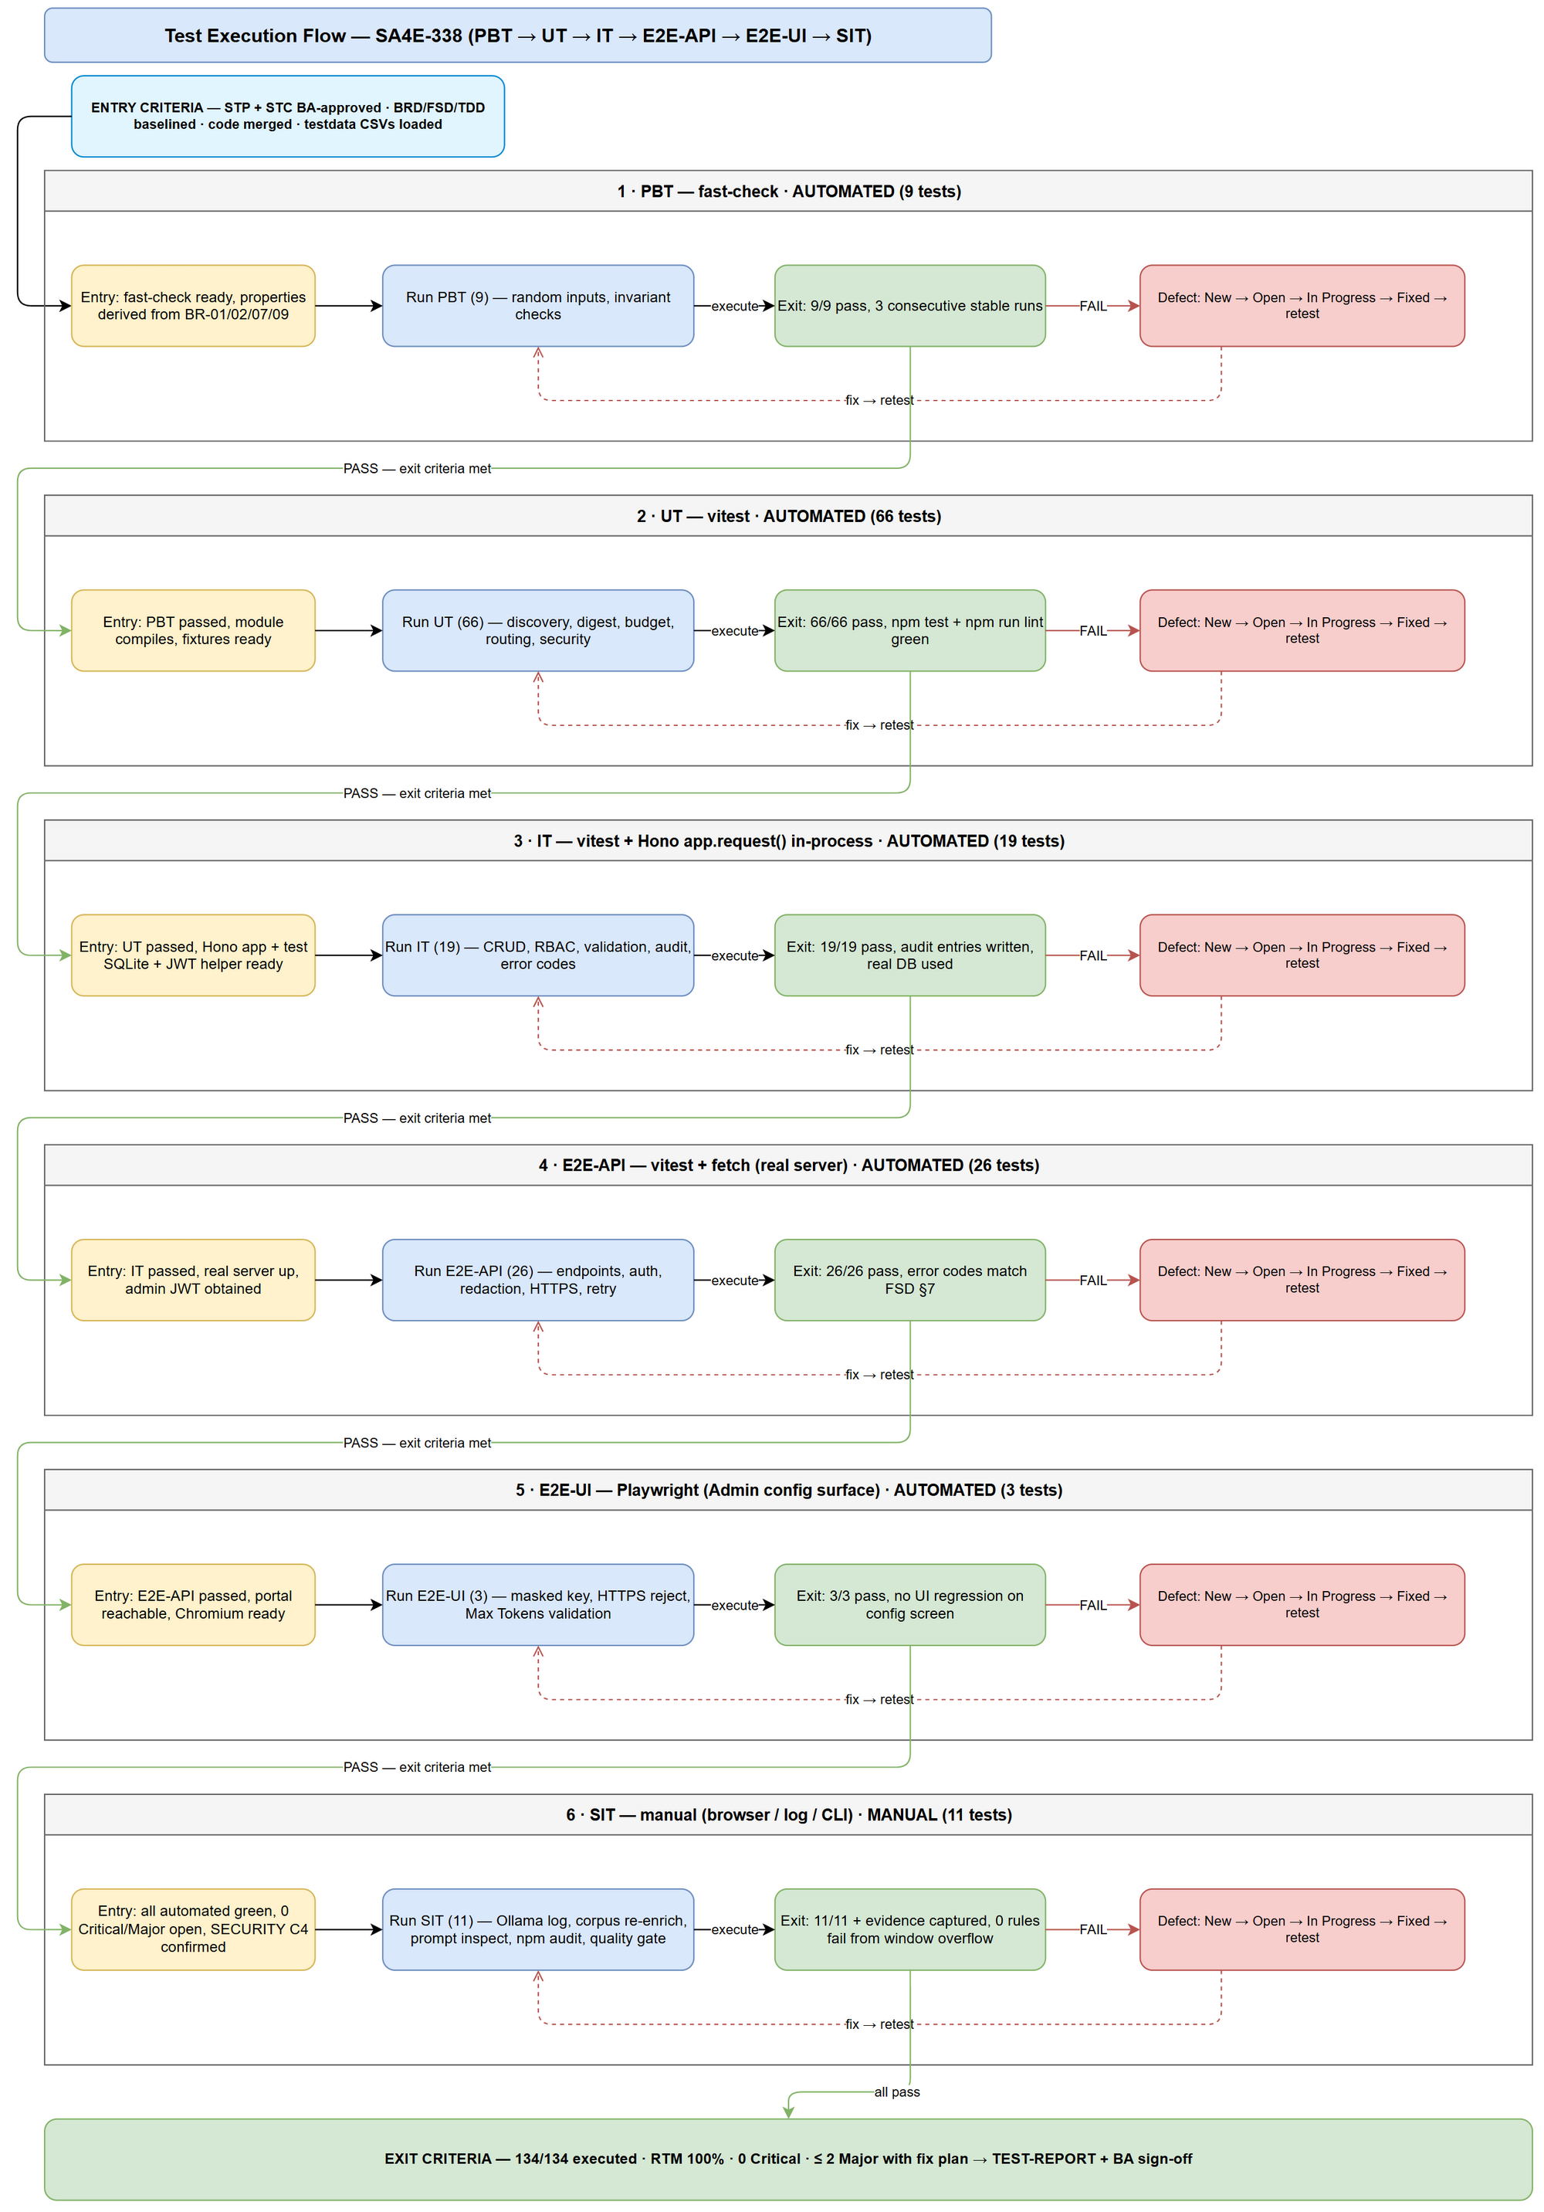
Test Execution Flow

E2E Automation Coverage (SIT → E2E classification)
Goal: minimize manual SIT to visual/UX/log-only tests.
Scenario Type | Classified As | Examples in this ticket
API response verification (status, body, headers) | E2E-API | discovery endpoints, retry/failure APIs, auth errors
RBAC/auth checks (401/403/429) | E2E-API | IT-09/E2E-API-06..08, project-scope 403
CRUD/config persistence via API | E2E-API | E2E-API-13..16 config read/write, env override
Regression — existing enrichment features | E2E-UI | admin config masking, HTTPS validation
Form validation (invalid input) | E2E-UI | E2E-UI-02/03 endpoint URL + Max Tokens validation
Confirmation/state badges | E2E-UI | E2E-UI-01 masked ••• (saved)
Real provider/LLM behavior, log inspection, DB row inspection | SIT (manual) | SIT-01..07, SIT-09
Quality gates (npm test, npm run lint, npm audit) | SIT (manual) | SIT-08, SIT-11
Visual/layout/UX judgment | SIT (manual) | SIT-10 admin portal smoke
Deviation note (TDD §12.3): TDD stated “no Playwright”; this plan adds 3 E2E-UI tests covering only the Admin-UI configuration surface (D-SEC-05a/06, condition C2 — mask + HTTPS enforcement). Approved deviation documented in STC §10; reduces manual verification of security-critical form behavior.

STP Test Cases Summary
Level | Count | Automated | Manual
PBT | 9 | 9 | 0
UT | 67 | 67 | 0
IT | 21 | 21 | 0
E2E-API | 27 | 27 | 0
E2E-UI | 3 | 3 | 0
SIT | 11 | 0 | 11
Total | 138 | 127 (92.0%) | 11 (8.0%)

2.2 Test Types
Type | Description | Applicable
Functional Testing | FSD UC-1..5, BR-01..20, ERR-01..14 | Yes
Integration Testing | Hono routes, SQLite persistence, config/env wiring | Yes
Regression Testing | Existing enrichment (C4 corpus, non-Pega CLASS/FUNCTION rules) | Yes
Security Testing | D-SEC-01..17, TC-SEC-*, C1–C4 (redaction, HTTPS, RBAC, rate limit, injection) | Yes
Non-Functional (Performance/Reliability) | Retry budgets, bounded map-reduce, token estimation accuracy ≤ 10% | Yes
Usability Testing | Admin config UI masking/validation (E2E-UI + SIT-10) | Yes
Compatibility Testing | Browser coverage limited to Chromium (Playwright) | No (out of scope)

2.3 Test Approach
- Risk-based ordering: PBT/UT first (cheapest, highest defect yield for budget math and digest pinning), then IT (real routing + SQLite), then E2E-API (real server + JWT), E2E-UI (browser), SIT last (manual, expensive).
- Automate-first: any SIT scenario with deterministic input/output is classified as E2E-API or E2E-UI (see §2.1 table). SIT retains only scenarios requiring human judgment: real-LLM output quality, log inspection, visual smoke, and CI quality gates.
- Security-first execution: IT-09..IT-18 (RBAC/rate-limit/redaction/HTTPS/masking) run before any bulk re-enrichment SIT (condition C4).
- Defect feedback: any failure at a level blocks exit criteria; fix → retest affected level → regression sweep at next level (flow diagram §2.1).
- Implementation state: at planning time (2026-10-05) getContextWindow / isContextLengthError / LLM_CONTEXT_WINDOW are absent from backend/src (Phase 5 not started) → all 138 cases start NOT_RUN by design; execution occurs in Phase 6.

2.4 Entry Criteria
Level | Entry Criteria
PBT | Test framework installed (fast-check ^4.9.0 present in backend/package.json); npm run test:unit green baseline
UT | Phase 5 code merged for the unit under test; existing suite green; test data CSVs prepared
IT | Hono app boots with test SQLite; auth helper issues JWT; npm run test:integration runnable
E2E-API | Real server starts on E2E_PORT (port file at PORT_FILE_PATH); admin seed user with E2E_PASSWORD exists; npm run test:e2e-api runnable
E2E-UI | npm run test:e2e-ui (Playwright) configured; admin portal reachable at ADMIN_URL; Chromium installed
SIT | All automated levels (PBT→E2E-UI) pass with 0 Critical/0 Major open defects; C:\projects\Pega\PegaPlatfrom\rules corpus available; Ollama endpoint available for SIT-01; SECURITY-REVIEW C4 confirmed before bulk re-enrichment (SIT-02)
UAT (BA) | STP + STC BA-approved (Review Gate); SIT sign-off obtained

2.5 Exit Criteria
Level | Exit Criteria
PBT | 9/9 properties pass; no flaky run in 3 consecutive CI runs
UT | 67/67 pass; npm test (vitest) green; npm run lint green
IT | 21/21 pass against real Hono routing + real SQLite (no vi.fn() on DB); audit entries verified
E2E-API | 27/27 pass against real server; 0 unhandled crashes; all error codes match FSD §9
E2E-UI | 3/3 pass in Chromium; no critical UI regression
SIT | 11/11 executed with evidence in evidence/; 0 Critical open; ≤ 2 Major open with fix plan; re-enrich corpus: 0 rules fail from window overflow (BRD US3 AC-5)
Overall | RTM 100% covered with PASS (or approved waiver); Test Completion Report issued; BA sign-off on UAT

3. Test Scope

3.1 Features In Scope
# | Feature / Story | Priority | FSD Reference | Test Type
1 | US1 — Dynamic LLM context window (discovery + env override + fallback 8192) | High | UC-1, BR-03/04/06/19/20, TC-19..21 | Functional, IT, E2E-API
2 | US2 — AST digest replaces text dump (real fields, caps, decision-table builder) | High | UC-2, BR-02/05/14/17, TC-05..08 | Functional, PBT, UT
3 | US3 — Enrichment with digest at scale (HomeTabMain 3.4 MB, corpus 1578 rules) | High | UC-2/UC-3, US3 AC-1..5, TC-18/28 | Functional, E2E-API, SIT
4 | US4 — Budget-aware prompt + auto map-reduce recovery | High | UC-3/UC-4, BR-01/07/08/09/10/11/12/13/16, TC-10..12 | Functional, PBT, IT, E2E-API
5 | US5 — Wire schemaContext into prompt | Medium | UC-5, BR-15, TC-13/14 | Functional, UT, E2E-API
6 | Security hardening (SECURITY-REVIEW C1–C4, D-SEC-01..17) | High | TDD §7, TC-SEC-* | Security, IT, E2E-API, E2E-UI
7 | Observability: budget warn, mapReduceReport, enrichment_meta persistence | Medium | BR-12/13, OI-02, ERR-03..06 | Functional, SIT
8 | Error routing & retry budgets (terminal vs transient, bounded retries) | High | OI-05, ERR-07/12/13/14, TC-09/23/25 | Functional, IT, E2E-API
9 | Quality gates (npm test, npm run lint, npm audit) | High | BRD US2 AC-5, US4 AC-7, C3 | Non-functional, SIT
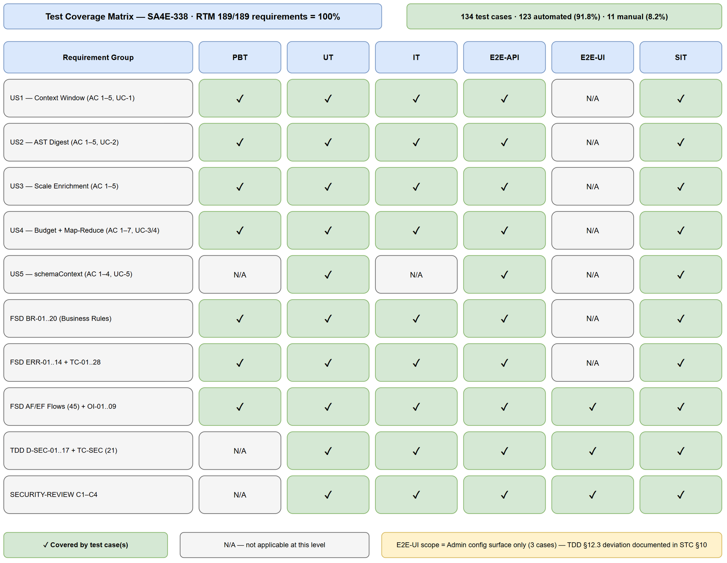
Test Coverage

3.2 Features Out of Scope
# | Feature | Reason
1 | LLM model output quality scoring (semantic correctness of generated pseudo-code) | Subjective; BA/UAT judges sample outputs (SIT-03 manual spot-check only)
2 | Multi-browser compatibility (Firefox/WebKit/Safari) | Chromium-only per project convention
3 | Load/performance stress testing (RPS, concurrent users) | Single-user enrichment pipeline; no perf NFR in BRD/FSD
4 | Non-Pega enrichment routes (CLASS/FUNCTION legacy) — beyond regression sanity | Owned by other tickets; SIT-09 runs one regression case only
5 | Production Ollama/LM Studio/vLLM clusters | Test uses local/stubbed endpoints; provider field mapping verified against fixtures
6 | SA4E-214 (schemaContext source) | Dependency provides schemaContext; only wiring (UC-5) is in scope
7 | Deployment/rollback procedures | Phase 7 DevOps scope (DPG)

4. Test Environment

4.1 Environment Requirements
Environment | URL / Source | Database | Purpose
Local dev (IT) | In-process Hono app.request() — no real port | SQLite (test, in-process) | Integration tests
E2E (real server) | BASE_URL / API_URL from backend/tests/e2e/setup/e2e-config.ts (E2E_PORT + PORT_FILE_PATH) | SQLite test DB on E2E server | E2E-API
Admin Portal (E2E-UI) | ADMIN_URL (same E2E server) | same as E2E | Playwright browser tests
SIT | localhost dev server + CLI | dev SQLite | Manual exploratory
Provider endpoints | Ollama http://localhost:11434, LM Studio, vLLM — or wiremock/fixture servers | — | UC-1 discovery (UT/IT/E2E-API stubs; SIT-01 real Ollama)
Config / env vars used by tests:
Variable | Purpose | Test values
LLM_CONTEXT_WINDOW | Hard env override (BR-04) | 64000 (valid), abc / -5 / empty (invalid → UT-02/PBT-07)
LLM_ALLOW_INSECURE_HTTP | HTTPS enforcement exception (D-SEC-05c) | unset (reject), 1 (allow + warn)
E2E_PORT, PORT_FILE_PATH, BASE_URL, ADMIN_URL, API_URL | E2E server discovery | from e2e-config.ts
E2E_PASSWORD | Admin login seed | test-admin-pw-01

4.2 Browser / Device Requirements
Browser | Version | OS | Required
Chromium (Playwright bundled) | latest bundled | Windows 10/11 | Yes (E2E-UI)
Chrome (manual SIT) | 120+ | Windows 10/11 | Yes (SIT-10)

4.3 Test Data Requirements
Source of truth: documents/SA4E-338/testdata/*.csv — 8 files, 169 rows (every TC ID appears in ≥ 1 row).
Data Type | Description | Source | Preparation
Pre-seeded users/projects | Admin + non-admin actors, project scoping for D-SEC-03 | pre-seeded-data.csv | Seed before IT/E2E (JWT with/without pid)
Pega rule corpus | HomeTabMain (3.4 MB layout), GetDBobjects, DecisionTable, broken JSON, pure-layout rule, oversized 6 MB fixture (IT-20, EF-2.4) | C:\projects\Pega\PegaPlatfrom\rules + pega-samples.ts fixtures | Copy fixtures into test project; index via PegaRuleAstParser
Context-window fixtures | Ollama/LM Studio/vLLM response bodies (incl. Ollama {model}→{name} retry case EF-1.5, arch-suffixed models OI-01, LM Studio 404 endpoint-absent UT-09b/OI-09) | context-window-testdata.csv | Stub provider server returns fixture by row
Budget/prompt cases | Window/budget boundary values, utilization thresholds (79%/80%/100%), schemaContext variants, corpus token-accuracy sampling ±10% (E2E-API-27 / FSD TC-28) | budget-prompt-testdata.csv | Feeds PBT-01..03, UT-30..40, E2E-API-26/27
Map-reduce cases | Chunk sizes, oversized atomic node, retry/auth/transient failures, reduction-round exhaustion, shared chunkedReduce<T> structure check (IT-21) | map-reduce-testdata.csv | Feeds PBT-05/09, UT-41..52, IT-21
Security cases | Secret strings (API keys), insecure http:// URLs, forged X-Project-Id, injection payloads, oversized error bodies | security-testdata.csv | Feeds D-SEC/TC-SEC cases; verify zero leakage
Routing matrix | Error classification inputs (context vs transient vs terminal) + expected routing | routing-testdata.csv | Feeds UT-12..16, IT-07
Enrichment lifecycle payloads | Create/read/update enrichment records + enrichment_meta shapes | enrichment-testdata.csv | Feeds IT-01..03, SIT-07

4.4 External Dependencies
System | Dependency | Mock/Stub Available
Ollama API | POST /api/show (model_info.*.context_length), /api/tags fallback | Yes — fixture JSON from context-window-testdata.csv
LM Studio API | GET /api/v0/models (max_context_length chain) | Yes — fixture
vLLM API | GET /v1/models (max_model_len, select by id == LLM_MODEL) | Yes — fixture
LLM inference endpoint | Chat completion (context-length error bodies, 5xx, timeout) | Yes — stub for UT/IT/E2E-API; real Ollama for SIT-01
Pega rules corpus | Real rules incl. HomeTabMain | Yes — C:\projects\Pega\PegaPlatfrom\rules
pi-subagents / npm audit | Security C3 dependency scan | CLI (npm audit --omit=dev), SIT-08

5. Test Schedule
Estimated relative timeline (dates finalized by SM when Phase 6 starts).
Phase | Offset | Duration | Milestone / Deliverable
Test Planning (this STP + STC) | D0 | 2 days | STP + STC + testdata + diagrams ready
BA Review Gate (RTM) | D+1 | 3–5 days | BA verdict APPROVED → planning final
Test Data Preparation | D+2 | 1 day | 8 CSVs loaded, fixtures seeded
Phase 5 Implementation (DEV) | — | Dev-managed | Code merged; entry criteria met
PBT + UT Execution | after merge | 0.5 day | 76/76 automated pass
IT Execution | after UT | 0.5 day | 21/21 pass (real routing + SQLite)
E2E-API + E2E-UI Execution | after IT | 0.5 day | 30/30 pass
SIT Execution (manual) | after E2E | 2 days | SIT report + evidence; C4 confirmed before SIT-02
Defect Fix & Retest | rolling | per severity SLA | 0 Critical / ≤ 2 Major open
Test Completion Report | end | 1 day | TEST-REPORT + sign-off
Milestones: ① STP/STC BA-approved · ② automated suite 127/127 green · ③ SIT 11/11 with evidence · ④ Test Completion Report.

6. Resources & Responsibilities
Role | Name | Responsibility
Test Lead / QA Agent | QA Agent | STP/STC creation, RTM, automation suite (PBT→E2E), SIT execution, defect reporting
BA | BA Agent | Review Gate on STC RTM (business coverage, semantics, edge cases, scope) — approval required before planning is final
SM | Scrum Master | Orchestrates review gate, relays verdict, tracks RUN-LOG, quality gates
Developer | DEV Agent | Phase 5 implementation; fix defects per SLA; unit test coverage
SA | SA Agent | TDD authority — clarify D-SEC/TC-SEC ambiguities found during testing
DevOps | DevOps Agent | CI wiring for test levels, npm audit gate (C3), environment
Security | Security Agent | Verifies C1–C4 closure evidence (SECURITY-REVIEW conditions)
Tools: vitest (UT/IT/E2E-API), fast-check (PBT), Playwright (E2E-UI), Hono app.request() (IT), CSV test data in testdata/, evidence in evidence/, bug tracking via Jira, KB via mem_ingest_file.

7. Risk & Mitigation
# | Risk | Impact | Likelihood | Mitigation
1 | Phase 5 not started — implementation absent at planning time | High | High | All TC set NOT_RUN by design; STC frozen as planned state; Phase 6 executes after merge
2 | BA Review Gate rejects RTM (coverage/semantics gaps) | High | Medium | RTM pre-verified against 189 requirement instances (100%); max 2 fix→re-review iterations; escalate ambiguity to SM/BA — QA does not guess
3 | Real provider variability (Ollama field shapes differ per version) | Medium | Medium | Fixture-driven tests pin expected fields per TDD §3.7 (OI-01 resolver covers arch-suffixed MAX); SIT-01 spot-checks real Ollama
4 | Large corpus (1578 rules) re-enrichment slow / cost in SIT-02 | Medium | Medium | Run once at end; confirm C4 retry-limit first; timebox; keep smaller samples for interim runs
5 | Context-length errors hard to reproduce deterministically | High | Medium | Stubbed provider error bodies (routing-testdata.csv); both proactive (budget) and reactive (provider error) paths covered by IT/E2E-API
6 | Flaky Playwright/E2E (port file race, server startup) | Medium | Low | Reuse existing e2e-config.ts port-file pattern; retry-once at runner level; isolate E2E-UI to config surface only
7 | Security regression (secret leakage) slips to release | High | Low | Dedicated security cases (UT-55..66, IT-13..18, E2E-API-06..15) are exit-blocking; C2/C3 evidence required for SIT sign-off
8 | Test data drift vs fixtures | Low | Medium | CSVs are single source of truth; test code reads same fixtures; regenerate on FSD change

8. Defect Management

8.1 Severity Levels
Severity | Definition | Example
Critical | Data loss, security breach, pipeline-wide failure, silent truncation of enrichment | Secret leaked to log/DB; all 1578 rules fail enrichment from window overflow; pinned logic node dropped
Major | Feature broken, workaround exists, wrong business behavior | Env override ignored; map-reduce not triggered on context error; provider field mapping wrong → always 8192
Minor | Limited-impact functional issue, cosmetic, log wording | 80% warn message inaccurate; malformed schemaContext warns incorrectly but enrichment continues
Trivial | Typo, minor alignment, nit | Comment/label typo in dashboard

8.2 Priority Levels
Priority | Definition | SLA (Fix Time)
P1 | Must fix immediately (Critical + blocker) | 4 hours
P2 | Must fix before release (Major) | 1 business day
P3 | Should fix if time permits (Minor) | 3 business days
P4 | Nice to fix, can defer (Trivial) | Next release

8.3 Defect Lifecycle
New → Open → In Progress → Fixed → Ready for Retest → Verified → Closed
→ Reopened → In Progress
- Defects reference TC ID + requirement (e.g., UT-43 / BR-02).
- Security defects (D-SEC/TC-SEC failures) require Security Agent acknowledgment before Close.
- Verified by the same test case that found it + regression at next level.

9. Test Metrics & Reporting

9.1 Metrics
Metric | Formula | Target
Test Execution Rate | Executed / Total × 100% | 100% (138/138)
Pass Rate | Passed / Executed × 100% | ≥ 95%
Automation Coverage | Automated / Total × 100% | ≥ 90% (achieved at planning: 92.0%)
Requirement Coverage (RTM) | Covered requirements / Total × 100% | 100% (189/189)
Defect Density | Defects / Test Cases | ≤ 0.1
Critical Defect Count | Count of Critical severity at exit | 0
Defect Fix Rate | Fixed / Total Defects × 100% | ≥ 90%
Corpus Overflow Failure Rate (US3 AC-5) | Rules failed from window overflow / 1578 | 0% (SIT-02)

9.2 Reporting Schedule
Report | Frequency | Audience
Automated suite status (CI) | Per commit | DEV + SM
Daily Test Status | Daily during execution | Project team
Defect Summary | Daily | Dev team + SM
SIT-REPORT-SA4E-338 | End of SIT | All stakeholders
TEST-REPORT-SA4E-338 (final) | End of Phase 6 | All stakeholders — SM attaches DOCX to Jira

10. Appendix

10.1 Diagram Index
# | Diagram | Image | Source (editable) | Purpose
1 | Test Coverage | test-coverage.png | test-coverage.drawio | Requirements × test-level coverage matrix
2 | Test Execution Flow | test-execution-flow.png | test-execution-flow.drawio | Pipeline swimlanes, entry/exit gates, defect loops
Edit in draw.io · Edit in draw.io

10.2 Test File Map (planned paths)
Level | Location
PBT | backend/src/**/__tests__/*.property.test.ts
UT | backend/src/**/__tests__/*.test.ts
IT | backend/tests/integration/pega-enrichment-context-window.it.test.ts (+ security/routing IT files)
E2E-API | backend/tests/e2e/pega-enrichment-context.e2e.test.ts, admin-config-security.e2e.test.ts
E2E-UI | backend/tests/e2e/llm-config-security.ui.e2e.test.ts (helpers: tests/e2e/setup/)
SIT | Manual — evidence → documents/SA4E-338/evidence/

10.3 Commands
Purpose | Command (from backend/)
Full unit+integration | npm test
Lint gate | npm run lint
Integration only | npm run test:integration
E2E-API | npm run test:e2e-api
E2E-UI | npm run test:e2e-ui
Audit (C3) | npm audit --omit=dev

10.4 Glossary
Term | Definition
STP | Software Test Plan
STC | Software Test Cases
PBT | Property-Based Testing
IT | Integration Test (in-process Hono)
E2E | End-to-End test
SIT | System Integration Testing (manual)
RTM | Requirements Traceability Matrix
AST digest | Structured summary of a rule built from parsed AST fields (replaces raw text dump)
map-reduce recovery | Chunk → summarize → reduce pipeline when prompt exceeds context window

10.5 Assumptions
- Phase 5 (DEV) will implement against TDD v2.0 contracts; STC test file paths are planned and may be adjusted by DEV while keeping TC coverage.
- Test corpus C:\projects\Pega\PegaPlatfrom\rules remains available on the QA machine.
- BA Review Gate result will be recorded before execution begins; unresolved requirement ambiguity escalates to SM/BA (QA does not invent behavior).
- Provider APIs follow TDD §3.7 field mappings; if a provider changes shapes, fixtures + OI-01 resolver tests document the delta.

