Get NFC cards

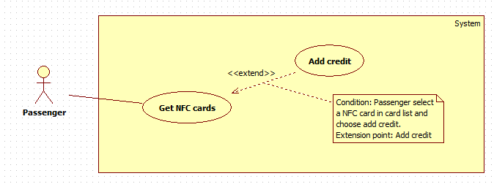

|  |  |  |  |
| --- | --- | --- | --- |
| **USE CASE – XXX** | | | |
| **Use Case No.** | **XXX** | **Use Case Version** | 1.0 |
| **Use Case Name** | Get NFC card | | |
| **Author** | HoangDN | | |
| **Date** | 13/09/2016 | **Priority** | Normal |
| **Actor:**   * Passenger   **Summary:**   * This use case allows Passenger to get their NFC cards list.   **Goal:**   * The passenger can view all their NFC cards and the information such as card id, credit remaining of a specific card.   **Triggers:**   * Passenger sends “Get NFC cards” command.   **Preconditions:**   * Actor logged in system with role “Passenger”. * Passenger has at least one NFC card in the system.   **Post Conditions:**   * **Success:** The NFC card list is show. * **Fail:** N/A   **Main Success Scenario:**   |  |  |  | | --- | --- | --- | | Step | Actor Action | System Response | | 1 | Passenger sends “Get NFC cards” command. | System gets NFC card list which belong to current logged account then display “Card list” view, each card has following information:  + “Mã thẻ”: label  + “Tên thẻ”: free text input, length 3-50, required  + “Ngày đăng kí”: label  + “Số dư”: label  + “Trạng thái”: label  + “Add credit” command.  [Alternative 1] |   **Alternative Scenario:**  [Alternative 1]   |  |  |  | | --- | --- | --- | | Step | Cause | System Response | | 1 | Passenger has no card on the system | System shows a message "Bạn chưa có thẻ nào trên hệ thống." |   **Exceptions:** N/A  **Relationships:** Add credit   * Extension point: Add credit * Condition: Passenger selects a NFC card in card list and sends “Add credit” command.   **Business Rules:**   * Card status is one of the following status: “Đã kích hoạt”, “Tạm khóa”, “Chưa kích hoạt” * Cards with status “Đã kích hoạt” or “Tạm khóa” will be showed to Passenger. | | | |

Edit card name

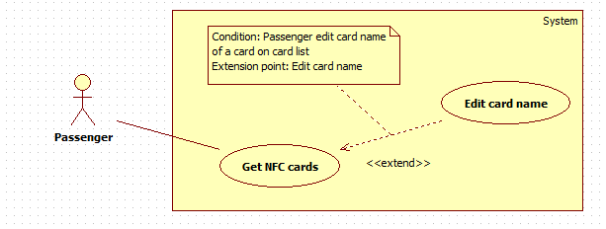

|  |  |  |  |
| --- | --- | --- | --- |
| **USE CASE – XXX** | | | |
| **Use Case No.** | **XXX** | **Use Case Version** | 1.0 |
| **Use Case Name** | Edit card name | | |
| **Author** | HoangDN | | |
| **Date** | 13/09/2016 | **Priority** | Normal |
| **Actor:**   * Passenger   **Summary:**   * This use case allows Passenger edit their NFC card name.   **Goal:**   * Passenger can update new name for their card which make them easy to identify each card in their card list.   **Triggers:**   * Passenger changing name of a card in card list.   **Preconditions:**   * Actor logged in system with role “Passenger”. * Passenger has at least one NFC card in the system.   **Post Conditions:**   * **Success:** New card name is updated. * **Fail:** Show an error message.   **Main Success Scenario:**   |  |  |  | | --- | --- | --- | | Step | Actor Action | System Response | | 1 | Passenger changing name of a card in card list. | System waits for user inputting. | | 2 | Passenger stops inputting. | System updates new name for corresponding card.  [Exception 1] |   **Alternative Scenario:** N/A  **Exceptions:**  [Exception 1]   |  |  |  | | --- | --- | --- | | No | Cause | System Response | | 1 | Passenger inputs card name with wrong format. | System displays error message: “Vui lòng nhập tên thẻ từ 3-50 ký tự ”. |   **Relationships:** Get NFC cards   * Extension point: Edit card name * Condition: Passenger edit card name of a card on card list.   **Business Rules:**   * New default card name when a new card is added to the system is “Thẻ {Card id}” * Card name will be used in outcome report for representing which card paid for ticket. | | | |

Add credit



|  |  |  |  |
| --- | --- | --- | --- |
| **USE CASE – XXX** | | | |
| **Use Case No.** | **XXX** | **Use Case Version** | 1.0 |
| **Use Case Name** | Add credit | | |
| **Author** | HoangDN | | |
| **Date** | 13/09/2016 | **Priority** | Normal |
| **Actor:**   * Passenger   **Summary:**   * This use case allows Passenger to add more credit to their NFC card.   **Goal:**   * Passenger can add more credit to their specific NFC card for using this card to buy ticket when traveling by bus.   **Triggers:**   * Passenger sends “Add credit” command of one card on their NFC card list.   **Preconditions:**   * Actor logged in system with role “Passenger”. * Passenger has at least one NFC card in the system. * The NFC card which passenger wants to add credit must have status “Đã Kích Hoạt”   **Post Conditions:**   * **Success:** Credits is added to corresponding card balance. * **Fail:** Show an error message.   **Main Success Scenario:**   |  |  |  | | --- | --- | --- | | Step | Actor Action | System Response | | 1 | Passenger sends “Add credit” command of one card on their NFC card list. | System shows “Add credit” view with following information:   * “Gói nạp tiền”: select one of the options such as “50.000đ”, “100.000đ”, etc. based on Credit plans created by Manager. * “Checkout” command. * “Cancel” command. | | 2 | Passenger selects one option.  [Alternative 1] |  | | 3 | Passenger sends “Checkout” command. | System redirects to Paypal payment gateway. | | 4 | Passenger processes the PayPal payment. | If the payment is succeed: Credits will be added to corresponding card balance. System redirects to “Card list” view and display successful message: “Thanh toán thành công!”  [Exception 1] |   **Alternative Scenario:**  [Alternative 1]   |  |  |  | | --- | --- | --- | | Step | Actor Action | System Response | | 1 | Passenger sends cancel command | System returns to “Card list” view. |   **Exceptions:**  [Exception 1]   |  |  |  | | --- | --- | --- | | No | Cause | System Response | | 1 | Payment failed | System returns to “Card list” view and displays error message: “Thanh toán không thành công!” |   **Relationships:** Get NFC cards   * Extension point: Add credit * Condition: Passenger selects a NFC card in card list and sends “Add credit” command.   **Business Rules:**   * Credit in the system mean the card’s balance which will be used to buy ticket. * After payment successfully, credits will be added to corresponding card balance and payment transaction will be saved to database for tracking by Bus Manager. * Credit plans and its price are loaded from system. These plans are created and managed by Bus Manager. | | | |

Get outcome report

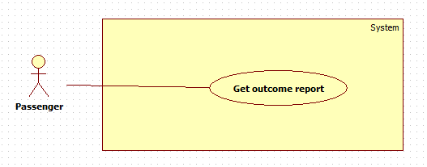

|  |  |  |  |
| --- | --- | --- | --- |
| **USE CASE – XXX** | | | |
| **Use Case No.** | **XXX** | **Use Case Version** | 1.0 |
| **Use Case Name** | Get outcome report | | |
| **Author** | HoangDN | | |
| **Date** | 13/09/2016 | **Priority** | Normal |
| **Actor:**   * Passenger   **Summary:**   * This use case allows Passenger get their outcome report.   **Goal:**   * Passenger can view how much they spend for bus in a specific date range and also the details list of bought tickets.   **Triggers:**   * Passenger sends “Get outcome report” command.   **Preconditions:**   * Actor logged in system with role “Passenger”.   **Post Conditions:**   * **Success:** Outcome report is showed. * **Fail:** Show error message.   **Main Success Scenario:**   |  |  |  | | --- | --- | --- | | Step | Actor Action | System Response | | 1 | Passenger sends “Get outcome report” command. | System shows “Get outcome report” view with following information:   * “Từ ngày”: date input, default date is 1st of current month, required. * “Đến ngày”: date input, default date is the current date, required. * “Get report” command. | | 2 | Passenger inputs date for both two field. |  | | 3 | Passenger sends “Get report” command. | System verifies input information. Get outcome report of current passenger based on input date range. Display report as a table, each row has following information:   * “Ngày giờ”: label * “Số tuyến”: label * “Thẻ thanh toán”: label * “Số tiền”: label   [Exception 1,2,3,4]  [Alternative 1] |   **Alternative Scenario:**  [Alternative 1]   |  |  |  | | --- | --- | --- | | Step | Cause | System Response | | 1 | If there is no data to show. | System shows a message “Không có dữ liệu trong khoảng thời gian đã chọn”. |   **Exceptions:**  [Exception 1,2,3,4]   |  |  |  | | --- | --- | --- | | No | Cause | System Response | | 1 | Passenger does not input required fields. | System notices that user need to input all required field.   * “Từ ngày”: System displays warning message “Vui lòng chọn ngày bắt đầu”. * “Đến ngày”: System displays warning message “Vui lòng chọn ngày kết thúc”. | | 2 | Passenger inputs start date greater than end date. | System displays error message: “Ngày bắt đầu phải nhỏ hơn ngày kết thúc.” | | 3 | Passenger inputs date range over 30 days. | System displays error message: “Khoảng thời gian không vượt quá 30 ngày.” | | 4 | Passenger inputs end date greater than current date. | System displays error message: “Ngày bắt đầu phải nhỏ hơn ngày kết thúc.” |   **Relationships:** N/A  **Business Rules:**   * Start date and end date format are “dd/mm/yyyy”. * End date must not be earlier than start date. * End date must not greater than current date. * Date range for getting report must be within 30 days. * System allows Passenger to search and sort report on all fields. | | | |

Find bus

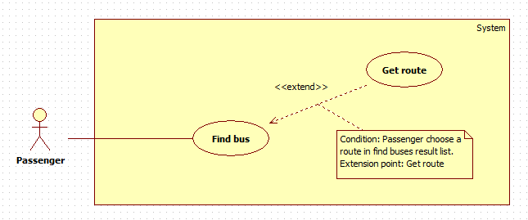

|  |  |  |  |
| --- | --- | --- | --- |
| **USE CASE – XXX** | | | |
| **Use Case No.** | **XXX** | **Use Case Version** | 1.0 |
| **Use Case Name** | Find bus | | |
| **Author** | HoangDN | | |
| **Date** | 13/09/2016 | **Priority** | Normal |
| **Actor:**   * Passenger   **Summary:**   * This use case allows Passenger to find bus routes.   **Goal:**   * Passenger can find bus routes based on starting point and destination for getting instructions to get to the destination.   **Triggers:**   * Passenger sends “Find bus” command.   **Preconditions:**   * Actor logged in system with role “Passenger”.   **Post Conditions:**   * **Success:** Bus routes result list is showed. * **Fail:** N/A   **Main Success Scenario:**   |  |  |  | | --- | --- | --- | | Step | Actor Action | System Response | | 1 | Passenger sends “Find bus” command. | System shows “Find bus” view with following information:   * “Điểm khởi hành”: free text input. * “Điểm đến”: free text input. * “Find” command. | | 2 | Passenger inputs information. |  | | 3 | Passenger sends “Find” command. | System verifies input information then finds bus routes. System displays routes list, each route has following information:   * “Số xe”: label * “Thời gian ước tính”: label   [Alternative 1] |   **Alternative Scenario:**  [Alternative 1]   |  |  |  | | --- | --- | --- | | Step | Cause | System Response | | 1 | No route found. | If there is no route as the result, system shows a message "Không tìm thấy kết quả nào phù hợp". |   **Exceptions:** N/A  **Relationships:** Get route   * Condition: Passenger chooses a route in route result list. * Extension point: Get route   **Business Rules:**   * If Passenger doesn’t input starting point or destination, system will use the current location automatically. * System finds and display result based on starting point and destination, top 5 results will be displayed to Passenger. | | | |

Get route



|  |  |  |  |
| --- | --- | --- | --- |
| **USE CASE – XXX** | | | |
| **Use Case No.** | **XXX** | **Use Case Version** | 1.0 |
| **Use Case Name** | Get route | | |
| **Author** | HoangDN | | |
| **Date** | 13/09/2016 | **Priority** | Normal |
| **Actor:**   * Passenger   **Summary:**   * This use case allows Passenger to get a bus route.   **Goal:**   * Passenger can view a bus route details and instruction for getting bus to get to the destination.   **Triggers:**   * Passenger sends “Get route” command of one route on bus route result list.   **Preconditions:**   * Actor logged in system with role “Passenger”. * The bus route result list has at least one route item.   **Post Conditions:**   * **Success:** Bus route detail is show. * **Fail:** N/A   **Main Success Scenario:**   |  |  |  | | --- | --- | --- | | Step | Actor Action | System Response | | 1 | Passenger send “Get route” command of one route on bus route result list.  [Alternative 1] | System gets correspond route details then shows “Route details” view:   * Details instructions * Route preview on map. |   **Alternative Scenario:**  [Alternative 1]   |  |  |  | | --- | --- | --- | | Step | Actor Action | System Response | | 1 | Passenger sends back command | System returns to bus route result list. |   **Exceptions:** N/A  **Relationships:** Find bus   * Condition: Passenger chooses a route in route result list. * Extension point: Get route   **Business Rules:**   * Route instruction will be display step by step to make sure it’s easy to follow. * Route instruction format:   {Estimated time} {Route Number List}  {Action 1}: {Destination1 or Route Number1}  {Action 2}: {Destination2 or Route Number2}  {Action 3}: {Destination3 or Route Number3} | | | |

Suggest promotions

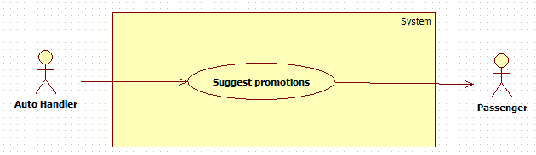

|  |  |  |  |
| --- | --- | --- | --- |
| **USE CASE – XXX** | | | |
| **Use Case No.** | **XXX** | **Use Case Version** | 1.0 |
| **Use Case Name** | Suggest promotions | | |
| **Author** | HoangDN | | |
| **Date** | 13/09/2016 | **Priority** | Normal |
| **Actor:**   * Auto Handler   **Summary:**   * This use case allows Auto Handler to get latest promotions then suggest to Passenger.   **Goal:**   * Passenger will receive latest promotions and offers from system such as credit plans sale off, free ticket, etc.   **Triggers:**   * The current time hit configured time.   **Preconditions:**   * Configured time has been set. * There is at least one promotion with status “True”.   **Post Conditions:**   * **Success:** Passenger receives latest promotion and offer. * **Fail:** Write error log.   **Main Success Scenario:**   |  |  |  | | --- | --- | --- | | Step | Actor Action | System Response | | 1 | Auto Handler checks the current time. If the current time hit configured time. Auto Handler send “Suggest promotions” command. | System gets latest promotions and sends to all passengers. Change related promotion and offer status to “False”.  Write to log file.  [Exception 1] |   **Alternative Scenario:** N/A  **Exceptions:**  [Exception 1]   |  |  |  | | --- | --- | --- | | No | Cause | System Response | | 1 | Auto Handler is interrupted | No promotion will be sent. Error details will be tracked in a log file. |   **Relationships:** N/A  **Business Rules:**   * The promotion which will be sent must have status “True”. * After Auto Handler sends promotion & offer successfully, the status will be change to “False”. * If the current time doesn’t hit configured time or no promotion have status “True”, do nothing. * If the current time hit configured time. Auto Handler get latest promotion which have status “True” then send to passengers. * Promotion will be send from 7pm – 9pm for not harassing passengers. * Sent log file structure:   File name: Promotions.log   |  |  |  |  | | --- | --- | --- | --- | | No | Time | Promotion Name | Result | |  |  |  |  | |  |  |  |  |  * Error log file structure:   File name: AutoHandler_Error.log   |  |  |  |  | | --- | --- | --- | --- | | No | Time | Auto Handler Name | Error Details | |  |  |  |  | |  |  |  |  | | | | |

Send notifications

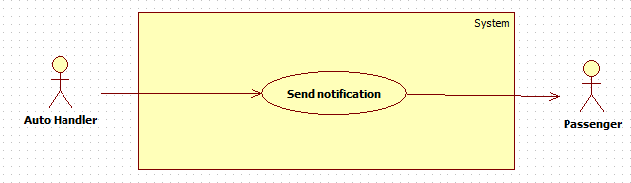

|  |  |  |  |
| --- | --- | --- | --- |
| **USE CASE – XXX** | | | |
| **Use Case No.** | **XXX** | **Use Case Version** | 1.0 |
| **Use Case Name** | Send notification | | |
| **Author** | HoangDN | | |
| **Date** | 13/09/2016 | **Priority** | Normal |
| **Actor:**   * Auto Handler   **Summary:**   * This use case allows Auto Handler to notify Passenger.   **Goal:**   * Passenger will receive notifications from system when their card’s balance is running out.   **Triggers:**   * Auto Handler sends “Send notification” command.   **Preconditions:**   * Passenger has recently bought a ticket. * Passenger’s card balance is running out.   **Post Conditions:**   * **Success:** Passenger receives notification from system. * **Fail:** Write error log.   **Main Success Scenario:**   |  |  |  | | --- | --- | --- | | Step | Actor Action | System Response | | 1 | Auto Handler is waiting for message. If it get any message from system about one card’s balance is running out. Auto Handler sends “Send notification” command. | System sends notification to Passenger: “Thẻ {Card ID} của bạn sắp hết tiền, vui lòng nạp thêm tiền vào thẻ!”  Write to log file.  [Exception 1] |   **Alternative Scenario:** N/A  **Exceptions:**  [Exception 1]   |  |  |  | | --- | --- | --- | | No | Cause | System Response | | 1 | Auto Handler is interrupted | No notification will be sent. Error details will be tracked in a log file. |   **Relationships:** N/A  **Business Rules:**   * Card’s balance is running out when the balance is less than 5.000đ * System notifies Passenger one time after they bought a ticket if their card’s balance is running out. * Sent log file structure:   File name: Notifications.log   |  |  |  |  | | --- | --- | --- | --- | | No | Time | Card ID | Result | |  |  |  |  | |  |  |  |  |  * Error log file structure:   File name: AutoHandler_Error.log   |  |  |  |  | | --- | --- | --- | --- | | No | Time | Auto Handler Name | Error Details | |  |  |  |  | |  |  |  |  | | | | |

Parse bus route

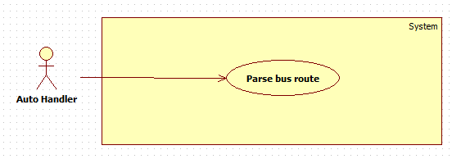

|  |  |  |  |
| --- | --- | --- | --- |
| **USE CASE – XXX** | | | |
| **Use Case No.** | **XXX** | **Use Case Version** | 1.0 |
| **Use Case Name** | Parse bus route | | |
| **Author** | HoangDN | | |
| **Date** | 13/09/2016 | **Priority** | Normal |
| **Actor:**   * Auto Handler   **Summary:**   * This use case allows Auto Handler to get newest bus route list.   **Goal:**   * Auto Handler can get newest bus route list for adapting changes of bus route in real life.   **Triggers:**   * The current time hit configured time.   **Preconditions:**   * Configured time has been set.   **Post Conditions:**   * **Success:** Newest bus route list is updated to the system. * **Fail:** Write error log.   **Main Success Scenario:**   |  |  |  | | --- | --- | --- | | Step | Actor Action | System Response | | 1 | Auto Handler checks the current time. If the current time hit configured time. Auto Handler sends “Parse bus route” command. | System parses and get newest route list and updates to database.  Write to log file.  [Exception 1] |   **Alternative Scenario:** N/A  **Exceptions:**  [Exception 1]   |  |  |  | | --- | --- | --- | | No | Cause | System Response | | 1 | Auto Handler is interrupted | No promotion will be sent. Error details will be tracked in a log file. |   **Relationships:** N/A  **Business Rules:**   * System will parse route list from <http://www.buyttphcm.com.vn/TTLT.aspx> * Sent log file structure:   File name: Promotions.log   |  |  |  |  | | --- | --- | --- | --- | | No | Time | Promotion Name | Result | |  |  |  |  | |  |  |  |  |  * Error log file structure:   File name: AutoHandler_Error.log   |  |  |  |  | | --- | --- | --- | --- | | No | Time | Auto Handler Name | Error Details | |  |  |  |  | |  |  |  |  | | | | |

XXX Overview Use Case Here

Manage Ticket Price

Add Ticket Type

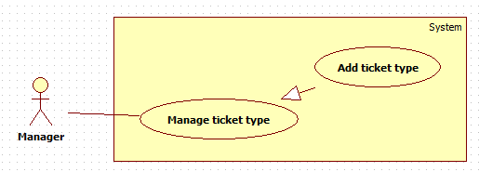

|  |  |  |  |
| --- | --- | --- | --- |
| **USE CASE – XXX** | | | |
| **Use Case No.** | XXX | **Use Case Version** | 1.0 |
| **Use Case Name** | Add ticket type | | |
| **Author** | HoangDN | | |
| **Date** | 13/09/2016 | **Priority** | Normal |
| **Actor:**   * Manager.   **Summary:**   * This use case allows Manager to add a ticket type.   **Goal:**   * Manager can create and add a ticket type to the system with specific ticket price that is suitable for correspond route distance.   **Triggers:**   * Manager sends “Add ticket type” command.   **Preconditions:**   * Actor logged in the system with role “Manager”.   **Post Conditions:**   * **Success:** New ticket type is added to the system. * **Fail:** System displays error message.   **Main Success Scenario:**   |  |  |  | | --- | --- | --- | | Step | Actor Action | System Response | | 1 | Manager sends “Add ticket type” command. | System displays “Add ticket type” view with following information:   * “Loại vé”: free text input, length 6-250, required. * “Mô tả”: free text area, required. * “Giá vé”: number input, positive integer number from 500 to 100000, required. * “Save” command. * “Cancel” command. | | 2 | Manager inputs information.  [Alternative 1] |  | | 3 | Manager sends “Save” command. | System verifies input information, adds new ticket type to the system then displays success message: “Thêm loại vé thành công”.  [Exception 1,2,3] |   **Alternative Scenario:**  [Alternative 1]   |  |  |  | | --- | --- | --- | | Step | Actor Action | System Response | | 1 | Manager sends cancel command. | System return to main view. |   **Exceptions:**  [Exception 1,2,3]   |  |  |  | | --- | --- | --- | | No | Cause | System Response | | 1 | Manager does not input required fields. | System notices that user need to input all required field.   * “Tên loại vé”: System displays warning message “Vui lòng nhập tên loại vé”. * “Mô tả”: System displays warning message “Vui lòng nhập mô tả”. * “Giá vé”: System displays warning message “Vui lòng nhập giá vé”. | | 2 | Manager inputs some fields with wrong format. | System notices that user need to input again.   * “Tên loại vé”: System displays warning message “Vui lòng nhập tên loại vé từ 6-250 ký tự”. * “Giá vé”: System displays warning message “Vui lòng nhập giá vé từ 500-100000”. | | 3 | Ticket type name is already existed in the system. | System displays warning message “Tên loại vé không được trùng”. |   **Relationships: N/A**  **Business Rules:**   * New ticket type will be added to the system with input information with status “True”. * Ticket type and its price depend on route distance and will be specify by company. * Each emulator on bus will be configured to a corresponding ticket type. * Passenger pays ticket price according to the ticket type of the bus they use. * Ticket type name is unique to make sure no ticket type is duplicated. | | | |

Edit ticket type

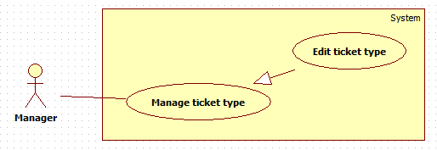

|  |  |  |  |
| --- | --- | --- | --- |
| **USE CASE – XXX** | | | |
| **Use Case No.** | XXX | **Use Case Version** | 1.0 |
| **Use Case Name** | Edit ticket type | | |
| **Author** | HoangDN | | |
| **Date** | 13/09/2016 | **Priority** | Normal |
| **Actor:**   * Manager.   **Summary:**   * This use case allows Manager to edit a ticket type in the system.   **Goal:**   * Manager can update a ticket type details in the system for adapting the ticket price change.   **Triggers:**   * Manager sends “Edit ticket type” command of one ticket type on ticket type list.   **Preconditions:**   * Actor logged in the system with role “Manager”. * There is at least one ticket type in the system.   **Post Conditions:**   * **Success:** Ticket type detail is updated to the system. * **Fail:** System displays error message.   **Main Success Scenario:**   |  |  |  | | --- | --- | --- | | Step | Actor Action | System Response | | 1 | Manager sends “Edit ticket type” command of one ticket type on ticket type list. | System displays “Edit ticket type” view and loads bus detail to a form with following information:   * “Loại vé”: free text input, length 6-250, required. * “Mô tả”: free text area, required. * “Giá vé”: number input, positive integer number from 500 to 100000, required. * “Save” command. * “Cancel” command. | | 2 | Manager edits information.  [Alternative 1] |  | | 3 | Manager sends “Save” command. | System verifies input information. Update ticket type detail to the system then displays success message: “Sửa thông tin loại vé thành công”.  [Exception 1,2,3] |   **Alternative Scenario:**  [Alternative 1]   |  |  |  | | --- | --- | --- | | Step | Actor Action | System Response | | 1 | Manager sends cancel command. | System return to main view. |   **Exceptions:**  [Exception 1,2,3]   |  |  |  | | --- | --- | --- | | No | Cause | System Response | | 1 | Manager does not input required fields. | System notices that user need to input all required field.   * “Tên loại vé”: System displays warning message “Vui lòng nhập tên loại vé”. * “Mô tả”: System displays warning message “Vui lòng nhập mô tả”. * “Giá vé”: System displays warning message “Vui lòng nhập giá vé”. | | 2 | Manager inputs some fields with wrong format. | System notices that user need to input again.   * “Tên loại vé”: System displays warning message “Vui lòng nhập tên loại vé từ 6-250 ký tự”. * “Giá vé”: System displays warning message “Vui lòng nhập giá vé từ 500-100000”. | | 3 | Ticket type name is already existed in the system. | System displays warning message “Tên loại vé không được trùng”. |   **Relationships: N/A**  **Business Rules:**   * Ticket type detail will be updated to the system with input information. * Ticket type and its price depend on route distance and will be specify by company. * Each emulator on bus will be configured to a corresponding ticket type. * Passenger pays ticket price according to the ticket type of the bus they use. * Ticket type name is unique to make sure no ticket type is duplicated. | | | |

Delete ticket type

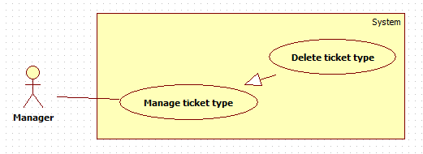

|  |  |  |  |
| --- | --- | --- | --- |
| **USE CASE – XXX** | | | |
| **Use Case No.** | XXX | **Use Case Version** | 1.0 |
| **Use Case Name** | Delete ticket type | | |
| **Author** | HoangDN | | |
| **Date** | 13/09/2016 | **Priority** | Normal |
| **Actor:**   * Manager.   **Summary:**   * This use case allows Manager to delete a ticket type from the system.   **Goal:**   * Manager can delete a ticket type from the system.   **Triggers:**   * Manager sends “Delete ticket type” command of one ticket type on ticket type list.   **Preconditions:**   * Actor logged in the system with role “Manager”. * There is at least one ticket type in the system. * The target ticket type has status “True”   **Post Conditions:**   * **Success:** Ticket type is deleted from the system. * **Fail:** System displays error message.   **Main Success Scenario:**   |  |  |  | | --- | --- | --- | | Step | Actor Action | System Response | | 1 | Manager sends “Delete ticket type” command of one ticket type on ticket type list. | System displays confirmation message: “Bạn có chắc chắn muốn xóa?” | | 2 | Manager sends “Yes” command.  [Alternative 1] | System deletes target ticket type from the system and displays success message: “Xóa thành công”; |   **Alternative Scenario:**  [Alternative 1]   |  |  |  | | --- | --- | --- | | Step | Actor Action | System Response | | 1 | Manager sends cancel command. | System return to main view. |   **Exceptions: N/A**  **Relationships: N/A**  **Business Rules:**   * The target ticket type must have status “True”. * If target ticket type has not been used yet. System delete this ticket type completely, otherwise system set its status to “False”. | | | |

Search Passenger

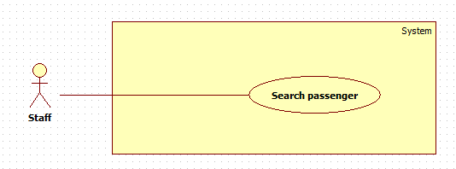

|  |  |  |  |
| --- | --- | --- | --- |
| **USE CASE – XXX** | | | |
| **Use Case No.** | XXX | **Use Case Version** | 1.0 |
| **Use Case Name** | Search passenger | | |
| **Author** | HoangDN | | |
| **Date** | 13/09/2016 | **Priority** | Normal |
| **Actor:**   * Staff.   **Summary:**   * This use case allows Staff to search a passenger.   **Goal:**   * Staff can get passenger list match input phone number and view the information of a specific passenger.   **Triggers:**   * Staff changes content of the search text input.   **Preconditions:**   * Actor logged in the system with role “Staff”. * There is at least one passenger in the system with status “True”.   **Post Conditions:**   * **Success:** Passenger list match searching criteria is showed. * **Fail:** N/A.   **Main Success Scenario:**   |  |  |  | | --- | --- | --- | | Step | Actor Action | System Response | | 1 | Staff inputs phone number to search text input field. | System loads the search results each time the search query changed. Information for each result:   * “Số điện thoại”: label * “Họ và tên: label * “Edit passenger” command.   [Alternative 1] |   **Alternative Scenario:**  [Alternative 1]   |  |  |  | | --- | --- | --- | | Step | Cause | System Response | | 1 | There is no passenger match searching criteria. | System shows message: “Không tìm thấy khách hàng nào.” |   **Exceptions: N/A**  **Relationships: N/A**  **Business Rules:**   * Each passenger has a unique phone number. * Any passengers with status “False” will be ignore from searching process and will not be display in search result. | | | |

Edit passenger

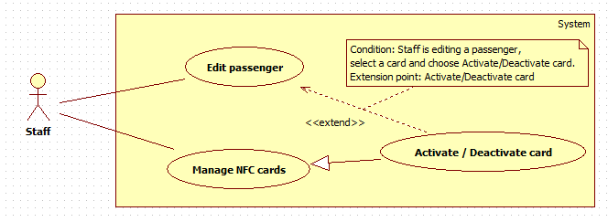

|  |  |  |  |
| --- | --- | --- | --- |
| **USE CASE – XXX** | | | |
| **Use Case No.** | XXX | **Use Case Version** | 1.0 |
| **Use Case Name** | Edit passenger | | |
| **Author** | HoangDN | | |
| **Date** | 13/09/2016 | **Priority** | Normal |
| **Actor:**   * Staff.   **Summary:**   * This use case allows Staff to edit a passenger.   **Goal:**   * Staff can update a passenger details and activate / deactivate their card in the system.   **Triggers:**   * Staff sends “Edit passenger” command of a passenger on passenger list.   **Preconditions:**   * Actor logged in the system with role “Staff”.   **Post Conditions:**   * **Success:** Passenger’s detail is updated to the system. * **Fail:** System displays error message.   **Main Success Scenario:**   |  |  |  | | --- | --- | --- | | Step | Actor Action | System Response | | 1 | Staff sends “Edit passenger” command of a passenger on passenger list. | System displays “Edit passenger” view with following information:   * “Số điện thoại”: label, read-only. * “Họ tên”: free text input, length 3 – 80, required. * NFC card list, each card has following information:   + “Mã thẻ”: label   + “Số dư”: label   + “Trạng thái”: select one of the options such as “Đã kích hoạt”, “Tạm khóa”.   + “Activate/Deactivate” command * “Save” command. * “Cancel” command. | | 2 | Staff edits information.  [Alternative 1,2] |  | | 3 | Staff sends “Save” command. | System verifies input information. System updates passenger details to the system then displays success message: “Cập nhật thông tin khách hàng thành công”.  [Exception 1,2] |   **Alternative Scenario:**  [Alternative 1,2]   |  |  |  | | --- | --- | --- | | Step | Actor Action | System Response | | 1 | Staff sends cancel command. | System returns to main view. | | 2 | Staff sends “Activate/Deactivate” command of a NFC card on card list. | If selected card is currently activated. System will deactivate corresponding card and display message “Đã khóa thẻ”.  If selected card is currently deactivated. System will activate corresponding card and display message “Đã mở khóa thẻ”. |   **Exceptions:**  [Exception 1,2]   |  |  |  | | --- | --- | --- | | No | Cause | System Response | | 1 | Staff does not input required fields. | System notices that user need to input all required field.   * “Họ tên”: System displays warning message “Vui lòng nhập họ tên”. | | 2 | Staff inputs some fields with wrong format. | System notices that user need to input again.   * “Họ tên”: System displays warning message “Vui lòng nhập họ tên từ 3-80 ký tự”. |   **Relationships:** Activate/Deactivate card   * Condition: Staff is editing a passenger, select a card and choose Activate/Deactivate card. * Extension point: Activate/Deactivate card   **Business Rules:**   * Passenger details will be updated to the system with input information. Passenger status won’t change. * Each passenger has a unique phone number. The system does not allow Staff to edit phone number. * System activate NFC card by changing card status to “Đã kích hoạt”. * System deactivate NFC card by changing card status to “Tạm khóa”. | | | |

Add card

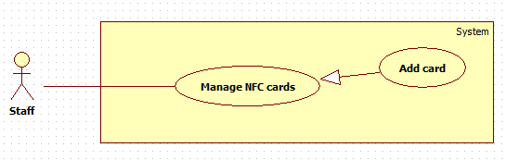

|  |  |  |  |
| --- | --- | --- | --- |
| **USE CASE – XXX** | | | |
| **Use Case No.** | XXX | **Use Case Version** | 1.0 |
| **Use Case Name** | Add card | | |
| **Author** | HoangDN | | |
| **Date** | 13/09/2016 | **Priority** | Normal |
| **Actor:**   * Staff.   **Summary:**   * This use case allows Staff to add a new NFC card to the system.   **Goal:**   * Staff can add a new NFC card to the system to make this card available to use or activate by Passenger.   **Triggers:**   * Staff sends “Add card” command.   **Preconditions:**   * Actor logged in the system with role “Staff”.   **Post Conditions:**   * **Success:** New NFC card added to the system. * **Fail:** System displays error message.   **Main Success Scenario:**   |  |  |  | | --- | --- | --- | | Step | Actor Action | System Response | | 1 | Staff sends “Add card” command. | System displays “Add card” view with following information:   * “Mã thẻ”: free text input, length 6 – 250, required. * “Số dư”: number input, positive integer number from 0 to 10000000. * “Save” command. * “Cancel” command. | | 2 | Staff inputs information.  [Alternative 1] |  | | 3 | Staff sends “Save” command. | System verifies input information, adds new card to the system then displays success message: “Thêm thẻ thành công”.  [Exception 1,2,3] |   **Alternative Scenario:**  [Alternative 1]   |  |  |  | | --- | --- | --- | | Step | Actor Action | System Response | | 1 | Staff sends cancel command. | System return to main view. |   **Exceptions:**  [Exception 1,2,3]   |  |  |  | | --- | --- | --- | | No | Cause | System Response | | 1 | Staff does not input required fields. | System notices that user need to input all required field.   * “Mã thẻ”: System displays warning message “Vui lòng nhập mã thẻ”. | | 2 | Staff inputs some fields with wrong format. | System notices that user need to input all required field.   * “Mã thẻ”: System displays warning message “Vui lòng nhập mã thẻ từ 6-250 ký tự”. * “Số dư”: System displays warning message “Vui lòng nhập số dư từ 0 – 10.000.000”. | | 3 | Card ID is already existed in the system. | System displays warning message “Mã thẻ đã tồn tại trên hệ thống”. |   **Relationships: N/A**  **Business Rules:**   * New card will be added to the system with input information with status “Chưa kích hoạt”. * If no card balance is input. New card balance is 15000. * New card is not belonged to any passenger but is still valid for using to buy ticket, but not allow adding more credit. * Bus company publishes many card for selling to temporary Passenger or in case of forgetting card. | | | |

Activate/Deactivate Card



|  |  |  |  |
| --- | --- | --- | --- |
| **USE CASE – XXX** | | | |
| **Use Case No.** | XXX | **Use Case Version** | 1.0 |
| **Use Case Name** | Activate / Deactivate card | | |
| **Author** | HoangDN | | |
| **Date** | 13/09/2016 | **Priority** | Normal |
| **Actor:**   * Staff.   **Summary:**   * This use case allows Staff to activate / deactivate NFC card in the system.   **Goal:**   * Staff can activate NFC card which will allow using this card to buy ticket. * Staff can deactivate NFC card which will lock this card from buying ticket.   **Triggers:**   * Staff sends “Activate/Deactivate” command of a card on card list.   **Preconditions:**   * Actor logged in the system with role “Staff”.   **Post Conditions:**   * **Success:** Target card status is changed. * **Fail:** N/A   **Main Success Scenario:**   |  |  |  | | --- | --- | --- | | Step | Actor Action | System Response | | 1 | Staff sends “Activate/Deactivate” command of a card on card list | If selected card is currently new and not activated yet. System will do nothing and display message “Thẻ này chưa kích hoạt!”.  If selected card is currently activated. System will deactivate corresponding card and display message “Đã khóa thẻ”.  If selected card is currently deactivated. System will activate corresponding card and display message “Đã mở khóa thẻ”. |   **Alternative Scenario:** N/A  **Exceptions:** N/A  **Relationships:** Activate/Deactivate card   * Condition: Staff is editing a passenger, select a card and choose Activate/Deactivate card. * Extension point: Activate/Deactivate card.   **Business Rules:**   * System activate NFC card by changing card status to “Đã kích hoạt” which will allow using this card to buy ticket. * System deactivate NFC card by changing card status to “Tạm khóa” which will lock this card from using to buy ticket. * System cannot activate/deactivate new card with status “Chưa kích hoạt”. | | | |

Manage credit plans

Add plan

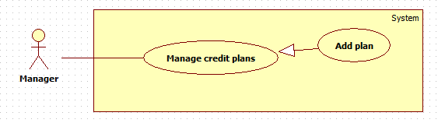

|  |  |  |  |
| --- | --- | --- | --- |
| **USE CASE – XXX** | | | |
| **Use Case No.** | XXX | **Use Case Version** | 1.0 |
| **Use Case Name** | Add plan | | |
| **Author** | HoangDN | | |
| **Date** | 13/09/2016 | **Priority** | Normal |
| **Actor:**   * Manager.   **Summary:**   * This use case allows Manager to add a new credit plan.   **Goal:**   * Manager can create and add a new credit plan to the system. Passenger can add credit to their card by buying these credit plans.   **Triggers:**   * Manager sends “Add plan” command.   **Preconditions:**   * Actor logged in the system with role “Manager”.   **Post Conditions:**   * **Success:** New credit plan is added to the system. * **Fail:** System displays error message.   **Main Success Scenario:**   |  |  |  | | --- | --- | --- | | Step | Actor Action | System Response | | 1 | Manager sends “Add plan” command. | System displays “Add plan” view with following information:   * “Tên gói”: free text input, length 3 – 250, required. * “Mô tả”: free text area, optional. * “Giá gói”: number input, positive integer number from 50000 to 10000000, required. * “Save” command. * “Cancel” command. | | 2 | Manager inputs information.  [Alternative 1] |  | | 3 | Manager sends “Save” command. | System verifies input information, adds new plan to the system then displays success message: “Thêm gói thành công”.  [Exception 1,2,3] |   **Alternative Scenario:**  [Alternative 1]   |  |  |  | | --- | --- | --- | | Step | Actor Action | System Response | | 1 | Manager sends cancel command. | System return to main view. |   **Exceptions:**  [Exception 1,2,3]   |  |  |  | | --- | --- | --- | | No | Cause | System Response | | 1 | Manager does not input required fields. | System notices that user need to input all required field.   * “Tên gói”: System displays warning message “Vui lòng nhập tên gói”. * “Giá gói”: System displays warning message “Vui lòng nhập giá gói”. | | 2 | Manager inputs some fields with wrong format | System notices that user need to input all required field.   * “Tên gói”: System displays warning message “Vui lòng nhập tên gói từ 3-250 ký tự”. * “Giá gói”: System displays warning message “Vui lòng nhập giá gói từ 50.000-10.000.000”. | | 3 | Credit plan name is already existed in the system. | System displays warning message “Tên gói không được trùng, vui lòng chọn tên gói khác.”. |   **Relationships: N/A**  **Business Rules:**   * New credit plan will be added to the system with input information with status “True” and will available to buy when Passenger want to add credit to their card. * Credit plan name is unique to make sure no plan is duplicated. | | | |

Edit plan

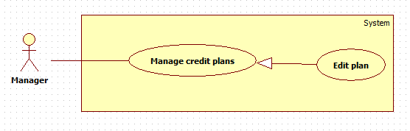

|  |  |  |  |
| --- | --- | --- | --- |
| **USE CASE – XXX** | | | |
| **Use Case No.** | XXX | **Use Case Version** | 1.0 |
| **Use Case Name** | Edit plan | | |
| **Author** | HoangDN | | |
| **Date** | 13/09/2016 | **Priority** | Normal |
| **Actor:**   * Manager.   **Summary:**   * This use case allows Manager to edit a credit plan.   **Goal:**   * Manager can update a credit plan details in the system for adapting price change.   **Triggers:**   * Manager sends “Edit plan” command of one plan on plan list.   **Preconditions:**   * Actor logged in the system with role “Manager”. * There is at least one credit plan in the system with status “True”   **Post Conditions:**   * **Success:** Credit plan details updated to the system. * **Fail:** System displays error message.   **Main Success Scenario:**   |  |  |  | | --- | --- | --- | | Step | Actor Action | System Response | | 1 | Manager sends “Edit plan” command of one plan on plan list. | System displays “Edit plan” view and loads plan detail to a form with following information:   * “Tên gói”: free text input, length 3 – 250, required. * “Mô tả”: free text area, optional. * “Giá gói”: number input, positive integer number from 50000 to 10000000, required. * “Save” command. * “Cancel” command. | | 2 | Manager edits information.  [Alternative 1] |  | | 3 | Manager sends “Save” command. | System verifies input information, updates credit plan details then displays success message: “Sửa thông tin gói thành công”.  [Exception 1,2,3] |   **Alternative Scenario:**  [Alternative 1]   |  |  |  | | --- | --- | --- | | Step | Actor Action | System Response | | 1 | Manager sends cancel command. | System returns to main view. |   **Exceptions:**  [Exception 1,2,3]   |  |  |  | | --- | --- | --- | | No | Cause | System Response | | 1 | Manager does not input required fields. | System notices that user need to input all required field.   * “Tên gói”: System displays warning message “Vui lòng nhập tên gói”. * “Giá gói”: System displays warning message “Vui lòng nhập giá gói”. | | 2 | Manager inputs some fields with wrong format | System notices that user need to input all required field.   * “Tên gói”: System displays warning message “Vui lòng nhập tên gói từ 3-250 ký tự”. * “Giá gói”: System displays warning message “Vui lòng nhập giá gói từ 50.000-10.000.000”. | | 3 | Credit plan name is already existed in the system. | System displays warning message “Tên gói không được trùng, vui lòng chọn tên gói khác.”. |   **Relationships: N/A**  **Business Rules:**   * New credit plan detail will be updated to the system with input information. No change on plan status. * Credit plan name is unique to make sure no plan is duplicated. | | | |

Delete plan

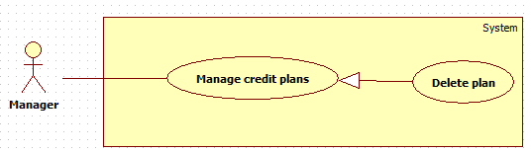

|  |  |  |  |
| --- | --- | --- | --- |
| **USE CASE – XXX** | | | |
| **Use Case No.** | XXX | **Use Case Version** | 1.0 |
| **Use Case Name** | Delete plan | | |
| **Author** | HoangDN | | |
| **Date** | 13/09/2016 | **Priority** | Normal |
| **Actor:**   * Manager.   **Summary:**   * This use case allows Manager to delete a credit plan.   **Goal:**   * Manager can delete a credit plan from the system to make it unavailable to buy in any situation.   **Triggers:**   * Manager sends “Delete plan” command of one plan on plan list.   **Preconditions:**   * Actor logged in the system with role “Manager”. * There is at least one credit plan in the system with status “True”   **Post Conditions:**   * **Success:** Credit plan is deleted from the system. * **Fail:** System displays error message.   **Main Success Scenario:**   |  |  |  | | --- | --- | --- | | Step | Actor Action | System Response | | 1 | Manager sends “Delete plan” command of one plan on plan list. | System displays confirmation message: “Bạn có chắc chắn muốn xóa?” | | 2 | Manager sends “Yes” command.  [Alternative 1] | System deletes target plan from the system and displays success message: “Xóa thành công”; |   **Alternative Scenario:**  [Alternative 1]   |  |  |  | | --- | --- | --- | | Step | Actor Action | System Response | | 1 | Manager sends cancel command. | System return to main view. |   **Exceptions: N/A**  **Relationships: N/A**  **Business Rules:**   * Plans which have status “False” will be unavailable for being bought by Passenger. * If a plan has not been related to any ticket, system delete this plan completely, otherwise, system sets its status to “False”. | | | |

Get income report

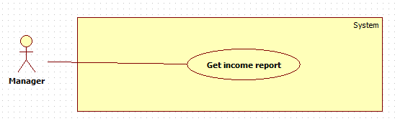

|  |  |  |  |
| --- | --- | --- | --- |
| **USE CASE – XXX** | | | |
| **Use Case No.** | **XXX** | **Use Case Version** | 1.0 |
| **Use Case Name** | Get income report | | |
| **Author** | HoangDN | | |
| **Date** | 13/09/2016 | **Priority** | Normal |
| **Actor:**   * Manager   **Summary:**   * This use case allows Manager can get outcome report.   **Goal:**   * Manager can view total income from selling ticket in a specific date range and also the details list of bought tickets.   **Triggers:**   * Manager sends “Get income report” command.   **Preconditions:**   * Actor logged in system with role “Manager”.   **Post Conditions:**   * **Success:** Income report is showed. * **Fail:** Show error message.   **Main Success Scenario:**   |  |  |  | | --- | --- | --- | | Step | Actor Action | System Response | | 1 | Manager sends “Get income report” command. | System shows “Get income report” view with following information:   * “Từ ngày”: date input, default date is 1st of current month, required. * “Đến ngày”: date input, default date is the current date, required. * “Get report” command. | | 2 | Manager inputs date for both two field. |  | | 3 | Manager sends “Get report” command. | System verifies input information, gets income report based on input date range. System displays report as a table, each row has following information:   * “Ngày giờ”: label * “Thẻ thanh toán”: label * “Khách hàng”: label * “Số tiền”: label   [Exception 1,2,3,4]  [Alternative 1] |   **Alternative Scenario:**  [Alternative 1]   |  |  |  | | --- | --- | --- | | Step | Cause | System Response | | 1 | If there is no data to show. | System shows a message “Không có dữ liệu trong khoảng thời gian đã chọn”. |   **Exceptions:**  [Exception 1]   |  |  |  | | --- | --- | --- | | No | Cause | System Response | | 1 | Manager does not input required fields. | System notices that user need to input all required field.   * “Từ ngày”: System displays warning message “Vui lòng chọn ngày bắt đầu”. * “Đến ngày”: System displays warning message “Vui lòng chọn ngày kết thúc”. | | 2 | Manager inputs start date greater than end date. | System displays error message: “Ngày bắt đầu phải nhỏ hơn ngày kết thúc.” | | 3 | Manager inputs date range over 30 days. | System displays error message: “Khoảng thời gian không vượt quá 30 ngày.” | | 4 | Manager inputs end date greater than current date. | System displays error message: “Ngày bắt đầu phải nhỏ hơn ngày kết thúc.” |   **Relationships:** N/A  **Business Rules:**   * Start date and end date format are “dd/mm/yyyy”. * End date must not be earlier than start date. * Total income would be calculated from all bought tickets match input date range. * End date must not greater than current date. * Date range for getting report must be within 30 days. * System allows Manager to search and sort report on all fields. | | | |

Create promotion and offer

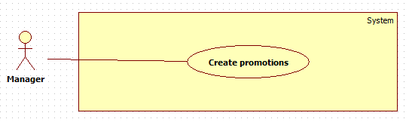

|  |  |  |  |
| --- | --- | --- | --- |
| **USE CASE – XXX** | | | |
| **Use Case No.** | **XXX** | **Use Case Version** | 1.0 |
| **Use Case Name** | Create promotions | | |
| **Author** | HoangDN | | |
| **Date** | 13/09/2016 | **Priority** | Normal |
| **Actor:**   * Manager   **Summary:**   * This use case allows Manager to create promotion and offer for suggesting Passenger.   **Goal:**   * Manager can create promotion in the system. * Passenger will receive latest promotion from the system when the Auto Handler sends it to them.   **Triggers:**   * Manager sends “Create promotions” command.   **Preconditions:**   * Actor logged in system with role “Manager”.   **Post Conditions:**   * **Success:** New promotion is added to the system. * **Fail:** Show error message.   **Main Success Scenario:**   |  |  |  | | --- | --- | --- | | Step | Actor Action | System Response | | 1 | Manager sends “Create promotion” command. | System shows “Create promotion ” view with following information:   * “Tên quảng cáo”: free text input, length 6-250, required. * “Nội dung”: html input area, required. * “Save” command. | | 2 | Manager inputs information. |  | | 3 | Manager sends “Save” command. | System verifies input information. Create new promotion with input information and add to system.  [Exception 1,2] |   **Alternative Scenario:** N/A  **Exceptions:**  [Exception 1,2]   |  |  |  | | --- | --- | --- | | No | Cause | System Response | | 1 | Manager does not input required fields. | System notices that user need to input all required field.   * “Tên quảng cáo”: System displays warning message “Vui lòng nhập quảng cáo”. * “Nội dung”: System displays warning message “Vui lòng nhập nội dung”. | | 2 | Manager inputs some fields with wrong format | System notices that user need to input all required field.   * “Tên quảng cáo”: System displays warning message “Vui lòng nhập tên quảng cáo từ 6-250 ký tự”. |   **Relationships:** N/A  **Business Rules:**   * New promotion will be created with input information and its status is “True”. * After Auto Handler sends promotion successfully, the status will be change to “False”. | | | |

Activate Account

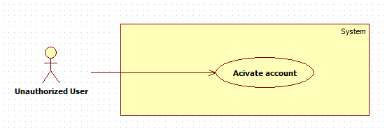

|  |  |  |  |
| --- | --- | --- | --- |
| **USE CASE – XXX** | | | |
| **Use Case No.** | **XXX** | **Use Case Version** | 1.0 |
| **Use Case Name** | Activate account | | |
| **Author** | HoangDN | | |
| **Date** | 13/09/2016 | **Priority** | Normal |
| **Actor:**   * Unauthorized User   **Summary:**   * This use case allows Unauthorized User to activate a new account.   **Goal:**   * Unauthorized User can activate a new account with an NFC card to become a Passenger.   **Triggers:**   * Unauthorized User sends “Activate account” command.   **Preconditions:**   * Actor logged in system with role “Unauthorized User”. * Actor has a NFC card which isn’t activated yet.   **Post Conditions:**   * **Success:** New account is created. * **Fail:** Send error SMS.   **Main Success Scenario:**   |  |  |  | | --- | --- | --- | | Step | Actor Action | System Response | | 1 | Unauthorized User sends “Activate account” command by sending an SMS with their NFC card id to the system. | System gets and verifies the sender’s phone number and card id from the SMS.  System creates a new account with the phone number and maps the NFC card which has card id from SMS with this account.  System sends a SMS contains account login detail back to user’s phone number.  [Exception 1] |   **Alternative Scenario:** N/A  **Exceptions:**  [Exception 1,2]   |  |  |  | | --- | --- | --- | | No | Cause | System Response | | 1 | Unauthorized User sends SMS with wrong format. | System sends an error back to user’s phone number: “Tin nhan sai cu phap, vui long kiem tra lai.” |   **Relationships:** N/A  **Business Rules:**   * New account will be created with input information and its status is “True”. * New account role is Passenger. * After activating account successful, user can login to the system with account login detail. | | | |

Logout

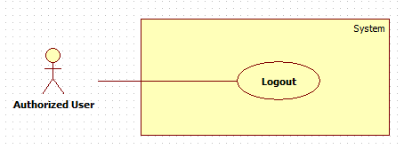

|  |  |  |  |
| --- | --- | --- | --- |
| **USE CASE – XXX** | | | |
| **Use Case No.** | **XXX** | **Use Case Version** | 1.0 |
| **Use Case Name** | Logout | | |
| **Author** | HoangDN | | |
| **Date** | 13/09/2016 | **Priority** | Normal |
| **Actor:**   * Authorized User   **Summary:**   * This use case allows Authorized User to logout.   **Goal:**   * Authorized User can logout of the system.   **Triggers:**   * Authorized User sends “Logout” command.   **Preconditions:**   * Actor logged in system with role “Authorized User”.   **Post Conditions:**   * **Success:** Authorized User is logged out. * **Fail:** N/A   **Main Success Scenario:**   |  |  |  | | --- | --- | --- | | Step | Actor Action | System Response | | 1 | Authorized User sends “Logout” command. | System clears the current session of the user then redirects to home page. |   **Alternative Scenario:** N/A  **Exceptions:** N/A  **Relationships:** N/A  **Business Rules:**   * After logging out of the system, user is no longer has permission to access any authorized function of the system. | | | |