CprE 381, Computer Organization and Assembly-Level Programming, Fall 2013

Lab Report for Project A

Lab Partners Abraham Devine

Robert Larsen

Darren Hushak

Colleen Riker

Section /Lab Time Thursday, 12-2

Total Score ________ /20

Refer to the highlighted language in the Project A instructions for the context of the following questions.

- [Prelab] With your project group members, create a list of best practices / tips for designing, compiling, and testing VHDL modules based on your experiences so far with these labs (for Prelab of the evaluation form.)

- Avoid duplicate code
- Use generics wherever possible to allow for scalability/duplicity
- Use structural design for higher-level hardware applications, to allow for higher chances of synthesis
- Keep a consistent naming convention: ours includes the component name first, followed by underscored designations, including _1bit for a 1 bit component, _Nbit for an N bit component, _tb for a testbench file

- [Part 1(a)] Draw a schematic for a 1-bit ALU that supports the following operations: add/sub (both signed and unsigned), slt, and, or, xor, nand, and nor. What are the inputs and outputs that are needed? (2 points)
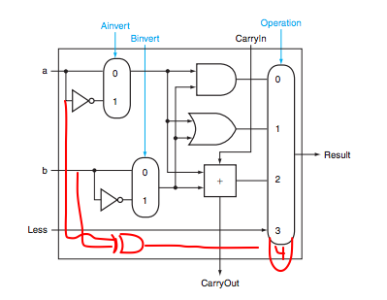
Inputs: A, B, Less, Carryin; Control Inputs: Ainv, Binv, Operation

- [Part 1(b)] In your project writeup, describe your design in terms of the VHDL coding style you chose and the control signals that are required. (2 points)

Used structural for every component; had an object for each operation: MUX, AND, OR, XOR, ADD/SUB, INVERT

Control signals required are: Ainv, Binv, and a 3 bit MUX address for function select/opcode

- [Part 1(c)] Describe how the execution of the different operations corresponds to the Modelsim waveforms in your writeup. (2 points)

See part g

- [Part 2(a)] Draw a simplified schematic for this 32-bit ALU. Consider the following questions: how is Overflow calculated? How is Zero calculated? How is slt implemented? (2 points)

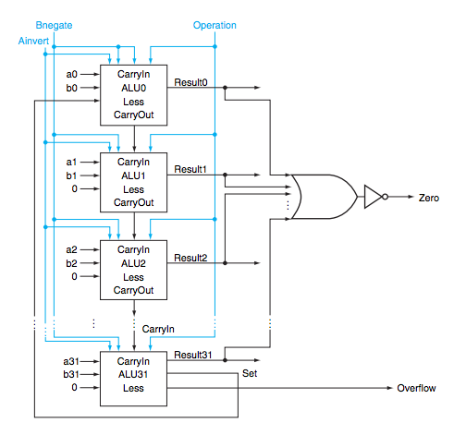

OF = Cin(31) XOR Cout(31)
ZERO = !(Set(1) OR Set(2) OR Set(3) … OR Set(31))

- [Part 2(b)] In your writeup, describe what challenges (if any) you faced in implementing this module. (2 points)

Lots of signals to keep track of, tried to do it the “right” way with simple, scalable objects to avoid repetitious code.

- [Part 2(c)] Describe how the execution of the different operations corresponds to the Modelsim waveforms in your writeup. (2 points)

- [Part 3(a)] Describe the difference between logical (srl) and arithmetic (sra) shifts. Why does MIPS not have a sla instruction? (2 points)

SRL shifts left without a sign extension, SRA does. SLA is not needed, because the sign is inherently kept when you shift left.

- [Part 3(b)] In your writeup, briefly describe how your VHDL code implements both the arithmetic and logical shifting operations? (2 points)

It uses a sign bit to determine to use either the srl or sra instruction. The sign is high for sra and low for srl.

- [Part 3(c)] In your writeup, explain how the right barrel shifter from part b) can be enhanced to also support left shifting operations? (2 points)

It is possible to implement a left shifting operation by flipping the input bits and output bits using mux's for the left shifting operations.

- [Part 3(d)] Describe how the execution of the different shifting operations corresponds to the Modelsim waveforms in your writeup? (2 points)

i_Sel in the waveform is the shift amount. It is a five bit number for the shifting of a 32 bit number. i_Flip represents whether or not to right or left shift, and i_Ext represents whether or not the number is arithmetic or not. So one can see when i_sel is 00010, i_Flip is 1, and i_Ext is 1, the output is shifted to the right 2 with the sign extended. (Seen in the image)

