Here’s how I got my Diymall 1.3” i2C Serial 128x64 OLED LCD LED Display to work with my Arduino UNO.

**I ordered this:**

<https://www.amazon.com/gp/product/B016HVG0MM>

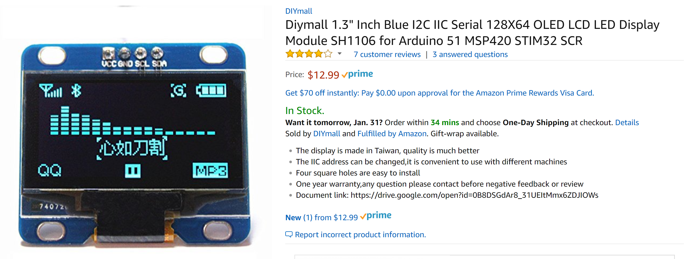

**Here’s How I connected the OLED to my Arduino UNO**

|  |  |
| --- | --- |
| Diymall OLED | Arduino UNO |
| Vcc | 5v |
| Gnd | Gnd |
| SCL | SCL |
| SDA | SDA |

**Install the U8g2 Library into the Arduino GUI**

you can search for it in the Library Manager or download it from: https://github.com/olikraus/u8g2

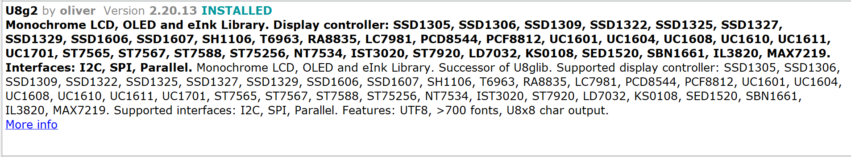

Locate the U8g2 Examples, uncomment the correct constructor and upload to Arduino!

Arduino\libraries\U8g2\examples\u8x8\HelloWorld\HelloWorld.ino

Uncomment THIS Constructor:

**U8X8_SH1106_128X64_NONAME_HW_I2C u8x8(/* reset=*/ U8X8_PIN_NONE);**

then Upload HelloWorld.ino to Arduino

Arduino\libraries\U8g2\examples\full_buffer\HelloWorld\HelloWorld.ino

&

Arduino\libraries\U8g2\examples\full_buffer\GraphicsTest\GraphicsTest.ino

Uncomment THIS Constructor:

**U8G2_SH1106_128X64_NONAME_1_HW_I2C u8g2(U8G2_R0, /* reset=*/ U8X8_PIN_NONE);**

Then Upload to Arduino