**Analyzing the static dataset of Zomato with DNIF**

**Dataset : Zomato Restaurant Data**

**Description:** This dataset lists restaurants in different countries according to their city, locality, cuisine, price range, availability of various other options and rating given by customers.

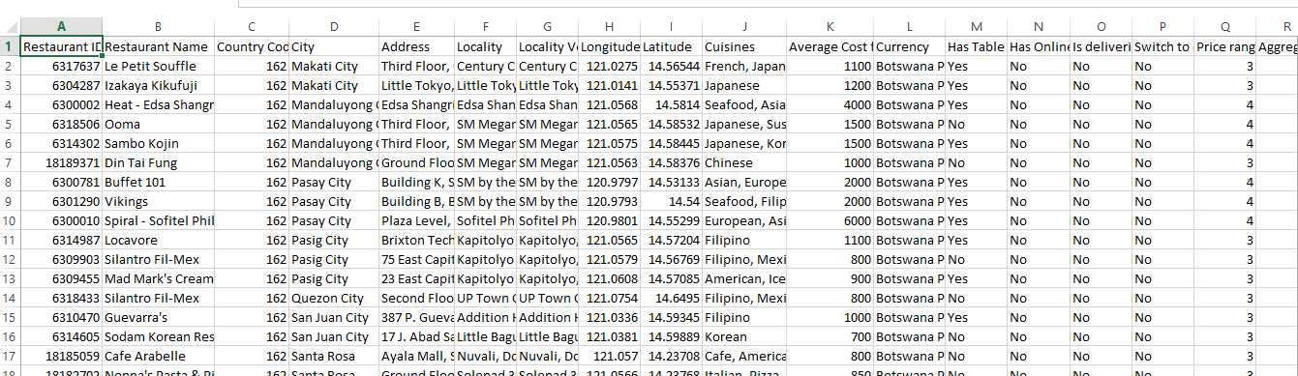

**Use Cases:**

1. One will be able to find the perfect restaurant according to his or her city, locality, and preferred cuisine. He can select the best restaurant according the ratings given by the customers.
2. If we get this data dynamically in every quarter of the year we will be able to know for which restaurant popularity is increasing and for which ones it is showing a decreasing trend. If popularity is showing a decreasing trend then owners of those restaurants can take preventive measures like giving discounts, lowering the price etc. in advance.

**Case 1: We can find the restaurants with a specific rating for a particular** **city.**

Query: 

Result:

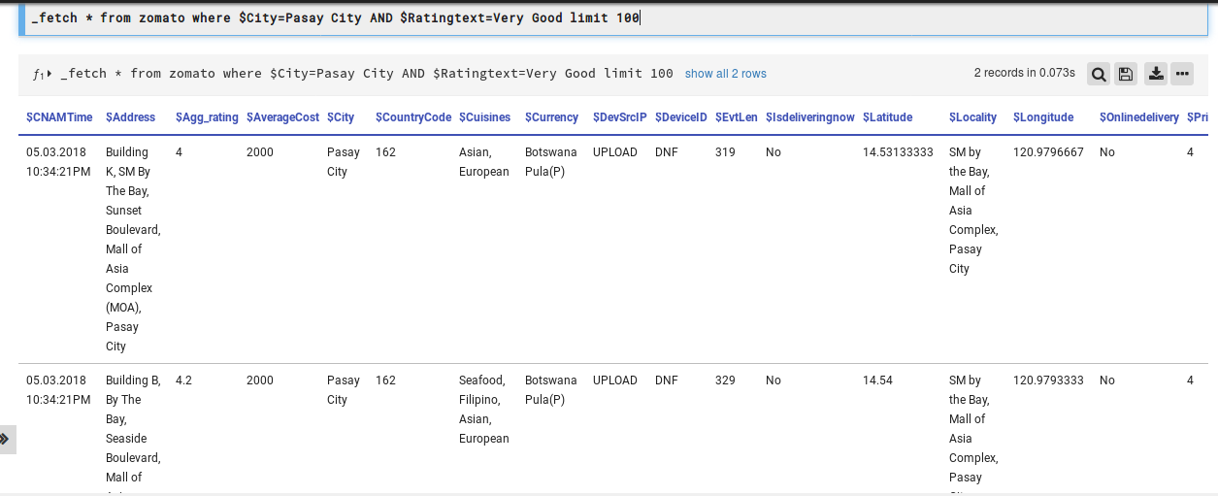

**Case 2:** From the list of Restaurants we can find the restaurants which are in Makaty City, Serve Japanese Cuisine, have provision of prior table booking and voted by more than 300 people.

Query:

**_fetch * from zomato where $City=Makaty City AND $Cuisines=Japanese AND $Tablebooking=Yes limit 100 >>_checkif int_compare $Votes>300 include**

Result:

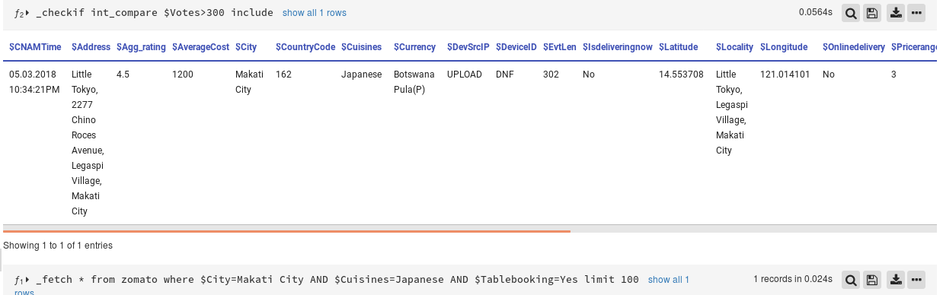

**Note:** The **_checkif** is a query directive that helps you to apply conditional logic to fetched result. It will include only those records for which the value of $Votes is greater than 300.

Case 3: If we want to know what are the different Cities listed in this dataset and which city have how many number of restaurant we can use the following query

Query:

**_fetch * from zomato limit 500>>_agg count_unique $City**

Result:

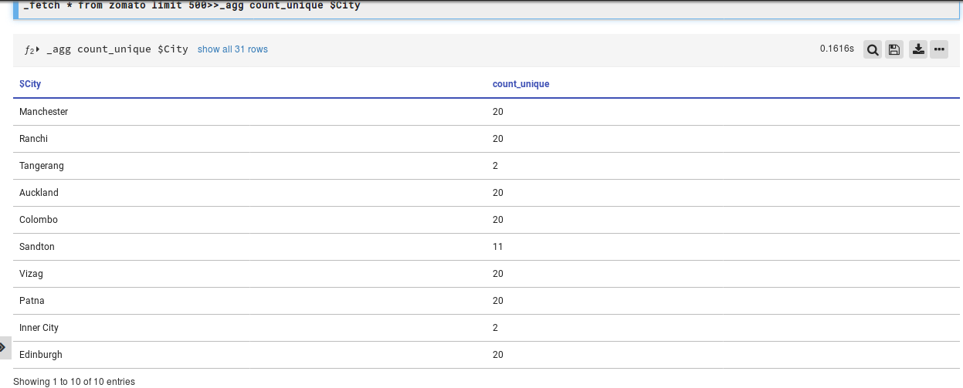

It will show the different cities listed in the dataset and the count of their number of occurrences in the list i.e. it shows the number of restaurants for every city. For Example – City Manchester has count_unique 20 i.e. for Twenty restaurants the value of $City is Manchester which implicates Manchester has 20 restaurants.

We can create a horizontal Bar- Chart for the same to show which city has what number of restaurants.

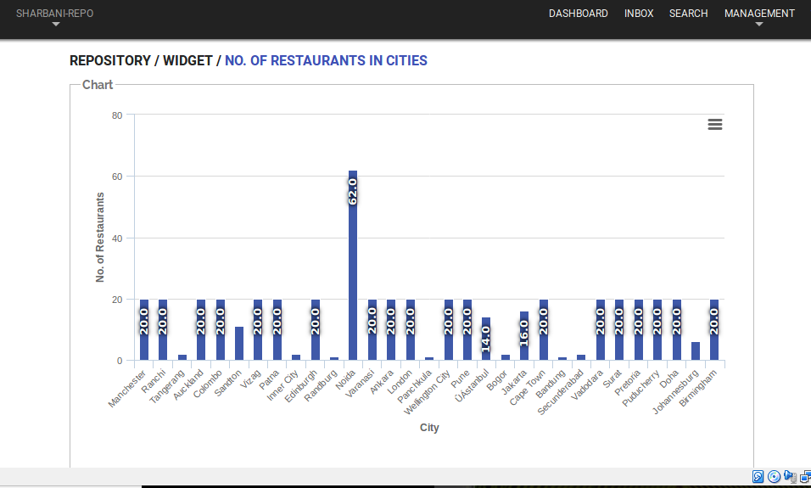

We can see from the Bar- Graph we can see that Noida has maximum no. of Restaurants and the number is 62.

This can also be shown using a Pie Chart and a Pyramid.

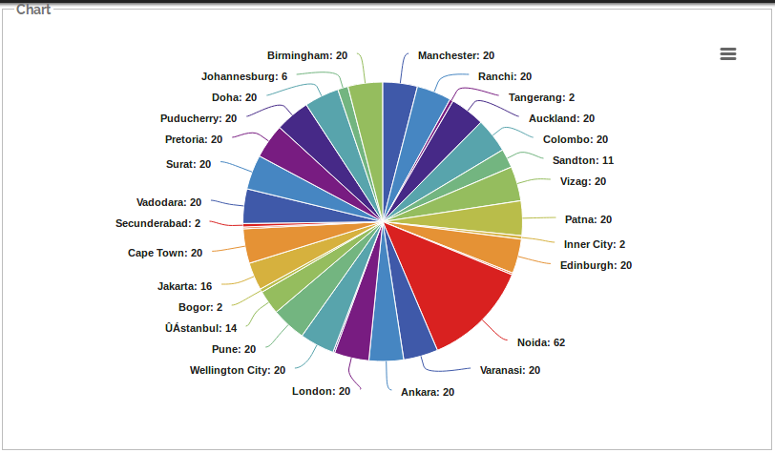

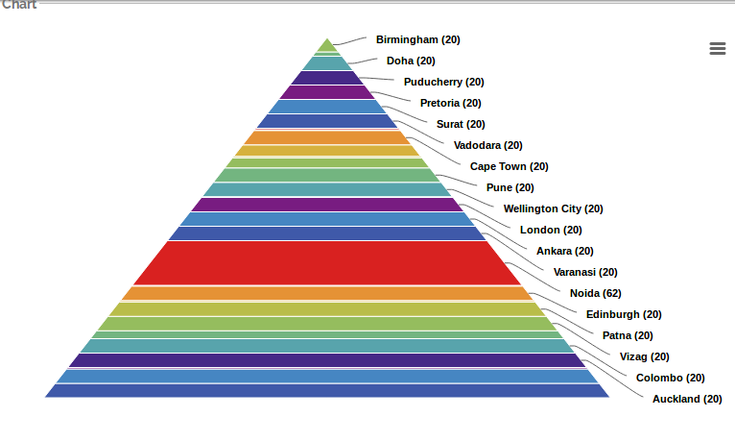

**Case 4**: If we have derived the counts for each city and now we want to know the total no. of Restaurants mentions in the list i.e. if we want to add the counts of the cities we can use the following query.

Query:

_**fetch * from zomato limit 500>>_agg count_unique $City>>_agg sum count_unique**

Result:

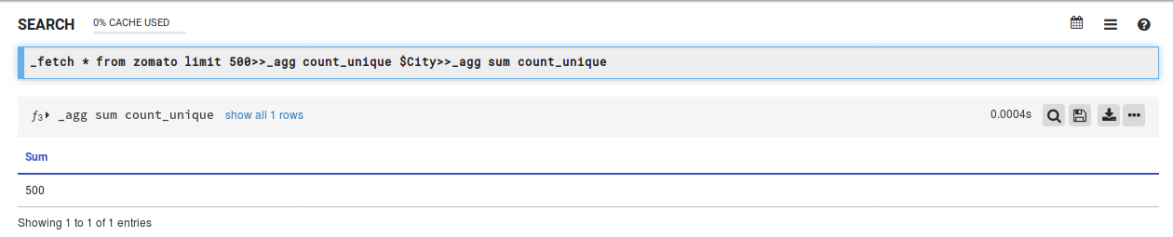

This query will add the counts of the city and give the total number of restaurants. It gives 500. We know from before that this dataset lists total 500 restaurants.

**Note: _agg** is a query directive which allows to count unique occurrences of an event and also allows to perform arithmetic operations on the grouped data. For example here we used **‘_agg sum count_unique’** to add the counts. Similarly, we can do these operations as well - **_agg max/min/avg count unique**

**Case 5.** We can find out the number of restaurants for each rating color and each rating text.

Query: **_fetch * from zomato limit 500>>_agg count_unique $Rating_color**

**_fetch * from zomato limit 500>>_agg count_unique $Ratingtext>>_sort by count_unique DESC**

Result: Here is the result for these two queries-

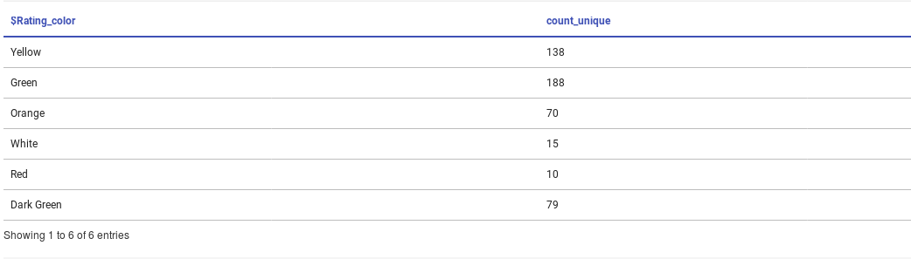

This Pie-chart shows the number of restaurant per rating color-

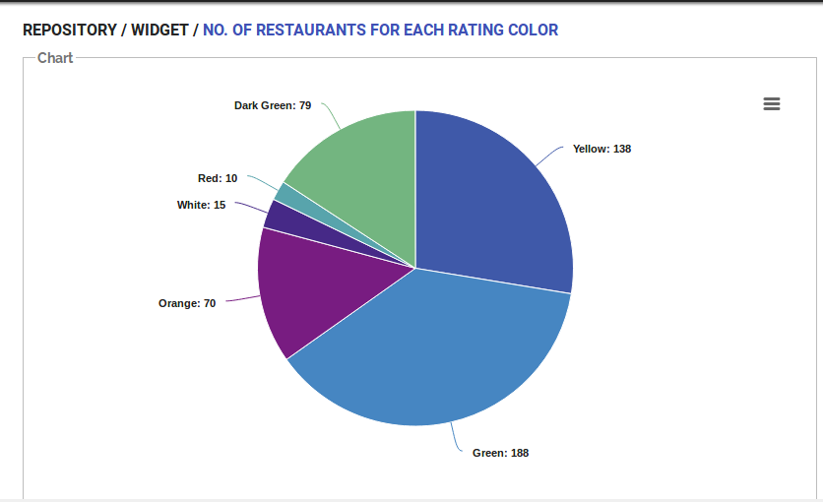

This result shows the no. of restaurant per rating text.

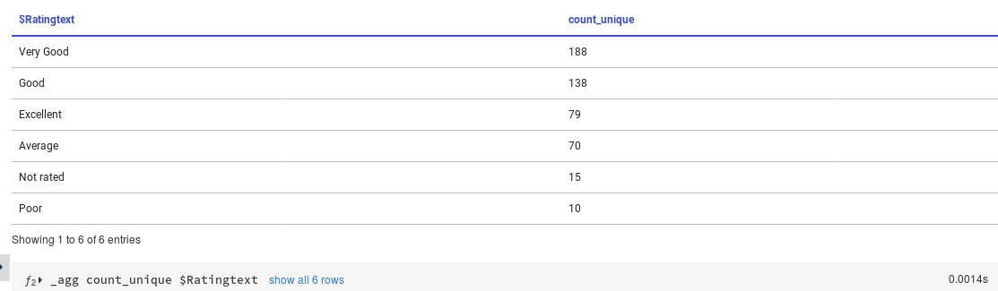

The following Bar graph shows the no. of restaurants for different rating text.

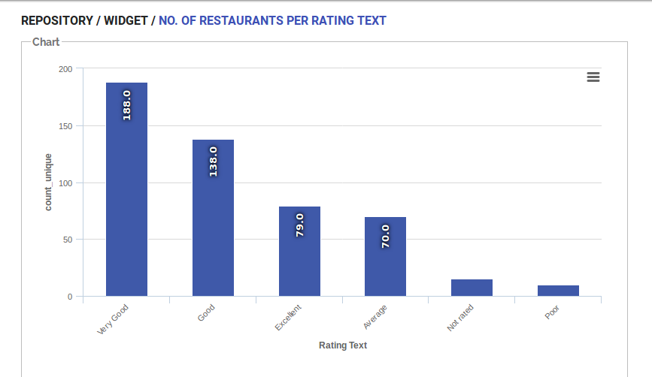

This line chart also shows the no. of Restaurants for different Rating color.

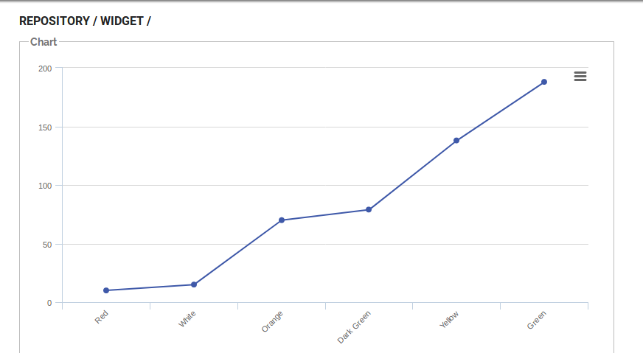

**Case 6:** We can show the number of restaurants for different rating color and different rating text with a single query and in a single double-dimention pie chart.

Query:

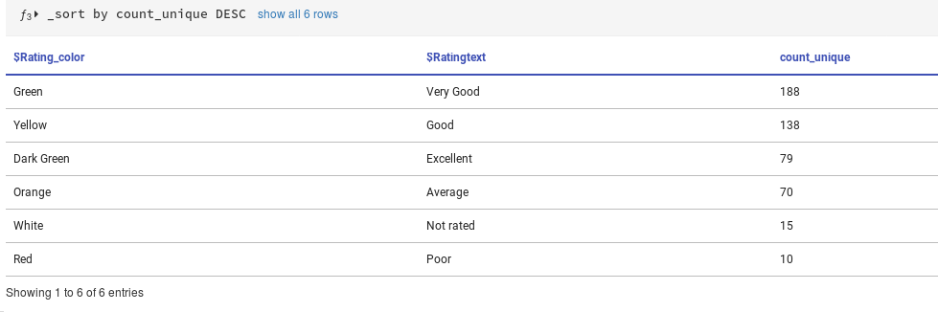

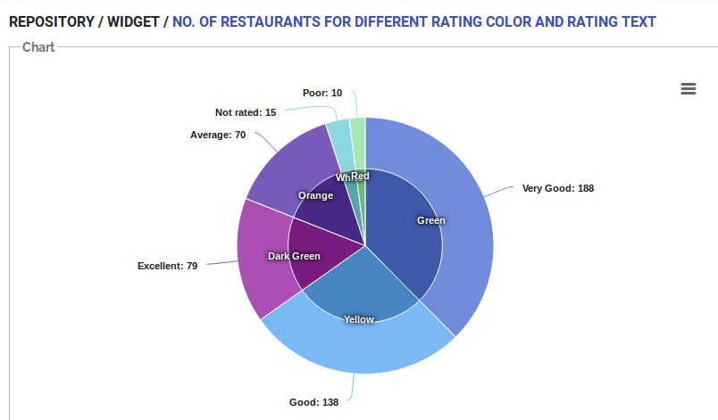

**Dashboard:** I have created a Dashboard for the Zomato Restaurants dataset which visually interprets the information we get after analyzing the dataset. It is shown below.

