

Contents

Configuration Steps for SMTP on DNIF: 2

1. Login to your Gmail Account: 2

2. Login to other Gmail Account (Optional): 2

3. DNIF SMTP Setup: 2

The SMTP Configuration Guide

**Note:** Having a G-Suite Account is an added advantage, both from efficiency and security perspective.

But in any case this is also effective.

# Configuration Steps for SMTP on DNIF:

In order for DNIF to send alerts and reports we will need a SMTP Server with its authenticating credentials. For this we will be using Google’s free SMTP service – which is smtp.gmai.com

We will do this in 3 steps. The numbered headings are nothing but steps.

## Login to your Gmail Account:

* Turn on less secure apps option. How? Follow these steps:
  + Go to “My Account”
  + Under "Sign-In & Security"
  + Scroll down till "Apps with less secure access."
  + Enable it.
  + Log-out.

## Login to other Gmail Account (Optional):

* Why? We're going to do our testing here, then on DNIF.
  + Go to Settings
  + Under “Accounts and Import”
  + Under “Send mail as”: Click "**Add another email address**" option
  + Fill in following details
    - **1st Pop-Up Page**

Name: Of your choice

Email: Mail Id from **Step 1** (This mail id’s credentials will be used to input in DNIF’s SMTP configuration file.

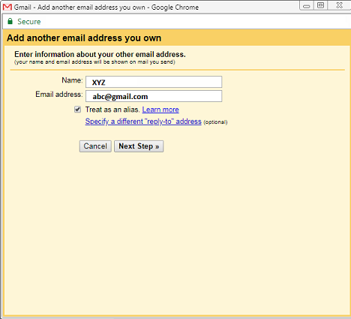

*Fig 1: 1st Pop-Up*

* + - **2nd Pop-Up Page**

Provide **Step1** mail id password

Check the TLS radio button if not checked and remember the port number.

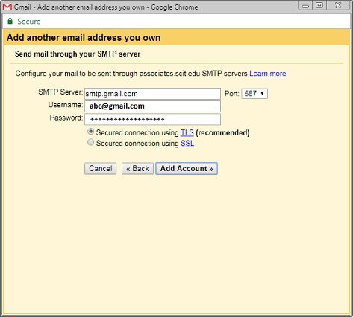

*Fig 2: 2nd Pop-Up*

* Perform the Verification step as directed by Google.
* If verification is complete. The setup works. Now we can move onto DNIF.

## DNIF SMTP Setup:

1. Start DNIF:

$ sudo docker-compose up -d

1. Log into container using SSH (To learn, visit here: <https://dnif.it/docs/guides/tutorials/configuring-smtp-in-docker.html>)
2. Change directory to:

$ cd /dnif/[yourkey]/tool

$ ls

1. Open the smtp.yaml file using the VIM editor

$ vim smtp.yaml

**NOTE:** Vim Editor can be tricky to use, please be careful)

1. When the file opens, enter the insert mode by pressing the following key.

'**i**'

1. Comment internal settings part carefully. Since we want to configure SMTP with authentication.

**NOTE:** Do not leave extra white spaces.

1. Uncomment external settings part carefully

**NOTE:** Do not leave extra white spaces

1. Put following under the key variables:

* **domain:** [smtp.gmail.com](http://smtp.gmail.com/)
* **username:** mail id from step 1
* **password:** its corresponding password
* **port:** 587
* **tls:** 1
* **from:** mail id from step 1
* **to:** your other mail id

Now press **Esc** key and type "**:wq**" (meaning write and quit) & hit enter.

1. Final command:

$ python configsmtp.py