

**Contents:**

**Introduction………………………………………………………………………………………………………….. Page 2**

**About Notification Group ……………………………………………………………………………………… Page 2**

**About Zomato Restaurants Dataset………………………………………………………………………. Page 2**

**Example of Report Creation with screenshots………………………………………………………. Page 2-15**

**Executing the Report and Sending it Over Email…………………………………………………….Page 15-19**

**Example of Creation of Workbook, Crontab with Screenshots……………………………….Page 19-22**

**_trigger Directive………………………………………………………………………………………………… Page 22**

**Alerts for Dynamic Data……………………………………………………………………………………….Page 22**

**Sending Alerts over Mail from DNIF:**

This document discusses about how to send alerts or notifications from DNIF over emails. Also it will describe about how to create notification groups, Reports and Workbooks on DNIF with examples. And we will talk about how to use _trigger directive of DNIF Query Language.

**Notification Group:**

We can send notification to one particular email address or can create a notification group of users using their email ids to which reports or alert can be sent.

To know how to create a Notification Group please follow the guidelines given in this document:

<https://dnif.it/docs/guides/tutorials/create-and-view-notif-group.html>

Here I am taking the static dataset of Zomato to create report and workbook. Below is the short description of the dataset –

**Zomato Restaurant Data**

**Description:** This dataset lists restaurants in different countries according to their city, locality, cuisine, price range, availability of various other options and rating given by customers.

The use case and more details of this dataset are described in the document ‘Analyzing Static Dataset with DNIF’ in Guiding Documents in this repository.

<https://github.com/dnif/DigiVigi/blob/master/Guiding_Documents/4_Analyzing_Static_Dataset_With_DNIF.docx>

**Reports:**

From many devices log-based information are collected on DNIF console. Reports are an effective way to view meaningful information out of these data. These reports can be triggered and sent to a notification group and email id.

We have to create reports in DNIF within a repository. The steps to create a report are given in this document-

<https://dnif.it/docs/guides/tutorials/how-to-create-reports.html>

To create report first in the management tab of DNIF you have to select repository.

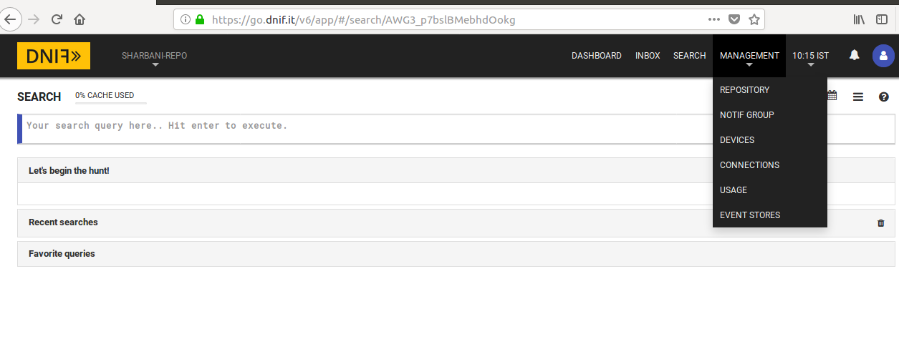

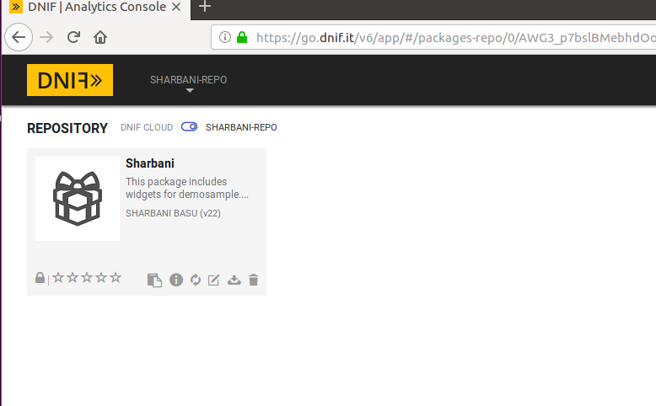

Then the package should be selected in which you want to create the report. After that the required details like Name, Description, References, and Tags should be given as mentioned in the above document.

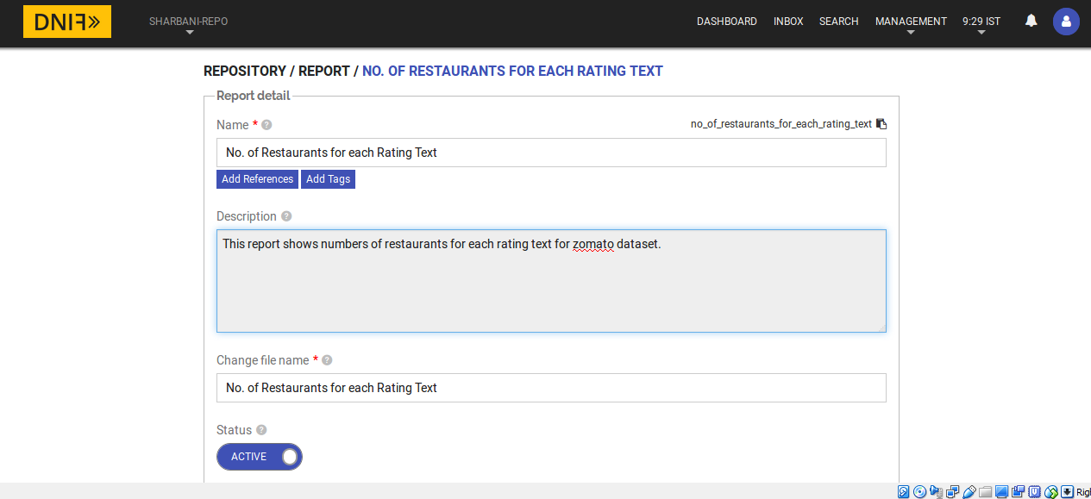

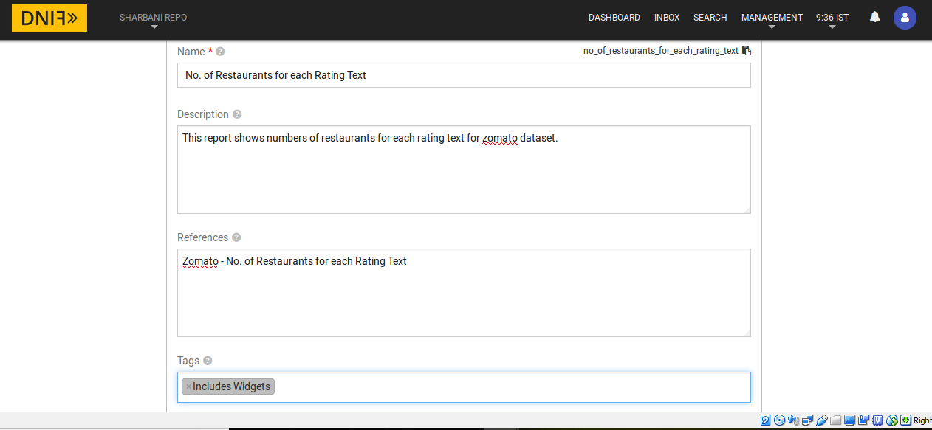

You can also refer this document -

<https://github.com/dnif/DigiVigi/blob/master/Process_1/P1_HowTo_WebScrapped_Data.docx>

After this we have option to add sections like Page Title, Page Sub- Title, Description Text, Free Rows, Data Table, Add Page etc.

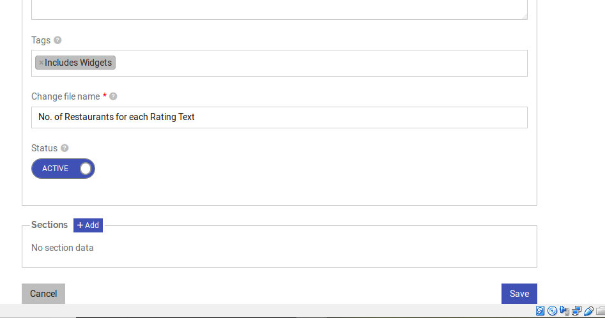

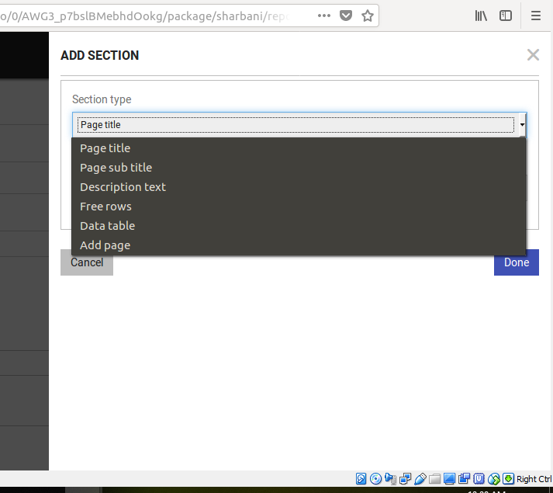

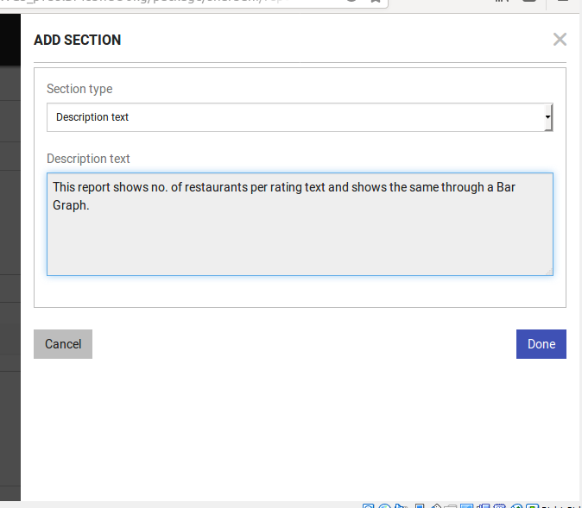

In this report I have given the **Title** as ‘No. of Restaurants per rating text’, **Description** as ‘This report shows no. of restaurants per rating text and shows the same through a Bar Chart’. All these texts is what will be included in the report.

In the ‘**Free Rows’** section let’s give 10 free rows to the report.

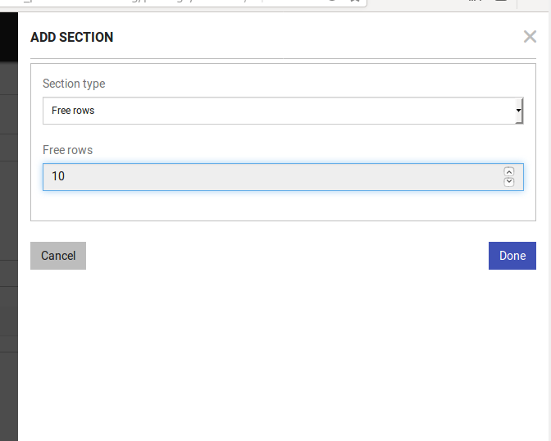

Next comes the most important section of the report where we will add the query which will run when we will run the report.

Let’s take the situation of the Zomato dataset example. Let’s assume that every month zomato takes rating of the restaurants from its users. The users give their ratings by rating text parameters like Excellent, Very Good, Good, Poor etc. To know each rating is received by how many number of restaurants let’s create a report which runs this query –

**_fetch * from zomato limit 500 where $Duration=1h >>_agg count_unique $Ratingtext>>_sort by count_unique DESC**

This query will sort the number of restaurants in each rating text in descending order.

We will add this query in **Data Table** section of the report.

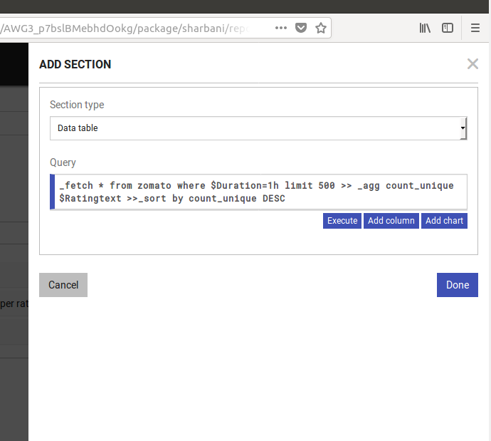

Now we have option to add more columns in the table. For that click on **Add Column.**

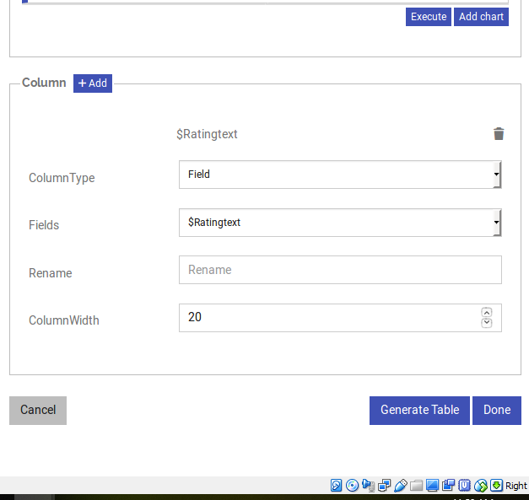

Here, as you can see we can add one more column called count_unique in this data table.

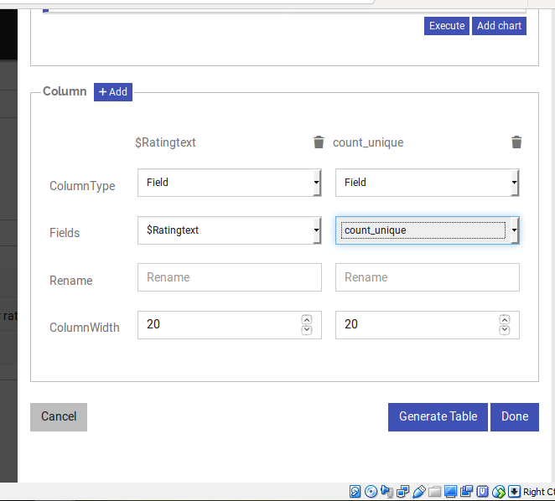

Now it’s time to generate the table.

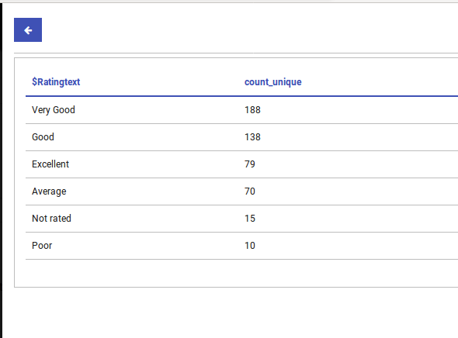

Now this is how the report looks like -

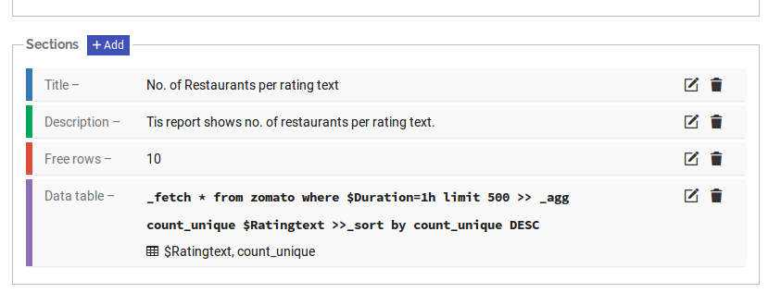

Also, we can add widgets like Bar Graph, Pie Chart and Line Graphs in the report. For that we have to click on **Add Chart** button.

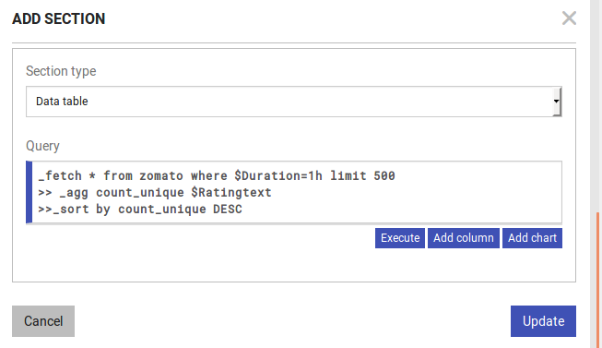

We can select from different types of Charts like Horizontal and Vertical Bar Chart and Pie Chart. Here, we are adding a Horizontal Bar Chart to this report. Then we have to select the level field and value field for this chart. After selecting all the field click on **Update.**

Now it is showing that a Horizontal Bar chart is added to the report.

Now click on **Save.** This will save the report in the selected package.

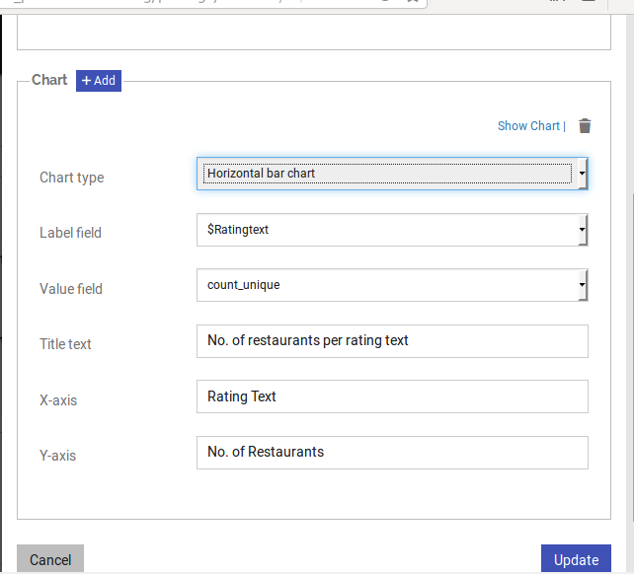

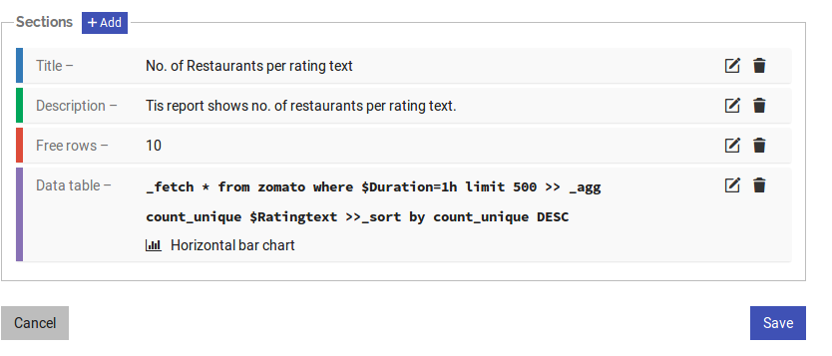

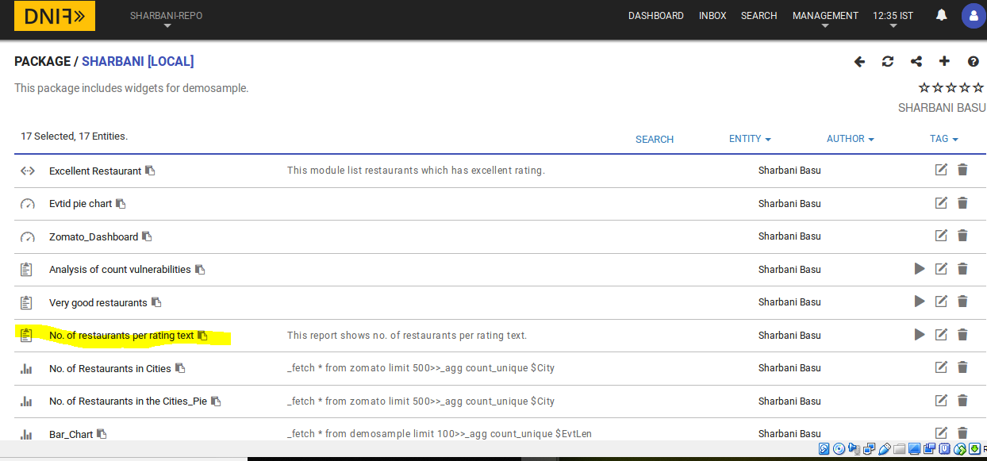

**Executing the report and Sending it over Email:**

**Note: To send report or any notification via email SMTP should be configured in DNIF. For the steps of the same please check this document:**

<https://github.com/dnif/DigiVigi/blob/master/Guiding_Documents/6_The_SMTP_Config_Guide.docx>

In the beginning of this document we mentioned about notify group. We can send this this to any particular email id, a group of email ids or can create a notify group of email ids to whom the report can be sent. I have created a **NOTIF group** called **Admins** with the four members in our team.

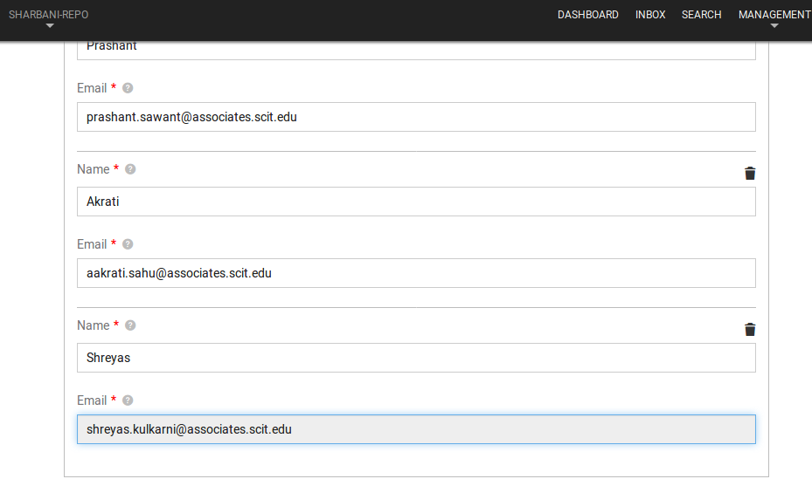

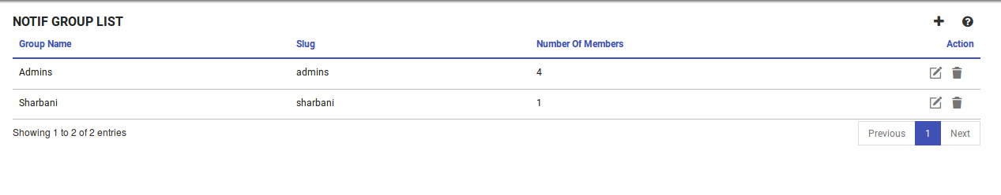

Now to send the report to this notify_group select the report in the package in which the report is created and click on **Run.**

Then select the Notif group in which you want to send the report. Click on **Run.**

There will be a message showing that ‘report added to queue’.

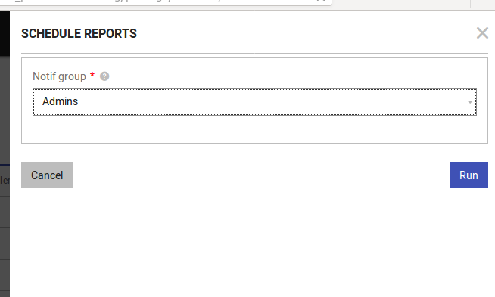

Check your mail. You and the other members given in the notif group must have received this mail in their respective email ids. The generated report will be attached with this mail.

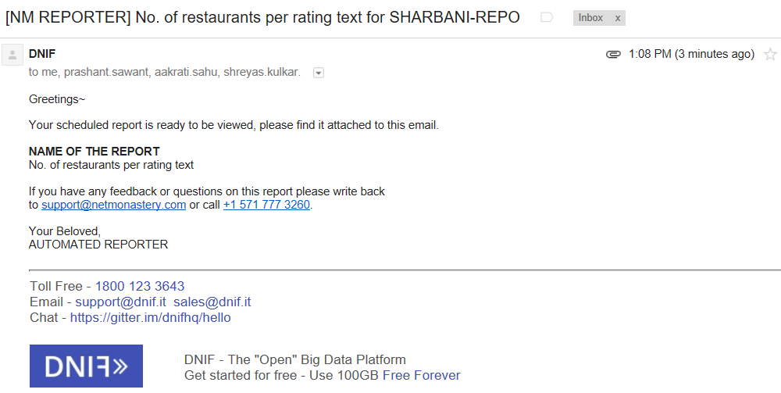

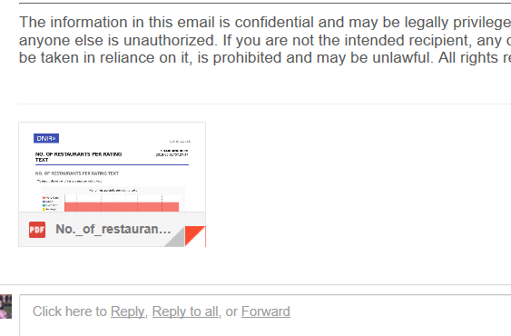

Let’s open the report.

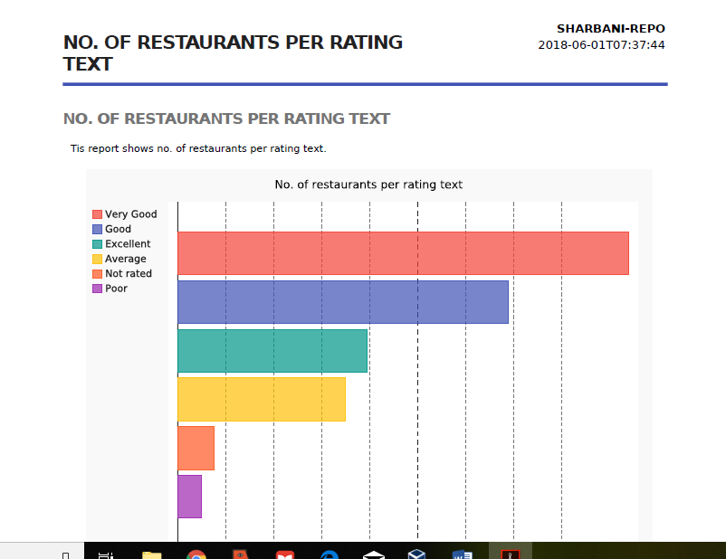

The report includes what we have written in the sections of Title and description and Horizontal Bar Chart which we have included in the report.

**Workbook:**

If we want to schedule an alert which will trigger after every specified duration workbooks are very useful way to do this. This eliminates the hassle of writing same query again and again in the search bar.

Suppose, Zomato takes vote for the restaurants every day from its users. It wants to check for every rating text how many restaurants are there every day. We will use the same query which we have used for creating the report-

**_fetch * from zomato limit 500 where $Duration=1h >>_agg count_unique $Ratingtext>>_sort by count_unique DESC**

And we want to run this query and send the notification mail to users every day. In workbooks there is a **Cron tab.** We can specify the duration after which we want this query to be triggered in the cron tab.

Please refer this document for the steps of creating Workbook-

<https://dnif.it/docs/guides/tutorials/how-to-create-workbooks.html>

In workbook the Name, Description, Reference, Tags these fields are self- explanatory. After that click on **‘Add new query’**. Insert the query which we want this workbook to execute in every specified duration. Here we will insert this query to run the query and send the output to our previously created notify group of Admins -

**_fetch * from zomato limit 500 where $Duration=1h >>_agg count_unique $Ratingtext>>_sort by count_unique DESC >> _trigger notify_group Admins**

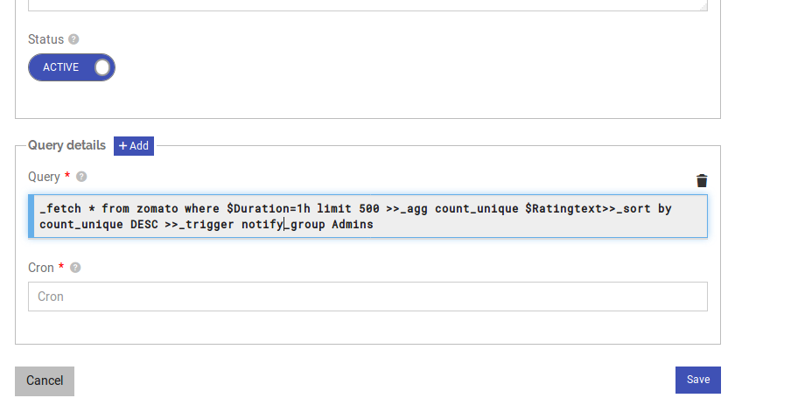

Now comes the turn of Cron tab. Refer the previously mentioned document or the website crontab.guru to understand this tab.

Let me show two examples. Suppose I want to schedule this query to run every day at 5 pm.

You should enter 17 at the hour section of the cron tab like this.

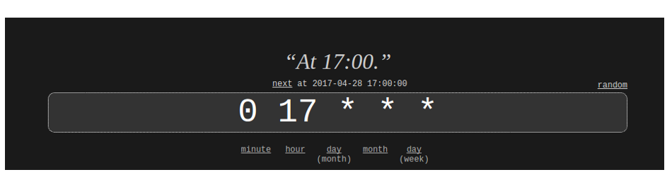

Next example, If you want your query to run every 04:05 am in the morning your cron tab should look like this –

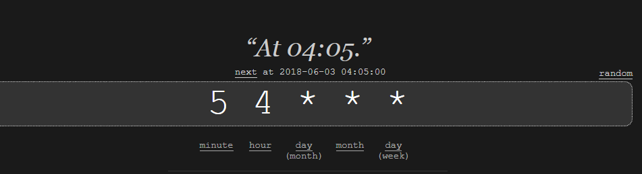

I want to run my workbook every day at 08:30 am. This is how my crontab looks

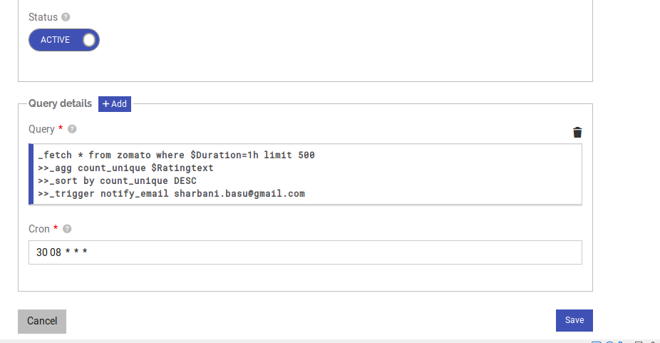

**_trigger Directive:**

We can also use _trigger directive to trigger reports, templates etc. to an email address or a notify group.

The syntax for triggering report is-

**_trigger report <package name> <report name> notify_email/notify_group email id/group name**

To trigger the report no_of_restaurants_per_rating_text the query is –

**_trigger report Sharbani no_of_restaurants_per_rating_text notify_group admins**

Please refer this document to know more about query directive-

<https://dnif.it/docs/learn/DQL/trigger.html>

**To send alerts for Dynamic Data:**

To know the process and codes for bringing dynamic data from Websites/API follow these documents –

<https://github.com/dnif/DigiVigi/blob/master/Process_1>

<https://github.com/dnif/DigiVigi/tree/master/Process_2>

After dynamic data is posted in DNIF web console to see the data we have to use this query to see the data-

_fetch * from event limit 100/500 (as per the number of records)

So in case of dynamic data we have to use event as event store name. Here in all the examples I have used zomato as event store name. When you are working on dynamic use event as the name of event store in all those queries.

We have coded our web scrappers in a way that it updates the data when they are changed in the source website. So the data which is stored in DNIF gets updated periodically. So when we are using a workbook to send alerts via mail after a particular period it will send the updated data.