IBM JAVA FULL STACK DEVELOPER BATCH

(OB – 19Th August)

LIST OF ALL THE FINAL PROJECTS

**CONDUIT**

**Problem Statement:** To develop Secure Single Page Application for the users to publish articles and also provide a platform for community specific discussions.

Conduit is a web application where users can read the articles,publish a new article even like the articles.All the articles published in this application can be viewed in Globalfeed section and liked articles will be displayed in the Yourfeed section. Users can search for articles by titles or by the tags. Users are given the privilege to comment on the articles as well as reply to the comments.

Git: <https://github.com/keerthanpm/CommunitySharingPlatform>

Thread- service : <https://thread-service.herokuapp.com/>

thread-interceptor-service: <https://thread-interceptor.herokuapp.com/>

Angular - <http://conduit.cfapps.io/>

MailServer - <https://mailservice.cfapps.io/>

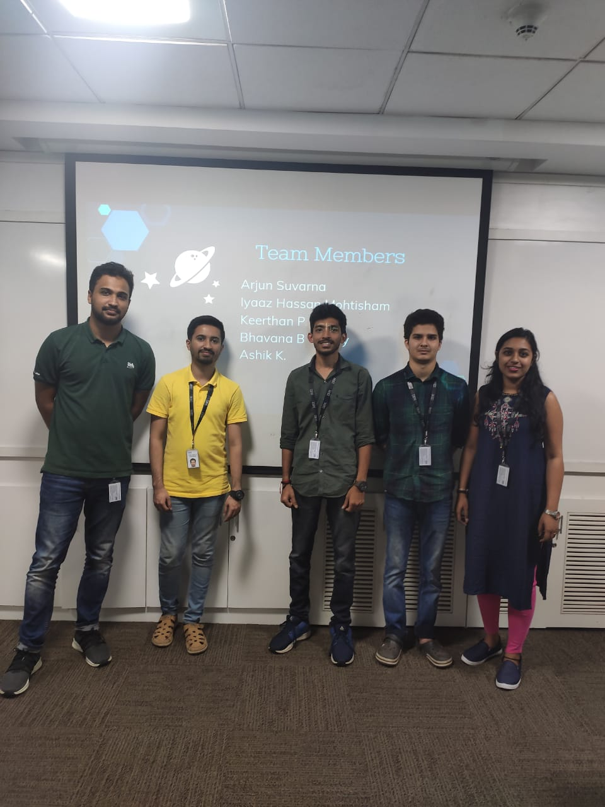

**Project Management**

**Problem Statement:** To create a single page application to manage all project related activities like project creation, assignment of the projects to the manager. Creation of the tasks and the subtask and their assignments to the employees. Viewing the progress of each subtask, task and the project.

Project management tool defines 3 main roles namely the admin, manager and the employee. Initially the admin creates a project and assigns to a manager who is available. A notification is sent to the manager with his login credentials which is auto generated. Once the manager logins in using these credentials, he can create the tasks and subtasks for the project and assign the employees for the subtasks. A mail is sent to all employees selected for the project which includes their login credentials respectively. When a subtask is assigned to an employee based on his expertise, a mail is sent to him notifying him of his newly assigned subtask. Then the employee can login using his credentials and then view his subtasks and also the progress percentage of that subtask. He can also update the progress percentage of his subtask.

Git: <https://github.com/Anusha-A/ProjectManagement.git>

Admin Service: <https://projectmanagementadminservice.cfapps.io/>

Login Service: <https://projectmanagementloginspring.cfapps.io/>

Manager Service: <https://projectmanagementmanagerservice.cfapps.io/>

Employee Service: <https://projectemployeeservice.cfapps.io/>

Angular: <http://projectmanagement.cfapps.io/>

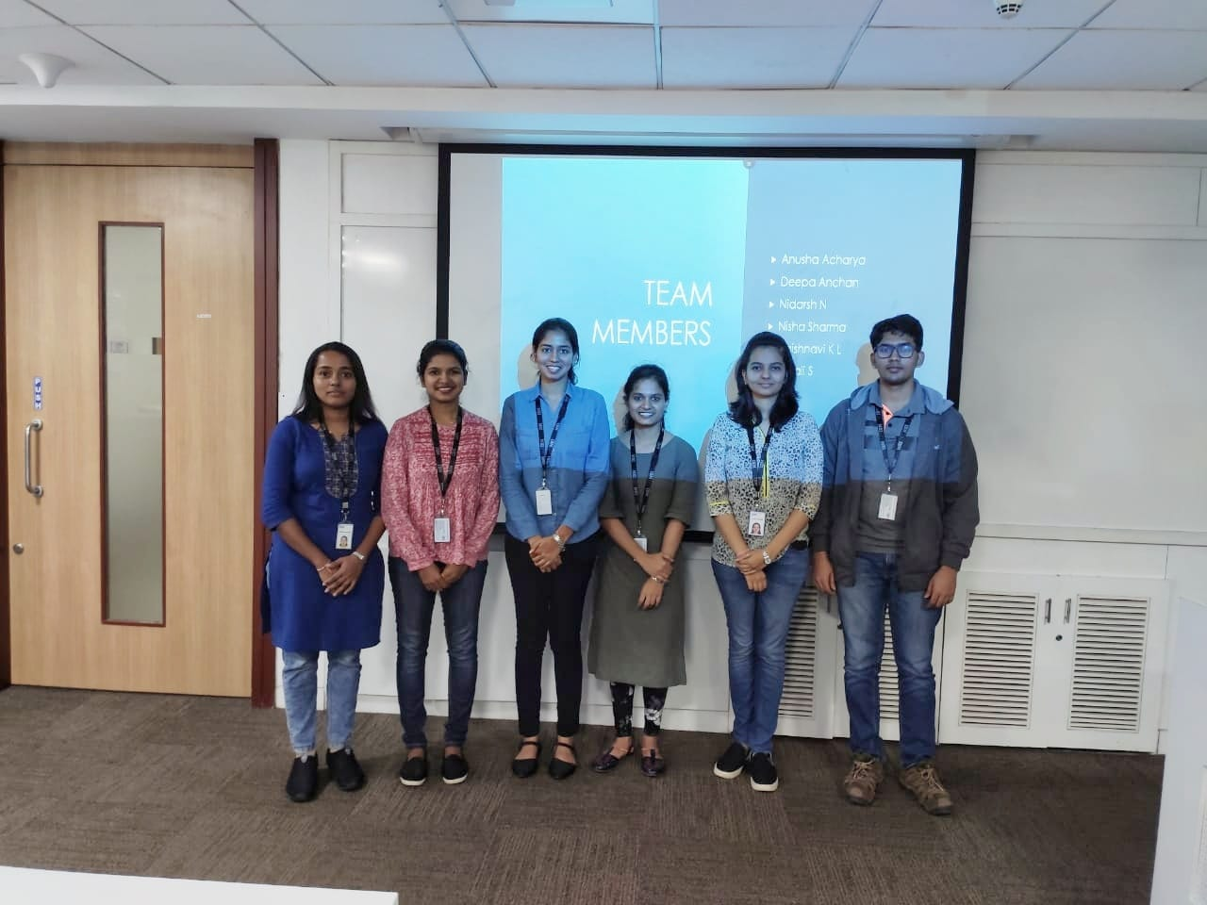

**E Gas Seva**

**Problem Statement**: To Provide an in-depth services for gas agency of Indian company highly benefiting their customers in vast area of company services providing to them, making the path for LPG Gas Connection and other services a smooth one.

Core application that is to be developed for allowing user to register for a new gas connection and also let existing user to book a cylinder .It also has a shopping cart that allows the user to buy gas related products. It also helps dealers to keep track of all his users and also his personal transaction

GitHub : https://github.com/Kiittyka/EGasSeva

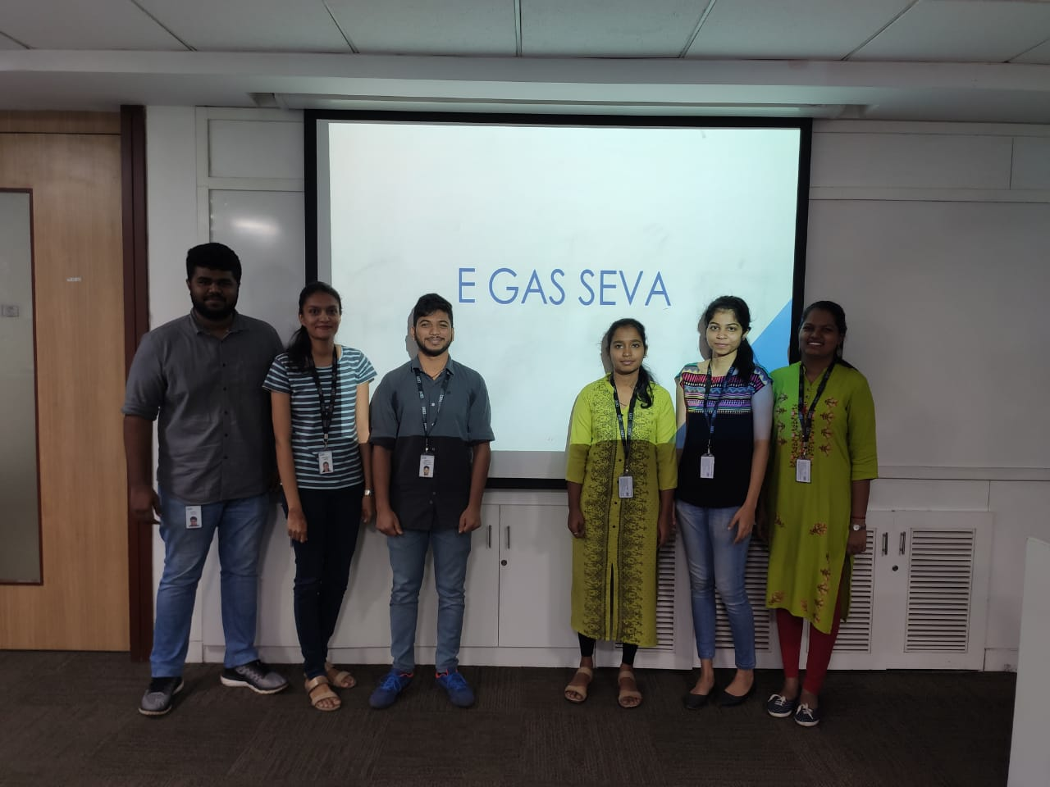

**PEOPLE’S HEALTH**

**Problem Statement** :To develop an application that enables patients to view hospital details, book and pay for their appointments, and also to post online feedback and queries.

People’s Health manages user and hospital data in order to facilitate the patient/users of the system to book hospital appointments as well as view their already booked appointments remotely. It enables users to access and pay for healthcare services without much difficulty. The software also includes a provision for users to make online payments and post their queries and feedback, if any. It also has provisions for the Admin to add doctors to particular branch and specialization as well as to manage all the appointment details and also reply to the enquiries made during appointment.

Git:<https://github.com/ramya123590/fsdProject.git>

DataBase:

https://us-east-2.console.aws.amazon.com/rds/home?region=us-east-2#databases: (Amazon AWS)

Instance - database-1.cjf8p0uqfj31.us-east-2.rds.amazonaws.com

Port – 3306

User Service: https://peolpeshealthdemo.cfapps.io/

Admin Service:https://admin-backend-12nn.cfapps.io/

OTP Service: https://peopleshealthotp.cfapps.io/

Payment Service: https://peopleshealthpayment.cfapps.io/

Angular: http://hospitalappointment3.cfapps.io/

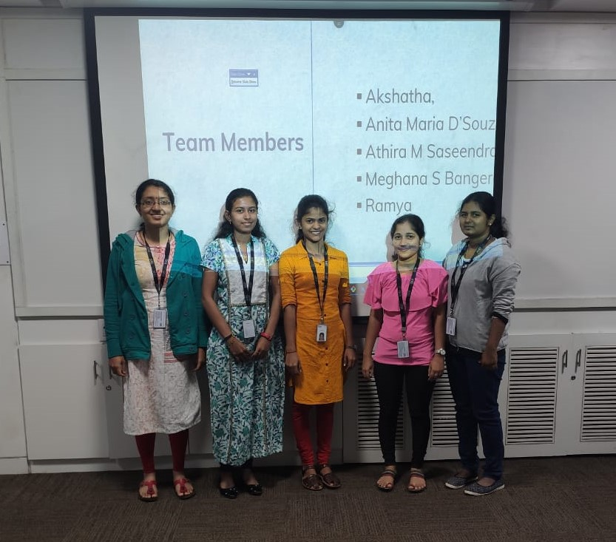

**RENTKARO**

**Problem Statement** :To build a single page application Rentkaro, that allows customers to rent products online.

The main scope of the project is to provide users a one stop rental portal. It provides services such as hiring automobiles, furniture and appliances. Customers should register on the portal in order to add the product to cart. Customers can view products based on the city. He can choose the products from the available list and then also select the quantity and the time period in months that he needs to rent the particular product. Once the order is confirmed, he needs to finish the payment for the order to be processed.

Git : <https://github.com/shefalibs/Rentkaro>

DataBase: [database-rentasticdb.cfxakz5cuf9b.us-east-2.rds.amazonaws.com](http://database-rentasticdb.cfxakz5cuf9b.us-east-2.rds.amazonaws.com)(Amazon AWS)

Angular: [angularapp.cfapps.io](http://angularapp.cfapps.io)

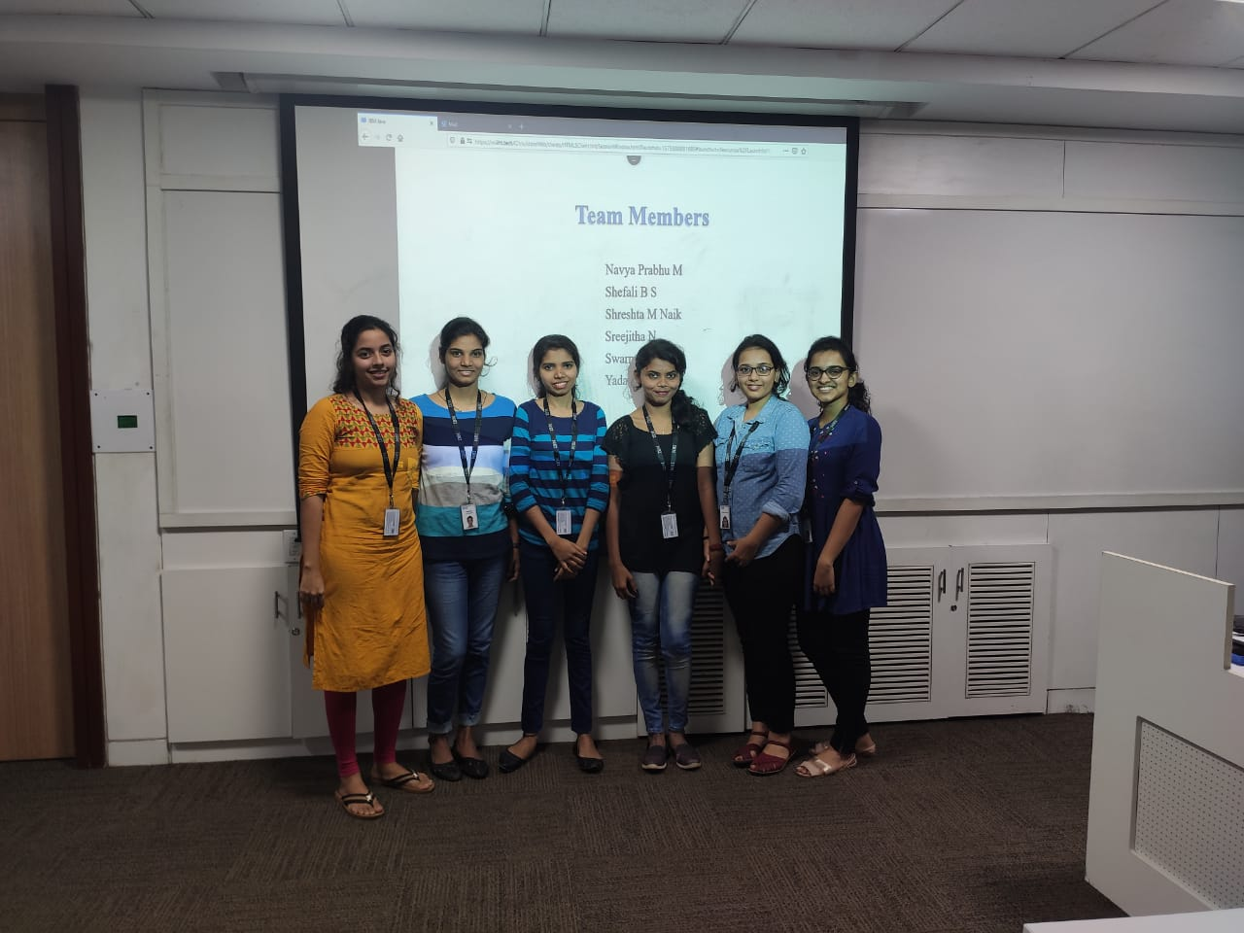

**SKILL TRACKER**

**Problem Statement:** John Dempsey works in an IT company. He is a new age HR Academic Manager. Few of his roles and responsibilities includes:

Keeping track of skill of individual Full Stack Engineers. To use the single page solution to keep track of associate skills. The proposed solution (Skills Tracker) will try to provide the above-mentioned features.

The Skills Tracker should be a Single Page Application (SPA). Using this internal portal John Dempsey will be able perform following operations:

**Search Associate**: John will be able to search associate with following criteria:

Search by associate name

Search by Email ID

Search by Mobile Number

Search by Country

Search by Skills

**Add new Associate:** John will be able to add new associate and its respective Full Stack Development Skills.

**Edit, Delete & View Associate:** The associate information which is searched can be updated, deleted ,viewed and communicated through email.

**Add Skill:** It will allow John to add new skills so that it can be used in “Add New Associate” page.

**Git**  : [https://github.com/sanath-acharya/Skill-Tracker](https://github.com/sanath-acharya/Skills-Tracker)

**SkillTracker** : http://skilltracker1.cfapps.io/

**MailService** : <https://mailserver.cfapps.io/>

**HR Service** : <https://skilltrackerhrsevice.cfapps.io/>

Database : skilltracker-1.cyi7sno1sh8z.us-east-2.rds.amazonaws.com/skills

