Evidences:

Screenshots are mentioned below as a successful setup showing project window

Composer

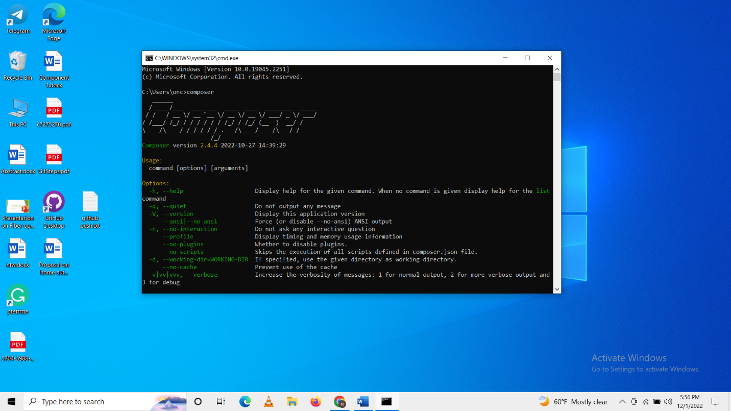

Fig: Command showing composer (PHP’s dependency manager)

Laravel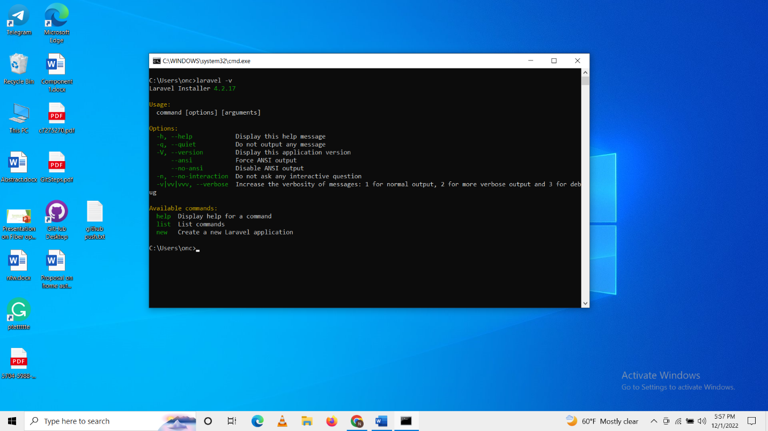

Fig: Command showing Laravel version

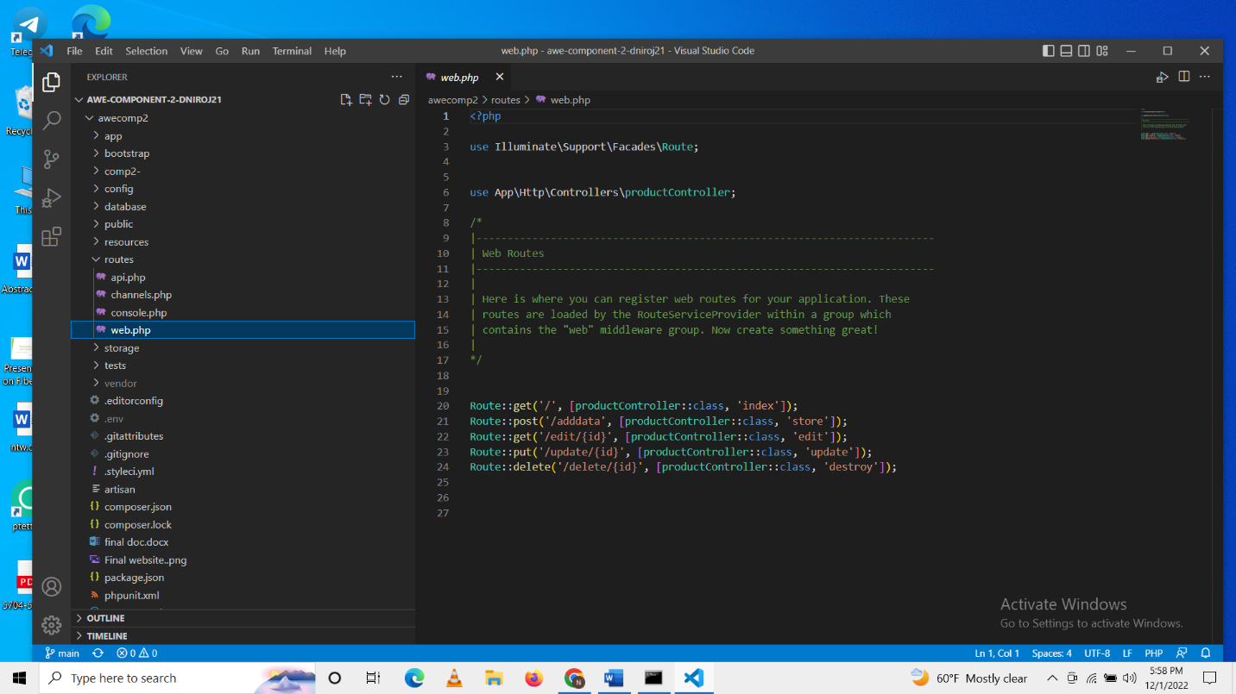

Fig: Sublime text 3 (showing the Laravel project folder in an IDE)