Индивидуальное задание

**Рассчитать время доставки по регионам**

SELECT

Region,

Round(AVG(Ship_Date - Order_Date),2) AS Time_Dilivery

FROM

Orders

GROUP BY

Region

ORDER BY

Time_Dilivery DESC;

**Создать таблицу по продажам сегментов**

DROP TABLE IF EXISTS Segment_Sales;

CREATE TABLE Segment_Sales AS

SELECT

Segment,

ROUND(SUM(Sales),2) AS Total_Sales

FROM

Orders

GROUP BY

Segment;

SELECT * FROM Segment_Sales

**Найти прибыль по городам**

SELECT

City,

ROUND(SUM(Profit),2) AS Total_Profit

FROM

Orders

GROUP BY

City

ORDER BY

Total_Profit DESC;

Создание физической модели

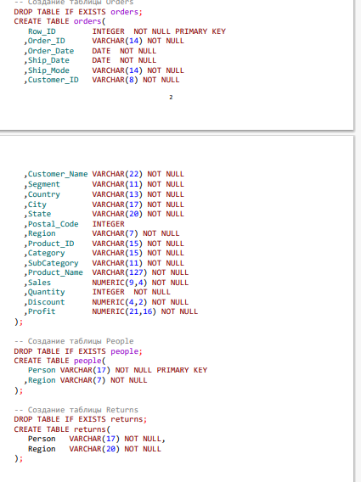

Практическая часть

