NAME  Dana Llanes |  | DATE  Feb 4, 2017 | SCORE
SCHEDULE  Saturday – 10:00-1:00 | SCORE |  | SCORE

LABORATORY EXERCISES
RECURSION

OBJECTIVES:
- Understand recursion and its parts
- Use recursion to solve programming problems

PROCEDURE:
- Encode the C++ program below.
- Save as rec1.cpp,and rec2.cpp, respectively.
- Compile and run the program by pressing Ctrl + F9.
- For each syntax or logical error encountered in the given program, do the following:
- Correct the error
- Recompile the program
- Repeat step 4 until no errors are encountered in the program.
- Illustrate the output of the modified program.

Program No. 1

#include <iostream>
Output:

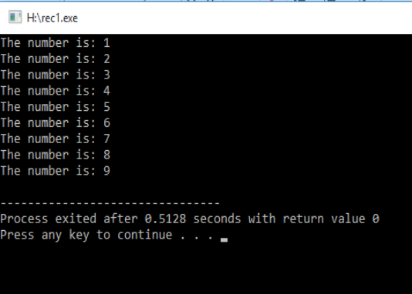

using namespace std;

void numberFunction(int i) {
cout << "The number is: " << i << endl;
i++;
if(i<10) {
numberFunction(i);
}
}

int main() {

int i = 1;
numberFunction(i);

return 0;
}

Program No. 2

#include <iostream>
using namespace std;

int factorial(int);

int main() {
int n;
cout<<"Enter a number to find factorial: ";
cin>>n;
cout<<"Factorial of "<<n<<" = "<<factorial(n);
return 0;
}
Output:

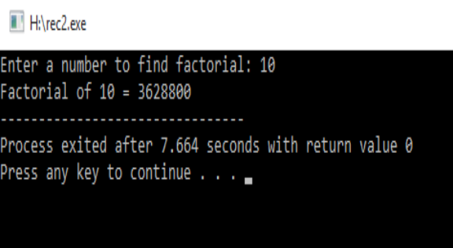

int factorial(int n) {
if (n>1) {
return n*factorial(n-1);
}
else {
return 1;
}
}

Supplementary Problem

- A recursive function that sums up the 10 integers in an array.

Program:

#include <iostream>
using namespace std;

int sum_array( int array[], int n ){
if (n < 0) {
return 0;
}else{
return array[n]+sum_array(array,n-1);
}
}
int main()
{
int array[] = {1,2,3,4,5,6,7,8,9,10};
int sum;
sum =sum_array(array,9);
cout<<"Sum of 10 elements are: "<<sum;

return 0;
}

Output:
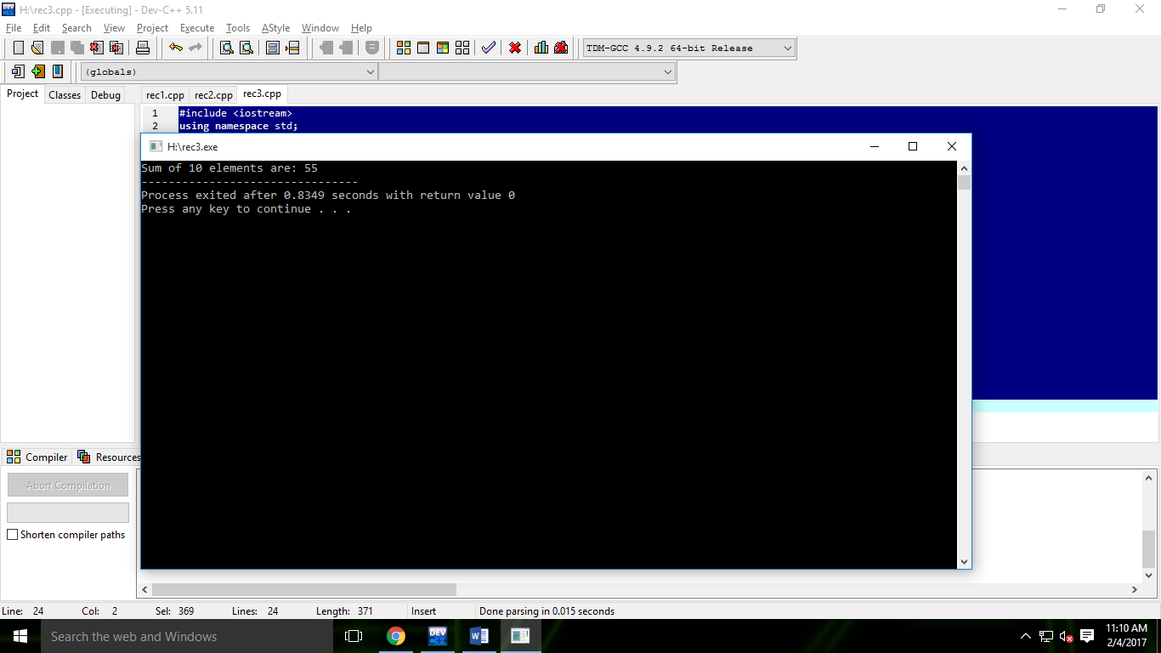

- A recursive function to produce the Fibonacci number for a given index in the series.
Use the function int fibonacci(int n)

Program:

#include <iostream>
using namespace std;

int fibonacci(int n){
if (n==0){
return 0;
}else if (n==1){
return 1;
}else
return fibonacci(n-1)+fibonacci(n-2);
}
int main(){
int n;
cout<<"Enter fibonacci number:";
cin>>n;
cout<<fibonacci(n);

return 0;
}

Output:
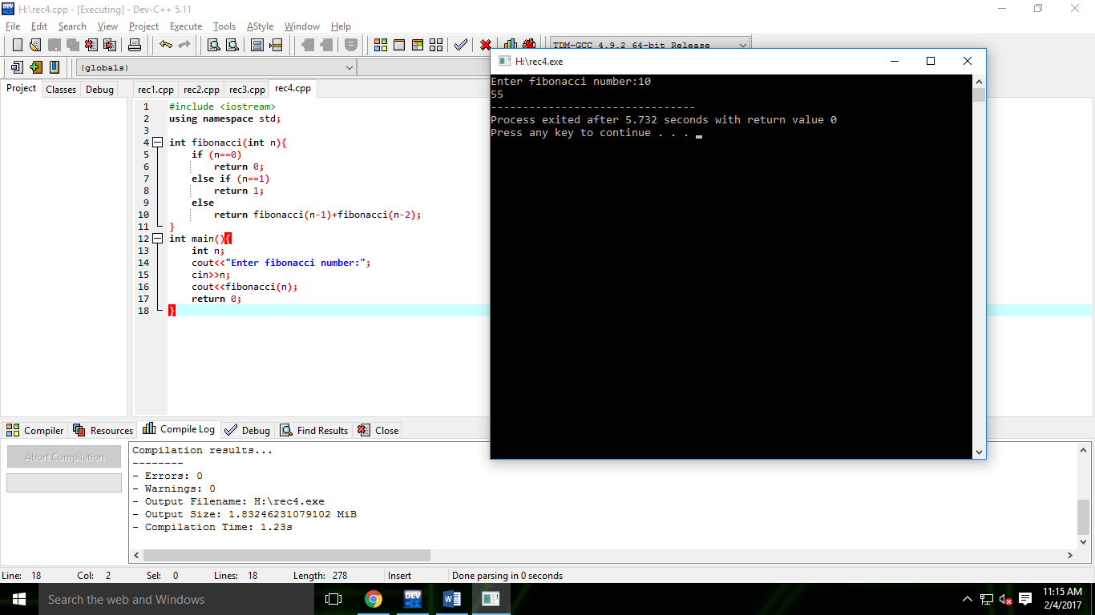

- A recursive function which raises its first parameter to the power of its second parameter.
Use the function int power(int number, int pow)

Program:

#include <iostream>
using namespace std;

int power(int number, int pow){
if (pow==1)
return number;
else
return number*power(number,pow-1);
}
int main(){
int number;
int exp;
cout<<"Input number: ";
cin>>number;
cout<<"Input exponent: ";
cin>>exp;
cout<<"Result is "<<power(number,exp);

return 0;
}

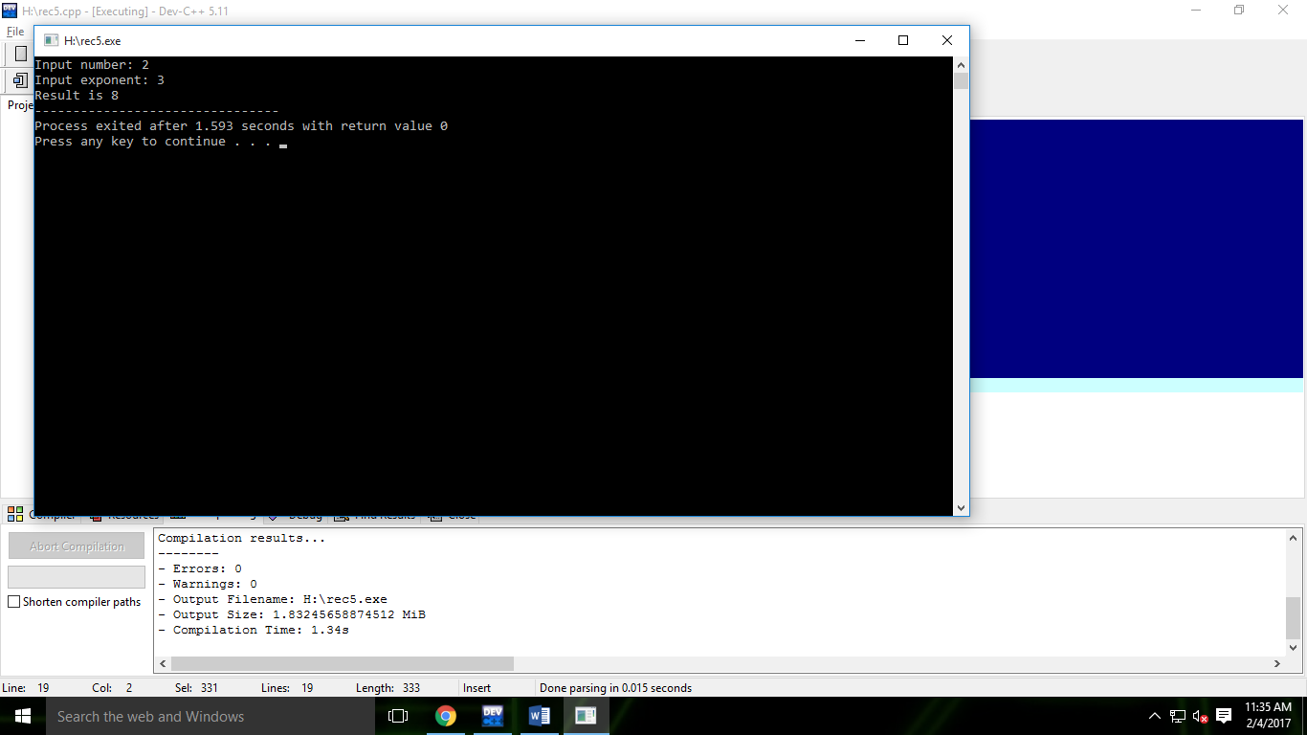
Output:

