A Major Project Report
on
PROJECTPILOT AI
AI-Powered Software Engineering and Project Management Platform
By
1. SALONI RAJABHAU GADEKAR (A-724)
2. DEEPTI NITIN MAHAJAN (A-756)
3. NANDINI UMESH MANE (A-758)
4. TEJAL JITENDRA MHATRE (A-762)

under the guidance of
Mr. D. P. Kapse

Juhu-Versova Link Road Versova, Andheri(W), Mumbai-53.
Department of Computer Engineering
University of Mumbai
October – 2026

Juhu-Versova Link Road Versova, Andheri(W), Mumbai-53.
Department of Computer Engineering
Certificate
This is to certify that
1. SALONI RAJABHAU GADEKAR (A-724)
2. DEEPTI NITIN MAHAJAN (A-756)
3. NANDINI UMESH MANE (A-758)
4. TEJAL JITENDRA MHATRE (A-762)
Have satisfactorily completed this project entitled
“PROJECTPILOT AI”
AI-Powered Software Engineering and Project Management Platform
Towards the partial fulfilment of the
BACHELOR OF ENGINEERING
IN
(COMPUTER ENGINEERING)
as laid by University of Mumbai.
Mr. D. P. Kapse  Guide | Prof. S. P. Khachane  Head of Department

Dr. Sanjay Bokade
Principal
Project Report Approval for B. E.
This project report entitled PROJECTPILOT AI – AI-Powered Software Engineering and Project Management Platform by Saloni Gadekar, Deepti Mahajan, Nandini Mane and Tejal Mhatre is approved for partial fulfilment of the degree of Bachelor of Engineering in Computer Engineering.

Examiners
1. _______________________________
2. _______________________________

Date:
Place:
Declaration
We wish to state that the work embodied in this project titled “PROJECTPILOT AI” forms our own contribution to the work carried out under the guidance of “Mr. D. P. Kapse” at the Rajiv Gandhi Institute of Technology.
We declare that this written submission represents our ideas in our own words and where others’ ideas or words have been included, we have adequately cited and referenced the original sources. We also declare that we have adhered to all principles of academic honesty and integrity and have not misrepresented or fabricated or falsified any idea/data/fact/source in our submission. We understand that any violation of the above will be cause for disciplinary action by the Institute and can also evoke penal action from the sources which have thus not been properly cited or from whom proper permission has not been taken when needed.

(Students Signatures)
SALONI RAJABHAU GADEKAR (A-724) _________________
DEEPTI NITIN MAHAJAN (A-756) _________________
NANDINI UMESH MANE (A-758) _________________
TEJAL JITENDRA MHATRE (A-762) _________________
Abstract
Software development teams often struggle to track project risk in real time because critical information is scattered across disconnected tools, such as source code repositories, issue trackers and team meetings, with no single system connecting them. As a result, delays, quality issues and resource imbalances are usually discovered only after they have already affected the project. Moreover, even where AI-based predictions are available, they are often difficult to interpret, leaving teams unsure why a risk score is high.
This project proposes ProjectPilot AI, an AI-powered software engineering and project management platform that gives teams continuous and explainable visibility into project risk across the software development lifecycle. The platform uses Large Language Models (LLMs) to convert requirements into development tasks, assist sprint planning, summarise meetings and extract action items, and answer project-related questions through a retrieval-augmented assistant. It monitors GitHub activity, such as commits and pull requests, to derive code-aware risk indicators; performs bus-factor analysis to identify potential single points of knowledge failure; and detects workload imbalance and overload risk from developer activity patterns. A machine learning model based on XGBoost predicts delay and risk, and SHAP (SHapley Additive exPlanations) identifies the key factors contributing to each prediction. These signals are finally combined into a single Release Readiness Score that supports informed go/no-go deployment decisions, while the final decision always remains with the project manager.
The platform is based on a Next.js dashboard, a FastAPI backend, PostgreSQL for structured data, and Groq-hosted LLMs for natural-language tasks, supported by Whisper for meeting transcription and Sentence Transformers for semantic retrieval. By connecting planning, development, monitoring and release in one explainable system, ProjectPilot AI aims to show that AI-assisted project management can provide technically rigorous and interpretable insights for software engineering teams.
This report presents the problem analysis, literature survey, proposed system, design and methodology of ProjectPilot AI, together with the software and hardware set-up and the implementation plan for the next semester.
Keywords: Software Project Management, Project Risk Prediction, Explainable AI, SHAP, XGBoost, Large Language Models, Retrieval-Augmented Generation, Bus Factor, Workload Analysis, Release Readiness.
Contents
List of Figures vii
List of Tables viii
List of Algorithms ix
List of Symbols x
1 Introduction 1
1.1 Introduction Description 1
1.1.1 Background 1
1.1.2 Project Overview 1
1.1.3 Motivation 3
1.1.4 Need for the System and Significance 3
1.2 Organization of Report 4
2 Literature Review 5
2.1 Survey of Existing Systems 5
2.2 Limitation of Existing Systems or Research Gap 9
2.3 Problem Statement and Objectives 10
2.3.1 Objectives 10
2.4 Scope 11
2.4.1 Scope of the Project 11
2.4.2 Applications 11
2.4.3 Limitations and Assumptions 11
2.4.4 Future Scope 12
3 Proposed System 13
3.1 Proposed System Statement 13
3.2 Analysis / Framework / Algorithm 14
3.2.1 Analysis 14
3.2.2 Framework 16
3.2.3 Algorithms and Techniques 16
3.3 Design Details 18
3.3.1 System Architecture 18
3.3.2 Detailed Design (UML) 21
3.4 Methodology 24
4 Experimental Set up 26
4.1 Details of Database or Details about Input to Systems or Selected Data 26
4.1.1 Input data sources 26
4.1.2 Database 26
4.1.3 Training data and the cold-start problem 26
4.2 Performance Evaluation Parameters (for Validation) 27
4.2.1 ML model: delay and risk prediction 27
4.2.2 Explainability 27
4.2.3 LLM-based modules 27
4.2.4 System-level 27
4.3 Software and Hardware Set up 28
4.3.1 Software Requirements 28
4.3.2 Hardware Requirements 29
5 Implementation Plan for Next Semester 30
5.1 Partial Implementation 30
5.2 Implementation Plan for Next Semester (Gantt Chart) 30
References 33
Acknowledgement 34
List of Figures
Figure 3.1: System architecture of ProjectPilot AI 19
Figure 3.2: System flowchart of ProjectPilot AI 20
Figure 3.3: Use case diagram of ProjectPilot AI 21
Figure 3.4: Risk prediction, explanation and release readiness pipeline 22
Figure 3.5: Sequence diagram: from a GitHub event to an explained risk alert 23
Figure 5.1: Gantt chart for next semester implementation (proposed) 31
List of Tables
Table 1.1: Sources of project information and the signals they hold 3
Table 2.1: Summary of the literature surveyed 5
Table 2.2: Comparison of existing practice and the proposed ProjectPilot AI 9
Table 3.1: Modules of ProjectPilot AI 13
Table 3.2: Users of the system 14
Table 3.3: Functional requirements 15
Table 3.4: Non-functional requirements 15
Table 3.5: Principal data entities (logical design) 23
Table 3.6: Module-wise input, processing and output 25
Table 4.1: Input data sources of ProjectPilot AI 26
Table 4.2: Software requirements and technologies 28
Table 5.1: Proposed implementation plan for next semester 31
List of Algorithms
Sr. No. | Name
1 | LLM-based task generation and prioritisation
2 | Sprint planning support
3 | Speech-to-text transcription (Whisper) and meeting summarisation
4 | Extreme Gradient Boosting (XGBoost) for delay and risk prediction
5 | SHAP feature attribution
6 | Retrieval-Augmented Generation (embedding-based retrieval)
7 | Bus-factor analysis (proposed)
8 | Workload and overload analysis (proposed)
9 | Release Readiness Score aggregation (proposed)
List of Symbols
Symbol | Meaning
x_i | Feature vector of the i-th sample (for example, indicators of one task)
ŷ_i | Predicted output of the model for sample i
y_i | Actual (true) value for sample i
f_k | k-th decision tree in the XGBoost ensemble
K | Number of trees in the ensemble
l | Loss function measuring the error of a prediction
Ω | Regularisation term penalising model complexity
φ_0 | Base (average) prediction value in SHAP
φ_i | SHAP value: contribution of feature i to a prediction
M | Number of features
q, d | Embedding vectors of a query and of a stored item
sim(q, d) | Cosine similarity between q and d
RRS | Release Readiness Score
w_j, s_j | Weight and normalised score of the j-th component of the RRS
TP, TN, FP, FN | True positives, true negatives, false positives, false negatives

Chapter 1

Introduction

1.1 Introduction Description

1.1.1 Background
Software projects move through several connected stages: requirement analysis, task creation, sprint planning, development, monitoring, testing, deployment and maintenance. At every stage the team generates a large volume of data. Source code repositories such as GitHub record commits, branches and pull requests; task and issue records hold tasks, their status and sprint information; and meetings and team chats capture the decisions, commitments and concerns of the team. Taken together, these sources describe the true state of a project, but they are usually used through separate tools and are not connected to one another.
Project managers therefore have to collect and correlate this information manually, through status meetings, ticket reviews and informal discussion. This is time-consuming and depends heavily on individual judgement. Problems such as a slipping sprint, a pull request that has grown too large to review, a developer carrying too much work, or a module that only one person understands tend to stay hidden until they appear as a missed deadline or a defect at release time.
Recent progress in Machine Learning (ML) and Large Language Models (LLMs) has made it possible to automate parts of this work. Studies on the use of Artificial Intelligence (AI) in project management report benefits in automation, data analysis and decision support, while emphasising that human expertise remains necessary in complex and uncertain situations [2]. Research also stresses that the final decision should stay with the project manager, with AI acting as decision support [2]. This shows both the promise of AI-assisted project management and the importance of keeping people in charge of decisions.

1.1.2 Project Overview
ProjectPilot AI is an intelligent, full-lifecycle software engineering management platform that continuously monitors code, tasks and meetings and gives teams explainable, early warnings about project risk. It supports a project from planning, through development and monitoring, to the final release decision. The main capabilities of the proposed platform are as follows:
- Requirement analysis and task generation: LLMs convert project requirements into ready-to-assign development tasks.
- AI-assisted sprint planning: tasks are organised by priority, dependencies, workload and velocity into realistic sprint plans.
- Project and GitHub monitoring: commits, pull requests, issues and development progress are tracked continuously.
- Code-aware risk detection: risk indicators are derived from commit and pull-request activity.
- Bus-factor analysis: areas of the project whose knowledge is concentrated in very few people are identified as potential single points of knowledge failure.
- Workload and overload analysis: team members who are overloaded, or who have spare capacity, are identified from developer activity patterns.
- Delay and risk prediction: an XGBoost model trained on historical task data flags tasks that are likely to be late.
- Explainable risk scoring: SHAP identifies the key factors contributing to each prediction.
- Meeting summarisation and action-item extraction: meeting audio is transcribed with Whisper, then summarised by an LLM into clear action items.
- AI-powered project assistant: an LLM with Retrieval-Augmented Generation (RAG) answers project-related queries from project data.
- Automated reporting and smart notifications: daily and weekly status reports are generated automatically, and alerts are raised only for genuine blockers and at-risk items.
- Release Readiness Score: the individual signals are combined into one project-level score to support go/no-go deployment decisions.
It is important to distinguish the roles of the different techniques used in the platform. LLMs are used for language tasks such as task generation, planning support, summarisation and question answering. Delay and risk prediction is performed by a separate ML model (XGBoost) and not by an LLM, and SHAP is used to explain the predictions of that model. The Release Readiness Score is a project-level indicator that combines the available signals; it is neither the prediction of risk for a single task nor an explanation of it. In line with a human-in-the-loop principle, the platform only recommends and alerts; the go/no-go decision is always taken by the project manager.
The platform is based on a Next.js dashboard, a FastAPI backend, PostgreSQL for structured data, Groq-hosted LLMs for natural-language tasks, and XGBoost with SHAP for explainable machine learning. These technologies are described in detail in Chapter 3 and Chapter 4.

1.1.3 Motivation
The motivation for this project comes from four observations about how software projects are monitored today.
Project information is scattered. As summarised in Table 1.1, each tool holds only one part of the project picture, and no single system connects them. Research on multi-modal agile project management makes the same point: conventional agile tools are limited because they rely on separate data sources, which forces users to filter collaboration data manually [5].
Table 1.1: Sources of project information and the signals they hold
Source | Data available | Project signals it can provide
GitHub | Commits, pull requests, branches, code | Development progress, nature and size of changes, distribution of work across developers
Task and issue records | Tasks, issues, sprint data, updates | Task status, sprint progress, work assigned to each team member
Meetings | Transcripts, notes | Decisions taken and action items agreed
Team chats | Messages, discussions | Informal communication and discussion among team members

Problems are found late. Delays, quality issues and resource imbalances are typically discovered only after they have already affected the project. Traditional monitoring is therefore reactive; a system that watches the data continuously can warn the team earlier.
Predictions are hard to interpret. Even where AI-based predictions exist, a bare risk score does not tell the team what to fix. Explainable approaches, such as the use of SHAP alongside a gradient-boosting model for effort, cost and delay-risk decisions [1], show that it is practical to attach reasons to a prediction and this makes the result actionable.
Human factors are rarely tracked. Overloaded developers and knowledge concentrated in one person are real project risks, but they are not visible in ticket status alone. They have to be inferred from code and activity data.

1.1.4 Need for the System and Significance
There is a need for a single system that brings together requirements, tasks, code activity and meeting outcomes, watches them continuously, and explains its warnings in terms a team can act on. Such a system would help project teams to:
- detect delays and risky changes early, instead of after they have become visible;
- see workload imbalance and single points of knowledge failure before they affect delivery;
- understand why a task or release is considered at risk, through explainable predictions;
- save manual effort in task creation, sprint planning, meeting minutes and status reporting; and
- take go/no-go release decisions on the basis of combined evidence rather than intuition.
The significance of ProjectPilot AI lies in connecting the software development lifecycle, from planning through deployment and maintenance, into one explainable system. It combines approaches that have so far been studied separately, such as LLM-based requirement handling [4], ML-based risk prediction [1], [3], and multi-source project monitoring [5], into a unified platform, and it keeps the project manager in control of the final decision.

1.2 Organization of Report
The report is organised into five chapters, following the prescribed format of the Department of Computer Engineering:
- Chapter 1 – Introduction: describes the background, overview, motivation and need for ProjectPilot AI, and outlines the organisation of the report.
- Chapter 2 – Literature Review: surveys existing research on AI in project management, software risk prediction and LLM-based requirement handling, identifies their limitations and the research gap, and states the problem statement, objectives and scope.
- Chapter 3 – Proposed System: presents the proposed system, its analysis and algorithms, design details (system architecture and detailed design) and the methodology followed.
- Chapter 4 – Experimental Set up: describes the data used by the system, the performance evaluation parameters, and the software and hardware set-up.
- Chapter 5 – Implementation Plan for Next Semester: presents the partial implementation and the plan, in the form of a Gantt chart, for completing the project in the next semester.
The report concludes with the list of references and the acknowledgement.
Chapter 2

Literature Review
Before designing ProjectPilot AI, we studied published work on machine learning for software project management, the use of AI in project management, software risk prediction, LLM-based requirements handling and multi-source project risk monitoring. The papers below shaped the objectives and design of the proposed system. Only information available in the sources we reviewed is reported; where a detail is not available to us, it is stated as such.

2.1 Survey of Existing Systems
Research relevant to this project can be grouped into the following categories:
- Predictive and explainable approaches: machine learning models that estimate effort, cost, delay or risk, with explanation of their output (Papers 1 and 3).
- Review and decision-support studies: work on the role of AI in project management and on how it should be combined with human judgement (Paper 2).
- LLM-based requirements engineering: generation and prioritisation of user stories and requirements using Large Language Models (Paper 4).
- Multi-source agile project risk management: systems that combine several project data sources to build backlogs and monitor risk (Paper 5).
The papers are summarised in Table 2.1 and discussed in detail below.
Table 2.1: Summary of the literature surveyed
Sr. | Title (Authors) | Publication and year | Methodology used | Findings
1 | A System-Oriented Machine Learning Approach for Planning and Execution of Decisions in Software Project Management (F. Gazzawe) | IJACSA, 2026 | DeciBoost-PM using CatBoost on Desharnais, PROMISE and an Apache issue-tracking dataset; SHAP for explainability | Supports effort, cost and delay-risk decisions across planning and execution; showed cross-dataset robustness and explainability
2 | Integrating Artificial Intelligence in Project Management: Challenges and Opportunities (U. Reddy et al.) | IEEE INCIP, 2025 | Review of AI in project management: automation, data analysis, decision support and the role of human judgement | AI can improve data analysis and decision-making, but human expertise remains necessary in complex and uncertain situations
3 | Software Risk Prediction at Requirement and Design Phase: An Ensemble Machine Learning Approach (Y. Assefa et al.) | IEEE ICT4DA, 2023 | Software-risk datasets from Zenodo and Harvard; four ensemble ML algorithms compared | Gradient Boost performed best and was selected; about 98.67% accuracy reported in their experiments
4 | Prioritizing Software Requirements Using Large Language Models (M. A. Sami et al.) | arXiv, 2024 | Web tool (React, Flask, OpenAI APIs) generating and prioritising user stories with LLMs, AHP and MoSCoW | LLMs can automate user-story generation and prioritisation; average prioritisation time of about eight seconds reported
5 | MAPM: Multi-Modal Auto-Agile Project Risk Management and Prediction for Collaboration Platform Using AI/ML (P. Sun and Q. Shao) | Technical Disclosure Commons, 2023 | Multi-modal agile system using conferencing and collaboration data to generate sprint backlogs and support risk management | Addresses limits of conventional agile tools by combining data sources for more real-time risk monitoring

Paper 1: A System-Oriented Machine Learning Approach for Planning and Execution of Decisions in Software Project Management
[1] F. Gazzawe, International Journal of Advanced Computer Science and Applications (IJACSA), 2026.
The paper proposes DeciBoost-PM, a machine learning approach that supports decisions across the planning and execution phases of software project management. The model is based on CatBoost, a gradient-boosting algorithm, and is evaluated on three public datasets: Desharnais, PROMISE and an Apache issue-tracking dataset. SHAP is used to explain the model outputs. The approach supports effort, cost and delay-risk decisions and was shown to remain robust across datasets.
Relevance to ProjectPilot AI:
This is the closest reference for ProjectPilot AI’s prediction layer. It supports the choice of a gradient-boosting model together with SHAP for explainable delay and risk prediction, while ProjectPilot AI extends the idea with repository-level signals.
Advantages:
- Covers both planning and execution decisions rather than a single estimate
- Uses SHAP so that predictions can be explained
- Tested on more than one dataset, which supports its robustness
Limitations:
- Works on project-level datasets; the material we reviewed does not describe use of live code-level signals such as commits and pull requests
- The material does not describe workload, bus-factor or release-readiness analysis
Paper 2: Integrating Artificial Intelligence in Project Management: Challenges and Opportunities
[2] U. Reddy, Y. P. Rangaiah, A. Nagpal, A. Meheta, G. Karuna and K. Adnan, IEEE INCIP, 2025.
This paper reviews the use of AI in project management, focusing on automation, data analysis and decision support. It also examines the role of human judgement alongside AI. It concludes that AI can improve data analysis and project decision-making, but human expertise remains necessary for complex and uncertain situations.
Relevance to ProjectPilot AI:
The paper supports the human-in-the-loop principle followed by ProjectPilot AI: the platform flags and explains, while the project manager takes the final go/no-go decision.
Advantages:
- Gives a balanced view of both challenges and opportunities
- Highlights the continuing importance of human judgement
Limitations:
- Being a review, it does not present or evaluate a specific system
- Does not propose a concrete method for explainable risk prediction
Paper 3: Software Risk Prediction at Requirement and Design Phase: An Ensemble Machine Learning Approach
[3] Y. Assefa, E. Alemneh, S. Nibret and A. Worku, IEEE ICT4DA, 2023.
The study uses software-risk datasets from Zenodo and Harvard and compares four ensemble machine learning algorithms for predicting software risk at the requirement and design phase. Gradient Boost achieved the best performance and was selected as the final model, with about 98.67% accuracy in the reported experiments.
Relevance to ProjectPilot AI:
It supports the use of tree-based boosting models (XGBoost) for risk prediction in ProjectPilot AI. The reported accuracy belongs to that study and is not a result of ProjectPilot AI.
Advantages:
- Shows that ensemble tree-based models are effective for software risk prediction
- Applies prediction early in the lifecycle (requirement and design phases)
Limitations:
- Concerned with the requirement and design phases; it does not use continuously updated repository activity
- The material we reviewed does not mention explainability of the predictions
Paper 4: Prioritizing Software Requirements Using Large Language Models
[4] M. A. Sami, Z. Rasheed, M. Waseem, Z. Zhang, T. Herda and P. Abrahamsson, arXiv, 2024.
The authors developed a web-based tool using React, Flask and OpenAI APIs that generates user stories and prioritises requirements using LLMs, the Analytic Hierarchy Process (AHP) and MoSCoW prioritisation. AHP prioritisation considered Business Value, Technical Feasibility and User Impact, and the prioritisation process took about eight seconds on average. The prototype showed that LLMs can automate user-story generation and requirements prioritisation.
Relevance to ProjectPilot AI:
It supports ProjectPilot AI’s requirement-to-task generation and task prioritisation module, which uses LLMs (Groq-hosted) for the same purpose.
Advantages:
- Automates a manual and time-consuming requirements task
- Uses structured prioritisation criteria alongside the LLM
Limitations:
- Restricted to requirement generation and prioritisation; it does not monitor project progress or predict risk
- Relies on a paid external LLM API in the described prototype
Paper 5: MAPM: Multi-Modal Auto-Agile Project Risk Management and Prediction for Collaboration Platform Using AI/ML
[5] P. Sun and Q. Shao, Technical Disclosure Commons, Defensive Publications Series, 2023.
The disclosure proposes a multi-modal agile project management system that uses conferencing platforms and project collaboration data to automatically generate sprint backlogs and support project-risk management. It addresses limitations of conventional agile tools by combining multiple project data sources and enabling more real-time risk monitoring, which reduces the need for users to manually filter collaboration data.
Relevance to ProjectPilot AI:
It is conceptually close to ProjectPilot AI’s idea of combining meetings and collaboration data with project data for continuous risk monitoring.
Advantages:
- Combines several data sources instead of relying on a single tool
- Reduces manual filtering of collaboration data
Limitations:
- It is a defensive publication describing an approach; evaluation results are not available in the material we reviewed
- Explainability of the risk output and code-level signals are not described in the material we reviewed

2.2 Limitation of Existing Systems or Research Gap
In current practice, project information is spread across separate tools and is reviewed manually. Table 2.2 compares this existing situation with the proposed system.
Table 2.2: Comparison of existing practice and the proposed ProjectPilot AI
Aspect | Existing practice and research | Proposed ProjectPilot AI
Project information | Scattered across repositories, task records, meetings and chats; no single connected view | Data from GitHub, tasks, meetings and chats is collected into one platform
Monitoring | Manual, through status meetings and ticket reviews | Continuous, event-driven monitoring through webhooks and background jobs
Risk identification | Reactive: problems are noticed after they become visible | Early warning through delay and risk prediction
Explainability | Predictions, where available, are hard to interpret | SHAP identifies the key factors behind each prediction
Code-level signals | Mostly ticket status; code activity is rarely linked to risk | Code-aware indicators from commits and pull requests
Workload and knowledge risk | Overload and single-person knowledge are hard to see | Workload/overload analysis and bus-factor analysis
Planning effort | Tasks, sprint plans and meeting minutes are written manually | LLM-based task generation, sprint planning support and meeting summaries
Release decision | Based on intuition and separate reports | Release Readiness Score supporting a human go/no-go decision

From the literature survey, the following gaps were identified:
- Existing studies address individual tasks, such as effort estimation [1], risk prediction at the design phase [3] or requirement prioritisation [4], but few connect the whole lifecycle from requirements to release.
- Where predictions are made, only some are accompanied by explanation, and the studies reviewed do not link explanations to repository-level signals.
- Human and knowledge-related risks, such as developer overload and single points of knowledge failure, are not described in the papers we reviewed.
- Multi-source monitoring [5] has been proposed, but the available material does not describe explainable output or a combined release-level indicator.
- Studies stress that human judgement must remain part of the process [2], so any solution should support decisions rather than replace them.

2.3 Problem Statement and Objectives
Software development teams struggle to track project risk in real time because critical information is scattered across disconnected tools such as source code repositories, task records and team meetings. As a result, delays, quality issues and resource imbalances are usually discovered only after they have affected the project, and AI-based predictions that do exist are often hard to interpret. There is a need for a system that connects these sources, monitors them continuously and explains its risk predictions, so that teams can act early.

2.3.1 Objectives
- To automate requirement analysis and task generation using Generative AI.
- To enable AI-assisted sprint planning by organising tasks according to priority, dependencies and timelines.
- To monitor project and development activities by integrating GitHub and project data, tracking progress, issues, pull requests and engineering activity.
- To predict and explain project risks using Machine Learning and Explainable AI, covering potential delays, risks, workload imbalances and their contributing factors.
- To automate project communication and reporting by summarising meetings, extracting action items, answering project-related queries and generating project reports using LLMs and Retrieval-Augmented Generation (RAG).
- To assess overall project and release readiness by combining project insights into a Release Readiness Score that supports informed deployment decisions.

2.4 Scope

2.4.1 Scope of the Project
The scope of ProjectPilot AI covers the following areas of a software project: requirement analysis and task generation; sprint planning; monitoring of GitHub activity; code-aware risk indicators; bus-factor and workload analysis; delay and risk prediction with SHAP explanation; meeting summarisation and action-item extraction; a project assistant; automated reports and notifications; and a Release Readiness Score. The platform provides decision support only; it does not automatically change plans or release software.

2.4.2 Applications
- Student and academic software projects, where a guide or team lead needs an early view of progress and risk.
- Small and medium software development teams that use GitHub and hold regular planning and review meetings.
- Project managers and team leads who need risk visibility, workload balance and reports without manual collection of data.
- Release reviews, where a combined readiness indicator with reasons supports the go/no-go discussion.

2.4.3 Limitations and Assumptions
- Prediction quality depends on the amount and quality of project data; a new project has little history (the cold-start problem), so the models must first be trained on public repository data.
- Activity-based indicators, such as commit timing and file ownership, are proxies and do not measure the true effort or wellbeing of a person; they should be used as prompts for discussion.
- LLM outputs (tasks, plans, summaries, answers) can contain errors and must be reviewed by the team.
- Meeting transcription quality depends on audio quality.
- Model accuracy has not yet been evaluated; evaluation is planned for the next semester (Chapter 4 and Chapter 5).

2.4.4 Future Scope
The following extensions are possible after the core system is stable: a code scaffolding agent that creates starter files and tests for a task; a code review assistant that flags pull requests breaking the team’s own patterns; a test case suggester; a scope-creep detector; a postmortem analyser that builds an incident timeline (which is where the optional graph database would be used); an onboarding copilot; a dependency-risk radar; an AI standup generator; a technical-debt heatmap; a data-driven retrospective; and a pull-request review-time predictor. Further work may include additional integrations, improved forecasting models and larger-scale deployment.
Chapter 3

Proposed System
The proposed system, ProjectPilot AI, is an intelligent, full-lifecycle software engineering management platform. It continuously monitors code, tasks and meetings and gives teams explainable, early warnings about project risk. The system supports a project from requirement analysis to the release decision and keeps the project manager in control of the final go/no-go decision.
The design described in this chapter is the proposed design of the system. The implementation status is reported in Chapter 5.

3.1 Proposed System Statement
ProjectPilot AI collects data from GitHub (commits, pull requests, issues and branches), the platform’s own task and sprint records, meeting audio and transcripts, and team chats. It stores and processes this data in PostgreSQL, applies AI and ML components to generate insights, and presents the results on a web dashboard, through a project assistant and through automated reports and alerts.
The main modules of the proposed system are listed in Table 3.1.
Table 3.1: Modules of ProjectPilot AI
Module | Function | Technique
Requirement analysis and task generation | Converts requirements into ready-to-assign development tasks and prioritises them | LLM (Groq-hosted)
AI-assisted sprint planning | Organises tasks by priority, dependencies, workload and velocity into sprint plans | LLM with planning rules
Project and GitHub monitoring | Continuously tracks commits, pull requests, issues and development progress | GitHub webhooks and API
Code-aware risk detection | Derives risk indicators from commit and pull-request activity | Feature engineering; ML model
Bus-factor analysis | Identifies code or knowledge concentrated in very few people | Analytics on contribution data
Workload and productivity analysis | Identifies overloaded team members and those with spare capacity | Analytics; ML model
Delay and risk prediction | Flags tasks likely to be late using historical task data | XGBoost
Risk explanation | Shows the key factors behind each prediction | SHAP
Meeting summarisation and action items | Converts meeting audio into a transcript, summary and action items | Whisper and LLM
AI-powered project assistant | Answers project-related queries from project data | LLM with RAG
Reports and notifications | Generates daily/weekly reports; alerts only for genuine blockers and at-risk items | LLM; rule-based prioritisation
Release Readiness Score | Combines project signals into one score to support go/no-go decisions | Score aggregation

Distinguishing the roles of the components. The following terms are used with distinct meanings throughout this report:
- Risk prediction estimates whether a task or item is at risk of delay. It is performed by the XGBoost model.
- Risk explanation shows why the model produced a given prediction. It is performed by SHAP on the XGBoost model.
- Release Readiness Score is a project-level indicator that combines the available signals (for example predicted risks, workload and bus-factor findings). It is neither a prediction for a single task nor an explanation.
- LLM functions (task generation, planning support, summarisation, question answering and report text) are language tasks. LLMs are not used to make the numerical risk prediction.
- Rule-based logic and analytics (for example alert prioritisation, counting contributors per file, workload totals) do not use machine learning and are not described as AI in this report.

3.2 Analysis / Framework / Algorithm

3.2.1 Analysis
Users and their roles. From the project description, the following users interact with the platform. The list of roles is derived from the description of the platform and will be finalised during implementation.
Table 3.2: Users of the system
User | Interaction with the platform
Project manager / team lead | Enters requirements, reviews generated tasks and sprint plans, monitors risks, workload and readiness, and takes the go/no-go decision
Developer / team member | Works on GitHub and assigned tasks; views own tasks, meeting action items and relevant alerts; uses the project assistant
Stakeholder | Reads plain-language project reports and status summaries
External systems | GitHub (webhooks and API); optionally Slack and Calendar for communication and scheduling data

Functional requirements. Table 3.3 lists the main functional requirements of the proposed system.
Table 3.3: Functional requirements
ID | Requirement
FR1 | The system shall authenticate users and control access using JWT / OAuth.
FR2 | The system shall accept project requirements and generate a prioritised list of development tasks.
FR3 | The system shall support sprint planning based on priority, dependencies, workload and velocity.
FR4 | The system shall receive GitHub events (commits, pull requests, issues) automatically through webhooks.
FR5 | The system shall compute code-aware risk indicators from commit and pull-request data.
FR6 | The system shall identify bus-factor risks and workload imbalance.
FR7 | The system shall predict delay/risk for tasks and show the key contributing factors using SHAP.
FR8 | The system shall transcribe meeting audio and produce a summary and action items.
FR9 | The system shall answer project-related questions using project data (RAG).
FR10 | The system shall generate daily/weekly reports and send priority-based alerts.
FR11 | The system shall calculate a Release Readiness Score and present it with its supporting reasons.

Non-functional requirements. Table 3.4 lists the quality attributes expected of the system. These are design goals; they have not yet been measured.
Table 3.4: Non-functional requirements
Attribute | Requirement
Explainability | Every risk prediction shall be accompanied by its main contributing factors.
Timeliness | New GitHub events shall be processed in the background without blocking the user interface.
Modularity | Layers shall be separable so that they can be developed and tested independently against an agreed API contract.
Security | Access shall be authenticated; API keys and tokens shall not be exposed to the client.
Human control | The system shall only recommend and alert; it shall not change plans or release automatically.
Portability | The application shall run consistently across machines using Docker containers.

3.2.2 Framework
ProjectPilot AI follows a layered architecture in which raw events flow upwards from integrations to the user interface, and alerts and answers flow back to the user. The layers are: Integrations, Data Ingestion, Data, ML Model, AI/LLM Orchestration, API and Presentation (Figure 3.1). A layered design lets different team members build and test their layers in parallel once the API contract between layers is agreed.
The machine learning part follows the usual supervised-learning process: data collection, feature engineering, model training, validation, prediction and explanation. The language part follows a retrieval-augmented pattern: project text is converted into embeddings, stored in a vector store, and the most relevant items are retrieved to ground the LLM’s answer.

3.2.3 Algorithms and Techniques
Algorithm 1 – LLM-based task generation and prioritisation. The requirement text is sent with a structured prompt to a Groq-hosted Llama model, which returns a list of tasks with a short description, priority and dependencies. The output is shown to the project manager for review before it is saved. The technique is motivated by [4].
Algorithm 2 – Sprint planning support. The reviewed tasks, their priorities and dependencies, the available capacity of each team member and the team velocity are given to the planning component, which proposes an assignment of tasks to sprints. Multi-step reasoning across tools is orchestrated with LangGraph / LangChain.
Algorithm 3 – Transcription and meeting summarisation. Meeting audio is converted to text by Whisper (which requires ffmpeg for audio handling). The transcript is then passed to an LLM to produce a summary and a list of action items with owners where these are mentioned.
Algorithm 4 – XGBoost for delay and risk prediction. XGBoost builds an ensemble of decision trees in which each new tree corrects the errors of the previous ones. For a sample with feature vector x_i, the prediction is the sum of K trees:
ŷ_i = Σ_{k=1..K} f_k(x_i), f_k ∈ F
and the model minimises a regularised objective, where l is the loss function and Ω penalises model complexity:
L = Σ_i l(y_i, ŷ_i) + Σ_k Ω(f_k)
In ProjectPilot AI the model is trained on historical task data to flag tasks likely to be late. The candidate input features are derived from GitHub and task data. Examples mentioned in the project material include the size of a change, whether tests were added, how many people usually touch the same file, task re-edits after the sprint starts, and late-night or weekend activity. The final feature set will be fixed during implementation.
Algorithm 5 – SHAP feature attribution. SHAP (SHapley Additive exPlanations) is based on Shapley values from game theory. It assigns each feature a contribution φ_i to a prediction such that the contributions add up to the difference between the prediction and the average prediction:
f(x) = φ_0 + Σ_{i=1..M} φ_i
where φ_0 is the base (average) value and M is the number of features. For tree models such as XGBoost, the TreeExplainer variant computes these values efficiently. The result is the list of the main factors that raised or lowered the predicted risk, for example “large change, no tests added”.
Algorithm 6 – Embedding-based retrieval for RAG. Project items (tasks, reports, meeting summaries) are converted to vectors by Sentence Transformers and stored in Chroma or pgvector. A user question is embedded in the same way, and the items with the highest cosine similarity are retrieved:
sim(q, d) = (q · d) / (‖q‖ ‖d‖)
The retrieved items are given to the LLM as context so that its answer is based on real project data.
Algorithm 7 – Bus-factor analysis (proposed). The bus factor is the smallest number of people whose absence would leave part of the code without anyone who understands it. The proposed approach uses contribution data from GitHub, such as the number of commits and changed lines per author for each file or module, to find areas where one person accounts for most of the work. The exact rule and threshold are not specified in the project material and will be decided during implementation.
Algorithm 8 – Workload and overload analysis (proposed). Workload is estimated from the open tasks assigned to each member and from activity patterns, such as late-night or weekend commits. Members whose load is high relative to the team, or who show sustained out-of-hours activity, are flagged as possibly overloaded, and members with spare capacity are identified. These are indicators for discussion and not assessments of an individual; the thresholds are yet to be defined.
Algorithm 9 – Release Readiness Score aggregation (proposed). The score combines several signals into a single value. A simple form is a weighted sum of normalised component scores:
RRS = Σ_j w_j · s_j, Σ_j w_j = 1, 0 ≤ s_j ≤ 1
where s_j may represent, for example, open high-risk tasks, workload balance, bus-factor exposure and progress against the sprint plan. The components and weights are not fixed in the project material and will be decided and tested in the next semester. The score is shown with its supporting reasons and supports, but does not replace, the human go/no-go decision.

3.3 Design Details

3.3.1 System Architecture
Figure 3.1 shows the layered architecture of ProjectPilot AI. Each layer is described below, from the bottom to the top.
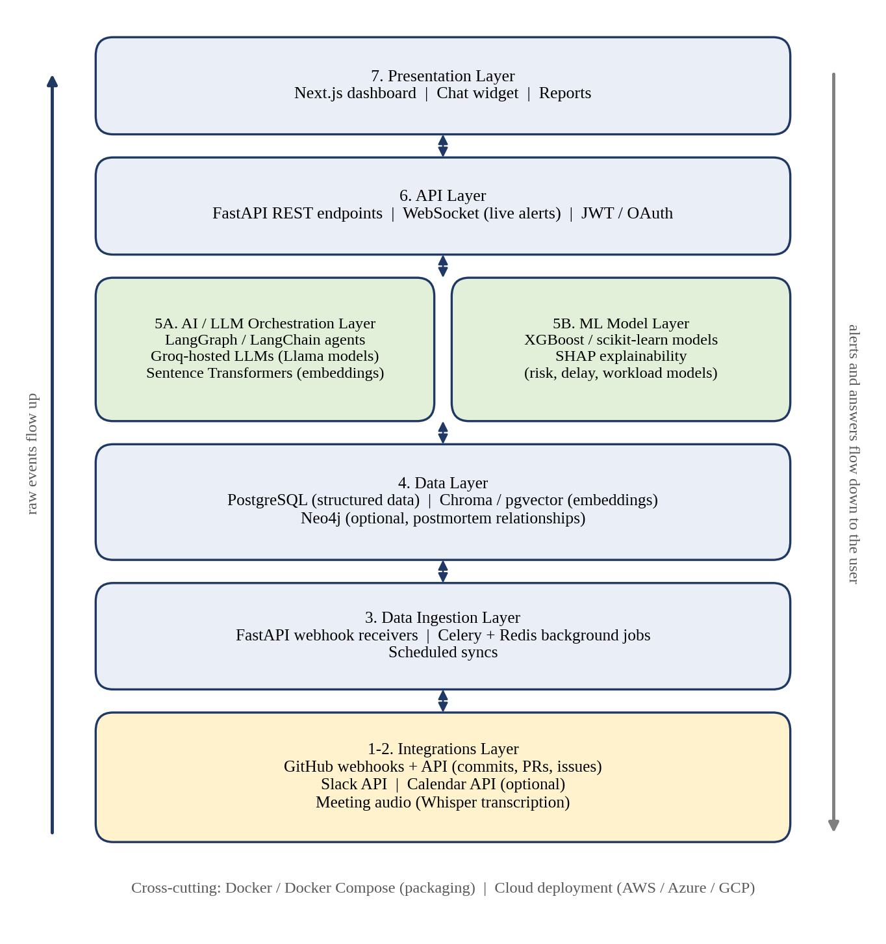
Figure 3.1: System architecture of ProjectPilot AI
- Integrations layer: GitHub webhooks and API supply commits, pull requests and issues; meeting audio is transcribed with Whisper; Slack and Calendar APIs are listed as optional sources of communication and scheduling data.
- Data ingestion layer: FastAPI webhook receivers accept incoming events. Celery workers with Redis run slow tasks (syncing GitHub data, generating reports) and scheduled jobs so that the application remains responsive.
- Data layer: PostgreSQL stores users, projects, tasks, sprints and metrics. Chroma or pgvector stores embeddings for retrieval. Neo4j is an optional store for relationships in postmortem analysis.
- ML model layer: XGBoost / scikit-learn models produce risk, delay and workload scores, and SHAP explains the predictions.
- AI / LLM orchestration layer: LangGraph / LangChain agents coordinate multi-step LLM tasks using Groq-hosted Llama models; Sentence Transformers create embeddings for semantic search.
- API layer: FastAPI REST endpoints, a WebSocket channel for live alerts, and JWT / OAuth for authentication and authorisation.
- Presentation layer: a Next.js dashboard (with Tailwind CSS), a chat widget and reports.
The overall workflow of the system is shown in the flowchart in Figure 3.2.
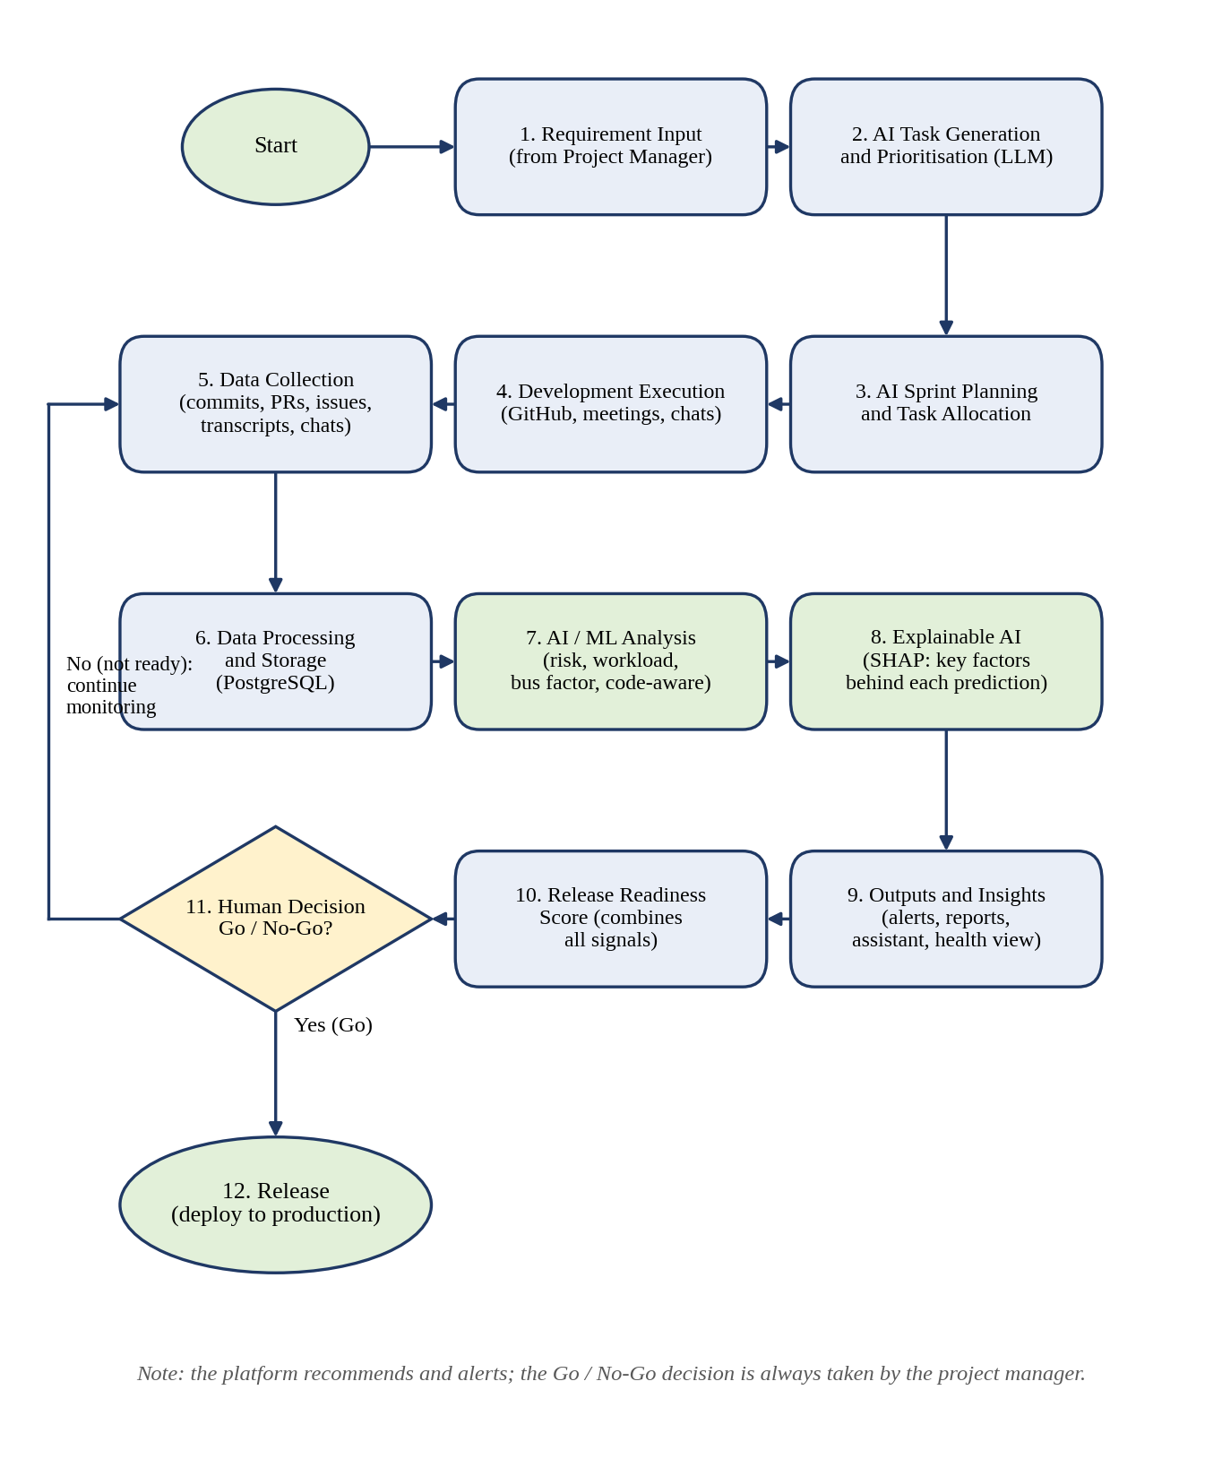
Figure 3.2: System flowchart of ProjectPilot AI
The workflow starts when the project manager provides requirements. The LLM generates and prioritises tasks, and sprint planning allocates them to the team. As the team works using GitHub, meetings and chats, the data is collected, cleaned and stored in PostgreSQL. The AI/ML engine then analyses the data for risk and delay, workload, bus factor and code-aware indicators, and SHAP explains the predictions. The results are presented as alerts, reports, a health overview and answers from the assistant. The Release Readiness Score combines the signals, and the project manager makes the go/no-go decision. If the project is not ready, monitoring continues; if it is ready, the software is released. The loop repeats continuously.

3.3.2 Detailed Design (UML)
Use case diagram. Figure 3.3 shows the interactions between users and the system. The project manager and developers use the platform through the dashboard, the stakeholder reads reports and status, and GitHub acts as an external system that sends events to the platform.
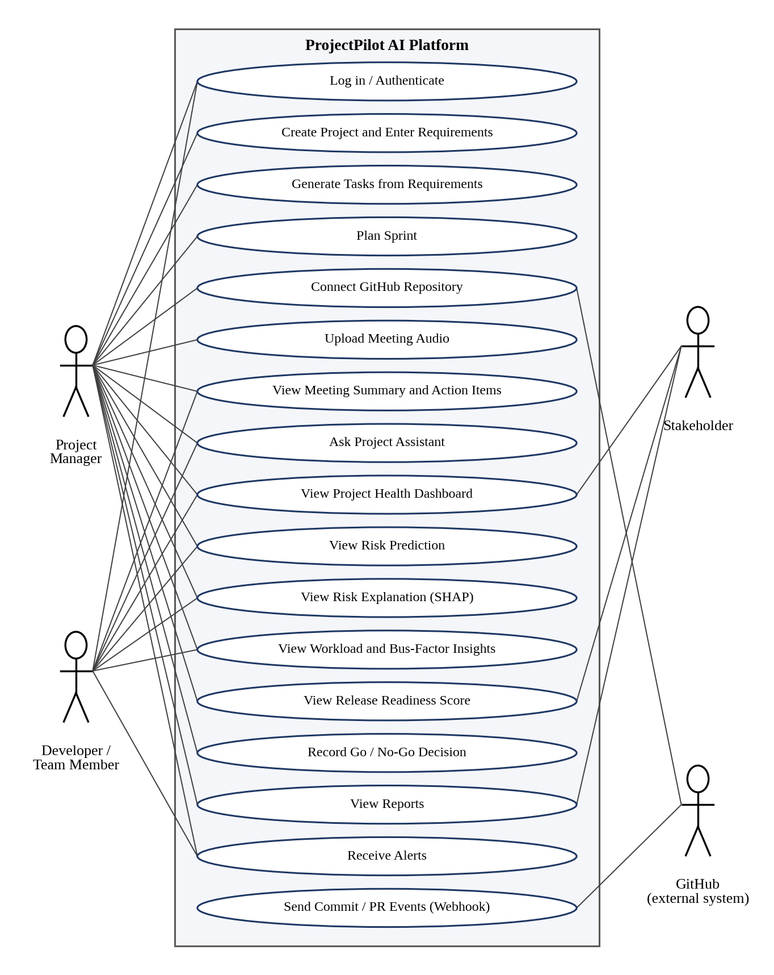
Figure 3.3: Use case diagram of ProjectPilot AI
Prediction, explanation and readiness pipeline. Figure 3.4 separates the different outputs of the ML part. The XGBoost model produces a risk score from engineered features (the prediction). SHAP then uses the model and the features to produce the contribution of each feature (the explanation). The Release Readiness Score is computed separately, at project level, by combining the risk scores with other signals such as bus factor and workload.
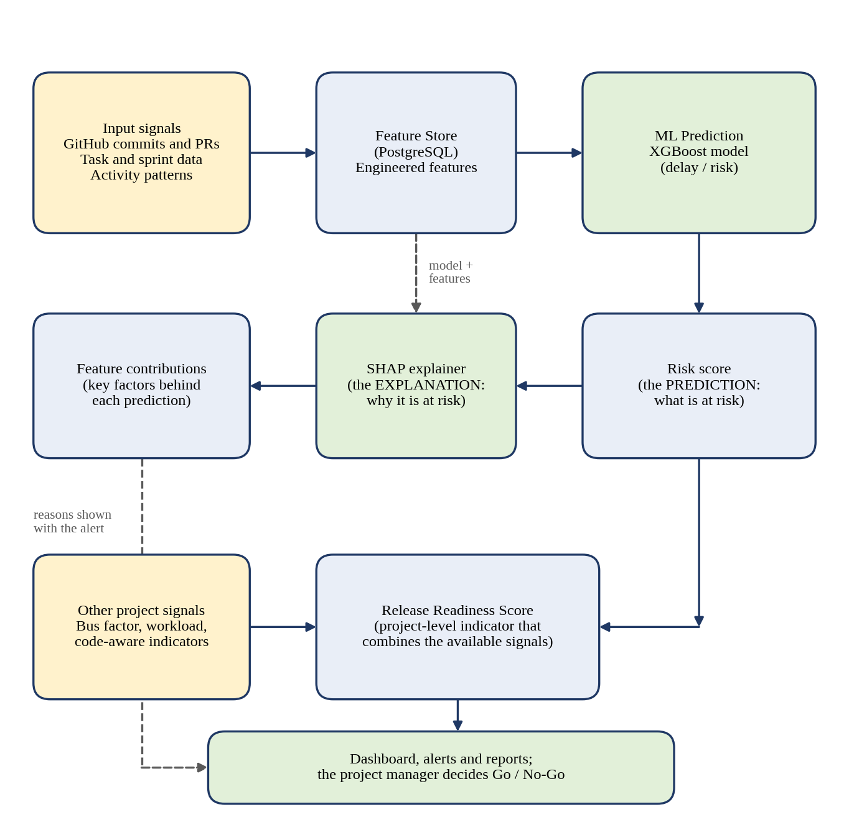
Figure 3.4: Risk prediction, explanation and release readiness pipeline
Sequence diagram. Figure 3.5 shows how a GitHub event becomes an alert with reasons. A commit or pull-request event is sent to the FastAPI webhook receiver, which validates it and queues a background job. The worker stores the raw event, computes features, and requests a prediction from the ML engine and an explanation from SHAP. The prediction and its reasons are stored in PostgreSQL, and an alert is pushed to the dashboard over WebSocket. The project manager then views the risk and its reasons and decides on action, for example reassigning a reviewer.
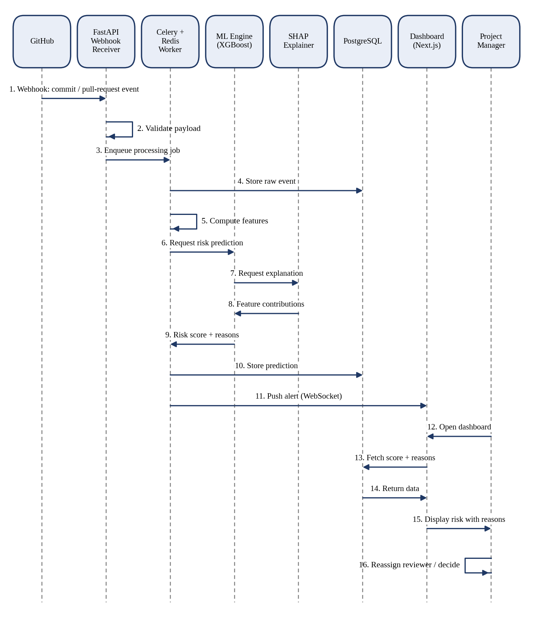
Figure 3.5: Sequence diagram: from a GitHub event to an explained risk alert
Data design. The principal data groups are listed in Table 3.5. They are based on the data named in the project material (users, projects, tasks, sprints and metrics; raw, processed and feature data; embeddings). The detailed table structure will be finalised during implementation.
Table 3.5: Principal data entities (logical design)
Entity | Description
Users | Registered users, roles and authentication details
Projects | Projects, linked repositories and team membership
Requirements and tasks | Requirements, generated tasks, priorities, dependencies, status and assignment
Sprints | Sprint plans, dates and the tasks planned in each sprint
Repository events | Commits, pull requests and issues received from GitHub (raw data store)
Meetings | Transcripts, summaries and action items
Metrics and features | Processed data and engineered features used by the ML models (processed and feature stores)
Predictions and explanations | Risk scores, SHAP contributions, bus-factor and workload findings, readiness scores
Embeddings | Vector representations of project text for retrieval (Chroma / pgvector)

3.4 Methodology
The approach to solving the problem is to connect the data produced during software development, analyse it with suitable AI and ML techniques, explain the results and present them to the team. The methodology is described step by step below.
- Requirement intake and task generation. The project manager enters the requirements. An LLM generates tasks and priorities, which the manager reviews and edits.
- Sprint planning. Approved tasks are arranged into sprints according to priority, dependencies, workload and velocity.
- Data collection. GitHub webhooks and API supply commits, pull requests and issues; meeting audio is transcribed; team chats and calendar data can be added as optional sources.
- Processing and storage. Incoming data is validated, cleaned, transformed and normalised, then stored in the raw, processed and feature stores in PostgreSQL. Long-running processing is done in background jobs.
- Feature engineering. Indicators are computed from the stored data, such as change size, test additions, file ownership, task re-edits and activity timing.
- Prediction. The XGBoost model predicts delay and risk. Bus-factor and workload analysis run alongside it.
- Explanation. SHAP computes the contribution of each feature to each prediction.
- Communication. Meetings are summarised and action items extracted; the project assistant answers questions using RAG; reports and priority-based alerts are generated.
- Release readiness. The available signals are combined into the Release Readiness Score with its reasons.
- Human decision and feedback. The project manager decides go or no-go; if not ready, monitoring continues and new data flows into the next cycle.
The module-wise description of input, processing, technique and output is given in Table 3.6.
Table 3.6: Module-wise input, processing and output
Module | Input | Processing | Technique | Output
Task generation | Requirement text | Prompted LLM produces tasks, priorities, dependencies | LLM | Draft task list
Sprint planning | Tasks, capacity, velocity | Allocates tasks to sprints | LLM + rules | Sprint plan
GitHub monitoring | Webhook events | Validate, queue, store | Rule-based | Stored events
Code-aware risk | Commits, PRs | Compute change-level indicators | Feature engineering | Feature values
Delay / risk prediction | Features | Trained tree-ensemble model | XGBoost (ML) | Risk score
Explanation | Model, features | Shapley-value attribution | SHAP | Feature contributions
Bus factor | Contribution data | Find knowledge concentrated in few people | Analytics | At-risk areas
Workload | Tasks, activity | Compare load and activity patterns | Analytics / ML | Overload indicators
Meeting module | Meeting audio | Transcribe, then summarise | Whisper + LLM | Summary, action items
Assistant | User question | Retrieve context, generate answer | Embeddings + LLM | Grounded answer
Release readiness | Signals above | Weighted aggregation | Score aggregation | Readiness score

Chapter 4

Experimental Set up
This chapter describes the data used by the system, the parameters proposed for evaluating it, and the software and hardware set-up. At the time of writing, the system is in the design stage and no experimental results are available; the evaluation described here will be carried out in the next semester.

4.1 Details of Database or Details about Input to Systems or Selected Data

4.1.1 Input data sources
Table 4.1: Input data sources of ProjectPilot AI
Source | Data | Used for
GitHub API and webhooks | Commits, pull requests, issues, branches and code activity | Progress tracking, code-aware risk indicators, bus factor, workload
Platform task records | Requirements, tasks, sprints, assignments and status | Task generation, sprint planning, delay prediction
Meeting audio | Recorded meetings (transcribed by Whisper) | Summaries and action items
Team chats (Slack API) | Messages and discussions; optional source | Project assistant context, communication data
Calendar API | Scheduling information; optional source | Planning and availability

4.1.2 Database
PostgreSQL is the main database. According to the system design, it holds users, projects, tasks, sprints and metrics, and is organised into a raw data store (data as received), a processed data store (cleaned and transformed data) and a feature store (engineered inputs to the ML models). Embeddings used for retrieval are kept in Chroma or pgvector. Neo4j is an optional graph store for relationships used in postmortem analysis. The logical data entities are given in Table 3.5.

4.1.3 Training data and the cold-start problem
The delay and risk models need historical examples to learn from, and a new project has none. To address this cold-start problem, the plan is to first train the models on the public history of two or three mature open-source GitHub repositories (commits and pull-request outcomes are public), and then to adapt them using the team’s own data once a few weeks of it are available. The specific repositories and the labelling of “delayed” or “risky” items have not yet been finalised. Public research datasets used in the literature, such as those in [1] and [3], are additional options for background study.

4.2 Performance Evaluation Parameters (for Validation)
The evaluation plan separates the parts of the system according to what they do. No values have been measured yet; the results will be reported after the implementation is complete.

4.2.1 ML model: delay and risk prediction
For a classifier that labels a task as at risk or not at risk, the confusion matrix counts true positives (TP), true negatives (TN), false positives (FP) and false negatives (FN). The following metrics are proposed:
Accuracy = (TP + TN) / (TP + TN + FP + FN)
Precision = TP / (TP + FP), Recall = TP / (TP + FN)
F1-score = 2 × Precision × Recall / (Precision + Recall)
The area under the ROC curve (AUC) will also be reported, since at-risk tasks are usually fewer than normal tasks and accuracy alone can mislead on imbalanced data. If delay is predicted as a number of days, mean absolute error (MAE) will be used.

4.2.2 Explainability
SHAP output will be checked for consistency, for example that the top contributing features change in the expected direction when the input changes, and reviewed with team members to judge whether the stated reasons are understandable and useful.

4.2.3 LLM-based modules
Generated tasks, sprint plans, meeting summaries and assistant answers will be assessed by manual review against reference material, for example whether the tasks cover the requirements, whether action items in the transcript are captured, and whether assistant answers are supported by project data. Whisper transcription quality will be checked on sample recordings.

4.2.4 System-level
Response time for processing a GitHub event and for dashboard queries, and correct functioning of each module in end-to-end tests, will be recorded.

4.3 Software and Hardware Set up

4.3.1 Software Requirements
Table 4.2: Software requirements and technologies
Category | Technology | Purpose in ProjectPilot AI
Operating system | Windows 10 / 11 | Development environment (Docker allows the same stack to run on other systems)
Languages | Python 3.10+; JavaScript / TypeScript | Python for backend, AI/ML and data processing; TypeScript for the web front end
Frontend framework | Next.js 14 (App Router), React | Project dashboard and web interface
Frontend libraries | Tailwind CSS; TanStack React Query v5; Zustand | Styling; server-data fetching and caching; client-side state
Backend | FastAPI | REST APIs and webhook handling, in the same language as the AI/ML code
Real-time and security | WebSockets; JWT / OAuth | Live alerts and updates; authentication and authorisation
API testing | Postman / Insomnia | Testing the platform’s own endpoints during development
LLMs | Groq-hosted Llama models | Fast responses for summaries, task generation, explanations and chat
LLM orchestration | LangGraph / LangChain | Chaining several AI steps (agents)
Embeddings | Sentence Transformers | Semantic search for the project assistant
Speech-to-text | Whisper (with ffmpeg) | Meeting audio transcription
Machine learning | scikit-learn, XGBoost | Risk, delay and workload prediction
Explainable AI | SHAP | Feature-level explanation of predictions
Database | PostgreSQL | Users, projects, tasks, sprints and metrics
Vector store | Chroma / pgvector | Embeddings for RAG retrieval
Graph store (optional) | Neo4j | Relationships for postmortem analysis
Background processing | Celery + Redis | Slow and scheduled jobs without blocking the app
Integrations | GitHub API and webhooks; Slack API; Calendar API | Repository activity (main source); optional communication and scheduling data
DevOps and tools | Docker / Docker Compose; Git / GitHub | Consistent environment; version control and collaboration
Cloud (deployment) | AWS / Azure / GCP | Cloud deployment, using the provider offering student credits

4.3.2 Hardware Requirements
The project material does not specify hardware requirements. The following are indicative development requirements, suggested from the tools used (Docker, PostgreSQL, Redis and Whisper running locally), and will be confirmed during implementation:
- Processor: multi-core CPU, for example Intel i5 or equivalent (minimum).
- RAM: 16 GB recommended for running the full Docker stack together with model training; 8 GB may be sufficient for individual modules.
- Storage: sufficient free disk space for containers, databases, repository data and model files.
- GPU: optional; may speed up local Whisper transcription, while LLM inference is done through Groq’s hosted service.
- Network: internet access for Groq, GitHub and other API calls.
Chapter 5

Implementation Plan for Next Semester

5.1 Partial Implementation
The work completed in this semester is the analysis and design of ProjectPilot AI. It consists of the problem analysis, the literature survey, the definition of objectives and scope, the selection of the technology stack, and the design of the architecture, workflow, use cases and data organisation presented in Chapters 2 to 4.
The project material available for preparing this report describes the design of the system and does not include screenshots or code of a working module, so no implementation results are claimed in this report. Any module that the team has already started should be described below, with screenshots of the code or output and a short description, as required by the report format.
[To be filled in by the team: screenshots of implemented work, if any (for example the project set-up, the first GitHub webhook received and logged by the backend, a first LLM call through Groq, or the dashboard shell), each with a short description. Delete this paragraph if there is nothing to add.]

5.2 Implementation Plan for Next Semester (Gantt Chart)
The implementation in the next semester will follow the order suggested by the project plan: the core functions are built first so that a demonstrable system is available early, followed by the differentiating analysis and explanation features, and finally integration, testing and documentation. The proposed 16-week schedule is shown in Figure 5.1 and Table 5.1.
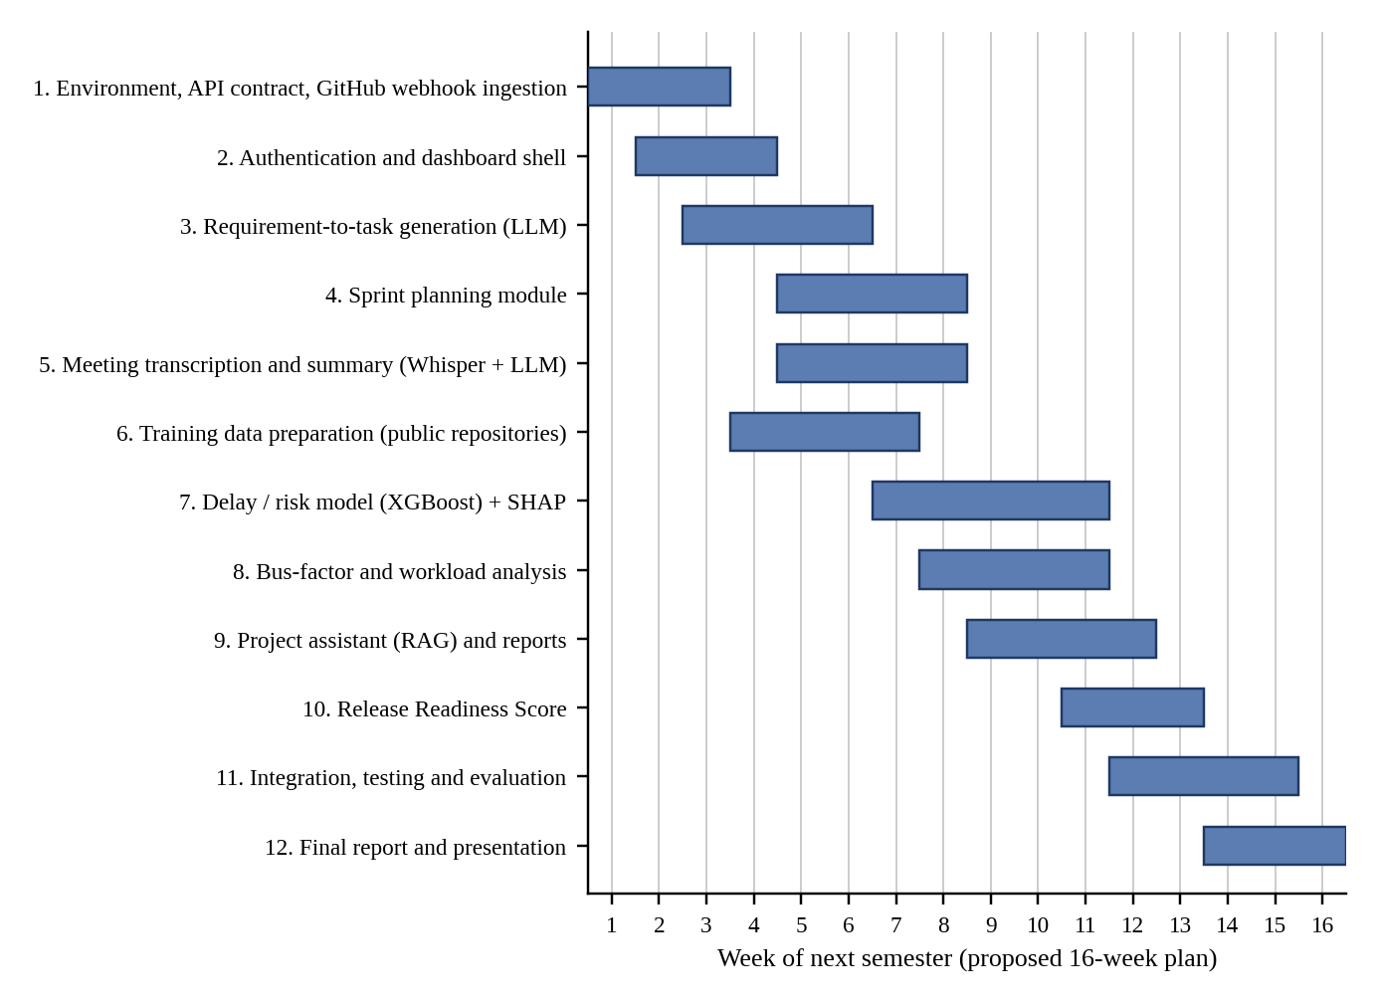
Figure 5.1: Gantt chart for next semester implementation (proposed)
Table 5.1: Proposed implementation plan for next semester
Sr. | Task | Weeks | Outcome
1 | Set up environment, agree the API contract between layers, receive and log a real GitHub webhook | 1 – 3 | Working ingestion pipeline
2 | Authentication and dashboard shell with sample data | 2 – 4 | Login and empty dashboard
3 | Requirement-to-task generation using Groq-hosted LLM | 3 – 6 | Task generation module
4 | Sprint planning module | 5 – 8 | Sprint plan output
5 | Meeting transcription and summary with action items | 5 – 8 | Meeting module
6 | Prepare training data from public repositories; define features and labels | 4 – 7 | Training dataset
7 | Train XGBoost delay/risk model and add SHAP explanation | 7 – 11 | Explainable risk prediction
8 | Bus-factor and workload analysis | 8 – 11 | Knowledge and workload indicators
9 | Project assistant (RAG), reports and notifications | 9 – 12 | Assistant and reports
10 | Release Readiness Score | 11 – 13 | Readiness score with reasons
11 | Integration, testing and evaluation using the parameters in Section 4.2 | 12 – 15 | Tested system and results
12 | Final report and presentation | 14 – 16 | Final submission

The schedule is a proposal and may be adjusted with the guide. Features beyond the core and differentiating set, listed under future scope in Section 2.4.4, will be taken up only if time allows.
References
[1] F. Gazzawe, “A System-Oriented Machine Learning Approach for Planning and Execution of Decisions in Software Project Management,” International Journal of Advanced Computer Science and Applications (IJACSA), 2026.
[2] U. Reddy, Y. P. Rangaiah, A. Nagpal, A. Meheta, G. Karuna, and K. Adnan, “Integrating Artificial Intelligence in Project Management: Challenges and Opportunities,” IEEE INCIP, 2025.
[3] Y. Assefa, E. Alemneh, S. Nibret, and A. Worku, “Software Risk Prediction at Requirement and Design Phase: An Ensemble Machine Learning Approach,” IEEE ICT4DA, 2023.
[4] M. A. Sami, Z. Rasheed, M. Waseem, Z. Zhang, T. Herda, and P. Abrahamsson, “Prioritizing Software Requirements Using Large Language Models,” arXiv, 2024.
[5] P. Sun and Q. Shao, “MAPM: Multi-Modal Auto-Agile Project Risk Management and Prediction for Collaboration Platform Using AI/ML,” Technical Disclosure Commons, Defensive Publications Series, 2023.
Acknowledgement
We wish to express our sincere gratitude to Dr. Sanjay U. Bokade, Principal, and Prof. S. P. Khachane, H.O.D. of the Department of Computer Engineering of Rajiv Gandhi Institute of Technology, for providing us an opportunity to do our project work on “ProjectPilot AI – AI-Powered Software Engineering and Project Management Platform”.
This project bears an imprint of many people. We sincerely thank our project guide, Mr. D. P. Kapse, for his guidance and encouragement in carrying out this project work.
Finally, we would like to thank our colleagues and friends who helped us in completing the project work successfully.

1. SALONI RAJABHAU GADEKAR
2. DEEPTI NITIN MAHAJAN
3. NANDINI UMESH MANE
4. TEJAL JITENDRA MHATRE
Plagiarism Report
[Attach the Turnitin plagiarism report here. The guide holds the Turnitin login; after the report is generated, request the guide to delete the project report from the Turnitin database.]

