PROGRAM

THIRTY-THIRD ANNUAL
PRECISE TIME AND TIME INTERVAL (PTTI)
SYSTEMS AND APPLICATIONS MEETING

November 27-29, 2001

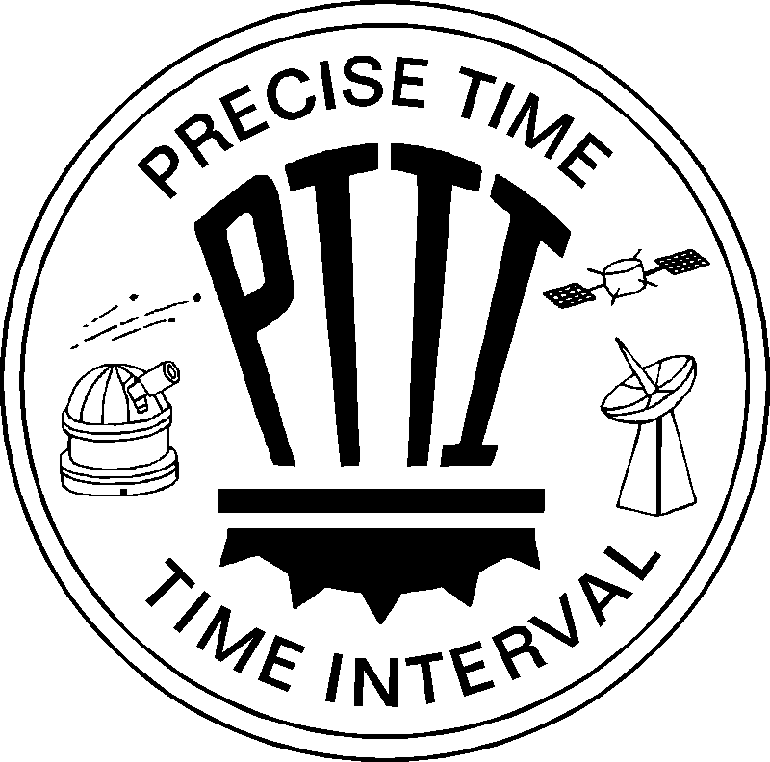

33 Years of Progress
1969-2001

Hyatt Regency Hotel
Long Beach, California

