**Software Requirements** **Specification**

**for**

# <Project>

**Version 1.0 approved**

**Prepared by <author>**

**<organization> <date created>**

## Table of Contents

1. **Introduction................................................................................................................................1**
   1. **Purpose ....................................................................................................................................1**
   2. **Document Conventions...........................................................................................................1**
   3. **Intended Audience and Reading Suggestions.......................................................................1**
   4. **Project Scope...........................................................................................................................1**
   5. **References................................................................................................................................1**
2. **Overall Description....................................................................................................................2**
   1. **Product Perspective.................................................................................................................2**
   2. **Product Features.....................................................................................................................2**
   3. **User Classes and Characteristics...........................................................................................2**
   4. **Operating Environment.........................................................................................................2**
   5. **Design and Implementation Constraints..............................................................................2**
   6. **User Documentation...............................................................................................................2**

**2.6. Assumptions and Dependencies.............................................................................................2**

1. **System Features..........................................................................................................................3**
   1. **System Feature 1.....................................................................................................................3**
   2. **System Feature 2.....................................................................................................................3**
2. **External Interface Requirements.............................................................................................4**
   1. **User Interfaces.........................................................................................................................4**
   2. **Hardware Interfaces...............................................................................................................4**
   3. **Software Interfaces.................................................................................................................4**
   4. **Communications Interfaces...................................................................................................4**
3. **Other Nonfunctional Requirements.........................................................................................5**
   1. **Performance Requirements....................................................................................................5**
   2. **Safety Requirements...............................................................................................................5**
   3. **Security Requirements............................................................................................................5**
   4. **Software Quality Attributes...................................................................................................5 6. Other Requirements...................................................................................................................5 Appendix A: Glosary.....................................................................................................................5 Appendix B: Analysis Models.......................................................................................................6**

**Appendix C: Issues List.................................................................................................................6**

## Revision History

**Name**

**Date**

**Reason For Changes**

**Version**

## 1. Introduction

### 1.1 Purpose

### 1.2 Document Conventions

### 1.3 Intended Audience and Reading Suggestions

### 1.4 Project Scope

### 1.5 References

## 2. Overall Description

### 2.1 Product Perspective

### 2.2 Product Features

### 2.3 User Classes and Characteristics

### 2.4 Operating Environment

### 2.5 Design and Implementation Constraints

### 2.6 User Documentation

### 2.7 Assumptions and Dependencies

## 3. System Features

### 3.1 System Feature 1

#### 3.1.1 Description and Priority

#### 3.1.2 Stimulus/Response Sequences

#### 3.1.3 Functional Requirements

REQ-1:

REQ-2:

**3.2 System Feature 2 (and so on)**

## 4. External Interface Requirements

### 4.1 User Interfaces

### 4.2 Hardware Interfaces

### 4.3 Software Interfaces

### 4.4 Communications Interfaces

## 5. Other Nonfunctional Requirements

### 5.1 Performance Requirements

### 5.2 Safety Requirements

### 5.3 Security Requirements

### 5.4 Software Quality Attributes

## 6. Other Requirements

## Appendix A: Glossary

## Appendix B: Analysis Models

<Incluir:

1. 1-Contexto del sistema

B.1.1-Diagrama de contexto (Ejemplo Wiegers adjunto)

B.1.2-Modelo dominio del sistema

B.1.3-Descripción modelo dominio (Para cada concepto indicar intención y extensión) B.1.4-Diagrama de casos de uso n iterac

1. 2-Descripción detallada cada CU 1 iterac (ordenados forma descend. por prioridad).
   1. 1-Caso de uso 1:

B.2.1.1-Texto del CU (formato Wiegers adjunto)

B.2.1.2-Pantalla (s) y/o reporte (s) del CU

B.2.1.3-Diagrama de actividades del CU

B.2.1.4-Casos de prueba del CU (Datos entrada y resultados) B.2.2- Caso de uso 2...n

>

## Appendix C: Issues List

< This is a dynamic list of the open requirements issues that remain to be resolved, including

TBDs, pending decisions, information that is needed, conflicts awaiting resolution, and the like.>

**ANEXOS**

1. **PLANTILLA PATRÓN REQS DATOS (Withall)**

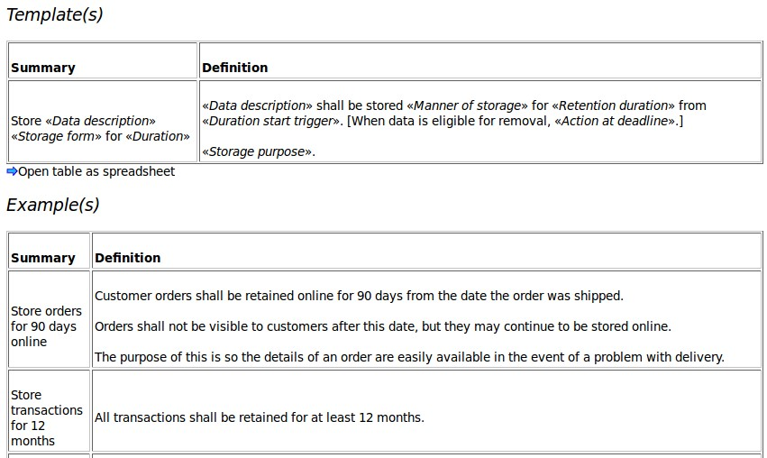

1. **PLANTILLA PARA DESCRIPCIÓN CU (Formato Wiegers)**

